Supplementary material 2: Seasonal and annual patterns in FComp2
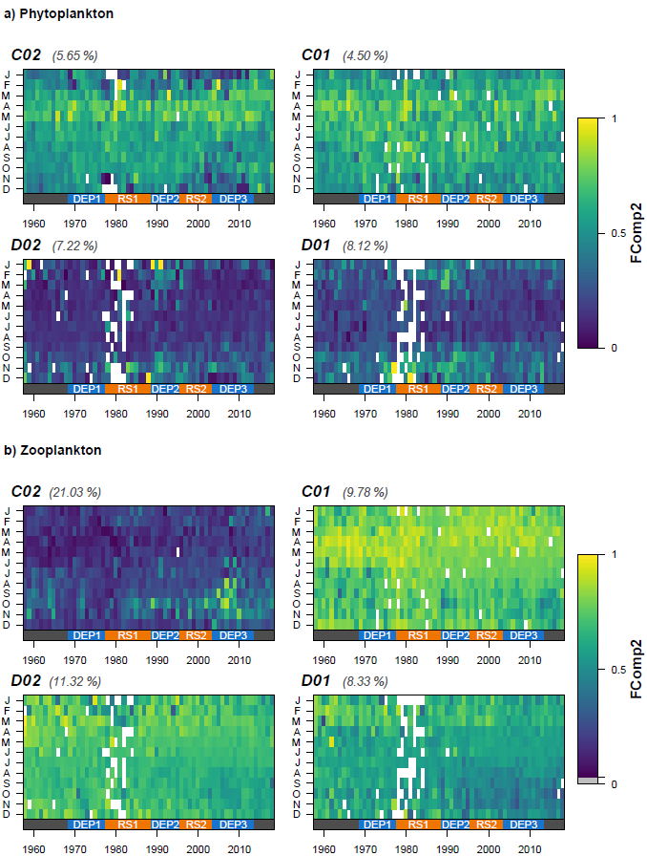
Figure S2.1 Seasonal (y-axes) and long-term (x-axes) variations in the second functional composition axis (FComp2) in a) phytoplankton and b) zooplankton communities in the four standard areas of the North Sea (C02, C01, D02, D01) in relation to regime shifts (RS) and dynamic equilibrium periods (DEP). Proportion of variance explained by FComp2 is given in brackets
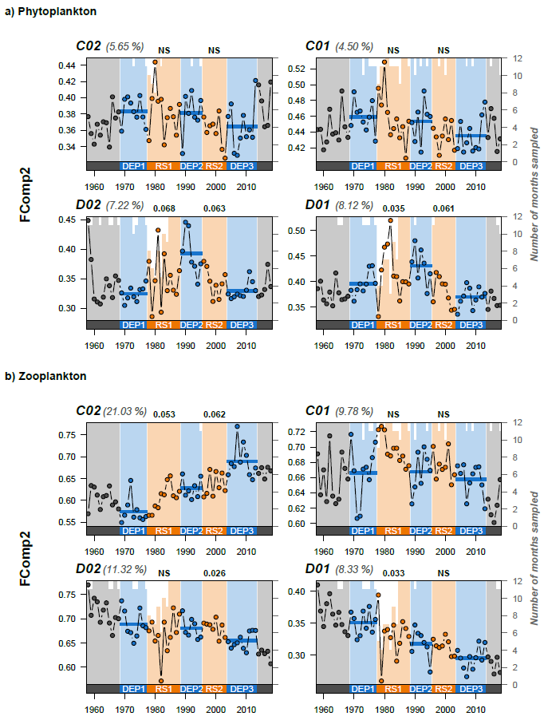
Figure S2.2 Annual averages in the second functional composition axis (left axes, FComp2) in a) phytoplankton and b) zooplankton communities in the four standard areas of the North Sea (C02, C01, D02, D01) with both regime shifts (RS, in orange) and dynamic equilibrium periods (DEP, in blue) represented. The proportion of variance explained by FComp2 is given in brackets. Bar plots in the background indicate sampling effort as the number of months sampled (right axes). Blue lines indicate the mean of FComp2 during DEP. The absolute difference between the mean FComp2 during DEP before and after each RS is given above each panel (NS = non-significant at α = 0.05, Kruskal-Wallis test)

