Supplementary material 3: Intersection of the trait-space of phyto- and zooplankton communities by PC1 of PCA on centroids
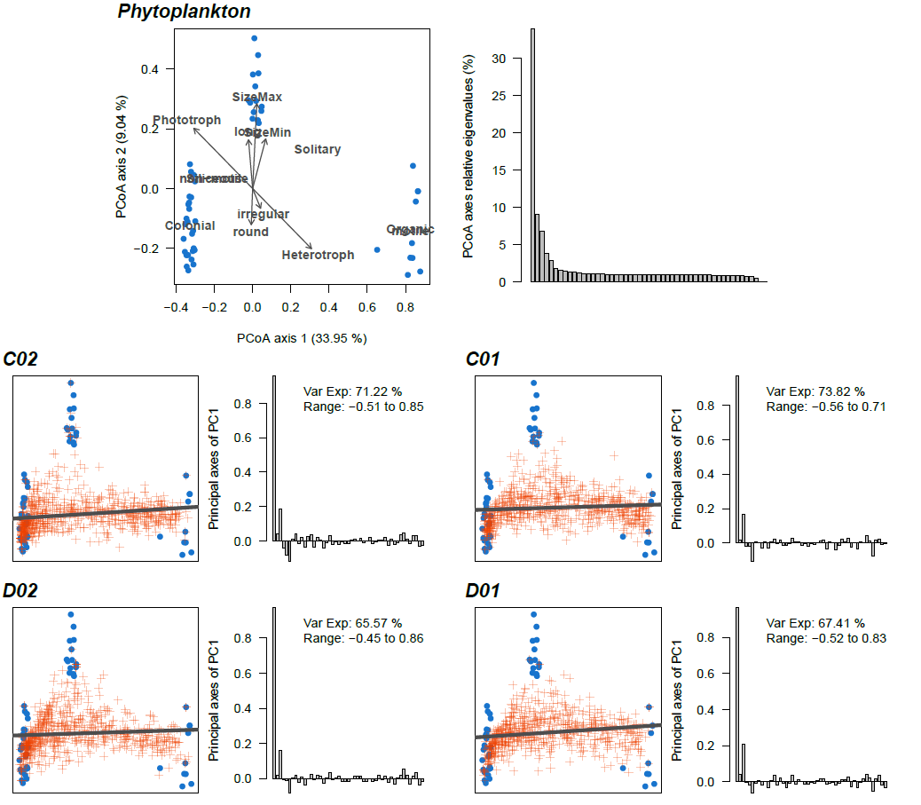
Figure S3.1 Trait-space of phytoplankton obtained through PCoA (top-left) and eigenvalues associated to PCoA axes (top-right). Blue points represent taxa position. Grey arrow and text represents correlation with traits. Below, for each standard area (C02, C01, D02, D01) the left panel present the position of centroids computed monthly between 1958 and 2018 in the trait space (orange crosses). A PCA is then performed on the centroid and the projection of PC1 on the two first PCoA axes is drawn (thick grey line). The right panel give the principal axes of PC1 (i.e. which PCoA axes contribute to PC1) as well as the variance it explains and the range of its principal components.
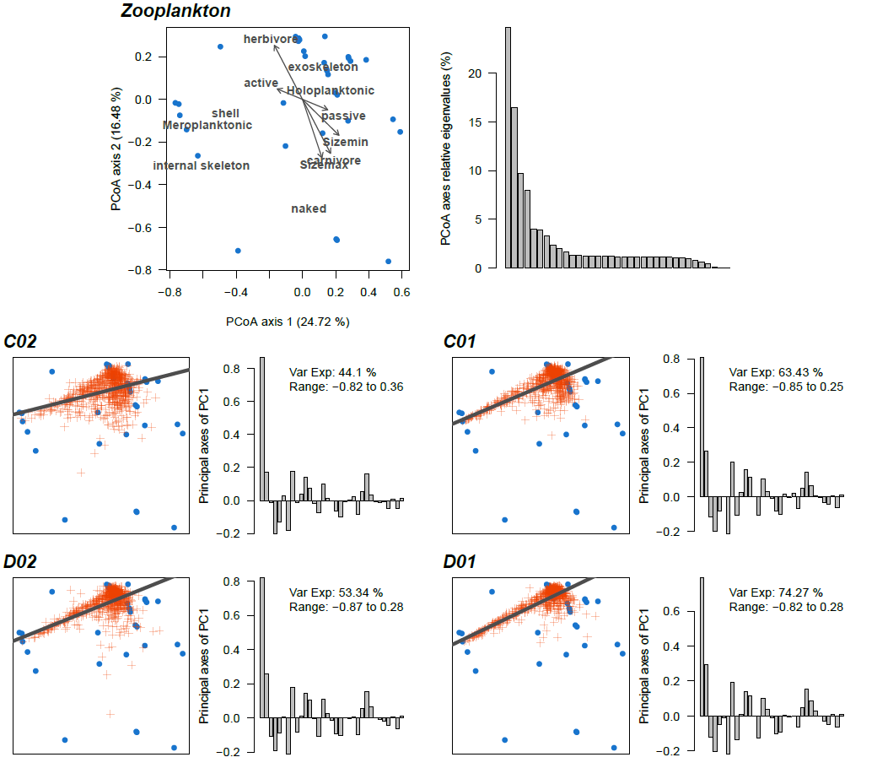
Figure S3.2 Trait-space of zooplankton obtained through PCoA (top-left) and eigenvalues associated to PCoA axes (top-right). Blue points represent taxa position. Grey arrow and text represents correlation with traits. Below, for each standard area (C02, C01, D02, D01) the left panel present the position of centroids computed monthly between 1958 and 2018 in the trait space (orange crosses). A PCA is then performed on the centroid and the projection of PC1 on the two first PCoA axes is drawn (thick grey line). The right panel give the principal axes of PC1 (i.e. which PCoA axes contribute to PC1) as well as the variance it explains and the range of its principal components.

