Supplemental Material for:
Correlation of paleoearthquake records at multiple sites along the southern Yangsan Fault, Korea: Insights into rupture scenario of intraplate strike-slip earthquakes

Taehyung Kim, Jin-Hyuck Choi, Youngbeom Cheon*, Tae-Ho Lee, Namgwon Kim, Hoil Lee, Chang-Min Kim, Yire Choi, Hankyung Bae, Young-Seog Kim, Chung-Ryul Ryoo, Yann Klinger
*E-mail: cheonyb@kigam.re.kr

This file includes:
Figure S1
Figure S2
Figure S3
Table S1

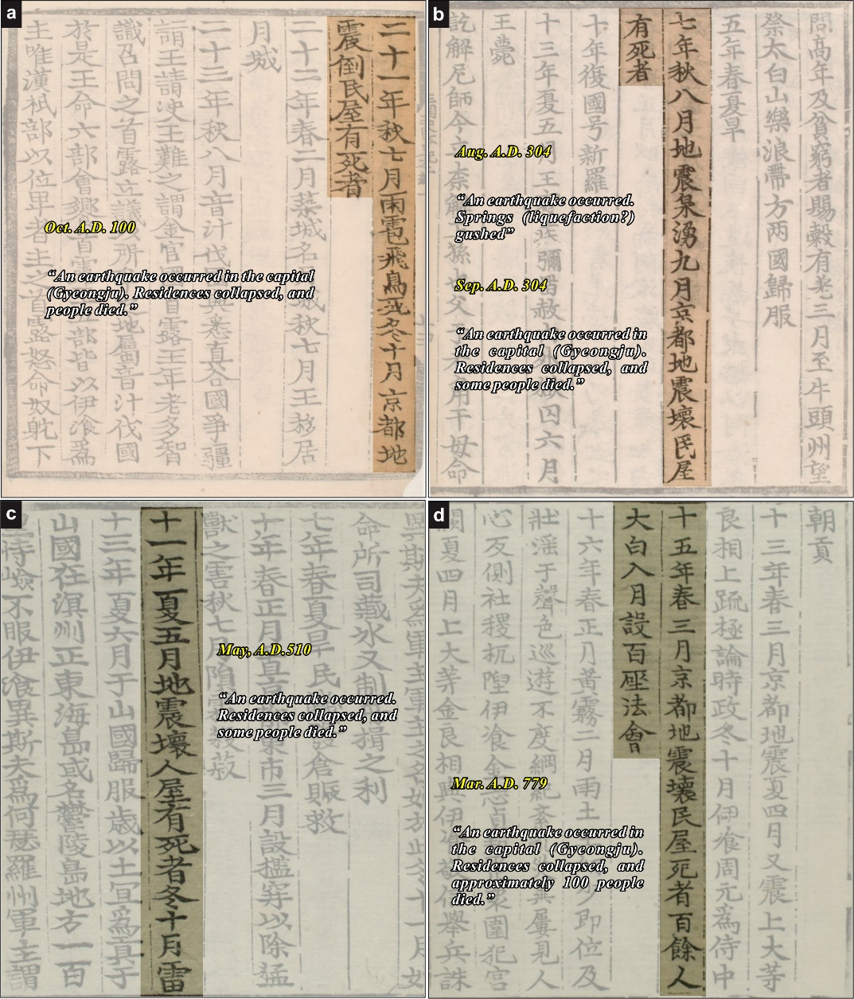
Figure S1 Historical earthquake records around the Gyeongju city from the ‘Samgukyusa (History of the Three Kingdoms)’
[Historical earthquake record]
October, AD100: An earthquake occurred in the capital (Gyeongju). Residences collapsed, and people died. [Samgukyusa (History of the Three Kingdoms)]
August, AD304: An earthquake occurred. Springs gushed. [Samgukyusa (History of the Three Kingdoms)]
September, AD304: An earthquake occurred in the capital (Gyeongju). Residences collapsed, and some people died. [Samgukyusa (History of the Three Kingdoms)]
May, AD510: An earthquake occurred. Residences collapsed, and some people died. [Samgukyusa (History of the Three Kingdoms)]
March, AD779: An earthquake occurred in the capital (Gyeongju). Residences collapsed, and approximately 100 people died. [Samgukyusa (History of the Three Kingdoms)]

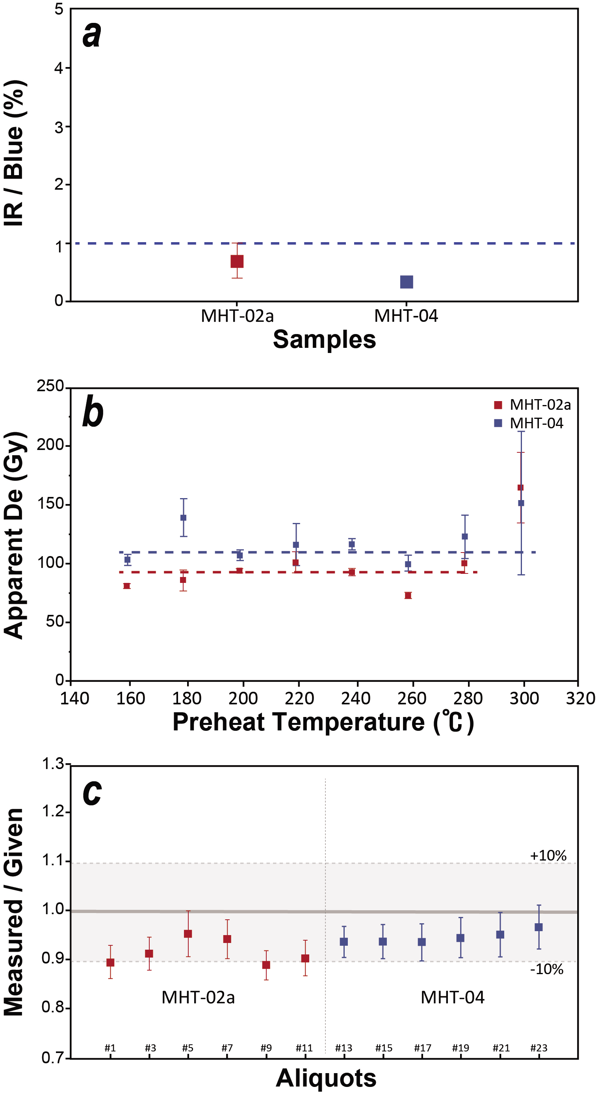
Figure S2 The results of IRSL (a), preheat plateau (b) and dose recovery tests (c) for two samples. IR/Blue ratio of most aliquots is less than 10%. The preheat plateau tests were conducted from 200 to 280 ℃ and 220 ℃ was chosen for D_{e} estimation. The dose recovery tests have been carried out on six aliquots per sample. All aliquots show dose-recovery ratios within 1.0 ± 10%.

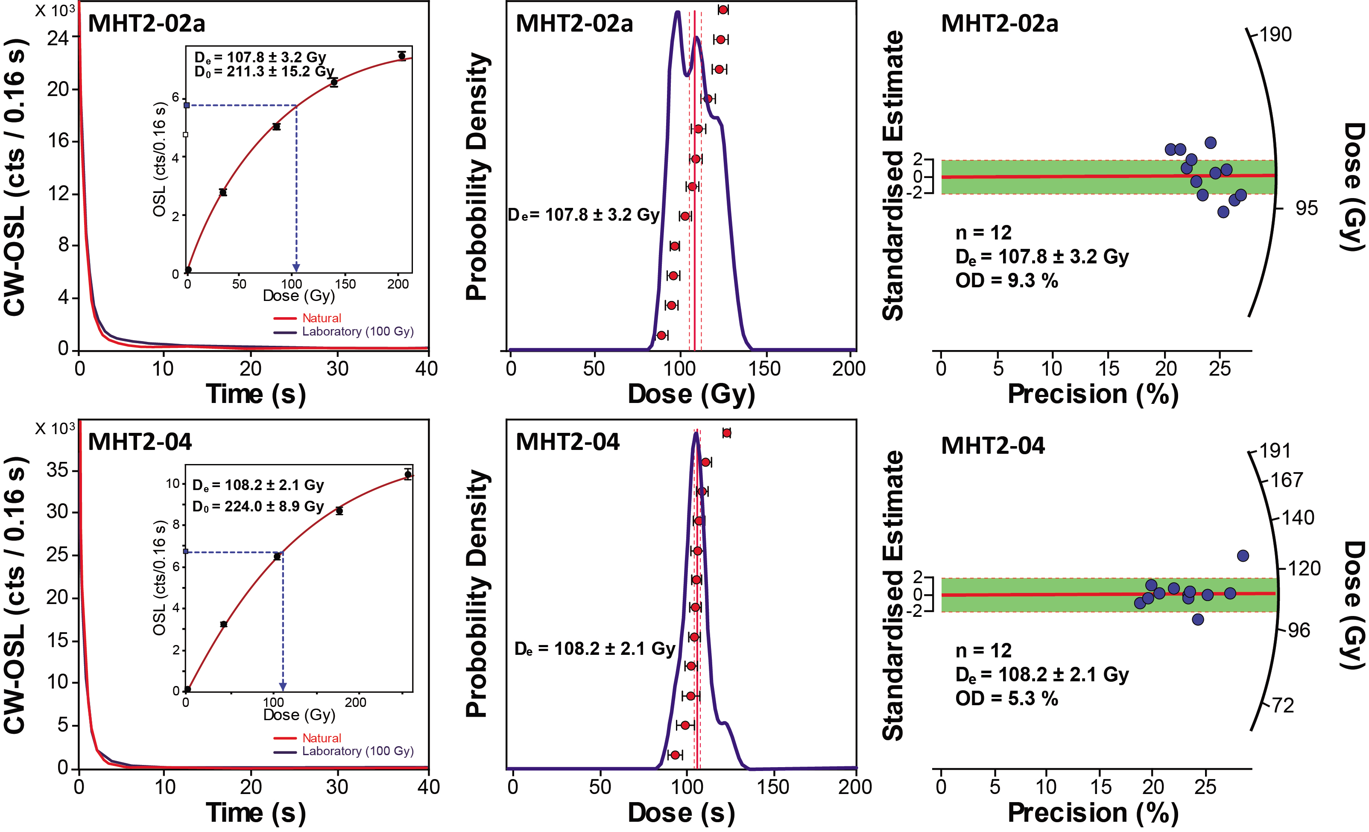
Figure S3 The natural OSL decay curves with dose response growth curves, dose distribution diagrams and radial plot of the analyzed samples. De values of two samples were using the CAM model.
[YF and UF references]
Table S1 Most recent earthquake timing information for Figure 11.
ID | ªFault | ^{b}X (°) | ^{b}Y (°) | MRE range (ka) | Dating methods | Reference
Y1 | YSF | 129.30450 | 36.20144 | 1.5–present | ¹⁴C | Kyung, 2010
Y2 | YSF | 129.25551 | 36.06917 | 3.2–present | OSL | Song et al., 2020
Y3 | YSF | 129.25406 | 36.06005 | 2.1–present | ¹⁴C | Cho et al., 2016
U1 | USF | 129.29050 | 35.89347 | 2.9–1.3 | ¹⁴C | Inoue and Choi, 2006
U2 | USF | 129.28875 | 35.89075 | 27.5–present | ¹⁴C | Okada et al., 1999
U3 | USF | 129.28751 | 35.88706 | 16.7–present | ¹⁴C | Kyung, 2010
U4 | USF | 129.32764 | 35.87869 | 47.3–present | ¹⁴C | Choi et al., 2012
U5 | USF | 129.33177 | 35.78299 | 51–present | OSL | Choi et al., 2014
U6 | USF | 129.33193 | 35.78333 | 35–present | OSL | Choi et al., 2014
U7 | USF | 129.33703 | 35.75498 | –5.8 | OSL & ¹⁴C | Kim et al., 2020
U8 | USF | 129.33703 | 35.74741 | 34.6–present | ¹⁴C | Okada et al., 1998
U9 | USF | 129.33419 | 35.73392 | 8.3–2.3 | ¹⁴C | Inoue and Choi, 2006
U10 | USF | 129.34318 | 35.72046 | 92.3–present | OSL | Choi et al., 2012
U11 | USF | 129.35111 | 35.72158 | 44.0–present | ¹⁴C | Choi et al., 2012
U12 | USF | 129.35101 | 35.69804 | 3.6–present | OSL & ¹⁴C | Kim et al., 2021
WS | YSF | 129.19459 | 35.72313 | 35.0–present | OSL | this study
MH | YSF | 129.17875 | 35.67687 | 28.0–15.0 (35-30) | OSL & ¹⁴C | this study
IBN | YSF | 129.16653 | 35.64760 | 37.0–17.0 | OSL | this study
IB | YSF | 129.16435 | 35.64260 | 29.0–present | OSL & ¹⁴C | Cheon et al., 2020a
ªYSF: Yangsan Fault, USF: Ulsan Fault
^{b}coordinates system: WGS1984(degree)

