Spatial distributions, environmenal drivers and co-existence patterns of key cold-water corals in the deep sea of the Azores (NE Atlantic)

Authors: Gerald Hechter Taranto^{1,2} *, José-Manuel González-Irusta^{1,2,3}, Carlos Dominguez-Carrió^{1,2}, Christopher K. Pham^{1,2}, Fernando Tempera^{1,4}, Manuela Ramos^{1,2}, Guilherme Gonçalves^{1,2}, Marina Carreiro-Silva^{1,2}, Telmo Morato^{1,2}.

1 - Instituto de Investigação em Ciências do Mar - Okeanos, Universidade dos Açores, Horta, Portugal
2 - IMAR Instituto do Mar, Universidade dos Açores, Horta, Portugal
3 - Instituto Español de Oceanografía, Centro Oceanográfico de Santander, 39080, Santander, Spain.
4 - IFREMER, RBE/STH/LBH, Centre de Bretagne, Z.I. de la Pointe du Diable, CS 10070, 29280 Plouzané, France.

* Corresponding author. Gerald H. Taranto, Instituto de Investigação em Ciências do Mar - Okeanos, Universidade dos Açores, 9901‐862 Horta, Portugal. Email: gh.taranto@gmail.com

Supporting information

Appendix A. Species selection and occurrence data 1
Table A.1 – Qualitative criteria adopted to define the relative abundance, structural complexity and vulnerability of CWCs in the Azores. 1
Table A.2 – Cold-water coral taxa selected for the habitat suitability modelling exercise. Their relative abundance, structural complexity (i.e. 3D-structure) and vulnerability were assessed and classified in 3 categories through an expert-driven process. Those results were used to select the taxa that show characteristics of foundation species and hence included in the modelling exercise. 2
Figure A.1 – Presence records of the selected octocoral (Alcyonacea) taxa. Suborders: (a-e) Calcaxonia; (f-g) Holaxonia; (h-i) Scleraxonia. In parenthesis the number of records used to develop the habitat suitability models. 3
Figure A.2 – Presence records of the selected Scleractinia (a-c), Anthoathecata (Stylasteridae) (d) and Antipatharia (e) species. In parenthesis the of number records used to develop the habitat suitability models. 4
Appendix B. Predictor layers 5
Table B.1 – Environmental layers considered in this study. The layers selected to develop habitat suitability models are highlighted in bold. Values of mean and standard deviation (SD) only consider areas shallower than 2000 m. (‡) Depth-derived layers computed in ArcGIS using the Benthic Terrain Modeller toolbox (Walbridge et al., 2018). (†) Seafloor conditions derived from the VIKING20 oceanographic model computed as the mean of monthly values for the period 1989-2009 (Böning et al., 2016). All layers from Amorim et al. (2017), Böning et al. (2016) and Wei et al. (2020) refer to seafloor conditions only. BPI: bathymetric position index; POC: particulate organic carbon. 5
Figure B.1 – Principal component analysis (PCA) of aragonite, calcite, nitrate, phosphate and silicate. (a-d) Locally weighted scatterplot smoothing (LOWESS) of the unscaled values of silicate, phosphate, nitrate, calcite and aragonite against the first principal component (PC1 – ‘seawater chemistry’). (e) Depths corresponding to aragonite and calcite undersaturation zones (Ω < 1). Panels (a-d) refer to seafloor locations at depths shallower than 2000 m. In order to show undersaturation zones, panel (e) includes locations below 2000 m depth, which are out of the scope of the present study. 6
Figure B.2 – Environmental layers used to develop the habitat suitability models. POC: particulate organic carbon export. Seawater chemistry (unitless) is the first principal component of the principal component analysis combining nutrient concentrations and aragonite/calcite saturation levels. BPI: bathymetric position index (unitless) computed with two radii (5 and 20 km). With the exception of panel (b), all panels refer to seafloor or near-seafloor conditions only. 7
Appendix C. Habitat suitability models 8
Figure C.1 – Workflow for the design and evaluation of habitat suitability models and niche analyses. CWC: cold-water coral; AUC: Area under the curve; TSS: true skill statistics; F_{kHC}: improved Fuzzy Kappa for high-confidence suitable cells. 8
Table C.1 – Category similarity matrix. Values of 1 mean that two categories are identical and values of zero that they are totally different. US: unsuitable cells; LC: low-confidence suitable cells; MC: medium-confidence suitable cells; HC: high-confidence suitable cells. 9
Appendix D. Model outputs 10
Figure D.1 – Standard deviations of (a) true skill statistics (ΔTSS) and (b) area under the curve (ΔAUC) scores plotted against the number of presence records used to develop habitat-suitability models (HSMs). (c) Improved fuzzy kappa scores for high quality cells (F_{kHC}) plotted against the number of presence records used to develop HSMs. In panels (a, b), filled circles are GAM and empty circles are Maxent models. 10
Figure D.2 – Habitat suitability maps produced by GAMs for Octocorallia (Alcyonacea). Local confidence (LC): the percentage of times a cell is classified as suitable when models are fitted with resampled input data. Overall confidence (OC): determined by the lowest score among AUC_{GAM} and TSS_{GAM}. AUC: area under the curve; TSS: true skill statistics. In parenthesis, the number of records used to train the models. 11
Figure D.3 – Habitat suitability maps produced by Maxent models for Octocorallia (Alcyonacea). Local confidence (LC): the percentage of times a cell is classified as suitable when models are fitted with resampled input data. Overall confidence (OC): determined by the lowest score among AUC_{Maxent} and TSS_{Maxent}. AUC: area under the curve; TSS: true skill statistics. In parenthesis, the number of records used to train the models. 12
Figure D.4 – Fuzzy similarity of the habitat suitability maps produced by GAM and Maxent models for Octocorallia (Alcyonacea). Local fuzzy matching (LF): computes the fuzzy matching of GAM and Maxent suitable cells using two membership functions (i) category similarity and (ii) distance decay. Fuzzy matching values greater than 0.5 means that the two cells are more similar than different. Overall similarity (OS): determined by the improved fuzzy kappa score for high quality cells (F_{kHC}). The score measures the degree of overlap of GAM and Maxent high confidence cells. 13
Figure D.5 – Habitat suitability maps produced by GAMs for Scleractinia (a-c), Anthoathecata (c) and Antipatharia (e). Local confidence (LC): the percentage of times a cell is classified as suitable when models are fitted with resampled input data. Overall confidence (OC): determined by the lowest score among AUC_{GAM} and TSS_{GAM}. AUC: area under the curve; TSS: true skill statistics. In parenthesis, the number of records used to train the models. 14
Figure D.6 – Habitat suitability maps produced by Maxent models for Scleractinia (a-c), Anthoathecata (c) and Antipatharia (e). Local confidence (LC): the percentage of times a cell is classified as suitable when models are fitted with resampled input data. Overall confidence (OC): determined by the lowest score among AUC_{Maxent} and TSS_{Maxent}. AUC: area under the curve; TSS: true skill statistics. In parenthesis, the number of records used to train the models. 15
Figure D.7 – Local fuzzy matching of GAM and Maxent habitat suitability. Scleractinia (a-c), Anthoathecata (c) and Antipatharia (e). Local fuzzy matching (LF): computes the fuzzy matching of GAM and Maxent suitable cells using two membership functions (i) category similarity and (ii) distance decay. Fuzzy matching values greater than 0.5 means that the two cells are more similar than different. Overall similarity (OS): determined by the improved fuzzy kappa score for high quality cells (F_{kHC}). The score measures the degree of overlap of GAM and Maxent high confidence cells. 16
Figure D.8 – Response curves for GAM (solid lines) and Maxent (dashed lines) models regarding the predictor seawater chemistry. Percentage values represent the permutation variable importance (in bold values > 10 %). Shared important variables are colored in red. Species are ordered according to the mean depth of their estimated suitable habitat. HSI: Habitat Suitability Index. 17
Figure D.9 – Response curves for GAM (solid lines) and Maxent (dashed lines) models regarding the predictor seafloor temperature. Percentage values represent the permutation variable importance (in bold values > 10 %). Shared important variables are colored in red. Species are ordered according to the mean depth of their estimated suitable habitat. HSI: Habitat Suitability Index. 18
Figure D.10 – Response curves for GAM (solid lines) and Maxent (dashed lines) models regarding the predictor POC flux (Particulate Organic Carbon flux). Percentage values represent the permutation variable importance (in bold values > 10 %). Shared important variables are colored in red. Species are ordered according to the mean depth of their estimated suitable habitat. HSI: Habitat Suitability Index. 19
Figure D.11 – Response curves for GAM (solid lines) and Maxent (dashed lines) models regarding the predictor oxygen saturation. Percentage values represent the permutation variable importance (in bold values > 10 %). Shared important variables are colored in red. Species are ordered according to the mean depth of their estimated suitable habitat. HSI: Habitat Suitability Index. 20
Figure D.12 – Response curves for GAM (solid lines) and Maxent (dashed lines) models regarding the predictor slope. Percentage values represent the permutation variable importance (in bold values > 10 %). Shared important variables are colored in red. Species are ordered according to the mean depth of their estimated suitable habitat. HSI: Habitat Suitability Index. 21
Figure D.13 – Response curves for GAM (solid lines) and Maxent (dashed lines) models regarding the predictor BPI_5km (bathymetric position index computed on a 5 km radius). Percentage values represent the permutation variable importance (in bold values > 10 %). Shared important variables are colored in red. Species are ordered according to the mean depth of their estimated suitable habitat. HSI: Habitat Suitability Index. 22
Figure D.14 – Response curves for GAM (solid lines) and Maxent (dashed lines) models regarding the predictor BPI_20km (bathymetric position index computed on a 20 km radius). Percentage values represent the permutation variable importance (in bold values > 10 %). Shared important variables are colored in red. Species are ordered according to the mean depth of their estimated suitable habitat. HSI: Habitat Suitability Index. 23
Figure D.15 – Response curves for GAM (solid lines) and Maxent (dashed lines) models regarding the predictor bottom current speed. Percentage values represent the permutation variable importance (in bold values > 10 %). Shared important variables are colored in red. Species are ordered according to the mean depth of their estimated suitable habitat. HSI: Habitat Suitability Index. 24
References 25

Appendix A. Species selection and occurrence data
A list of CWCs particularly vulnerable to human activities and with the characteristics of foundation species (sensu Crotty et al., 2019) in the Azores was defined considering three ecological traits: relative abundance, structural complexity and vulnerability to bottom longline and handline fishing, the main benthic extractive activities in the region. Traits were scored qualitatively after an expert-driven process, and refer only to the morphology that colonies form in the Azores. Underwater videos and collected specimens informed the expert driven classification of CWC with respect to the three ecological traits. The general criteria adopted to classify CWC are reported in Table A.1.
Only species scoring high in at least one of the selected traits were considered for the modelling exercise (Table A.2) with the final list including: Acanthogorgia spp., Callogorgia verticillata, Coralliidae spp., Dentomuricea aff. meteor, Desmophyllum pertusum, Errina dabneyi, Leiopathes cf. expansa, Madrepora oculata, Narella bellissima, Narella versluysi, Paracalyptrophora josephinae, Paragorgia johnsoni, Solenosmilia variabilis and Viminella flagellum. From the initial pool of species considered, Candidella imbricata, c.f. Eguchipsammia spp. and Leptosammia spp. were excluded because of insufficient presence points. Presence records were aggregated at higher taxonomic levels when species identifications were uncertain. This was the case for the genus Acanthogorgia (mostly A. armata and A. hirsuta in the region; Braga-Henriques et al., 2013) and the family Corallidae (Pleurocorallium johnsoni, Hemicorallium niobe and Hemicorallium tricolor; Sampaio et al., 2019). Presence records were obtained from both video surveys (see Table 1) and bycatch collection programs (Figures A.1 and A.2).

Table A.1 – Qualitative criteria adopted to define the relative abundance, structural complexity and vulnerability of CWCs in the Azores.
Trait | Low | Medium | High
Relative abundance | When present, the species is generally not the most abundant (e.g., Madrepora oculata) | When present, the species is known to occasionally be the most abundant of the coral assemblage (e.g., Dentomuricea aff. meteor) | When present, the species tends to be the most abundant of the coral assemblage (e.g., Viminella flagellum)
Relative structural complexity | Whip corals (e.g., Narella versluysi) | Branched colonies of medium size (e.g., Narella bellissima) | Branched colonies of large size (e.g., Paragorgia johnsoni)
Relative vulnerability | Colonies persist and dominate coral assemblages in heavily fished areas and do not show serious damages owed to longlines (e.g., Viminella flagellum) | Not applicable | Branched colonies with rigid supporting axes (e.g. Corallidae); extensive damages to colonies from longlines (e.g., Paracalyptrophora josephinae); very vulnerable life histories (e.g., Leiopathes cf. expansa)

Table A.2 – Cold-water coral taxa selected for the habitat suitability modelling exercise. Their relative abundance, structural complexity (i.e. 3D-structure) and vulnerability were assessed and classified in 3 categories through an expert-driven process. Those results were used to select the taxa that show characteristics of foundation species and hence included in the modelling exercise.
Group | Taxon | Relative Abundance | Relative structural complexity | Relative Vulnerability
Antipatharia | Leiopathes cf. expansa | Medium | High | High
Calcaxonia | Callogorgia verticillata | Medium | High | High
Calcaxonia | Narella bellissima | High | Medium | Low
Calcaxonia | Narella versluysi | High | Low | Low
Calcaxonia | Paracalyptrophora josephinae | Medium | High | High
Calcaxonia | Viminella flagellum | High | Low | Low
Holaxonia | Acanthogorgia spp.¹ | High | Medium | Low
Holaxonia | Dentomuricea aff. meteor | Medium | High | High
Scleractinia | Desmophyllum pertusum² | Low | Medium | High
Scleractinia | Madrepora oculata | Low | Medium | High
Scleractinia | Solenosmilia variabilis | Low | Medium | High
Scleraxonia | Coralliidae spp.³ | Medium | Medium | High
Scleraxonia | Paragorgia johnsoni | Medium | Large | High
Stylasteridae | Errina dabneyi | Medium | Medium | High

¹ in this work, it includes the species A. armata and A. hirsuta;
² previously known as Lophelia pertusa, it results from the recent ascription of the genus Lophelia and Demophyllum into the generic name Desmophyllum (see Addamo et al., 2016);
³ in this work, it includes the species Pleurocorallium johnsoni, Hemicorallium niobe and Hemicorallium tricolor.

Figure A.1 – Presence records of the selected octocoral (Alcyonacea) taxa. Suborders: (a-e) Calcaxonia; (f-g) Holaxonia; (h-i) Scleraxonia. In parenthesis the number of records used to develop the habitat suitability models.

Figure A.2 – Presence records of the selected Scleractinia (a-c), Anthoathecata (Stylasteridae) (d) and Antipatharia (e) species. In parenthesis the of number records used to develop the habitat suitability models.

Appendix B. Predictor layers

Table B.1 – Environmental layers considered in this study. The layers selected to develop habitat suitability models are highlighted in bold. Values of mean and standard deviation (SD) only consider areas shallower than 2000 m. (‡) Depth-derived layers computed in ArcGIS using the Benthic Terrain Modeller toolbox (Walbridge et al., 2018). (†) Seafloor conditions derived from the VIKING20 oceanographic model computed as the mean of monthly values for the period 1989-2009 (Böning et al., 2016). All layers from Amorim et al. (2017), Böning et al. (2016) and Wei et al. (2020) refer to seafloor conditions only. BPI: bathymetric position index; POC: particulate organic carbon.
Available predictors | Original resolution | Mean and SD | Units | Source
Depth | 115 m | 1507 ± 415 | m | EMODnet, 2018
BPI_5km (5 km radius)‡ | 115 m | 29.6 ± 107.5 | - | Derived from depth
BPI_20km (20 km radius) ‡ | 115 m | 158.4 ± 316.3 | - | Derived from depth
Slope‡ | 115 m | 6.19 ± 4.97 | ° | Derived from depth
Ruggedness (5km radius)‡ | 115 m | 0.0016 ± 0.0025 | - | Derived from depth
Eastness‡ | 115 m | 0.004 ± 0.553 | - | Derived from depth
Northness‡ | 115 m | -0.017 ± 0.556 | - | Derived from depth
Temperature† | 0.05° | 5.63 ± 2.56 | °C | Böning et al., 2016
Salinity† | 0.05° | 35.20 ± 0.27 | PSU | Böning et al., 2016
Current speed† | 0.05° | 0.010 ± 0.008 | m s⁻¹ | Böning et al., 2016
Aragonite | 1° | 1.34 ± 0.27 | Ω | Wei et al., 2020
Calcite | 1° | 2.07 ± 0.43 | Ω | Wei et al., 2020
Nitrate | 1° | 17.74 ± 1.90 | µmol/l | Amorim et al., 2017
Phosphate | 1° | 1.14 ± 0.13 | µmol/l | Amorim et al., 2017
Silicate | 1° | 12.64 ±1.85 | µmol/l | Amorim et al., 2017
Dissolved Oxygen | 1° | 5.58 ± 0.51 | ml/l | Amorim et al., 2017
Oxygen Saturation | 1° | 79.40 ± 4.76 | % | Amorim et al., 2017
Oxygen Utilization | 1° | 1.44 ± 0.29 | ml/l | Amorim et al., 2017
Seawater chemistry | 1° | 3.01 ± 1.74 | - | This study
POC flux | 9 km | 14.92 ± 1.52 | mg C_{org} m⁻² d⁻¹ | This study

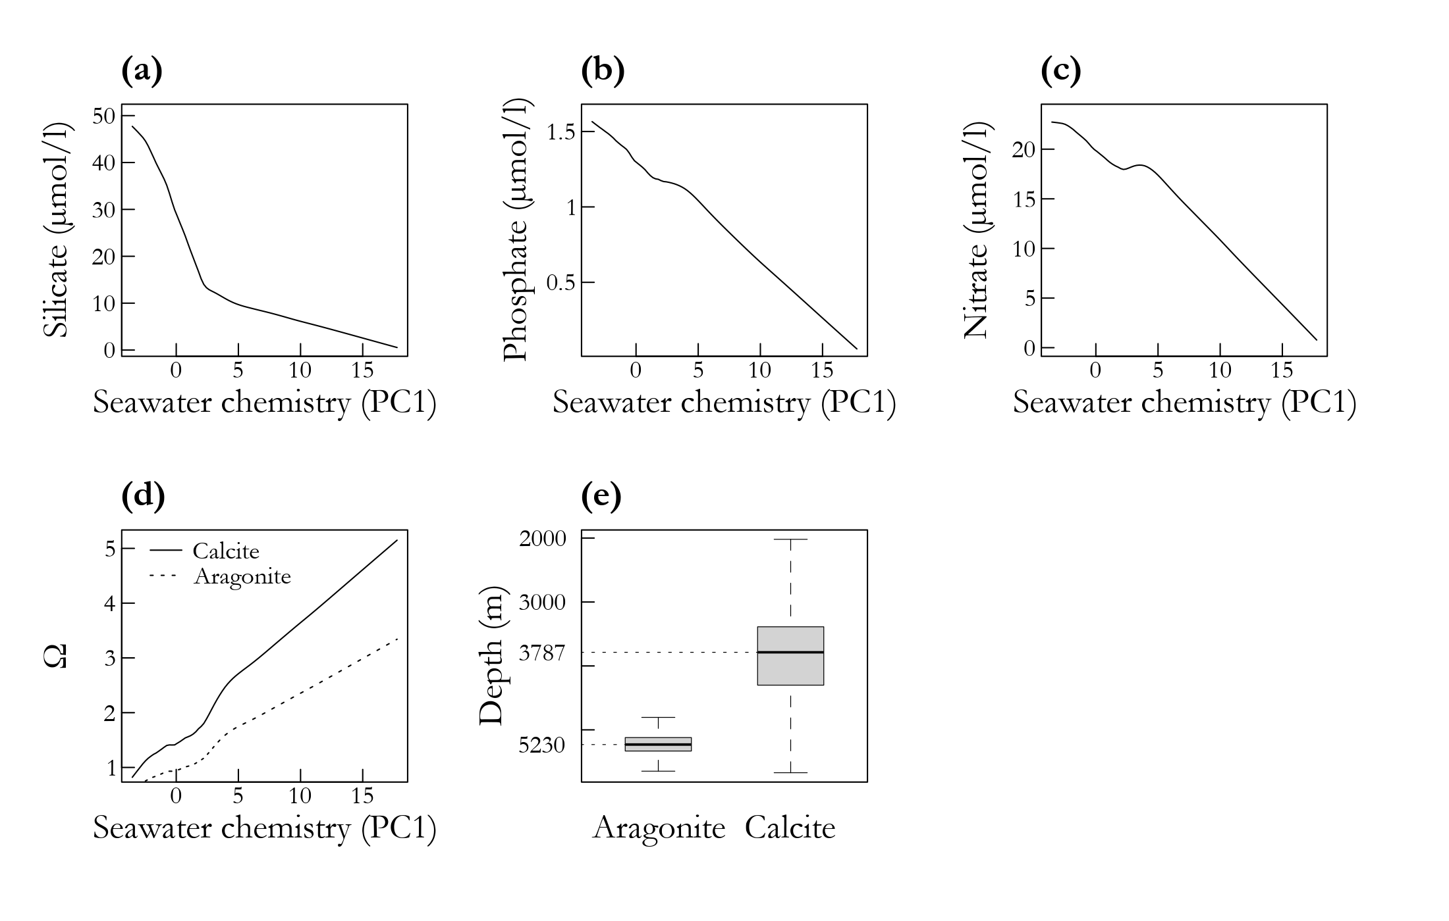

Figure B.1 – Principal component analysis (PCA) of aragonite, calcite, nitrate, phosphate and silicate. (a-d) Locally weighted scatterplot smoothing (LOWESS) of the unscaled values of silicate, phosphate, nitrate, calcite and aragonite against the first principal component (PC1 – ‘seawater chemistry’). (e) Depths corresponding to aragonite and calcite undersaturation zones (Ω < 1). Panels (a-d) refer to seafloor locations at depths shallower than 2000 m. In order to show undersaturation zones, panel (e) includes locations below 2000 m depth, which are out of the scope of the present study.

Figure B.2 – Environmental layers used to develop the habitat suitability models. POC: particulate organic carbon export. Seawater chemistry (unitless) is the first principal component of the principal component analysis combining nutrient concentrations and aragonite/calcite saturation levels. BPI: bathymetric position index (unitless) computed with two radii (5 and 20 km). With the exception of panel (b), all panels refer to seafloor or near-seafloor conditions only.

Appendix C. Habitat suitability models

Figure C.1 – Workflow for the design and evaluation of habitat suitability models and niche analyses. CWC: cold-water coral; AUC: Area under the curve; TSS: true skill statistics; F_{kHC}: improved Fuzzy Kappa for high-confidence suitable cells.

Table C.1 – Category similarity matrix. Values of 1 mean that two categories are identical and values of zero that they are totally different. US: unsuitable cells; LC: low-confidence suitable cells; MC: medium-confidence suitable cells; HC: high-confidence suitable cells.
 | US | LC | MC | HC
US | - | 0 | 0 | 0
LC | - | 1 | 0.6 | 0.3
MC | - | - | 1 | 0.6
HC | - | - | - | 1

Appendix D. Model outputs

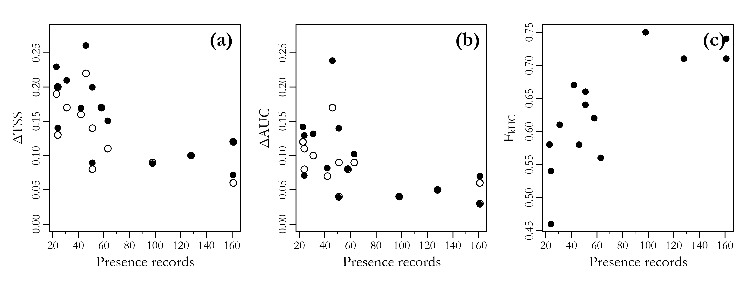

Figure D.1 – Standard deviations of (a) true skill statistics (ΔTSS) and (b) area under the curve (ΔAUC) scores plotted against the number of presence records used to develop habitat-suitability models (HSMs). (c) Improved fuzzy kappa scores for high quality cells (F_{kHC}) plotted against the number of presence records used to develop HSMs. In panels (a, b), filled circles are GAM and empty circles are Maxent models.

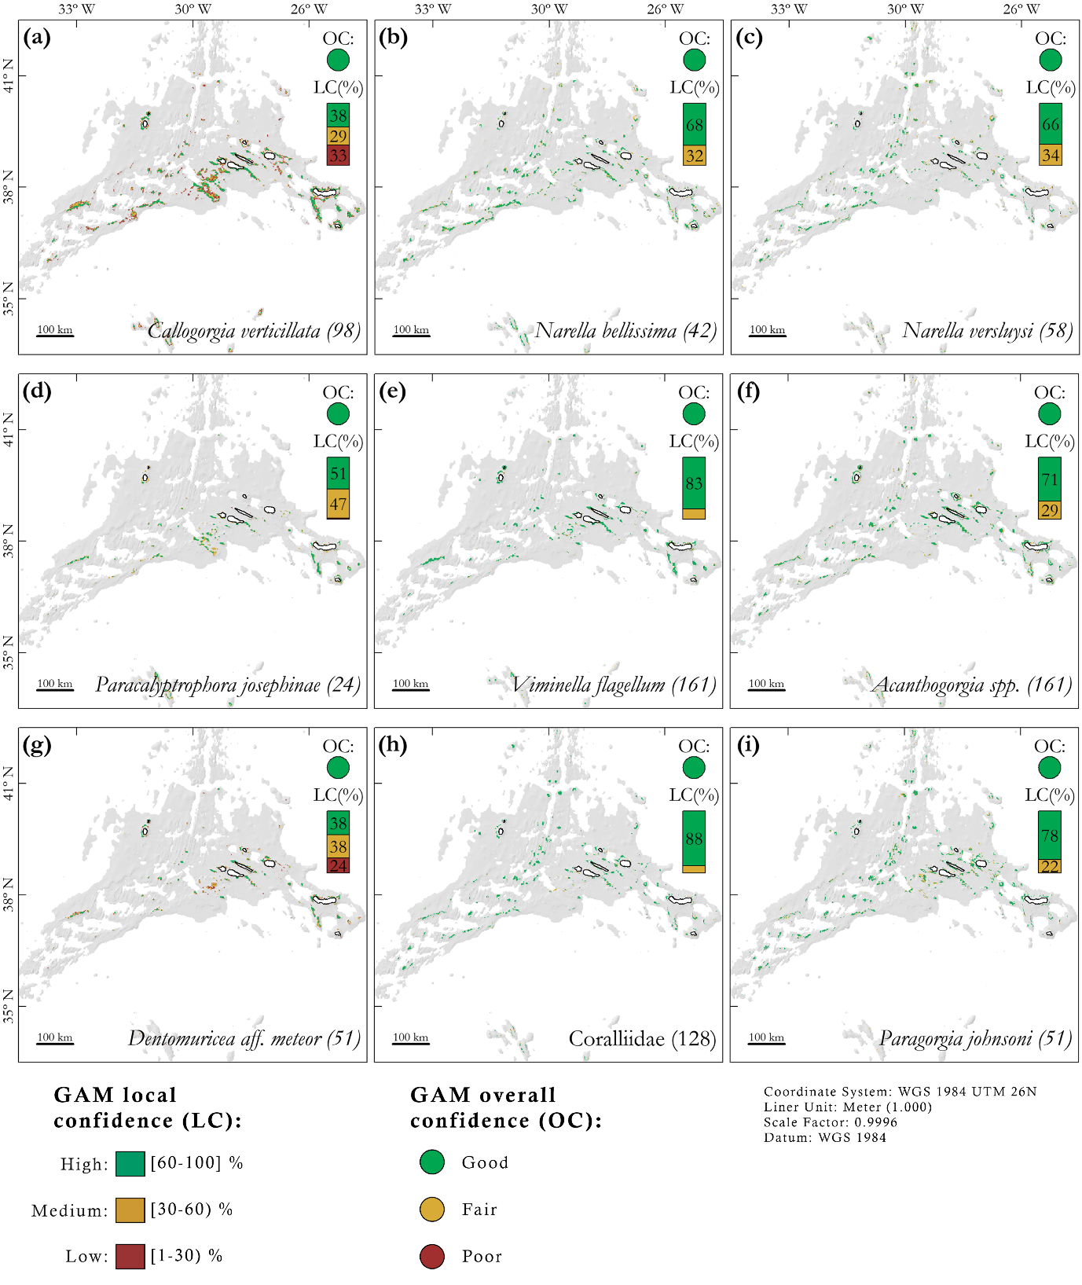

Figure D.2 – Habitat suitability maps produced by GAMs for Octocorallia (Alcyonacea). Local confidence (LC): the percentage of times a cell is classified as suitable when models are fitted with resampled input data. Overall confidence (OC): determined by the lowest score among AUC_{GAM} and TSS_{GAM}. AUC: area under the curve; TSS: true skill statistics. In parenthesis, the number of records used to train the models.

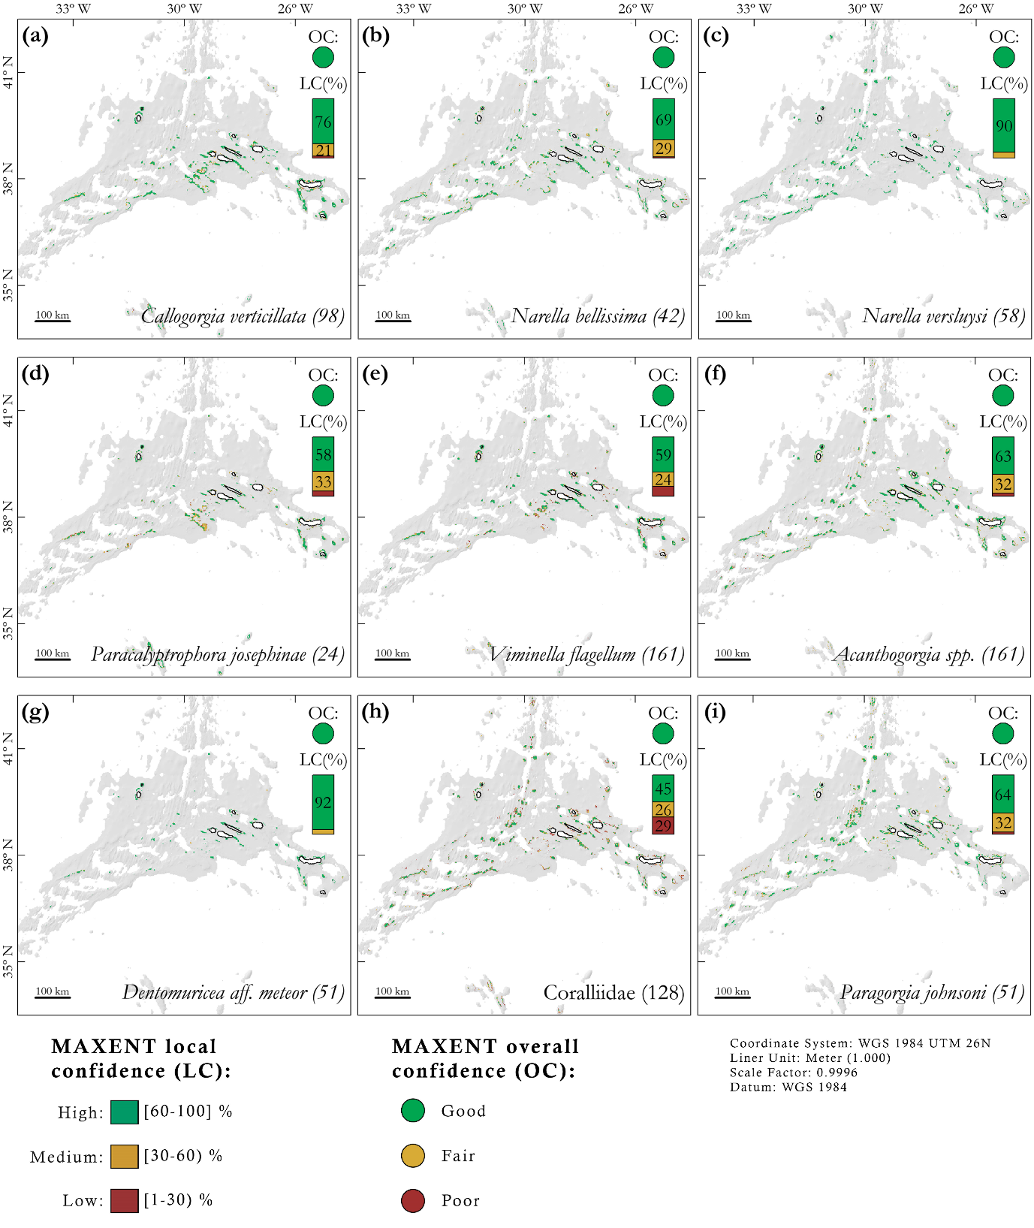

Figure D.3 – Habitat suitability maps produced by Maxent models for Octocorallia (Alcyonacea). Local confidence (LC): the percentage of times a cell is classified as suitable when models are fitted with resampled input data. Overall confidence (OC): determined by the lowest score among AUC_{Maxent} and TSS_{Maxent}. AUC: area under the curve; TSS: true skill statistics. In parenthesis, the number of records used to train the models.

Figure D.4 – Fuzzy similarity of the habitat suitability maps produced by GAM and Maxent models for Octocorallia (Alcyonacea). Local fuzzy matching (LF): computes the fuzzy matching of GAM and Maxent suitable cells using two membership functions (i) category similarity and (ii) distance decay. Fuzzy matching values greater than 0.5 means that the two cells are more similar than different. Overall similarity (OS): determined by the improved fuzzy kappa score for high quality cells (F_{kHC}). The score measures the degree of overlap of GAM and Maxent high confidence cells.

Figure D.5 – Habitat suitability maps produced by GAMs for Scleractinia (a-c), Anthoathecata (c) and Antipatharia (e). Local confidence (LC): the percentage of times a cell is classified as suitable when models are fitted with resampled input data. Overall confidence (OC): determined by the lowest score among AUC_{GAM} and TSS_{GAM}. AUC: area under the curve; TSS: true skill statistics. In parenthesis, the number of records used to train the models.

Figure D.6 – Habitat suitability maps produced by Maxent models for Scleractinia (a-c), Anthoathecata (c) and Antipatharia (e). Local confidence (LC): the percentage of times a cell is classified as suitable when models are fitted with resampled input data. Overall confidence (OC): determined by the lowest score among AUC_{Maxent} and TSS_{Maxent}. AUC: area under the curve; TSS: true skill statistics. In parenthesis, the number of records used to train the models.

Figure D.7 – Local fuzzy matching of GAM and Maxent habitat suitability. Scleractinia (a-c), Anthoathecata (c) and Antipatharia (e). Local fuzzy matching (LF): computes the fuzzy matching of GAM and Maxent suitable cells using two membership functions (i) category similarity and (ii) distance decay. Fuzzy matching values greater than 0.5 means that the two cells are more similar than different. Overall similarity (OS): determined by the improved fuzzy kappa score for high quality cells (F_{kHC}). The score measures the degree of overlap of GAM and Maxent high confidence cells.
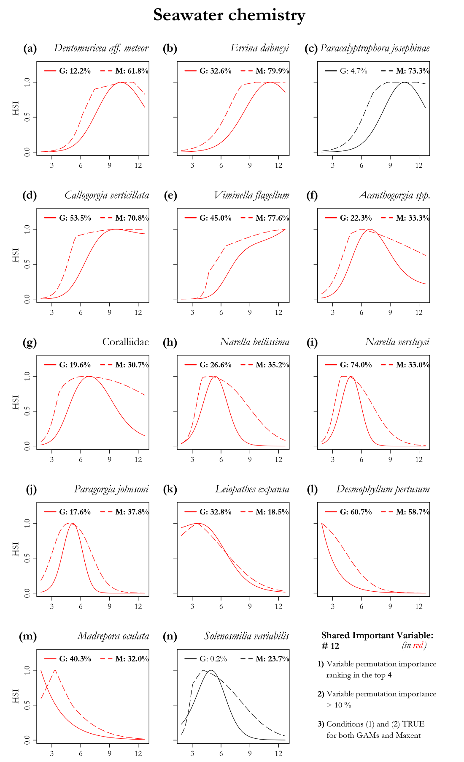

Figure D.8 – Response curves for GAM (solid lines) and Maxent (dashed lines) models regarding the predictor seawater chemistry. Percentage values represent the permutation variable importance (in bold values > 10 %). Shared important variables are colored in red. Species are ordered according to the mean depth of their estimated suitable habitat. HSI: Habitat Suitability Index.
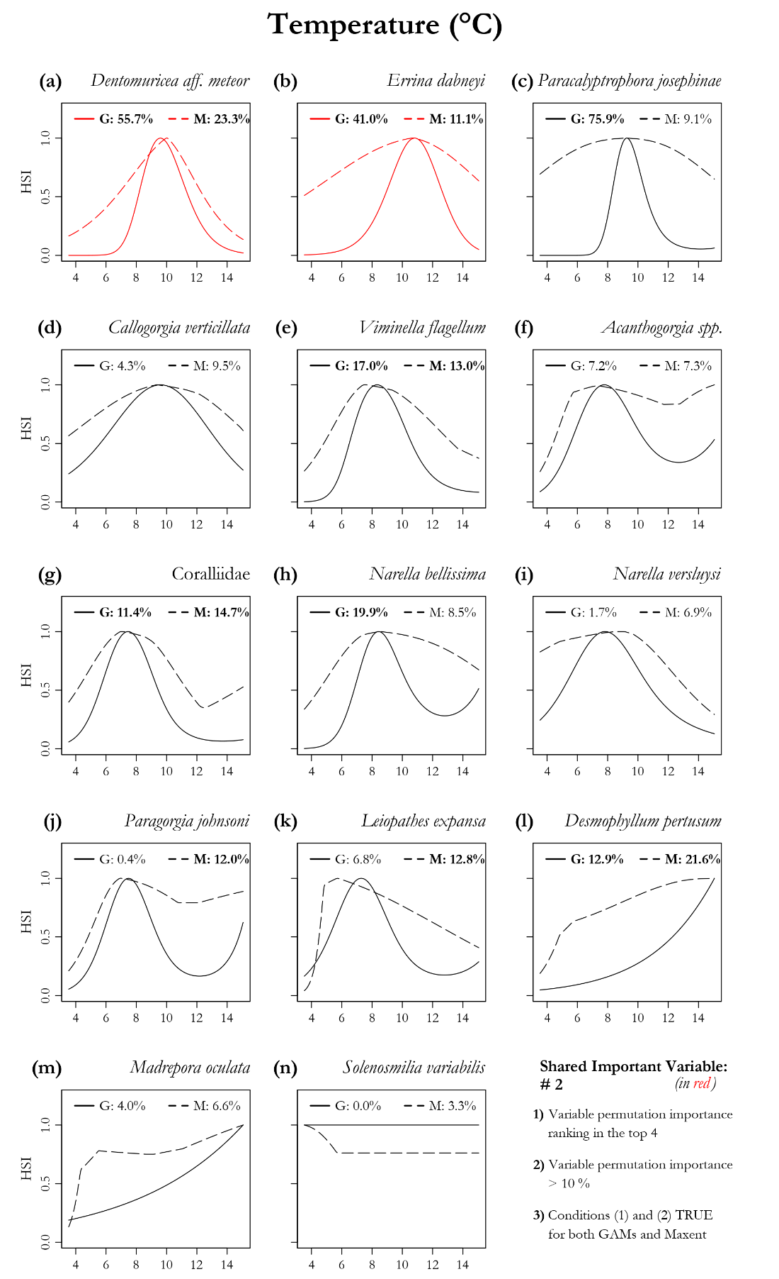

Figure D.9 – Response curves for GAM (solid lines) and Maxent (dashed lines) models regarding the predictor seafloor temperature. Percentage values represent the permutation variable importance (in bold values > 10 %). Shared important variables are colored in red. Species are ordered according to the mean depth of their estimated suitable habitat. HSI: Habitat Suitability Index.
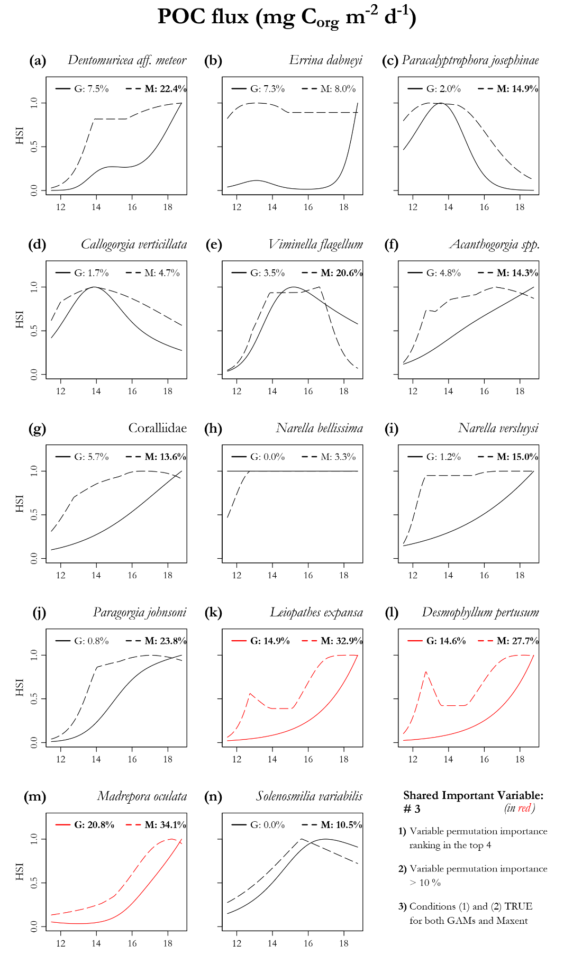

Figure D.10 – Response curves for GAM (solid lines) and Maxent (dashed lines) models regarding the predictor POC flux (Particulate Organic Carbon flux). Percentage values represent the permutation variable importance (in bold values > 10 %). Shared important variables are colored in red. Species are ordered according to the mean depth of their estimated suitable habitat. HSI: Habitat Suitability Index.
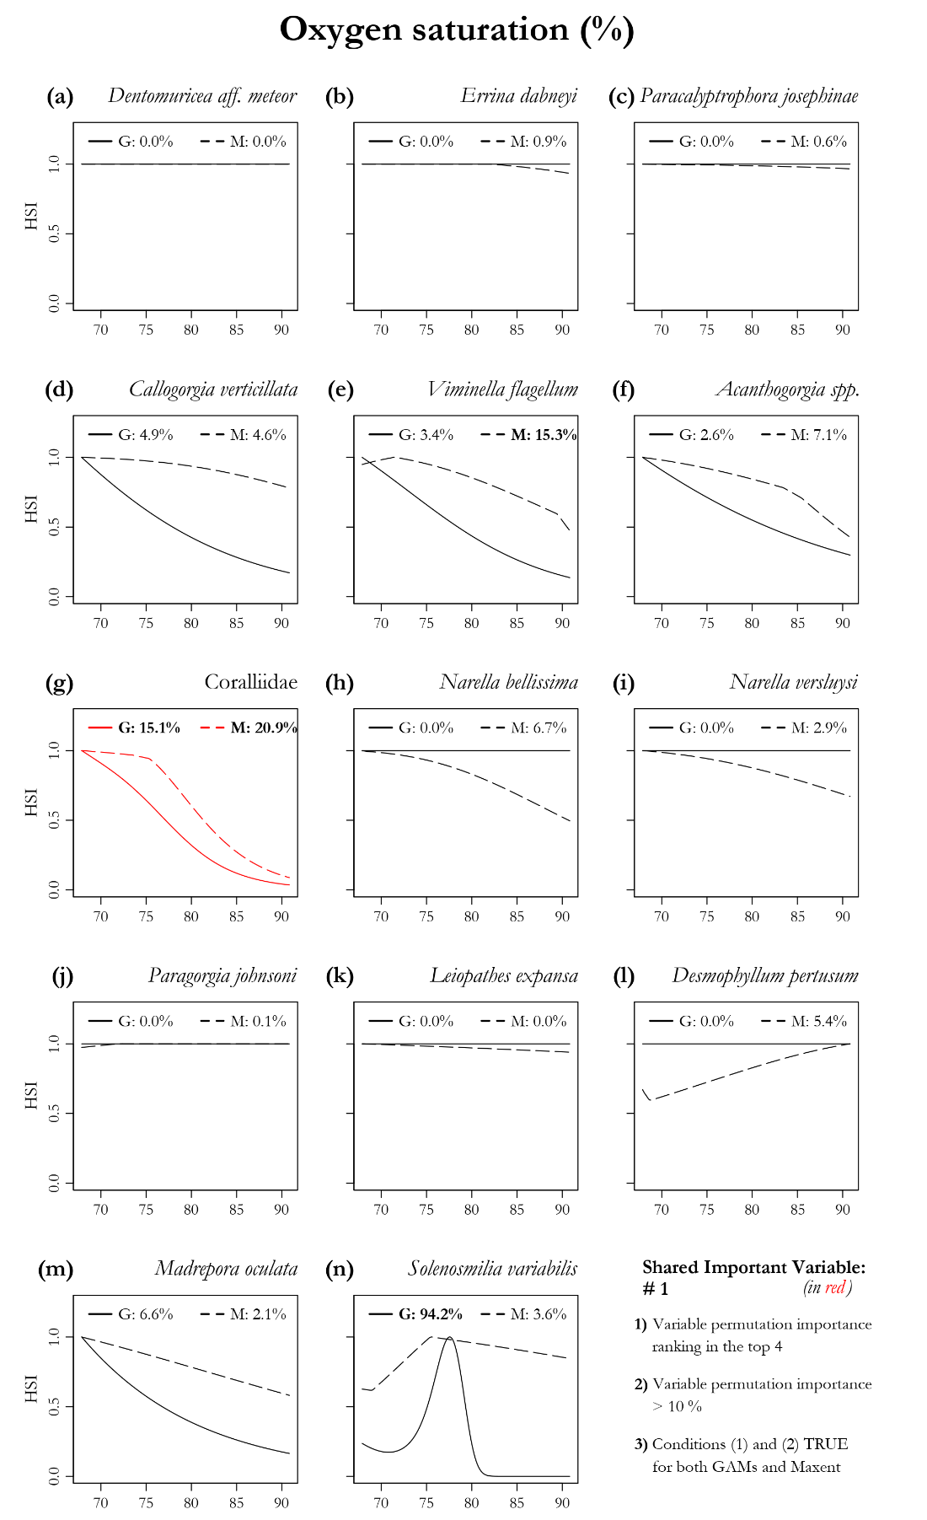

Figure D.11 – Response curves for GAM (solid lines) and Maxent (dashed lines) models regarding the predictor oxygen saturation. Percentage values represent the permutation variable importance (in bold values > 10 %). Shared important variables are colored in red. Species are ordered according to the mean depth of their estimated suitable habitat. HSI: Habitat Suitability Index.
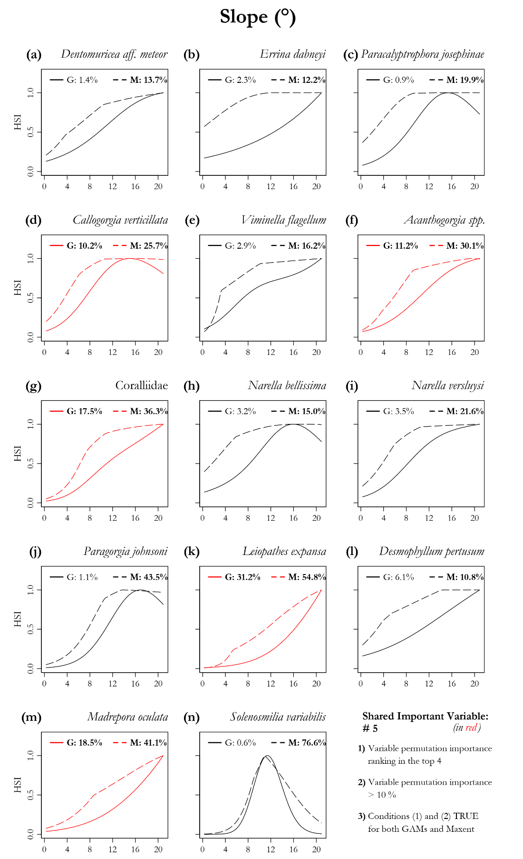

Figure D.12 – Response curves for GAM (solid lines) and Maxent (dashed lines) models regarding the predictor slope. Percentage values represent the permutation variable importance (in bold values > 10 %). Shared important variables are colored in red. Species are ordered according to the mean depth of their estimated suitable habitat. HSI: Habitat Suitability Index.
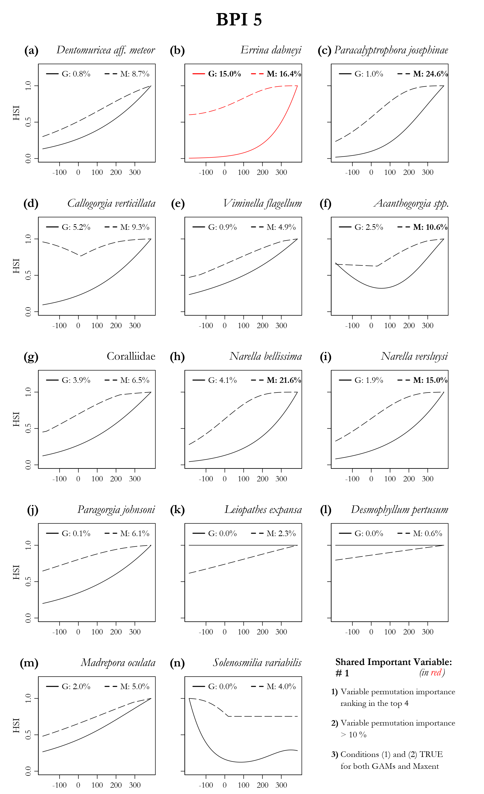

Figure D.13 – Response curves for GAM (solid lines) and Maxent (dashed lines) models regarding the predictor BPI_5km (bathymetric position index computed on a 5 km radius). Percentage values represent the permutation variable importance (in bold values > 10 %). Shared important variables are colored in red. Species are ordered according to the mean depth of their estimated suitable habitat. HSI: Habitat Suitability Index.
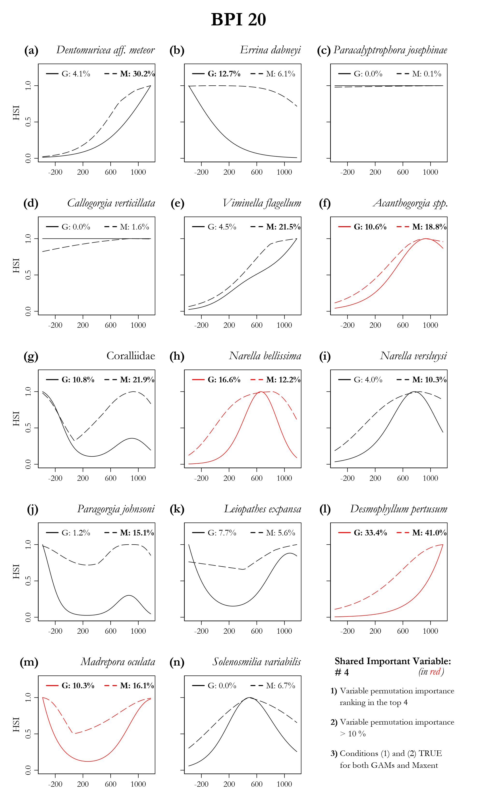

Figure D.14 – Response curves for GAM (solid lines) and Maxent (dashed lines) models regarding the predictor BPI_20km (bathymetric position index computed on a 20 km radius). Percentage values represent the permutation variable importance (in bold values > 10 %). Shared important variables are colored in red. Species are ordered according to the mean depth of their estimated suitable habitat. HSI: Habitat Suitability Index.
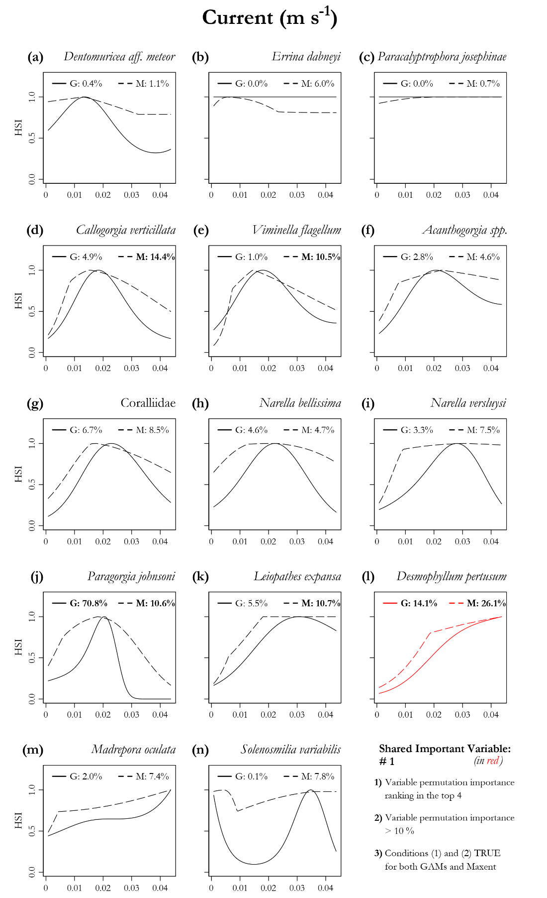

Figure D.15 – Response curves for GAM (solid lines) and Maxent (dashed lines) models regarding the predictor bottom current speed. Percentage values represent the permutation variable importance (in bold values > 10 %). Shared important variables are colored in red. Species are ordered according to the mean depth of their estimated suitable habitat. HSI: Habitat Suitability Index.

References

Addamo, A.M., Vertino, A., Stolarski, J., García-Jiménez, R., Taviani, M., Machordom, A., 2016. Merging scleractinian genera: the overwhelming genetic similarity between solitary Desmophyllum and colonial Lophelia. BMC Evol. Biol. 16, 108. https://doi.org/10.1186/s12862-016-0654-8
Amorim, P., Perán, A.D., Pham, C.K., Juliano, M., Cardigos, F., Tempera, F., Morato, T., 2017. Overview of the Ocean Climatology and Its Variability in the Azores Region of the North Atlantic Including Environmental Characteristics at the Seabed. Front. Mar. Sci. 4, 1–16. https://doi.org/10.3389/fmars.2017.00056
Böning, C.W., Behrens, E., Biastoch, A., Getzlaff, K., Bamber, J.L., 2016. Emerging impact of Greenland meltwater on deepwater formation in the North Atlantic Ocean. Nat. Geosci. 9, 523–527. https://doi.org/10.1038/ngeo2740
Braga-Henriques, A., Porteiro, F.M., Ribeiro, P.A., de Matos, V., Sampaio, Í., Ocaña, O., Santos, R.S., 2013. Diversity, distribution and spatial structure of the cold-water coral fauna of the Azores (NE Atlantic). Biogeosciences 10, 4009–4036. https://doi.org/10.5194/bg-10-4009-2013
Crotty, S.M., Altieri, A.H., Bruno, J.F., Fischman, H., Bertness, M.D., 2019. The Foundation for Building the Conservation Capacity of Community Ecology. Front. Mar. Sci. 6, 1–8. https://doi.org/10.3389/fmars.2019.00238
EMODnet, 2018. EMODnet Digital Bathymetry (DTM 2018). https://doi.org/10.12770/18ff0d48-b203-4a65-94a9-5fd8b0ec35f6
Sampaio, Í., Freiwald, A., Porteiro, F.M., Menezes, G., Carreiro-Silva, M., 2019. Census of octocorallia (cnidaria: Anthozoa) of the azores (NE atlantic) with a nomenclature update. Zootaxa 4550, 451–498. https://doi.org/10.11646/zootaxa.4550.4.1
Walbridge, S., Slocum, N., Pobuda, M., Wright, D., 2018. Unified Geomorphological Analysis Workflows with Benthic Terrain Modeler. Geosciences 8, 94. https://doi.org/10.3390/geosciences8030094
Wei, C.-L., González‐Irusta, J., Dominguez‐Carrió, C., Morato, T., 2020. Set of terrain (static in time) and environmental (dynamic in time) variables used as candidate predictors of present-day (1951-2000) and future (2081-2100) suitable habitat of cold-water corals and deep-sea fishes in the North Atlantic, PANGEA. https://doi.org/10.1594/PANGAEA.911117

