SUPPLEMENTARY INFORMATION

Appendix S1 Dataset Information
Species names not found in Jetz et al. (2012) were changed to match the Jetz taxonomy. Several of those not found were due to the species being split / lumped between the source paper’s publication and the publication of Jetz et al. (2012). However, if a species name did match with one in Jetz we did not check its splitting / lumping status. As such, some of the pre-existing datasets based on older data may include species that have since been split / lumped. However, as these will likely all involve very close relatives, the effects of this on FD and PD should be minimal. We also grouped sub-species, where they occurred, to species level.
For the true island datasets sourced from Baiser et al. (2017), we updated the original datasets using a variety of literature sources, including Birds of the World (Billerman et al. 2022) and the recent multi-archipelago datasets of Boyer (2019), Sayol et al. (2021), Soares et al. (2022) and Triantis et al. (2022), as well as multiple archipelago specific field guides and databases. In some cases, we also used e-bird to verify uncertain records. It is worth nothing that we did not use the Avibase database, as for many islands the data seemed quite coarse, with numerous species listed on particular islands that are known to not be breeding species.
In regard to the datasets compiled as part of this study, the Azores and Canary Island datasets were originally produced by P.A.V.B., and we updated them using the above sources as well as region specific field guides (e.g. Clarke 2006; Garcia-del-Rey et al. 2018). The Ryukyu Islands dataset was compiled by Y.K. and colleagues, with data sourced from published literature, checklists and observation databases. The Zhoushan dataset was compiled by X.S. and colleagues through field work conducted on the archipelago in 2020 and 2021. Finally, the New Zealand dataset was compiled by T.E.M, building on a previous dataset by Diamond (1984; described in more detail in Appendix S2).
For most datasets (including all habitat island datasets), we used the island area values provided by the source paper authors. The datasets in Baiser et al. (2017) were originally sourced from Blackburn et al. (2004), and we have mostly used the area values presented there. For true island datasets, when calculating island isolation and intra-archipelago isolation (see Appendix S2 for full details) using GIS, we also calculated island area. These values were used as a sense check; if the GIS values and the dataset values were very different, we performed an additional check using Google Earth and then decided which value to use. We also used the database of Weigelt et al. (2013) as a further check for some islands. It is worth nothing that two datasets sourced from Baiser et al. (2017) (Society Islands and Cook Islands) contained a number of atolls. Each atoll comprises a number of small islets connected by areas of sand or shallow water, but was considered by Baiser et al. (and the present study) to represent a single island. Measuring “island” area for such atolls is not straightforward and in a number of cases there were relatively large differences in island area values provided by different sources. In general, we have used the values provided by Baiser et al. (2017), although in a few cases we updated values using Weigelt et al. (2013) and our own measurements using Google Earth. We classified Guadeloupe in the Lesser Antilles as a single island with a single area value as, while technically two islands separated by a narrow (100m) channel, it is nearly always treated as a single island by zoologists, for example in the original Lesser Antilles dataset (Baiser et al., 2017), and in the wider ornithological literature (e.g., Raffaele et al., 2003).
Citations
Baiser, B., Valle, D., Zelazny, Z. & Burleigh, J.G. (2017) Non-random patterns of invasion and extinction reduce phylogenetic diversity in island bird assemblages. Ecography, 41, 361–374.
Billerman, S.M., Keeney, B.K., Rodewald, P.G. & Schulenberg, T.S. (2022) Birds of the world. Available at: https://birdsoftheworld.org/bow/home.
Blackburn, T. M., Cassey, P., Duncan, R. P., Evans, K. L. and Gaston, K. J. (2004). Avian extinction and mammalian introductions on oceanic islands. Science, 305, 1955–1958.
Boyer, A.G. (2019). The island bird fossil database. Available at: https://github.com/alisonboyer/IslandBirdFossilDB
Clarke, T. (2006) Birds of the Atlantic Islands. Christopher Helm, London.
Diamond, J.M. (1984) Distributions of New Zealand birds on real and virtual islands. New Zealand Journal of Ecology, 7, 37–55.
Garcia-del-Rey, E. (2018) Birds of the Canary Islands. Christopher Helm, London.
Jetz, W., Thomas, G.H., Joy, J.B., Hartmann, K. & Mooers, A.O. (2012) The global diversity of birds in space and time. Nature, 491, 444–448.
Raffaele, H., Wiley, J., Garrido, O., Keith, A. & Raffaele, J. (2003). Birds of the West Indies. Helm Field Guides, London.
Sayol, F., Cooke, R.S.C., Pigot, A.L., Blackburn, T.M., Tobias, J.A., Steinbauer, M.J., Antonelli, A. & Faurby, S. (2021) Loss of functional diversity through anthropogenic extinctions of island birds is not offset by biotic invasions Science Advances, 7, eabj5790.
Soares, F.C., de Lima, R.F., Palmeirim, J.M., Cardoso, P. & Rodrigues, A.S.L. (2022) Combined effects of bird extinctions and introductions in oceanic islands: decreased functional diversity despite increased species richness. Global Ecology and Biogeography, 31, 1172-1183.
Triantis, K.A., Rigal, F., Whittaker, R.J., Hume, J.P., Sheard, C., Poursanidis, D., Rolland, J., Sfenthourakis, S., Matthews, T.J., Thébaud, C. & Tobias, J.A. (2022) Deterministic assembly and anthropogenic extinctions drive convergence of island bird communities. Global Ecology and Biogeography, 31, 1741-1755.
Weigelt, P., Jetz, W. and Kreft, H. (2013). Bioclimatic and physical characterization of the world’s islands. Proceedings of the National Academy of Sciences, 110, 5307 – 15312.

Table S1. Dataset information including location, number of islands (NI), number of species (Gamma) and island type. Island type split into habitat islands, oceanic islands (mainly of volcanic origin and never connected to continental land masses) and other true islands. + indicates datasets sourced from Chase et al. (2019; see this study for information on the original source papers). Note some data were provided by the source paper authors.
No. | Dataset name | Location | NI | Gamma | Island type
1 | Battisti et al. (2009) Anzio | Italy | 13 | 28 | Habitat
2 | Battisti et al. (2009) CH | Italy | 20 | 32 | Habitat
3 | Berg (1997)+ | Sweden | 12 | 41 | Habitat
4 | Blake (1991) | USA | 12 | 47 | Habitat
5 | Brotons & Herrando (2001) | Spain | 51 | 37 | Habitat
6 | Cieślak & Dombrowski (1993) | Poland | 49 | 50 | Habitat
7 | Daily et al. (2001) | Costa Rica | 8 | 131 | Habitat
8 | Dami et al. (2012)+ | Nigeria | 31 | 132 | Habitat
9 | dos Anjos & Boçon (1999) | Brazil | 12 | 189 | Habitat
10 | dos Anjos (2004) | Brazil | 14 | 173 | Habitat
11 | Edwards et al. (2010)+ | Borneo | 12 | 78 | Habitat
12 | Fernández-Juricic (2000) | Spain | 25 | 30 | Habitat
13 | Ford (1987) | UK | 20 | 46 | Habitat
14 | Gillespie & Walter (2001) | Nicaragua & Costa Rica | 7 | 69 | Habitat
15 | Langrand (1995) | Madagascar | 7 | 47 | Habitat
16 | Martensen et al. (2012) Cau+ | Brazil | 17 | 62 | Habitat
17 | Martensen et al. (2012) RG+ | Brazil | 17 | 70 | Habitat
18 | Martensen et al. (2012) TAP+ | Brazil | 19 | 87 | Habitat
19 | McCollin (1993) | UK | 16 | 48 | Habitat
20 | Simberloff & Martin (1991) | Finland | 34 | 45 | Habitat
21 | Ulrich et al. (2016)+ | Kenya | 12 | 69 | Habitat
22 | Wang et al. (2013) | China | 20 | 39 | Habitat
23 | Watson (2003) | Mexico | 17 | 129 | Habitat
24 | Wethered & Lawes (2005) Balgowan | South Africa | 9 | 55 | Habitat
25 | Wethered & Lawes (2005) Gilgoa | South Africa | 9 | 52 | Habitat
26 | Azeria (2004) | Dahlak Archipelago | 25 | 35 | Other true
27 | Baiser et al. (2017) | Cape Verde | 12 | 33 | Oceanic
28 | Baiser et al. (2017) | Cook Islands | 15 | 26 | Oceanic
29 | Baiser et al. (2017) | Galapagos | 11 | 54 | Oceanic
30 | Baiser et al. (2017) | Hawaii | 6 | 38 | Oceanic
31 | Baiser et al. (2017) | Lesser Antilles | 12 | 104 | Oceanic
32 | Baiser et al. (2017) | Marianas | 15 | 29 | Oceanic
33 | Baiser et al. (2017) | Society Islands | 11 | 25 | Oceanic
34 | Bengtson & Bloch (1983) | Faroe Islands | 22 | 40 | Oceanic
35 | Bradstreet & McCracken (1978) | Thousand Islands National Park | 10 | 68 | Other true
36 | Haila et al. (1983) | Vargskär archipelago | 44 | 71 | Other true
37 | Nudds et al. (1996) | Fathom Five Islands | 15 | 88 | Other true
38 | Nudds et al. (1996) | Georgian Bay | 23 | 94 | Other true
39 | O’Connell et al. (2020) | Wakatobi | 9 | 76 | Other true
40 | Power (1972) | Californian Islands | 16 | 45 | Other true
41 | Si et al. (2017) | Thousand island lake (China) | 36 | 57 | Other true
42 | Simaiakis et al. (2012) | Aegean Islands | 77 | 101 | Other true
43 | Simberloff & Martin (1991) | Haida Gwaii | 40 | 30 | Other true
44 | Simberloff & Martin (1991) | Maddalena Archipelago | 8 | 37 | Other true
45 | Sin et al. (2022) | Riau Lingaa | 26 | 154 | Other true
46 | Sin et al. (2022) | West Sumatra | 15 | 183 | Other true
47 | This study | Azores | 9 | 27 | Oceanic
48 | This study | Canaries | 7 | 74 | Oceanic
49 | This study | Ryukyu Islands | 68 | 99 | Other true
50 | This study | New Zealand | 22 | 104 | Other true
51 | This study | Zhoushan | 34 | 96 | Other true

Source paper references
Azeria, E.T. (2004) Terrestrial bird community patterns on the coralline islands of the Dahlak Archipelago, Red Sea, Eritrea. Global Ecology and Biogeography, 13, 177–187.
Baiser, B., Valle, D., Zelazny, Z. & Burleigh, J.G. (2017) Non-random patterns of invasion and extinction reduce phylogenetic diversity in island bird assemblages. Ecography, 41, 361–374.
Battisti, C., Luiselli, L., Frank, B. & Lorenzetti, E. (2009) Should fragment area reduction be considered a stress for forest bird assemblages? Evidence from diversity/dominance diagrams. Community Ecology, 10, 189–195.
Bengtson, S.-A. & Bloch, D. (1983) Island land bird population densities in relation to island size and habitat quality on the Faroe Islands. Oikos, 41, 507–522.
Blake, J.G. (1991) Nested subsets and the distribution of birds on isolated woodlots. Conservation Biology, 5, 58–66.
Bradstreet, M.S.W. & McCracken, J.D. (1978) Avifaunal survey St. Lawrence Islands National Park. Unpublished report for Parks Canada, c/o St. Lawrence Islands National Park Mailorytown Landing Ontario, Canada, p. 343.
Brotons, L. & Herrando, S. (2001) Reduced bird occurrence in pine forest fragments associated with road proximity in a Mediterranean agricultural area. Landscape and Urban Planning, 57, 77–89.
Chase, J.M., Liebergesell, M., Sagouis, A., May, F., Blowes, S.A., Berg, Å. et al. (2019) FragSAD: a database of diversity and species abundance distributions from habitat fragments. Ecology, 100, e02861.
Cieślak, M. & Dombrowski, A. (1993) The effect of forest size on breeding bird communities. Acta Ornithologica, 27, 97–111.
Daily, G.C., Ehrlich, P.R. & Sánchez-Azofeifa, G.A. (2001) Countryside biogeography: use of human-dominated habitats by the avifauna of southern Costa Rica. Ecological Applications, 11, 1–13.
dos Anjos, L. & Boçon, R. (1999) Bird communities in natural forest patches in southern Brazil. The Wilson Bulletin, 111, 397–414.
dos Anjos, L., Zanette, L. & Lopes, E.V. (2004) Effects of fragmentation on the bird guilds of the Atlantic Forest in north Paraná, southern Brazil. Ornitología Neotropical, 15, 137–144.
Fernández-Juricic, E. (2000) Bird community composition patterns in urban parks of Madrid: The role of age, size and isolation. Ecological Research, 15, 373–383.
Ford, H.A. (1987) Bird communities on habitat islands in England. Bird Study, 34, 205–218.
Gillespie, T.W. & Walter, H. (2001) Distribution of bird species richness at a regional scale in tropical dry forest of Central America. Journal of Biogeography, 28, 651–662.
Haila, Y., Jarvinen, O. & Kuusela, S. (1983) Colonization of islands by land birds: prevalence functions in a Finnish archipelago. Journal of Biogeography, 10, 499–531.
Langrand, O. (1995) The effects of forest fragmentation on bird species in Madagascar: a case study from Ambohitantely Forest Reserve on the central high plateau. In: Department of Zoology and Entomology. University of Natal Pietermaritzburg.
McCollin, D. (1993) Avian distribution patterns in a fragmented wooded landscape (North Humberside, U.K.): the role of between-patch and within-patch structure. Global Ecology and Biogeography Letters, 3, 48–62.
Nudds, T.D., Bogart, J.P., Britton, D., Hager, H.A., Middleton, A.L.A., Potter, D.N. et al. (1996) Species-area relations of woody plants, vertebrates and selected invertebrates on islands in Georgian Bay: the role of national parks in evaluating null models of biodiversity. Final report of the Guelph Biological Inventory of the Georgian Bay Islands. Report to Parks Canada, Fathom Five National Marine Park, Ontario, Canada.
O'Connell, D.P., Kelly, D.J., Kelly, S., Analuddin, K., Karya, A., Nicola et al. (2020) An assessment of the avifauna of the Wakatobi Islands, South-east Sulawesi, Indonesia: species recorded and taxonomic considerations. Raffles Bulletin of Zoology, 68, 574–587.
Power, D.M. (1972) Numbers of bird species on the California Islands. Evolution, 26, 451–463.
Si, X., Cadotte, M.W., Zeng, D., Baselga, A., Zhao, Y., Li, J. et al. (2017) Functional and phylogenetic structure of island bird communities. Journal of Animal Ecology, 86, 532–542.
Simaiakis, S.M., Dretakis, M., Barboutis, C., Katritis, T., Portolou, D. & Xirouchakis, S. (2012) Breeding land birds across the Greek islands: a biogeographic study with emphasis on faunal similarity, species–area relationships and nestedness. Journal of Ornithology, 153, 849–860.
Simberloff, D. & Martin, J.L. (1991) Nestedness of insular avifaunas: simple summary statistics masking complex species patterns. Ornis Fennica, 68, 178–192.
Sin, Y.C.K., Kristensen, N.P., Gwee, C.Y., Chisholm, R.A. & Rheindt, F.E. (2022) Bird diversity on shelf islands does not benefit from recent land-bridge connections. Journal of Biogeography, 49, 189–200.
Wang, Y., Ding, P., Chen, S. & Zheng, G. (2013) Nestedness of bird assemblages on urban woodlots: implications for conservation. Landscape and Urban Planning, 111, 59–67.
Watson, D.M. (2003) Long-term consequences of habitat fragmentation–highland birds in Oaxaca, Mexico. Biological Conservation, 111, 283–303.
Wethered, R. & Lawes, M.J. (2005) Nestedness of bird assemblages in fragmented Afromontane forest: the effect of plantation forestry in the matrix. Biological Conservation, 123, 125–137.

Appendix S2 Supplementary Methods

Creating land bird datasets
In our main analyses, after removing introduced species, we used the datasets (and hence the species lists) as originally published in the source papers, meaning that the exact types of species included varied slightly between datasets. As such, to roughly standardise the datasets, we created alternative versions that only included land birds. To do this, we removed all species classified as coastal, marine, riverine or wetland in the AVONET trait database (Tobias et al., 2022).
Reducing the number of species in datasets to only include land birds meant that two (oceanic) datasets had to be removed, given this resulted in multiple islands with zero or very few species: Cook Islands and Society Islands. For the remaining datasets, two needed a single zero-species island removed.

Dataset characteristics
For each dataset, we recorded a number of variables that are predicted to affect IDAR form (Matthews et al., 2019a, 2021). These included the number of islands (Ni), the ratio between the largest and smallest island (AreaScale), the archipelago species richness (Gamma), and the total archipelago land area (ArchArea). For each true island dataset, we extracted climate data from WorldClim (30 seconds resolution; Fick & Hijmans, 2017) and then took the mean of the annual mean temperature values across islands as the temperature variable for that dataset. We also calculated the maximum elevation in each true island archipelago using a digital elevation model (30 seconds resolution) provided by WorldClim. It was not possible to obtain island-specific co-ordinates for the habitat island datasets as this information was generally not provided in the source papers. Instead, we located the study region for each habitat island dataset using the source paper and Google Earth, and took the co-ordinates of the rough centre of the study extent. We built a 5.5km (0.05 decimal degrees) buffer around this point, and took the maximum elevation and the mean of the temperature values within this buffer.
For each true island dataset, we also calculated isolation from the mainland and intra-archipelago isolation. Geospatial data for the majority of true islands in the 26 true island datasets were obtained from the Global Island Database, provided by the United Nations Environment Program’s World Conservation Monitoring Centre (UNEP-WCMC, 2013). Using these data, we built island shape files for each dataset. For some datasets, it was not possible to determine the names / locations of a small number of islands from the source papers, and these were not included in the shapefiles, and thus not in the isolation or climate calculations. Mainland coastline data were taken from the Global Self-consistent, Hierarchical, High-resolution Geography Database (GSHHG) version 2.3.7 (Wessel & Smith, 1996). We added the world’s largest islands (e.g., Borneo, Madagascar, Java) to the mainland shapefile, as these represent likely source pools (see Matthews et al., 2019a). The distance from each true island’s centroid to the mainland was calculated using the ‘geosphere’ R package (Hijmans, 2019), and the minimum geodesic distance taken as a measure of archipelago isolation. In each case, we cross-checked the minimum value using Google Earth and in a small number of cases where islands were very close to the mainland, we adjusted the value as the geosphere function seemed to overestimate distances by a small amount in these cases (likely due to distances being calculated from the island centroid and not the actual coastline). As a measure of intra-archipelago isolation, the mean distance between all pairs of islands in an archipelago (MeanDist) was calculated for the 26 datasets (Cabral et al., 2014). This involved calculating the distances among all pairs of islands within an archipelago using the ‘Near’ tool in ArcGIS 10 (ESRI, 2012), and then taking the mean of these values as MeanDist. See Matthews et al. (2021) for further information on the calculation of these metrics. As we did not have location information for individual habitat islands, it was not possible to calculate the mainland isolation (a concept that is not straightforward to apply to habitat islands anyway) and intra-archipelago isolation metrics for the habitat island datasets.

Cabral, J.S., Weigelt, P., Kissling, W.D. & Kreft, H. (2014). Biogeographic, climatic and spatial drivers differentially affect α-, β- and γ-diversities on oceanic archipelagos. Proceedings of the Royal Society B: Biological Sciences, 281, 20133246.
ESRI (2011). ArcGIS Desktop: Release 10. Environmental Systems Research Institute Redlands, CA.
Fick, S.E. & Hijmans, R.J. (2017). WorldClim 2: new 1-km spatial resolution climate surfaces for global land areas. International Journal of Climatology, 37, 4302–4315.
Hijmans, R.J. (2019). geosphere: spherical trigonometry. R package version 1.5-10.
Matthews, T.J., Rigal, F., Triantis, K.A. & Whittaker, R.J. (2019). A global model of island species–area relationships. Proceedings of the National Academy of Sciences USA, 116, 12337–12342.
Matthews, T.J., Triantis, K.A. & Whittaker, R.J. (2021). The species–area relationship: theory and application. Cambridge University Press Cambridge, UK.
UNEP-WCMC (2015). Global distribution of islands. Global Island Database (version 2.1, November 2015). UNEP World Conservation Monitoring Centre Cambridge, UK.
Wessel, P. & Smith, W.H.F. (1996). A global, self-consistent, hierarchical, high-resolution shoreline database. Journal of Geophysical Research: Solid Earth, 101, 8741-8743.

Calculating FD / PD using global vs. pruned trees
When calculating FD/PD for islands within a given archipelago and a global tree (i.e. including all the world’s species), two main approaches can be used. First, PD can be calculated using the global tree directly (i.e. providing this to picante’s ‘pd’ function). Second, the tree can be pruned to only include the species in the archipelago, and then this pruned tree used to calculate PD. When using the first option, the global tree is actually pruned inside the ‘pd’ function, but there is then re-scaling undertaken such that “PD is the sum of edges in subtree [pruned tree], plus any difference in the max distance (of only present tips) between original [i.e. global] and subtree”. Thus, in this case, the PD of a single species island is the distance from the root to tip in the original global tree. However, when pruning the tree first manually (an act which drops unused branches), this re-scaling is not done and the pruned tree may have a new root at a more recent common ancestor (for the pruned species), meaning the PD of single species island is no longer the distance from the root to tip in the original global tree.
Based on the above, while different absolute PD values are generated depending on whether a pruned or global tree is used, the relative differences between PD values in a given dataset are identical regardless of which method is used (i.e. they are all just shifted by a given amount). Thus, for a given archipelago, the difference in PD values between islands will be identical regardless of whether you use the global or pruned tree. However, the PD of the smallest island, and thus the difference between this value and zero (i.e. the origin), will differ and thus the slope of the power model can differ when fitted to PD values generated using the two different methods. In reality, for most datasets the power model slopes were very similar regardless of which approach was used, but in some cases, there could be relatively large differences (particularly if not accounting for functional outliers [i.e. the four kiwi species]). Given neither approach is, at least to our knowledge, statistically preferable, we decided to use the global tree approach as this then means a consistent tree is used for all datasets / archipelagos. However, using the global tree meant it was necessary to edit the normal taxa shuffling null model algorithm (i.e. taxa labels in picante::ses.pd) as this shuffles tips across all species in the tree which means, when using the global tree, that the whole global bird species list is used as the species pool for the null model rather than the archipelago list (which was our chosen approach).

Introduced and Extinct species datasets
To create versions of the datasets including introduced species, for six datasets we took the versions created by Baiser et al. (2017). The remaining four datasets (Azores, Canaries, Ryukyus, New Zealand) were those compiled by us for this study. For all ten datasets, we cross-checked records with a range of databases, including Boyer (2019), Sayol et al. (2021), and Soares et al. (2022), as well as archipelago-specific literature and field guides. We also used e-bird records to help confirm whether a species was present on an island where this was otherwise uncertain. We only included currently established introduced species, which meant we excluded several records in these various databases which likely relate to species that i) have been recorded but never became (or have yet to become) fully established, or ii) were previously established but have now been extirpated (either through management interventions or natural processes). Certain islands (e.g. Hawaii, Tenerife) have numerous records of such species. We also included conservation translocations as introductions; this mainly affected the New Zealand dataset.
To create versions of the datasets including extinct species, we focused on two time periods: i) historic (the avifauna present on the islands at around 1500 CE) and ii) pre-historic (the avifauna present on the islands prior to human colonisation). Obviously, our knowledge of (ii) is limited relative to (i), and we were only able to focus on a subset of datasets to study (ii). Overall, we were able to build eight historic datasets (Cape Verde, Cook Islands, Hawaii, Lesser Antilles, Marianas, New Zealand, Society Islands and the Canaries), and five pre-historic datasets (Canaries, Cook Islands, Hawaii, New Zealand and Marianas). While these eight include many of the archipelagos known to have experienced particularly high extinction rates since human colonisation, clearly other island groups have also suffered extinctions. However, very little is known about extinctions in these groups at the island-level as opposed to the archipelago level, and the former is necessary to study IDARs. Below, we detail the methods used to build the datasets and estimate the trait and phylogenetic data for the extinct species. More detailed information regarding data compilation and each individual dataset is provided in Appendix S1.
- Historic datasets
Apart from the Canaries and New Zealand, we took as a starting point the datasets provided by Baiser et al. (2017). These “reflect species present when islands were discovered by European colonists (∼1500 CE), and thus, they do not include species that went extinct in the prehistoric time period due to human activities” (Baiser et al. 2017, p. 363). Using four primary sources (Steadman, 2006; Hume, 2017; Sayol et al. 2020; Billerman et al. 2022) and references within we then updated these datasets with records of extinct species and extant species on islands from which they are now extirpated. For specific datasets, we used additional studies to supplement these records (e.g., for Hawaii; James, 1987; James & Olson, 1991; Olson & James, 1991; Burney et al., 2001; Pyle & Pyle 2017; Walther & Hume, 2022). For the Canaries, Illera et al. (2016), Garcia-del-Rey (2018), and Clarke (2006) were the primary sources used to build the dataset. Soares et al. (2022) was used as an additional check for the Hawaiian, Canary Island, Mariana Island and Lesser Antilles datasets, and Boyer (2019) for the same groups in addition to Azores, Cape Verde, Galapagos, the Cook Islands and the Society Islands.
For New Zealand, a dataset compiled by Diamond (1984) was used as a foundation. The presence of extant breeding species on each island was determined by consulting maps and text in four sources; Robertson & Heather (2015), the IUCN Red List (International Union for Conservation of Nature, 2021), Billerman et al. (2022), and New Zealand Birds Online (2022). Lists of historic extinct breeding species (those considered extinct >1500AD) were obtained from Sayol et al. (2020, 2021) and additional literature searches. Once all species occurring outside the study area range (e.g. outlying islands) were excluded, the spatial distribution of historical extinctions was determined by using the above named sources. Note however, the status of birds in New Zealand can be complex, and in some cases a species can have a general status of “Native” but be introduced on certain islands on which they never occurred naturally (through conservation translocations). Additionally, extant species can be extinct on some islands, and extinct species sometimes experienced staggered extinctions, with the last extinctions being historical but with extinctions on some islands being prehistorical.
The number of extinct species in the historic datasets ranged from one (Cook Islands) to 25 (Hawaii) (note these numbers do not include extirpations of extant species).
- Prehistoric datasets
As mentioned above, it was only possible to build five prehistoric datasets, primarily due to a lack of fossil data from many islands, but also because some island groups were only colonised by humans recently or are not known to have suffered many extinctions. For example, some archipelagos have detailed fossil data but from only a single island, with the other islands having no fossil records (see Steadman, 2006). Even with the five datasets included, there are variations in fossil sample completeness between islands and these datasets should only be taken as coarse estimates of avifaunal compositions prior to human colonisation. For the Cook Islands and the Marianas, Steadman (2006) was used as the primary source, again supplemented with additional sources (e.g., Pregill & Steadman, 2009; Baiser et al. 2017; Hume, 2017; Sayol et al., 2020). It should be noted that Steadman (2006) used the cut-off of 1800AD rather than 1500AD to divide the prehistoric from the historic. However, all prehistoric extinct species in these datasets are listed as going extinct prior to 1500AD by Sayol et al. (2020). For Hawaii, Hume (2017), Sayol et al. (2020) and Walther & Hume (2022) and references within those sources were used, alongside a range of other Hawaii-specific sources (see references listed in (i)). For the Canaries, Illera et al. (2016) and Sayol et al. (2020) were the primary sources, alongside a range of other Canary-specific papers. For New Zealand, spatial distributions of prehistoric extinctions were determined exclusively from New Zealand Birds Online (2022), the only source that provided detailed information on these species. The databases of Boyer (2019), Soares et al. (2022), and Triantis et al. (2022) were also used where relevant.
For these five datasets, we excluded all marine species given that fossil data are even more patchy for marine species. As such, we did not compare the results based on the prehistoric datasets with those from the corresponding historic datasets. Instead, we compared them with new versions of the datasets representing the current time period, but also excluding marine species. For extant species, we removed all species classified by AVONET (Tobias et al., 2022) as ‘marine’. Extinct species were first classified as marine or not (see below), with those classified as marine then removed from the datasets. It should also be noted that the Marianas and Cook Island prehistoric datasets contain fewer islands than the current and historic versions, as we decided to focus on islands where more fossil data were available. The number of extinct species in the prehistoric datasets ranged from seven (Canary Islands) to 73 (Hawaii).
As an aside, we decided not to include the domesticated chicken (Gallus gallus) in the historic and prehistoric datasets, even though they had been introduced on many islands during these time periods (e.g. Wood et al., 2016), given the difficulties of separating domestic and established feral populations of this species.
- Traits and phylogenies
Before estimating trait values and grafting extinct species onto our consensus phylogenetic tree, we calibrated our extinct species with the same taxonomy used in our main analyses (i.e., the Jetz et al., 2012 BirdTree taxonomy). Thus, we assessed each extinct species and attempted to match it with the correct genus, family, order etc. in BirdTree (where possible accounting for splits and lumps), noting where it was clear that the genus was now extinct. Two points are worth noting here. First, Mohoidae is a wholly extinct family, which is thus not included in BirdTree. However, until 2008 Mohoidae species were considered by most sources to be in Meliphagidae, which is in BirdTree, and the Mohoidae are also known to be relatively morphologically similar to the species in Meliphagidae. As such, here we subsume Mohoidae under Meliphagidae. Second, BirdTree lists Psittaculidae species as Psittacidae, and we have followed this.
We used the same set of traits for the extinct species (i.e., the nine morphological measurements) as for the extant species (see the main text). For the extinct species, we only collected measurements of the Kipp’s distance and not the secondary length. As such, to calculate the secondary length for extinct species we simply subtracted the Kipp’s distance from the wing length. Extinct species trait data were sourced from the literature or measured using museum specimens. Missing traits were then estimated using known taxonomic relationships and imputed using a Bayesian Hierarchical Probabilistic Matrix Factorization (BHPMF) method. BHPMF is a machine learning algorithm that represents an extension of probabilistic matrix factorization. It uses known taxonomic relationships between species as a proxy for phylogenetic signal in the traits, and uses this information in combination with the observed correlation between trait measurements (data for at least one trait are necessary for every species) to fill in the gaps. The observed trait data can include traits that are not used in any subsequent functional diversity analysis (e.g., in our case, skeleton measurements; details below). This enables the inference of morphological traits for extinct species where only fossil remains are available. The method can also include trait data for extant species with no gaps to provide additional information and increase the accuracy of the approach. The method has been shown to provide a robust and accurate approach for estimating traits (Schrodt et al., 2015), including for extinct island birds specifically (Sayol et al., 2021). For example, in a sensitivity test where the method was used to estimate known trait values for island birds, the average R² between the observed and predicted trait values was ~0.98-0.99 (Sayol et al., 2021). The ‘BHPMF’ R-package (Schrodt et al., 2015) was used to run the algorithm.
In total, across the historic and prehistoric datasets built in the present study, there were 158 extinct species (four of which are included in both Jetz et al., 2012, and Tobias et al., 2022). A three-step-process was used to obtain trait data for these 158 species. First, for four recently extinct species, full data for all nine traits were available in the AVONET trait database. Second, for 135 of these 158, we were able to acquire at least one measurement from skin or skeleton (or both) specimens in museums and/or the wider literature. Third, for the 23 species with no trait data (skin or skeleton) it was necessary to estimate at least one of the nine traits in order to employ the BHPMF method to impute the remaining missing trait values. To this end, we focused on body mass. For a subset of species, values were sourced from Triantis et al. (2022), who estimated the traits of extinct species using expert knowledge informed by known taxonomic relationships (e.g., closest extant relative) and fossil data (where available). For another subset, one author who is an expert on extinct island birds and extinct bird fossils (JPH; e.g., Hume, 2017), estimated body mass using known taxonomic relationships, available fossil data, and a range of literature sources. For the few remaining species (n = 8) where it was not possible to estimate body mass (due to a lack of suitable fossil remains), the median body mass of extant species in the genus / family was used. An additional five species – marine species that went extinct in the prehistoric period (three from the Canaries and two from New Zealand) – were included in the final dendrogram, but were excluded from the final datasets because we ultimately decided not to include marine species in the prehistoric versions.
We filled all trait gaps (~70%; but note this figure only relates to the nine traits used in the analyses and does not include skeletal measurements, which were available for many species lacking skin measurements) using the BHPMF method. Full observed morphological trait data (i.e., the same AVONET trait data we use in our main analyses) for all extant species were used to inform the method. We also included skin and skeleton measurements from a further ~440 extinct species to inform the imputation (these data will be published as part of a future full database of extinct bird traits). The BHPMF method was applied using the extant species trait data along with the morphological measurements of extinct species and available data (for both extant and extinct species) for 22 linear skeletal measurements, including three measurements for each of the long bones (distal width, proximal width, and total length) and four beak measurements (total length, length from nares, width, and depth). Four levels of taxonomic information (infraclass / superorder [Palaeognathae, Galloanserae and Neoaves], order, family and genus) were used. Further information on this approach is provided in Sayol et al. (2021). To include imputation uncertainty in the analysis, we ran the algorithm ten times, resulting in ten different versions of the estimated traits. We then averaged trait values across the ten datasets, although it should be noted that the values were highly correlated across the ten runs. Just considering the datasets that included extinct species, the average Pearson’s correlation between FD values calculated using the average values and each of the ten runs was 0.99. For individual traits, the correlation between imputed values across the ten runs ranged from 0.93 for tail and wing length, to 0.99 for beak length (culmen), beak width, body mass and tarsus length. As a further sensitivity test, we also re-ran the analyses using a randomly chosen individual imputation run.
For each extinct species, we also determined its coarse habitat classification, specifically whether it was an aquatic species (riverine, coastal, wetland or marine in AVONET) or not. This was done to allow us to run the sensitivity test focusing only on land birds. We searched the literature for habitat information for each extinct species and also looked at the habitat classification of all extant relatives in AVONET, where possible (e.g. in the same genus and family if these were extant). While it would have been possible to have used a statistical imputation for this also, we decided to use published information and expert opinion given there are several cases of island species occupying distinct habitat niches from other species in the same genus on the mainland (i.e. an example of an island syndrome). For the majority of species for which no explicit habitat information was available, it was relatively straightforward to make an educated guess based on the habitat classifications of extant relatives. However, for a subset of extinct species very little is known about their ecology, with some also belonging to extinct genera and families. As such, for these species there is relatively large uncertainty regarding this aquatic classification.
To build a phylogeny with the extinct species, we took our consensus tree (based on Jetz et al., 2012) used in the main analyses as a starting point. Four of the 158 extinct species were already included in the consensus tree. Of the remaining extinct species, for 92 the order, family and genus were all known; for these species, we randomly grafted them onto the consensus tree within their respective genera. Species from extinct genera (or where the genus is not known) were randomly grafted within their respective families by constraining the grafting to the nodes connecting the different genera within the focal family. For extinct genera with more than one species (in these datasets), we assumed the genera were monophyletic. One issue is that many of the genera and families within the Jetz et al. (2012) tree are not monophyletic. As such, extinct genera were randomly grafted to be sister to extant monophyletic genera within the family. Dinornithiformes is an extinct order, with the closest extant order thought to be Tinamiformes; thus, species in Dinornithiformes were grafted as a sister group to Tinamiformes. Within the Dinornithiformes, the two non-monotypic genera [Dinornis (2 species) and Pachyornis (3 species)] were assumed to be monophyletic. Aptornithidae is an extinct family, which is believed to have been sister to Sarothruridae (Boast et al., 2019). As such, we grafted the two species in Aptornithidae as a sister group to the genus Sarothrura, the largest genus within the Sarothruridae (given this family is not monophyletic in Jetz et al.). The additional extinct prehistoric marine species, which were ultimately excluded from the analyses, were also grafted. We repeated this grafting procedure 100 times and calculated phylogenetic diversity (PD) for all the islands across the historic and prehistoric datasets (i.e., all datasets that included extinct species) using each of the 100 trees. For each dataset, we then calculated the pairwise Pearson’s correlations between each set of PD values across the 100 trees. The mean correlation coefficient across datasets was 0.999. As such, for the main analyses we simply selected one of the trees to use.
- Caveats
While we spent considerable effort in trying to ensure the historic and prehistoric datasets were as complete as possible, for several reasons they represent only rough estimates of previous island composition. First, there are known biases in the fossil record, whereby certain species (e.g., large-bodied species, abundant species) are more likely to leave material evidence.
Second, as stated above, the fossil record, with very few exceptions (e.g., Mangaia in the Cook Islands; Steadman, 2006), is likely incomplete and the level of completeness will vary among islands in the same archipelago, as noted by Franklin & Steadman (2008, p.1889) who described “the extreme rarity of high-quality fossil records on multiple islands in a single island group”. For example, in the Society Islands, the only fossil records of prehistoric birds are from the island of Huahine, resulting in this island having the same known prehistoric land bird richness as Tahiti, an island an order of magnitude larger but for which no fossil data are available (Steadman, 2006). We do not include a prehistoric Society Islands dataset for this reason.
Third, several studies present data on which islands extinct species occurred on, with fewer presenting data on the past distributions of extant species, particularly in the prehistoric time period. Many extant species which are only present on one or two islands today likely had wider distributions in the past. While some data are available on these types of changes, there are likely still several gaps.
Fourth, the datasets were built in several cases by working backwards: starting with the current composition and adding in extinct and extirpated records to the different islands. However, some species may have only colonised archipelagos or islands over the last couple of centuries and thus would not have been present when humans first colonised the islands. For example, this is known to be the case for a small number of species in the Canary Islands (Illera et al. 2016; Garcia-del-Rey, 2018) and the Lesser Antilles (Raffaele et al., 2003). Where we found evidence of this, we edited the datasets accordingly, but again there are likely to be gaps in what is known.
Fifth, the trait estimation and imputation, and phylogeny grafting, procedures obviously involve a certain degree of uncertainty, although sensitivity tests indicate the approaches are relatively robust. Finally, it should be noted that many recent analyses incorporating extinct island species (e.g., Valente et al., 2020; Sayol et al., 2021; Triantis et al., 2022) have been undertaken at the archipelago scale, whereas to fit IDARs it is necessary to obtain data at the island-level, a process that involves more uncertainty.

v. Citations
Baiser, B., Valle, D., Zelazny, Z. & Burleigh, J.G. (2017). Non-random patterns of invasion and extinction reduce phylogenetic diversity in island bird assemblages. Ecography, 41, 361–374.
Billerman, S.M., Keeney, B.K., Rodewald, P.G. & Schulenberg, T.S. (2022). Birds of the world. Available at: https://birdsoftheworld.org/bow/home.
Boast, A.P., Chapman, B., Herrera, M.B., Worthy, T.H., Scofield, R.P., Tennyson, A.J.D. et al. (2019) Mitochondrial genomes from New Zealand’s extinct adzebills (Aves: Aptornithidae: Aptornis) support a sister-taxon relationship with the Afro-Madagascan Sarothruridae. Diversity, 11, 24.
Boyer, A.G. (2019). The island bird fossil database. Available at: https://github.com/alisonboyer/IslandBirdFossilDB
Burney, D.A., James, H.F., Burney, L.P., Olson, S.L., Kikuchi, W., Wagner, W.L. et al. (2001). Fossil evidence for a diverse biota from Kaua‘i and its transformation since human arrival. Ecological Monographs, 71, 615-641.
Clarke, T. (2006). Birds of the Atlantic Islands. Christopher Helm, London.
Franklin, J. & Steadman, D.W. (2008). Prehistoric species richness of birds on oceanic islands. Oikos, 117, 1885-1891.
Garcia-del-Rey, E. (2018). Birds of the Canary Islands. Christopher Helm, London.
Hume, J.P. (2017). Extinct birds. Bloomsbury, London.
Illera, J.C., Spurgin, L.G., Rodriguez-Exposito, E., Nogales, M. & Rando, J.C. (2016). What are we learning about speciation and extinction from the Canary Islands? Ardeola, 63, 15-33.
International Union for Conservation of Nature (2021). The IUCN Red List of Threatened Species. Version 2021-3. Accessed 07/05/22 from: https://www.iucnredlist.org/
James, H.F. (1987). A late Pleistocene avifauna from the island of Oahu, Hawaiian Islands. Documents des Laboratoires de Géologie de la Faculte des Sciences de Lyon, 99, 221–230.
James, H.F. & Olson, S.L. (1991). Descriptions of thirty-two new species of birds from the Hawaiian Islands. II. Passeriformes. Ornithological Monographs, 46, 1–88.
Jetz, W., Thomas, G.H., Joy, J.B., Hartmann, K. & Mooers, A.O. (2012). The global diversity of birds in space and time. Nature, 491, 444–448.
New Zealand Birds Online (2022). New Zealand Birds Online. Accessed 07/05/22 from: https://www.nzbirdsonline.org.nz/
Olson, S.L. & James, H.F. (1991). Descriptions of thirty‐two new species of birds from the Hawaiian Islands. I. Non‐passeriformes. Ornithological Monographs, 45, 1–88.
Pregill, G.K. & Steadman, D.W. (2009). The prehistory and biogeography of terrestrial vertebrates on Guam, Mariana Islands. Diversity and Distributions, 15, 983-996.
Pyle, R.L. & Pyle, P. (2017) The birds of the Hawaiian Islands: occurrence, history, distribution, and status. Version 2. Available at: http://hbs.bishopmuseum.org/birds/rlp-monograph.
Raffaele, H., Wiley, J., Garrido, O., Keith, A. & Raffaele, J. (2003). Birds of the West Indies. Helm field guides, London, UK.
Robertson, H. & Heather, B. (2015). The Hand Guide to the Birds of New Zealand. Second edition. Penguin, Auckland.
Sayol, F., Cooke, R.S.C., Pigot, A.L., Blackburn, T.M., Tobias, J.A., Steinbauer, M.J. et al. (2021). Loss of functional diversity through anthropogenic extinctions of island birds is not offset by biotic invasions Science Advances, 7, eabj5790.
Sayol, F., Steinbauer, M.J., Blackburn, T.M., Antonelli, A. & Faurby, S. (2020). Anthropogenic extinctions conceal widespread evolution of flightlessness in birds. Science Advances, 6, eabb6095.
Schrodt, F., Kattge, J., Shan, H., Fazayeli, F., Joswig, J., Banerjee, A. et al. (2015). BHPMF – a hierarchical Bayesian approach to gap-filling and trait prediction for macroecology and functional biogeography. Global Ecology and Biogeography, 24, 1510-1521.
Soares, F.C., de Lima, R.F., Palmeirim, J.M., Cardoso, P. & Rodrigues, A.S.L. (2022). Combined effects of bird extinctions and introductions in oceanic islands: decreased functional diversity despite increased species richness. Global Ecology and Biogeography, DOI: 10.1111/geb.13494
Steadman, D.W. (2006). Extinction and biogeography of tropical Pacific birds. University of Chicago Press, Chicago.
Triantis, K., Rigal, F., Whittaker, R.J., Hume, J.P., Sheard, C., Poursanidis, D. et al. (2022). Deterministic assembly and anthropogenic extinctions drive convergence of island bird communities. Global Ecology and Biogeography. DOI: 10.1111/geb.13556
Valente, L., Phillimore, A.B., Melo, M., Warren, B.H., Clegg, S.M., Havenstein, K. et al. (2020). A simple dynamic model explains the diversity of island birds worldwide. Nature, 579, 92–96.
Walther, M. & Hume, J.P. (2022) Extinct birds of Hawai'i. Mutual Publishing, Honolulu.
Wood, J.R., Herrera, M.J.B., Scofield, R.P. & Wilmshurst, J.M. (2016). Origin and timing of New Zealand's earliest domestic chickens: Polynesian commensals or European introductions? Royal Society Open Science, 3, 160258.

SAR models used
TABLE S2. The twenty SAR models available in the ‘sars’ R package. The model shape is the general model shape, following the classification used in the ‘sars’ R package. However, the observed shape can deviate from the general model shape in cases when fitting certain models.

Model | Model abbreviation | No. parameters | Model shape
Asymptotic | asymp | 3 | Convex/Sigmoid
Beta-P | betap | 4 | Sigmoid
Chapman–Richards | chapman | 3 | Sigmoid
Logarithmic | loga | 2 | Convex
Extended Power 1 | epm1 | 3 | Convex/Sigmoid
Extended Power 2 | epm2 | 3 | Sigmoid
Gompertz | gompertz | 3 | Sigmoid
He & Legendre Logistic | heleg | 3 | Convex/Sigmoid
Kobayashi | koba | 2 | Convex
Linear | linear | 2 | Linear
Logistic | logistic | 3 | Sigmoid
Monod | monod | 2 | Convex
Negative Exponential | negexpo | 2 | Convex
Persistence Function 1 | p1 | 3 | Convex/Sigmoid
Persistence Function 2 | p2 | 3 | Sigmoid
Power | power | 2 | Convex
Power Rosenzweig | power | 3 | Convex
Rational | ratio | 3 | Convex
Weibull-3 | weibull3 | 3 | Sigmoid
Weibull-4 | weibull4 | 4 | Sigmoid

Non-linear regression starting parameter values
The ‘sars’ package uses a range of methods for calculating effective starting parameter values to be used in the non-linear regression optimisation algorithm (Matthews et al., 2019). However, non-linear regression is very sensitive to the starting parameter values selected (Ratkowsky, 1990), and in addition we discovered the methods in the package (that were designed for use with ISAR data) were not as effective when used with response variables with very different ranges to those normally used in ISAR studies. For example, PD often ranges into the thousands, whereas the number of species on an island rarely exceeds a few hundred. As such, we designed a grid search method for selecting starting parameter values. For each model parameter, this worked by selecting a large number of starting values within a sensible range and then creating a grid of all possible combinations of these values across parameters. We also added in specific sets of starting values for specific problematic models (e.g., the Gompertz and Chapman Richards models). Model fitting was undertaken using all (or a random subset) of these combinations and the best fit object taken as the fitted model. For the two Weibull models, we found that using the grid search method often selected parameters that resulted in very strange model fits (e.g., step function type curves). As such, for these two models we did not use the grid search method and instead relied on our default parameter choices; further research is needed to determine the best way of automating selecting parameter estimates for Weibull models in regard to ISARs. Using grid search with the cumulative beta-P distribution also often resulted in a step type function representing the best fit. However, we decided to leave this as it generally appeared a more interpretable fit and the model is known to be very flexible, with four parameters (Tjørve, 2003). Further information is provided in the ‘sars’ package vignette. This grid search method, in addition to some other changes to model fit optimisation, has been added to the ‘sars’ package (version 1.3.5; now available from CRAN) and can be used by setting the ‘grid_start’ and ‘grid_n’ arguments in all model fit functions. We recommend its use going forward, even when only using ISAR data, as it tends to result in better fits for some of the more complex models (e.g., the Gompertz model). In our analyses here, we set ‘grid_start’ to ‘exhaustive’ and ‘grid_n’ to 25,000; this was time-consuming but ensured a better search of parameter space.
Threshold SAR models
In regard to the FD.ES and PD.ES–area relationships, we initially compared the fit of a simple linear model with a one-threshold continuous breakpoint model using new functionality in the ‘sars’ R package (Matthews & Rigal, 2021). The models were fit in semi-log space and compared with an intercept-only model. We set the ‘interval’ argument to 0.001 in the ‘sar_threshold’ function to enable an intensive search of the breakpoint parameter space. The one-threshold continuous breakpoint model has five parameters: the slope and intercept of the first segment, the slope of the second segment, the variance, and the search for the breakpoint, which we considered to represent a free parameter (Matthews & Rigal, 2021). Models were compared using AIC_{c}. However, given the relatively small number of data points in several datasets, and the five parameters, the fits of the breakpoint model were often difficult to interpret and affected by individual data points. As such, we dropped the breakpoint model from the ES–area relationship comparisons.
Effect size calculation
We used the effect size (ES) approach of Lhotsky et al. (2016; see also Bernard-Verdier et; Matthews et al., 2020). This works by calculating the empirical probability (P) that the observed value is less than expected using the formula:
P= (length(null < obs) + (length(null = obs)) / 2)/(n + 1),
where null is the vector of null distribution values, obs is the observed value and n is the number of null model iterations (here n = 999). This probability was then probit transformed (see Lhotsky et al., 2016) using the ‘VGAM’ R package (Yee, 2015) to obtain the ES value. As values of 0 and 1 cannot be probit transformed, we added obs into the null vector, i.e., null has a length of 1000. ES values greater than 1.96 (probit of roughly 0.975) or less than -1.96 (probit of roughly 0.025) can be considered to be significantly greater or less than expected, based on an alpha level of 0.05. It should be noted that, while the theoretical ES range is between positive and negative infinity, the actual achievable range will depend on n: minimum P = 0.5 / (n +1) and max P = (n + 0.5) / (n + 1). Significant positive ES values (ES > 1.96) were considered to represent cases of significant functional / phylogenetic overdispersion, and significant negative values (ES < -1.96) were taken to represent significant clustering. Non-significant ES values (-1.96 < ES < 1.96) were considered to represent random community structure.
References
Bernard-Verdier, M., Navas, M.-L., Vellend, M., Violle, C., Fayolle, A. & Garnier, E. (2012) Community assembly along a soil depth gradient: contrasting patterns of plant trait convergence and divergence in a Mediterranean rangeland. Journal of Ecology, 100, 1422–1433.
Lhotsky, B., Kovács, B., Ónodi, G., Csecserits, A., Rédei, T., Lengyel, A. et al. (2016) Changes in assembly rules along a stress gradient from open dry grasslands to wetlands. Journal of Ecology, 104, 507–517.
Matthews, T.J., Triantis, K., Whittaker, R.J. & Guilhaumon, F. (2019) sars: an R package for fitting, evaluating and comparing species–area relationship models. Ecography, 42, 1446–1455.
Matthews, T.J., Rigal, F., Kougioumoutzis, K., Trigas, P. & Triantis, K.A. (2020) Unravelling the small-island effect through phylogenetic community ecology. Journal of Biogeography, 47, 2341–2352.
Matthews, T.J. & Rigal, F. (2021) Thresholds and the species–area relationship: a set of functions for fitting, evaluating and plotting a range of commonly used piecewise models in R. Frontiers of Biogeography, 13, e49404.
Pigot, A.L., Sheard, C., Miller, E.T., Bregman, T.P., Freeman, B.G., Roll, U. et al. (2020) Macroevolutionary convergence connects morphological form to ecological function in birds. Nature Ecology & Evolution, 4, 230–239.
Ratkowsky, D.A. (1990) Handbook of nonlinear regression models. Marcel Dekker, New York.
Tjørve, E. (2003) Shapes and functions of species–area curves: a review of possible models. Journal of Biogeography, 30, 827–835.
Yee, T.W. (2015) Vector generalized linear and additive models: with an implementation in R. Springer, New York.

Appendix S3 Supplementary Tables and Figures

Table S3. IDAR model fitting results (not using body-size corrected traits). Reported results include the z and c parameters of the power model fitted to the ISAR, IFDAR and IPDAR, the best model for each (according to AIC_{c}) from a set of twenty candidate models, and the best model and slope of the linear model fitted to the PD.ES and FD.ES–area relationships. For the latter, two models were compared (in semi-log space and using AIC_{c}): a linear model and an intercept only model. There were 51 datasets in total: 25 habitat island, and 26 true island datasets. Dataset numbers match those provided in Appendix S1. Full model names matching the abbreviations are provided in Table S2 in Appendix S2.
Dataset | Isl. Type | ISAR  best | ISAR  z | ISAR  c | IPDAR  best | IPDAR  z | IPDAR  c | IFDAR  best | IFDAR  z | IFDAR  c | IPDAR_ES  best | IPDAR_ES  slope | IFDAR_ES  best | IFDAR_ES  slope
1 | Habitat | loga | 0.16 | 17.23 | power | 0.15 | 680.3 | power | 0.15 | 16.99 | 0.96 | Intercept | 0.40 | Linear
2 | Habitat | loga | 0.11 | 19.85 | koba | 0.12 | 788.49 | loga | 0.10 | 20.04 | 0.77 | Linear | 0.82 | Linear
3 | Habitat | linear | 0.38 | 63.47 | linear | 0.24 | 1522.3 | linear | 0.15 | 26.59 | 0.10 | Intercept | -0.58 | Linear
4 | Habitat | loga | 0.18 | 30.77 | loga | 0.13 | 990.49 | loga | 0.14 | 23.48 | 0.86 | Intercept | 0.03 | Intercept
5 | Habitat | koba | 0.17 | 20.6 | koba | 0.14 | 861.25 | koba | 0.11 | 20.78 | 0.43 | Intercept | 0.07 | Intercept
6 | Habitat | koba | 0.50 | 96.17 | p1 | 0.41 | 2599.74 | power | 0.37 | 51.38 | 0.93 | Intercept | -0.21 | Linear
7 | Habitat | linear | 0.20 | 104.39 | linear | 0.14 | 2619.05 | linear | 0.15 | 69.63 | 0.86 | Intercept | 0.15 | Intercept
8 | Habitat | loga | 0.26 | 102.72 | loga | 0.22 | 2885.94 | loga | 0.20 | 61.54 | 0.78 | Intercept | -0.02 | Intercept
9 | Habitat | logistic | 0.15 | 107.00 | logistic | 0.12 | 3006.13 | logistic | 0.13 | 73.08 | 0.77 | Intercept | 0.47 | Linear
10 | Habitat | linear | 0.07 | 91.62 | linear | 0.03 | 2697.15 | linear | 0.05 | 65.8 | 0.22 | Linear | -0.82 | Intercept
11 | Habitat | power | 0.16 | 31.41 | power | 0.14 | 1292.9 | linear | 0.13 | 30.16 | 0.55 | Intercept | 0.24 | Intercept
12 | Habitat | loga | 0.17 | 17.46 | loga | 0.12 | 709.39 | loga | 0.11 | 19.05 | 0.39 | Intercept | 0.01 | Intercept
13 | Habitat | logistic | 0.18 | 48.35 | koba | 0.17 | 1711.75 | koba | 0.13 | 35.37 | 0.58 | Intercept | 0.45 | Intercept
14 | Habitat | koba | 0.17 | 16.27 | power | 0.13 | 867.81 | power | 0.11 | 22.37 | 0.55 | Intercept | 0.57 | Intercept
15 | Habitat | loga | 0.16 | 40.68 | loga | 0.15 | 2037.39 | loga | 0.14 | 39.63 | 0.91 | Linear | 0.96 | Intercept
16 | Habitat | linear | 0.06 | 28.17 | monod | 0.03 | 911.76 | linear | 0.03 | 21.74 | 0.09 | Intercept | -0.47 | Intercept
17 | Habitat | linear | 0.11 | 32.53 | monod | 0.07 | 1067.42 | linear | 0.07 | 24.32 | 0.33 | Intercept | -0.08 | Intercept
18 | Habitat | monod | 0.04 | 29.56 | loga | 0.05 | 1030.96 | negexpo | 0.03 | 24.39 | 0.06 | Intercept | 0.62 | Intercept
19 | Habitat | monod | 0.18 | 36.58 | monod | 0.18 | 1475.46 | monod | 0.15 | 30.96 | 0.51 | Intercept | 0.82 | Intercept
20 | Habitat | asymp | 0.37 | 37.17 | asymp | 0.34 | 1433.78 | gompertz | 0.32 | 30.34 | 0.82 | Intercept | 0.07 | Intercept
21 | Habitat | monod | 0.16 | 31.58 | loga | 0.13 | 1121.24 | loga | 0.13 | 23.7 | 0.37 | Intercept | -0.04 | Intercept
22 | Habitat | koba | 0.29 | 26.87 | koba | 0.22 | 984.15 | loga | 0.23 | 26.1 | 0.75 | Intercept | 0.23 | Linear
23 | Habitat | logistic | 0.20 | 18.12 | gompertz | 0.15 | 738.97 | power | 0.15 | 18.37 | 0.85 | Intercept | -0.01 | Intercept
24 | Habitat | linear | 0.07 | 38.00 | linear | 0.08 | 1476.61 | linear | 0.08 | 30.15 | 0.59 | Intercept | 0.50 | Intercept
25 | Habitat | power | 0.04 | 35.43 | power | 0.05 | 1407.54 | power | 0.05 | 27.58 | 0.59 | Intercept | 0.54 | Intercept
26 | Water | logistic | 0.25 | 5.74 | logistic | 0.20 | 373.88 | p1 | 0.16 | 10.06 | 0.33 | Linear | -0.6 | Linear
27 | Water | linear | 0.16 | 6.58 | linear | 0.12 | 536.38 | linear | 0.11 | 11.67 | 0.37 | Intercept | 0.30 | Intercept
28 | Water | linear | 0.14 | 5.19 | power | 0.24 | 256.27 | power | 0.17 | 7.94 | 0.34 | Linear | 1.91 | Linear
29 | Water | ratio | 0.13 | 15.17 | epm1 | 0.12 | 754.95 | ratio | 0.11 | 20.42 | 0.90 | Linear | 0.57 | Linear
30 | Water | monod | 0.19 | 4.24 | monod | 0.11 | 407.51 | negexpo | 0.12 | 9.41 | 0.39 | Intercept | -0.20 | Intercept
31 | Water | power | 0.15 | 18.04 | power | 0.11 | 1001.26 | power | 0.10 | 25.07 | 0.75 | Intercept | 0.30 | Intercept
32 | Water | koba | 0.06 | 8.90 | loga | 0.06 | 570.74 | power | 0.05 | 13.34 | 0.09 | Intercept | 0.52 | Intercept
33 | Water | power | 0.21 | 3.44 | power | 0.21 | 258.93 | power | 0.16 | 7.60 | 0.70 | Linear | 1.09 | Intercept
34 | Water | power | 0.21 | 11.08 | power | 0.17 | 520.47 | power | 0.15 | 15.84 | 0.91 | Intercept | 0.21 | Intercept
35 | Water | loga | 0.15 | 31.09 | koba | 0.12 | 1143.3 | koba | 0.10 | 27.92 | 0.50 | Intercept | -0.06 | Intercept
36 | Water | weibull3 | 0.41 | 30.4 | chapman | 0.35 | 1099.18 | p1 | 0.31 | 25.03 | 0.93 | Intercept | -0.04 | Linear
37 | Water | koba | 0.29 | 41.00 | power | 0.24 | 1384.53 | power | 0.23 | 35.70 | 0.90 | Linear | -0.48 | Linear
38 | Water | koba | 0.33 | 38.23 | koba | 0.28 | 1173.03 | koba | 0.26 | 31.10 | 0.89 | Linear | -0.35 | Intercept
39 | Water | power | 0.22 | 18.19 | power | 0.16 | 1150.14 | power | 0.16 | 24.89 | 0.50 | Intercept | -0.44 | Intercept
40 | Water | power | 0.18 | 7.64 | power | 0.12 | 480.23 | power | 0.09 | 13.34 | 0.28 | Intercept | -0.22 | Linear
41 | Water | power | 0.10 | 32.15 | power | 0.08 | 1079.81 | power | 0.07 | 27.33 | 0.72 | Intercept | 0.06 | Linear
42 | Water | p1 | 0.27 | 7.27 | power | 0.19 | 331.97 | p1 | 0.18 | 9.51 | 0.78 | Linear | -0.81 | Linear
43 | Water | chapman | 0.14 | 14.70 | chapman | 0.11 | 666.07 | chapman | 0.10 | 18.12 | 0.57 | Intercept | -0.21 | Linear
44 | Water | koba | 0.43 | 10.17 | power | 0.35 | 502.76 | power | 0.33 | 12.11 | 0.99 | Linear | -1.27 | Intercept
45 | Water | epm1 | 0.26 | 17.79 | epm1 | 0.20 | 864.20 | epm1 | 0.19 | 22.48 | 0.95 | Intercept | -0.22 | Intercept
46 | Water | linear | 0.35 | 5.70 | linear | 0.26 | 412.72 | linear | 0.23 | 12.14 | 0.68 | Intercept | 0.23 | Intercept
47 | Water | power | 0.08 | 12.65 | monod | 0.10 | 575.85 | power | 0.06 | 16.49 | 0.68 | Linear | 1.49 | Intercept
48 | Water | linear | 0.12 | 21.70 | linear | 0.11 | 950.37 | linear | 0.11 | 20.62 | 0.57 | Intercept | 1.32 | Intercept
49 | Water | power | 0.18 | 18.72 | koba | 0.15 | 962.92 | koba | 0.14 | 22.54 | 0.62 | Linear | 0.41 | Linear
50 | Water | power | 0.10 | 22.86 | koba | 0.07 | 1235.15 | power | 0.08 | 26.31 | 0.89 | Linear | 0.47 | Linear
51 | Water | power | 0.15 | 21.27 | power | 0.12 | 884.74 | power | 0.12 | 21.93 | 0.67 | Intercept | 0.19 | Intercept

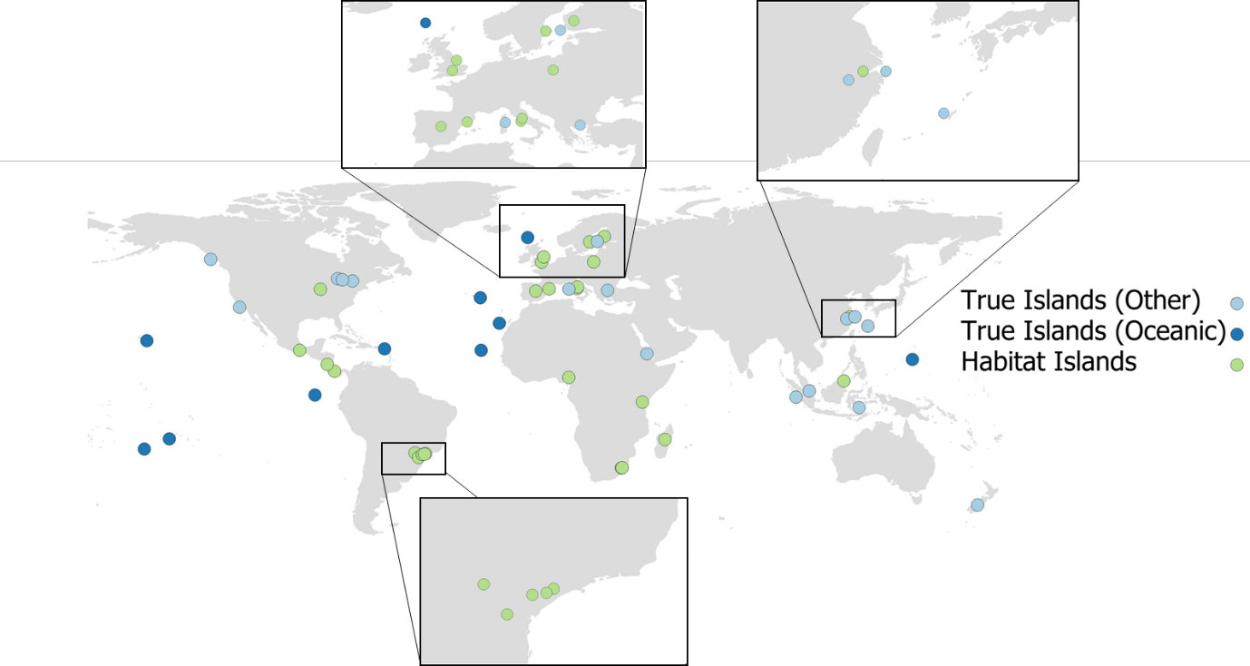
Figure S1. A map of the sourced island datasets, distinguishing between true (oceanic and other) and habitat archipelagos.

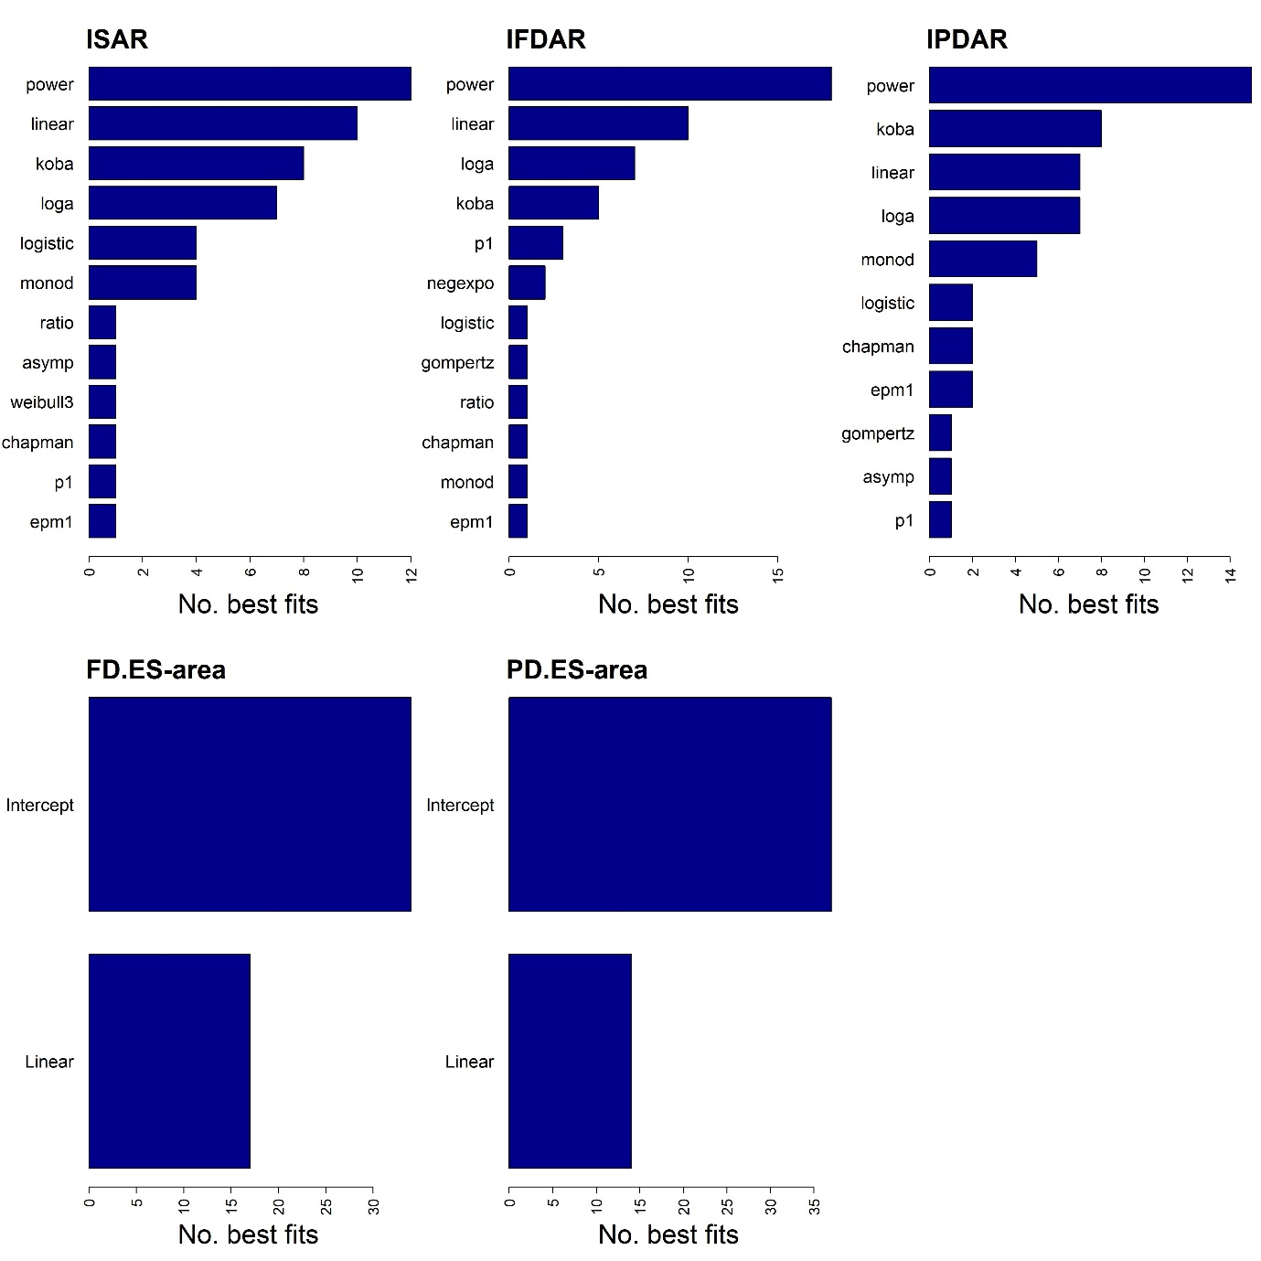

Figure S2. The number of times a model provided the best fit (according to AIC_{c}) to a dataset, for the five island IDARs. The total number of datasets is 51. Full model names can be found in Table S2. In each plot, models that never provided the best fit are not included.

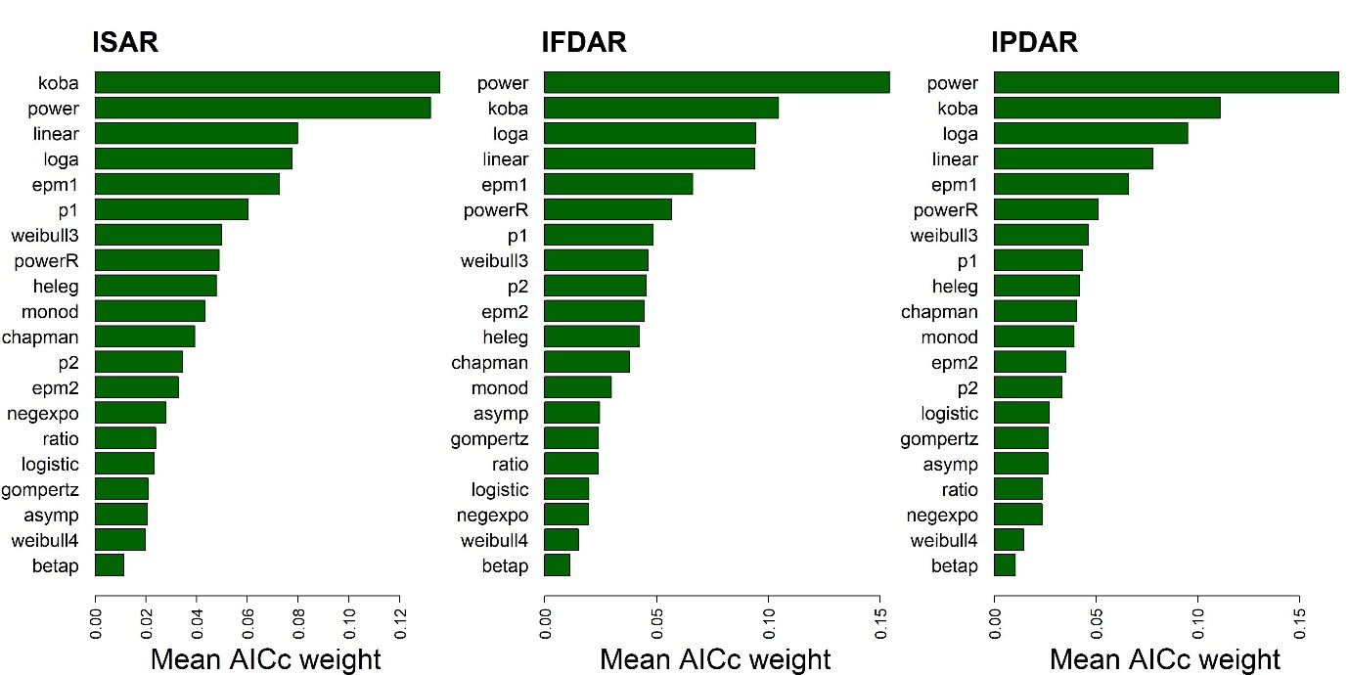
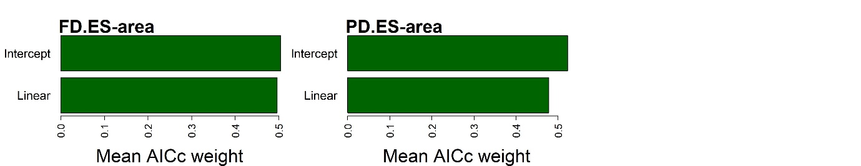
Figure S3. The mean model AIC_{c} weights across all true island datasets in which a model fit converged, for the five island IDARs. The total number of true island datasets is 26. Full model names can be found in Table S2. For the FD.ES–area and PD.ES–area relationships, the two models were fitted in semi-log space, for the other IDARs in untransformed space.

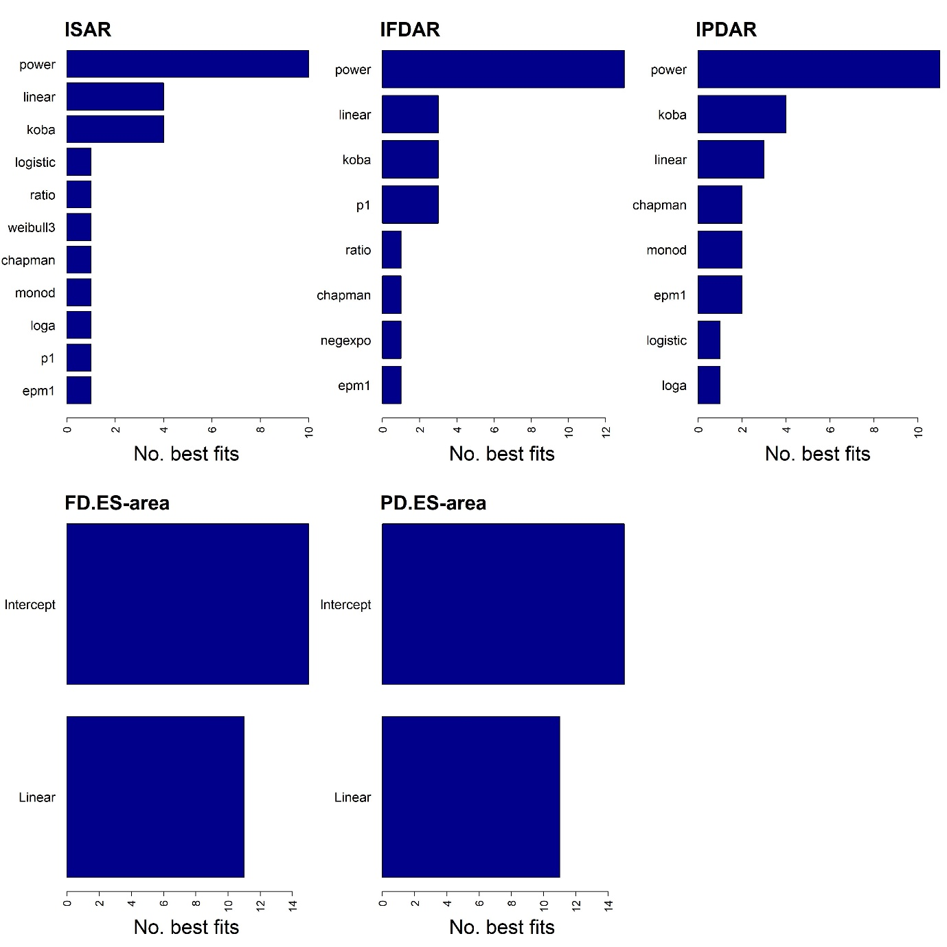

Figure S4. The number of times a model provided the best fit (according to AIC_{c}) to a true island dataset, for the five island IDARs. The total number of true island datasets is 26. Full model names can be found in Table S2. In each plot, models that never provided the best fit are not included.

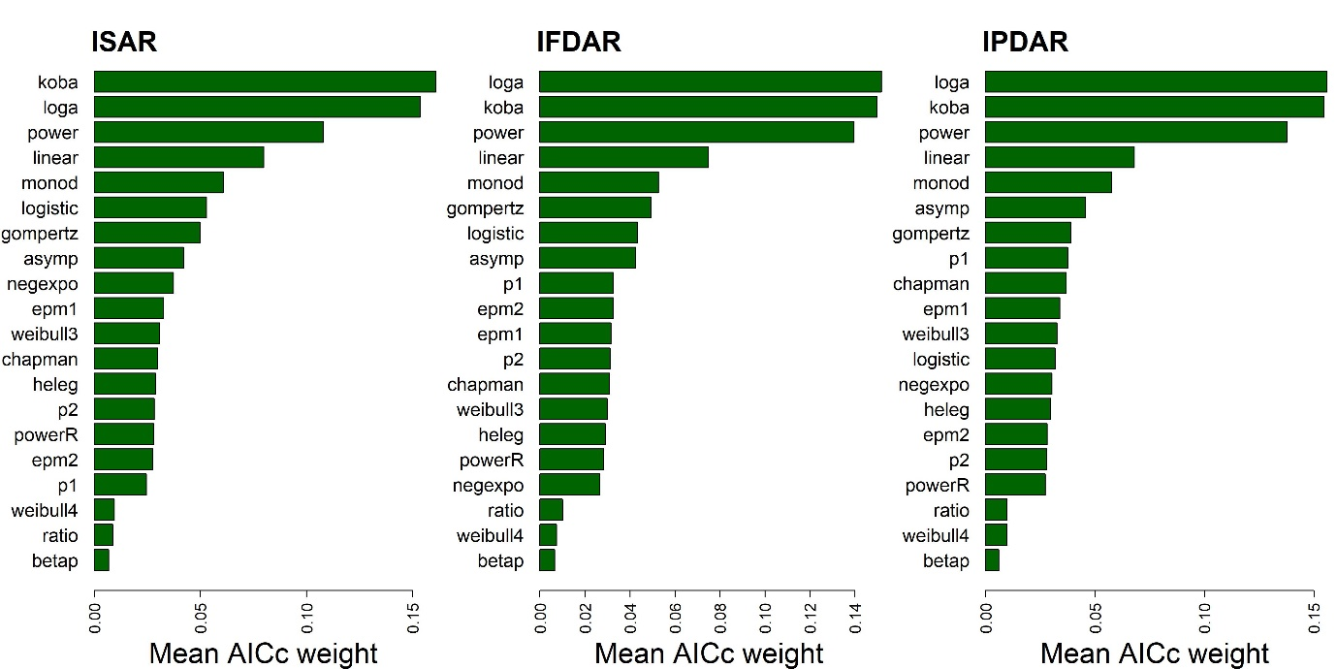
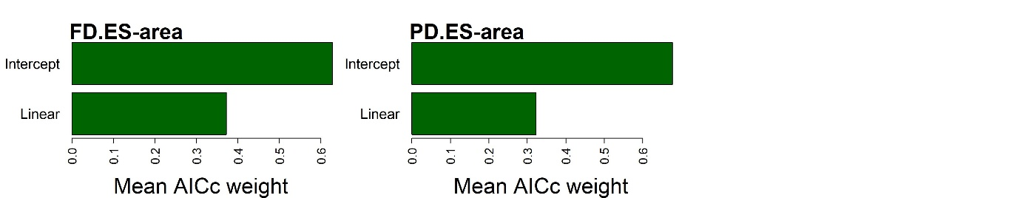
Figure S5. The mean model AIC_{c} weights across all habitat island datasets in which a model fit converged, for the five island IDARs. The total number of habitat island datasets is 25. Full model names can be found in Table S2. For the FD.ES–area and PD.ES–area relationships, the two models were fitted in semi-log space, for the other IDARs in untransformed space.

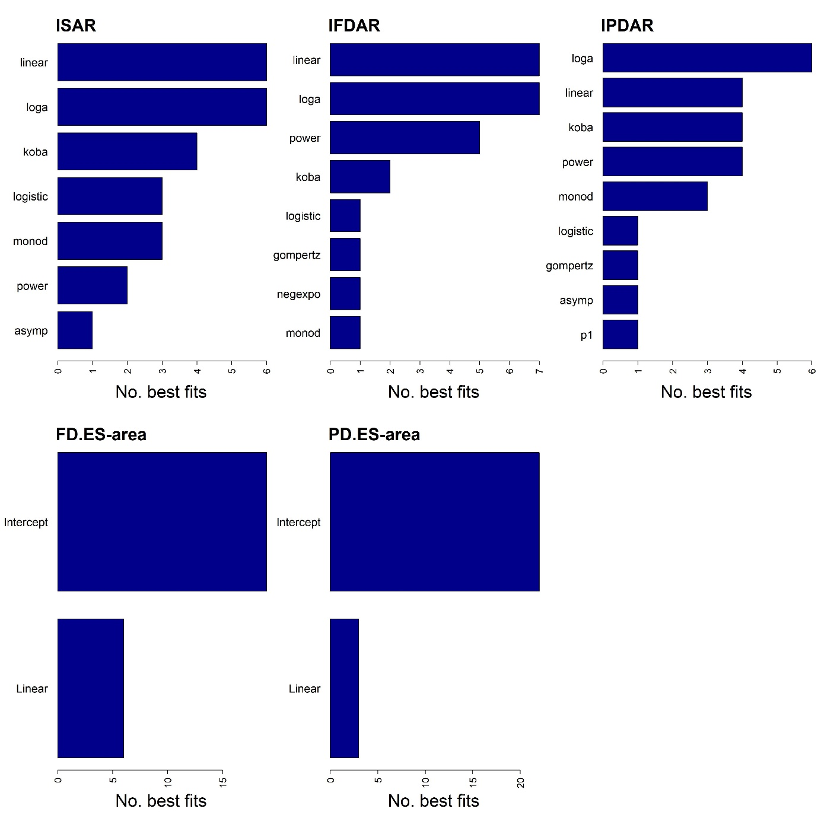

Figure S6. The number of times a model provided the best fit (according to AIC_{c}) to a habitat island dataset, for the five island IDARs. The total number of habitat island datasets is 25. Full model names can be found in Table S2. In each plot, models that never provided the best fit are not included.

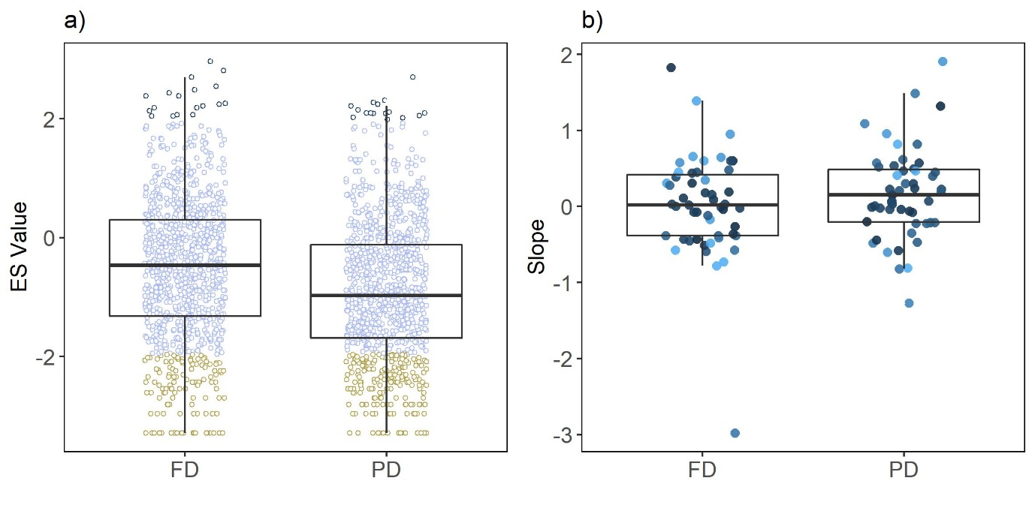

Figure S7. a) The distribution of effect sizes (ES) of the bird communities on 1,051 islands, for functional diversity (FD) and phylogenetic diversity (PD). ES values were generated using a null model (999 iterations; see main text for details). Significant positive ES values (ES > 1.96) represent cases of overdispersion, significant negative values (ES < -1.96) represent clustering, and non-significant cases (-1.96 < ES < 1.96) represent random community assembly. b) Distribution of the slopes of a standard linear model fitted to the FD.ES–area and PD.ES-area relationships for all datasets. The points are coloured by the AIC_{c} weight of the linear model. The boxplots include the median value (thick black line), first and third quartiles (hinges), and the whiskers extend no further than 1.5 * the inter-quartile range.

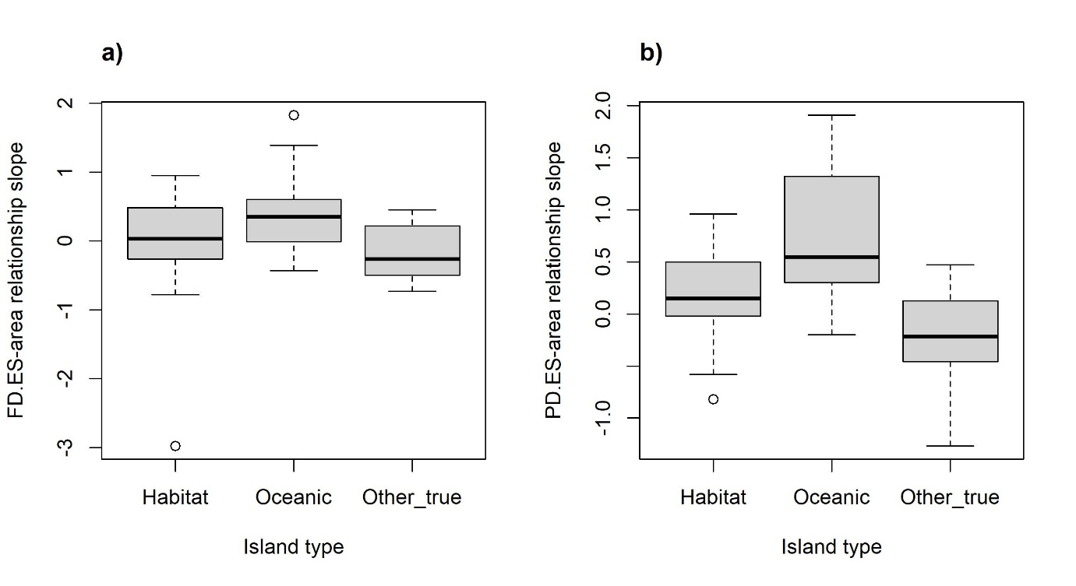
Figure S8. Variation in (a) FD.ES and (b) PD.ES–area relationship slope by island type. Slope was taken from a linear model fitted to log₁₀(area) vs. the ES values, for 51 island datasets. The three island types were habitat islands (n = 25), oceanic islands (n = 10) and other true islands (e.g., continental-shelf islands and lake islands; n = 16).

Appendix S4 Body-Size Corrected Traits Results
To run these analyses, first a dendrogram was constructed using body-size corrected traits (residuals from a linear regression of a given trait against body mass; both log-transformed). The complete set of analyses was then re-run, including the ISAR, IPDAR and PD.ES analyses. Given the stochastic selection of starting parameters for the SAR models, and the use of null models to generate ES values, it is possible that some results for the ISAR, IPDAR and PD.ES may differ slightly from those presented in the full paper.
The model selection results for the IFDAR and FD.ES–area relationships (Fig. S9-S10) were very similar to those generated in the main paper using non-body-size corrected traits. A plot of the differences in z-values between the three IDARs, ordered by increasing ISAR z is provided as Fig. S11. The avifauna of most islands (86% for FD, and 79% for PD) exhibited random structure regarding FD.ES and PD.ES values, with a small proportion being characterised as clustered (14% for FD, and 19% for PD). Very few island avifauna were over-dispersed (<1% and 2%, respectively). Mean ES values were -0.71 for FD and -0.90 for PD, indicating a slight tendency toward clustering. FD.ES and PD.ES significance results were equivalent for most islands, but there were notable exceptions (Fig. S13); for example, 90 of the islands had significantly negative PD.ES values, but non-significant FD.ES values (Fig. S13).
Across all datasets, the intercept only model had the higher mean AIC_{c} weight and provided the best fitting candidate model (i.e., lowest AIC_{c} in 33 and 39 out of 51 datasets, respectively), for both the FD.ES and PD.ES–area relationships. However, there were notable exceptions, with some FD.ES and PD.ES–area relationships exhibiting positive and negative linear relationships. When looking at true and habitat islands separately, it was apparent that, for true islands, the relative performance of the linear model, regarding the ES–area relationships, improved.
Only considering cases where the linear model provided the best fit, there were 10 positive and eight negative relationships for the FD.ES–area, and seven and five respectively for the PD.ES–area relationship. The majority of significant linear cases were true island datasets, particularly for PD.ES (13 and 10 for the FD.ES and PD.ES relationships, respectively). The median slope of the linear model across all datasets was 0.14 (0.12 and 0.22 for true and habitat island datasets, respectively) for the FD.ES–area and 0.18 (0.13 and 0.18) for the PD.ES–area relationship. Interestingly, when only focusing on the ten oceanic island datasets, the median linear slope values were higher: 0.57 and 0.54 for the FD.ES and PD.ES–area relationships, respectively (see Fig. S16).
The (paired) Wilcoxon signed-rank tests indicated that the differences between A and B were significant for the ISAR (P = 0.03), IFDAR (P = 0.02) and IPDAR (P = 0.02). The differences between B and C were significant for all three IDAR types (P = 0.02, 0.03 and 0.04 for the ISAR, IFDAR and IPDAR, respectively), while the differences between A and C were non-significant. For the FD.ES–area and PD.ES–area relationship slopes, there were significant decreases in slopes between A and B (P = 0.04 and 0.04 for FD.ES and PD.ES, respectively) and A and C (P = 0.02 and 0.01), but the differences between B and C were not significant (P > 0.05) (Fig. S14).

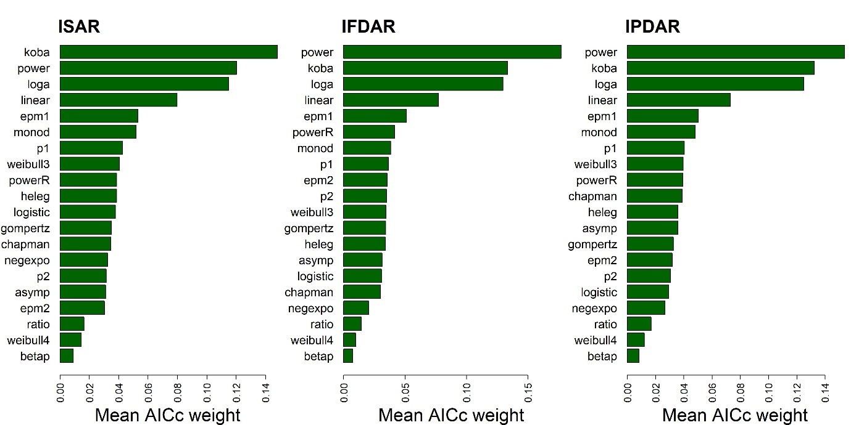
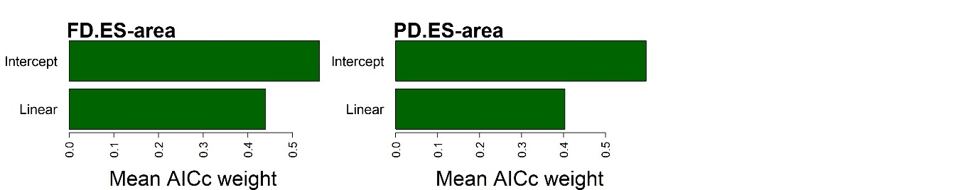
Figure S9. Same as Figure 2 in the main paper, but using body-size corrected traits. Note the results for species richness and PD may also differ slightly given the stochastic selection of SAR model starting parameters and the use of null models to generate ES values. See legend of Figure 2 for information.

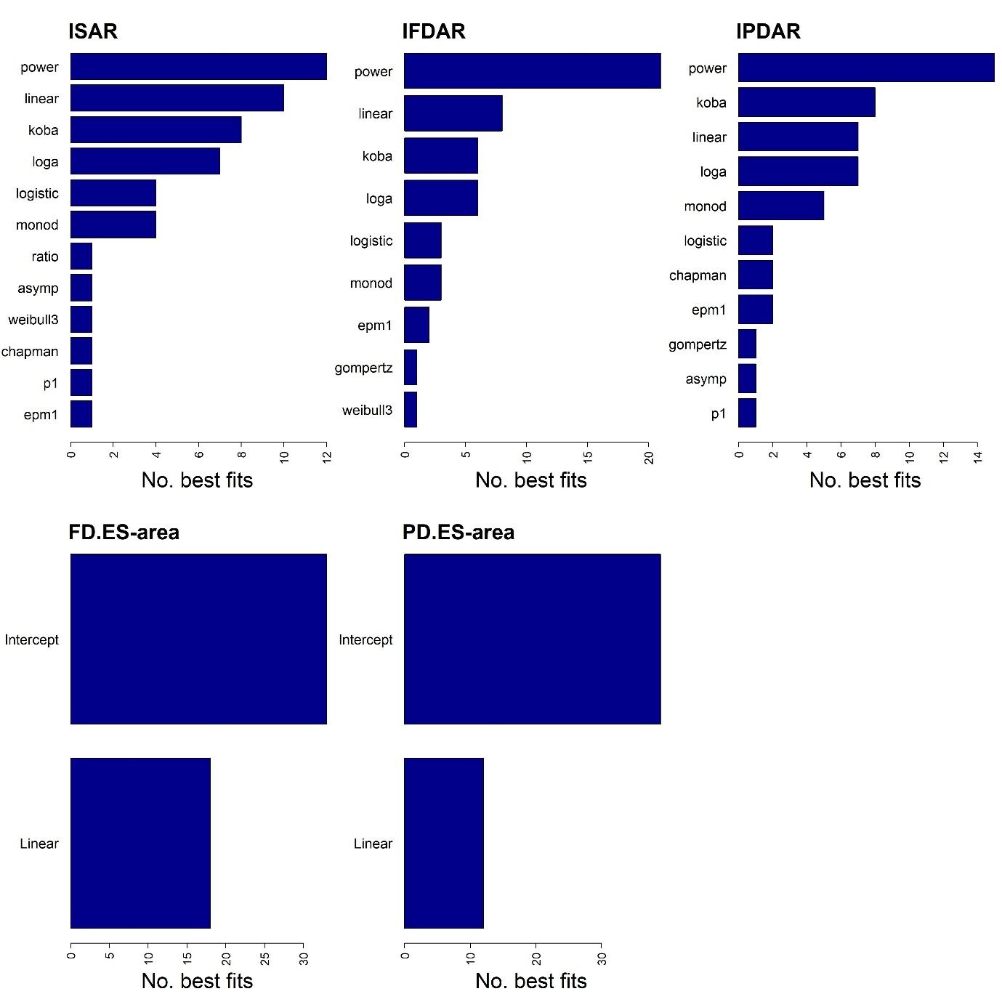

Figure S10. Same as Figure S2 in the main paper, but using body-size corrected traits. Note the results for species richness and PD may also differ slightly given the stochastic selection of SAR model starting parameters and the use of null models to generate ES values. See legend of Figure S2 for information.

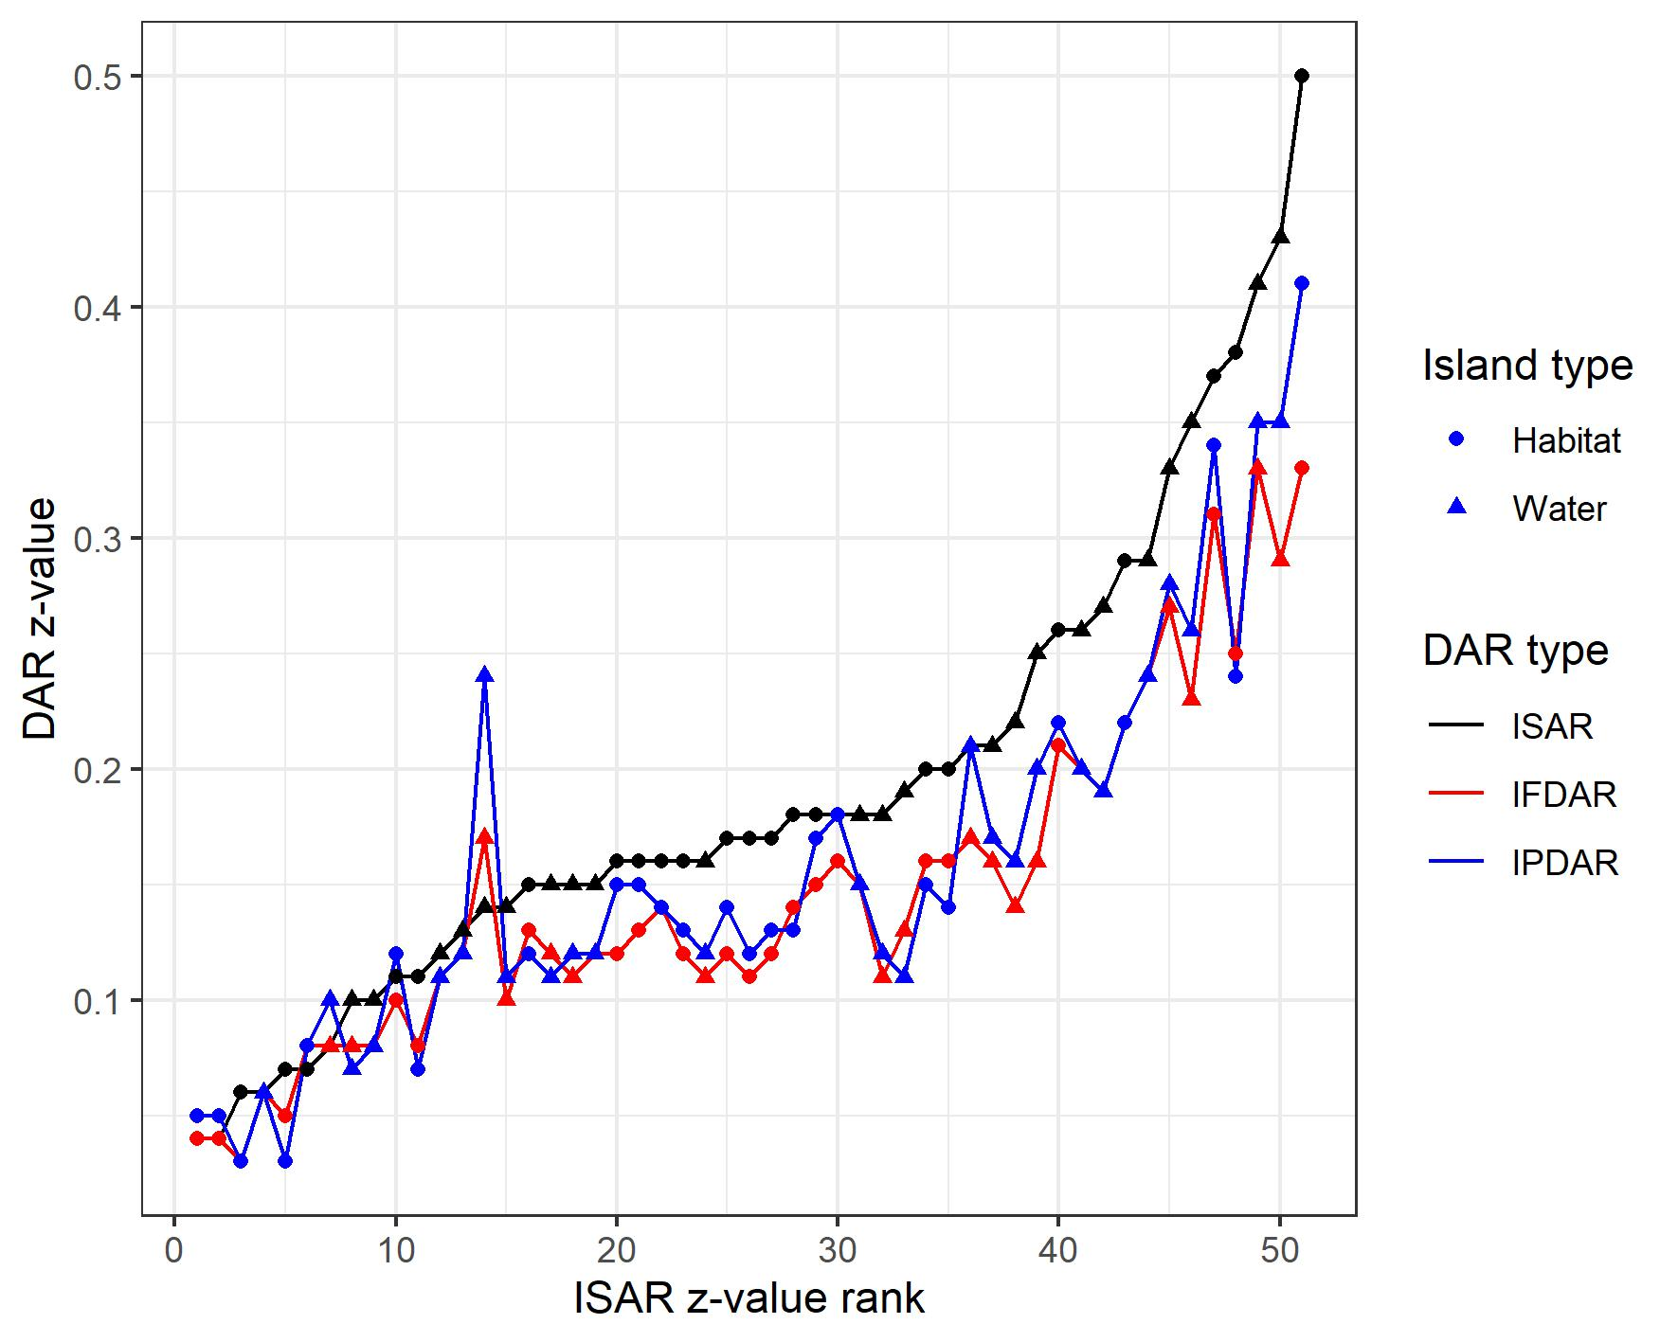

Figure S11. Same as Figure 4 in the main paper, but using body-size corrected traits. See legend of Figure 4 for information.

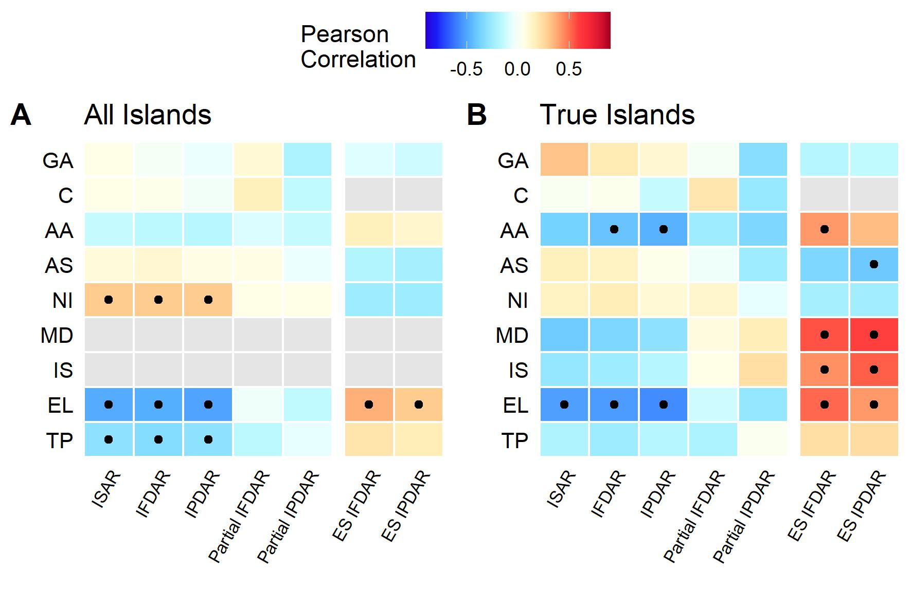
Figure S12. Same as Figure 5 in the main paper, but using body-size corrected traits. See legend of Figure 5 for information.

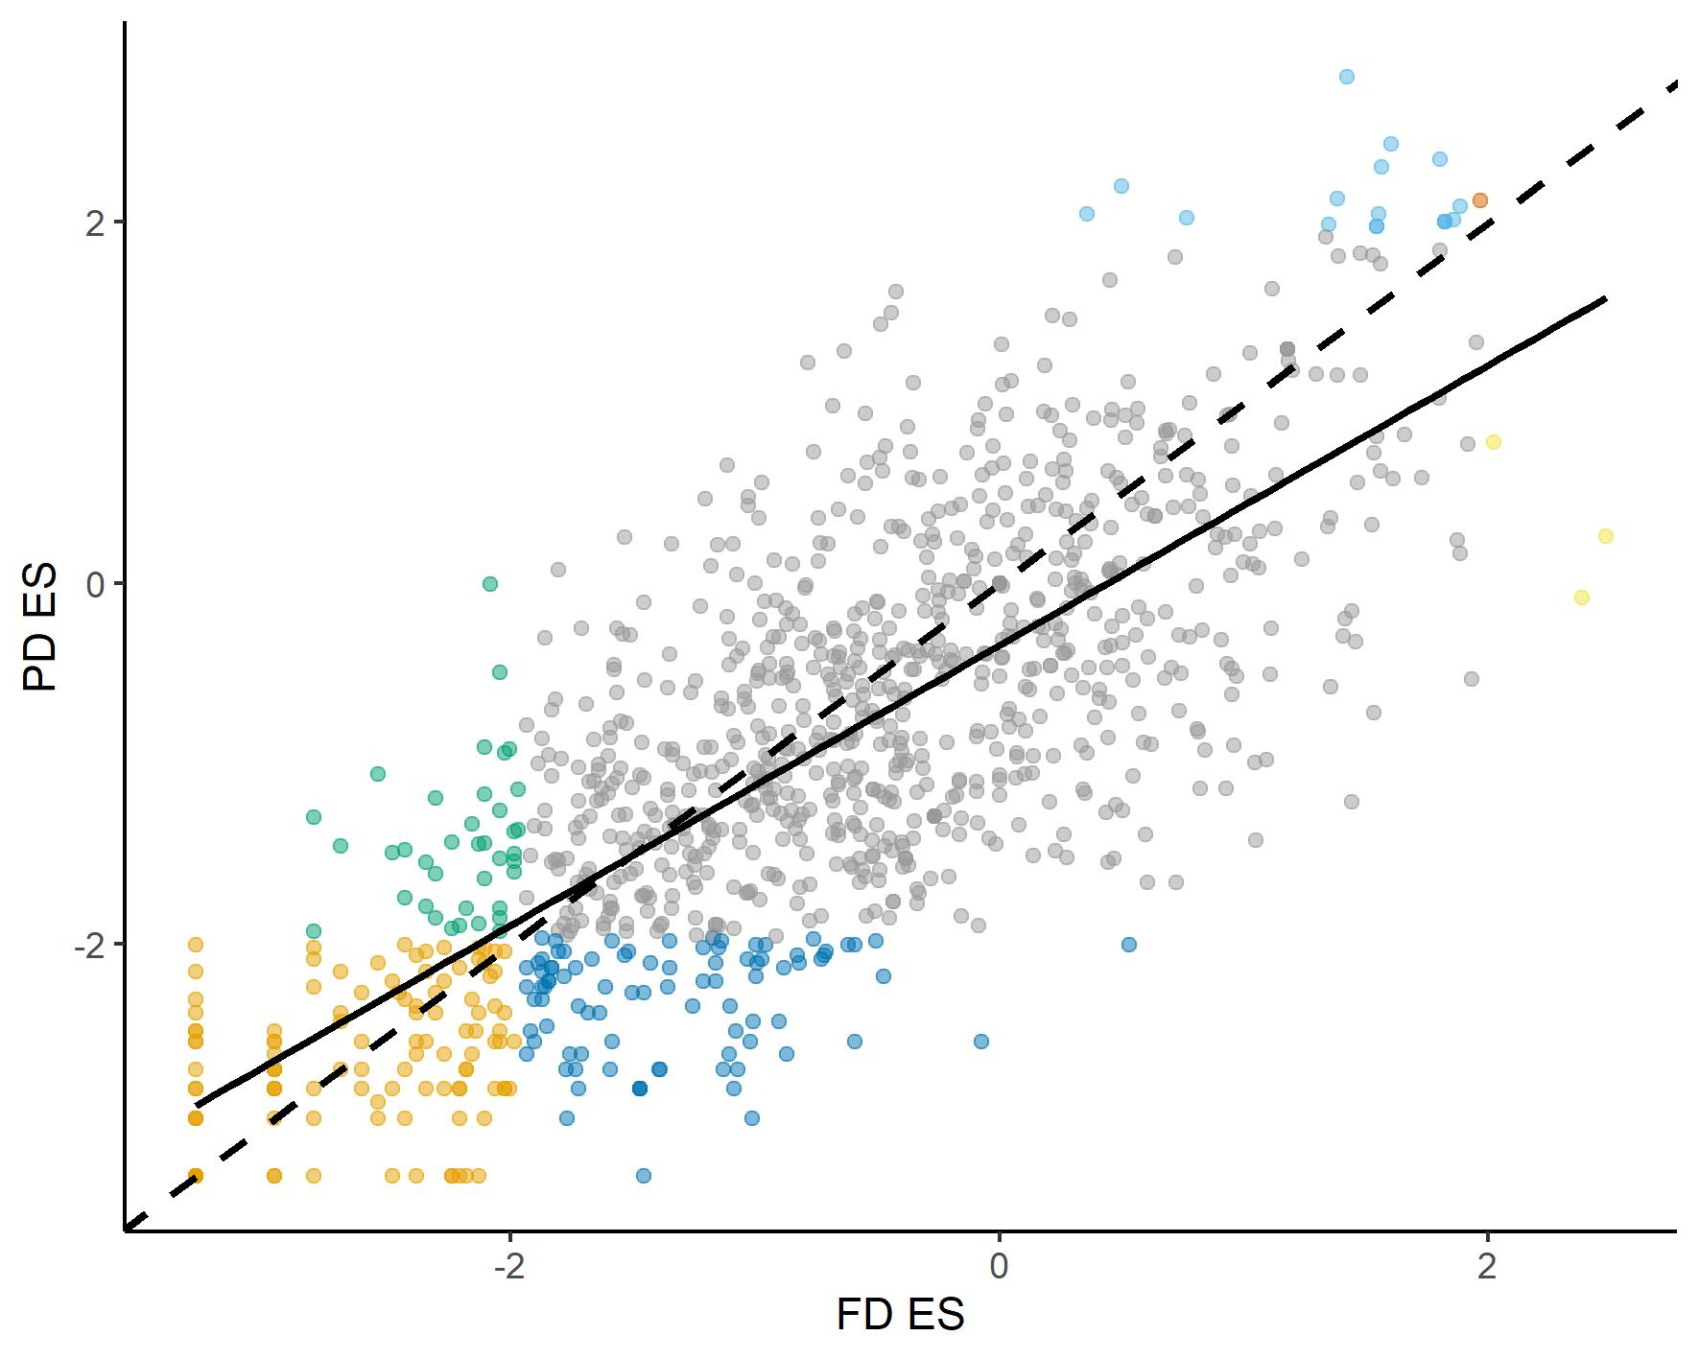
Figure S13. Same as Figure 6 in the main paper, but using body-size corrected traits. Note the results for PD may differ slightly given the use of null models to generate ES values. See legend of Figure 6 for information.

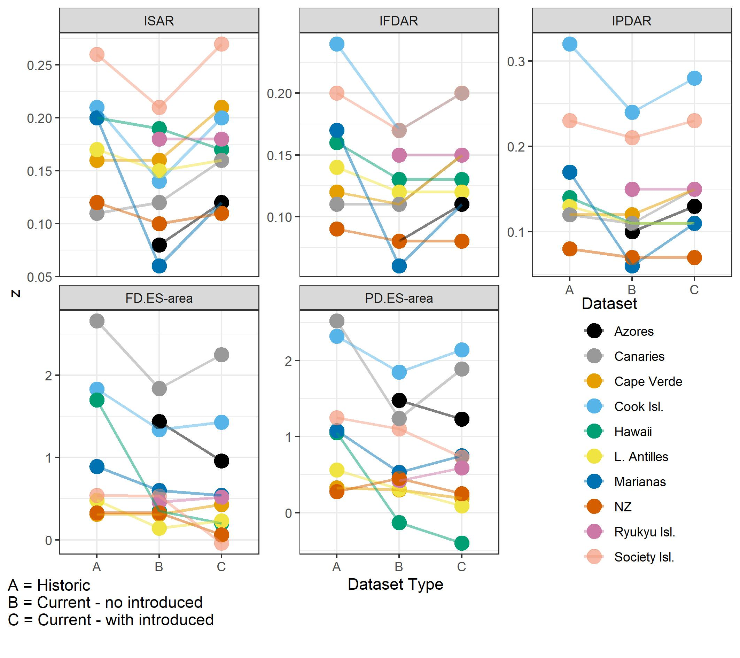
Figure S14. Same as Figure 7 in the main paper, but using body-size corrected traits. Note the results for PD.ES may differ slightly given the use of null models to generate ES values. See legend of Figure 7 for information.

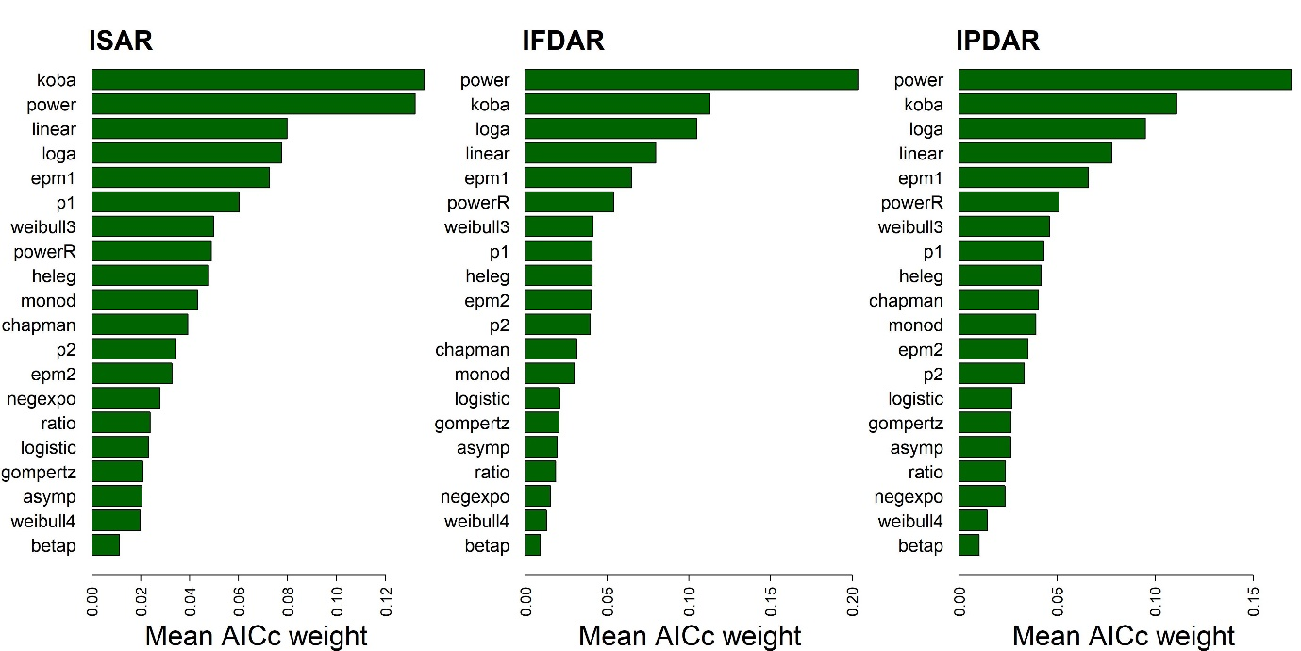
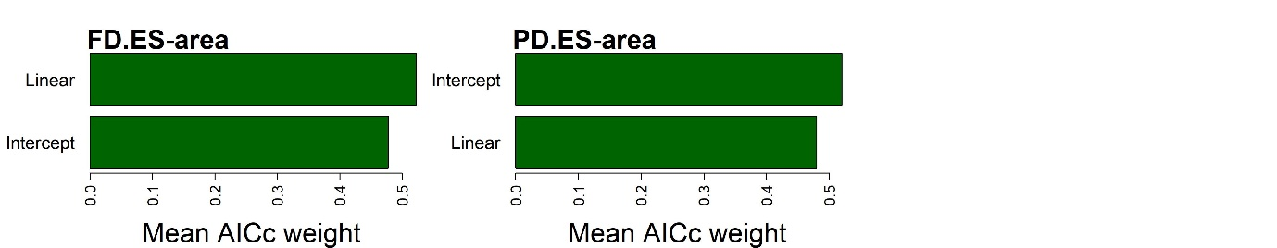
Figure S15. Same as Figure S3 in the main paper (the model selection results for true islands only), but using body-size corrected traits. Note the results for species richness and PD may also differ slightly given the stochastic selection of SAR model starting parameters and the use of null models to generate ES values. See legend of Figure S3 for information.

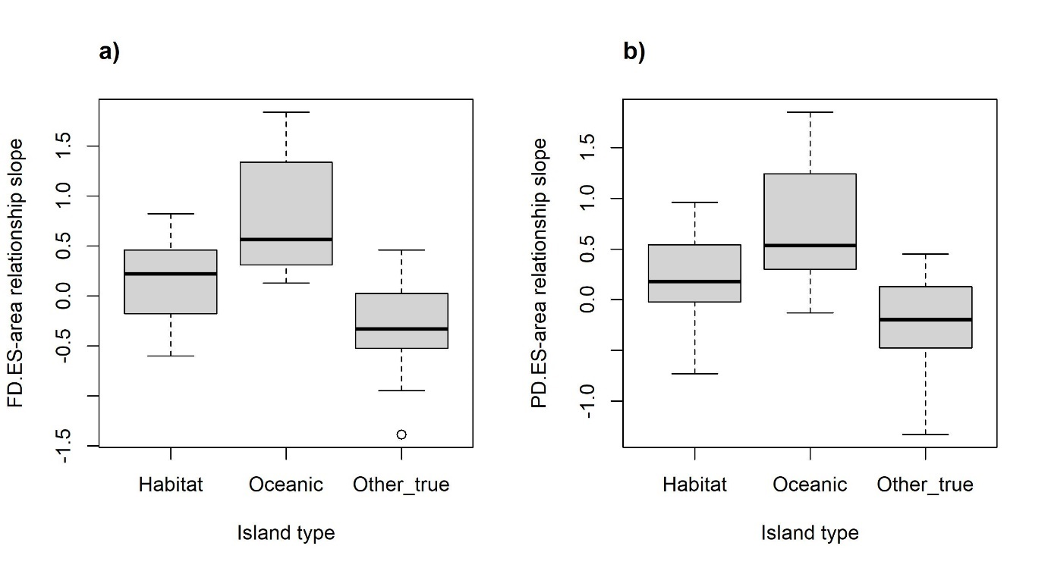
Figure S16. Same as Figure S8 in the main paper, but using body-size corrected traits. Note the results for PD.ES may also differ slightly given the use of null models to generate ES values. See legend of Figure S8 for information.

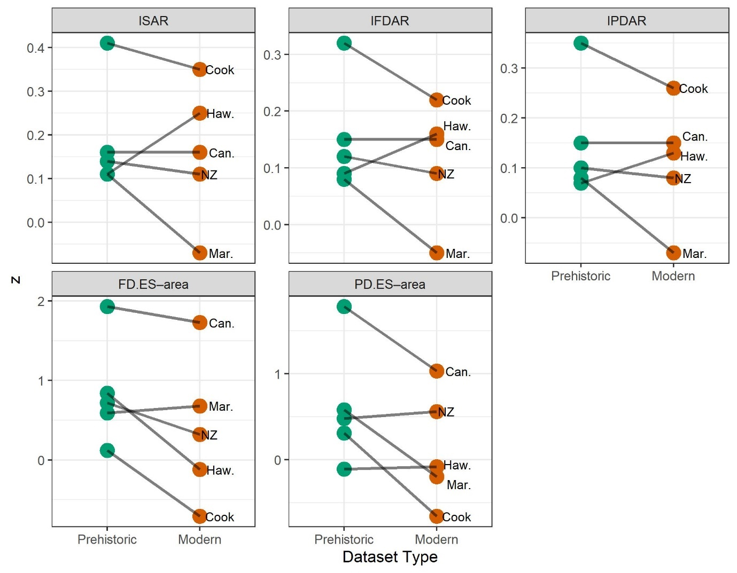
Figure S17. Same as Figure 8 in the main paper, but using body-size corrected traits. Note the results for PD.ES may differ slightly given the use of null models to generate ES values. See legend of Figure 8 for information.

Appendix S5 Land Bird Species Results
To roughly standardise the datasets, we created an alternative version for each dataset by sub-setting only the land birds, and re-running the analyses (see Appendix S2 for details). Due to our imposed constraint of islands having to contain a minimum of one species, the standardisation process involved removing two (oceanic) datasets when analysing just land birds (Appendix S2).
The non-asymptotic convex-upward Kobayashi, power and logarithmic models had the highest mean AIC_{c} values for the ISAR, IFDAR and IPDAR (in different orders), across the 49 datasets (Fig. S18). In terms of the number of best fits (i.e., cases of lowest AIC_{c} for a given IDAR and dataset), the top three models for the ISAR were the Kobayashi, logarithmic and linear models, while for the IFDAR and IPDAR the top three were power, linear and logarithmic, and logarithmic, power and Kobayashi models, respectively. In general, for a given dataset, the z-value of the ISAR was larger than the IPDAR, which was larger than the IFDAR. A plot of the differences in z-values between the three IDARs, ordered by increasing ISAR z is provided as Fig. S19.
The avifauna of most islands (88% for FD, and 83% for PD) exhibited random structure regarding FD.ES and PD.ES values, with a small proportion being characterised as clustered (11% for FD, and 15% for PD). Very few island avifauna were over-dispersed (1% and 2%, respectively). Mean ES values were -0.48 for FD and -0.79 for PD, indicating a slight tendency toward clustering. FD.ES and PD.ES significance results were equivalent for most islands, but there were notable exceptions (Fig. S21); for example, 95 of the islands had significantly negative PD.ES values, but non-significant FD.ES values (Fig. S21).
Across all datasets, the intercept only model had the higher mean AIC_{c} weight and provided the best fitting candidate model (i.e., lowest AIC_{c} in 34 and 37 out of 49 datasets, respectively), for both the FD.ES and PD.ES–area relationships. However, there were notable exceptions, with some FD.ES and PD.ES–area relationships exhibiting positive and negative linear relationships. When looking at true and habitat islands separately, it was apparent that, for true islands, the relative performance of the linear model, regarding the PD.ES–area relationships, improved slightly, although to a lesser extent compared to the main results, and there were now few differences between the two island types in regard to the FD.ES–area relationship.
Only considering cases where the linear model provided the best fit, there were eight positive and seven negative relationships for the FD.ES–area, and seven and five respectively for the PD.ES–area relationship. The median slope of the linear model across all datasets was 0.04 (0.07 and 0.03 for true and habitat island datasets, respectively) for the FD.ES–area and 0.13 (0.13 and 0.18) for the PD.ES–area relationship. Interestingly, when only focusing on the eight oceanic island datasets, the median linear slope value was higher for the PD.ES–area relationship (0.24), but a difference from the main results was the equivalent slope for the FD.ES–area relationship (0.09) was now similar to the values for all true islands and habitat islands (Fig. S25).
The main differences between the main results and those focused just on land birds related to the introduced and extinct species analysis (Fig. S22) and the exploratory correlations (Fig. S20). Regarding the former, while, for the ISAR, IFDAR and IPDAR, some datasets followed the pattern of a decrease in slope between periods A and B, followed by an increase between B and C, the results were less clear and none of the paired Wilcoxon tests were significant (P > 0.05), although this is perhaps expected given the removal of two datasets as part of this analysis meant only 6-8 datasets were used in the comparisons. However, consistent with the main results, for the FD.ES–area and PD.ES–area relationship slopes, there were still significant (or marginally non-significant) decreases in slopes between A and B (P = 0.03 and 0.09) and A and C (P = 0.09 and 0.03), and the differences between B and C were still not significant (P > 0.05). Regarding the latter, while the effects of elevation and temperature were still apparent, there was now no significant association involving the number of islands, or the isolation variables (for the ES–area relationships). Interestingly, there were now several variables with significant correlations in the partial IFDAR and IPDAR analyses (particularly when just analysing true island datasets), compared to none in the main analyses. The reasons for this require further evaluation.

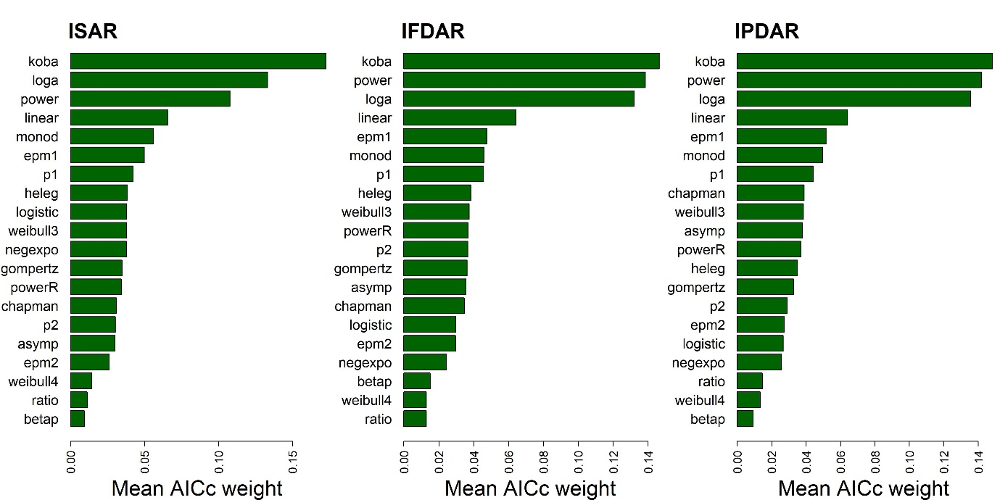
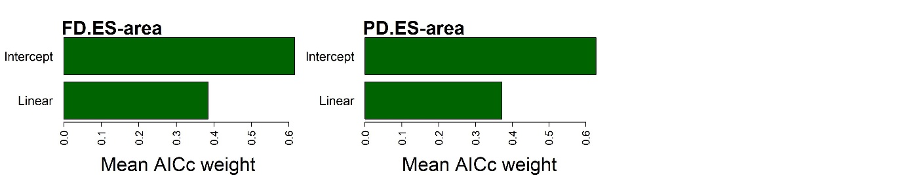
Figure S18. Same as Figure 2 in the main paper, but using versions of the datasets only including land birds. See legend of Figure 2 for information.

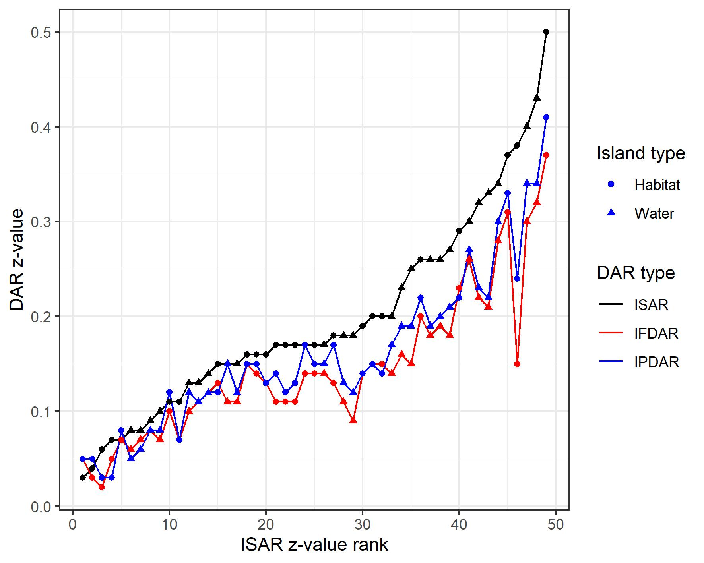
Figure S19. Same as Figure 4 in the main paper, but using versions of the datasets only including land birds. See legend of Figure 4 for information.

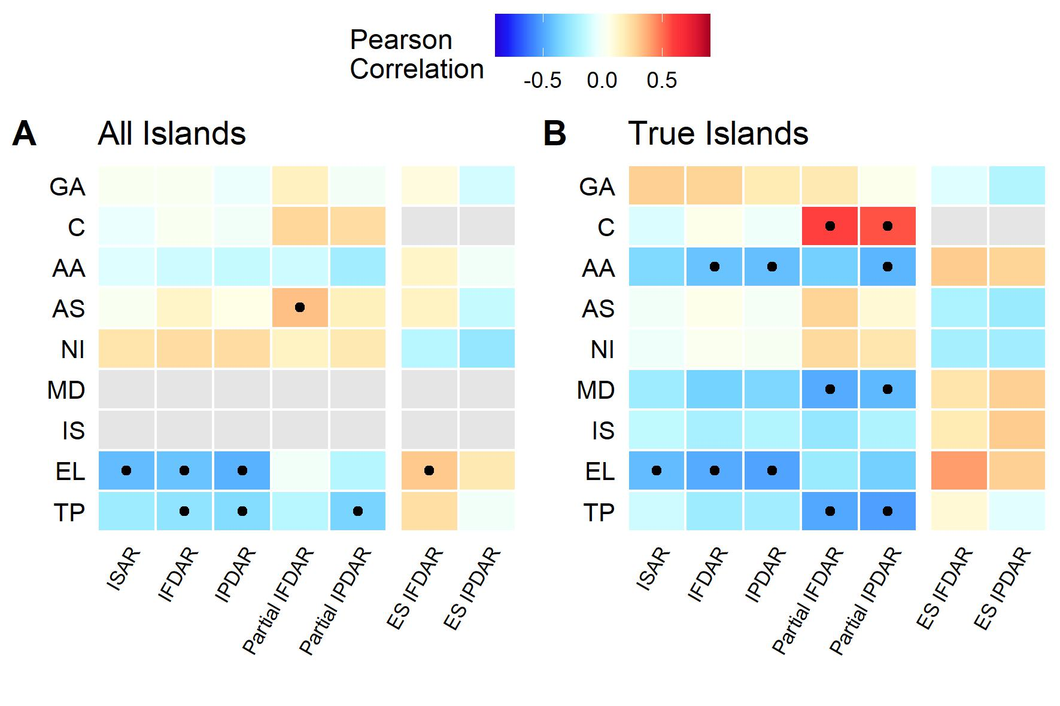
Figure S20. Same as Figure 5 in the main paper, but using versions of the datasets only including land birds. See legend of Figure 5 for information.

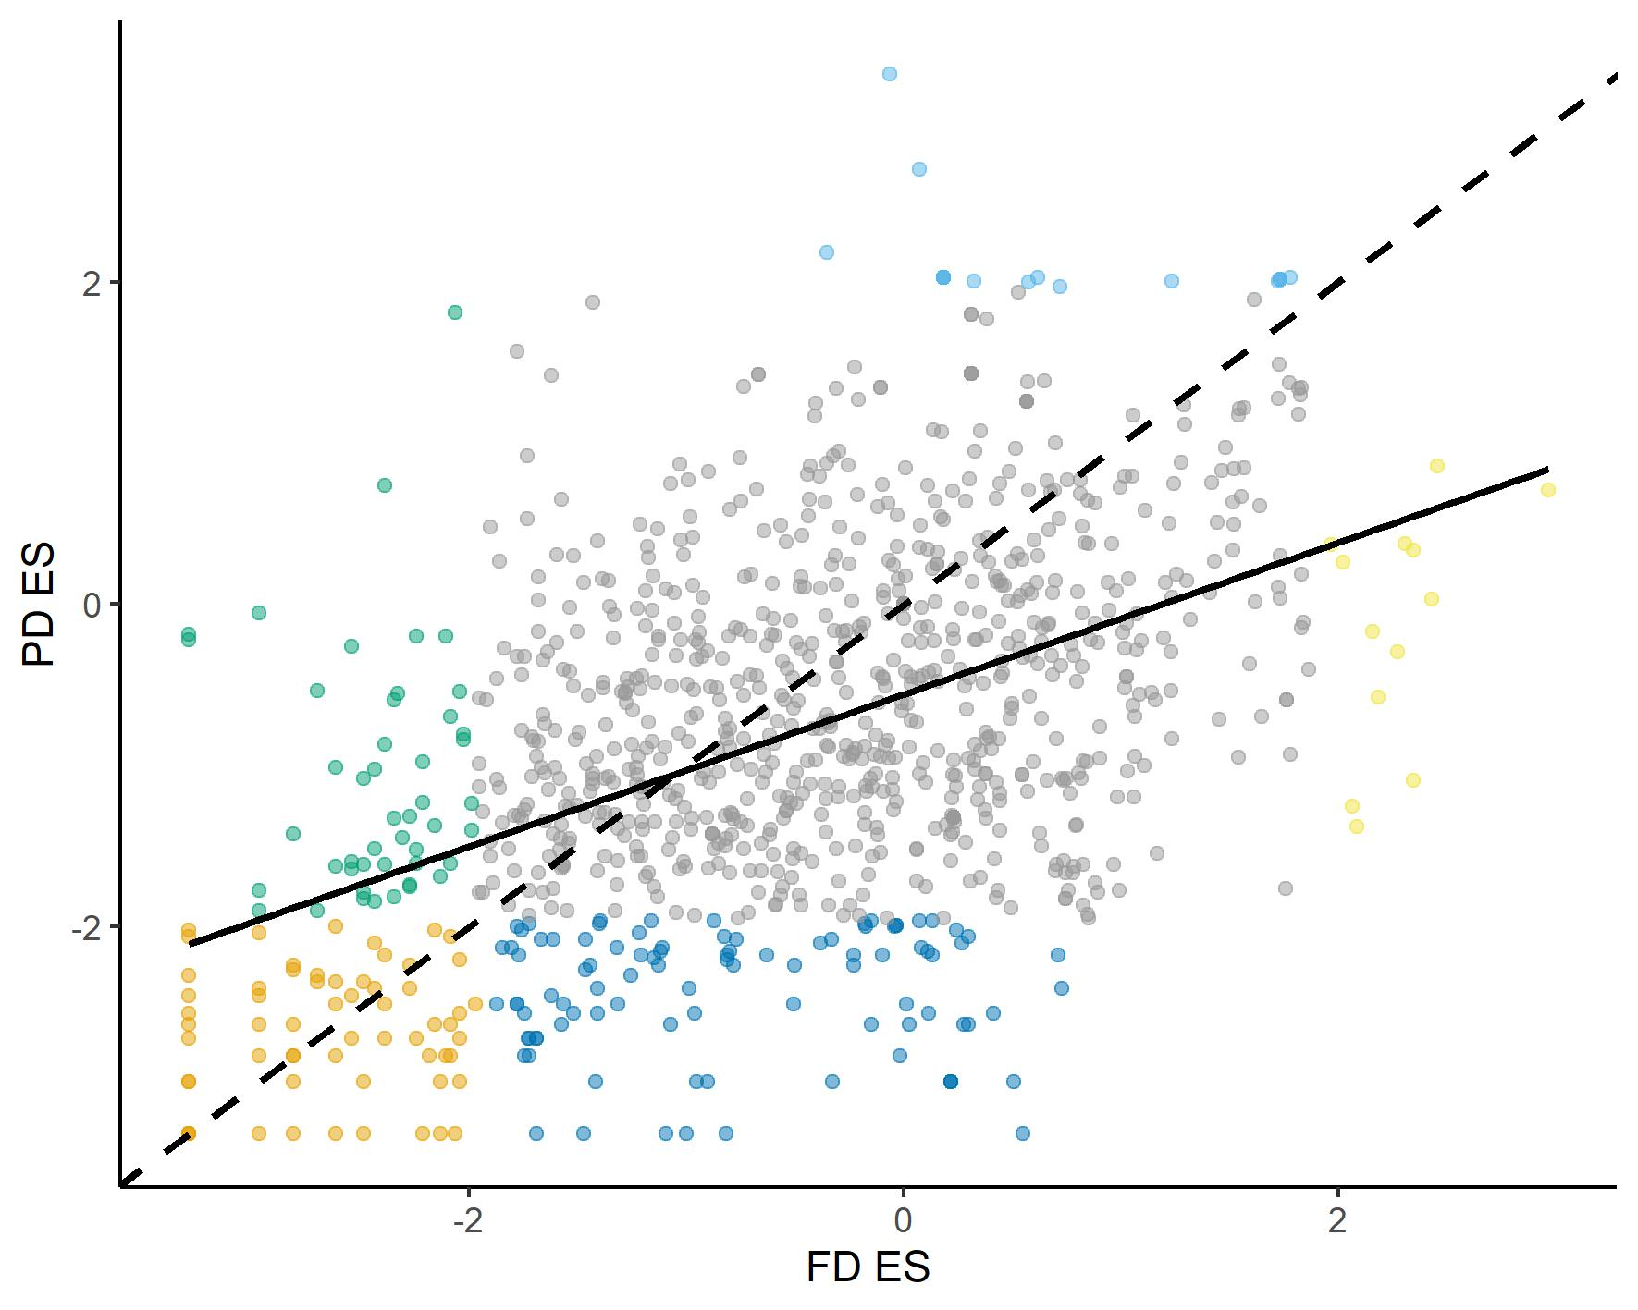
Figure S21. Same as Figure 6 in the main paper, but using versions of the datasets only including land birds. See legend of Figure 6 for information.

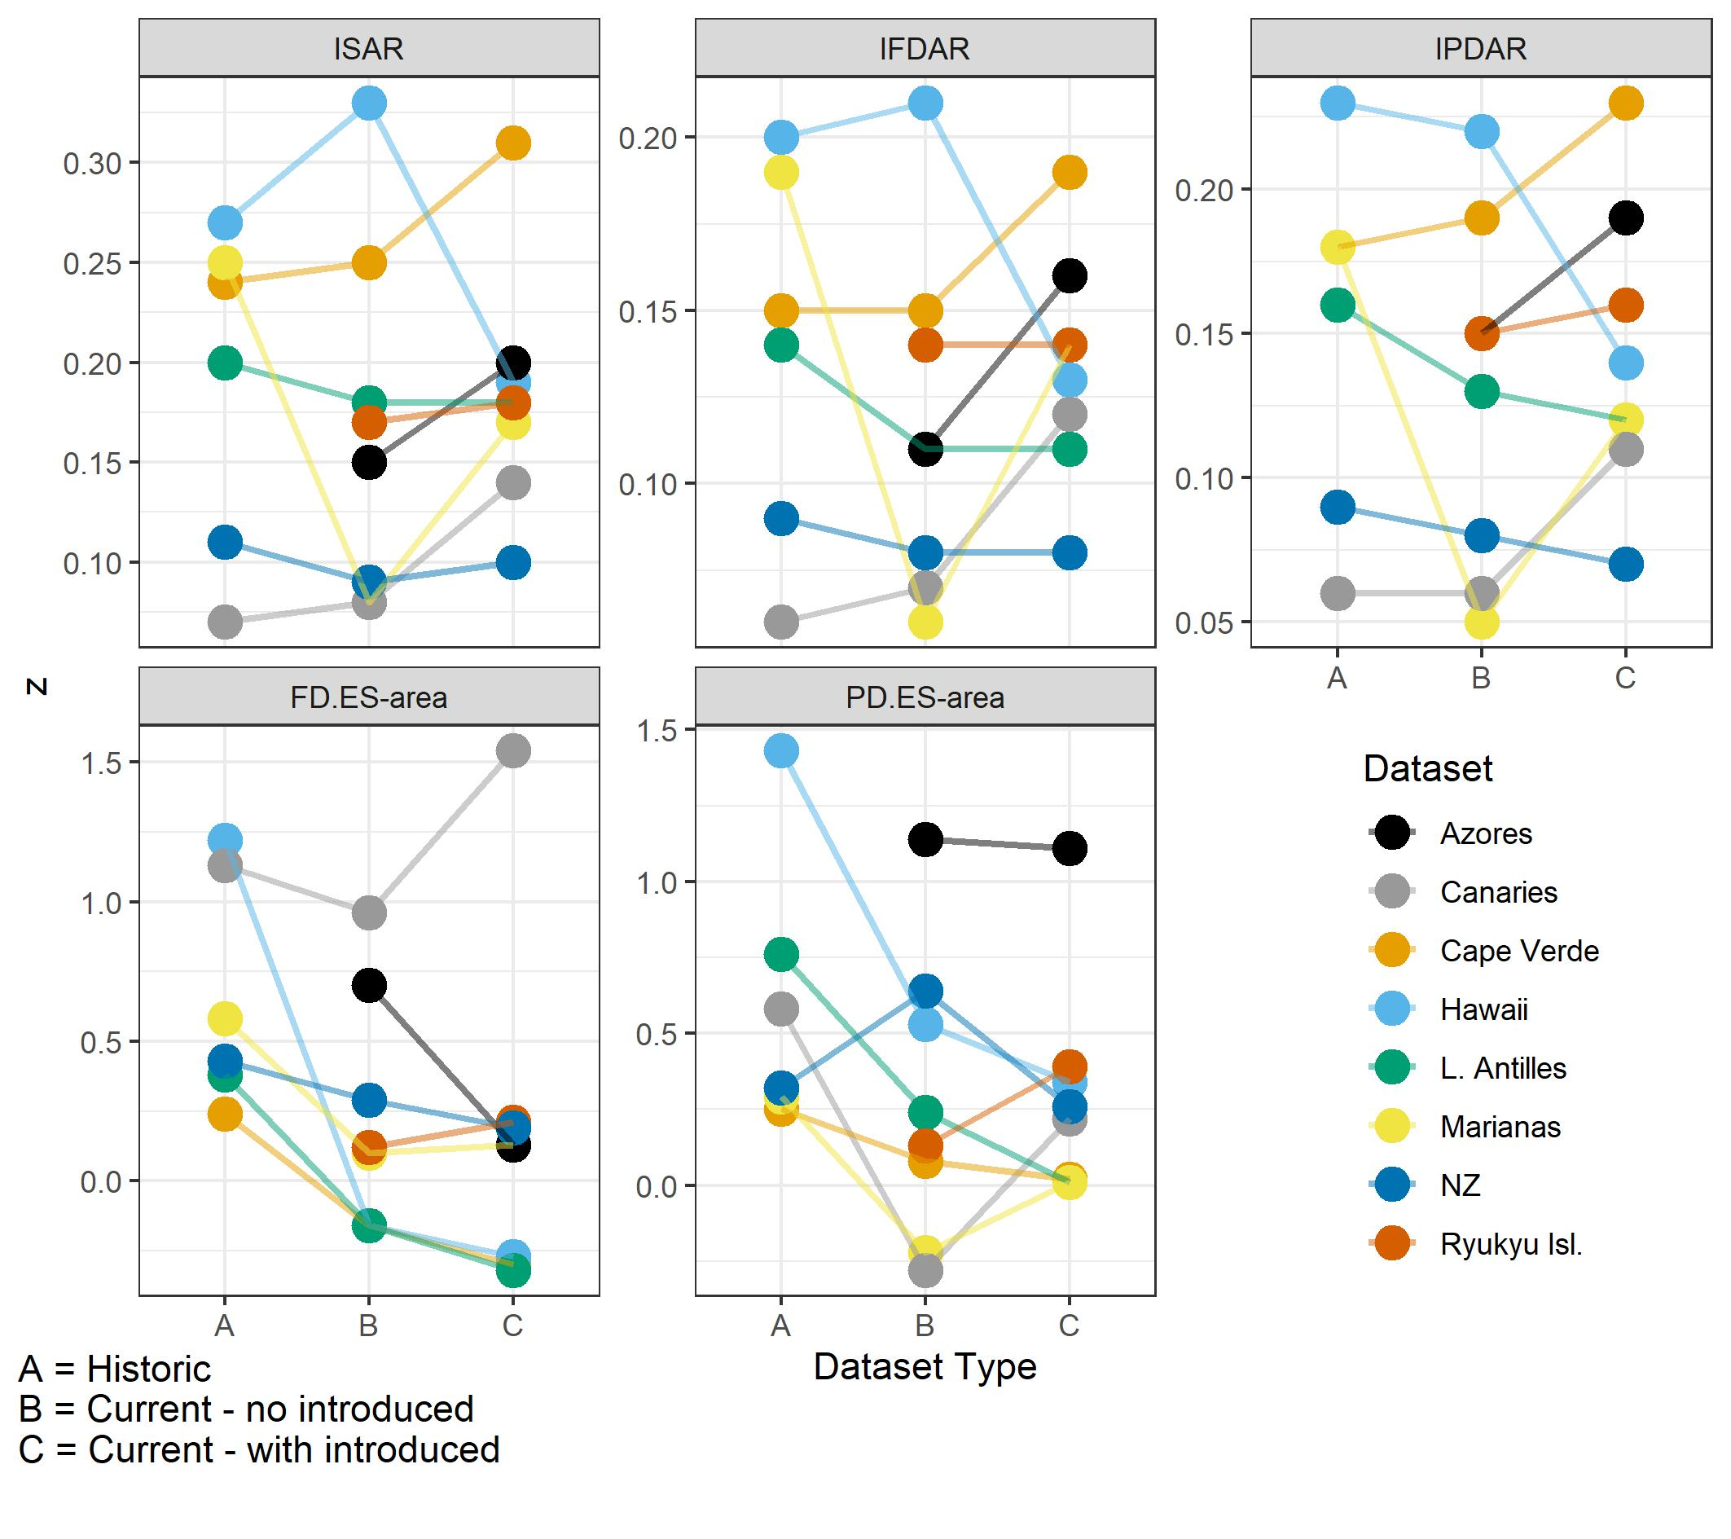
Figure S22. Same as Figure 7 in the main paper, but using versions of the datasets only including land birds. See legend of Figure 7 for information.

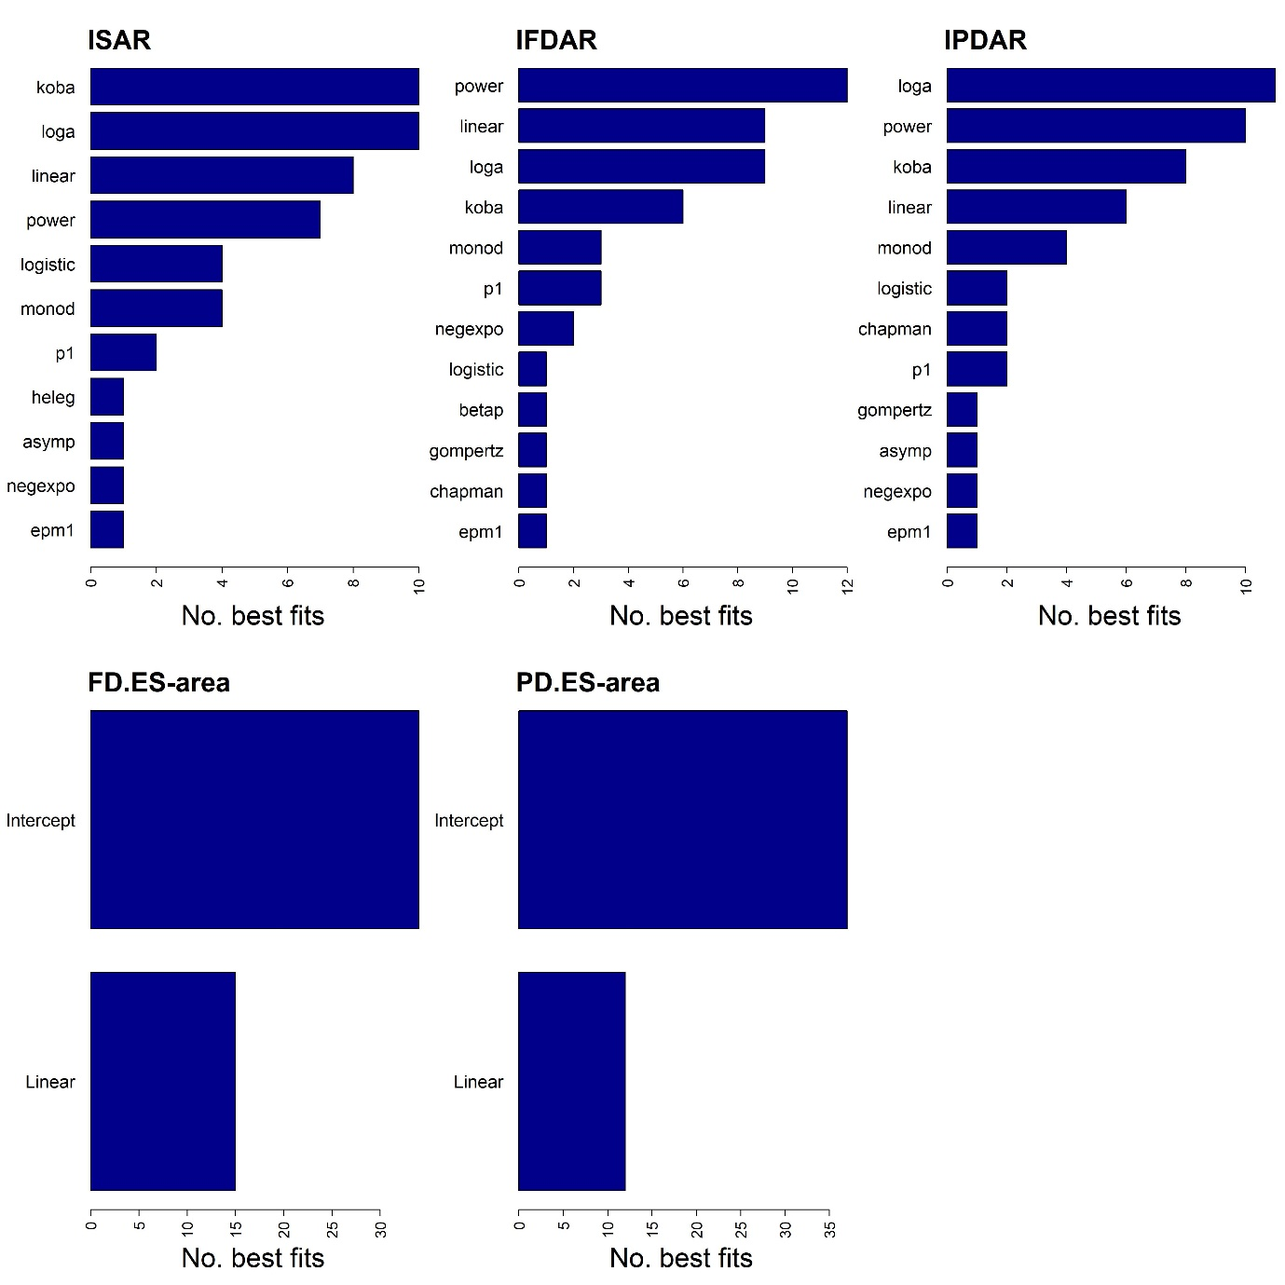
Figure S23. Same as Figure S2 in the main paper, but using versions of the datasets only including land birds. See legend of Figure S2 for information.

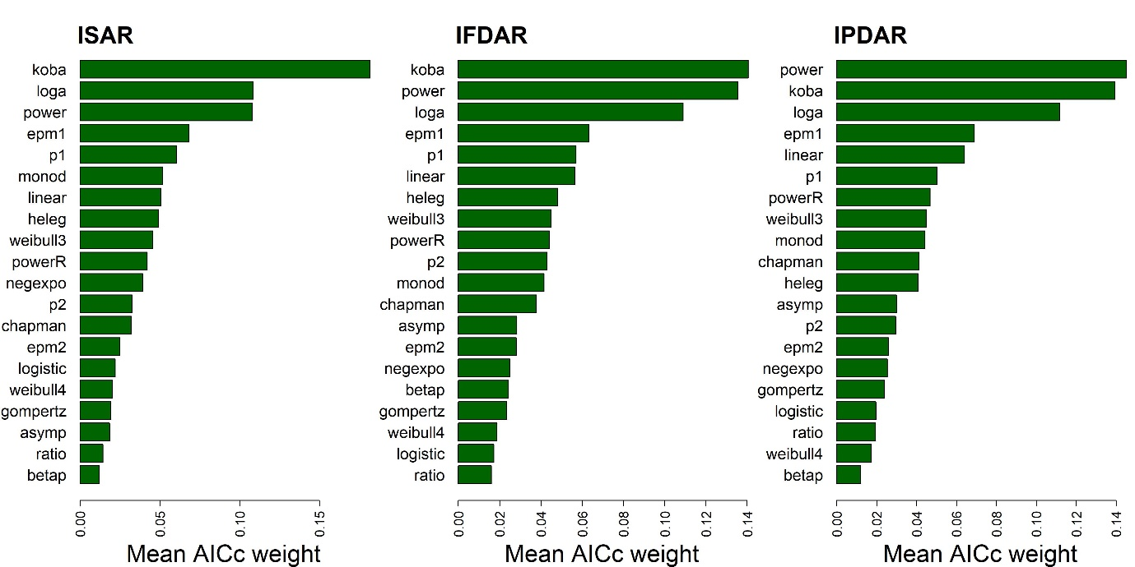
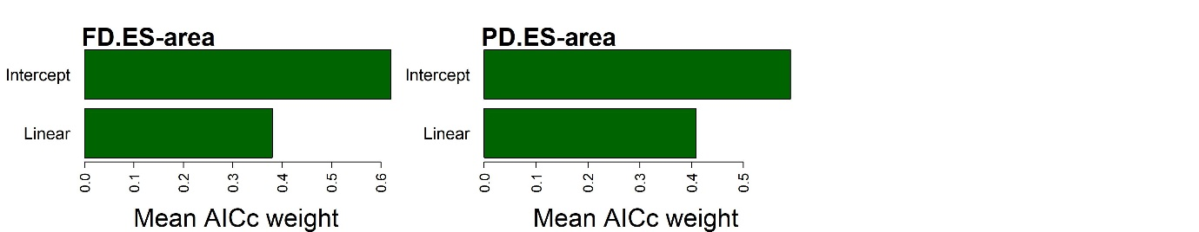

Figure S24. Same as Figure S3 in the main paper (the model selection results for true islands only), but using versions of the datasets only including land birds. See legend of Figure S3 for information.

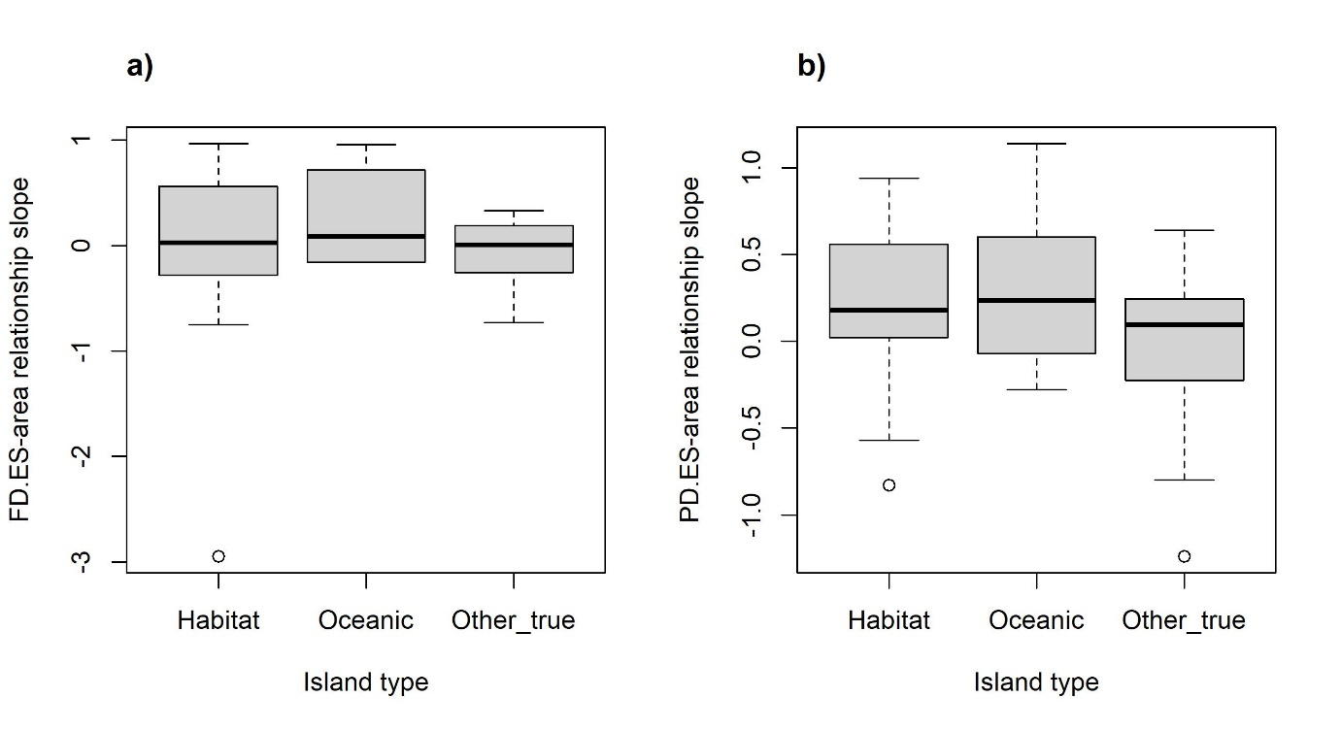
Figure S25. Same as Figure S8 in the main paper, but using versions of the datasets only including land birds. See legend of Figure S8 for information.

Appendix S6 Results Using Residual Assumption Checks
To ensure the same models were fitted in all cases, we did not remove model fits based on residual assumptions checks (e.g., normality). However, given that the least square parameter estimates equal the maximum likelihood estimates only under the assumption of normal errors with constant variance (see discussion in ‘sars’ package vignette), and given we are using AIC_{c}, we re-ran the non-linear model selection including checks for both these properties. As an additional sensitivity test, we also re-ran the various power model z-value analyses using the z-values from the log₁₀–log₁₀ (linear) power model. Non-body size corrected traits were used in these analyses. Normality was assessed using a Shapiro–Wilk test, and homoscedasticity by correlating the absolute residuals with the fitted values (both tests were undertaken using functionality in the ‘sars’ R package). For a given dataset, if a model failed one or both of the assumption tests, it was removed from the final set of fitted models. As such, for a given model, the mean AIC_{c} of fits across datasets only relates to datasets in which it passed the tests. If, for a given dataset, only a single model of the 20 passed the checks, we considered there to be no successful model fits (i.e., there was a minimum of two successful model fits).
The power model passed the assumption checks for 41, 41 and 45 datasets for the ISAR, IFDAR and IPDAR, respectively. For 41 (ISAR), 43 (IFDAR), and 44 (IPDAR) datasets, at least 15 of the 20 models passed the assumption checks. No model passed the residual assumption checks for two and three datasets, for the ISAR and IPDAR, respectively.
Using the z-values from the linear (log₁₀–log₁₀) power model generated similar results. For the analysis looking at the effect of introduced and extinct species, the results using the linear power model z-values were largely consistent with the main results (Fig. S28). In regard to the paired Wilcoxon tests, the difference between period A and B was significant (or marginally non-significant) for the ISAR (P = 0.08), IFDAR (P = 0.02) and IPDAR (P = 0.01), with the differences between B and C also being significant / marginally non-significant (P = 0.049, 0.049 and 0.08, respectively).

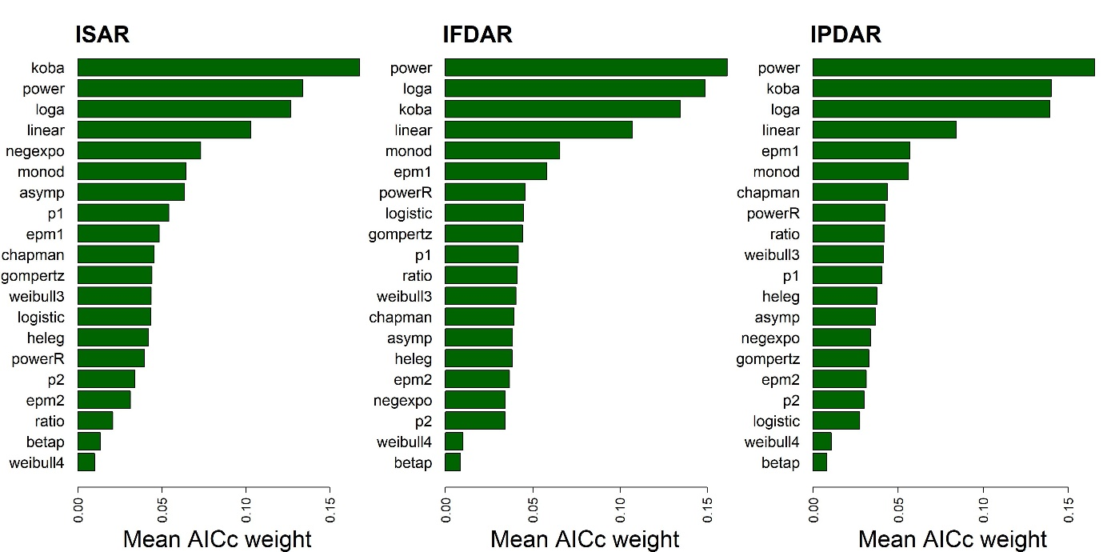
Figure S26. Same as Figure 2 in the main paper, but after removing model fits that did not pass the residual assumptions tests (and thus two and three entire datasets for the ISAR and IPDAR, respectively). Residual checks were only undertaken for the non-linear models and thus the ES–area relationships are now shown. See legend of Figure 2 for information.

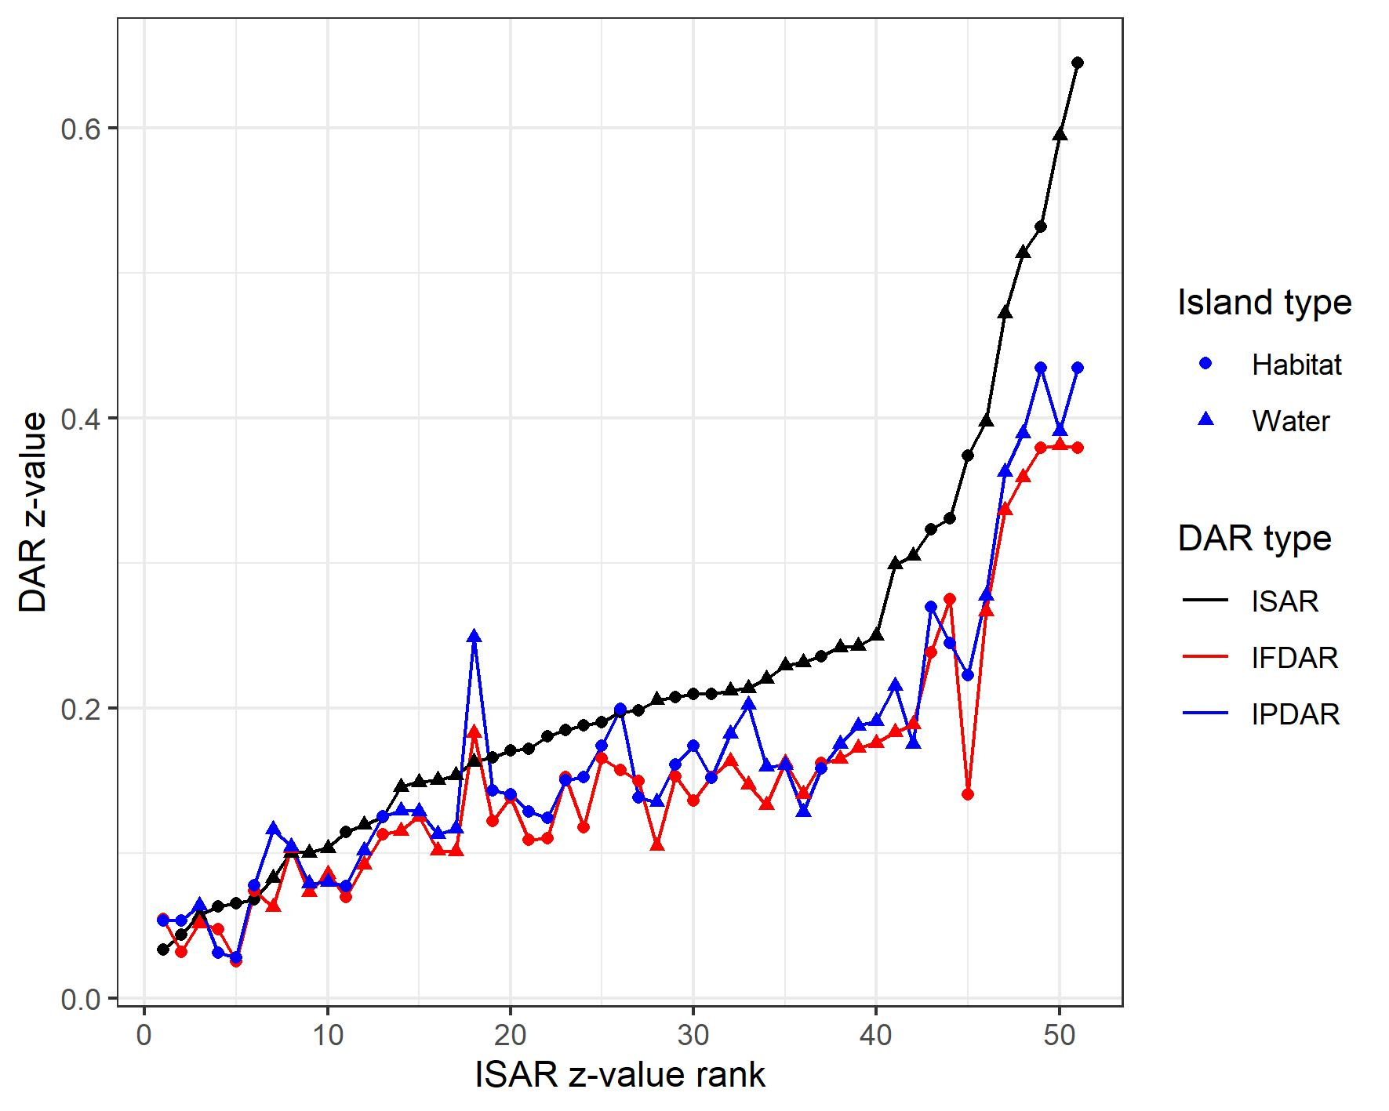
Figure S27. Same as Figure 4 in the main paper, but using z-values from the linear (log₁₀–log₁₀) power model. See legend of Figure 4 for information.

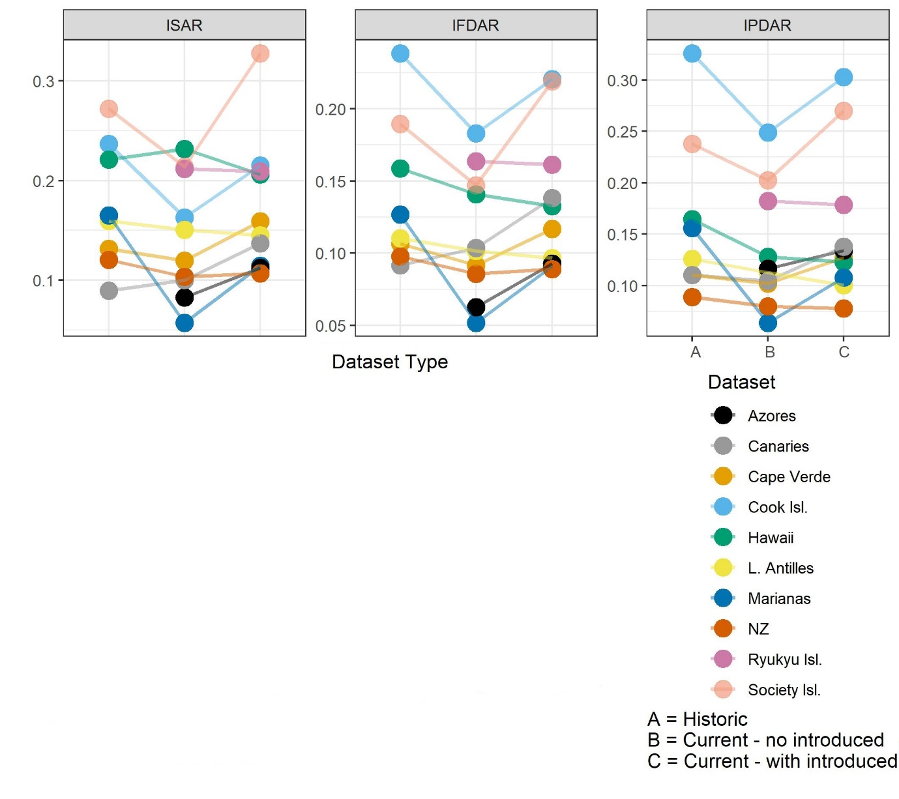
Figure S28. Same as Figure 7 in the main paper, but using z-values from the linear (log₁₀–log₁₀) power model. See legend of Figure 7 for information. The ES-area relationships are not presented as they did not use the power model originally.

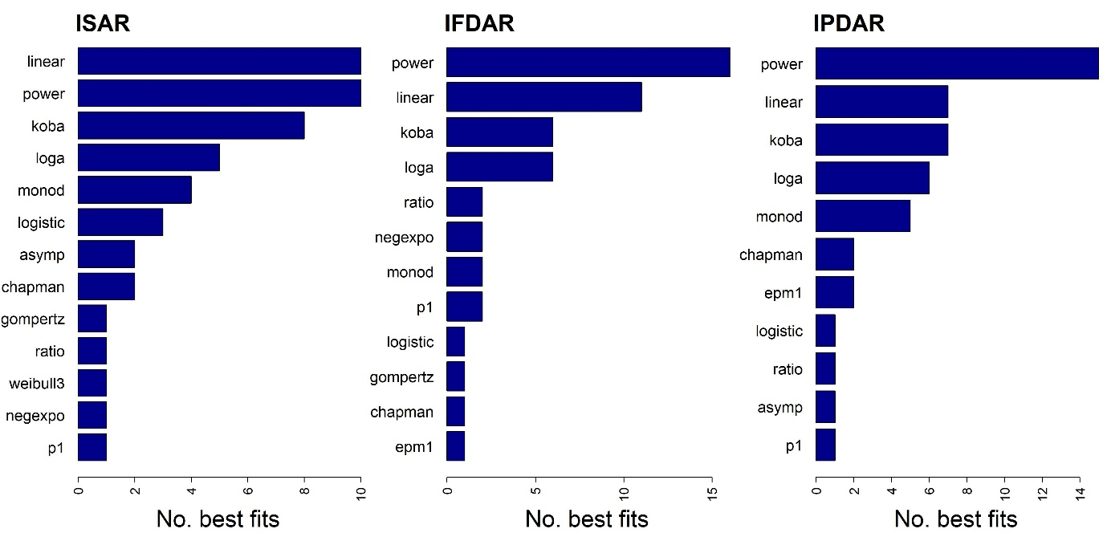
Figure S29. Same as Figure S2 in the main paper, but after removing model fits that did not pass the residual assumptions tests. Residual checks were only undertaken for the non-linear models and thus the ES–area relationships are now shown. See legend of Figure S2 for information.

Appendix S7 Results Using Trait Values from a Single Imputation

Some authors have argued that, when imputing gaps in trait data, it is not appropriate to average across imputation runs. Thus, we re-ran the analyses but for the extinct species, instead of averaging imputed trait values across the ten imputation runs, we randomly chose one of the ten runs to use. In addition, we also randomly selected one of the 3,000 Jetz et al. (2012) phylogenies and used this instead of our consensus tree, randomly grafting the extinct species follow the same approach as outlined in Appendix S2. Due to the computational resourced required to run the analyses, it was only possible to run this sensitivity test once.
The avifauna of most islands (86% for FD, and 79% for PD) exhibited random structure regarding FD.ES and PD.ES values, with a small proportion being characterised as significantly clustered (12% for FD, and 20% for PD). Very few island avifaunas were significantly overdispersed (2% and 2%, respectively). Mean ES values were -0.59 for FD and -0.90 for PD, indicating a slight tendency toward clustering. FD.ES and PD.ES significance results were equivalent for most islands, but there were notable exceptions; for example, 131 of the islands had significantly negative PD.ES values, but non-significant FD.ES values.
Across all datasets, the intercept-only model had the higher mean AIC_{c} weight, and provided the best fitting candidate model the most times, for both the FD.ES and PD.ES–area relationships (i.e., lowest AIC_{c} in 33 and 33 out of 51 datasets, respectively). Considering cases where the linear model provided the best fit, there were 10 positive and eight negative relationships for the FD.ES–area, and 13 and five respectively for the PD.ES–area relationship. The majority of significant linear cases were true island datasets, particularly in the case of PD.ES (11 and 13 cases for the FD.ES and PD.ES relationships, respectively). The median slope of the linear model across all datasets was 0.02 (0.04 and 0.02 for true and habitat island datasets, respectively) for the FD.ES–area and 0.25 (0.18 and 0.38) for the PD.ES–area relationship. Interestingly, when only focusing on the ten volcanic oceanic island datasets, the median linear slope values were higher: 0.36 and 0.72 for the FD.ES and PD.ES–area relationships, respectively.
The (paired) Wilcoxon signed-rank tests indicated that the differences between A and B were significant for the ISAR (P = 0.03), IFDAR (P = 0.03) and IPDAR (P = 0.04). The differences between B and C were also significant for all three IDAR types (P = 0.02, 0.03 and 0.03 for the ISAR, IFDAR and IPDAR, respectively), while the differences between A and C were non-significant. For the FD.ES–area and PD.ES–area relationship slopes, there were significant decreases in slopes between A and B (P = 0.02 and 0.04) and A and C (P = 0.05 and 0.01), but the differences between B and C were not significant (P > 0.05) (Fig. S31).
Comparing models for the prehistoric and current avifaunas (excluding introduced and marine species) for five datasets, the z-values decreased or remained relatively constant for the ISAR, IFDAR and IPDARs, with the exception of Hawaii, for which z-values increased (Fig. 8). For the FD.ES and PD.ES–area relationships, with three exceptions (Canaries and Marianas for FD.ES and New Zealand for PD.ES) the slope of the relationships decreased between the two time periods (Fig. S31).

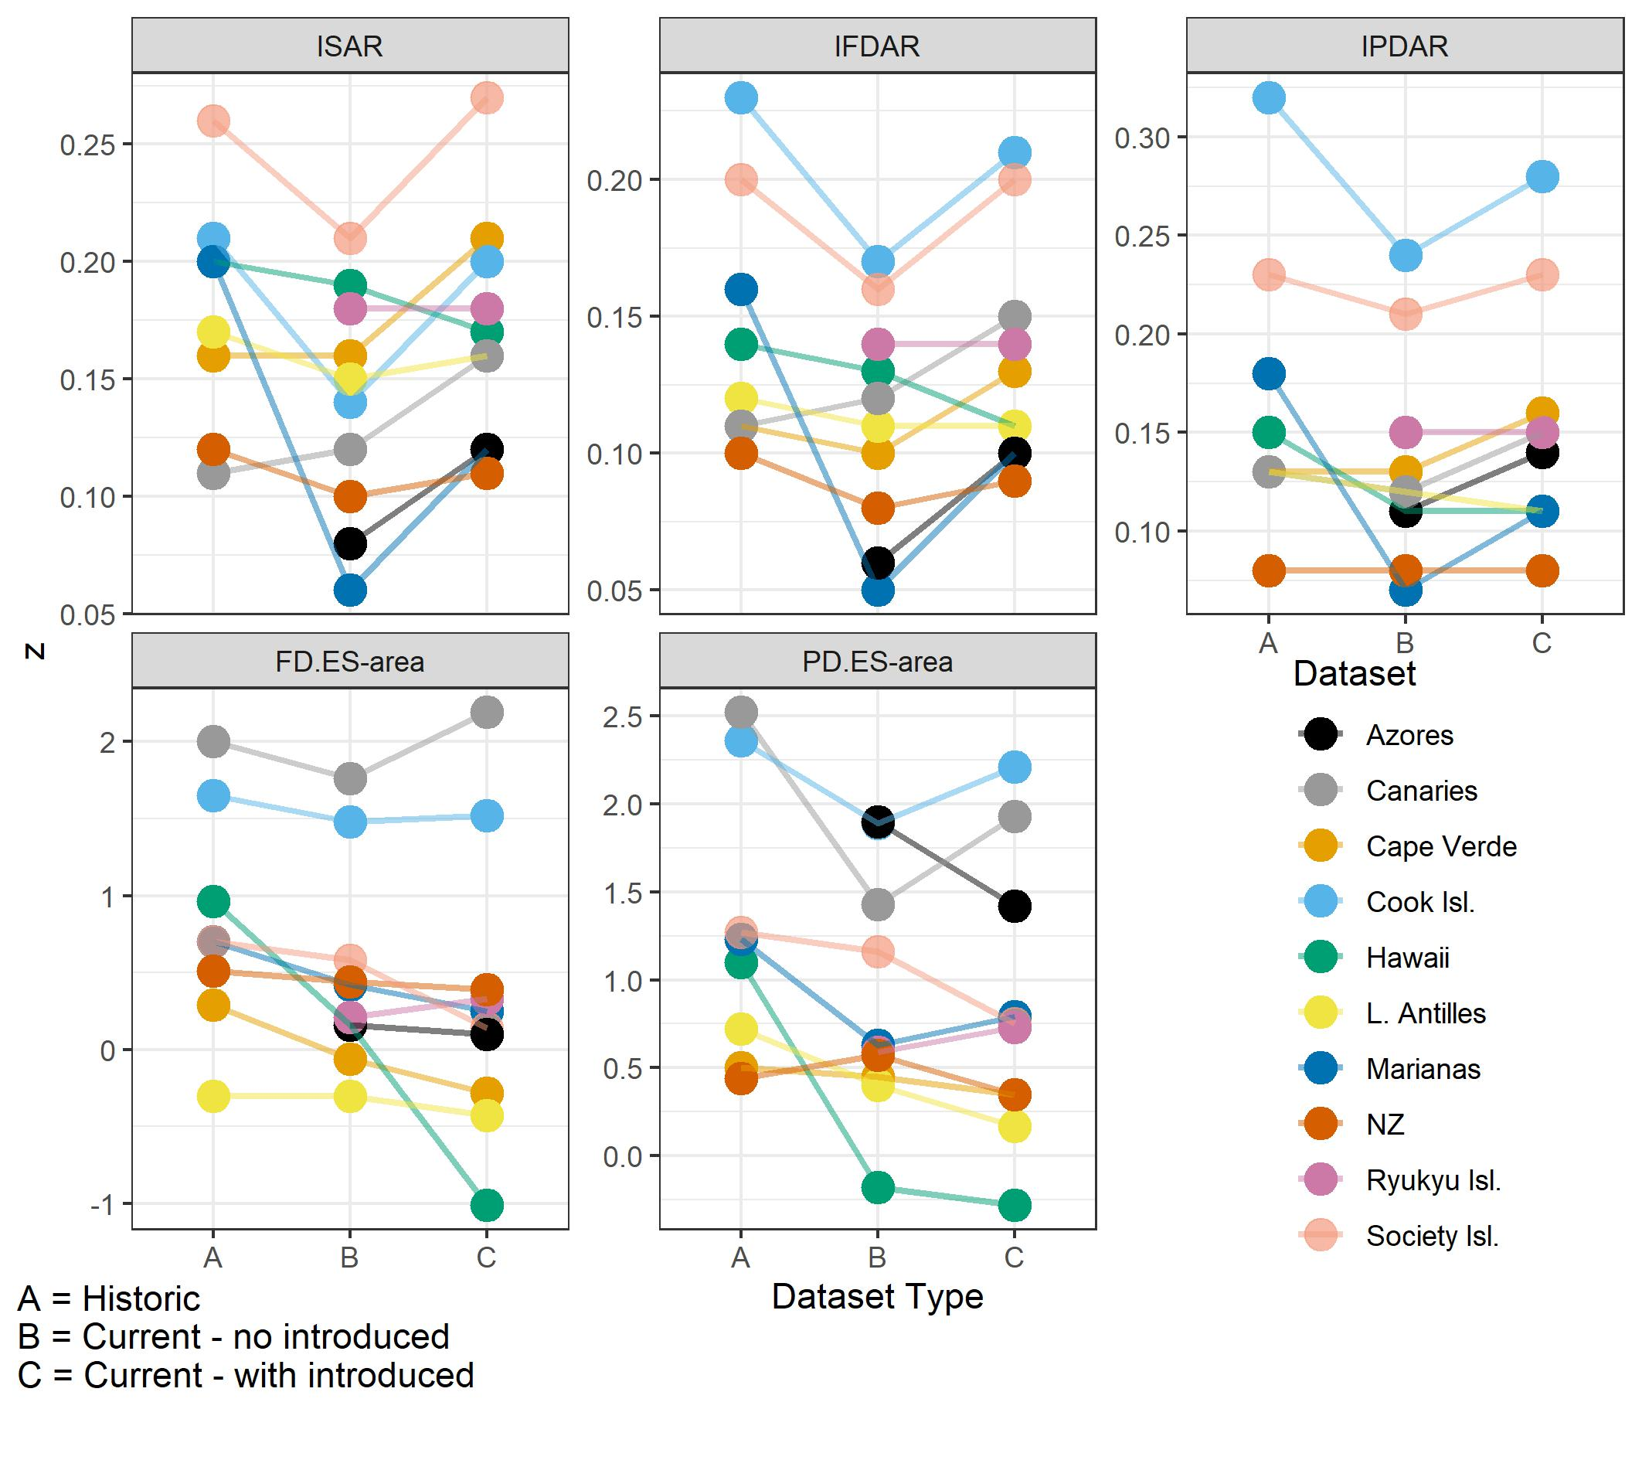
Figure S30. Same as Figure 7 in the main paper, but here using an individual trait imputation run (rather than averaging across 10 runs as in the main analysis) and a randomly selected BirdTree phylogeny (rather than the consensus tree).

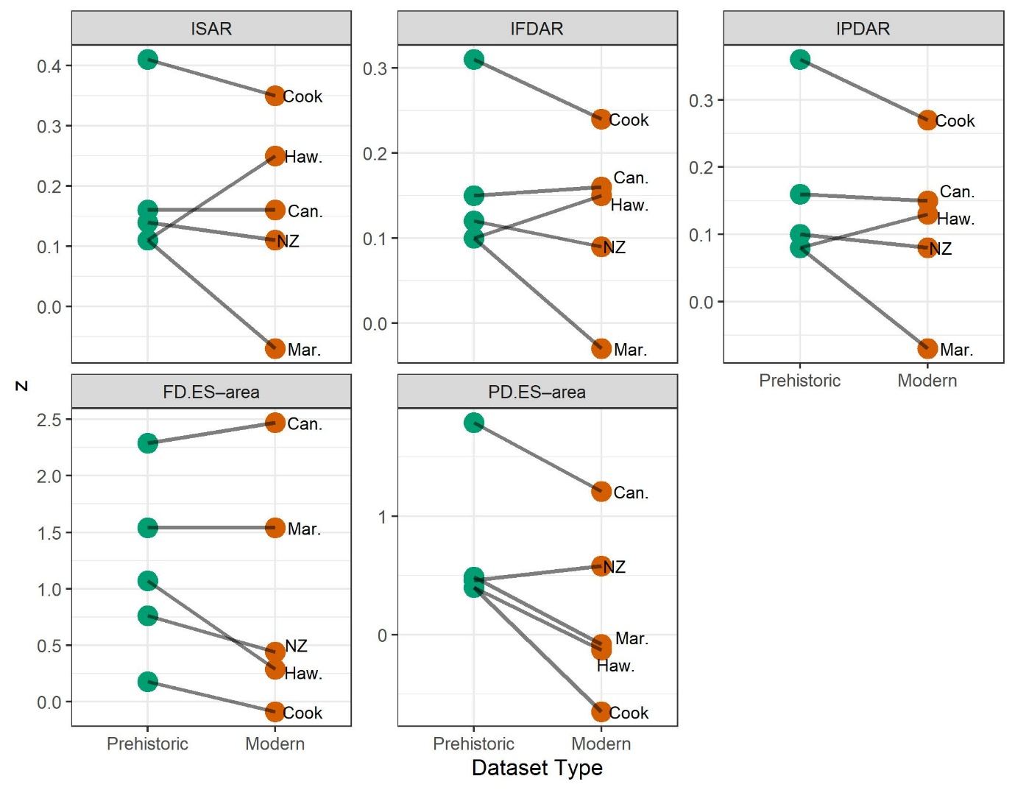

Figure S31. Same as Figure 8 in the main paper, but here using an individual trait imputation run (rather than averaging across 10 runs as in the main analysis) and a randomly selected BirdTree phylogeny (rather than the consensus tree).

