Supporting Information
Table of contents:
Figure S1: Representation of the maximum abundance of each taxon recorded during the monitoring program according to their persistence during the monitoring program (the number of sites and years, i.e, the number of observations, they are detected) in each habitat. The vertical line represents the threshold under which species were considered as LOLAS and upper which the species were considered as core species.
Figure S2: Proportion of species kept (core species) and removed (LOLAS) in each site of each habitat. Numbers in white give the total number of species kept or removed in each site over the 14 years. Numbers in black at the top of each bar give the total species richness in each site over the 14 years.
Supporting Information: Simulation procedure of the non-directional null model.
Figure S3: Representation of community trajectories without LOLAS on the first two PCoA axes with their directionality values associated for each site in the four habitats monitored from 2005 to 2018. One point represents the community state of a site at a given year (one observation). Site specific consecutive community states are linked by a segment and taken together depicts the site trajectory, the arrow represents the final community state of a trajectory (i.e., the community state of a given site in 2018 here).
Table S1: Mean and standard error (se) values of sites’ trajectory metrics in the subtidal biogenic habitat monitored from 2005 to 2018, with and without the site of Trévignon (20) and considering the community with and without LOLAS. dBDtot = the total dynamic Beta Diversity computed on the dissimilarity DSDSP between centered trajectories, length = the total path length of the trajectory, net change = the distance between the starting point and the final point of the trajectory, angle = the mean angle between two consecutive segments of the trajectory.
Figure S4: Percentage of relative abundances of the taxa (taxonomic level of the family) present at each year and each site of each habitat monitored. Others = all taxa under a relative abundance of 5%. NA = taxa whose family could not be identified.
Figure S5: Comparison of the distributions of total Beta Diversity (BDtotal) values and its two components in proportion: Replacement (Repl/BDtotal) and Richness Difference (RichDif/BDtotal) (Podani family – Ružička) (see Legendre and De Cáceres 2013, Legendre 2014), computed between each two consecutive years of each site in each habitat in the observed communities and the simulated ones.
Figure S6: Trajectory segment lengths of the communities observed in SBIO without Trévignon (20), monitored from 2005 to 2018.
Figure S7: Seasonal anomalies of environmental variables in the Intertidal bare habitat over the period of 2004–2018 (grey line: median value between all sites). Seasonal anomaly is computed as the difference between the mean value of the environmental variable measured during the season considered and the reference value of the environmental variable during this season (average value of the environmental variable during the season considered between 2004 and 2018). Daily air temperature (°C), total rainfall (mm) and windspeed (m/s) were extracted from the SIM2-SAFRAN model of METEO-FRANCE (8km resolution). The values of the cells included in 8km radius buffers around the points of each site were average to minimize edge effect. Values at the site level were estimated by averaging values of the three points of each site.
Figure S8: (a) Evolution of the species richness of each site (one yellow point) of the Intertidal bare habitat from 2005 to 2018 (red points: mean values between all sites). (b) Evolution of the total Beta Diversity (BDtotal) values and its two components: Replacement (Repl) and Richness Difference (RichDif) (Podani family – Ružička) (see Legendre and De Cáceres 2013, Legendre 2014) computed between each two consecutive years of each site in the Intertidal bare habitat (here the mean values between all sites are represented).
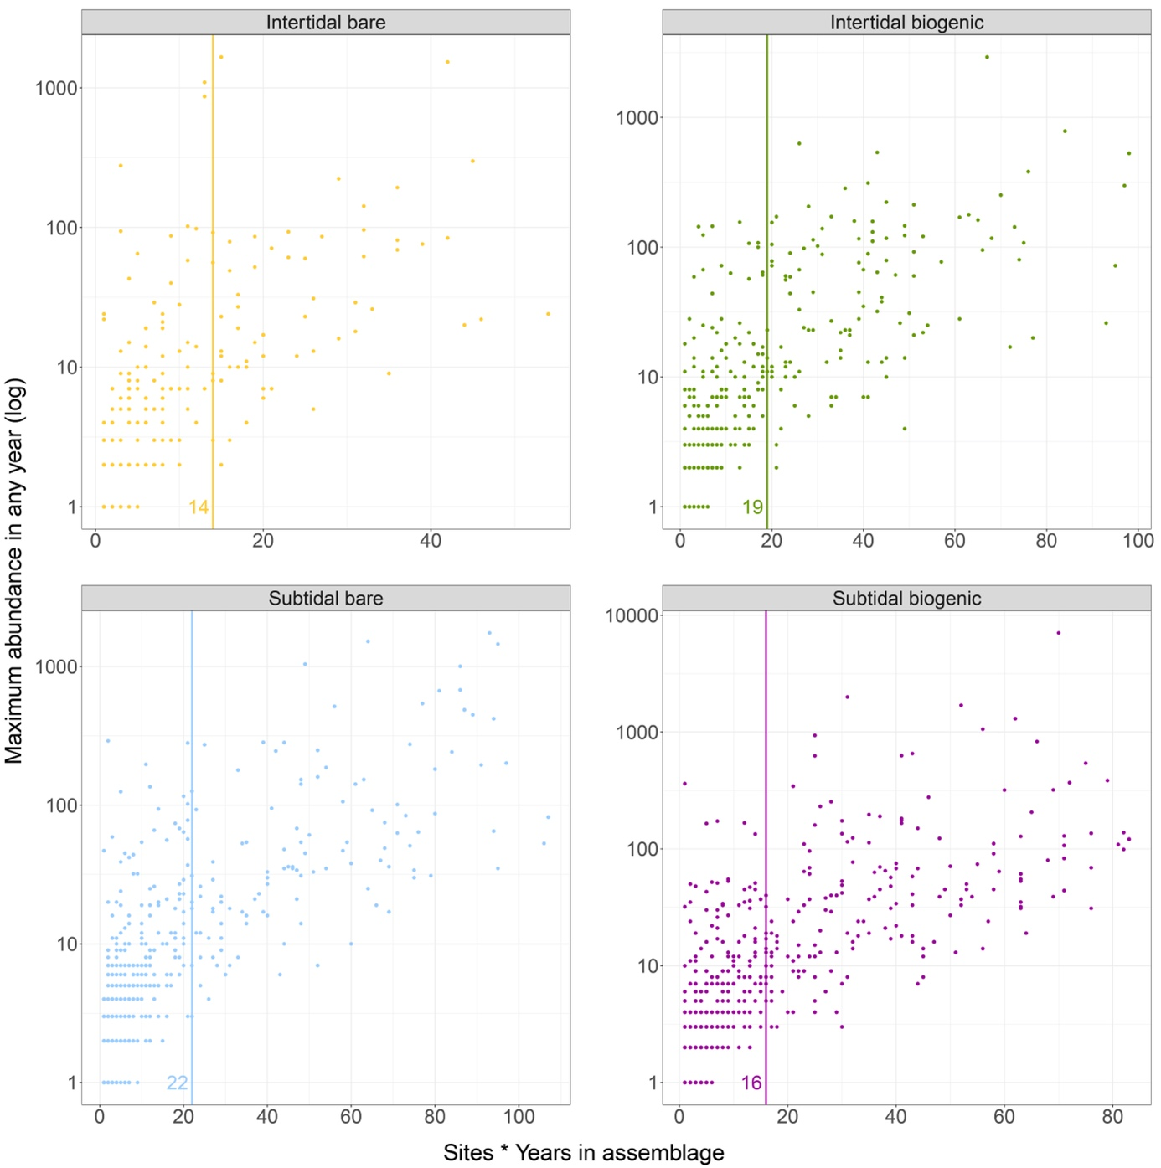
Figure S1: Representation of the maximum abundance of each taxon recorded during the monitoring program according to their persistence during the monitoring program (the number of sites and years, i.e, the number of observations, they are detected) in each habitat. The vertical line represents the threshold under which species were considered as LOLAS and upper which the species were considered as core species.
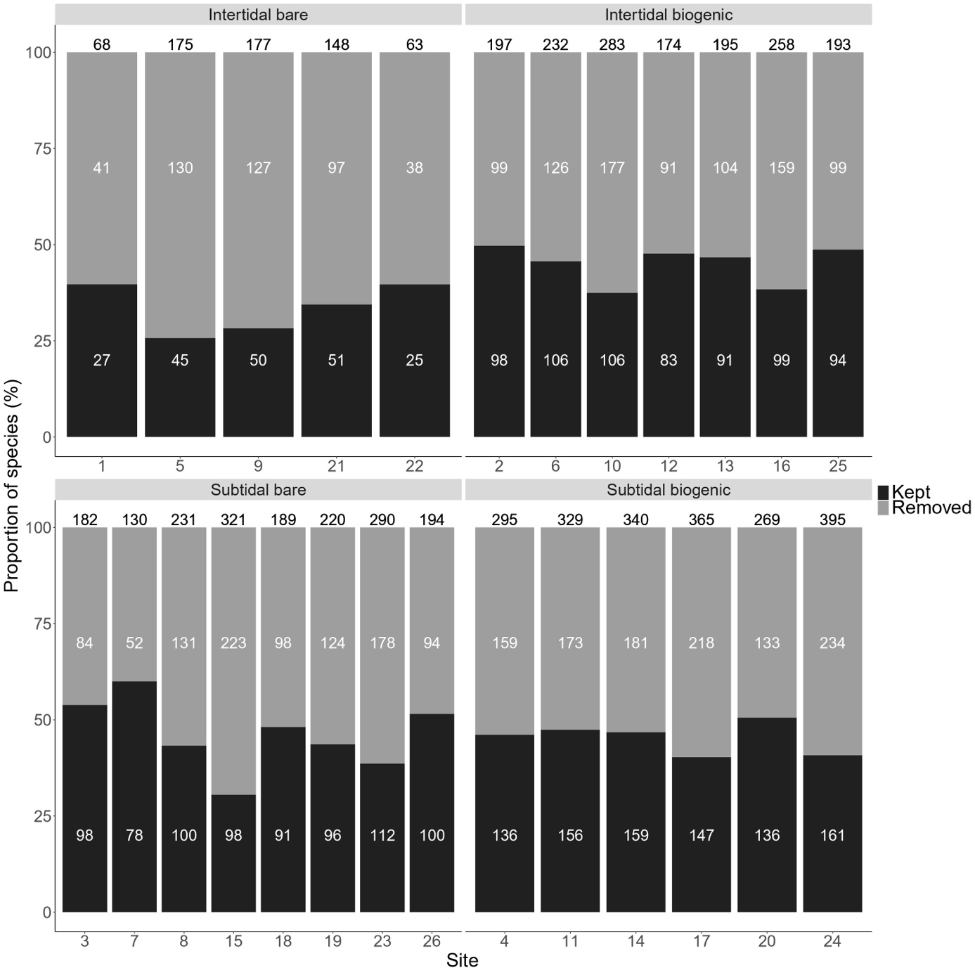
Figure S2: Proportion of species kept (core species) and removed (LOLAS) in each site of each habitat. Numbers in white give the total number of species kept or removed in each site over the 14 years. Numbers in black at the top of each bar give the total species richness in each site over the 14 years.
Supporting Information: Simulation procedure of the non-directional null model.
For each habitat, steps of the simulation were as follows:
- At $t=0$, the community is generated by sampling $n_{0}$ species from the species pool with their occurrence frequency as weights, where $n$ is a number of species sampled from the empirical distribution of observed values of species richness.
- For each species of the generated community, a value of abundance is sampled from the empirical distribution of observed abundances of the corresponding species.
- The abundances are then rescaled to match a value of total abundance also sampled from the empirical distribution of total observed abundances, keeping relative abundances constant.
- For each following time step, a new value $n_{t}$ of species richness is sampled with the following constraints:
  - Limiting species loss: the new species richness $n_{t}$ should not have a value $n_{t}<n_{t-1}×\left(1-extinction rate\right)$to maintain the fixed extinction rate.
  - Limiting species gain: $n_{t}-n_{t-1}$ should not have a value greater than the maximum difference of species richness observed at any site between two consecutive years in the habitat.
- If $n_{t}<n_{t-1}$, a proportion of species equal to the value of the set extinction rate is removed from the community present at $t-1$. The lower the abundance of species the more likely they are to be removed.
- If $n_{t}>n_{t-1}$, a proportion of species equal to the value of the set extinction rate is removed from the community present at $t-1$. The lower the abundance of species the more likely they are to be removed. Species from the species pool are sampled (with their frequency of occurrence as weights) until the value $n_{t}$ is reached. Only species that have not been removed between $t$ and $t-1$ and species that are not already in the community can be sampled from the species pool and added to the community.
- The abundances of each species are then sampled and rescaled as in steps 2 and 3.
We generated 15 years of community dynamics 100 times (i.e., in 100 virtual sites) for each habitat. The communities at t=0 were removed because the initial set of species is not generated in the exact same way as the communities in the other time steps. CTA metrics were then computed on the trajectories of the simulated communities with a 14 years dynamic to have the same number of surveys as the observed communities.
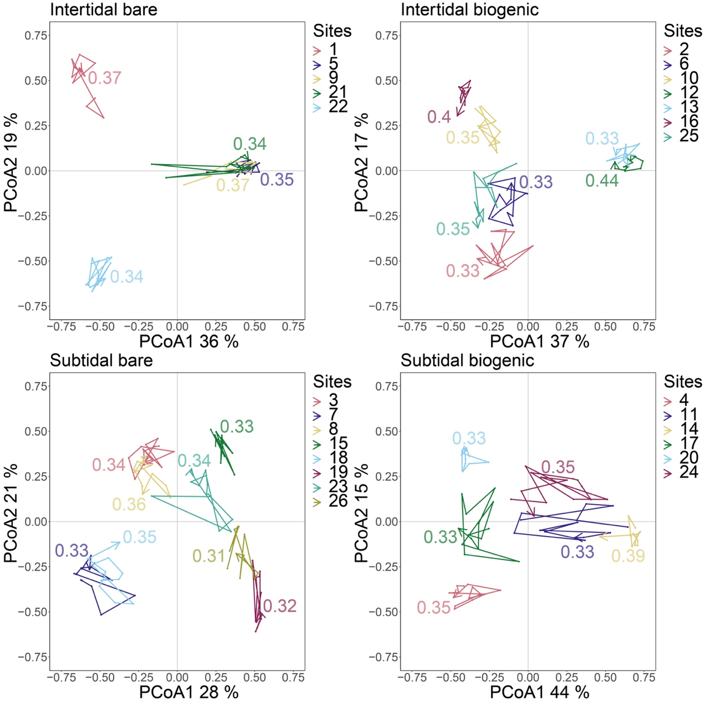
Figure S3: Representation of community trajectories without LOLAS on the first two PCoA axes with their directionality values associated for each site in the four habitats monitored from 2005 to 2018. One point represents the community state of a site at a given year (one observation). Site specific consecutive community states are linked by a segment and taken together depicts the site trajectory, the arrow represents the final community state of a trajectory (i.e., the community state of a given site in 2018 here).
Table S1: Mean and standard error (se) values of sites’ trajectory metrics in the subtidal biogenic habitat monitored from 2005 to 2018, with and without the site of Trevignon (20) and considering the community with and without LOLAS. dBDtot = the total dynamic Beta Diversity computed on the dissimilarity D_{SDSP} between centered trajectories, length = the total path length of the trajectory, net change = the distance between the starting point and the final point of the trajectory, angle = the mean angle between two consecutive segments of the trajectory.
 | Global community |  |  |  | Without LOLAS
Habitat | dBD_{tot} | Mean length ± se | Mean angle ± se | Mean net ± se | dBD_{tot} | Mean length ± se | Mean angle ± se | Mean net ± se
Subtidal biogenic | 0.19 | 8.31±0.91 | 117.23±1.35 | 0.74±0.07 | 0.10 | 6.22±0.6 | 118.3±1.88 | 0.58±0.07
Subtidal biogenic without Trevignon (20) | 0.22 | 9.17±0.38 | 116.98±1.42 | 0.8±0.03 | 0.10 | 6.36±0.71 | 117.87±2.15 | 0.62±0.07

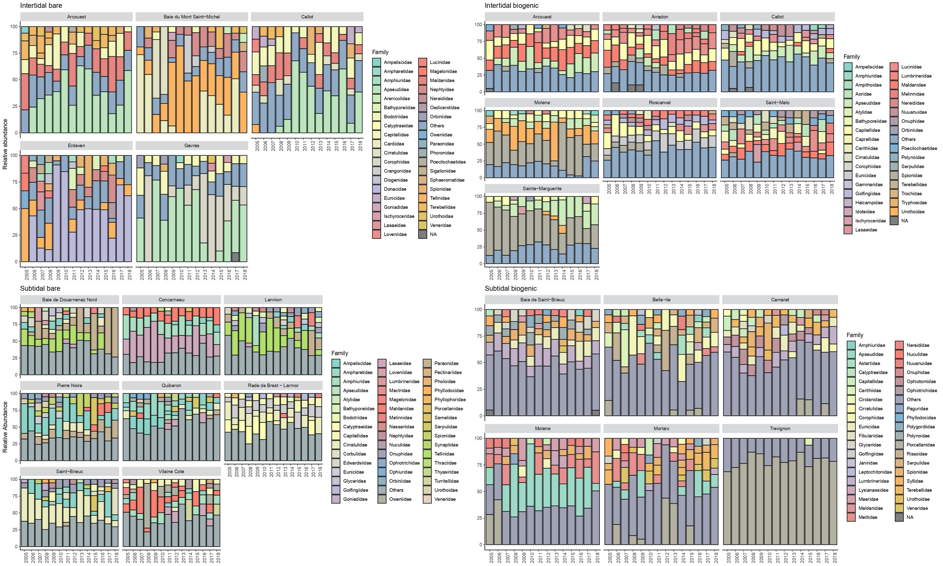
Figure S4: Percentage of relative abundances of the taxa (taxonomic level of the family) present at each year and each site of each habitat monitored. Others = all taxa under a relative abundance of 5%. NA = taxa whose family could not be identified.

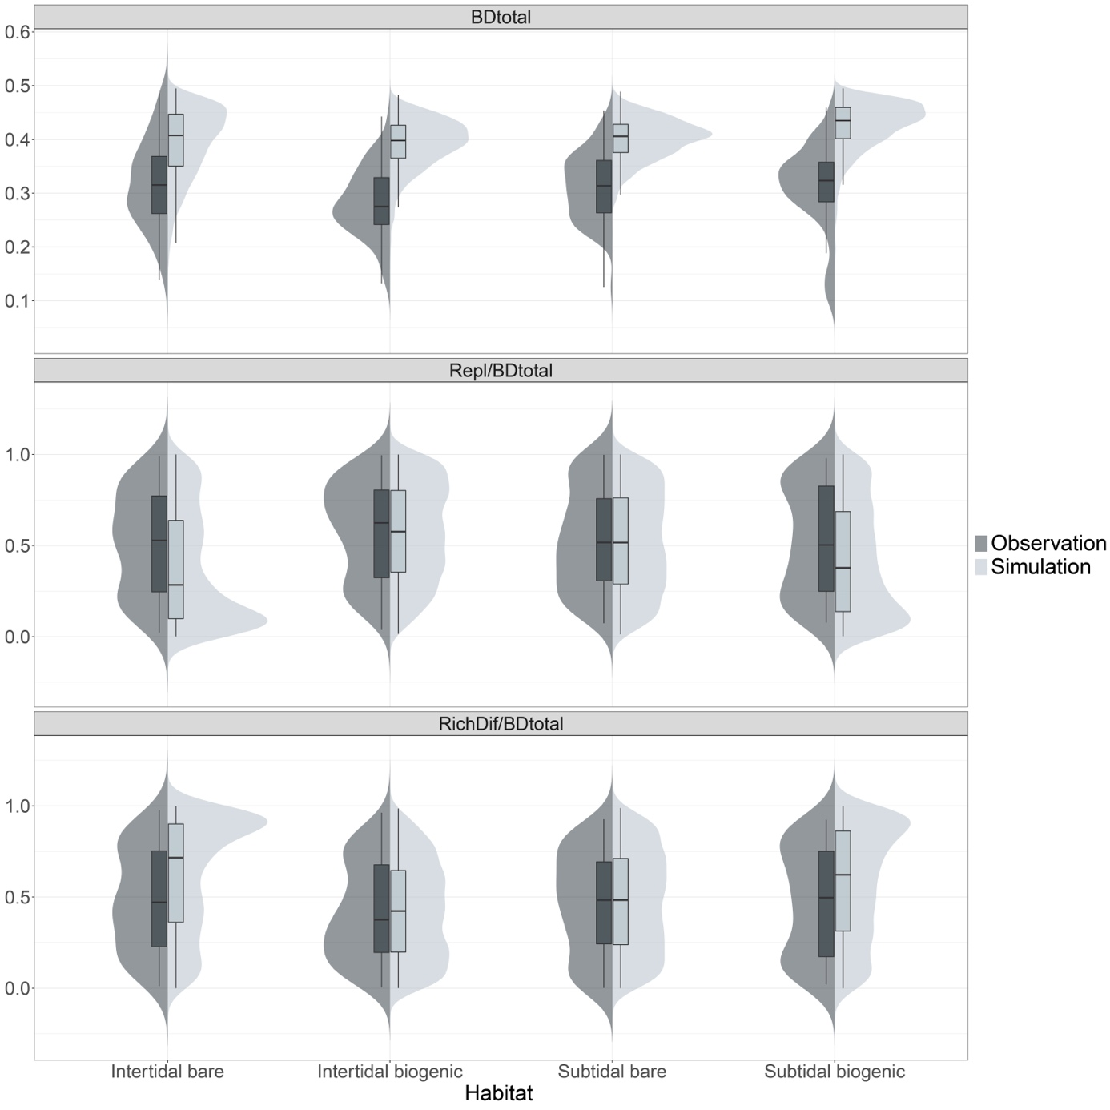
Figure S5: Comparison of the distributions of total Beta Diversity (BDtotal) values and its two components in proportion: Replacement (Repl/BDtotal) and Richness Difference (RichDif/BDtotal) (Podani family – Ružička) (see Legendre and De Cáceres 2013, Legendre 2014), computed between each two consecutive years of each site in each habitat in the observed communities and the simulated ones.
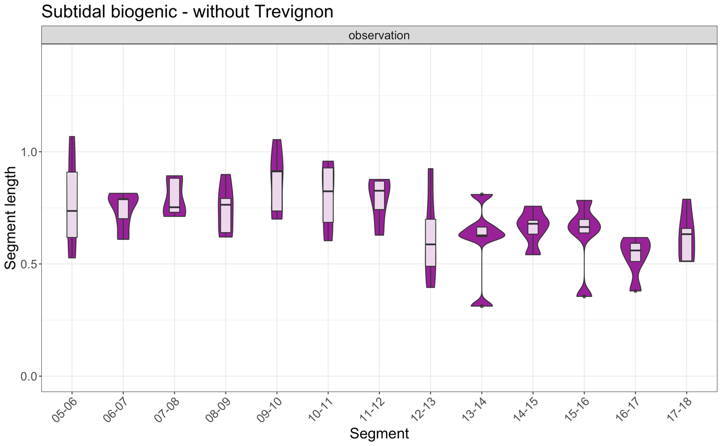
Figure S6: Trajectory segment lengths of the communities observed in SBIO without Trévignon (20), monitored from 2005 to 2018.

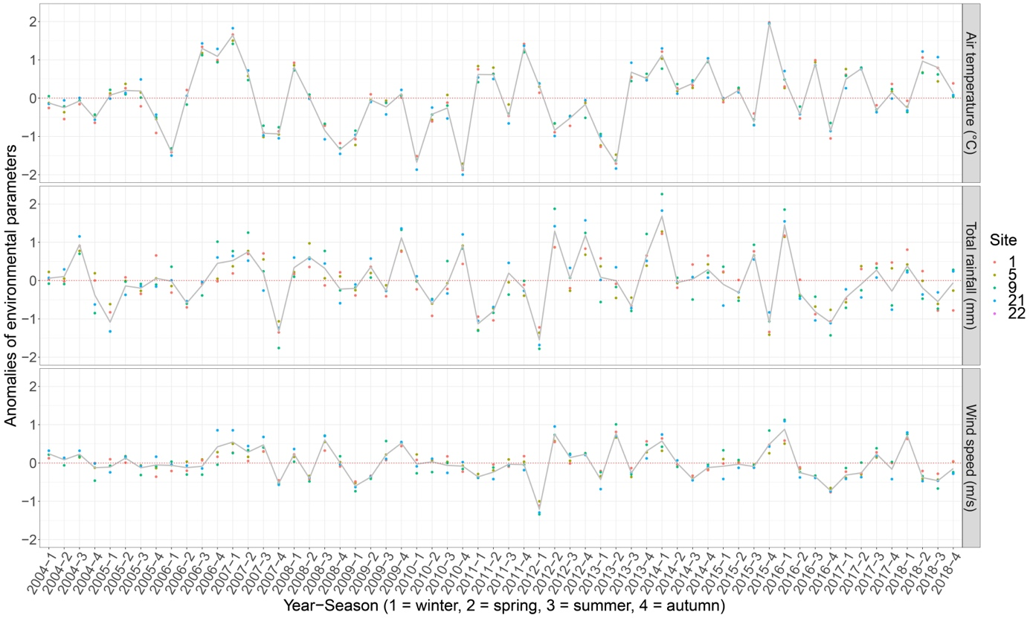
Figure S7: Seasonal anomalies of environmental variables in the Intertidal bare habitat over the period of 2004–2018 (grey line: median value between all sites). Seasonal anomaly is computed as the difference between the mean value of the environmental variable measured during the season considered and the reference value of the environmental variable during this season (average value of the environmental variable during the season considered between 2004 and 2018). Daily air temperature (°C), total rainfall (mm) and windspeed (m/s) were extracted from the SIM2-SAFRAN model of METEO-FRANCE (8km resolution). The values of the cells included in 8km radius buffers around the points of each site were average to minimize edge effect. Values at the site level were estimated by averaging values of the three points of each site.
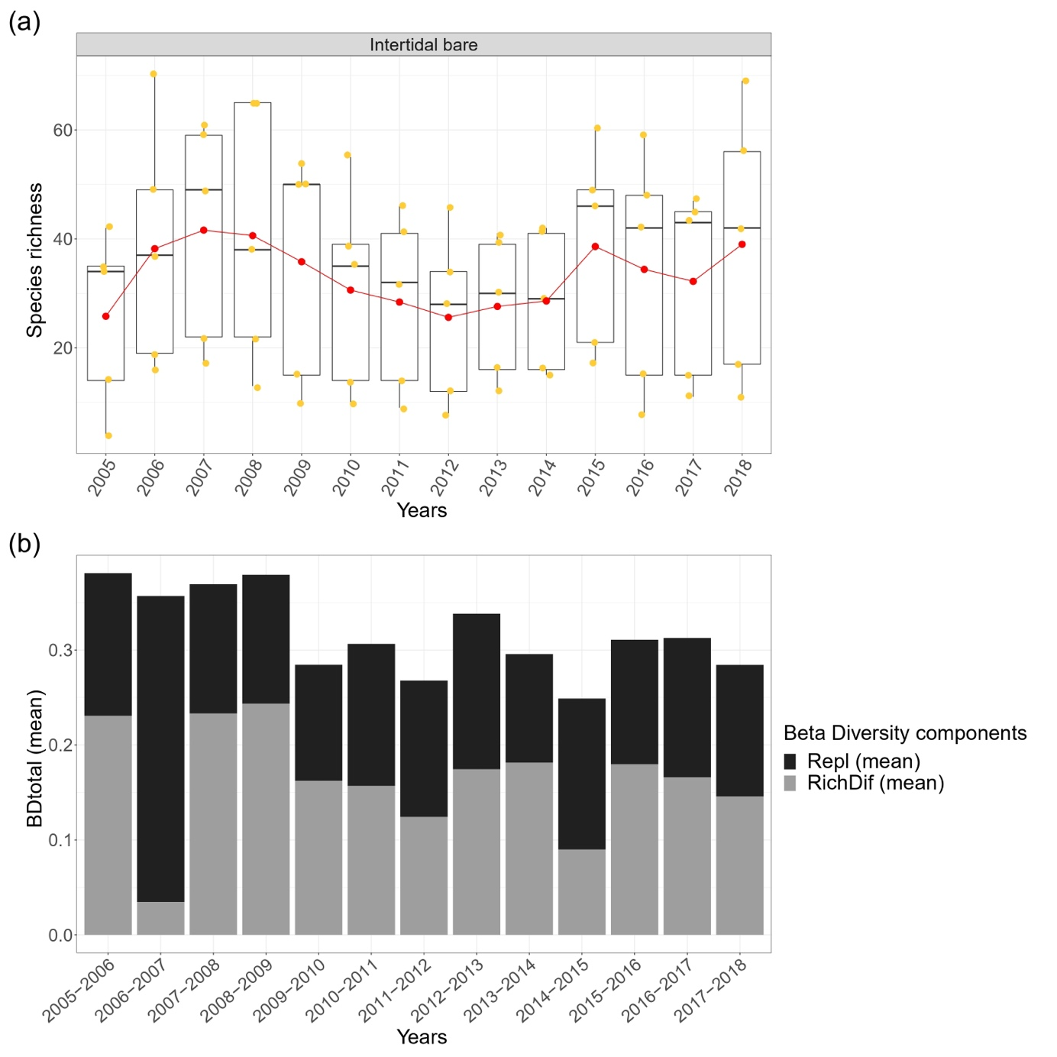
Figure S8: (a) Evolution of the species richness of each site (one yellow point) of the Intertidal bare habitat from 2005 to 2018 (red points: mean values between all sites). (b) Evolution of the total Beta Diversity (BDtotal) values and its two components: Replacement (Repl) and Richness Difference (RichDif) (Podani family – Ružička) (see Legendre and De Cáceres 2013, Legendre 2014) computed between each two consecutive years of each site in the Intertidal bare habitat (here the mean values between all sites are represented).
References:
Legendre, P. 2014. Interpreting the replacement and richness difference components of beta diversity: Replacement and richness difference components. - Glob. Ecol. Biogeogr. 23: 1324–1334.
Legendre, P. and De Cáceres, M. 2013. Beta diversity as the variance of community data: dissimilarity coefficients and partitioning (H Morlon, Ed.). - Ecol. Lett. 16: 951–963.

