Supplementary information
Adding to the mix – challenges of management of the mixed fisheries in the North Sea under climate change and technical interactions

Supplement T1
The North Sea FLBEIA model includes assumptions about future catchability, effort, capacity and quota shares. Future catchabilities were based on historic data and kept constant as last year values for the simulations. The effort model mainly determines how fleets derive to their catch, by simulating the tactical behaviour of the fleets in each time step related to the stock abundance, management restrictions and effort-shares among metiers. The effort per fleet and effort share among its métiers determined at each time step is based on the FLBEIA-internal ‘simple mixed fisheries behaviour’ (SMFB), taking a fixed effort share per métier as input and calculating realised effort based on stock abundance and management restrictions (‘min’ fleet control for landing obligation scenarios, ‘fixed’ for status-quo effort). A detailed description of this model can be found in the Technical manual for FLBEIA (García et al., 2017).
Briefly, the effort of each fleet is restricted by the quotas for a list of restrictive stocks (COD-NS, HAD, POK, WHG-NS, PLE-NS, PLE-EC, SOL-NS, TUR, WIT). The effort to catch the given quota for a stock is calculated via the Cobb-Douglas production function, dependent if the stock is age-based or biomass-based. The fleet control determines how an overall effort for a fleet is calculated, given the individual efforts for each of its stocks caught. In the scenario with a landing obligation, a “min” fleet control was used, that limits the effort to the minimum among possible efforts and to stay below/equal to the capacity for this fleet. Subsequently the catch is calculated with the derived effort level and compared to the quotas for each of the stocks. This process is reiterated until the derived effort level matches the quota restrictions as close as possible. Any deviations between actual catch and quota for a given season is proportionally added/removed to the shares of remaining seasons under the constraint that the annual quota shares remain the same (not relevant for our model, since we do only consider annual quotas).
As capital model, we assumed ‘fixed capital’ where future capacity is unchanged during the simulation. Quota shares among countries down to métier in the model is set to the average catches of the last three historical data years, reflecting a situation where quota swapping already has taken place as this was not explicitly modelled in the North Sea FLBEIA model.
The cost model does not affect fleet behaviour, but simply upscales/downscales variable costs based on the costs per unit of effort, crew share per unit of landings and capital costs per unit of capital. Fixed costs are taken from the input data and corrected for inflation as described in the main text.

Supplement T2
To split the related costs in the FLBEIA model into fixed costs, variable costs and crew share the following STECF data categories were used:
Fixed costs – Calculated as the sum of "Consumption of fixed capital" and "Other non-variable costs". "Consumption of fixed capital" was referred to as "Annual depreciation costs" in previous versions of the STECF data. These costs are defined at the fleet level in the FLBEIA model, and are constant over time (i.e. we do not assume any changes in the fleet size).
Variable costs – Calculated as the sum of "Fuel costs", "Value of unpaid labour", "Repair and maintenance costs" and "Other variable costs". These costs are defined at the métier level in the FLBEIA model, and are a function of changes in fleet effort over time multiplied by the effort share of a given métier. Fuel costs are of particular interest in the future scenarios and were examined for their consistency to particular fishing operations. A large degree of variability is observed, which is seen to be in part determined by the type of fishing operation, e.g. use of active vs. passive gears (Fig. S2). Further variability is likely due to vessel size, and thus efficiency.
Crew share costs – A large part of salaries paid to fishers is in the form of a proportion of the landings value. These rates are not provided within the STECF data, but were assumed to make up the bulk of the "Personnel costs" category, which is technically defined as the "Total remuneration, in cash or in kind, payable by an employer to an employee (regular and temporary employees as well as home-workers)". Thus, the crew share was calculated as the ratio of Personnel costs / landings value, which was quite stable over time among fleets and lends support for this assumption (Fig. S3). Furthermore, these crew shares were roughly on the scale often reported (Guillen et al., 2017) (Fig. S3). Crew share costs are defined at the fleet level in the FLBEIA model and are a function of the changes in landings value (i.e. revenue).

Revenue and scaling of costs in FLBEIA
Revenue by fleet is based on the total landings value, which is provided at the fleet/métier level for each stock, but does not differentiate prices for different sizes/ages (i.e. €/kg) of the landings. Fish prices for 2018 were taken directly from the WGMIXFISH data call (ICES, 2019). Using the ratios fixed costs / revenue and variable costs / revenue derived from the STECF data, the fixed and variable cost of the FLBEIA fleets and métiers could be estimated based on their revenue. The last data year (2018) thus represents these STECF cost / revenue ratios exactly, but will change during the forecasts to reflect changes in catches and fishing effort.

Fleet definitions in FLBEIA
Table S1: Fleet names and corresponding fleet codes used by the ICES WGMIXFISH group in the North Sea FLBEIA model, with information on country, main gear applied and vessel length class (a ‘+’ indicates that vessel sizes equal and larger than the specified size are involved in the aggregation).
Fleet name | WGMIXFISH Fleet code | Country | Main Gear | Vessel length [m]
BE Beam trawls >= 24m | BE_Beam>=24 | Belgium | Beam trawls | 24+
BE Beam trawls < 24m | BE_Beam<24 | Belgium | Beam trawls | <24
BE Danish-Seines | BE_DSeine | Belgium | Danish Seine | 10-40
BE Otter trawls | BE_Otter | Belgium | Otter Trawls | 10-40
BE Static gears | BE_Static | Belgium | Static Gear | 10-24
DK small-scale trawlers | DK_<10towed | Denmark | Otter Trawls | <10
DK Beam trawls | DK_Beam | Denmark | Beam trawls | 10-40+
DK Otter trawls >= 24m | DK_Otter>=24 | Denmark | Otter Trawls | 24+
DK Otter trawls < 24m | DK_Otter<24 | Denmark | Otter Trawls | <24
DK Seines fleet | DK_Seine | Denmark | Seine | 10-40
DK Static gears | DK_Static | Denmark | Static Gear | <10-40
EN small-scale fleet | EN_<10 | England | Otter Trawls | <10
EN Beam trawls | EN_Beam | England | Beam trawls | 10-40+
EN fully-documented trawl/seine fleet | EN_FDF | England | Otter Trawls | Various*
EN Otter trawls >= 40m | EN_Otter>=40 | England | Otter Trawls | 40+
EN Otter trawls < 24m | EN_Otter<24 | England | Otter Trawls | <24
EN Otter trawls 24-40m | EN_Otter24-40 | England | Otter Trawls | 24-40
EN Static gears | EN_Static | England | Static Gear | Various*
FR small-scale fleet | FR_<10 | France | Otter Trawls | <10
FR Beam trawls | FR_Beam | France | Beam trawls | 10-40+
FR Netters | FR_Nets | France | Nets | 10-40
FR with other gears | FR_OTH | France | Other | 10-40+
FR Otter trawls >= 40m | FR_Otter>=40 | France | Otter Trawls | 40+
FR Otter trawls 10-40m | FR_Otter10-40 | France | Otter Trawls | 10-40
GE Beam trawls >= 24m | GE_Beam>=24 | Germany | Beam trawls | 24+
GE Beam trawls < 24m | GE_Beam<24 | Germany | Beam trawls | <24
GE Otter trawls >= 40m | GE_Otter>=40 | Germany | Otter Trawls | 40+
GE Otter trawls < 24m | GE_Otter<24 | Germany | Otter Trawls | <24
GE Otter trawls 24-40m | GE_Otter24-40 | Germany | Otter Trawls | 24-40
GE Static gears | GE_Static | Germany | Static Gear | <10-40
NL Beam trawls >= 40m | NL_Beam>=40 | Netherlands | Beam trawls | 40+
NL Beam trawls < 24m | NL_Beam<24 | Netherlands | Beam trawls | <24
NL Beam trawls 24-40 m | NL_Beam24-40 | Netherlands | Beam trawls | 24-40
NL Otter trawls | NL_Otter | Netherlands | Otter Trawls | 10-40+
NL Pelagic trawls | NL_Pelagic | Netherlands | Pelagic Gears | 10-40+
Other fleetª | OTH_OTH | Other | Other | Various*
SC Otter trawls >= 24m | SC_Otter>=24 | Scottland | Otter Trawls | 24+
SC Otter trawls < 10m | SC_Otter<10 | Scottland | Otter Trawls | <10
SC Otter trawls < 24m | SC_Otter<24 | Scottland | Otter Trawls | <24
SC Static gears | SC_Static | Scottland | Static Gear | Various*
SW Otter trawls | SW_Otter | Sweden | Otter Trawls | <10-40
SW Static gears | SW_Static | Sweden | Static Gear | Various*
*’Various’ refers to size classes, with no additional vessel length information other than “all” or “fdf” (fully documented fishery) in the original Intercatch data, or where various size classes have been lumped together as in the case of the ‘Other fleet’. ª The ‘Other fleet’ is an aggregation of vessels mostly lacking WGMIXFISH accession data, like Norway, but also other smaller métiers of less importance for the North Sea demersal mixed fisheries.

Fitting EMSRRs for the main gadoid stocks (Cod, Whiting, Saithe)
Table S2: Stocks and environmental datasets (Env. variables derived from which datasets) considered in the stock recruitment model fitting procedure indicating which historical years informed the model fitting (Years considered), the recruitment age for the stock (Rec. age), the lag used for the environmental time series relative to the recruitment year (Lags considered), the Seasons over which the environmental time series were averaged (DJF – December, January, February; MAM – Marc, April, May; JJA – June, July, August; SON – September, October, November; yrs – yearly average) and the total number of variables that were passed to the feature selection algorithm
Stock | Years considered | Rec. age | Env. variables derived from which datasets | Lags considered | Seasons | Total No. of variables passed to the feature selection
Cod | 1964-2017  (n = 54) | 1 | AHOI-SST,  AHOI-Salinity, ORAS4-Currents | 0 (only DJF),1,  2 (only SON) | DJF, MAM, JJA, SON, yrs | 69
Saithe | 1978-2017  (n = 40) | 3 | AHOI-SST,  AHOI-Salinity, ORAS5-Currents | 2-3 | DJF, MAM, JJA, SON | 87
Whiting | 1979 – 2017  (n = 39) | 1 | AHOI-SST,  AHOI-Salinity, ORAS5-Currents | 0-1 | DJF, MAM, JJA, SON | 87

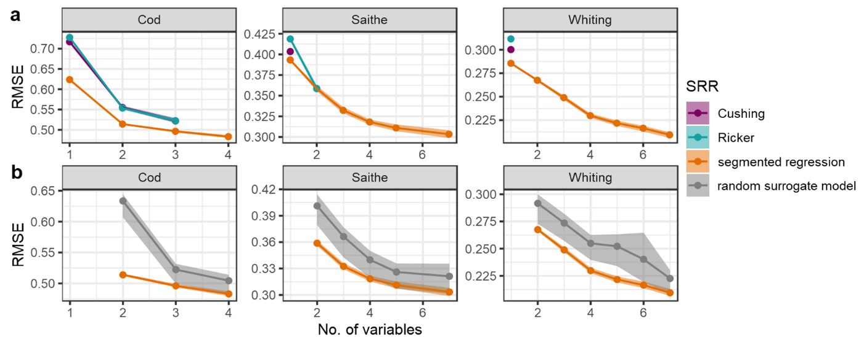
Figure S1: a) Comparison of the Pareto Fronts for the Stock recruitment relationship (SRR): Cushing (purple), Ricker (turquoise) and segmented Regression (orange) showing the fitness metric on the y-axis (log-transformed RMSE) and the number of Variables on the x-axis for Cod, Saithe and Whiting; b) Criterion to choose a final model from the Pareto front: the performance (y-axis) of a solution with a certain complexity (x-axis) depicted for the models within the Pareto front (median (orange dots) and 95% confidence bands (orange shading)) and a comparison model, where the last added covariate(s) was exchanged with random noise (median (gray dots) and 95% confidence bands (gray shading)); the final model is the one, with the highest median performance and the fewest number of variables that does not overlap with the 95%-confidence bands of the random surrogate model aka the 3-variable solution for Cod, the 4-variable solution for Saithe, and the 6-variable solution for Whiting (all including SSB).
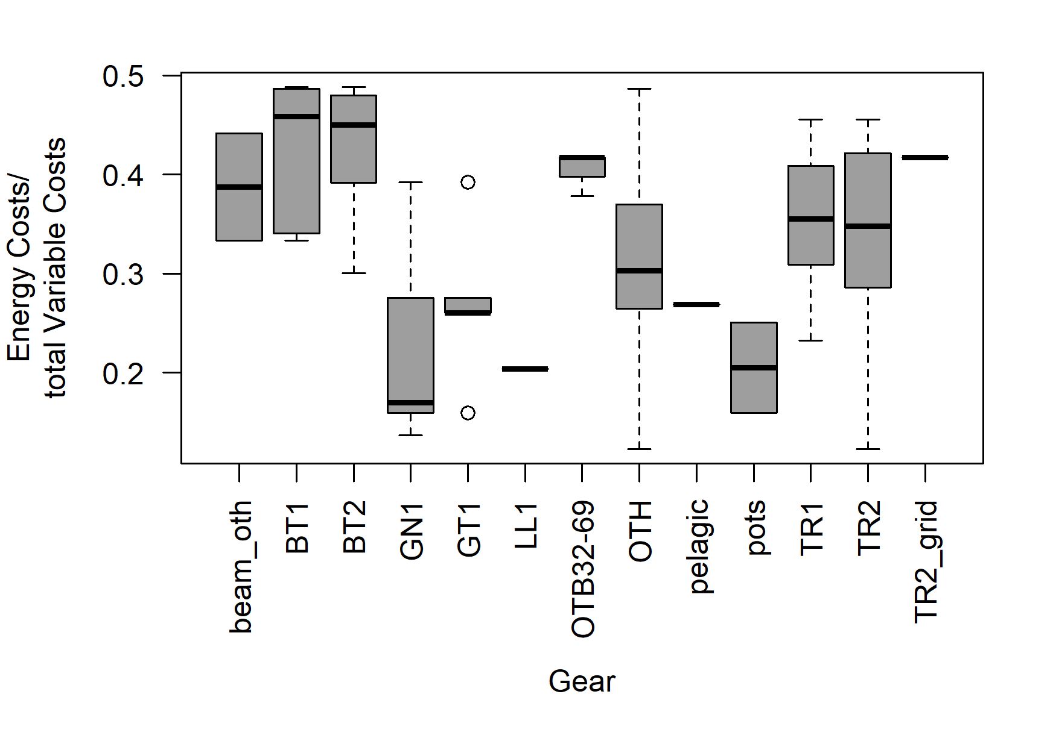
Figure S2: Distribution of energy costs ratios, as a fraction of total variable costs, by fishing gear (BT1 – Beam trawl ≥ 120 mm mesh size, BT2 – Beam trawl between ≥ 80 – 120 mm mesh size, beam_oth – Other Beam trawls (not BT1 or BT2), GN1 – Gillnets, GT1 - Trammel nets, LL1 – Longlines, OTB32-69 – Bottom otter trawl between 32 and 69 mesh size, OTH – any gear, pelagic – pelagic gears type, Pots – Pots, TR1 – Otter trawl or demersal seine ≥ 100 mm mesh size, TR2 – Otter trawl and demersal seine between ≥ 70 - 100 mm mesh size). Passive gears (e.g. gillnets – GN1, longlines – LL1, traps – pots) are associated with lower energy usage, and thus costs.
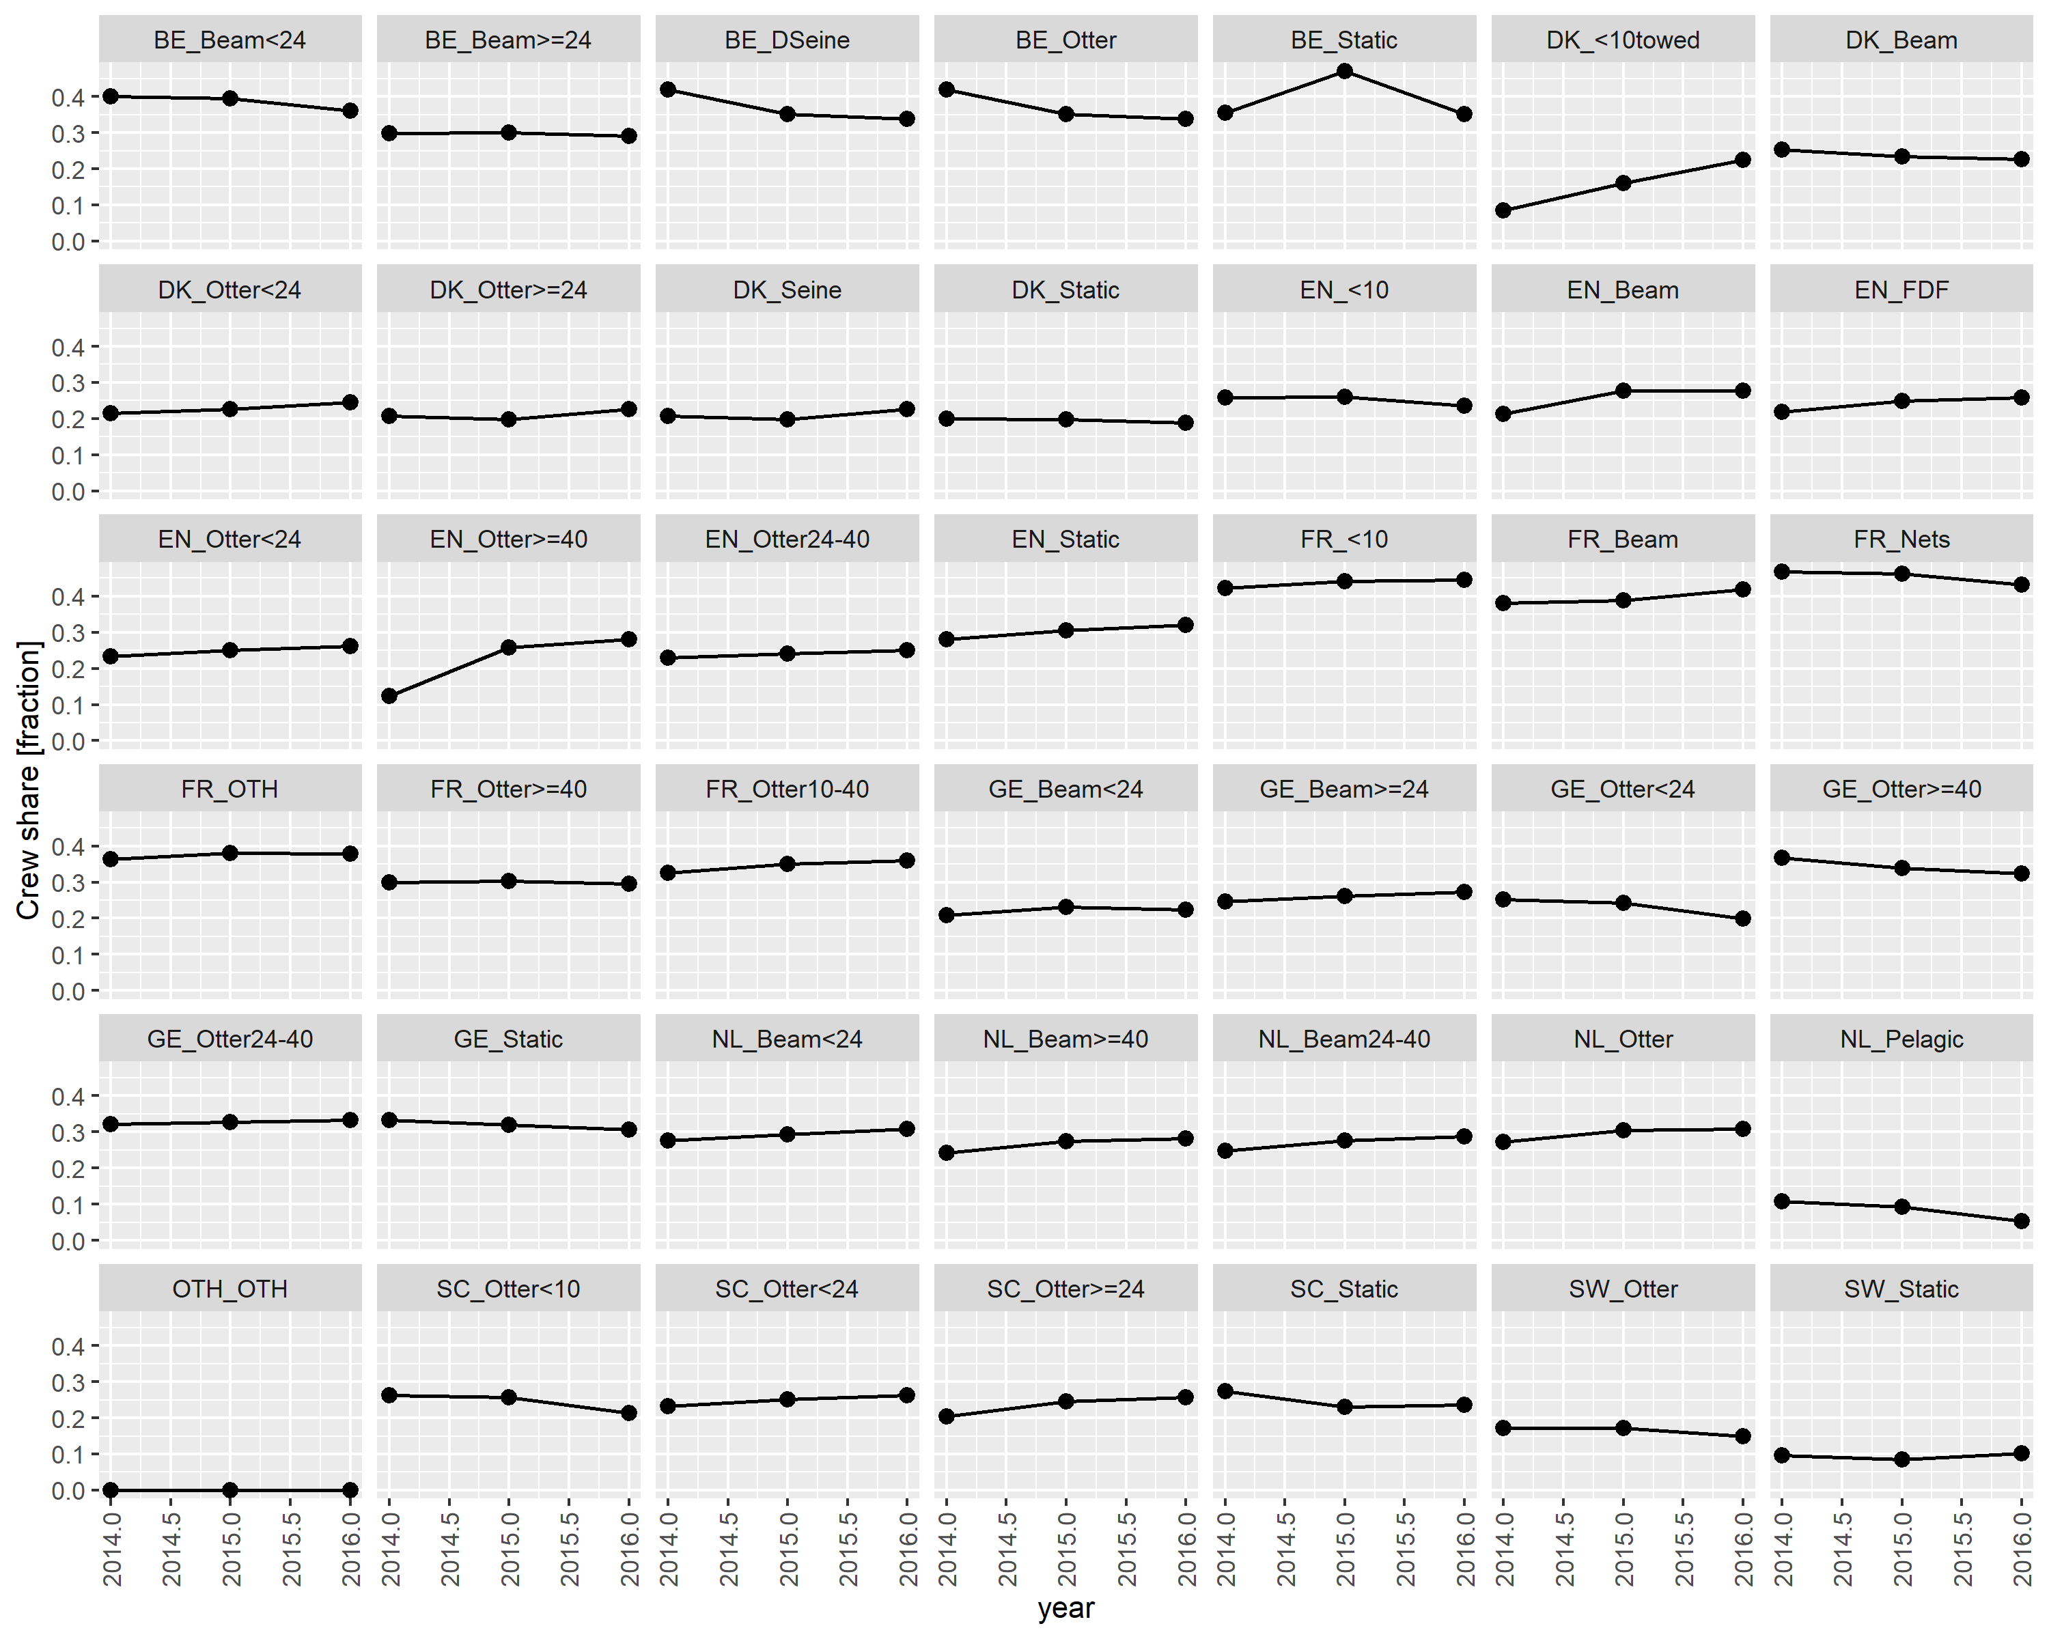
Figure S3: Crew share by fleet as calculated from the ratio of personnel costs / landings value as reported in the STECF data for the years 2014 - 2016. Fleet abbreviations can be found in table S1.
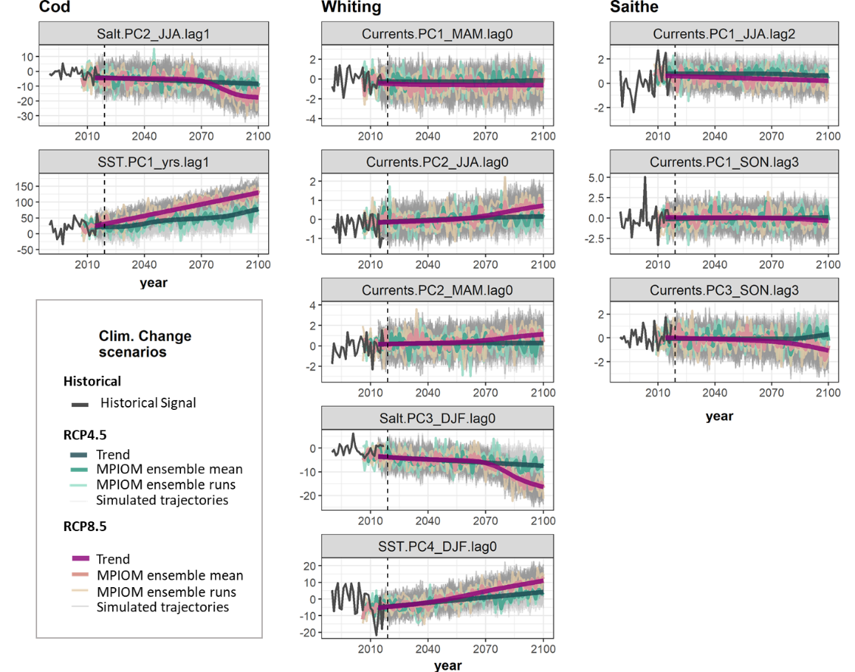
Figure S4: Principal component time series (PCs, unitless) of the historical environmental signal (dark grey) and projected environmental covariates used in the environmentally-mediated stock recruitment relationship for each stock for RCP4.5 (green) and RCP8.5 (purple) climate projections, showing the extracted, monotonous trend, three MPIOM ensemble runs and their respective mean as well as the simulated 100 trajectories used in the FLBEIA model to account for variability in the environmental processes (see legend for line colours). The start year of the simulations 2019 is shown as dashed vertical line. Variable names (e.g. “SST.PC1_yrs.lag1”) reflect the environmental covariate (SST, Currents, Salt), the order of principal component (PC), the specific season over which the covariate was averaged (DJF – December, January, February; MAM – Marc, April, May; JJA – June, July, August; SON – September, October, November; yrs – yearly average) and the time lag relative to the recruitment year (lag) of the stock.
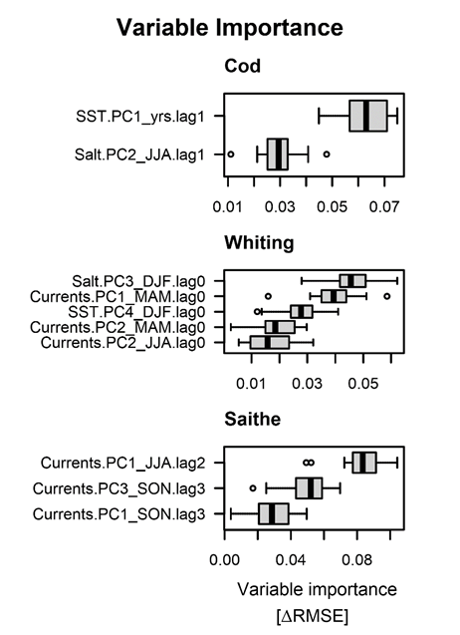
Figure S5: Permutated variable Importance (comparison of the change in RMSE of the full model vs. a model, where the variable of interest was permutated) of the different covariates in the EMSRRs for cod, whiting and saithe. Higher values indicate higher importance in the model. Variable names (e.g. “SST.PC1_yrs.lag1”) reflect the environmental covariate (SST, Currents, Salt), the order of principal component (PC), the specific season over which the covariate was averaged (DJF – December, January, February; MAM – Marc, April, May; JJA – June, July, August; SON – September, October, November; yrs – yearly average) and the time lag relative to the recruitment year (lag) of the stock.

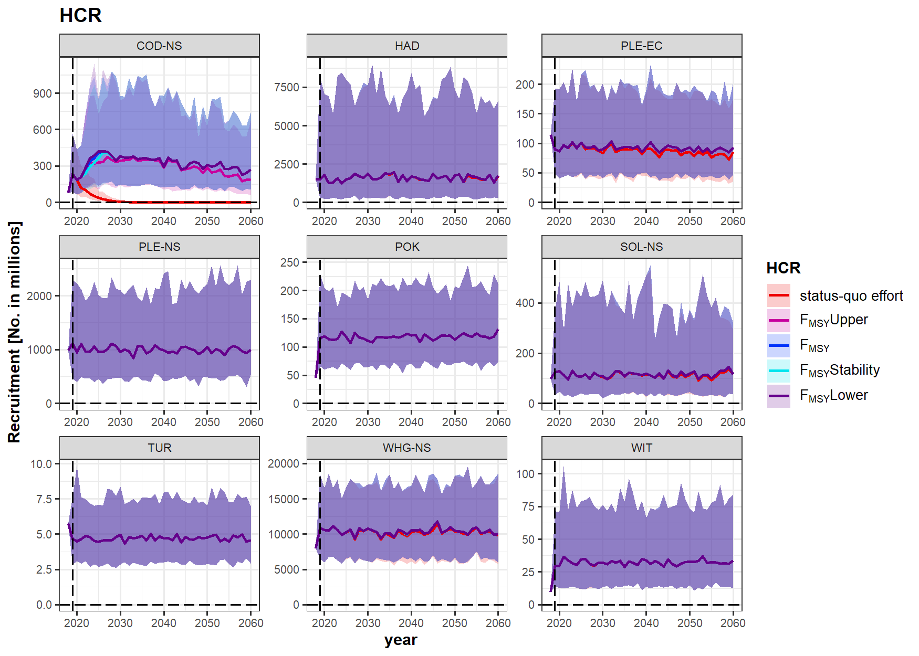
Figure S6: Recruitment for the age-based stocks in the mixed fisheries simulations under different HCRs (coloured lines, line corresponds to the median, shaded bands are 5 - 95% quantiles). Stock abbreviations: COD-NS – North Sea Cod, HAD – Haddock, PLE-EC – eastern English Channel Plaice, PLE-NS – North Sea Plaice, POK – Saithe, SOL-NS – North Sea Sole, TUR – Turbot, WHG-NS – North Sea Whiting, WIT – Witch.
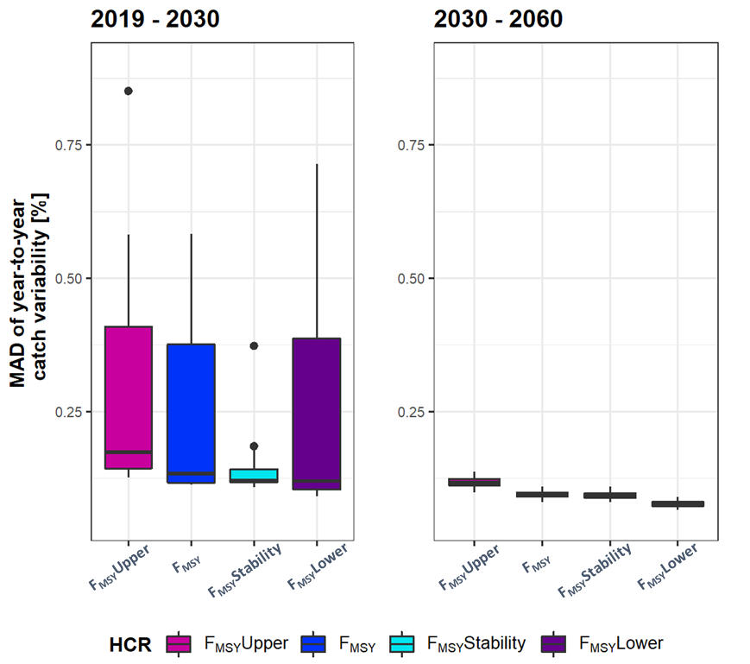
Figure S7: Median absolute deviation (MAD) of year-to-year catch variability in percentage for the different HCRs for the highly variable short- to mid-term period up to 2030 (left) and from 2030 – 2060 (right) where catches reached their equilibrium levels
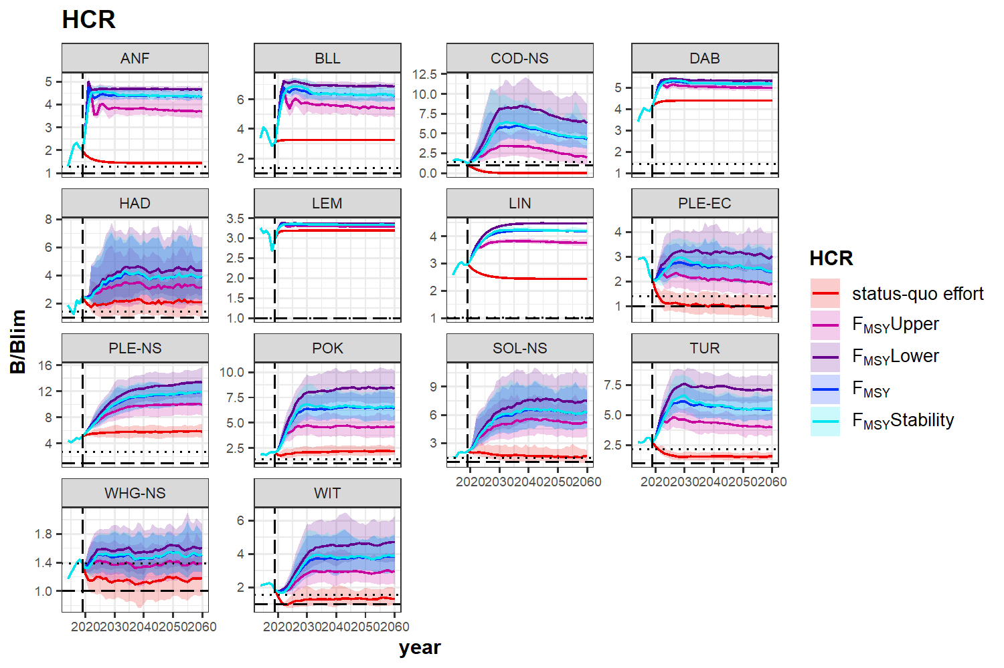
Figure S8: B/Blim for the different age/biomass-based stocks in the model under different HCRs (coloured lines, line corresponds to the median, shaded bands are 5 - 95% quantiles), B=Blim is shown as dashed line, B=Btrigger is added as dotted line. Stock abbreviations: ANF – Anglerfish, BLL – Brill, COD-NS – North Sea Cod, DAB – Dab, HAD – Haddock, LEM – Lemon sole, LIN – Ling, PLE-EC – eastern English Channel Plaice, PLE-NS – North Sea Plaice, POK – Saithe, SOL-NS – North Sea Sole, TUR – Turbot, WHG-NS – North Sea Whiting, WIT – Witch.
Economic effects on fleet level
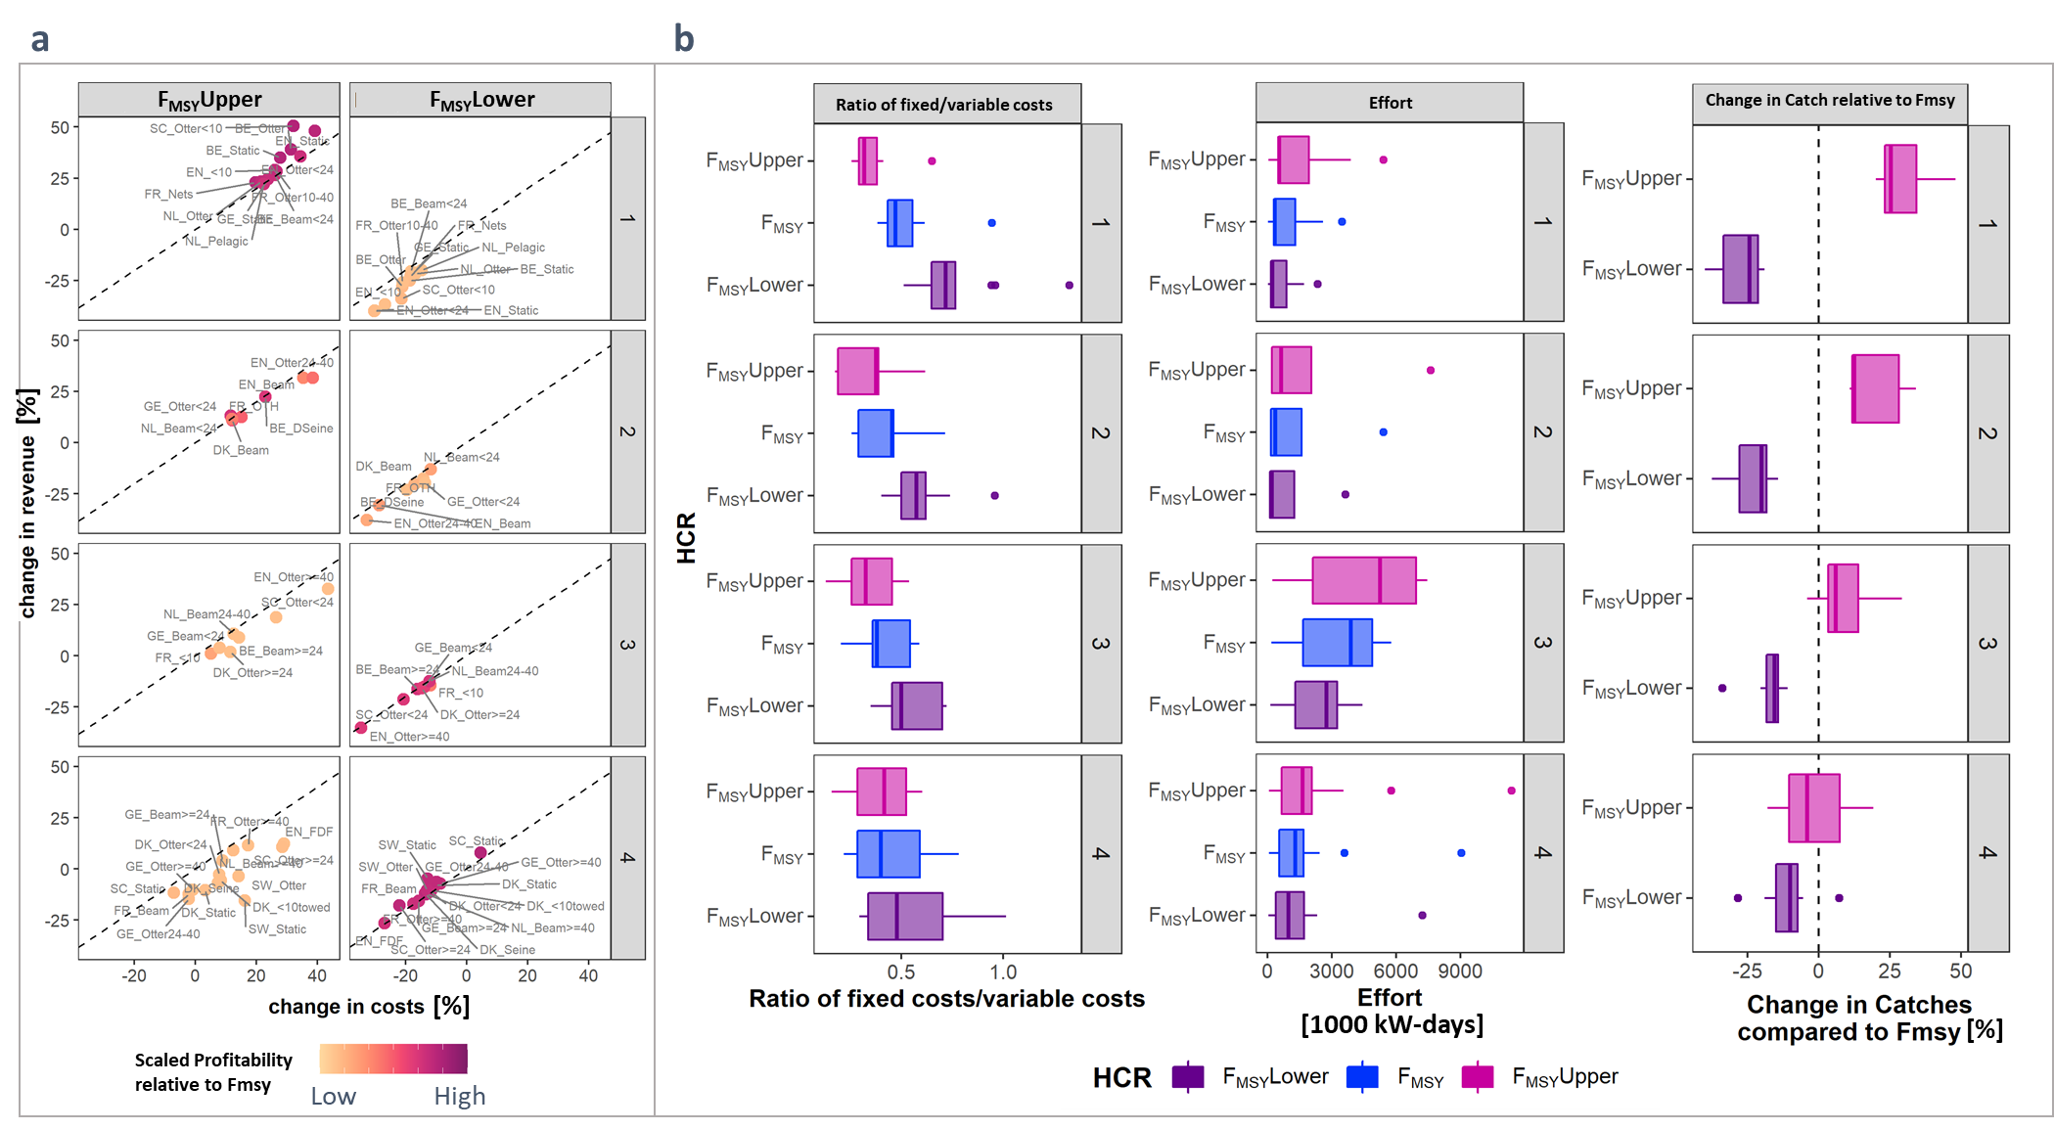
Figure S9: a) Relative change in costs (x-axis) to revenue (y-axis) for F_{MSY}Upper and F_{MSY}Lower compared to F_{MSY}. Fleets below the dashed line have a higher relative change in costs than revenues, whereas fleets above the dashed line have a higher change in revenues than costs compared to the the F_{MSY} HCR (colors and groups are the same as in Fig. 6 in the main manuscript) b) Boxplots of the ratio of fixed/variable costs (left), effort (middle), and percentage of change in catches relative to F_{MSY} (right) for the different HCRs grouped by profitability of the different fleets (same groups as in Fig. 6 of the main manuscript)

References

García, D., Prellezo, R., Sánchez, S., Andrés, M., Urtizberea, A., Carmona, I., 2017. Technical manual for FLBEIA a R package to conduct Bio-Economic Impact assessments using FLR (version 1.15) [WWW Document]. URL https://flbeia.azti.es/wp-content/uploads/2017/07/FLBEIA_manual.pdf
Guillen, J., Boncoeur, J., Carvalho, N., Frangoudes, K., Guyader, O., Macher, C., Maynou, F., 2017. Remuneration systems used in the fishing sector and their consequences on crew wages and labor rent creation. Marit. Stud. 16, 1–36. https://doi.org/10.1186/s40152-017-0056-6
ICES, 2019. ICES Fisheries Data call 2019 for landings, discards, biological sample, catch and effort data. ICES Data calls. https://doi.org/10.17895/ices.data.18596231

