Supplementary Material

FOAM Project Team members
- P. Bonnefond - SYRTE, Observatoire de Paris, PSL Research University, CNRS, Sorbonne Universités, UPMC Univ. Paris 06, LNE, 77 avenue Denfert-Rochereau, 75014 Paris, France
- O. Laurain - OCA-GEOAZUR, 250 av. A. Einstein, 06560 Valbonne, France
- V. Ballu, X. Bertin, C. Chupin E. Poirier and Y-T. Tranchant – LIENSs, UMR 7266, CNRS/ La Rochelle Université, Bâtiment ILE, 2, rue Olympe de Gouges, 17000 La Rochelle, France
- M.-P. Bonnet, J. Darrozes, P. Exertier, F. Frappart, F. Perosanz, G. Ramillien and A. Santamaría-Gómez - OMP-GET/GRGS, 14 av. Ed. Belin, 31000 Toulouse, France
- D. Allain, M. Bergé-Nguyen, S. Calmant, J.-F. Crétaux, F. Lyard and L. Testut - LEGOS, 18 av. Ed. Belin, 31000 Toulouse, France
- C. Brachet, M. Calzas, C. Drezen, A. Guillot and L.Fichen - DT INSU, Bâtiment IPEV, BP 74 29280 Plouzane, France
- M. Cancet - NOVELTIS, 153 rue du Lac 31670 Labège, France
- P. Schaeffer - CLS, 8-10 rue Hermes, Parc Technologique du Canal 31526 RAMONVILLE St-Agne, France
- Flavien Mercier - CNES, 18, av. Ed. Belin 31401 Toulouse, France
- F. Seyler - UMR – ESPACE DEV, maison de la télédétection, 500 rue Jean-François Breton, 34093 Montpellier, France
- R. Abarca Del Rio - DGEO, University of Concepcion, Casilla: 160-C, Barrio Universitario S/N, Concepcion, Chili
- D. Medeiros Moreira - CPRM, Av. Pasteur, 404 - Urca Rio de Janeiro - RJ - Brazil 22290-255
- J. Santos da Silva - CESTU/UEA, Avenida J. Batista 3578, Manaus, Brazil

Additional Tables and Figures
Table S1. Statistics of SSH differences with M5 tide gauge (zodi – M5) within 250 m (velocity < 0.3 m/s) for the different sampling of the troposphere delay estimation (iPPP processing).
Delay per day | Mean (mm) | Standard Deviation (mm) | Number of data | Mean Distance (m)
1 | -21.4 | 13.2 | 21551 | 92
2 | -21.4 | 13.2 | 21551 | 92
12 | -23.7 | 13.8 | 21551 | 92
24 | -29.1 | 17.6 | 21551 | 92
96 | -28.0 | 21.8 | 21551 | 92
Table S2. Statistics of SSH differences with M5 tide gauge (cngh – M5) within 250 m (velocity < 0.3 m/s) for the different sampling of the troposphere delay estimation (iPPP processing).
Delay per day | Mean (mm) | Standard Deviation (mm) | Number of data | Mean Distance (m)
1 | -18.5 | 13.9 | 5954 | 115
2 | -18.5 | 13.9 | 5954 | 115
12 | -18.9 | 11.1 | 5954 | 115
24 | +0.5 | 16.9 | 5954 | 115
96 | +3.9 | 21.4 | 5954 | 115
Table S3. Statistics of SSH differences with M5 tide gauge (cngh – M5) within 250 m (velocity < 0.3 m/s) with weighted and smoothed (see section 3.5) crossover corrections (using M3&M5 tide correction, see Table 2) but without geoid corrections. Values in brackets (separated by a “/”) are for the first and second period of static measurements respectively (see vertical orange lines in Figure 9).
Type | Mean (mm) | Standard Deviation (mm) | Number of data | Mean Distance (m)
Short | -1.8  (-7.0 / -2.8) | 4.1  (5.7 / 2.6) | 5961  (1673 / 4040) | 115
Air | +2.6  (-3.0 / +4.2) | 7.0  (8.8 / 3.3) | 5957  (1672 / 4037) | 115
iPPP | -16.6  (-19.7 / -17.1) | 10.4  (11.9 / 6.9) | 5954  (1672 / 4034) | 115
Table S4. Statistics of SSH differences with M5 tide gauge (cngh – M5) within 250 m (velocity < 0.3 m/s) with linearly interpolated crossover corrections (using M3&M5 tide correction, see Table 2).
Type | Mean (mm) | Standard Deviation (mm) | Number of data | Mean Distance (m)
Short | -1.7 | 4.5 | 5961 | 115
Air | +2.9 | 7.1 | 5957 | 115
iPPP | -16.4 | 10.7 | 5954 | 115
Table S5. Statistics of SSH differences with M5 tide gauge (cngh – M5) within 250 m (for all velocities) with geoid correction.
Type | Mean (mm) | Standard Deviation (mm) | Number of data | Mean Distance (m)
Short | +6.3 | 7.8 | 7665 | 126
Air | +8.2 | 11.3 | 7665 | 126
iPPP | -5.9 | 16.4 | 7634 | 125
Table S6. Statistics of SSH differences with M5 tide gauge (cngh – M5) within 250 m (for all velocities) with linearly interpolated crossover corrections (using M3&M5 tide correction, see Table 2). Values in brackets correspond to common data in time with the ones with geoid correction (see Table S5).
Type | Mean (mm) | Standard Deviation (mm) | Number of data | Mean Distance (m)
Short | +0.3 (+0.1) | 6.9 (7.3) | 8697 (7665) | 118 (126)
Air | +4.3 (+4.2) | 8.7 (8.6) | 8697 (7665) | 118 (126)
iPPP | -9.0 (-10.1) | 16.1 (15.6) | 8685 (7634) | 118 (125)
Table S7. Statistics of SSH differences with M5 tide gauge (cngh – M5) within 250 m (for all velocities) with weighted and smoothed (see section 3.5) crossover corrections (using M3&M5 tide correction, see Table 2). Values in brackets correspond to common data in time with the ones with geoid correction (see Table S5 and Table S8 below).
Type | Mean (mm) | Standard Deviation (mm) | Number of data | Mean Distance (m)
Short | +0.3 (0.0) | 6.4 (6.7) | 8697 (7665) | 118 (126)
Air | +3.9 (+3.9) | 8.3 (8.2) | 8697 (7665) | 118 (126)
iPPP | -9.3 (-10.6) | 15.3 (14.4) | 8685 (7634) | 118 (125)
Table S8. Statistics of SSH differences with M5 tide gauge (cngh – M5) within 250 m (for all velocities) with crossover corrections (using M3&M5 tide correction, see Table 2) and with geoid correction.
Type | Mean (mm) | Standard Deviation (mm) | Number of data | Mean Distance (m)
Short | +7.4 | 6.7 | 7665 | 126
Air | +11.5 | 10.0 | 7665 | 126
iPPP | -2.9 | 14.0 | 7634 | 125
Table S9. Statistics of SSH differences with M3 tide gauge (cngh – M3) within 250 m (for all velocities).
Type | Mean (mm) | Standard Deviation (mm) | Number of data | Mean Distance (m)
Short | -2.2 | 14.7 | 394 | 172
Air | +2.6 | 13.4 | 394 | 172
iPPP | +4.1 | 22.3 | 394 | 171
Table S10. Statistics of SSH differences with M3 tide gauge (cngh – M3) within 250 m (for all velocities) with geoid correction.
Type | Mean (mm) | Standard Deviation (mm) | Number of data | Mean Distance (m)
Short | -2.9 | 11.6 | 251 | 161
Air | +3.3 | 9.4 | 251 | 161
iPPP | +3.4 | 19.4 | 249 | 161
Table S11. Statistics of SSH differences (cngh – M3) at distance < 250 m (for all velocities) with linearly interpolated crossover corrections (using M3&M5 tide correction, see Table 2). Values in brackets correspond to common data in time with the ones with geoid correction (see Table S10).
Type | Mean (mm) | Standard Deviation (mm) | Number of data | Mean Distance (m)
Short | -4.8 (-8.9) | 8.7 (6.1) | 394 (251) | 172 (161)
Air | +0.8 (-1.9) | 8.1 (5.7) | 394 (251) | 172 (161)
iPPP | -0.9 (-5.8) | 11.3 (8.7) | 394 (249) | 171 (161)
Table S12. Statistics of SSH differences with M3 tide gauge (cngh – M3) within 250 m (for all velocities) with weighted and smoothed (see section 3.5) crossover corrections (using M3&M5 tide correction, see Table 2) but without geoid corrections. Values in brackets correspond to common data in time with the ones with geoid correction (see Table S13).
Type | Mean (mm) | Standard Deviation (mm) | Number of data | Mean Distance (m)
Short | -2.2 (-6.2) | 7.5 (5.8) | 394 (251) | 172 (161)
Air | +3.5 (+0.8) | 6.0 (4.8) | 394 (251) | 172 (161)
iPPP | +2.8 (-1.4) | 8.9 (7.5) | 394 (249) | 171 (161)
Table S13. Statistics of SSH differences with M3 tide gauge (cngh – M3) within 250 m (for all velocities) with weighted and smoothed (see section 3.5) crossover corrections (using M3&M5 tide correction, see Table 2) and with geoid corrections.
Type | Mean (mm) | Standard Deviation (mm) | Number of data | Mean Distance (m)
Short | -3.5 | 5.1 | 251 | 161
Air | +3.5 | 4.7 | 251 | 161
iPPP | +1.4 | 6.3 | 249 | 161
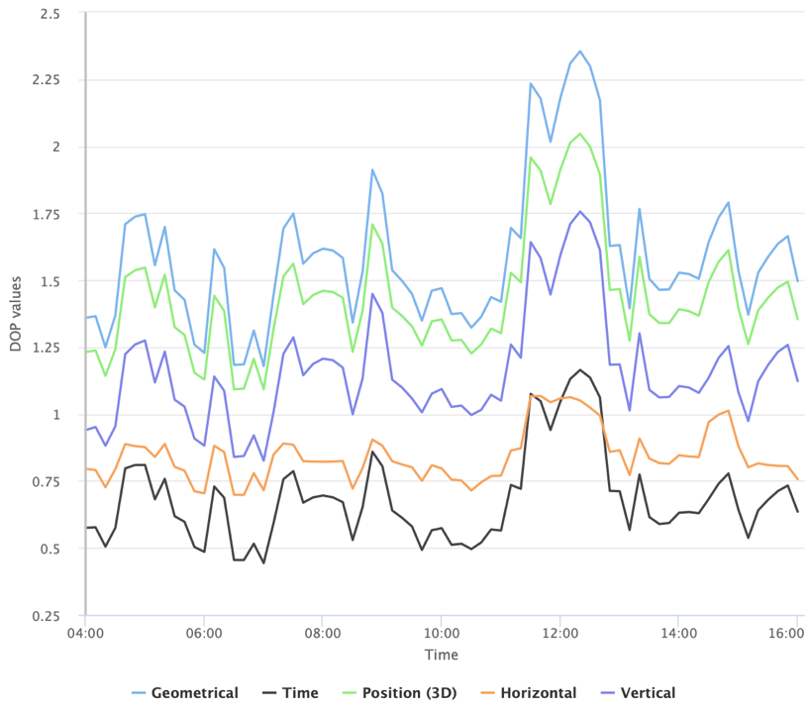
Figure S1. Dilution Of Precision (DOP) time series from Trimble planning software (https://www.gnssplanning.com/).

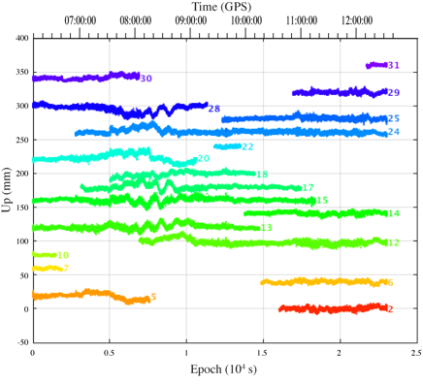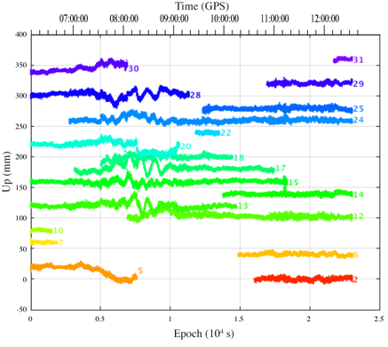
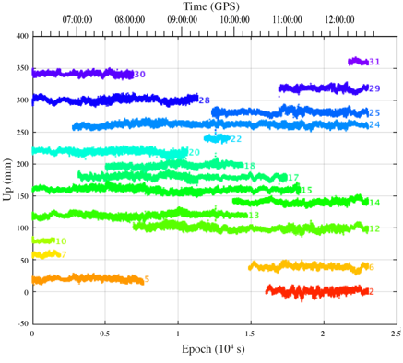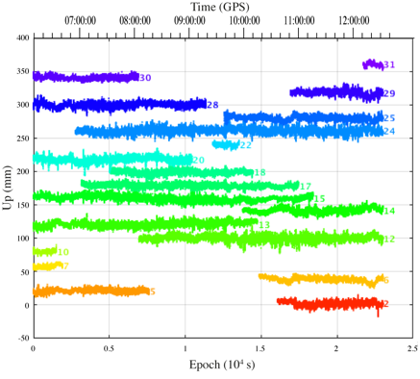
Figure S2. Time series of the cngh’s phase residuals for each GPS satellite (shifted by 20 mm for readability). Top: for “Short” processing (left: L1; right: L2). Bottom: for “Air” (left) and iPPP (right), both for LC.

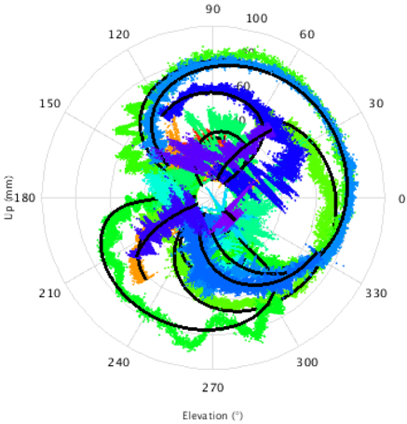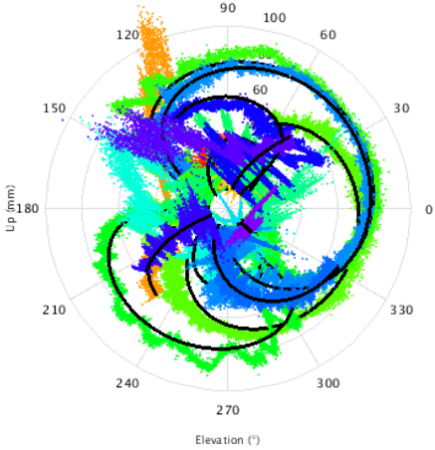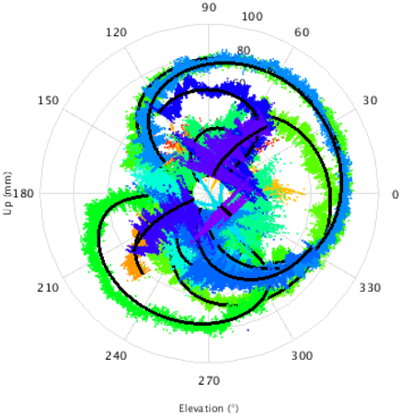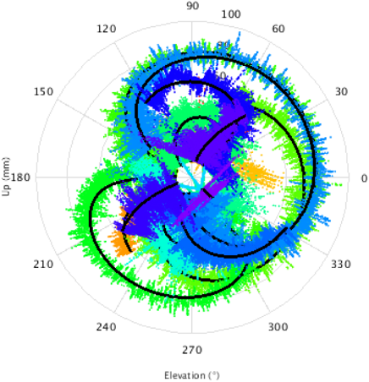
Figure S3. Sky plots of the cngh’s phase residuals for each GPS satellite (same colors than Figure S2 for each satellite). Top: for “Short” processing (left: L1; right: L2). Bottom: for “Air” (left) and iPPP (right), both for LC.

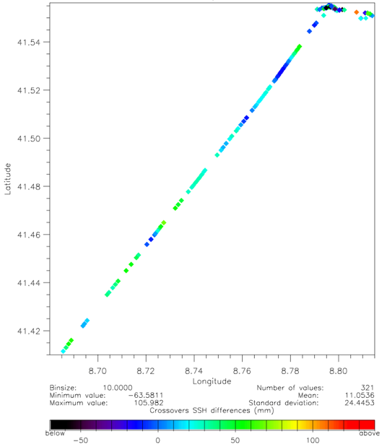
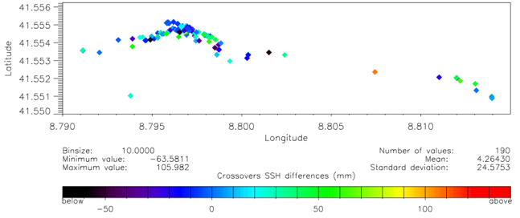
Figure S4. Map of the crossovers SSH differences for the “Short” processing. Top: whole area; Bottom: zoom on the coastal area.
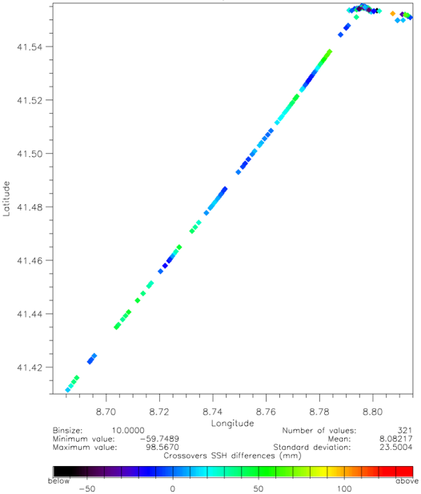
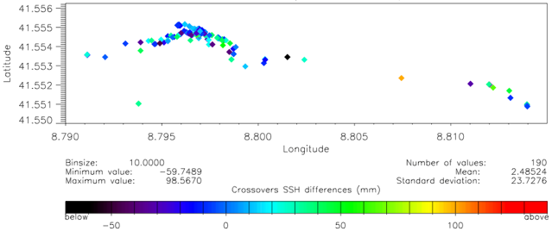
Figure S5. Map of the crossovers SSH differences for the “Air” processing. Top: whole area; Bottom: zoom on the coastal area.
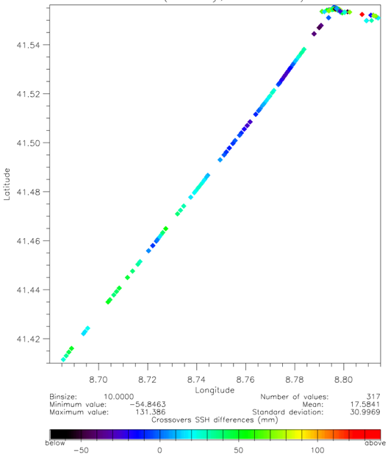
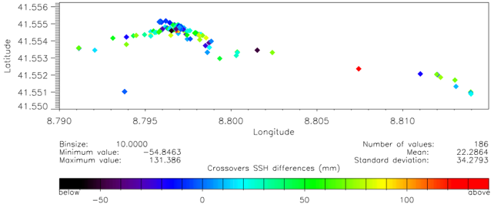
Figure S6. Map of the crossovers SSH differences for the “iPPP” processing. Top: whole area; Bottom: zoom on the coastal area.
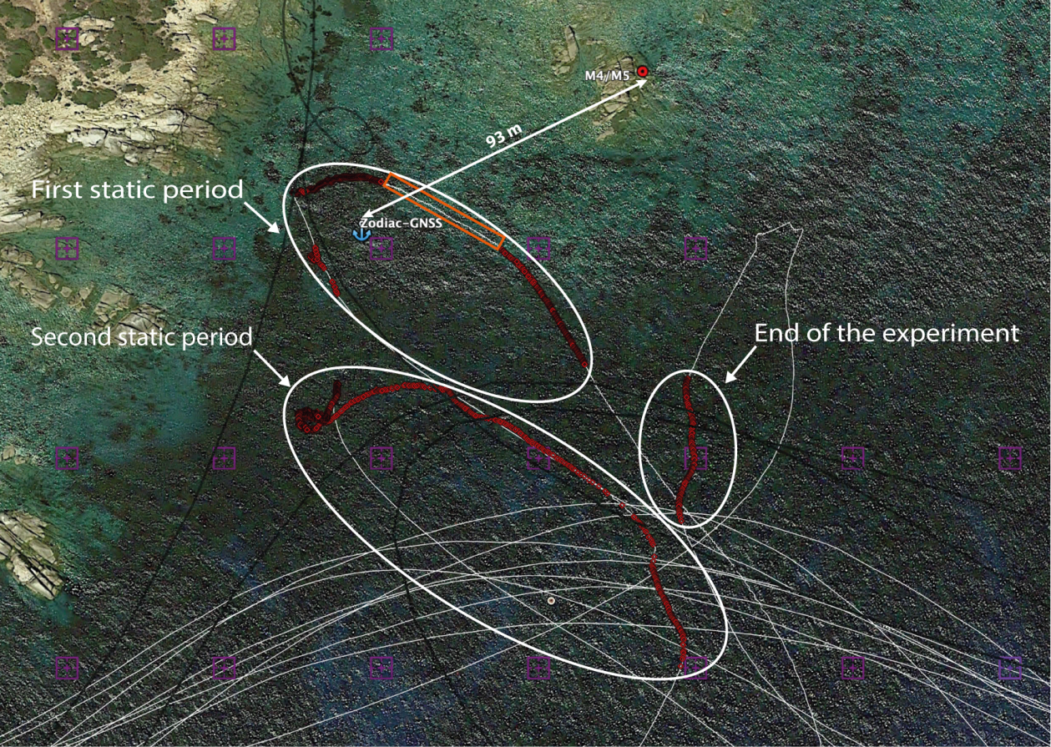
Figure S7. Locations of CalNaGeo for velocity below 0.3 m/s within 250 m of M5 tide gauge. The red dots correspond to the selected measurements with statistics given in Table 5. The orange box shows the locations of measurements not corrected from the geoid because outside of the geoid grid (purple crosses). The anchor shows the average location of the Zodiac-GNSS for statistics given in Table 3. The first static period lasts from 6h20 to 6h48 (UTC) and the se

