Appendix S2

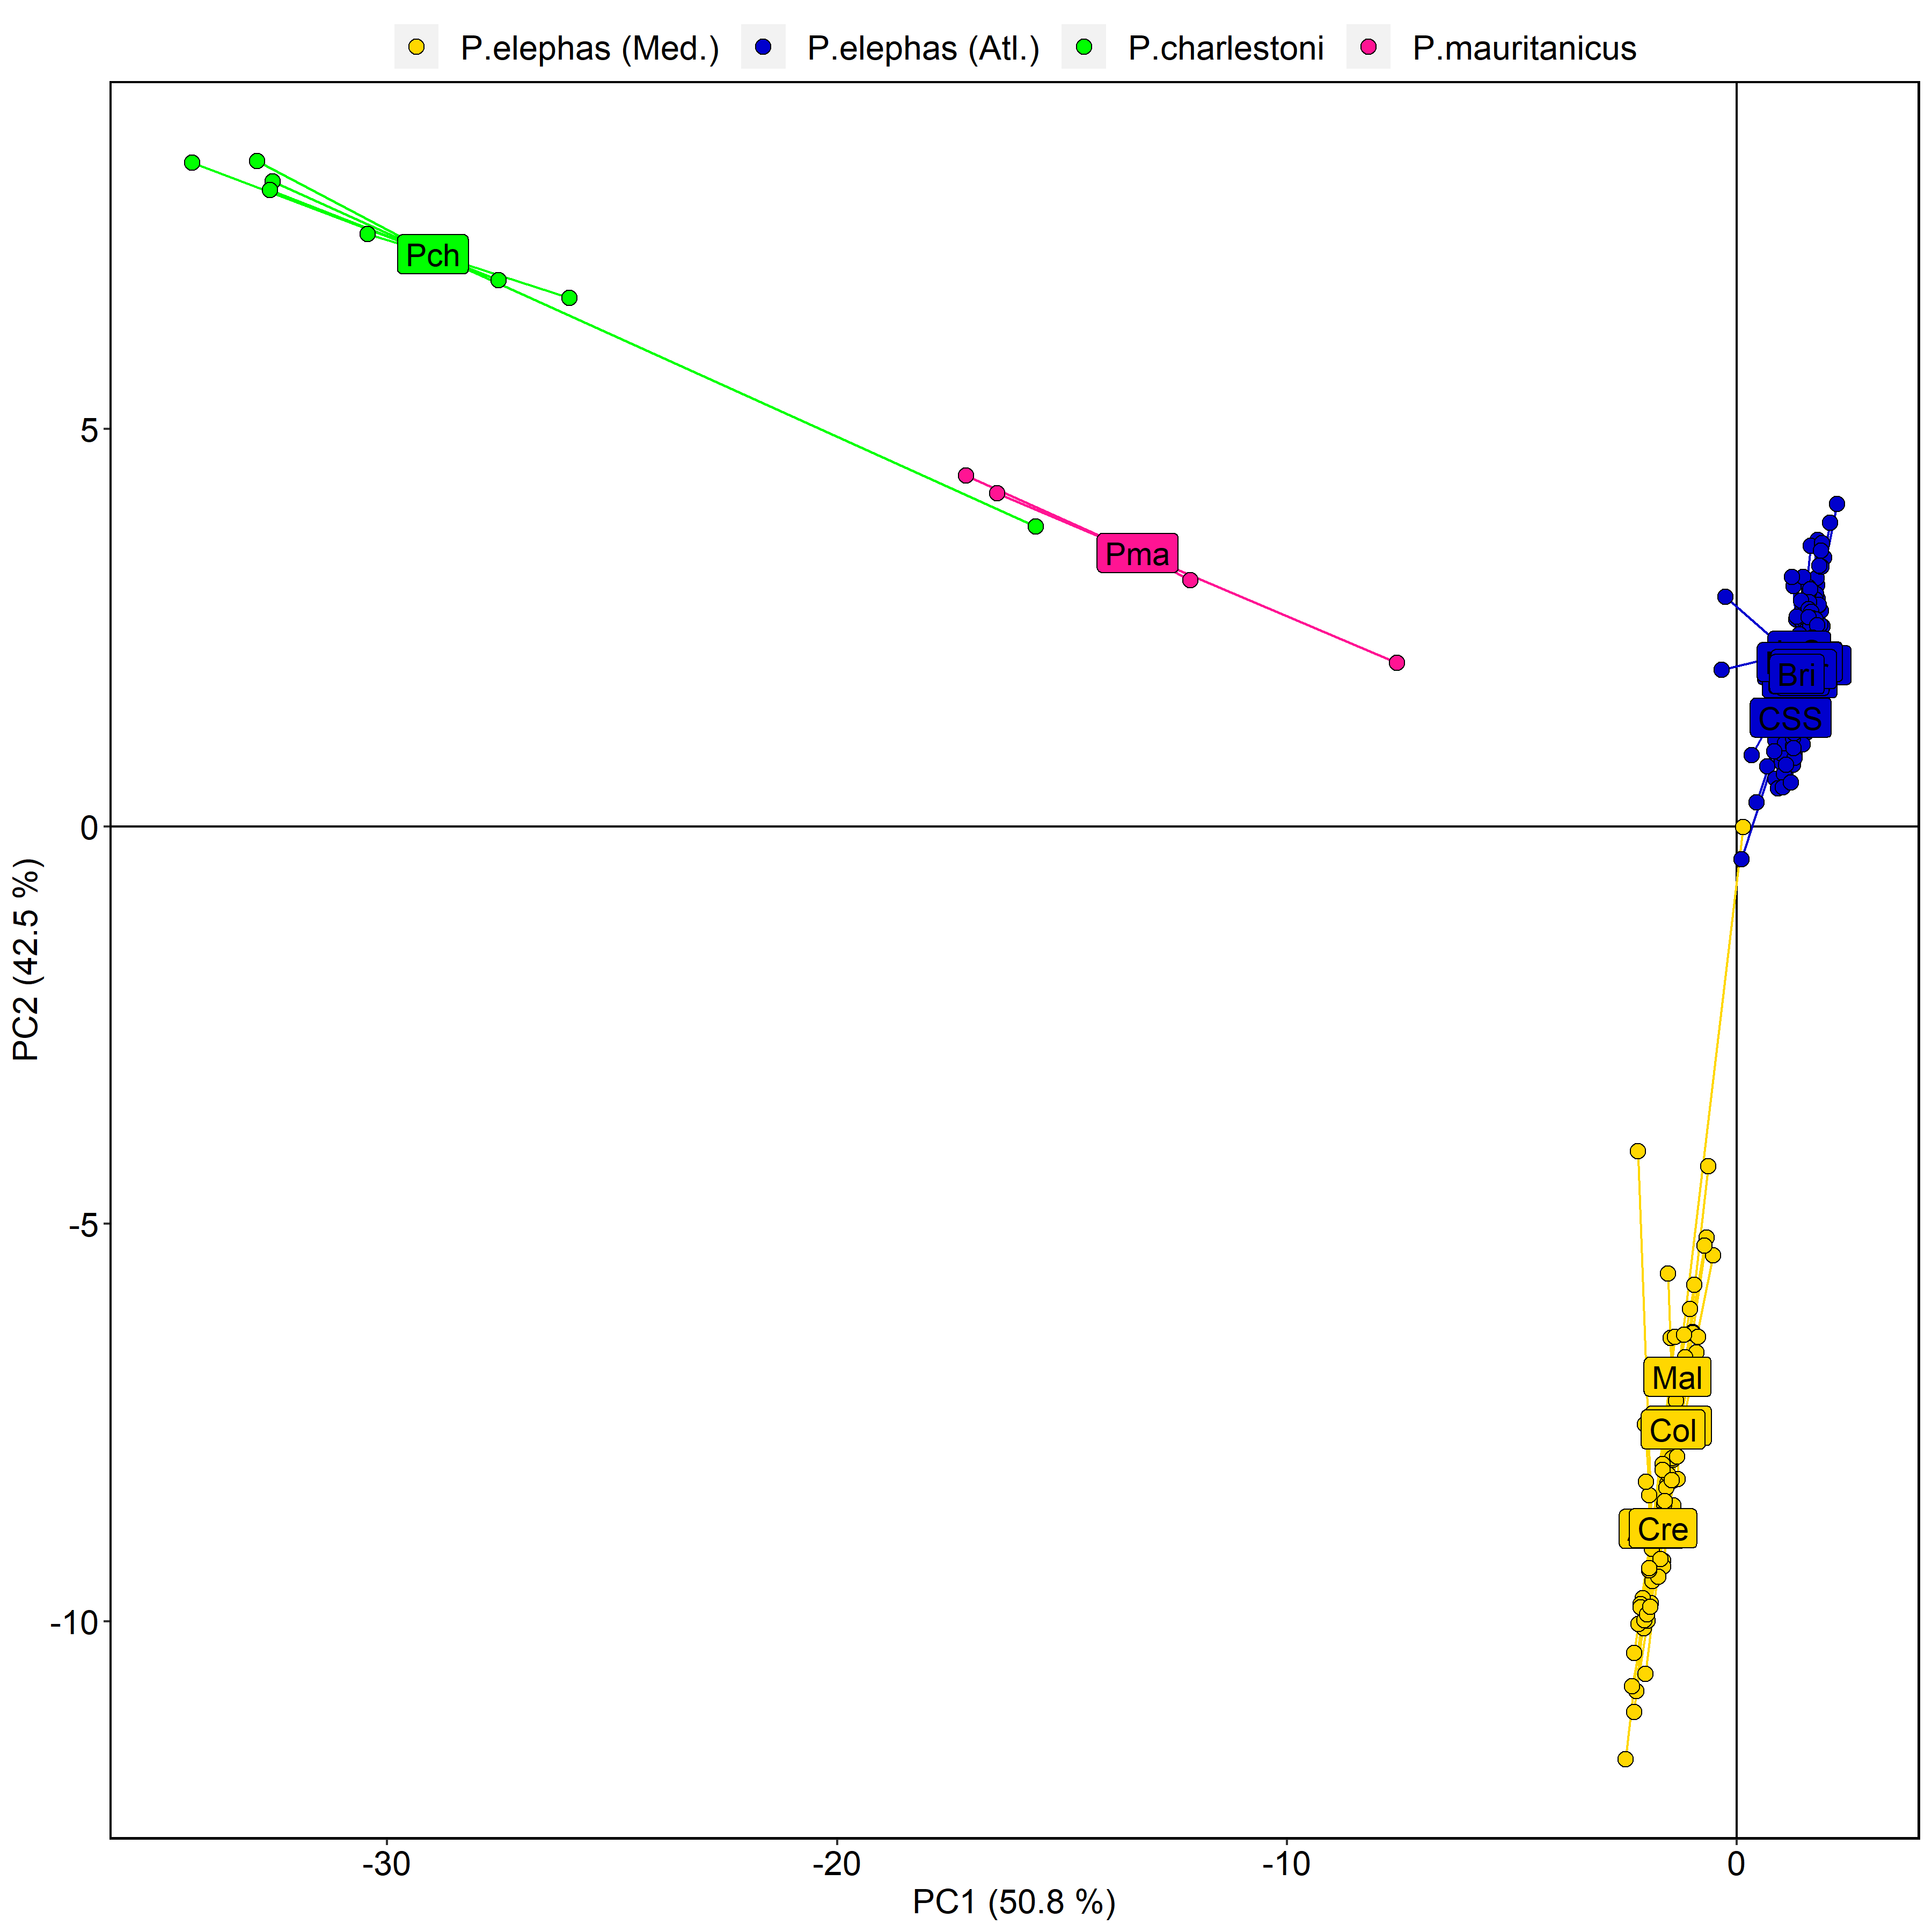

Fig.S2.1: A DAPC plot for 11,122 SNP loci in 376 Palinurus sp. individuals from 17 species/location samples. Putatively P. elephas samples are all distinct from clusters attributed to congenic species with overlapping ranges, P. mauritanicus and P. charlestoni, both supplied via fishers in Cape Verde. One putatively P. charlestoni individual clusters with P. mauritanicus likely representing an erroneous taxonomic designation by the sampler. Additionally, one P. elephas attributed to a Mediterranean stock actually groups with Atlantic individuals. This sample was putatively of Tunisian origin, but was sourced from a holding facility in France and appears not to be of Mediterranean descent. This sample and all interspecific controls were removed from the dataset ahead of downstream analysis. Note: axis labels should be LD1/2, not PC1/2.

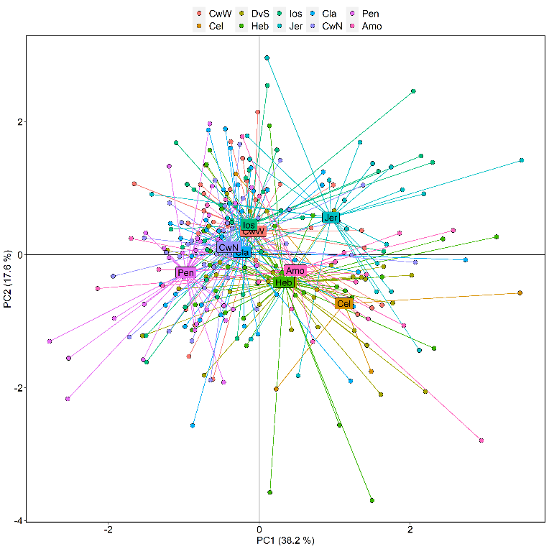
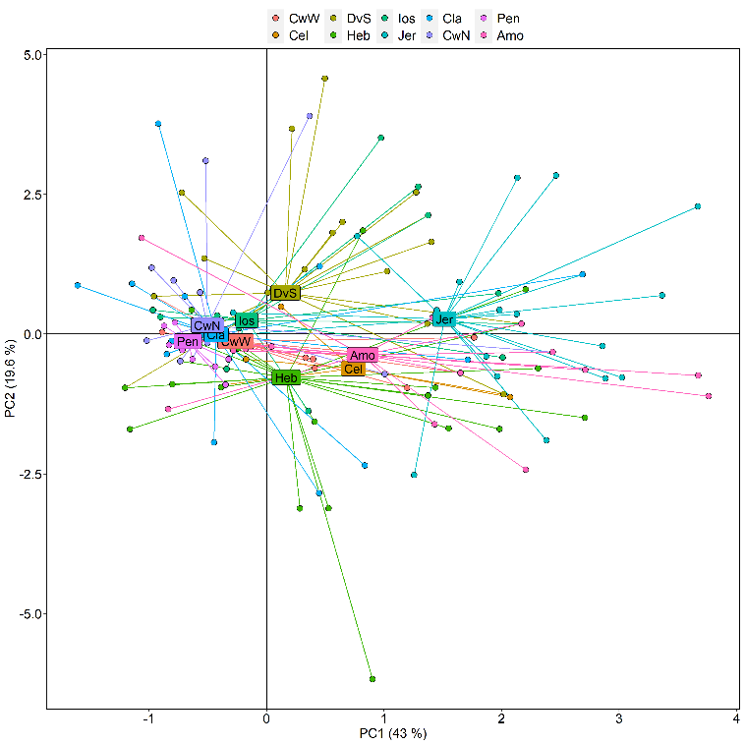
Fig.S2.2: DAPC plots of 276 P. elephas individuals from 10 Atlantic locations using 16 outlier SNPs detected by Bayescan v2.1 (left plot) and 58 outlier SNPs detected by Outflank v0.2 (Whitlock & Lotterhos, 2015) using the gl.outflank function of the dartR package v1.1.11 in R (right plot). Note: axis labels should be LD1/2, not PC1/2.

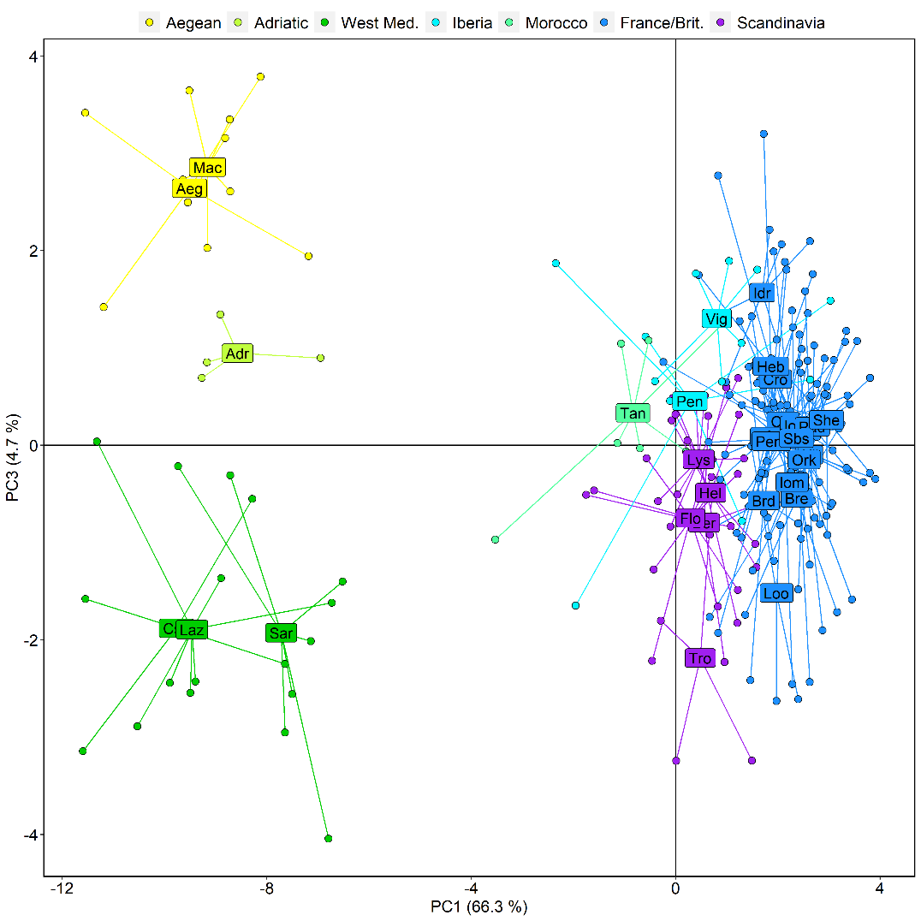
Fig.S2.3: DAPC plot of 214 H. gammarus from 32 sites using 51 outlier SNPs detected by Bayescan. Note: axis labels should be LD1/3, not PC1/3.
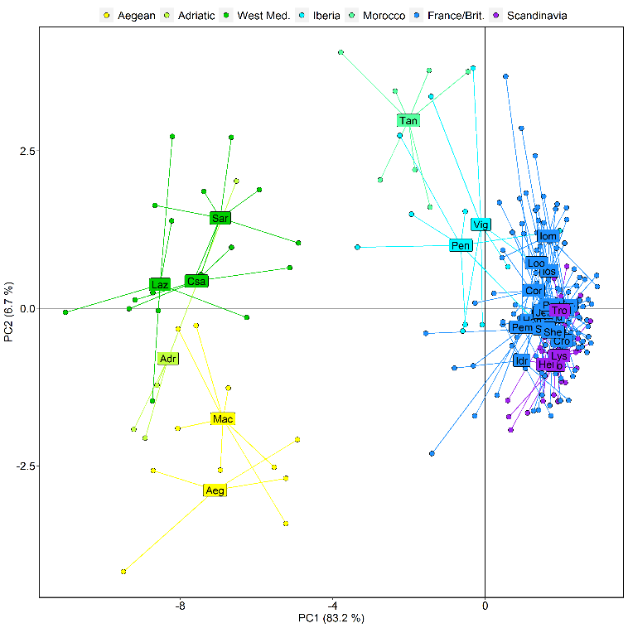
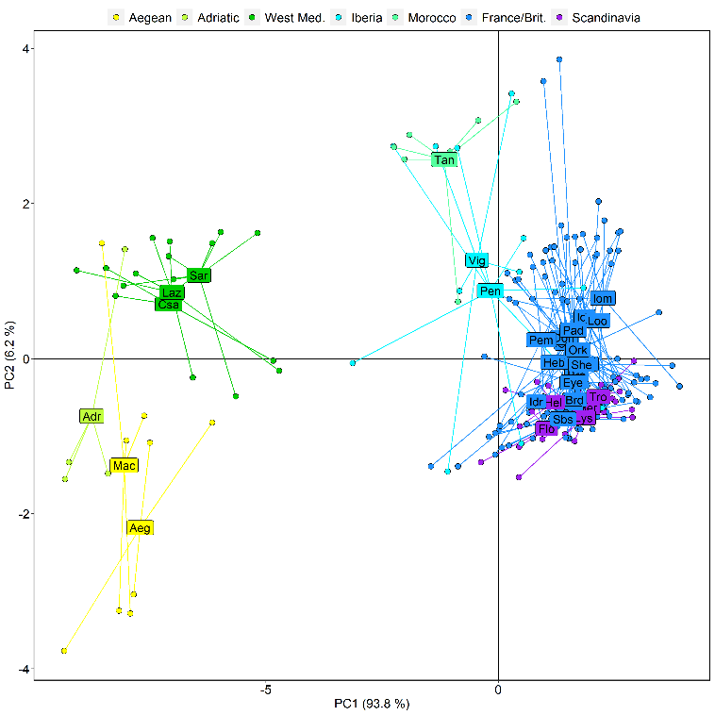

Fig.S2.4: DAPC plots of all 214 H. gammarus from all sites: (left) using 87 outlier SNPs with genotype-environment associations (GEA) as identified by RDA; (right) using 30 outlier SNPs detected by both GEA-RDA and Bayescan. Note: axis labels should be LD1/2, not PC1/2.

