Supplementary Material S3

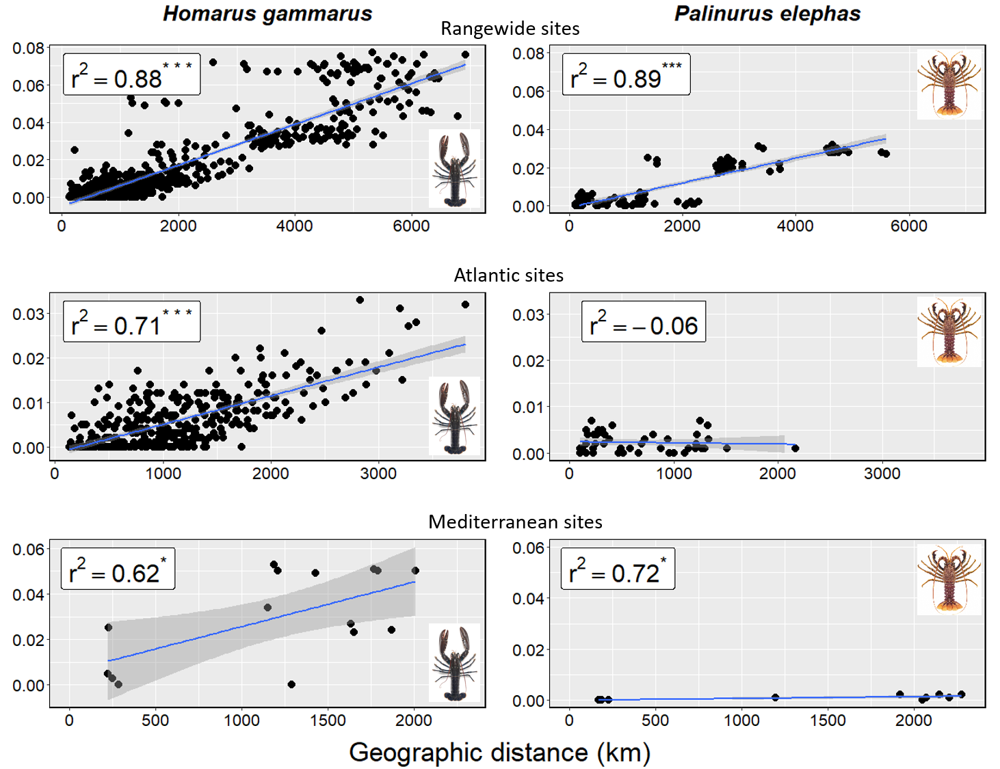
Fig.S3.5: Scaled plots of isolation-by-distance (IBD) for lobsters Homarus gammarus (left) and crawfish Palinurus elephas (right), with measures of pairwise genetic (F_{ST} – Weir & Cockerham’s θ, 1984) and geographic (kilometres – minimum oceanic paths) distance regressed between geographic sites for all samples (top) and only those from the Atlantic (middle) and Mediterranean (bottom) basins. Correlation coefficients (r²) and associated p-values are calculated from Mantel testing (significance denoted as * = p<0.05, ** = P<0.01, *** = p<0.001). Blue lines depict linear regression model fits, with corresponding 95% confidence intervals shaded in darker grey. Note: although featuring the same data as Figure 3, these plots differ in having X and Y axes standardised for exact comparisons between species at each spatial scale.

Fig.S3.6a-d: Basin-wide plots of discriminant analysis of principal components (DAPC), in which points represent individuals and labels represent the mean position of all individuals comprising each geographic sampling site, with colours set according to discrete regional genetic clusters (except c, for which regional area is used in the absence of discernible cluster divergence). For the lobster Homarus gammarus, plots depict clustering using all 6,340 SNP loci across a) only 181 Atlantic individuals, retaining 18 P-axes, and b) only 33 Mediterranean individuals, retaining 3 P-axes. For the crawfish Palinurus elephas, plots depict clustering using all 7,681 SNP loci across c) only 276 Atlantic individuals, retaining 6 P-axes, and d) only 73 Mediterranean individuals, retaining 3 P-axes. Associated basin-wide F_{ST} of these SNP datasets are displayed on each plot. Plots a-c depict the linear discriminant axes LD1 vs 2, whereas plot d depicts LD1 vs 3, which was more informative. Explanatory power of each LD axis (%) are displayed on plot axes.

