Appendix S5
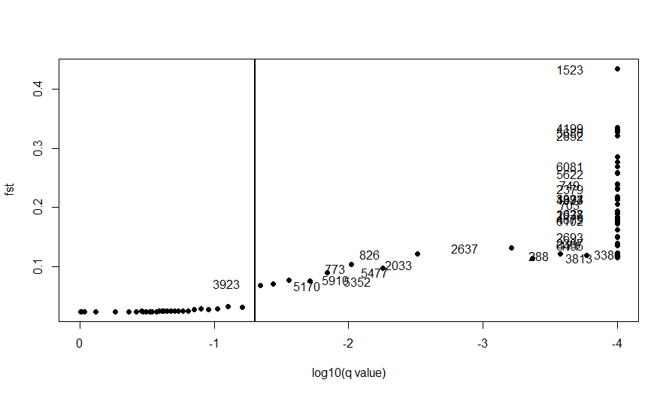
a
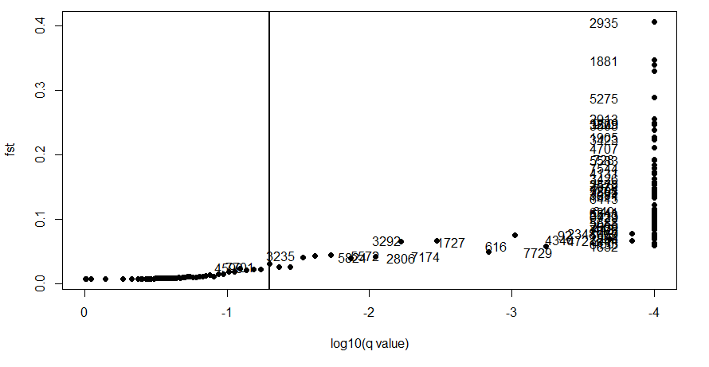
b
Fig.S5.8: Plots of results of Bayescan analysis, with highly differentiated loci meeting the criteria as candidates for selection separated to the right of the vertical line: 8a) n = 50 selection candidate loci from range-wide H. gammarus samples, and; 8b) n = 80 selection candidate loci from range-wide P. elephas samples.

