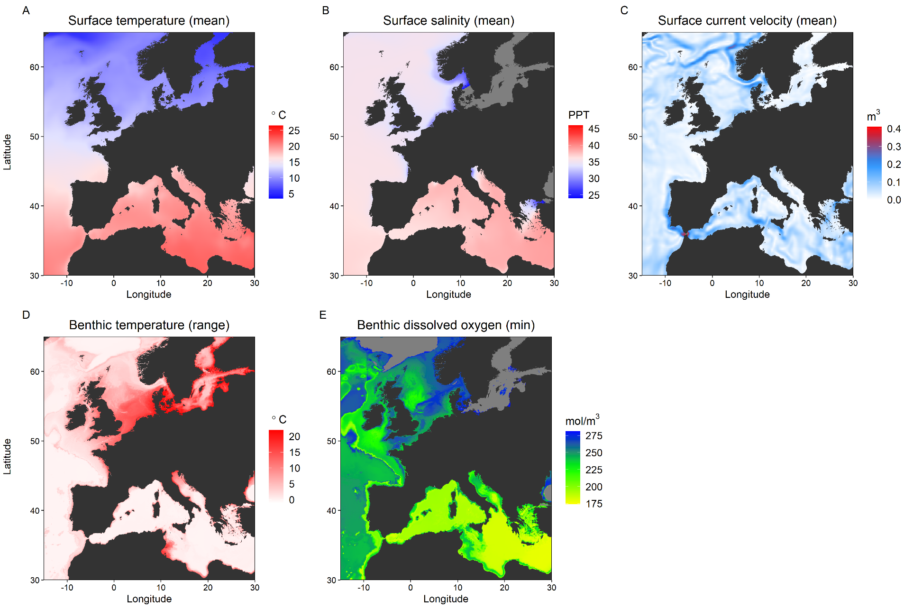
Appendix S6
Fig.S6.9a-e: Heatmaps across the study range for the environmental variables investigated as factors in redundancy analyses (RDAs) also featuring genetic data (GEA-RDA) and genetic and spatial data (db-RDA). A = SST, B = SSS, C = SSV, D = SBT, and E = SBO. Data extracted from Bio-Oracle v2.0.
https://bio-oracle.org/

Appendix S6
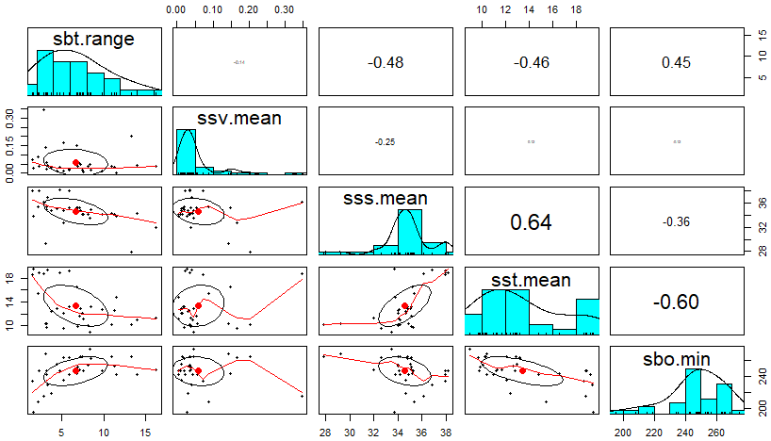
Fig.S6.10: Plot investigating collinearity in environmental variables across H. gammarus sampling sites that were run as factors in RDAs. Raw distributions of each parameter follow the diagonal, with pairwise regressions of datasets below and corresponding R² values above.

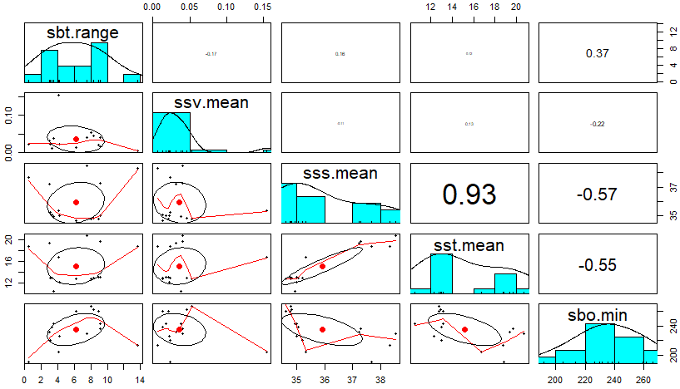
Fig.S6.11: Plot investigating collinearity in environmental variables across P. elephas sampling sites that were run as factors in RDAs. Raw distributions of each parameter follow the diagonal, with pairwise regressions of datasets below and corresponding R² values above. Mean SSS (surface salinity) and SST (surface temperature) co-vary to a degree that would usually require one to be removed (Forester, 2019), but both were retained in RDAs with P. elephas allele frequencies to ensure methodological standardisation between species.

