Supplementary material

A more in-depth description of the methods used during the 3 online and 1 in person workshop for the High Seas.

Methods

Online workshops

The overarching structure of the online workshops followed the general structure of the three horizons framework[1], but adapted it from the usual, more innovations-led approach. Referencing the three ‘horizons’ of the framework- present, future, and transition space, we hosted three online workshops with a group of high seas experts (Figure 1). The online workshops were structured as follows: Workshop 1: the aim was to determine challenges to the high seas in the current regime that need to be overcome (Horizon 1); Workshop 2: the aim was to imagine visions of the high seas in the future using the Nature Futures Framework (Horizon 3); and then Workshop 3 aimed at starting a discussion of how to get there (Horizon 2) that was to be preparatory work for the fourth, in-person meeting that aimed to refine all of these steps.

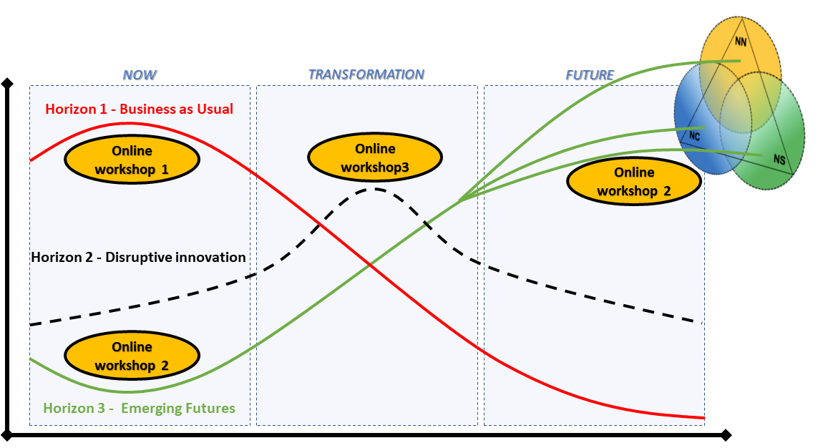
Figure 1: Organisational diagram of the three online workshops, following the three-horizons framework[1] .

As this was intended to be a participatory process, but since it is impossible to get full representation of all stakeholders for the high seas, we designed it as an expert-led process. As it is critical to have the right mix of people in the room when undertaking such processes, we chose participants based on three factors: 1- that their work connected strongly with the high seas; 2- that there were diverse perspectives represented (ie research, but also governance and business) and 3- that we had a good range of ages and geographies represented. As it was quite a big request to make of people to attend 3X3 hour online sessions over the course of 6 months, we started with reaching out to people with whom either the convenors (Ortuño Crespo and Pereira) or the advisory board of the project (Table 1) had connections and then snowballed further participants from there. All participants were asked to sign a consent form prior to the workshop and it was agreed that Chatham House rules would be followed. Ethical approval for the research was granted by Stockholm Resilience Centre in May 2021.

Table 1: Advisory Board for the Nature Futures Framework High Seas project

Name | Region
Renuka Badhe | Europe/Polar
Frida Bengtsson | Europe
William Cheung | Americas
Daniel Dunn | Asia-Pacific
Andrew Merrie | Europe
Rashid Sumaila | Africa
Clement Yow Mulalap | Asia-Pacific

We held two sessions for each of the online workshops on separate days to account for the different regional time zones and availability of the participants. Given the global distribution of workshop participants, each of the three workshops had two sister replicate sessions: 1: Africa, Asia, Europe, Oceania & 2: Africa, Europe, Americas. The same structure was followed for both workshops. The first day hosted the Americas, Africa and Europe group and the second day, the Asia, Oceania, Africa and Europe group.

Online Workshop 1 (Horizon 1) - Identifying High Seas Challenges
As a first step towards this visioning process we invited participants to take part in the first of three virtual workshops via two separate sessions that were held on the 12th and 14th of July 2021. We had a total of 26 participants and 5 facilitators from +20 different countries and a variety of sectors including academia, private, governmental and inter- and non-governmental organisations. The main objectives of this first workshop were to acquaint participants with the NFF and three horizons frameworks and to identify the main challenges associated with the high seas using the S.T.E.E.P. (Societal, Technological, Economic, Environmental & Political) approach for categorising these challenges. Before the workshop, participants were also invited to fill in an online survey identifying the challenges in the ABNJ. The virtual workshop was held over Zoom and we used Miro (https://miro.com/), a virtual whiteboard platform for note taking and voting. The workshop was divided into three sessions:

Session 1: In the first session participants and facilitators introduced themselves and explained their relationship with the Ocean; this helped build trust amongst a diverse group of people who, for the most part, did not know each other. This was followed by a short introduction to the overall workshop structure and rationale.

Session 2: In this session the challenges from the pre-workshop survey were briefly outlined with the objective of refreshing everyone’s mind on the potential challenges they may want to focus on later in the workshop. Participants were then assigned to one of the two breakout groups where they brainstormed the most important high seas challenges using the S.T.E.E.P. categories; they could repeat challenges from the pre-workshop survey, or identify new ones. The outcome was a total of 130 challenges across the categories, which the participants were then asked to prioritise by voting for their top 5 challenges by placing their assigned color-coded dot on the relevant sticky note. Each of the participants had 6 votes for this (Figure 2).
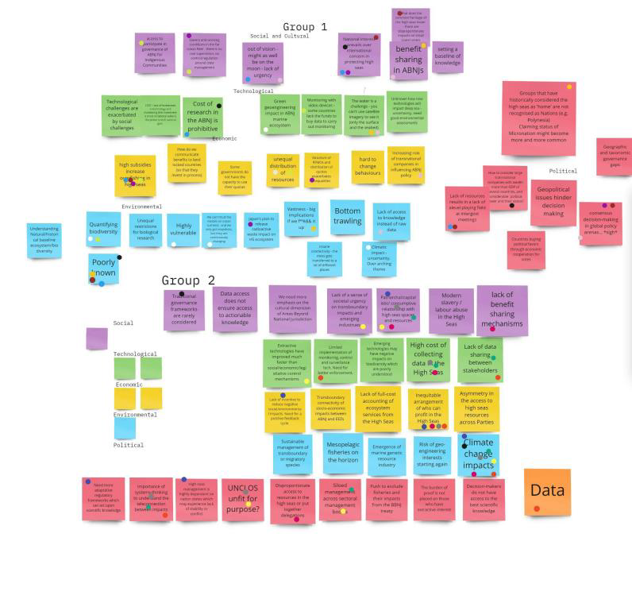
Figure 2: Challenges prioritised by participants, across each of S.T.E.E.P. categories in both workshops; there was some overlap (e.g climate change) in the challenges identified across the break-out groups.

Session 3: The participants all returned to the main meeting room from their breakout rooms and did a further prioritisation exercise on the 10 combined challenges (top 5 from each breakout room) based on their relative importance and effort to address . This time participants voted by placing their dot on an axis (Figure 3). The voting resulted in a prioritisation of challenges that were most important and also the hardest to address. The reasons why addressing a challenge may require more or less effort were left open to interpretation and could be related to political will, technological capabilities or costs. Since two replicate sessions of Workshop 1 were conducted, a total of 20 high seas challenges were identified and prioritised ([2]).
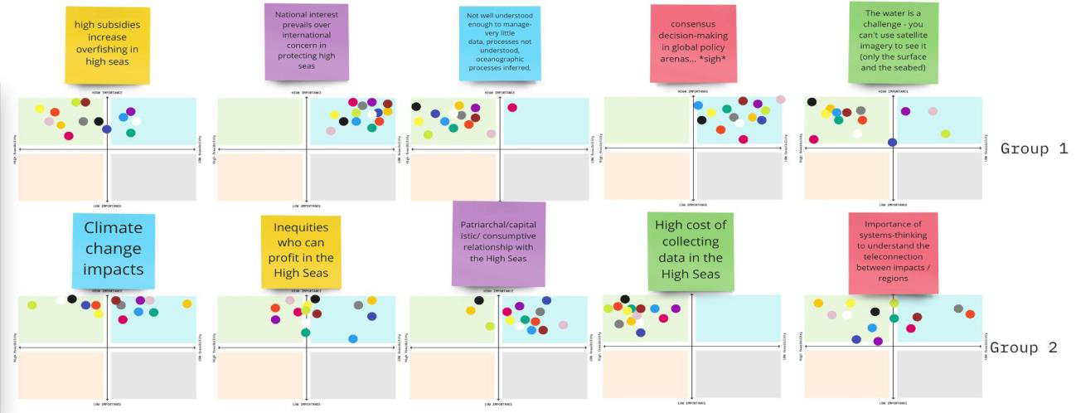
Figure 3: Index of importance (y-axis) and effort to solve (x-axis) for the top-10 challenges in one of the two workshops.

Post-workshop Thematic Analysis
While the discrete categorical framework provided by S.T.E.E.P. was intuitive and practical for the purpose of identifying challenges during the workshops, participants emphasised the cross- cutting nature of many of the challenges identified. After the workshop we collated all the challenges and conducted a thematic analysis to cluster the challenges again and identify alternative thematic areas.

Online Workshop 2 (Horizon 3) - Seeds of Innovation & Future Scenarios

The aim of this workshop was to explore the Third Horizon through imaginative worldbuilding and storytelling methods. Participants co-designed futures in line with the three different corners of the Nature Futures Framework: Nature for Nature, Nature as Culture and Nature for Society. The main method for story building follows a similar protocol to science fiction prototyping, which brings scientific and objective empirical understandings of the world into dialogue with imagined seemingly implausible futures[3].

A core objective of this workshop was to overcome current mental models and transcend ways of thinking that tend to extrapolate and reinforce the status quo[4]. This required enabling the freedom to think and try what may seem impossible, despite the constraints of being in an online environment. This is an important challenge in doing visioning exercises because, while creativity is an ability that humans have the potential to develop, it requires a series of personal and contextual conditions (traits and environment) and a proactive and intentional exercise[5], especially because it is aimed at challenging existing norms and processes as a way to bring forth something new[6]. In line with this, the workshop structure was planned around a series of steps that could depart from current knowledge in order to then transcend it and enable a collective creative process. This process was facilitated by the design of a generative tool[7] in the form of virtual worksheets on Miro. Three spaces were developed with the aims of: synthesising participant’s contributions, supporting facilitation and conversation, and the possibility for participants to develop a storyline based on previous contributions. In addition, creativity is also influenced by non-rational processes such as emotional states or intuition[5]. To this end, the facilitators made use of inspirational images, music and multiple references to visual or other sensory qualities: colors, shapes and smells.

Workshop 2 took place on 13th and 15th September 2021 with a pilot run on the 8th September with a smaller group who couldn’t attend the other workshops. It began with a welcome to the participants and a recap of the 3 Horizons Framework and Nature Futures Framework. The facilitators asked participants to put aside the challenges discussed in the first workshop and instead enter a mindframe more conducive to creating radically transformative future scenarios. The workshop was again organised into three sessions.

Session 1: As homework, each participant had completed a questionnaire asking for them to submit a seed- a process, initiative or way of seeing the world that was currently marginal, but that they thought could contribute to a better future for the high seas[8]. In the first plenary session the participants explained their seeds and the mature condition of the seed. An artist had created some seed inspired artistic representations capturing some of the aesthetic, visual and metaphorical features described by the participants (For a detailed description of the seeds, please see Workshop Report 2[9]). As participants introduced each seed, they were arranged at each NFF corner using a collage-based method inspired by an exquisite corpse surrealist game[10] (Figure 4). The adoption of this technique was meant to inspire and trigger the participant’s minds beyond familiarity and into a space of possibility, setting the stage to allow for playful exploration and collective imagination. The arts-based method of collage enables a logic that can enable multiple and plural significations or associations, as it challenges “all dogmatisms” and the need to search for one truth[11]. The resulting fragmented and fantastical assemblages were shared back to the participants with a short presentation of the artist’s outcomes and thought process.

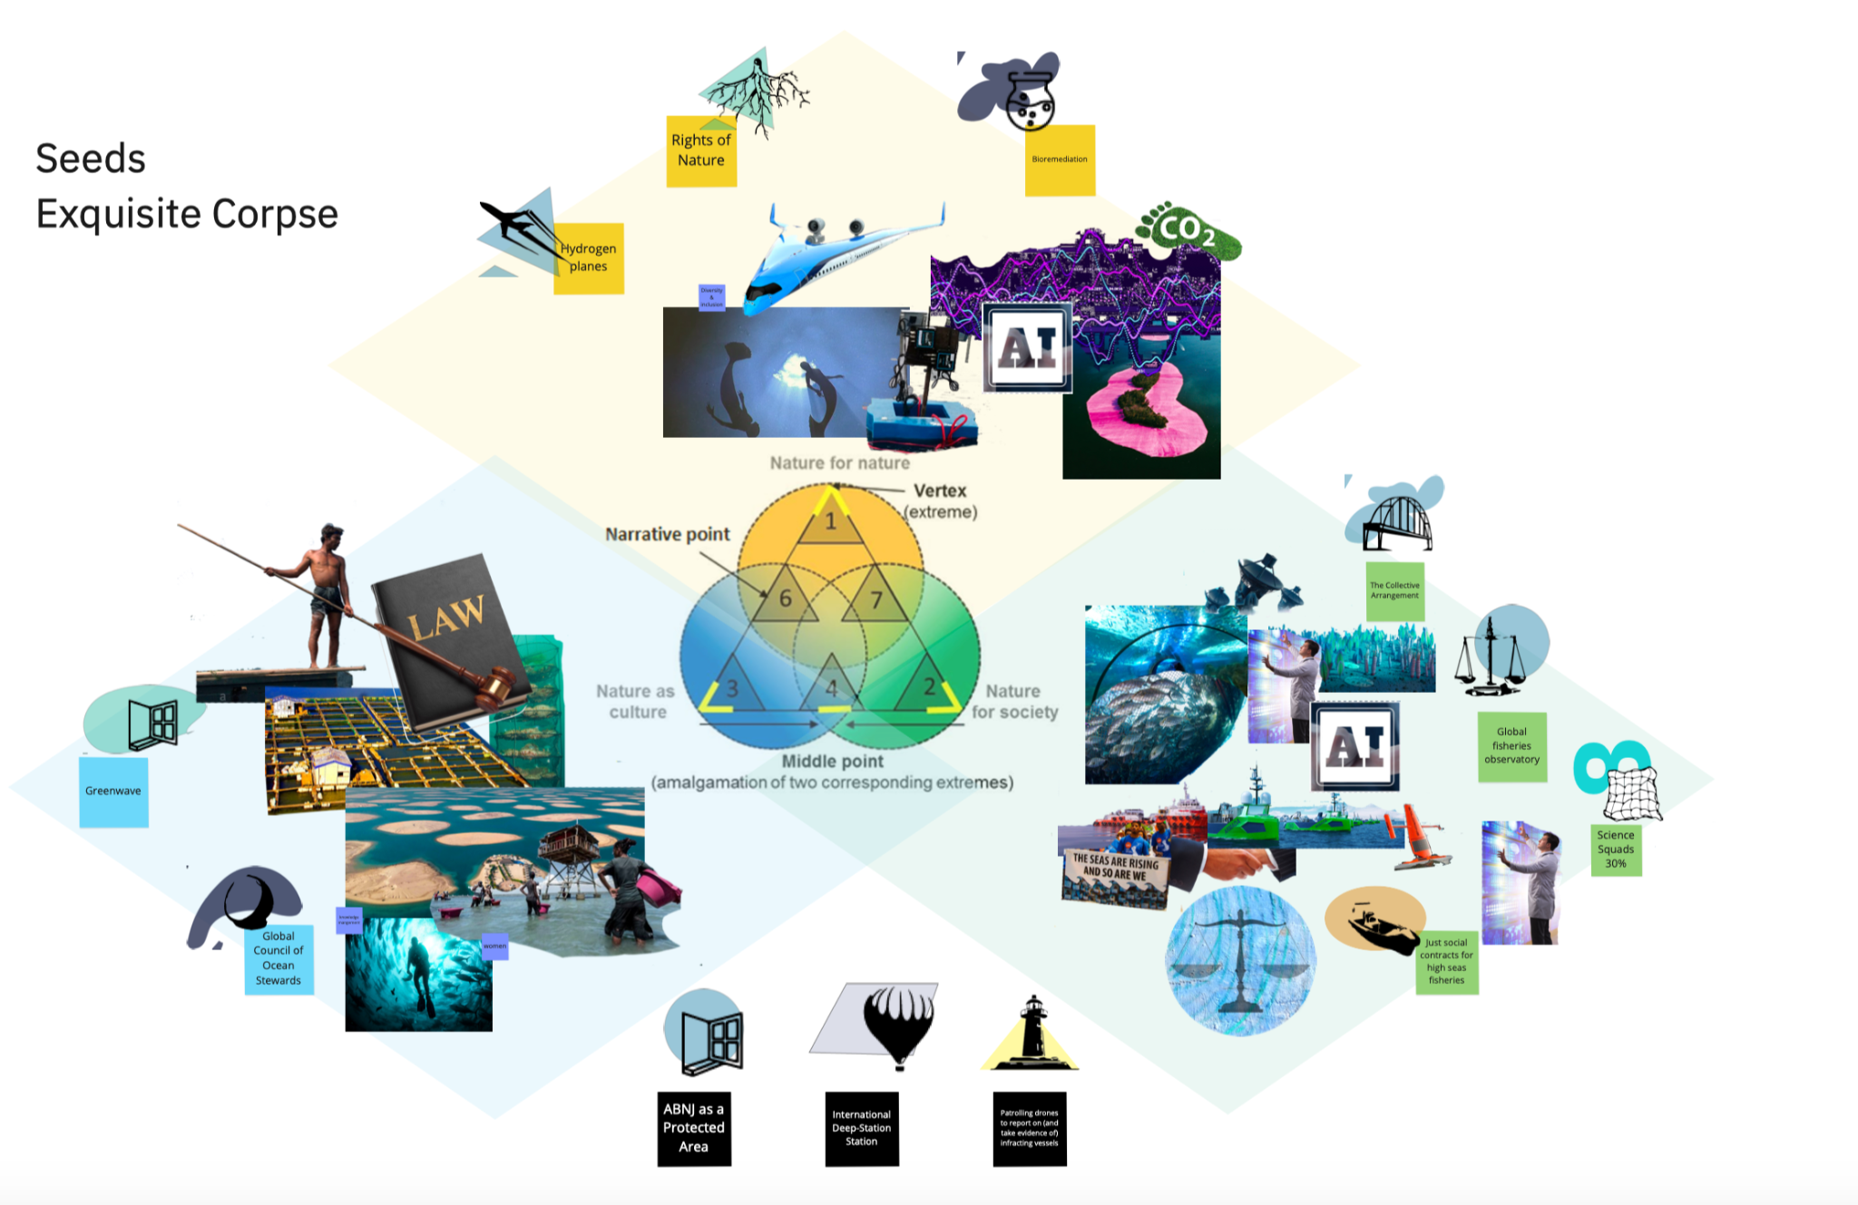
Figure 4: View of the assemblages resulting from the exquisite corpse-inspired technique

Session 2: Participants were then allocated to a breakout room (one for each corner of the NFF: i.e nature for nature, nature for society or nature as culture) based on how well their seed connected to that value perspective. Each breakout room consisted of a facilitator and a note taker team and the participants. The facilitator guided the team through a discussion of what a future world would look like with the mature seeds and asked them what else would be needed to create this ideal world. This section of the workshop focused on a worldbuilding exercise that prompted participants to characterize, imagine and describe a future world. By asking participants to reflect on changes by means of five lenses such as technology, politics and governance, social norms or ecosystems, the group members and facilitators could build on each other’s ideas to give shape to an outline of a world that was solid enough upon which to later layer a narrative. Towards the end of the session, the group was asked to close their eyes and try to imagine the world that had been created and to name the sights, sounds and smells they would experience. Finally, a name for the new world was discussed and decided on. Naming the world was meant to help the group agree upon the vision while acknowledging it as a collective creation that could be easily described or remembered.

Session 3: The breakout room groups reconvened after a break and began a science fiction prototyping exercise. The facilitator led them through the story building using six prompts i.e “Every day...”, “Until one day...”, “Because of this...”, “Then that...”, “Until finally...”, and “Ever since...”. The stories began with the group on board a research vessel named “the Manta'' and with each one of them having a role and tasks. Using the story prompts the narrative was fleshed out (Figure 5). In order to push the participants to think about a much more radical, far future, seven characters were developed, each with a bit more of an affinity to a particular NFF corner (See Appendix 1 below ). Each group rolled a dice to see which of the characters they would encounter in their story, and develop the narrative accordingly. The group told a story of how their everyday life on the Manta is disrupted by an event, their meeting of one of the main characters, how they resolve problems and how they adapt and evolve to further protect their worlds.
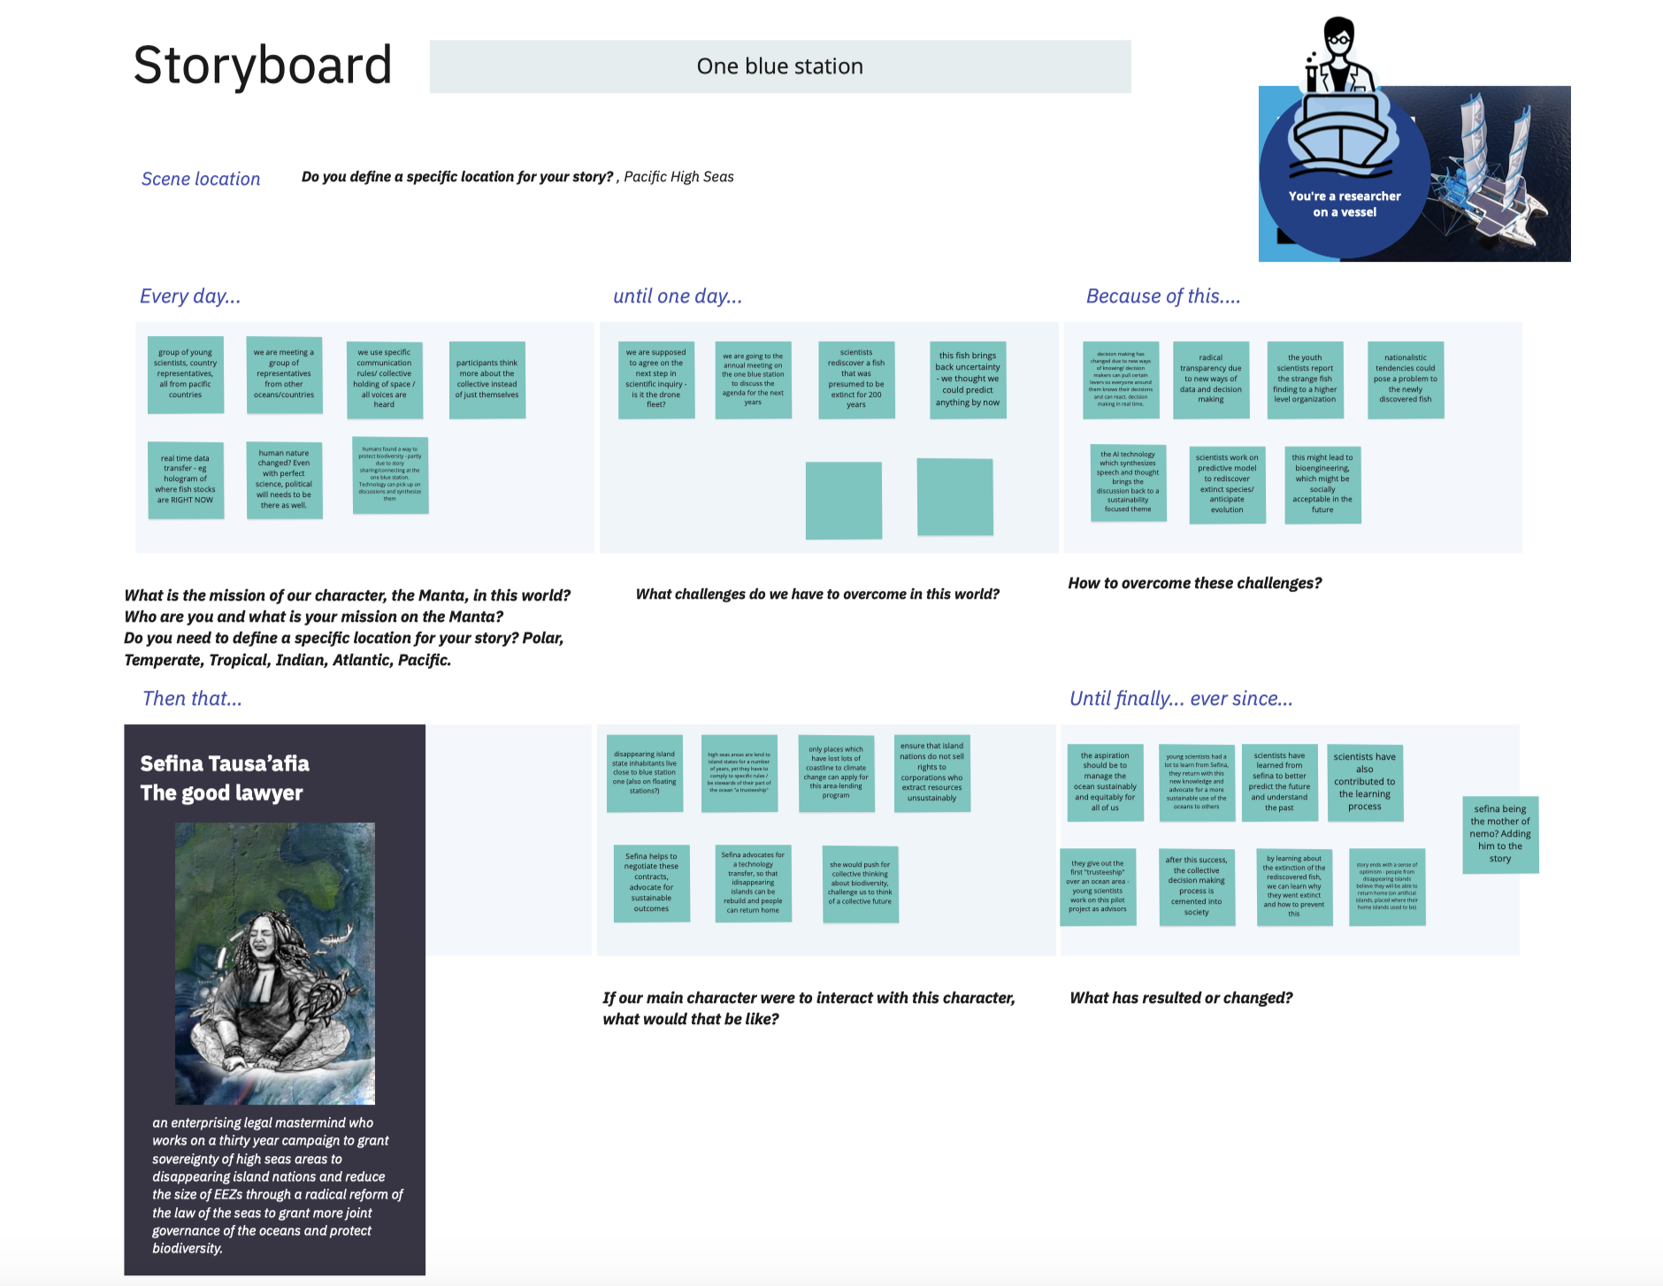

Figure 5: Example of a storyboard from the One Blue Station group

After the workshop, the stories were written up into a complete narrative, and key dynamics were drawn from each story [9,12].

Online Workshop 3 (Horizon 2) - Transformational Pathways & Leverage Points

The final online workshop was a precursor to the in-person meeting. Here, participants started by placing the challenges and drivers on the ‘iceberg model’ (i.e. categorising according to what is an event, what are patterns of behaviour, what is a systems structure and what is a mental model) The final online workshop was a precursor to the in-person meeting aimed at initiating a conversation on what sort of pathways could address the challenges identified in workshop 1 to get to the futures described in workshop 2. The starting point for this workshop was the ‘iceberg model’ where the group categorised the challenges as events, patterns of behaviour, systems structures and, at the deepest layer, mental models (See Figure 6 [13]. This generally follows the leverage points approach where deeper points of leverage are linked to paradigms and mental models [14]. Based on this categorisation, the group chose challenges that they wanted to unpack for the first session of the workshop. These challenges were: Lack of regulation and enforcement, consumptive relationship with the high seas, and decision-making in the high seas.
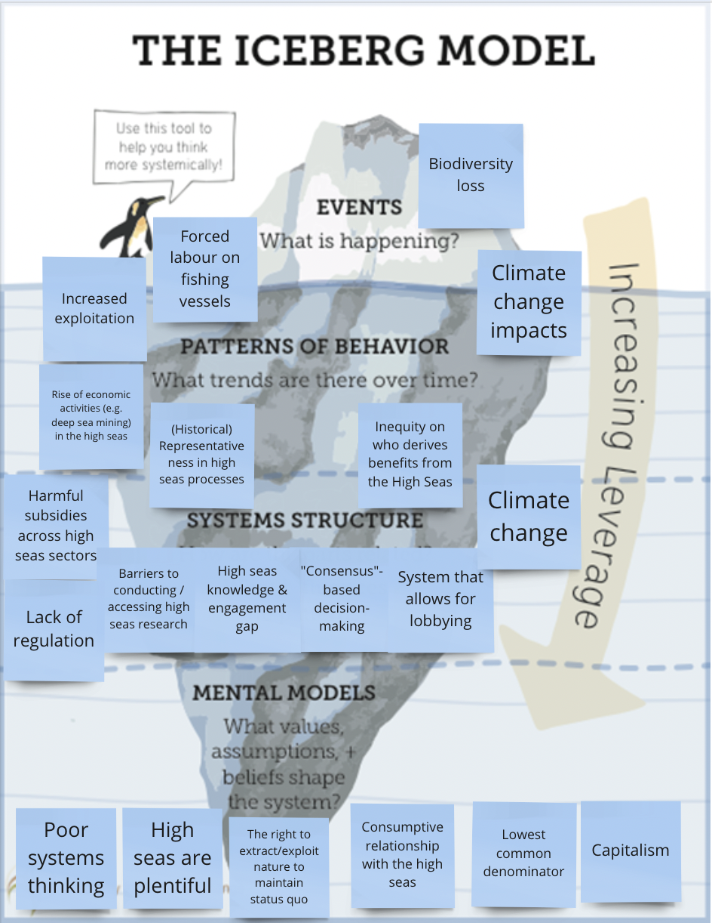
Figure 6: An example of mapping the challenges onto the iceberg model

For each challenge, the direct and indirect drivers as well as the relevant actors related to the challenge were mapped.Then, the potential responses to address these drivers and the responsible actors that could enable these interventions as well as potential barriers to these responses were identified (Figure 7). The second session focused on choosing the seeds that are most relevant for addressing the identified challenges and to map what needs to be done to enable the seed to grow (enabling conditions), who needs to do this (actors), and what the barriers to the seed growing are. Finally, to summarise, the most important ideas from the group discussions were all placed on the ‘three horizons’ diagram to illustrate what needed to be done for the current system to decline (addressing present challenges in Horizon 1) and for the future system to grow (enabling the seeds in Horizon 3) (Figure 8). Some of the same mechanisms were needed both to make the current system decline, but also to enable the preferable future system to grow. Based on this categorisation, two challenges that the group wanted to work on were identified and the rest of the workshop was spent discussing how these could be addressed. Firstly, all the relevant actors related to the challenge were mapped, then the indirect and direct drivers of the challenges and finally the potential responses to address these drivers and the responsible actors that could enable these interventions. Potential barriers to these responses were also identified. The responses were then placed on the leverage points figure to see how deep of a transformation they might enable. The most transformative interventions were placed on the second horizon of the ‘three horizons’ figure in chronological order. The second session focused on choosing the seeds that are most relevant for addressing the identified challenges and to map what needs to be done to enable the seed to grow (enabling conditions), who needs to do this (actors), and what the barriers to the seed growing are. These were then also placed on the ‘three horizons’ diagram and there was a realisation that some of the same mechanisms were needed both to make the current system decline, but also to enable the preferable future system to grow (Horizons 1 & 3).

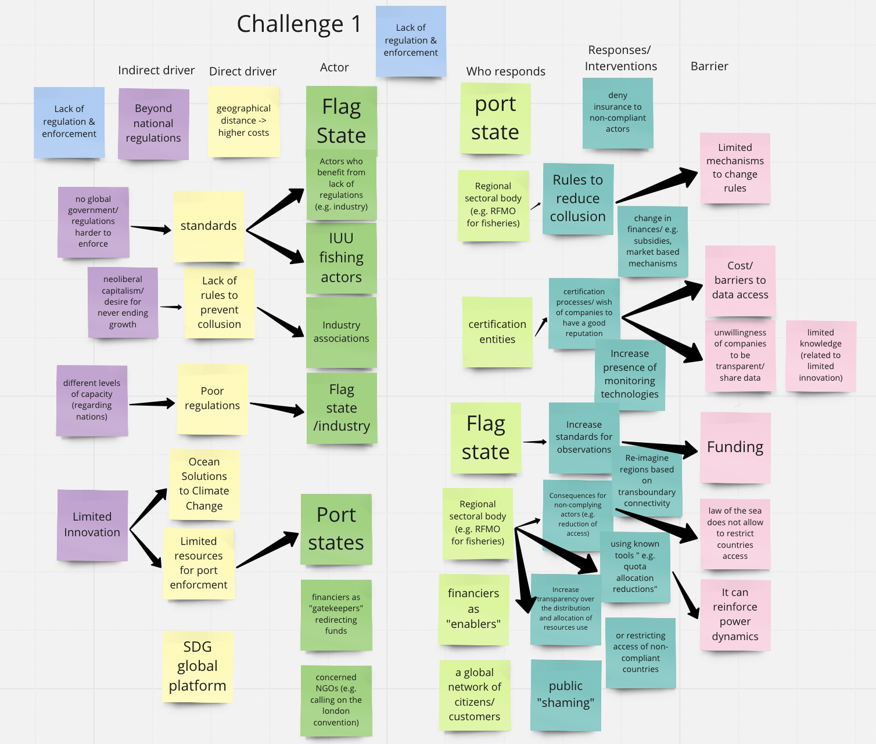
Figure 7: An example of mapping the actors, drivers, responses and barriers for each challenge

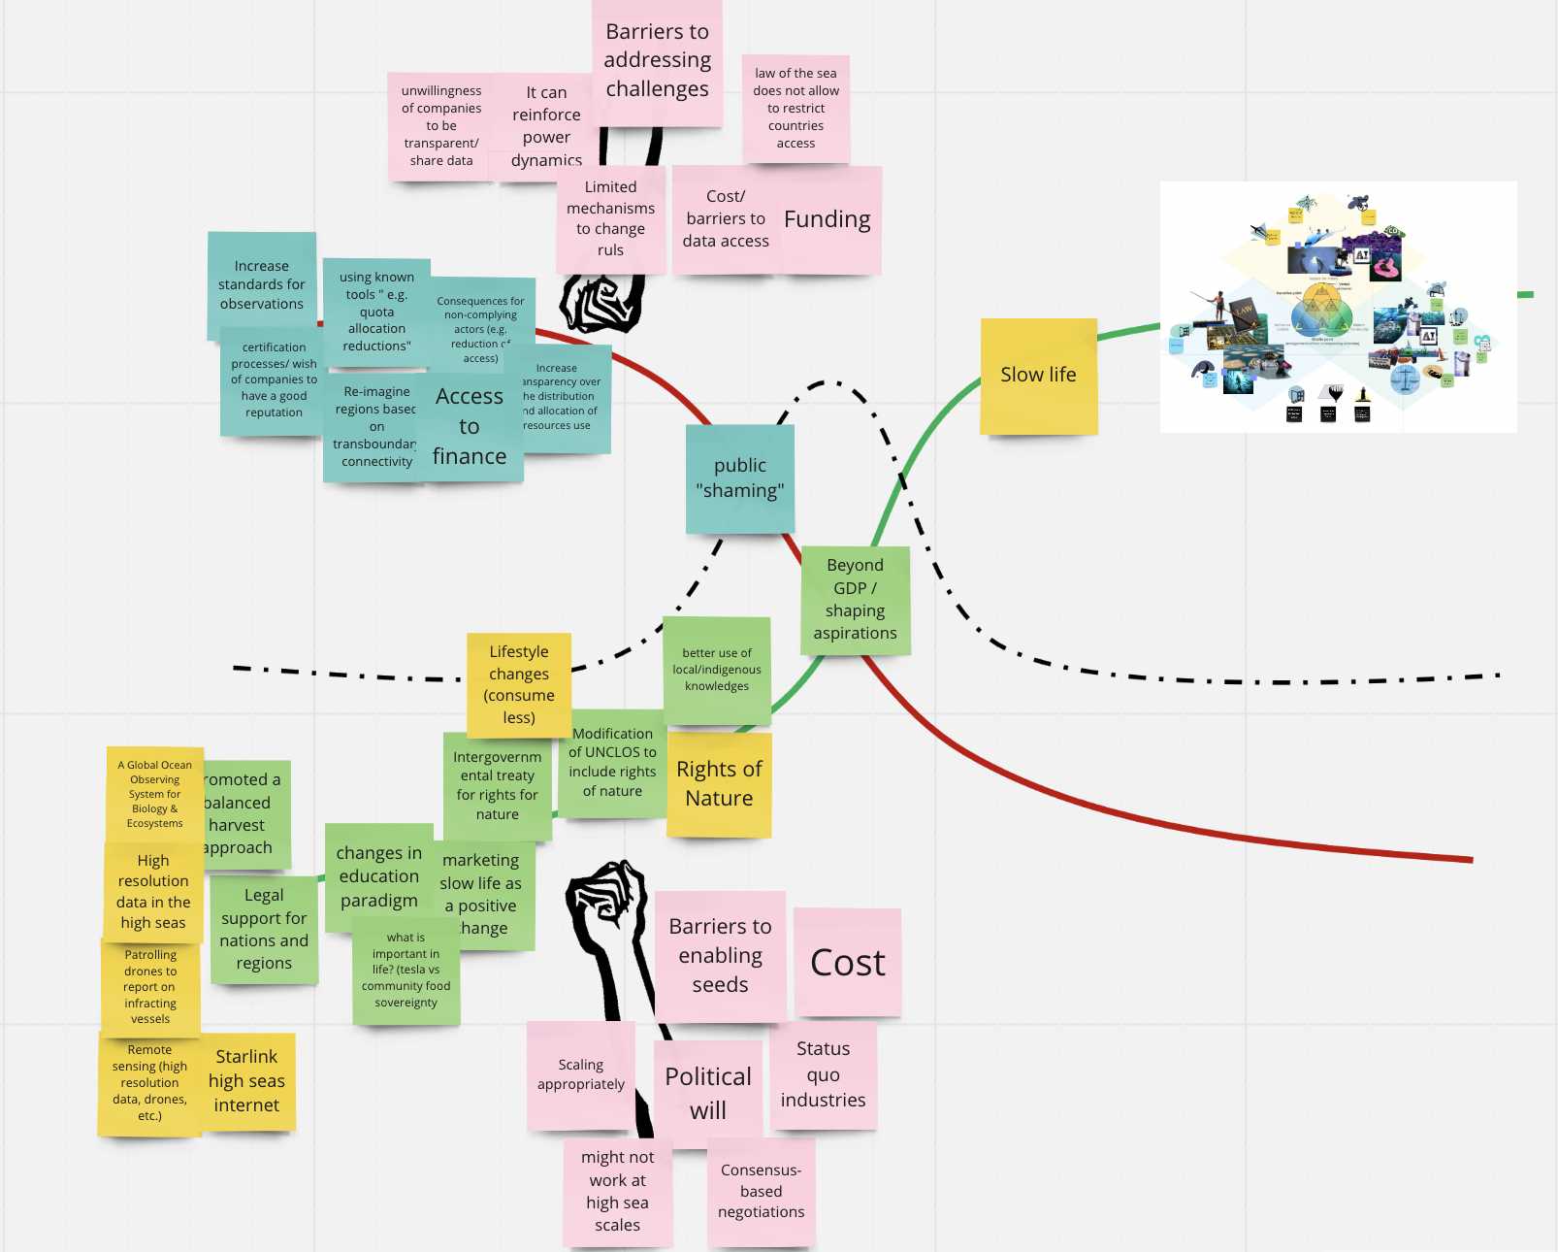
Figure 8: Mapping the interventions on the Three Horizons diagram and the potential barriers to allowing the system to decline and to enable the future system to grow.

Time was a constraining factor in the workshop and so the outcomes of this process were used as inputs into the in-person workshop rather than as an output in and of itself.

In-person workshop 4: Cape Town 2022

A smaller group of participants who were able to travel met in Cape Town from 28th February - 3rd March 2022. Six participants representing research, governance and practitioners and the two co-convenors met at Monkey Valley resort, Noordhoek, Cape Town for 4 days of intensive workshopping to finalise the scenarios that were emerging from the process. As this was an intensive process, not only for the work that needed to be done, but also as one of the first in person meetings after the pandemic lockdowns had been lifted, each morning started with a check-in to see how everyone was feeling and social events were organised for every evening.

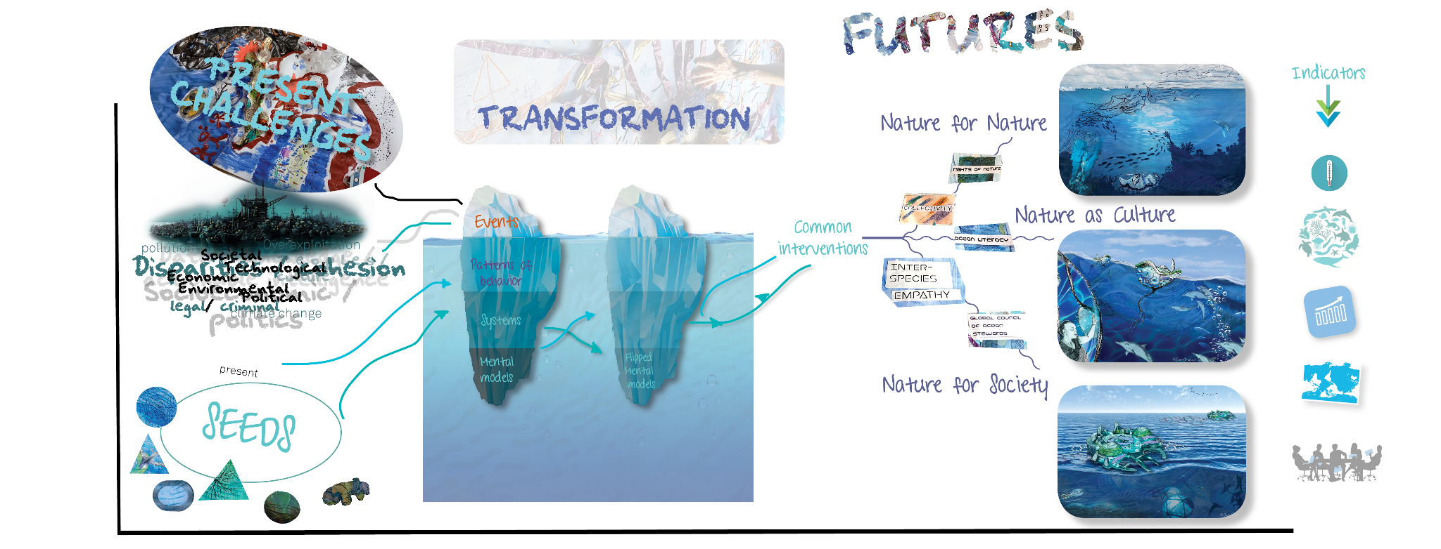
Time

Figure 9: Overarching process adapting the three horizons framework. Starting with challenges and seed ideas in the present (left side) and then moving through a transformative process of flipping paradigms through the iceberg model (middle), that offers the common starting points for the three more preferable futures to emerge on the right and brainstorming the indicators that would be needed to measure progress. Source: Authors’ own.

Day 1: Recap what had been done and decide whether the three final vision endpoints were chronological (ie as they had been written, the Nature for Society story happened before the Nature as Culture and the Nature as Nature was furthest into the future) or whether they were three deviating endpoints. This required a lot of discussion and it ended with a World Cafe process where three sub-groups steadily built on descriptions and indicators of each of the stories. It was decided that to stay true to the NFF, it was best to design three endpoints that deviate from each at different points along a timeline rather than happening chronologically.

Day 2: Return to the challenges by combining the iceberg models from the two final online workshop sessions and see whether there were any additions that needed to be made. Realising that it was going to take too long to unpack specific intervention pathways to address each of the challenges, as had been started in the online Workshop 3, instead an appreciative enquiry approach was used whereby the ‘bad’ mental models of the present were flipped into an alternative iceberg model that could be used as basis for developing the three final stories[15,16] (Figure 10). It became clear that it was necessary to have these as a common starting point from which the three stories could then emerge and that further work would need to be undertaken to see how the ‘flip’ could be enabled. This reasoning aligns well with the IPBES Task Force on scenarios and models methodological guidance that refers to common features that are needed to get ‘into’ the normative space of the NFF before it is then possible to outline specific features for the corners.

The larger group broke up into two. One group focused on plotting out interventions from this ‘flipped iceberg’, (which became the basis of the Horizon 2 pathways) to get to the three divergent futures, i.e. what features needed to be common to all and what were differentiating interventions that characterised the different stories developed in the online workshop 2. The other group brainstormed indicators and models for each of the storylines, for example unpacking what kind of metrics would need to be developed to create inter-species empathy.

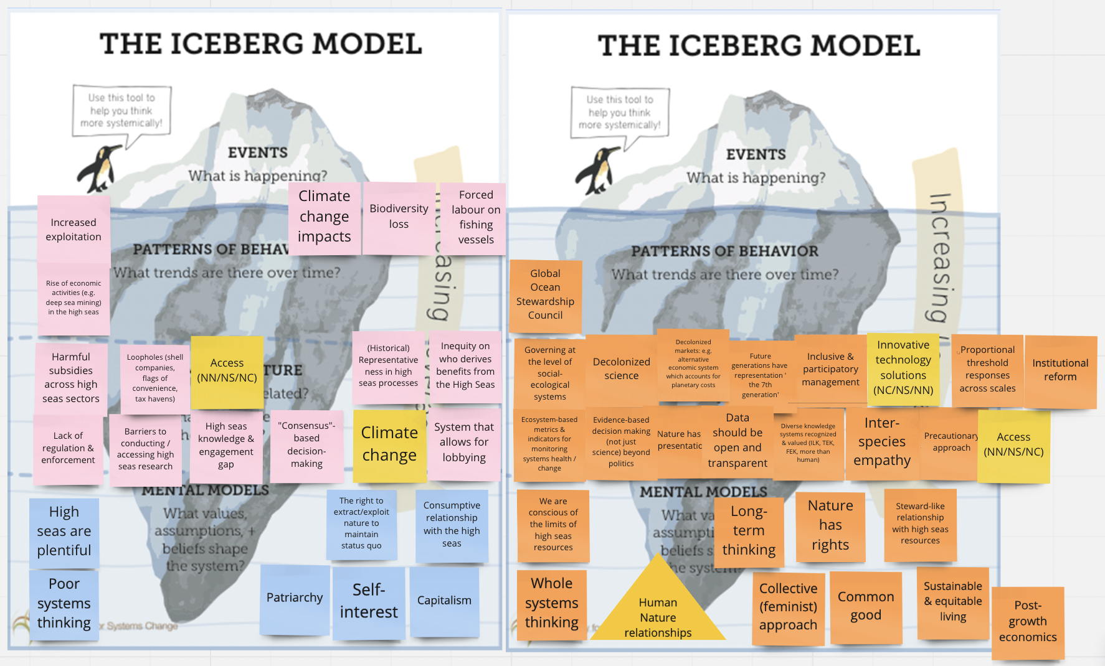
Figure 10: Iceberg model with the problems of the current system on the left and the reimagined future using appreciative enquiry on the right

Day 3: Each group finalised their work and then the afternoon was dedicated to an immersive artistic experience facilitated by Claire Creative and documented by Sandile Fanana. Using paint, strong material and junk items, as a group we co-created a visual representation of each of the Horizons, starting with the chaotic challenges in Horizon 1 (Figure 11) and then the calming end point visuals of Horizon 3 (Figure 12) and then through a performance, enacted how the transformation from one system would need the current system to break down and allow the alternative future to emerge (Figure 13). This shared creativity allowed the group to land in a similar understanding of what the journey from the present to the alternative futures could look like and made it easier to agree on the specific pathways.

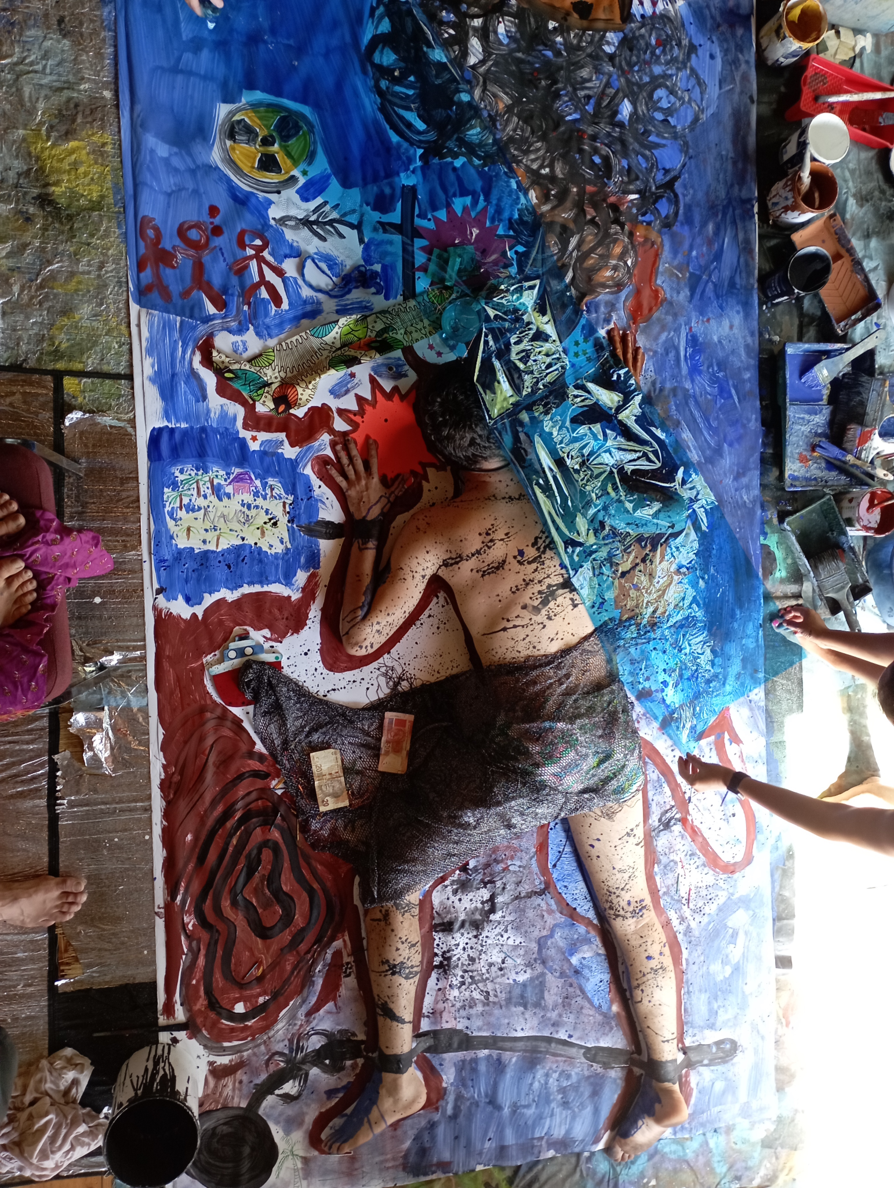
Figure 11: Painting Horizon 1: Present Challenges
“Climate change, increase in storms, heatwaves, nuclear waste/war, overfishing, refugees/migrants/oppressed people, islands submerged, mutations of uncared for species, sad picture, money wasted, lost communities, humanity shackled to a dependence on fossil fuels, capitalism, plastic pollution, downward spiral, media pretends it’s not happening, money driving everything, noise pollution, corals are dying, addictions, slaves, trapped in bad habits, explosions, motivated by greed. Many colours = chaotic difference.”

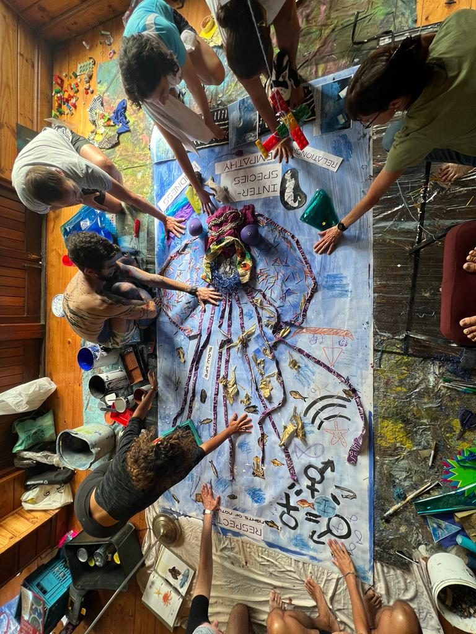

Figure 12: Painting Horizon 3: Future Potentials
“Positive direction, room for everyone and everything. Based on respect, empathy and kindness, human to human and human to nature. We have broken inter species communication barriers, using technology for good, what does biodiversity want for its future, redistribution of justice for human and non-human, using technology for good, humans are supporting nature now rather than eroding it, we have transitioned from a fast life patterns based on capitalism to a slow life community pattern, matriarchy. We are not naive and we will not repeat the same mistakes as the past, maybe there are unforeseen problems, new ways to harness energy in line with nature: accessible and equitable. Hope and light. Positive values, 3 streams: Nature, Culture, Society. Squid/Cephalopod inspiration: efficiently pump water and move in an unknown direction, but with purpose, intelligent beings that don’t take more than they need: a phosphorescence in the creature against the deep seas = a signal of hope. All cultures of the high seas are represented, resilience, preserving primordial forms of life, inspiring characters from our stories, learning and passing on knowledge. A peacefulness and quiet. A more enjoyable painting to make than the first. Relaxing and calming. Harmonious diversity. “

Day 4: Each sub-group shared the work they had done with inputs from all, reflected on the process and decided on the final outcomes of both the pathways and the indicators. Next steps in terms of what outputs would be most useful and a delegation of tasks closed the workshop.

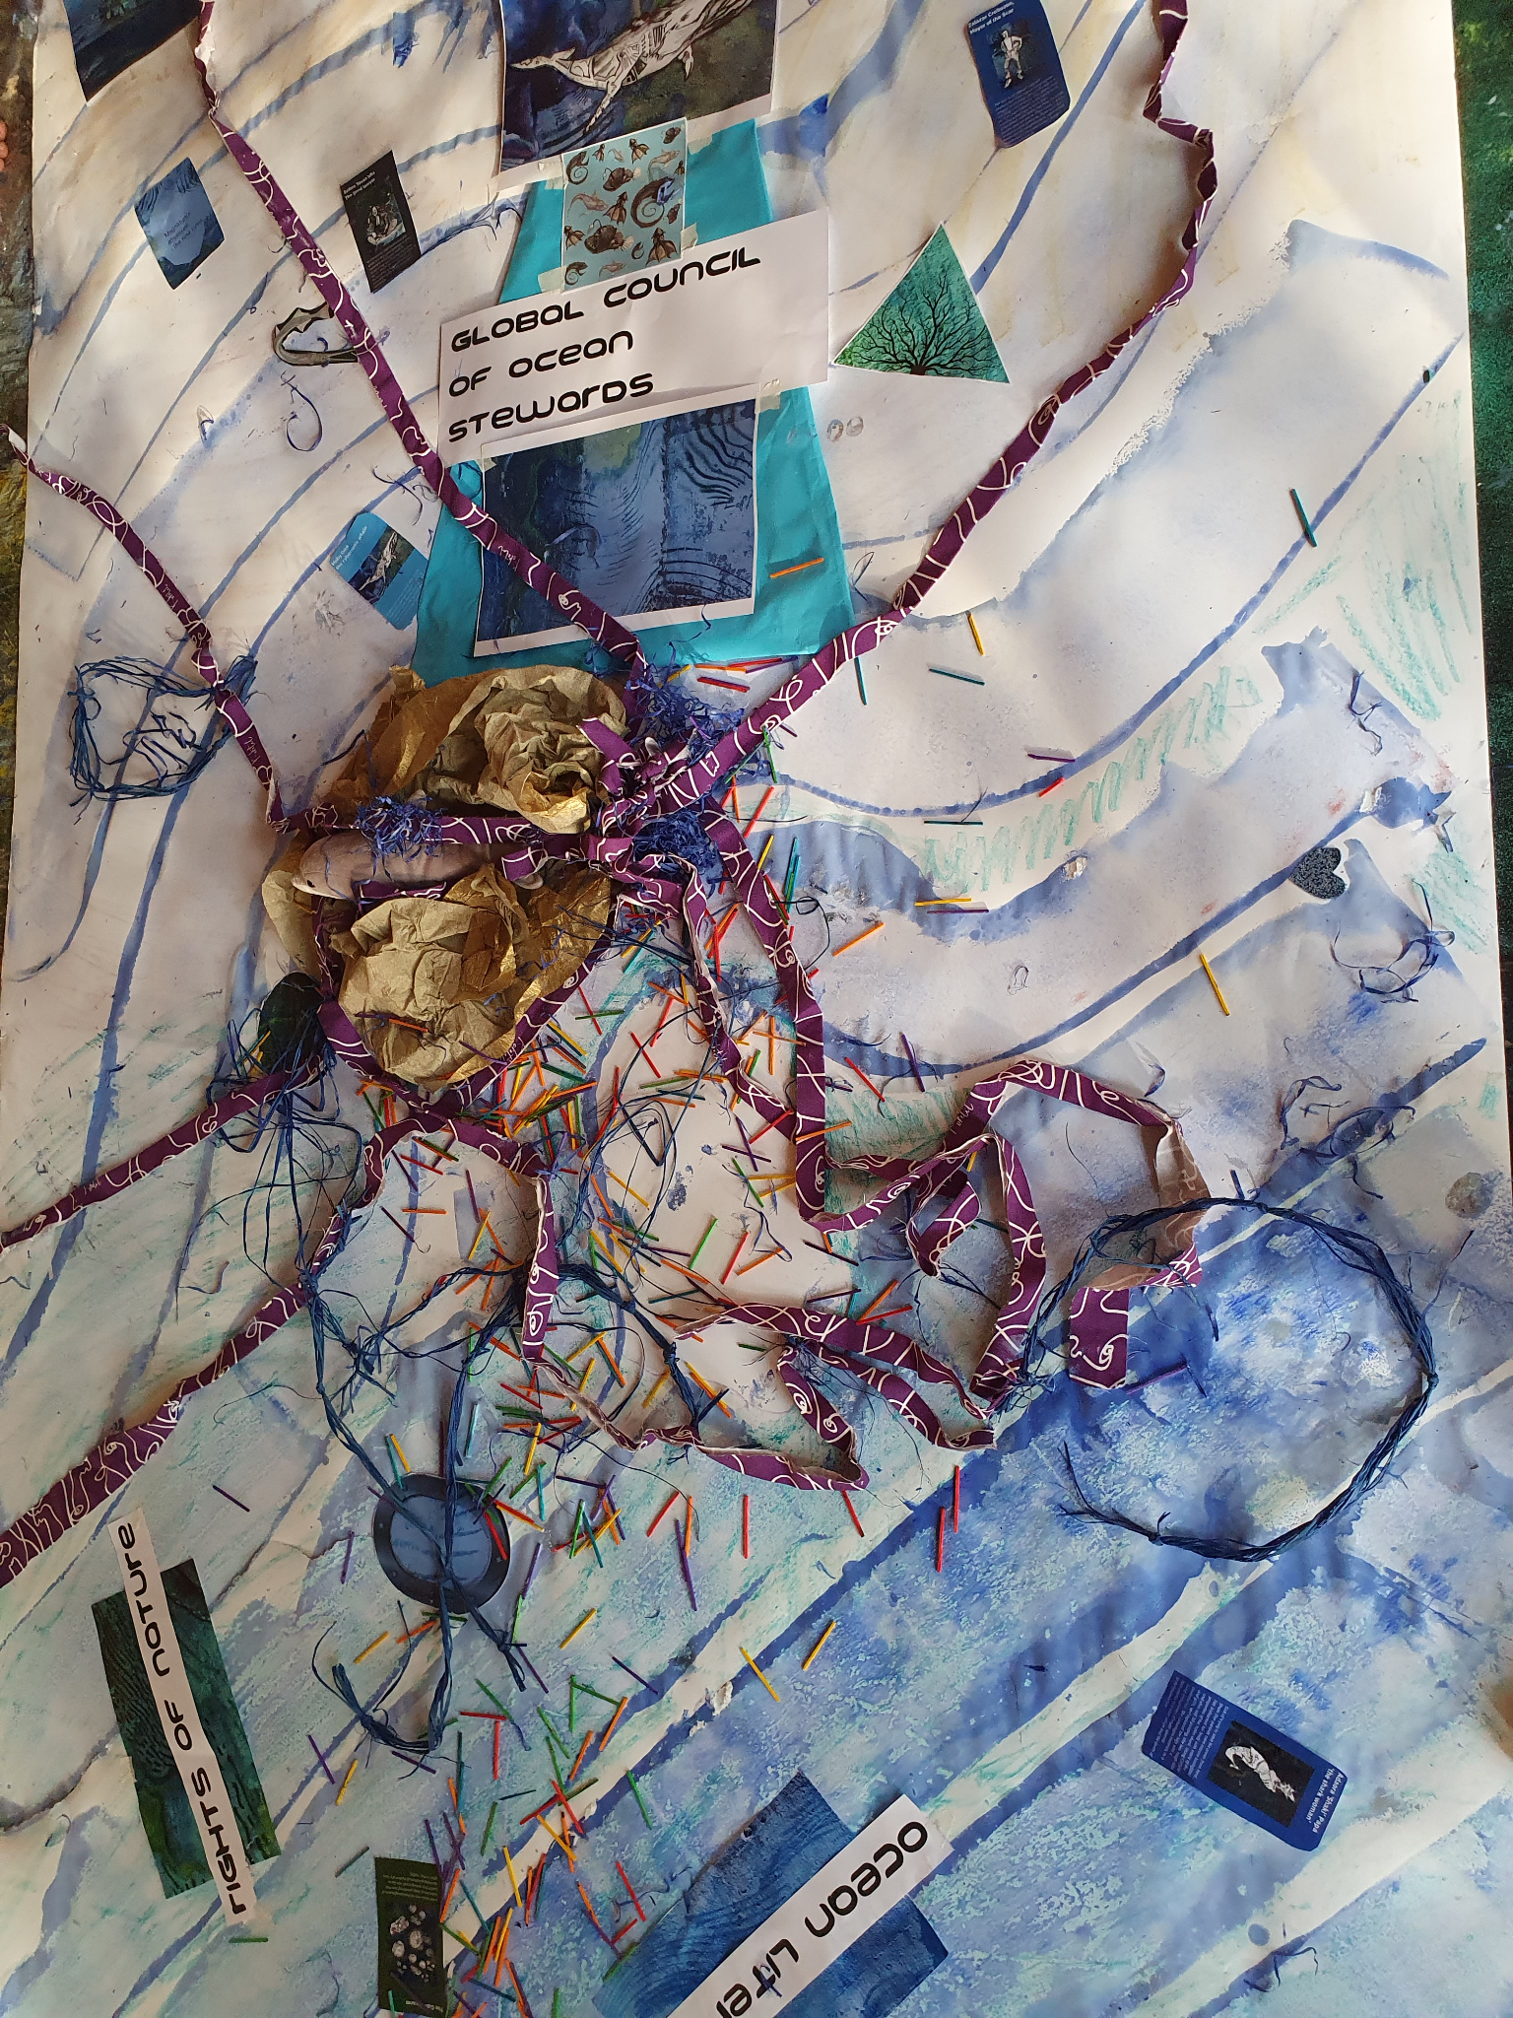
H2 video 1.mov

Figure 13, Video 1: Painting Horizon 2: Transformation… “Something is brewing, change is happening, shifts: movement. Symbol for transformation, towards a more collective future, a new global council of ocean stewards, involvement of existing arrangements that take responsibility for nature, culture and society. Love and harmony between nature and humans is beginning to expand. Change from the stomach (the emotions) from the first painting and then with the tools of logic and science we channel change. The feelings are the impetus for the eruption of change. Change coming in waves, Nature is at the centre, at the core. Collectivity was the base. We have to do it together, from a broken and nonfunctional planet to a whole and healthy one. Expanding in all directions. Nature will be fine without us, but we can’t survive without nature. What are we really aiming for? When we know then we can encourage change in that direction. We allow a different system of values to emerge, we promote these values for the next generation. We are making these tentacles as elements to hold onto (future visions) as things start to break down (the ripping starts to happen). Holistic Visions. Multiple tentacles/ multiple features/ ways existing simultaneously and the present breaks down. No hierarchy of possible futures but there are many, desirable, compatible with humans and nature despite their differences. Some characters along the paths to change are encouraging us. Waves of change, ripples in the sand = connections of love and harmony coming through. Global transformation. Maybe in the future there are not so many humans on the high seas: It is acknowledged as a global commons. We built on each other’s ideas and concepts as a way to attain a healthy future. If there is no collectivity then nothing can work.”

Appendix 1: Characters

Nature for Nature
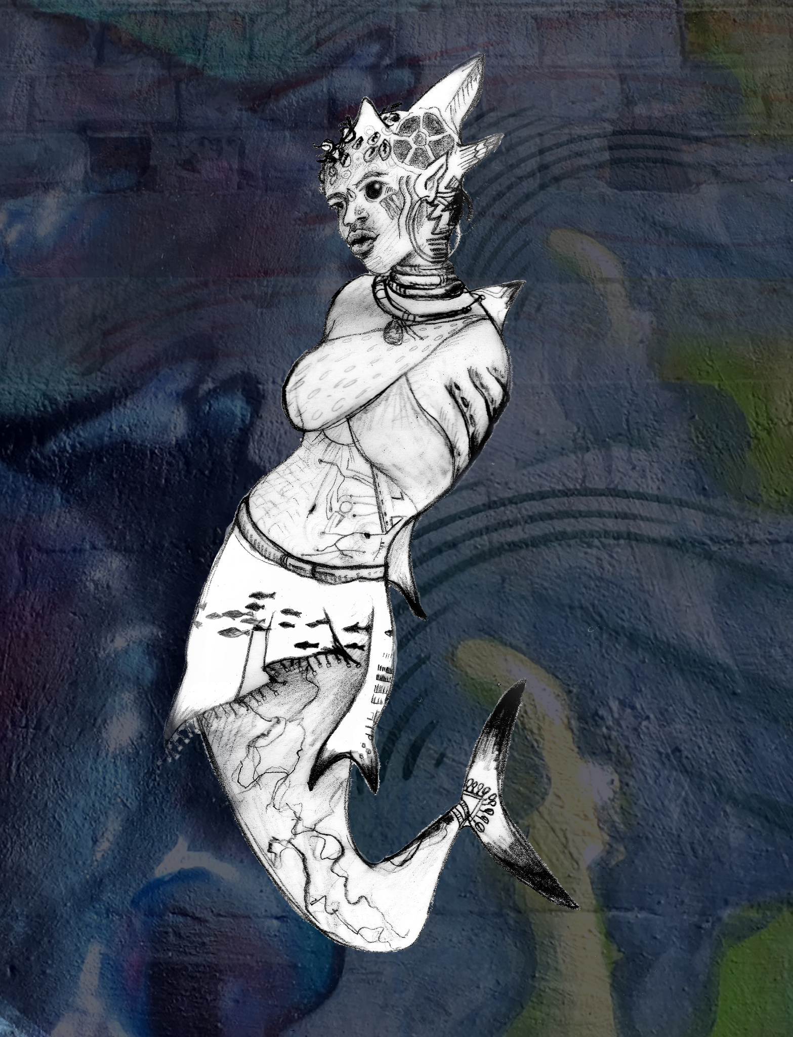
Adaora ​​’Shaki’ Papa ‘the shark woman’ - sick of trying to save the ocean from land, Shaki (her parents were marine biologists) has biohacked her body with many of the properties of the mako shark. Using CRISPR and stem-cell 3D printing, she has rough skin and replaced her legs with a powerful tail and gills. She campaigns tirelessly as a living embodiment of multi-species approaches to conservation and the death of anthropocentrism

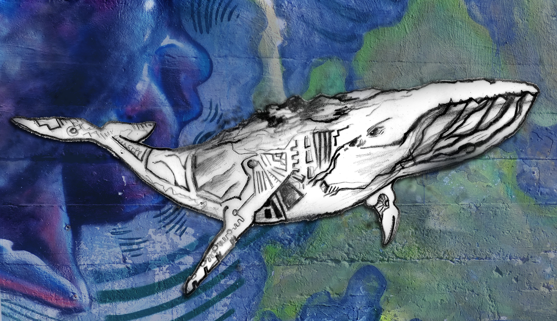
Moby Dick- the cybernetic whale whose skin, due to extensive cybernetic augmentation, is bleached white and has started hunting illegal fishers in the spirit of vengeance and terror - channeling the animus of the ocean

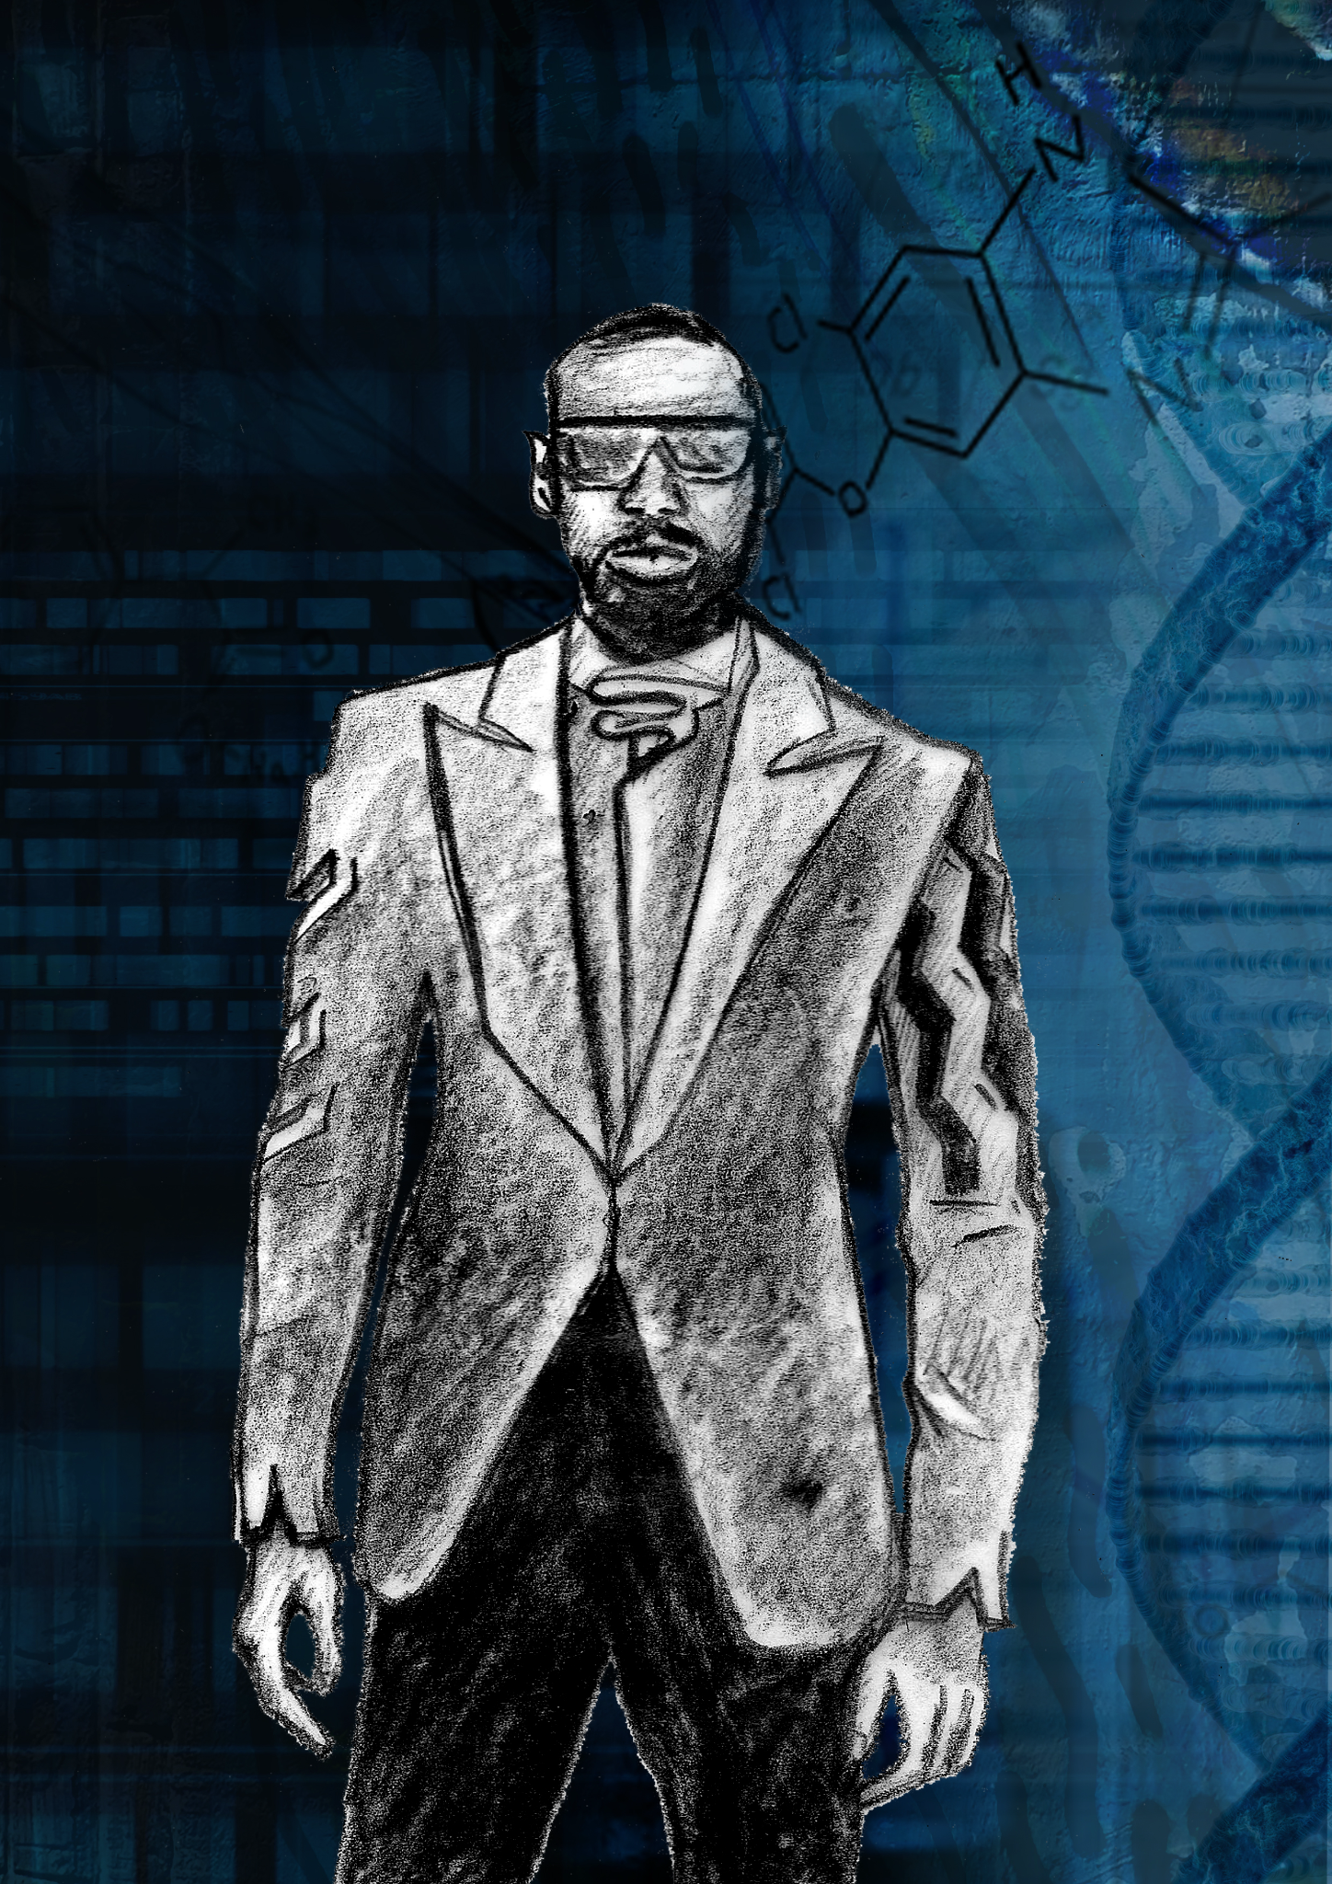
Nature for Society
Agent Nemo - A shady corporate spy that has an advanced deep sea submersible that strips genetic sequences from the deep ocean and sells them to the highest bidder for development of new biotech and pharmaceutical products.

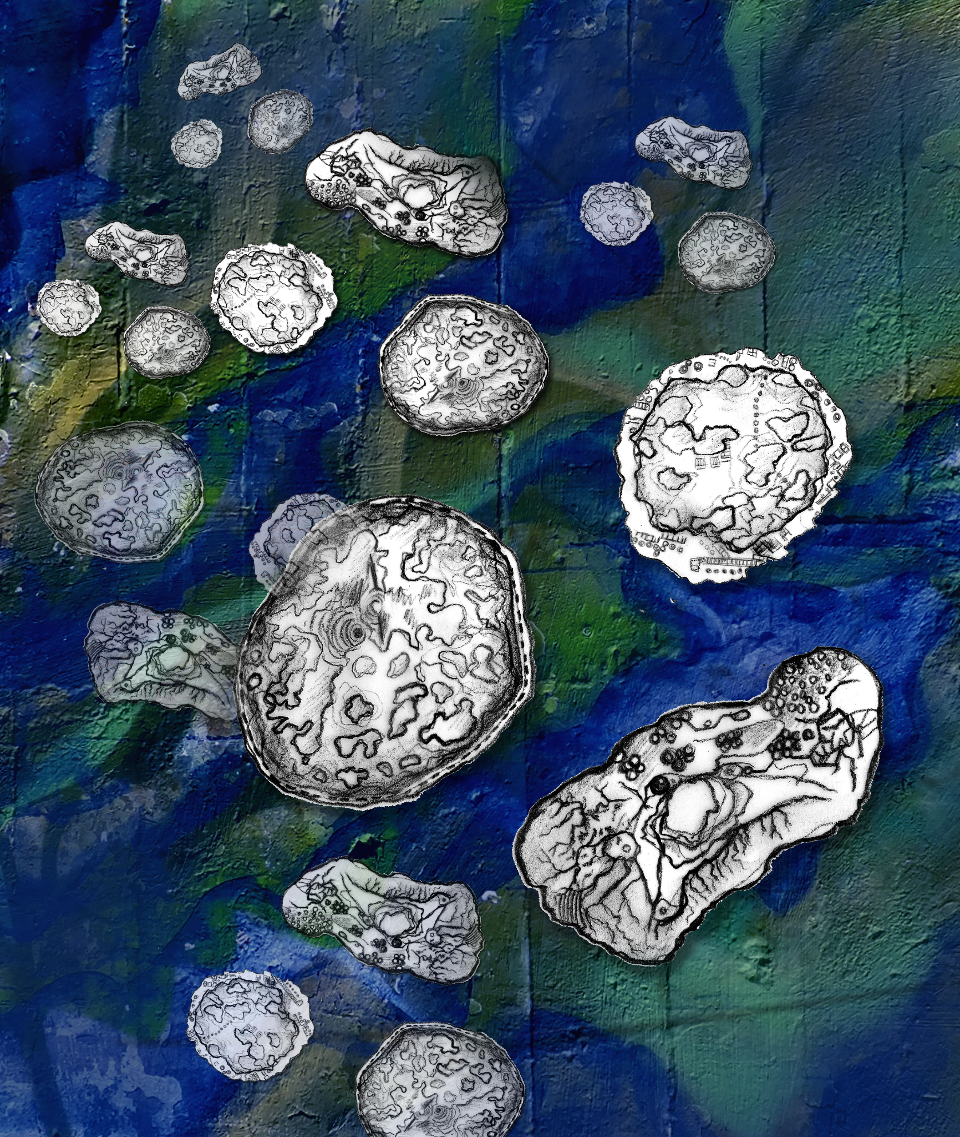
The Gaia Swarm - A self aware and self replicating swarm of autonomous deep sea mining bots that switch from mining cobalt nodules to becoming guardians of biodiversity via a glitch in their coding.

Nature as Culture
Caliban the Great, ‘the Tuna Herder’- a mysterious figure in a bright purple boat that follows schools of tuna throughout the high seas, constantly monitoring their state via surveillance drones and keeping away predatory fishing fleets as the tuna move between EEZs.
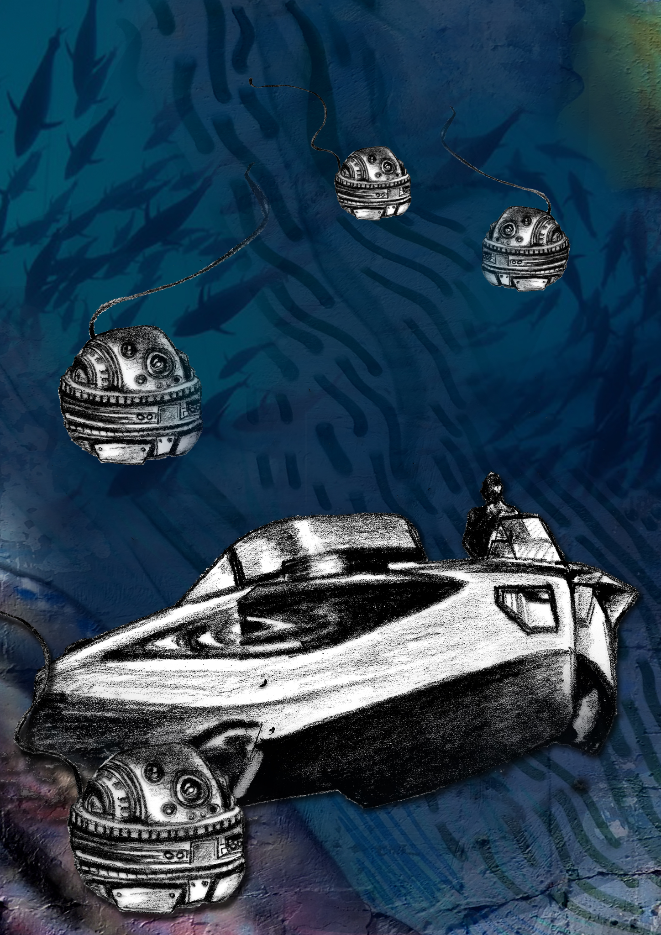

Zalazar Crobuzon, Mayor of the Scar: The scar is a flotilla of assorted mismatched ships representing climate refugees from across the pacific and from low-lying coastal areas. They gather and tie their ships together in the pacific gyre, building a floating city from their dilapidated ships and scrap from the great pacific garbage patch. They create a green anarchist solar punk city, floating on the ocean and growing their own algae which they process into novel biotech using floating bioreactors.
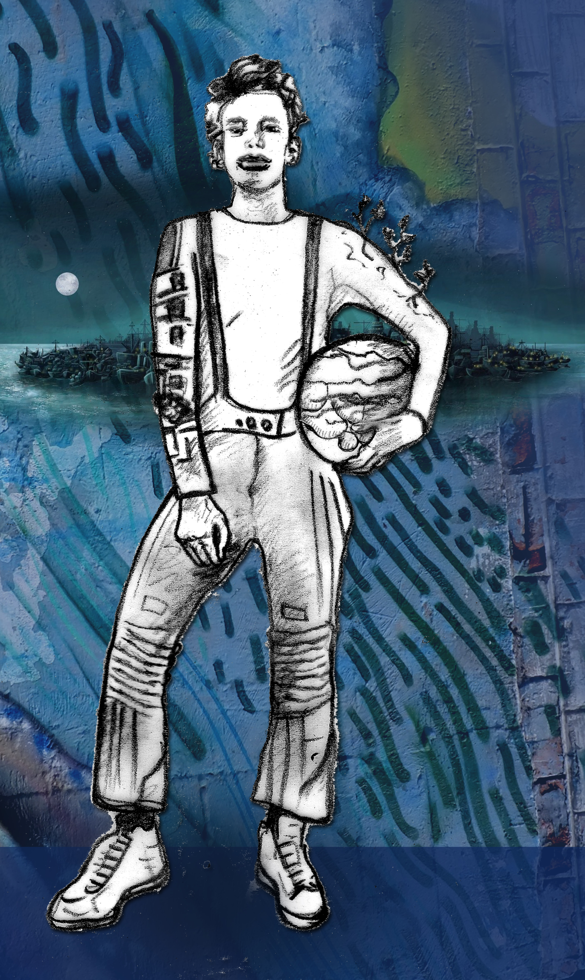

Cross-cutting
Sefina Tausa’afia - The good lawyer – an enterprising legal mastermind who works on a thirty year campaign to grant sovereignty of high seas areas to disappearing island nations and reduce the size of EEZs through a radical reform of the law of the seas to grant more joint governance of the oceans and protect biodiversity.
