Geochemistry, Geophysics, Geosystems
Supporting Information for
Evolution of a cold intra-transform ridge segment through oceanic core complex splitting and mantle exhumation, St Paul Transform system, Equatorial Atlantic
Clément Vincent (1a), Marcia Maia (1), Anne Briais (1,2), Daniele Brunelli (3, 4), Marco Ligi (5), Susanna Sichel (6)
(1) Geo-Ocean, UMR6538 CNRS-IFREMER-UBO-UBS Institut Universitaire Européen de la Mer IUEM, Brest, France.
(2) Geosciences Environnement Toulouse – GET, Universite Toulouse III - Paul Sabatier, Toulouse, France.
(3) Dipartimento di Scienze Chimiche e Geologiche, Università di Modena e Reggio Emilia, Italy
(4) IGAG-CNR, Istituto di Geologia Ambientale e Geoingegneria, Rome, Italy
(5) Institute for Marine Sciences CNR-ISMAR, Bologna, Italy
(6) LAGEMAR, Universidade Federal Fluminense, Niteroi, Brazil
(a) Now at: School of Earth and Environmental Sciences, Seoul National University, Seoul, Korea

Contents of this file

Text S1
Figures S1 to S3

Introduction
This supporting information provides the reflectivity map (Figure S1) of the entire surveyed area of the St Paul Transform Fault System in the Equatorial Mid-Atlantic Ridge, the southernmost Intra Transform Ridge Segment (ITRS3). The text S1 and the figure S2 present the details of the gravity models calculated in this study and the related figures. The figure S3 shows pictures of the rock sample COL-DR27-01 after A. de Brito (2019).

Figure S1. Backscatter image of the St. Paul ITRS 3, from multibeam echosounder data. Light areas are high-backscatter areas and darker areas are low-backscatter areas. The St. Paul ITRS 3 is bounded by the transform faults TF C and TF D (black lines). Black and grey lines show ridge axis.
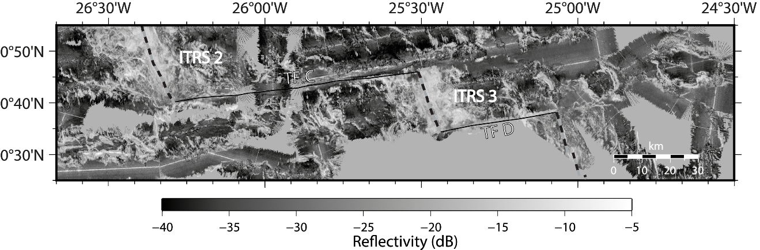

Text S1. Methods used for the gravity models calculation
To perform the gravity calculations, we proceeded following the steps proposed by Maia and Arkani-Hamed (2002) and already used and described in Maia and co-authors (2016). First, a free-air anomaly grid (Figure S2a) was computed merging free-air anomalies (FAA) obtained with the ship gravity meter and the satellite-derived free-air anomaly grid (Sandwell et al., 2014), and then we estimated the Mantle Bouguer Anomaly (MBA). Often, in the absence of seismic data, the models to estimate the MBA only consider two interfaces: the seafloor topography and the crust-mantle interface (Moho discontinuity). As good quality seismic lines were available for part of our area, acquired both during the COLMEIA cruise (Maia, 2013) and previous cruises (Gasperini et al., 1997; Udintsev, 1996), we chose to add the information about sediment thicknesses. To do so we digitized the seafloor and the basement interfaces from the seismic lines, therefore obtaining the sediment thicknesses (Figure S2b). The values along the profiles were extrapolated to the neighboring areas using visual control from the bathymetric maps. Where seismic lines were absent, the values were set to zero. Finally, the values were digitized and projected using an UTM projection, yielding a 1 km step grid. The procedure smooths the high frequencies and prevents the introduction of spurious signal. Where sediment thicknesses are zero, the model becomes a simple two layers one. Over the study area, sediment thickness values range from 0 to more than 800 m, with the thickest sediment being associated with the old portions of fracture zone basins (Figure S2b). The majority of ITRS3 has 0 m values, mainly due to sparse seismic coverage, so the effect of the sediment layer will be inexistent away from the fracture zones. This grid was subtracted from a 1 km-step bathymetry grid, yielding a basement grid (Figure S2c). Our final model then comprises three layers, plus the water: sediments, crust (or a low-density altered mantle) and mantle. The crustal (or equivalent low-density layer) thickness was taken to be 6 km and the layer densities, 1500 kg/m³, 2800 kg/m³ and 3300 kg/m³, respectively, plus 1030 kg/m³ for the water layer. Sediment density was chosen following Tenzer and Gladkikh (2014). The gravity effects of the sediment, basement and theoretical Moho were computed in the Fourier domain, with the multi-layer method, following Maia and Arkani-Hamed (2002). The total gravity effect of the model was subtracted from the FAA grid, yielding the MBA (Figure S2d).
The final step is to remove the gravity effect of the cooling of the lithosphere from the MBA to obtain the Residual Mantle Bouguer Anomaly (RMBA). This is done by computing a density distribution either using a simple cooling plate model using an age grid (Rommevaux et al., 1994) or a passive mantle flow model (e.g., Morgan and Forsyth, 1988; Blackman and Forsyth, 1992; Ligi et al., 2008). Both approaches have advantages and disadvantages. When studying areas covering long time periods, as spreading configuration changes through time, thermal models should approach in the best possible way, these changes. In this case, computing the thermal contribution using an age grid and simpler cooling models, such as the plate model (Rommevaux et al., 1994), may be a better choice. In this case, cooling effects related to transform faults cannot be taken into account.
Usually, a passive flow model uses a given axial geometry and fixed plate velocities to compute the temperature and density distributions, assuming this geometry is constant through time and that the spreading is symmetric (Morgan and Forsyth, 1988). Some models also include age-dependent plate thickness (e.g., Blackman and Forsyth, 1992; Ligi et al., 2008). The advantage of these models is that the cooling effect of transform faults on ridge axes can be calculated (Ligi et al., 2008). However, local processes may significantly counterbalance this effect, as shown by highly magmatic ridge-transform intersections (Maia et al., 2016) and recent numerical models (Grevemeyer et al., 2021).
As we were computing the gravity models for the St. Paul system as a whole (see Maia et al., 2016), fixed spreading geometries would imply large errors for the older part of the system. Conversely, as very large offset transform faults offset the ridge segments, not considering their cooling effect might also induce significant errors, especially near the ridge axis. We therefore, decided to calculate the thermal effects using both models, in order to compare their respective gravity signals and impacts on the derived crustal structure.
Using a plate model with a lithospheric age grid would partly solve the problem of the variable spreading geometry (Maia, 2019) but not of the asymmetry. As we cannot dispose of reliable magnetic picks due to the proximity of the magnetic equator, we calculated one Myr steps along several flowlines, using published rotation poles (Cande et al., 1988, Shaw and Cande, 1990) that fit well the crustal ages along the Vema transform fault (M. Ligi, pers. comm.) and adjusted the ages using the fracture zone/transform fault geometry taken from the bathymetry. This approach yielded an age grid that roughly fits the main boundaries of the spreading segments, but does not account for ridge instabilities and asymmetry. We then followed the approach described in Rommevaux et al. (1994) and computed the asthenosphere-lithosphere boundary using a half-space model with a thermal diffusivity of 1 mm²/yr. The gravity effect of this thickening lithosphere was computed assuming a density contrast of -600 kg/m³ and is shown in figure S2e.
The passive flow model was calculated following the numerical approach of Ligi et al. (2008) (Figure S2f). The model consists of a thickening lithospheric plate overlying a density layered mantle. Our model uses the present-day plate geometry and symmetrical spreading rates, but, differently from models used in near-axis studies, the plate velocities are estimated at each point using published rotation poles (Cande et al., 1988, Shaw and Cande, 1990). This allows to roughly reproduce the spreading changes through time and reduce the associated errors. We used a thermal expansion coefficient of 2.7 x 10⁻⁵ °C⁻¹. The resulting gravity effect is shown in Figure S2f. Differences between the two models are minor, and mainly connected with the axis of the MAR south of St. Paul. The resulting residuals (RMBA) are shown in figure S2g for the cooling plate model and S2h for the passive mantle flow model.
Thickness variations from the originally assumed 6 km-thick 2800 kg/m³ density layer were calculated following the procedure of Prince and Forsyth (1988). After applying a bandpass filter with 15-35 km cutoffs, we downward continued the RMBA anomalies to the average Moho depth assumed by the crustal model and inverted for thickness variations of an interface with a density contrast consistent with that assumed in the model, 500 kg/m³. The layer thickness variations were then added to the average value of 6 km yielding the thickness of the so-called low-density layer (Figure S2i and S2j; the figure S2j corresponds to the figure 3b in the main text. Figure S2k shows the differences in the crustal thickness computed with the two RMBAs. Positive values correspond to areas where the LDL thickness is larger for the plate cooling model (Figure S2i) and conversely, negative values correspond to areas where the LDL thickness is larger for the mantle flow model (Figure S2j). The larger difference is associated with the axis of the MAR south of St. Paul, where they reach ~1km. For ITR3, the differences are in average 0.2 ± 0.1 km and reach ~0.4 km on the easternmost part of the east flank.

Figure S2. Figures illustrating the gravity models calculated in this study and presented in detail in the supplementary material Text S1. a) Free air anomalies; b) Sediment thickness; c) Basement grid; d) Mantle bouguer anomaly; e) Gravity effect of a cooling plate model derived from the age grid; f) Gravity effect of the passive mantle flow model; g) Residual Mantle Bouguer Anomaly (RMBA) using a cooling plate model; h) RMBA using a passive mantle flow model; i) Low-density layer (LDL) using a cooling plate model ; j) LDL using a passive mantle flow model; k) Differences between the thicknesses of the LDL derived from the two models, cooling plate and mantle flow.
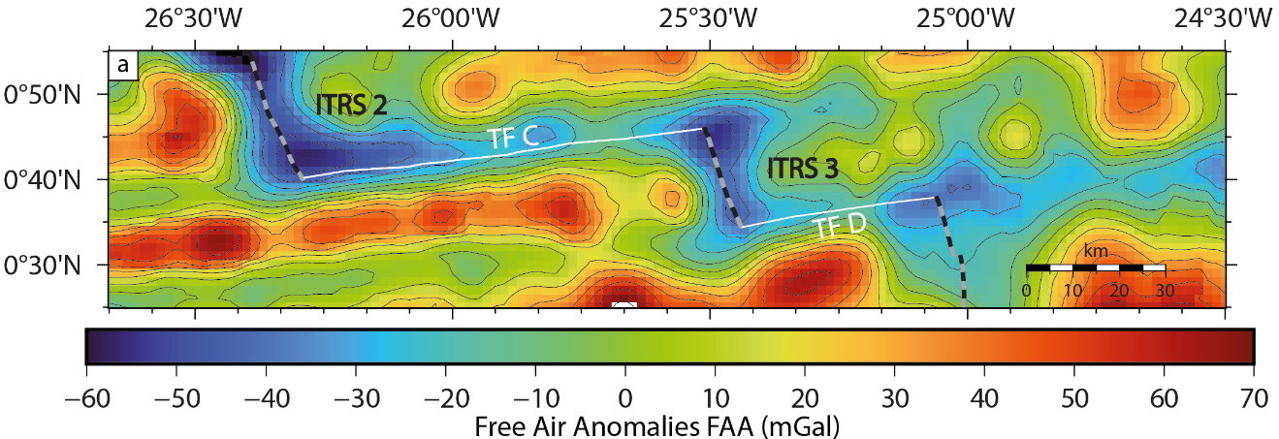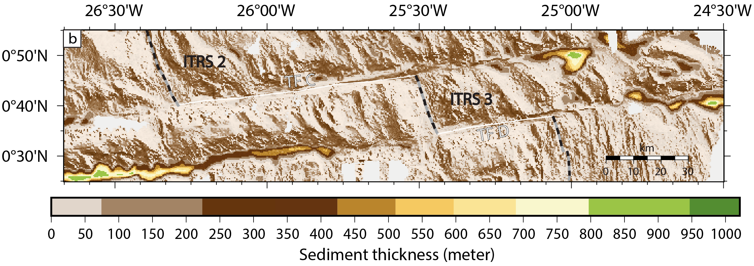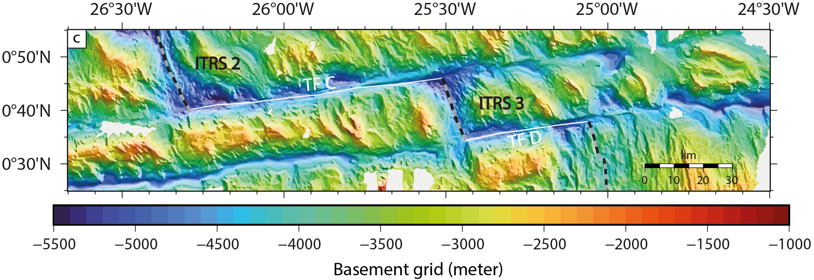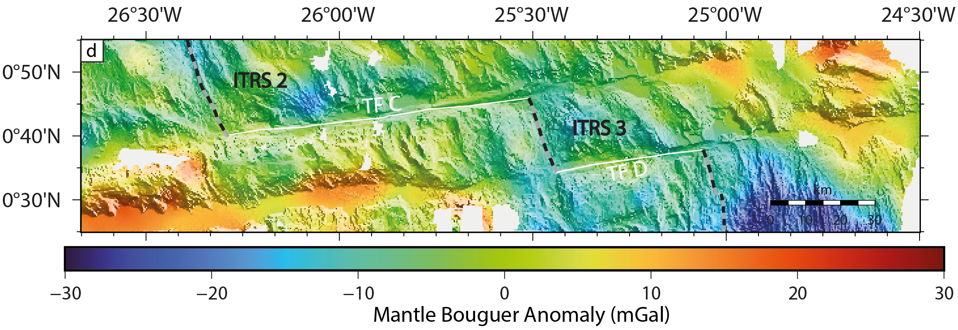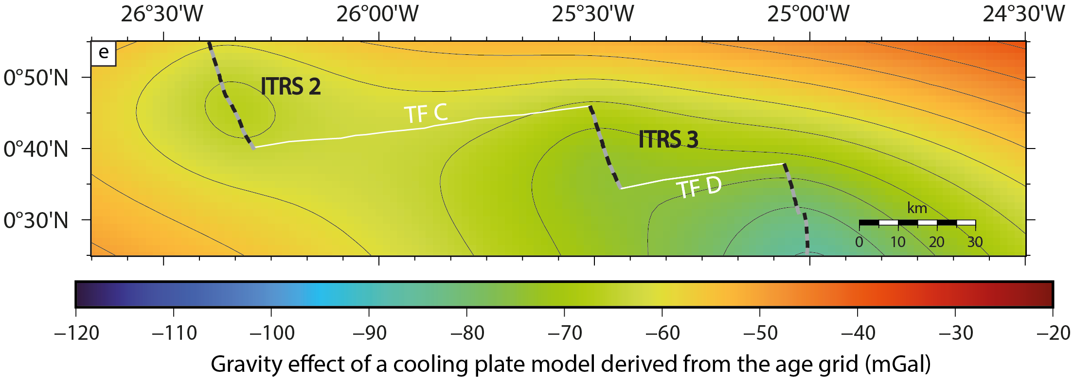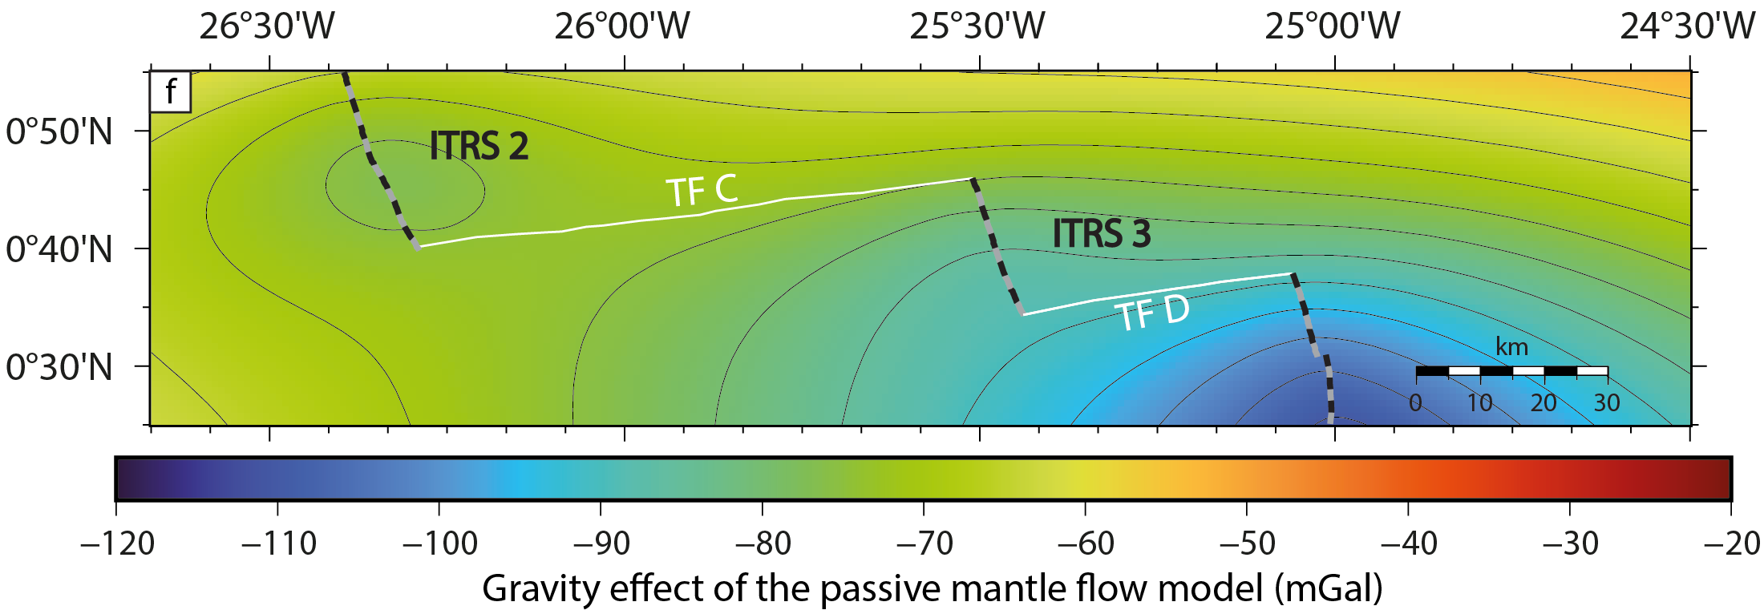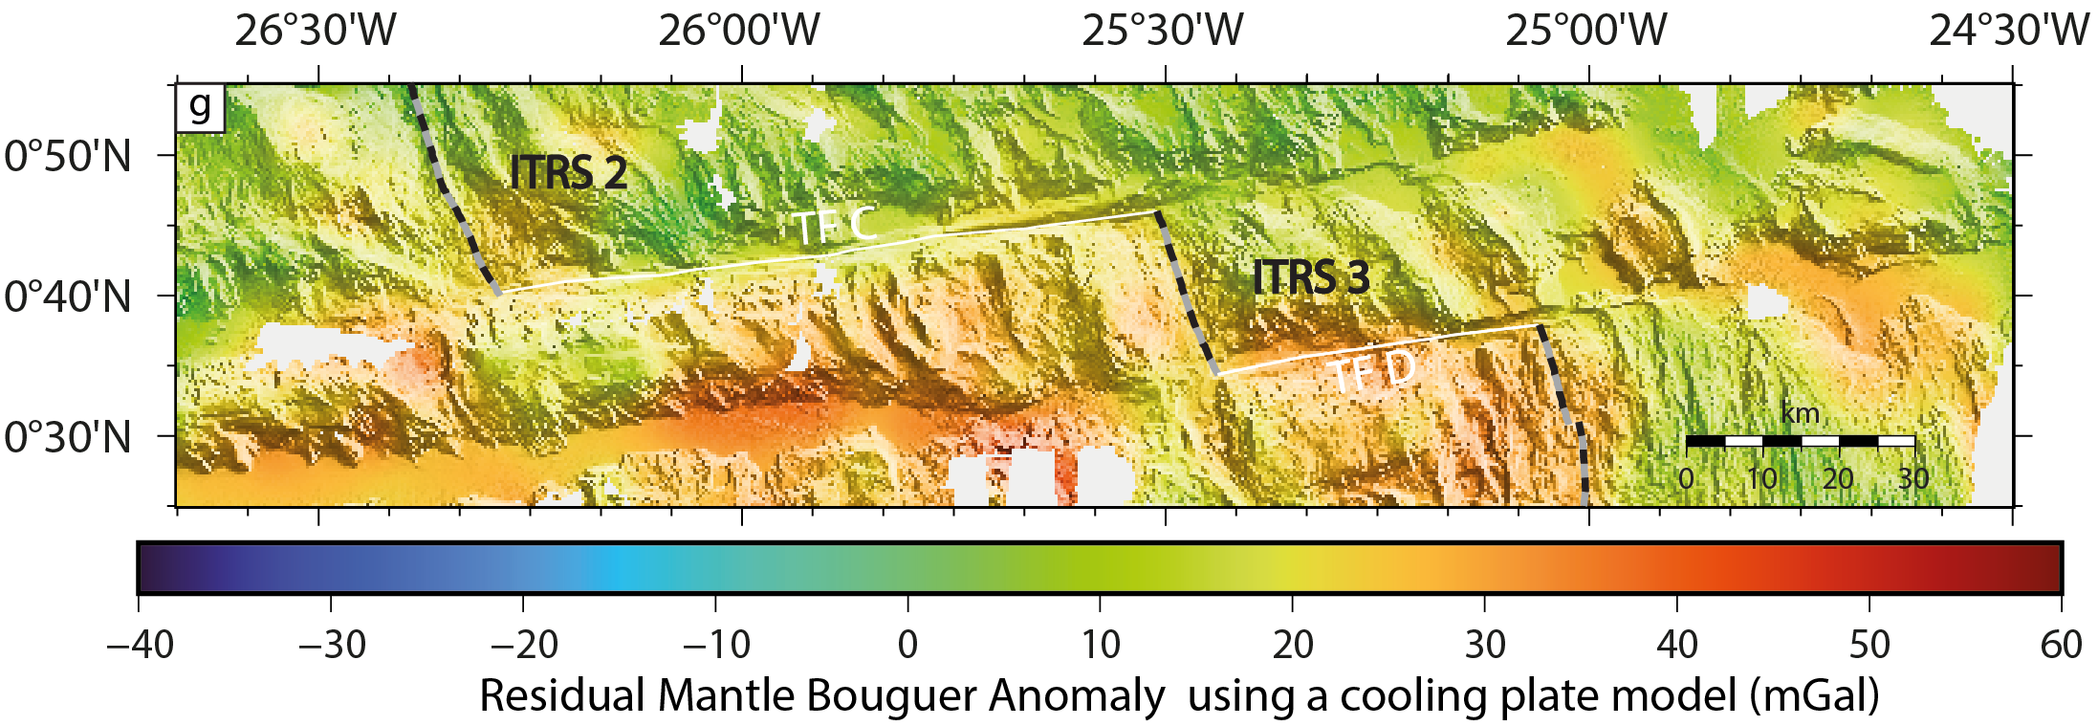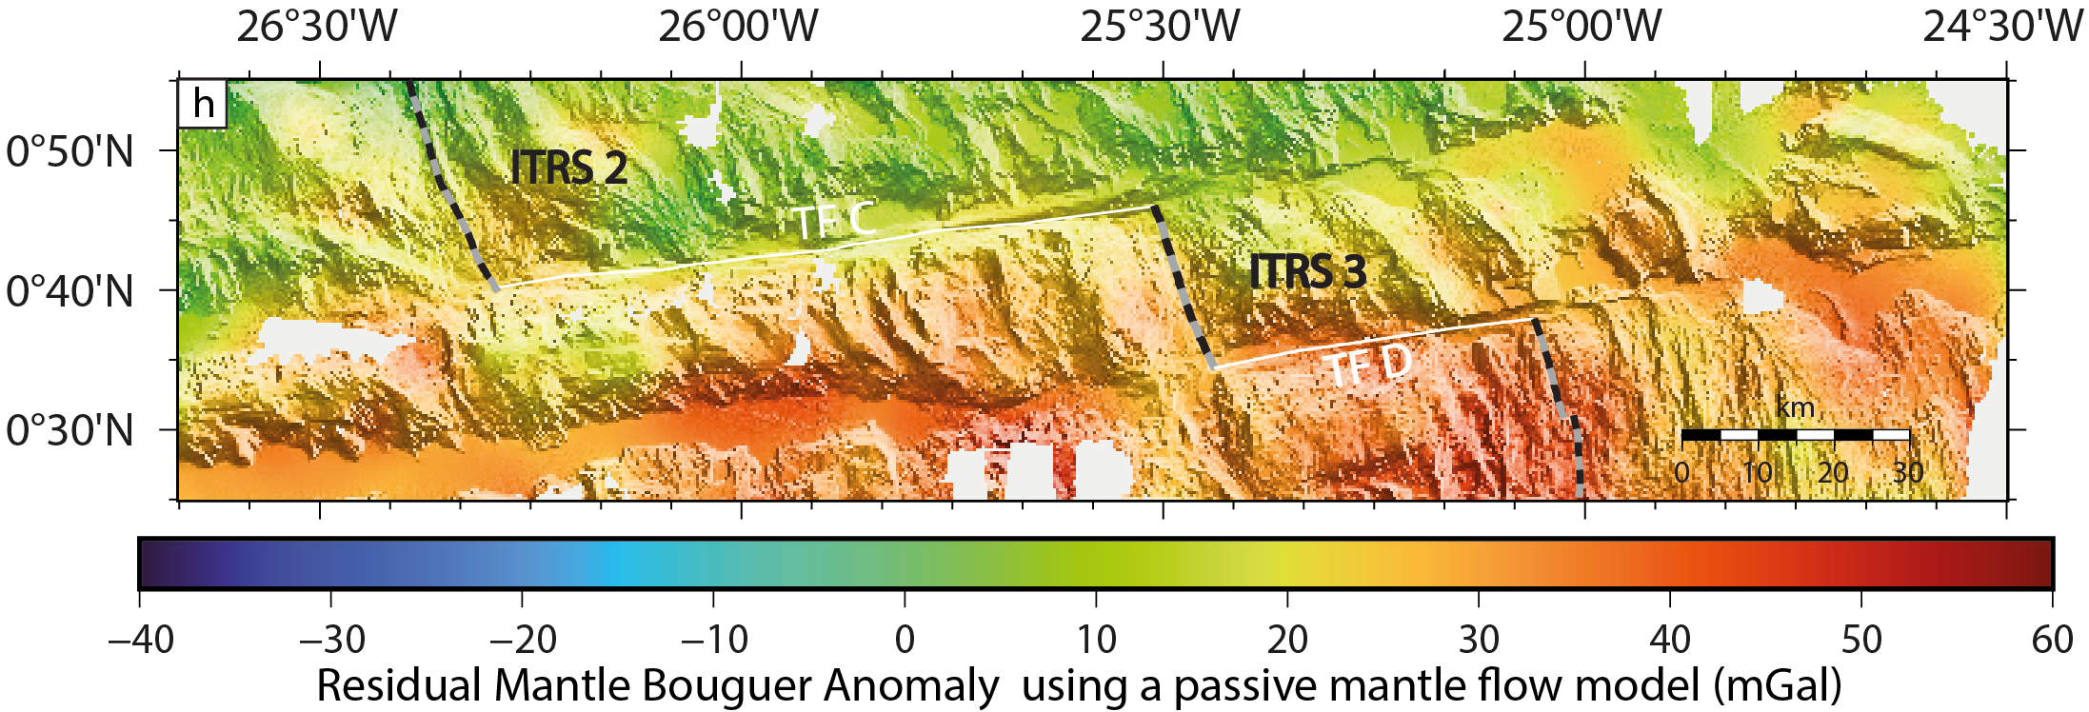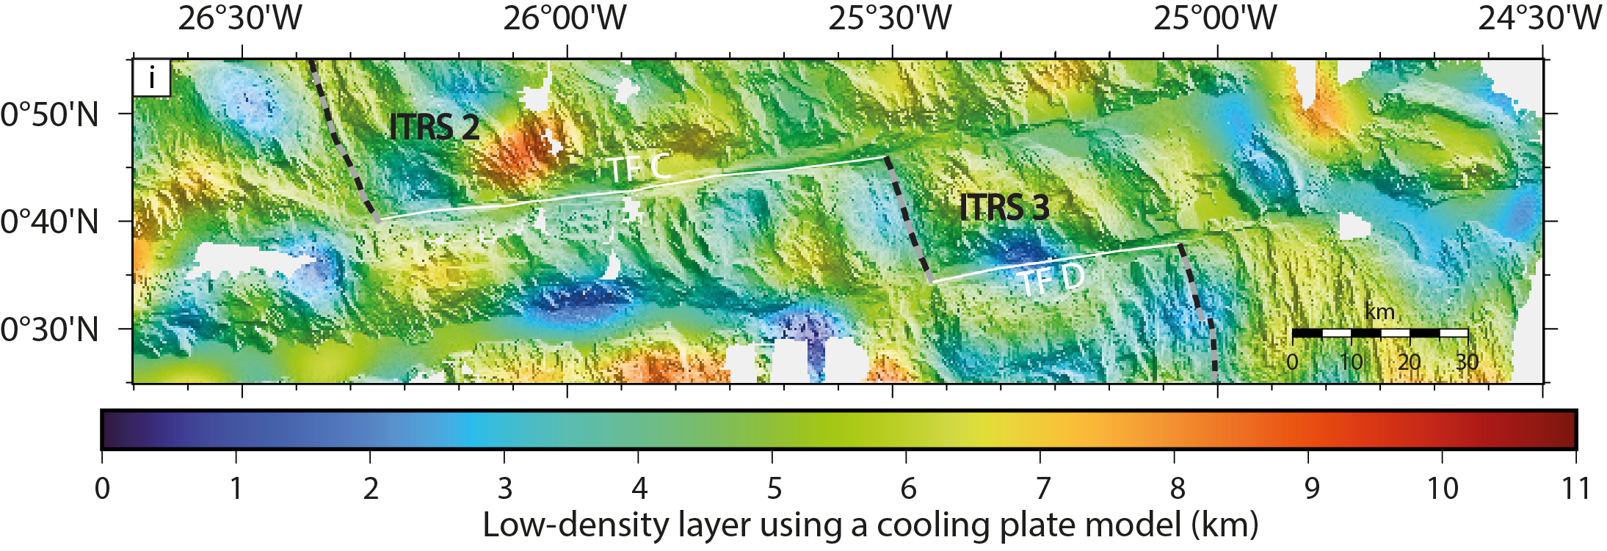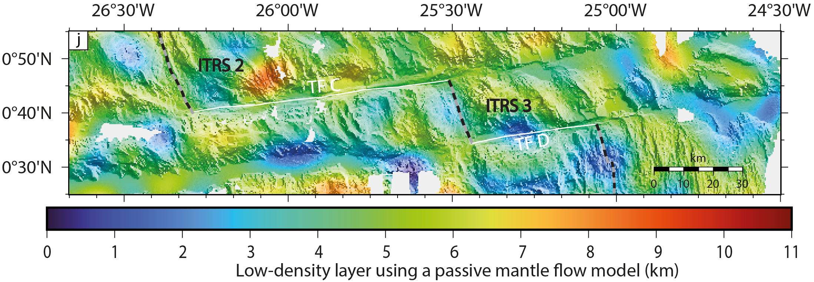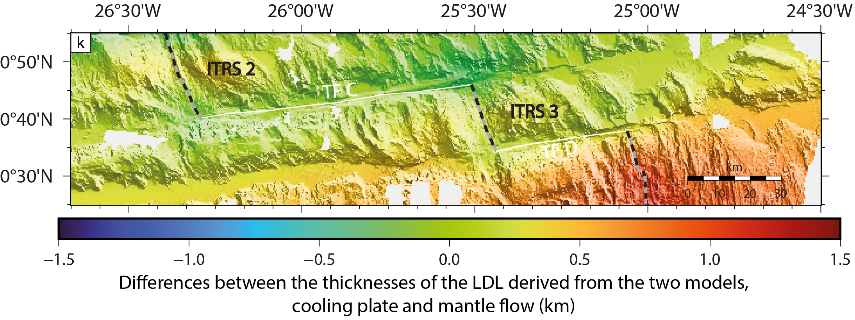

Figure S3. Sample COL-DR27-01. Mylonitized gabbro containing 15 cm-large boudins of ultramylonitic gabbro. This sample attests for an intense, multiphase deformation, of lower crustal lithologies (see text). (A) Image of the rock on the ship deck (the ruler is 15 cm) and the thin section scan of the contact between the host mylonite and the boudin ultramylonite: plane light (B) and crossed nicols (C). (After A. de Brito, 2019)

