**Supplementary Material**

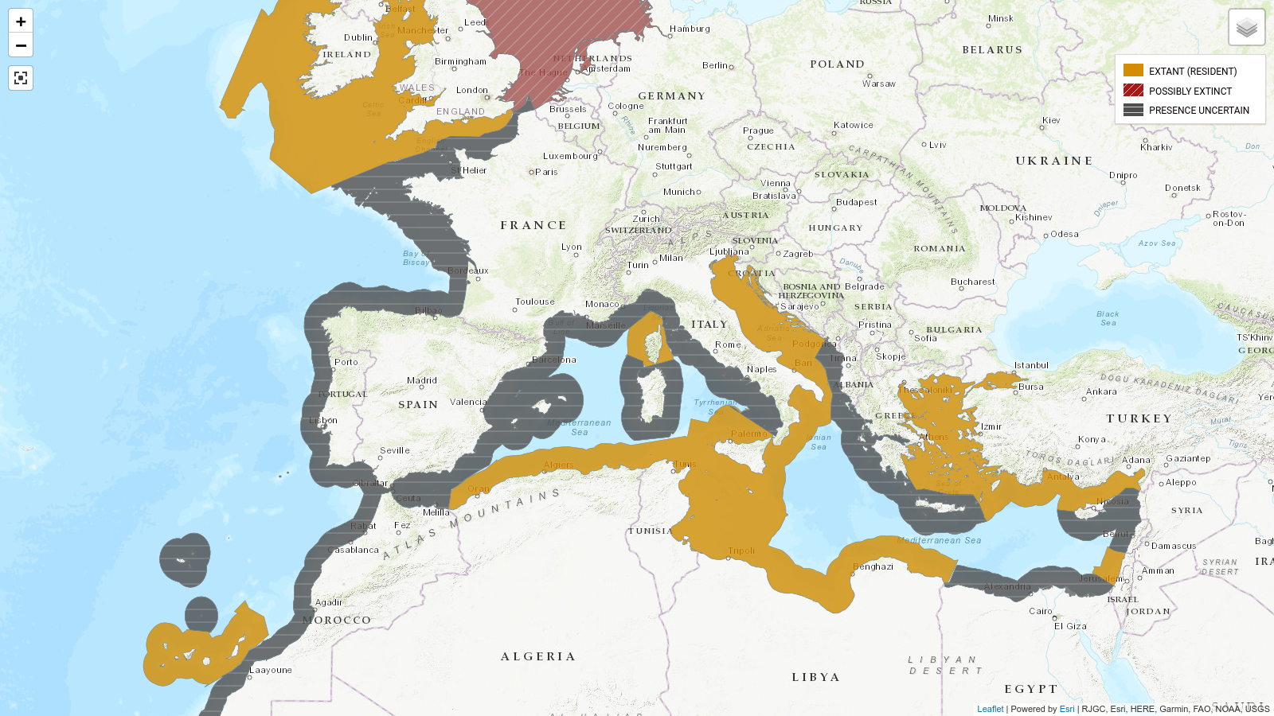**Appendix S1. Current distribution of the angelshark *S. squatina* (orange color) according to the IUCN Red List of Threatened Species** (Morey et al., 2019). The species is considered extinct in the red zone and its presence is uncertain in the gray zones. The entire area around Corsica is colored orange, yet *S. squatina* is only known to occur on the east coast according to published data and fishermen's observations (Lapinski & Giovos, 2019; Durieux and Bousquet, pers. comm.; Riutort, pers. comm.).

**Appendix S2. Current protection measures for the angelshark *S. squatina*** (Lawson et al., 2020).

|  |  |
| --- | --- |
| **International measures** | Convention on the Conservation of Migratory Species of Wild Animals. |
| **Regional measures** | OSPAR (list of threatened and/or declining species and habitats). |
| Barcelona (List of Endangered or Threatened Species) and Bern (Protected Fauna in Mediterranean) conventions. |
| European Council Regulations (prohibit to fish for, to retain on board, to tranship and to land the species). |
| **National and territory measures** | Protection measures in the UK, Monaco, Spain, Croatia, Malta, Turkey, Israel. |

**Appendix S3. Protocol for designing a primer pair and probe in silico for the detection of a target eDNA barcode by qPCR.** The main steps of the protocol outlined in Klymus et al. (2020) are indicated in the first column and the results found in our study focusing on the angelshark (*S. squatina*) are included in the second column.

|  |  |  |
| --- | --- | --- |
|  | **Protocol by Klymus et al. (2020)** | **Angel shark study** |
| Step 1 | Identify your target species for eDNA detection. | Angelshark (*S. squatina*) |
| Step 2 | List the sympatric species. | Smoothback angelshark (*S. oculata*)  Sawback angelshark (*S. aculeata*) |
| Step 3 | Identify available mitochondrial sequences from the NCBI’s Nucleotide Database  (<https://www.ncbi.nlm.nih.gov/nucleotide/>) for the species on your list. Extract the selected mitochondrial sequences from NCBI. | *S. squatina*: 3 whole mitochondrial DNA, 30 COI and 5 16S sequences.  *S. oculata*: 9 COI and 1 16S sequences.  *S. aculeata*: 17 COI and 3 16S sequences. |
| Step 4 | Import and align the sequences of each gene region separately using an alignment software, such as the Geneious Prime software (https://www.geneious.com). | All sequences mentioned in step 3 were imported and aligned in Geneious Prime software. |
| Step 5 | Set the following parameters in Geneious Prime software:  • Melting temperature (Tm) of the primer: 60°C ≤ Tm ≤ 64°C  • Maximum Tm difference of 2°C between the two primers  • The Tm of the probe should be 6-8°C higher than the primers  • Set the annealing temperature (Ta) of the qPCR reaction 5 °C below the melting temperature, around 55-60 °C.  • Percentage of G/C nucleotides in the primers: 35% ≤ %GC ≤ 65%  • Have at least 2 G or C bases in the last 5 nucleotides of each primer at the 3' end, where the DNA polymerase binds and elongation begins. It will increase specificity as it would help the primer to make a stronger bond.  • Ensure that there is no G at the 5' end of the probe, as this will interfere with the fluorescent signal emitted by the probe.  • GC clamp = 2  • Avoid repeats of one or two bases more than 4 times (it can cause issues with mispriming).  • Primer length: 18 - 25 bp  • Probe length: 20 - 25 bp  • Barcode length : 100 - 250 bp  • Check that the primers and the probe do not form a hairpin structure or dimers, to ensure good hybridization; check for self-dimerisation or dimerisation between the forward and reverse.  Geneious Prime software will return primer pairs and probes that meet all these criteria for the target species. | Results for COI:  102 primer pairs matching the criteria.  Results for 16S:  43 primer pairs matching the criteria.  Results for 12S:  189 primer pairs matching the criteria. |
| Step 6 | In Geneious Prime, test in silico each primer pair and probe returned by the software (step 5) against the sequences of sympatric species imported into the software (step 4). | All primers and probes were tested in silico against *S. squatina*, *S. aculeata* and *S. oculata* sequences.  In the case of the 12S region, in the absence of sequences for *S. aculeata* and *S. oculata*, the identified primer pairs were tested in silico on 12S sequences belonging to five *Squatina* species allopatric to *S. squatina* (*S. californica*, *S. dumeril*, *S. formosa*, *S. japonica* and *S. nebulosa*), in order to check whether some of the identified markers do not amplify any of these closely-related species. |
| Step 7 | Identify the species whose DNA will potentially be amplified by each pair of primers, using the ecoPCR program (Ficetola et al., 2010) and the complete EMBL nucleotide database (Amid et al., 2020, release 143, dataclass STD). The ecoPCR program performs an in silico PCR with a given primer pair and thus provides an exhaustive list of all the sequences in the EMBL database that are amplified, with their accession number and corresponding taxon.  NOTE: we allow up to 3 mismatches in each primer. | The best option was to select a primer pair and probe targeting a 173-bp COI sequence common to 16 different species (**Appendix S6**), among which only *S. oculata*, *S. aculeata* are present in the range of *S. squatina*. None of the 13 other species are present in the Mediterranean and Eastern Atlantic. |
| Step 8 | If the primer pair amplifies the DNA of the target species but also the DNA of various other species: find out if these species are present in the range of the target species. For this, use species databases such as FishBase (Froese & Pauly, 2019). | See **Appendix S6**.  The designed primer pair and probe are therefore specific to *S. squatina*, *S. oculata* and *S. aculeata* when used on samples from the Mediterranean and Eastern Atlantic. |
| Step 9 | Order your designed primers and probes from a company that makes oligos. | We ordered our primers and probe at Eurogentec (<https://www.eurogentec.com/en/>) |
| Step 10 | Test the designed primer pair and probe on tissues of the target species and closely-related species to verify in vitro that the target DNA barcode is well amplified by these primers. | Successful amplification of *S. squatina, S. oculata* and *S. aculeata* tissue-extracted DNA by PCR using the designed primer pair. Therefore, a sequencing step of all qPCR products was added to know which sympatric species was detected by qPCR.  NOTE: We tested two different annealing temperatures for PCR (60°C and 62°C), for which the target DNA was well amplified. We therefore chose an annealing temperature of 62°C to increase specificity when analyzing our eDNA samples by qPCR (even though the Tm of the primers are 60.6°C and 62.6°C, **Table 1**). |
|  | | |
| **Result for this angel shark study**. Full DNA fragment (5’-3’) located in the COI gene of the *S. squatina* mitogenomeand targeted by the primers in the developed qPCR assay. The sequence for the primers are highlighted in grey and the probe is underlined and in bold: | | |
| 5’TACTTTTACTACTTGCCTCAGCCGGAGTTGA**AGCAGGAGCCGGCACTGGTT**GAACGGTTTACCCTCCTCTTGCAGGAAATTTAGCTCACGCCGGAGCATCGGTAGATTTAGCAATTTTTTCCTTACATTTAGCTGGTATTTCTTCAATCCTAGCCTCTATTAATTTCATTACAACCATTATTAATATAAAACCCCCAGCCATTTCCCAGTATCAAACACCAC -3’ | | |

**Appendix S4. Description of the filtration set-up.**

To reduce the risks of contamination and decrease the sampling time, our solution consists of a submersible pump combined with a hose (type DeepWater 2) equipped with a suction strainer and an encapsulated filter (0.2 µm sampling capsule) provided by the single-use VigiDNA kit from SPYGEN (le Bourget du Lac, France). This device is capable of collecting and filtering freshwater and seawater between 0 to -140 m deep. It has a rechargeable battery and the filtration kit (pipe and filter) can be mounted and changed with sterile gloves both above and below the water surface, the pump is also equipped with a self-timer and a timer. The pump is calibrated by the manufacturer to obtain a 1 L/min filtration debit with a DeepWater 2 hose ; tests made in our laboratory showed that 30 ± 1 liters are filtered in 30 minutes. Field tests have also shown that the pump must be running for the filter to fill with water and for DNA to be detected. After each transect/filtration, the device was brought back on board the boat, the hose was removed and the seawater was drained to be replaced by the buffer solution of the VigiDNA kit. The filters were kept away from light, at room temperature, while waiting for further treatment in the laboratory.

A small camera (Paralenz) displaying the depth was attached to the pump and permitted to a posteriori verify the depth and the distance between the seabed and the device.

**Appendix S5. qPCR standard curves for *S. squatina***

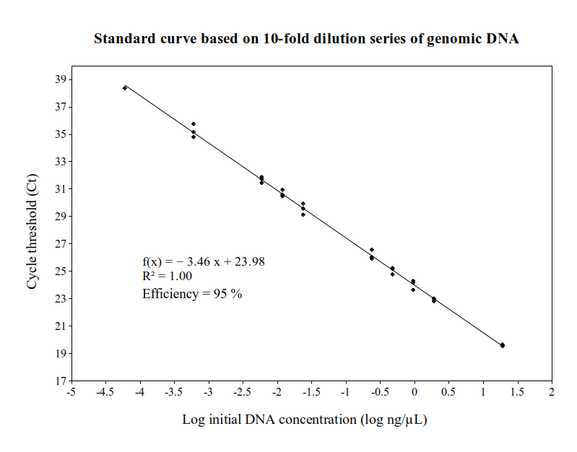

**S5.1)** Standard curve n°1 (y = -3.46x + 23.98, r2 = 1, efficiency = 95%) plotted using a 13-fold serial dilutions of *S. squatina* tissue-extracted DNA (19 to 6×10-08 ng/µL), which were only successfully amplified for ten concentrations between 19 and 6×10-05 ng/µL. The highest cycle threshold value was used to determine the LoD value of the qPCR assay. The slope of the regression line of the standard curve (-3.46) indicates a qPCR efficiency of 0.948 (95%). The coefficient of determination (r2 = 1) shows that the concentration values have been correctly quantified.

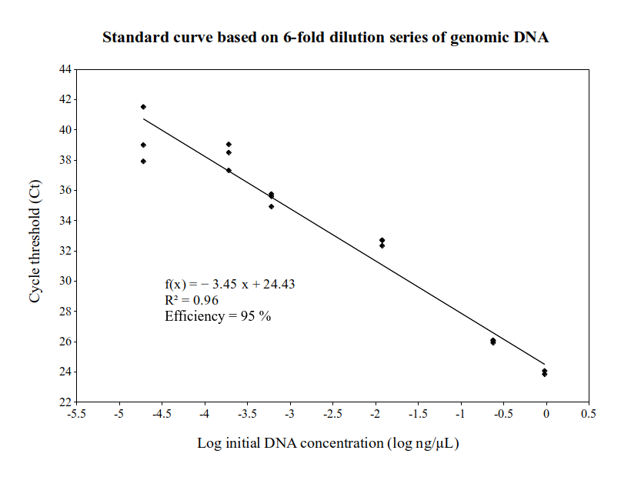

**S5.2)** Standard curve n°2 (y = -3.45x + 24.43, r2 = 0.96, efficiency = 95%) plotted using a 6-fold serial dilution of DNA extracted from *S. squatina* tissue. The highest cycle threshold values were used to determine the LoD value of the qPCR assay.

**Appendix S6. List of the 16 species whose COI sequence is amplified in silico by the developed primer pair.** The table includes the common and scientific name of each species and its current distribution.

|  |  |  |
| --- | --- | --- |
| **Common name** | **Scientific name** | **Current distribution** |
| Angelshark | *Squatina squatina* | Northeast Atlantic (Mediterranean, Black seas, Celtic seas, Canary islands) |
| Smoothback angelshark | *Squatina oculata* | Eastern Atlantic (Mediterranean, Morocco to Angola) |
| Sawback angelshark | *Squatina aculeata* | Eastern Atlantic (Mediterranean, Morocco to Angola) |
| Japanese angelshark | *Squatina japonica* | Northwest Pacific (Japan, Korea, China) |
| Taiwan angelshark | *Squatina formosa* | North Western Pacific (Taiwan, Philippines) |
| Ocellated angelshark | *Squatina tergocellatoides* | Northwest Pacific (Taiwan Strait) |
| Japanese eagle ray | *Myliobatis tobijei* | Northwest Pacific (Japan, Korea, China) |
| Southern stingray | *Hypanus americanus* | Western Atlantic (USA to Brazil, Caribbean) |
| Redtail parrotfish | *Sparisoma chrysopterum* | Western Atlantic (Caribbean) |
| Blackspotted stickleback | *Gasterosteus wheatlandi* | Western Atlantic (Newfoundland, Canada to Massachusetts, USA) |
| Slimy head | *Hoplostethus mento* | Eastern Pacific (Costa Rica to Chile, deep waters) |
| Delagoa threadfin bream | *Nemipterus bipunctatus* | Indian ocean |
| Gulf darter | *Etheostoma swaini* | North american rivers (USA) |
| Rainbow darter | *Etheostoma caeruleum* | North american rivers (USA) |
| / | *Schistura longa* | Chinese rivers |
| / | *Sinorhodeus microlepis* | Chinese rivers |

**Appendix S7**. DNA sequences (173-bp) resulting from this study and available on GenBank (NCBI).

|  |  |  |  |  |  |  |  |
| --- | --- | --- | --- | --- | --- | --- | --- |
| **Sequence ID** | **Genbank accession number** | **Species** | **Type of DNA** | **Target gene** | **Locality** | **Transect number** | **Sampling date** |
| PF65 | OQ704341 | *Squatina squatina* | Tissue DNA | COI mtDNA | Bastia, Corsica | / | 10-Jun-2020 |
| PF66 | OQ704342 | *Squatina squatina* | Tissue DNA | COI mtDNA | Bastia, Corsica | / | 10-Jun-2020 |
| PF103 | OQ704343 | *Squatina squatina* | Tissue DNA | COI mtDNA | Aquarium Valencia, Spain | / | 26-Oct-2020 |
| AM10 | OQ704344 | *Squatina oculata* | Tissue DNA | COI mtDNA | Sicily, Italy | / | 30-Jun-2017 |
| AM11 | OQ704345 | *Squatina aculeata* | Tissue DNA | COI mtDNA | Sicily, Italy | / | 31-Dec-2015 |
| eDNA201196 | OQ704346 | *Squatina squatina* | Sea water eDNA | COI mtDNA | Tarco, Corsica | / | 2020 |
| eDNA210671 | OQ704347 | *Squatina squatina* | Sea water eDNA | COI mtDNA | Agriate, Corsica | n°5 | 27-Apr-2021 |
| eDNA210672 | OQ704348 | *Squatina squatina* | Sea water eDNA | COI mtDNA | Bastia, Corsica | n°38 | 29-Apr-2021 |
| eDNA210721 | OQ704349 | *Squatina squatina* | Sea water eDNA | COI mtDNA | Golo River, Corsica | n°44 | 29-Apr-2021 |
| eDNA210719 | OQ704350 | *Squatina squatina* | Sea water eDNA | COI mtDNA | Santa-Lucia-di-Moriani, Corsica | n°50 | 29-Apr-2021 |
| eDNA210705 | OQ704351 | *Squatina squatina* | Sea water eDNA | COI mtDNA | Solenzara, Corsica | n°73 | 01-May-2021 |

**References**

Amid, C., Alako, B. T., Balavenkataraman Kadhirvelu, V., Burdett, T., Burgin, J., Fan, J., ... & Cochrane, G. (2020). The European nucleotide archive in 2019. *Nucleic acids research*, *48*(D1), D70-D76.

Ficetola, G. F., Coissac, E., Zundel, S., Riaz, T., Shehzad, W., Bessière, J., ... & Pompanon, F. (2010). An in silico approach for the evaluation of DNA barcodes. *BMC genomics*, *11*(1), 1-10. <https://doi.org/10.1186/1471-2164-11-434>

Froese, R. and D. Pauly. Editors. 2019. FishBase. World Wide Web electronic publication. www.fishbase.org, version (12/2019).

Klymus, K. E., DV, R. R., Thompson, N. L., & Richter, C. A. (2020). Development and Testing of Species-specific Quantitative PCR Assays for Environmental DNA Applications. *Journal of Visualized Experiments: Jove*, (165). doi: [10.3791/61825](https://dx.doi.org/10.3791/61825)

Lapinski, M., & Giovos, I. (2019). New records of the critically endangered *Squatina squatina* (Linnaeus, 1758) from Corsica, France. *Acta Adriatica, 60*(2), 205-210. <https://doi.org/10.32582/aa.60.2.10>

Lawson, J. M., Pollom, R. A., Gordon, C. A., Barker, J., Meyers, E. K., Zidowitz, H., ... & Dulvy, N. K. (2020). Extinction risk and conservation of critically endangered angel sharks in the Eastern Atlantic and Mediterranean Sea. *ICES Journal of Marine Science*, *77*(1), 12-29. <https://doi.org/10.1093/icesjms/fsz222>

Morey, G., Barker, J., Hood, A., Gordon, C., Bartolí, A., Meyers, E. K. M., ... & Pollom, R. (2019). *Squatina squatina. The IUCN Red List of Threatened Species 2019*, 2019-1. <http://dx.doi.org/10.2305/IUCN.UK.2019-1.RLTS.T39332A117498371.en>