Supplementary Material

A global gridded ocean salinity dataset with 0.5° horizontal resolution since 1960 for the upper 2000 m
Guancheng Li^{1,2,3}, Lijing Cheng^{1,3*}, Yuying Pan^{1,3}, Gongjie Wang⁴, Hailong Liu^{1,5}, Jiang Zhu^{1,3}, Bin Zhang⁶, Huanping Ren⁶, Xutao Wang²
* Correspondence: Lijing Cheng: chenglij@mail.iap.ac.cn

Supplementary Figures and Tables

Supplementary Figures
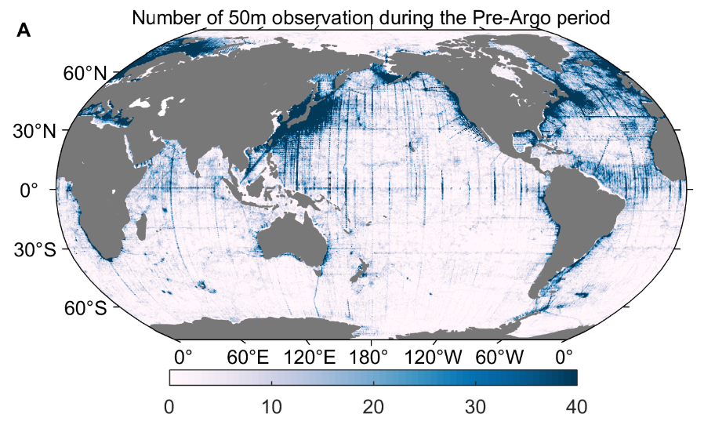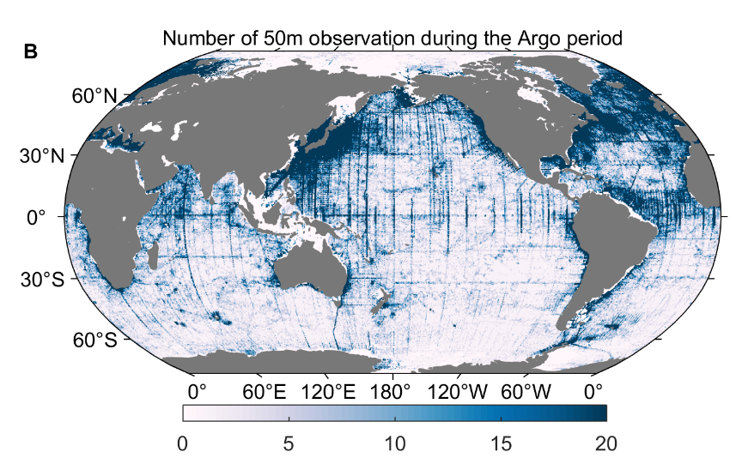
Supplementary Figure 1 Distribution of the number of salinity observations in 50m depth layer within each 0.5° by 0.5° grid box during (A) the Pre-Argo period (1960–2004) and (B) the Argo period (2005–present).

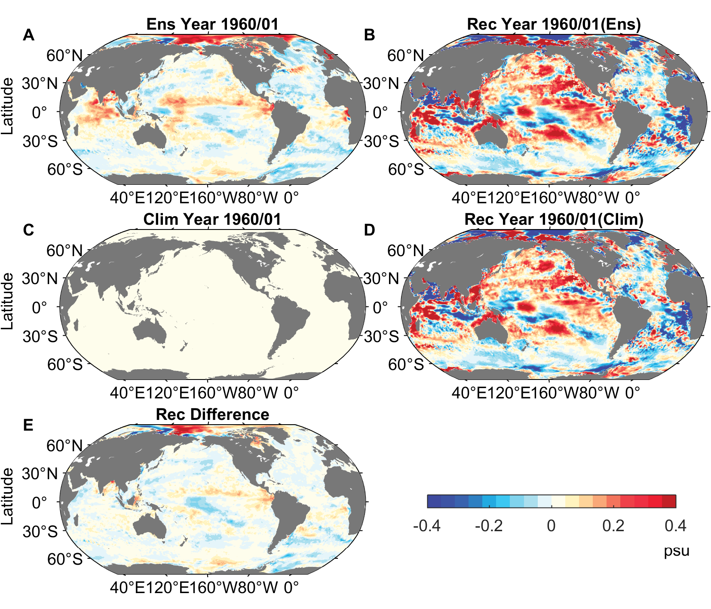
Supplementary Figure 2. The comparison of reconstruction of 50m depth salinity anomaly fields in January 1960 between using (A) the high-resolution ensemble members and (B) the climatology (zero-anomaly) as the first guess (units: psu). (C) and (D) are their reconstructed fields respectively and their difference is shown in (E).

Supplementary Figure 3. Sampling uncertainty for global and basin means of the 0–2000 m salinity anomaly. (A) Global (Glo), (B) Pacific (Pac), (C) Atlantic (Atl), (D) Indian (Ind), and (E) Southern oceans (So) (units: psu). The blue (red) dots represent the sampling errors for IAP-05 (IAP-1) mapping method corresponding to 22 different truth fields, with the ensemble mean shown by the blue (red) line and the vertical bars corresponding to two standard deviations.

Supplementary Figure 4. Geographic distribution of the linear trends of mean sampling errors of 0–2000m mean (upper panels) and globally zonal mean of salinity anomaly (bottom panels) based on the “synthetic” subsample test: (A) and (C) for IAP-05 data, (B) and (D) for IAP-1 data.

Supplementary Figure 5. Geographic distribution of the standard deviation of linear trends in sampling errors of 0–2000m mean (upper panels) and globally zonal mean of salinity anomaly (bottom panels) based on the “synthetic” subsample test: (A) and (C) for IAP-05 data, (B) and (D) for IAP-1 data.

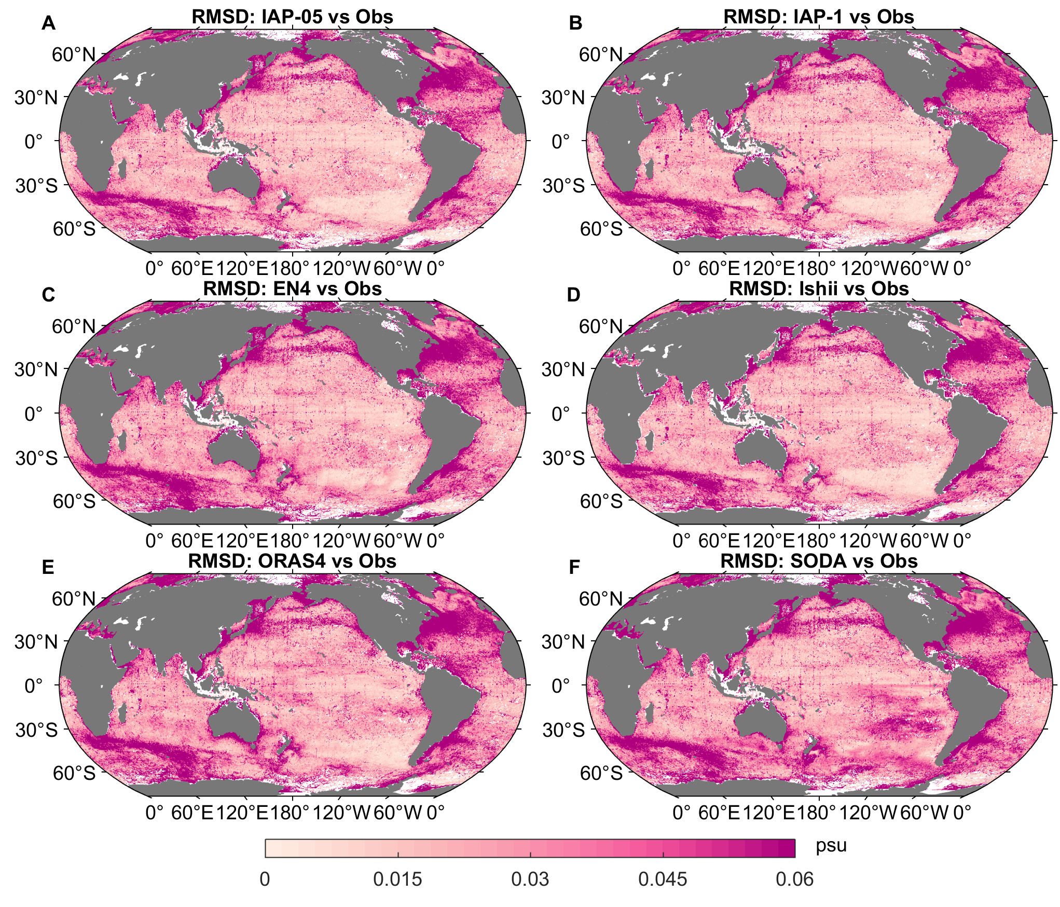
Supplementary Figure 6. RMSD of 0–2000m averaged salinity anomalies of the gridded in situ data with (A) IAP-05, (B) IAP-1, (C) EN4, (D) Ishii, (E) ORAS4, (F) SODA during 1980-2017. All the salinity climatology fields are relative to 1990-2010. The 1° gridded IAP-1, EN4, Ishii and ORAS4 have been interpolated into 0.5° versions.

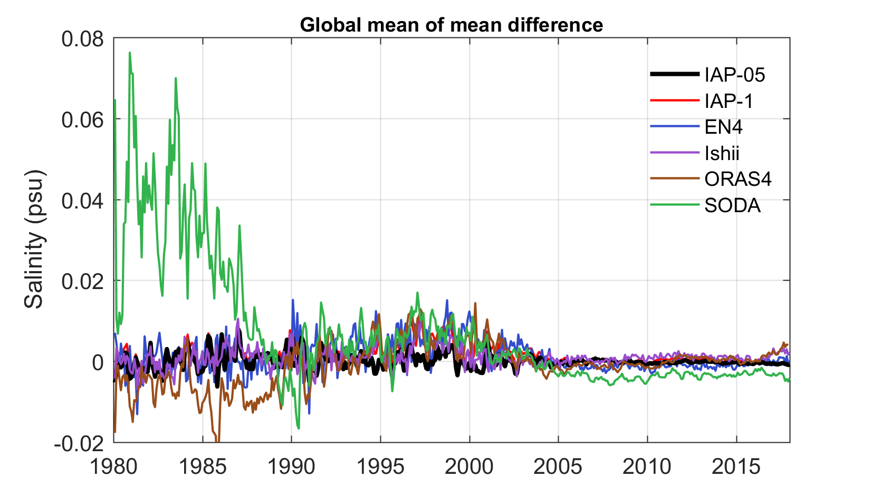
Supplementary Figure 7. Mean difference of globally 0–2000m mean salinity anomalies between the in situ data and IAP-05, IAP-1, EN4, Ishii, ORAS4 and SODA during 1980-2017. All the salinity climatology fields are relative to 1990-2010. The 1° gridded IAP-1, EN4, Ishii and ORAS4 have been interpolated into 0.5° versions.

Supplementary Figure 8. Comparison of the sea surface salinity (SSS) long-term trends during the 1980–2016 period with the gridded SSS data for the Atlantic Ocean (LEGOS). (A) IAP-05, (B) IAP-1, (C) EN4, (D) Ishii, (E) NCEI, (F) ORAS4, (G) SODA and (H) LEGOS (units: 10⁻³ psu yr⁻¹). Contour lines show the associated climatological mean salinity (1990–2010; units: psu). Linear trends are significant at the 95% confidence level in the dotted areas. The 1° gridded IAP-1, EN4, Ishii, ORAS4 and LEGOS have been interpolated into 0.5° versions.
Supplementary Figure 9. Linear regression of the SSS anomaly onto the S-IOD index during the Argo period (2005–2017) for different gridded products (contour lines and shadings). (A) IAP-05, (B) IAP-1, (C) EN4, (D) Ishii, (E) ORAS4, and (F) SODA (units: psu psu⁻¹). The blank areas indicate that the regression coefficients are not significant at the 90% confidence level. Green boxes denote the locations of the central equatorial IO (Northern) and southeastern IO (Southern), respectively. The 1° gridded IAP-1, EN4, Ishii and ORAS4 have been interpolated into 0.5° versions.

Supplementary Figure 10. Linear regression of the SSS anomaly onto the S-IOD index during the pre-Argo period (1980–2004) for different gridded products (contour lines and shadings). (A) IAP-05, (B) IAP-1, (C) EN4, (D) Ishii, (E) ORAS4, and (F) SODA (units: psu psu⁻¹). The blank areas indicate that the regression coefficients are not significant at the 90% confidence level. Green boxes denote the locations of the central equatorial IO (Northern) and southeastern IO (Southern), respectively. The 1° gridded IAP-1, EN4, Ishii and ORAS4 have been interpolated into 0.5° versions.
Supplementary Table 1 Salinity gridded datasets used in the data comparison.
 | IAP-05 | IAP-1 |  | EN4 |  | Ishii | NCEI | ORAS4 | SODA
Modelling centers | IAP, CAS | IAP, CAS |  | Met Office Hadley Center |  | JAMSTEC | NOAA | ECMWF | NCAR
Data description | Objective analyzed product | Objective analyzed product | Objective analyzed product |  | Objective analyzed product |  | Objective analyzed product | Ocean reanalyses | Ocean reanalyses
Horizontal resolution | 0.5°×0.5° | 1°×1° |  | 1°×1° |  | 1°×1° | 1°×1° | 1°×1° | 0.5°×0.5°
Vertical levels | 41 levels  (2000m) | 41 levels  (2000m) |  | 42 levels  (5500m) |  | 28 levels (6350m) | 26 levels  (2000m) | 42 levels (5350m) | 50 levels  (5395m)
Period | 1960–2020 | 1960–2020 |  | 1960–2020 |  | 1960–2020 | 1955–2020 | 1960–2017 | 1980–2018

