Air-Sea fluxes of CO₂ in the Indian Ocean between 1985 and 2018: A synthesis based on Observation-based surface CO₂, hindcast and atmospheric inversion models.

VVSS Sarma¹, B. Sridevi¹, N. Metzl², P. Patra³, Z. Lachkar⁴, Kunal Chakraborty⁵, C. Goyet^{6,7}, M. Levy², M. Mehari⁴, N. Chandra³

¹CSIR-National Institute of Oceanography, Regional Centre, 176 Lawsons Bay Colony, Visakhapatnam, India

²LOCEAN/IPSL laboratory, Sorbonne Université, CNRS/IRD/MNHN, Paris, France

3Japan Agency for Marine-Earth Science and Technology, Kanagawa, Japan

⁴Arabian Center for Climate and Environmental Sciences, New York University Abu Dhabi, Abu Dhabi, United Arab Emirates

⁵Indian National Centre for Ocean Information Services, Ministry of Earth Sciences, Hyderabad, India

⁶Espace-Dev, UPVD, Perpignan France
⁷Espace-Dev, Univ. Montpellier, UPVD, IRD, Montpellier, France

Supplementary Figure S1: Locations of pCO₂ data collected with reference to space and time are given in the Indian Ocean (Source: SOCAT, Bakker et al, 2020)
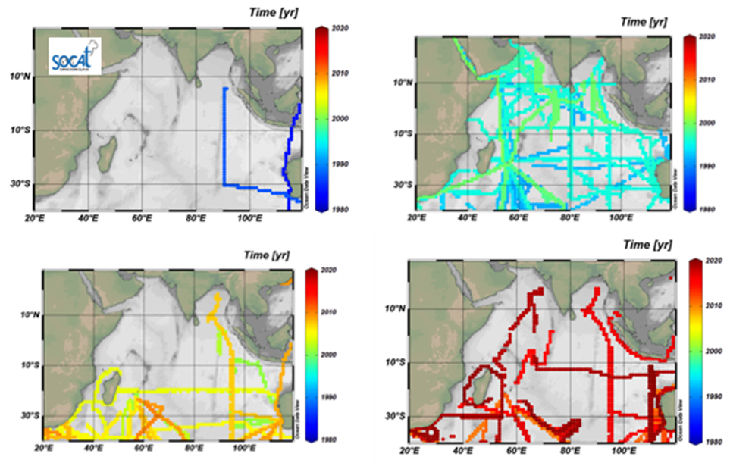

Supplementary Figure S2: The simulated mean sea surface temperature (1985-2018) by hindcast models in the Arabian Sea. Due to a lack of SST data from the CESM_ETHZ model, it was not included.
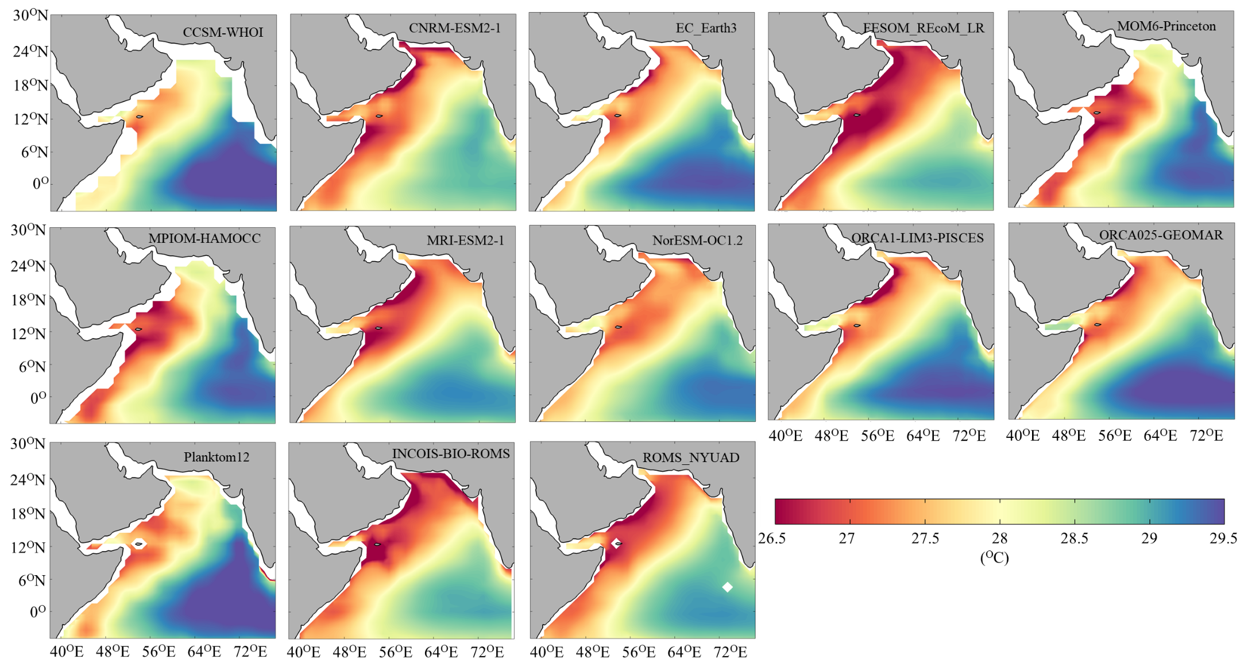

Supplementary Figure S3: The simulated mean sea surface salinity (1985-2018) by hindcast models in the Bay of Bengal. Due to a lack of SSS data from the CESM_ETHZ model, it was not included.
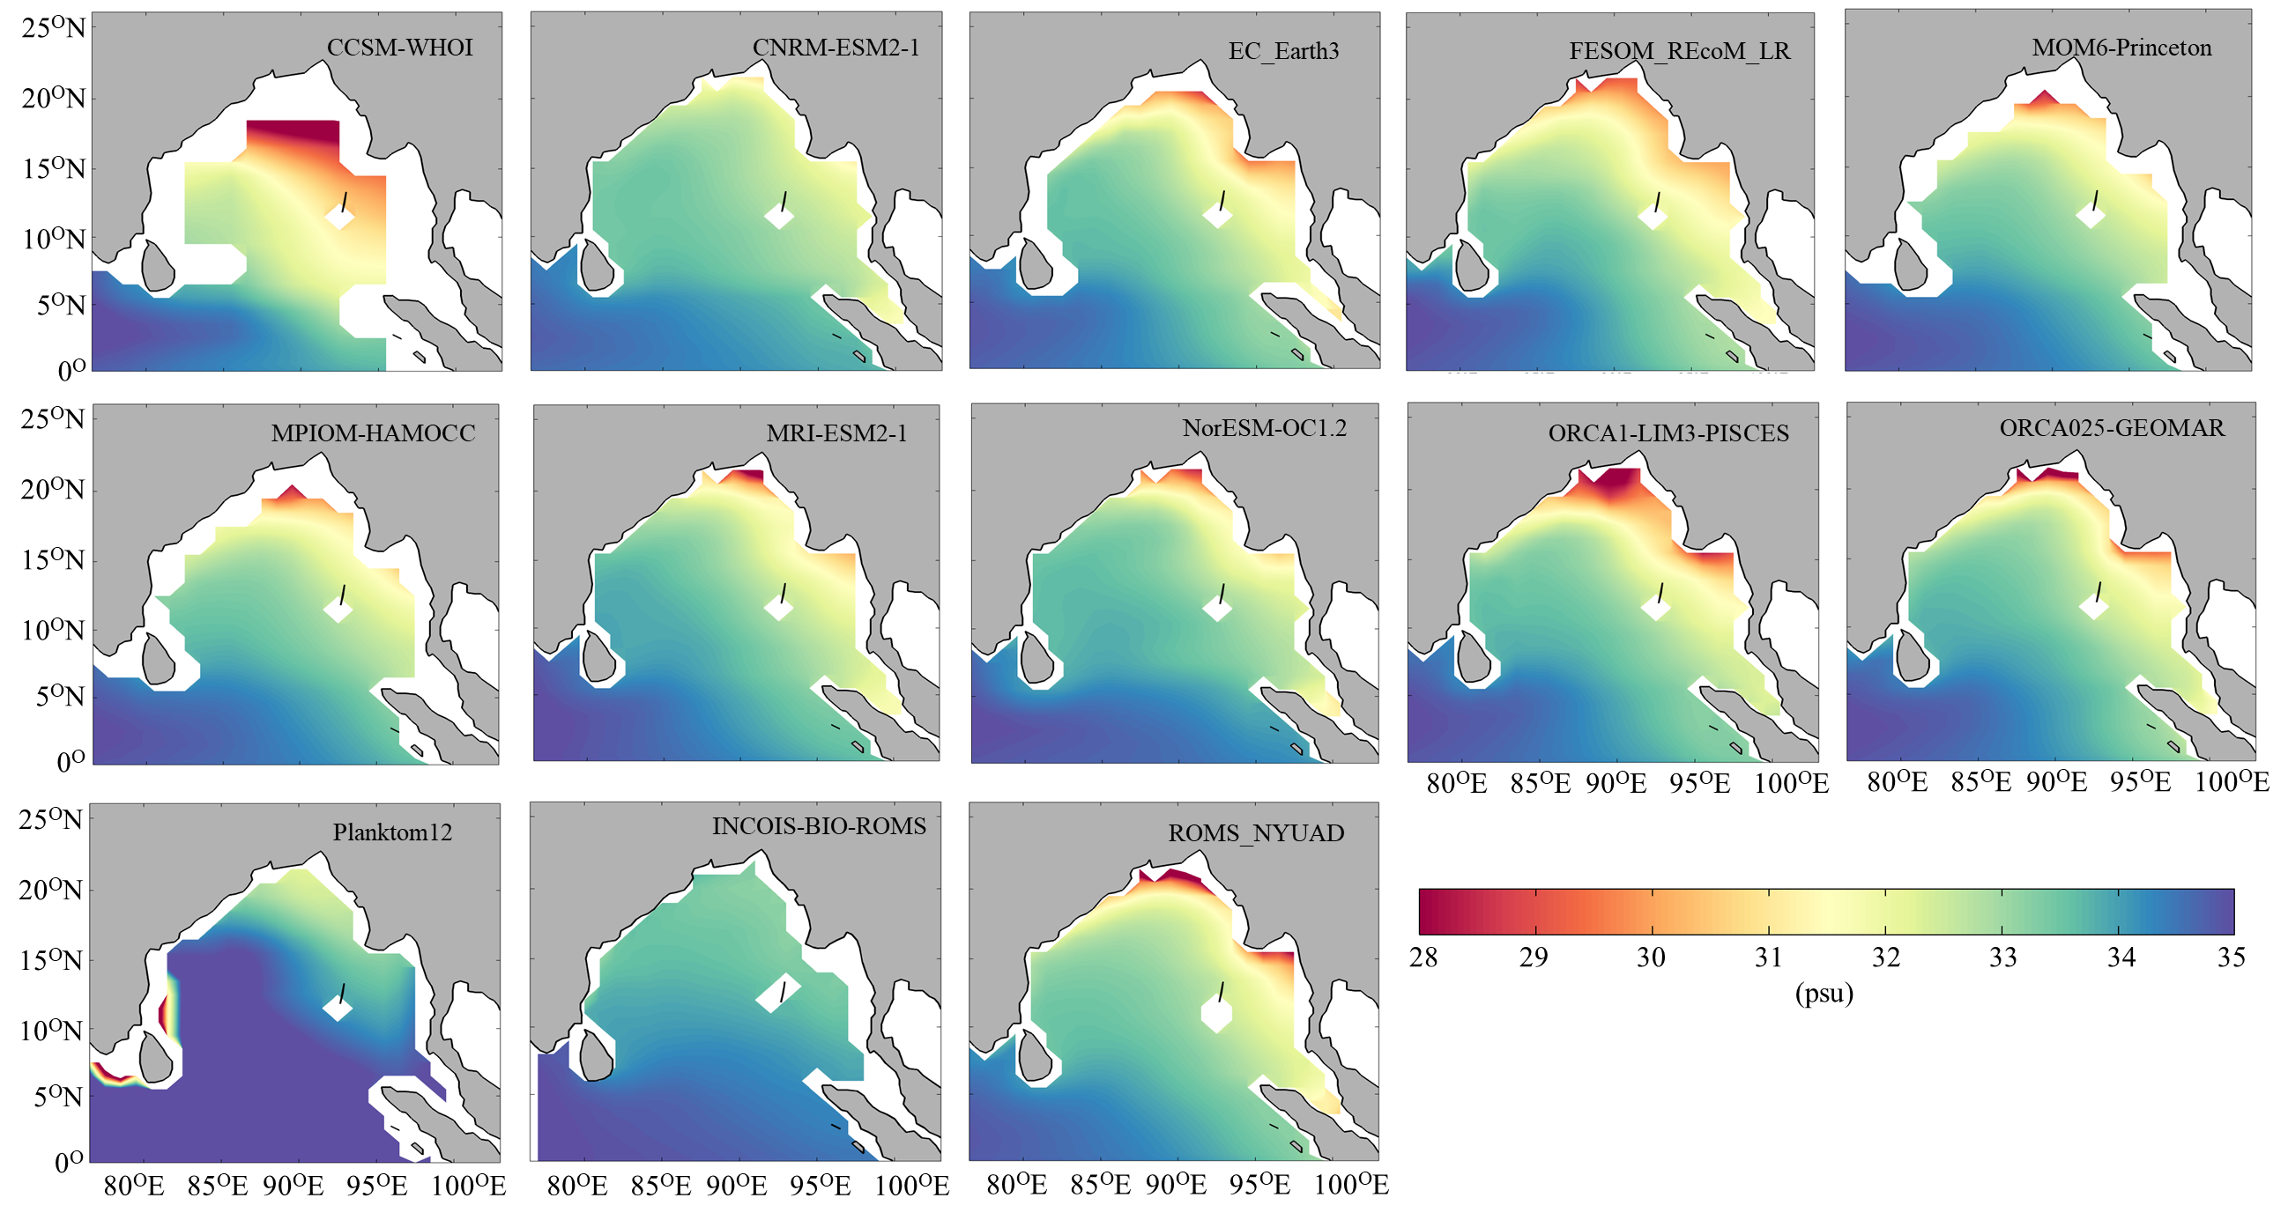

Supplementary Figure S4: The simulated mean sea surface temperature (1985-2018) by hindcast models in the Bay of Bengal. Due to a lack of SST data from the CESM_ETHZ model, it was not included.

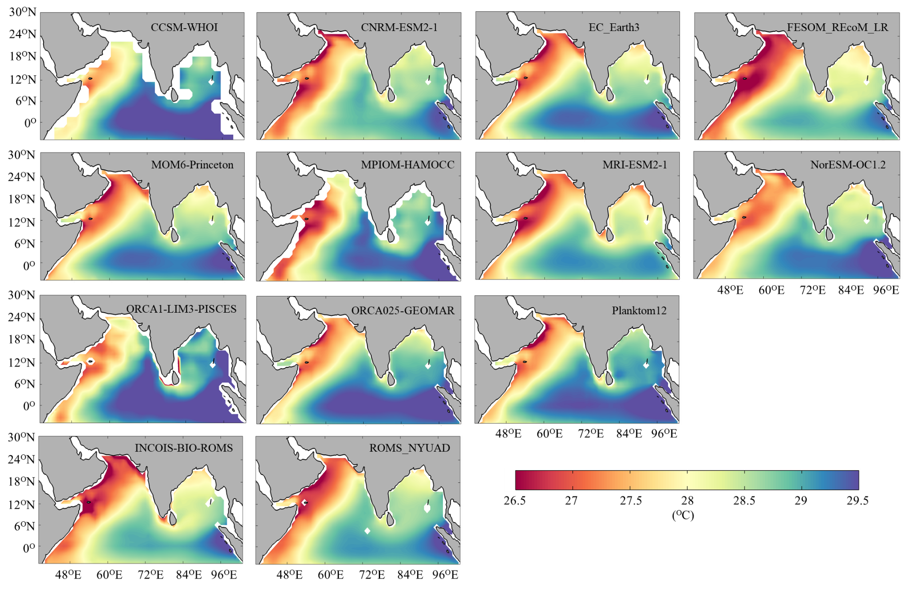

Supplementary Figure S5: Seasonal cycle of the CO2 flux (PgC yr⁻¹; left panel) and δpCO₂ (μatm; right panel) from observations and hindcast models in the Indian Ocean, Arabian Sea, BoB, EIO and SIO.

