**Supplementary materials**

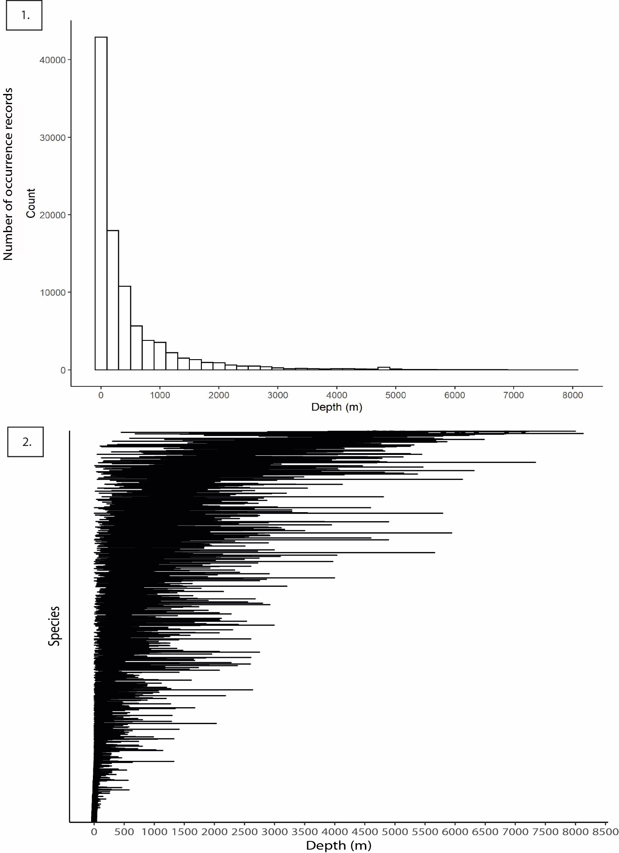

Supplementary Figure 1. Depth distribution of the Ophiuroidea data. 1. The average collection depth for occurrence records, 2. The average, minimum and maximum depth range per species arranged by the average depth.

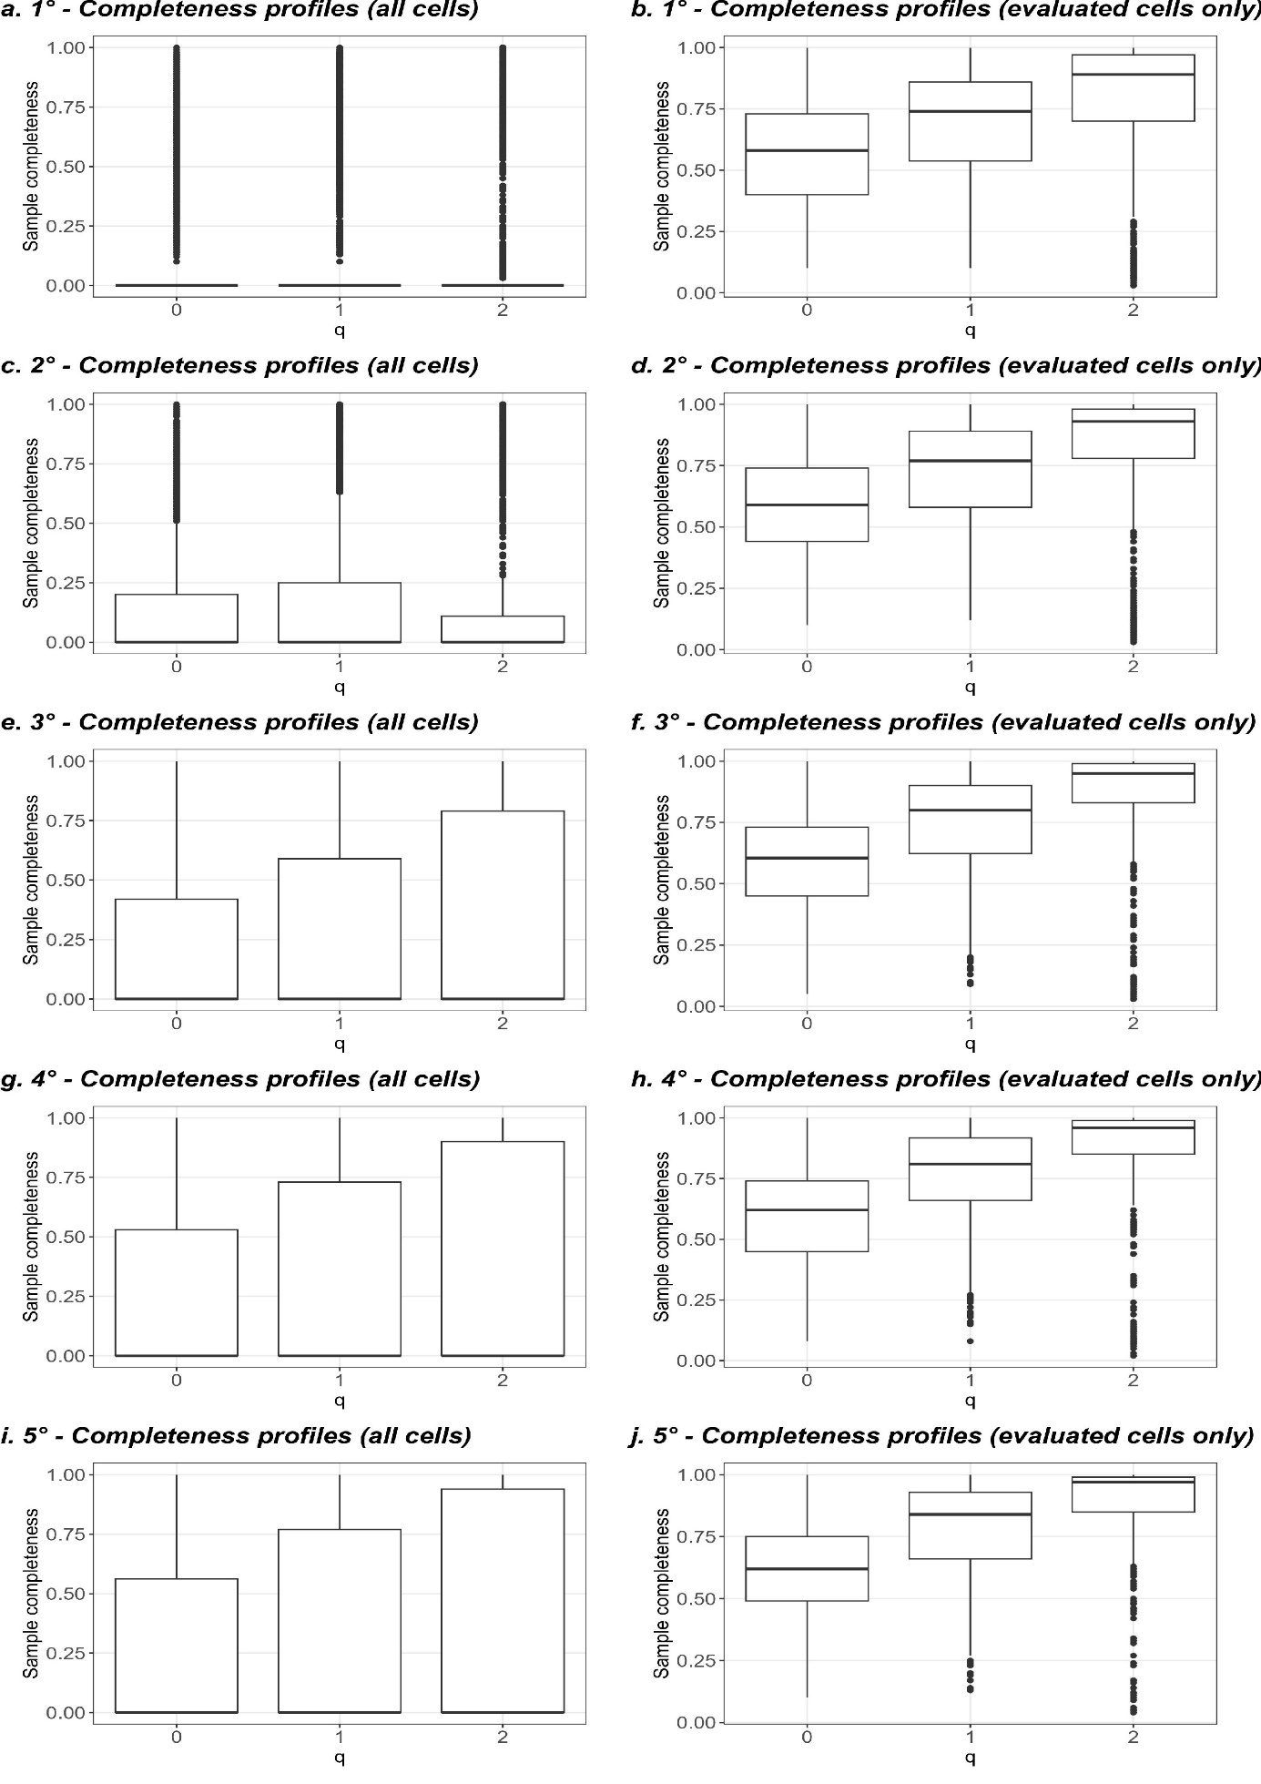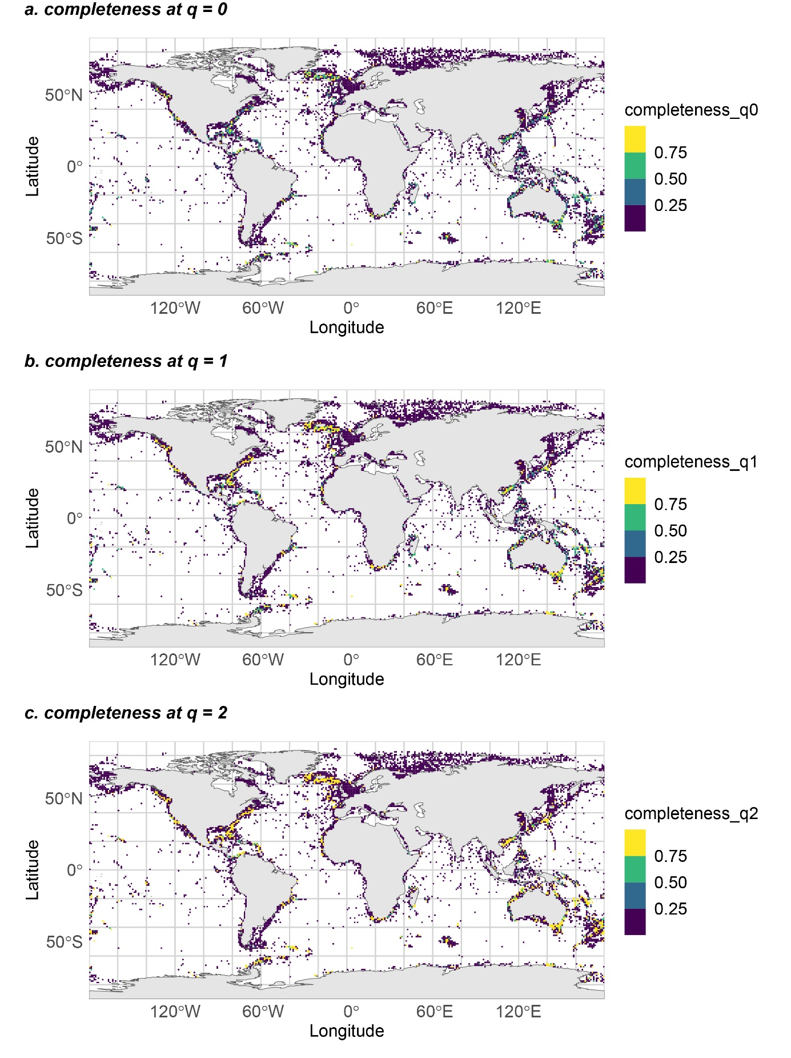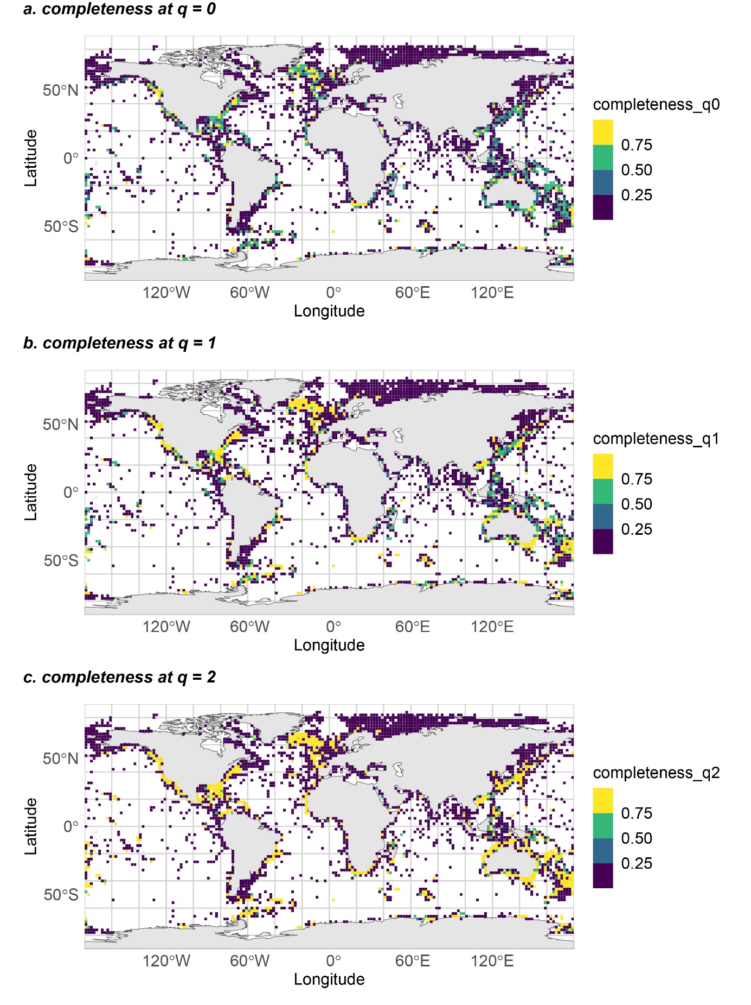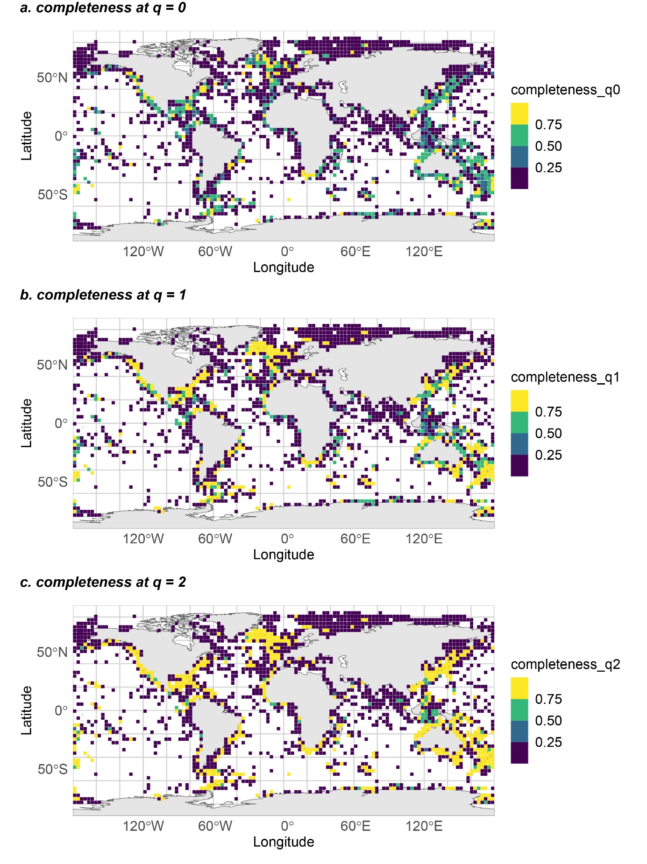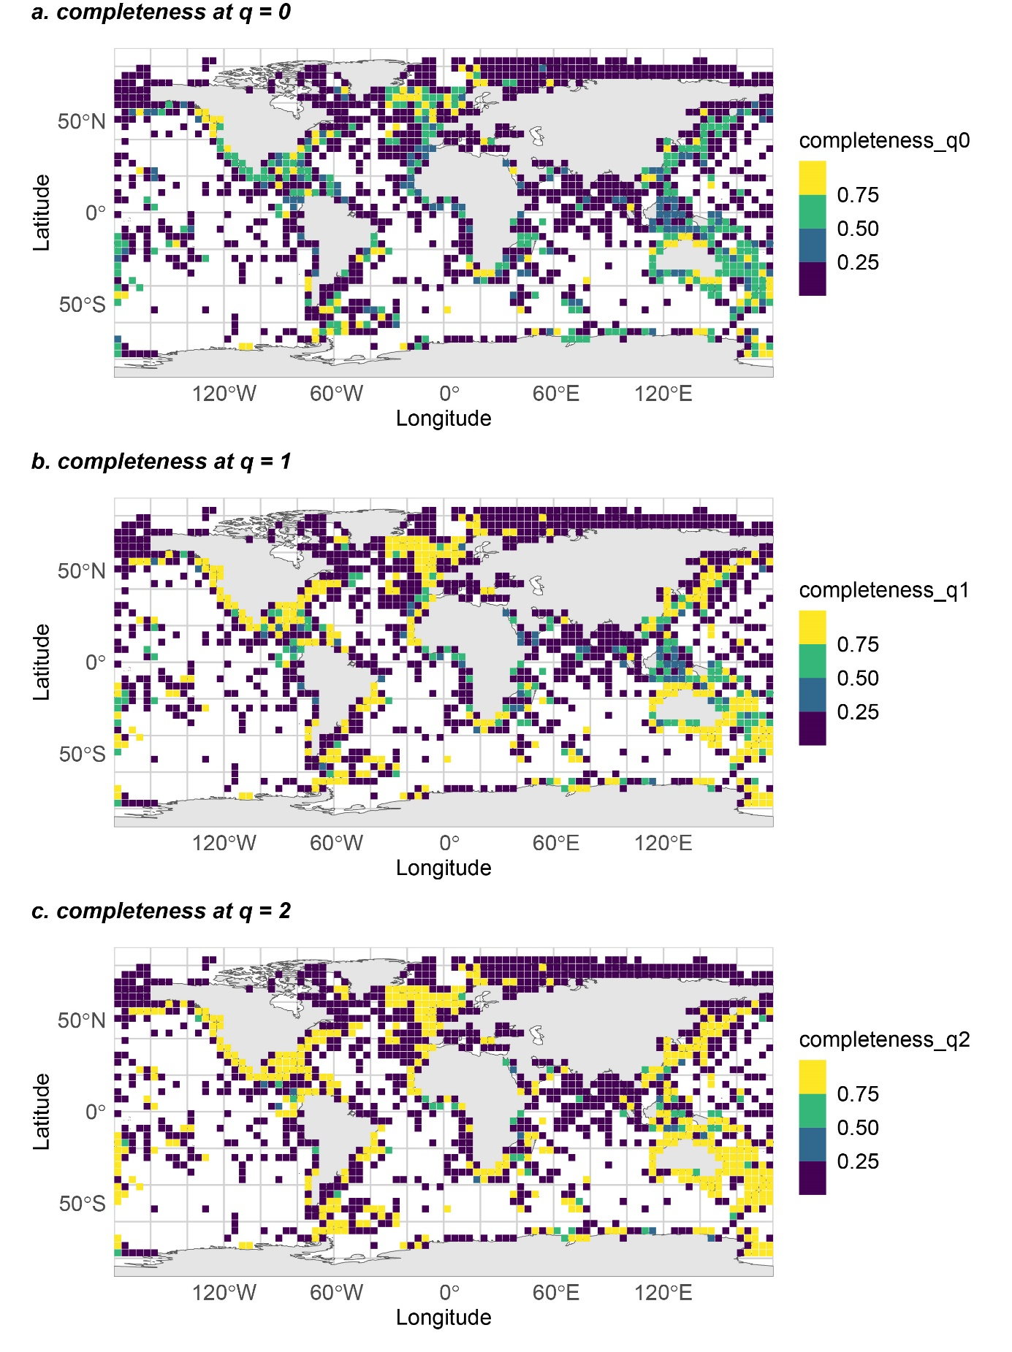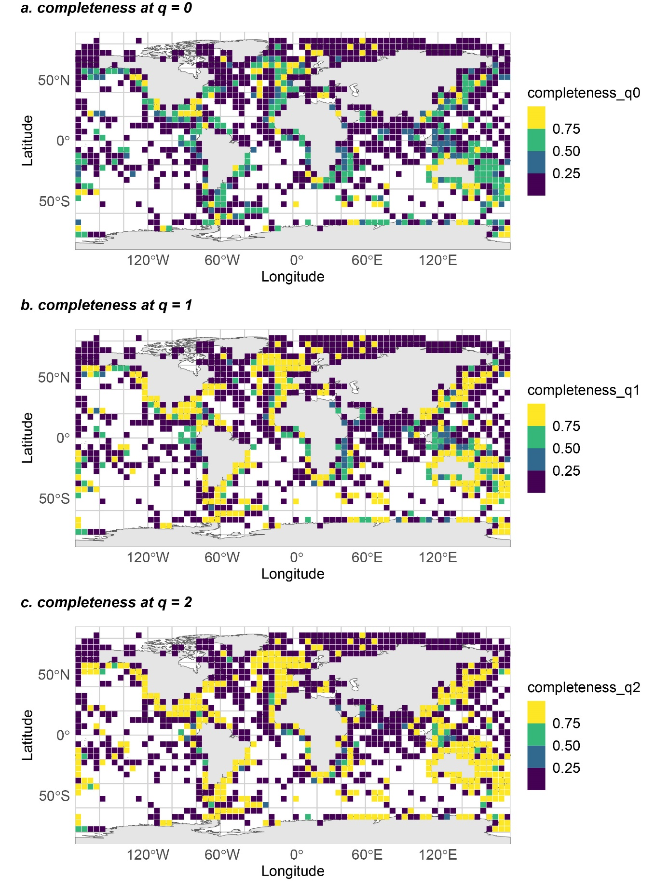

**1.**

**2**.

**3**.

**4**.

**5**.

**6**.

Supplementary Figure 2. Evaluation of completeness across resolutions.

1. Box-and-whisker plots of completeness profiles at orders q = 0, 1 and 2 (Chao et al. 2020) for all sampled cells. Boxes represent the range between the first and third quartiles, and whiskers indicate the outer quartiles without outliers; outliers were defined as points lying beyond 1.5 the interquartile range. Completeness values range from 0 to 1, and can be interpreted as percentage of inventory completeness. Completeness at q = 0 is an upper-bound estimation of the sampled species richness - which means that in most cells we cannot reliably estimate the true species richness because of a lack of samples and so the completeness value at q = 0 is uncertain. Completeness at q = 1 estimates the completeness with equal weighting to both frequent and infrequent species. This order gives an indication of the percentage of undetected frequent species. Completeness at q = 2 estimates the completeness with disproportionately high weights to frequent species. It gives an indication of the percentage of undetected super-frequent species.

Interpretation of the boxplot figure:

At resolution 1°, most cells could not be evaluated (83% of the 5,579 cells), hence the number of cells with a completeness above 0 was very limited (panel a). Considering only the evaluated cells, the median completeness at q = 1 and 2 were relatively high (panel b). As the resolution increased, the number of cells that had a sufficient sampling increased (Table S4 and boxplots panels c, e, g, i), and starting at resolution 3° the completeness profiles with values above 0 were no longer outliers. For the evaluated cells (panels d, f, h and j), the completeness slowly increased with the resolution. Overall, there is no objective criterion to choose the optimal resolution; the choice is a trade-off between sampling completeness (higher at coarser resolutions) and avoiding to lump together species across large areas which would blur the limits of biogeographical regions (the coarser the resolution, the larger the risk. We eventually chose the 3° resolution which had a substantial amount of adequately sampled cells (at least 2/3 of the cells could be evaluated, see Table S4) had a good yet not too large spatial coverage (see maps 2-6), and had high completeness values for most cells at orders q = 1 and 2 (boxplot panel d), meaning that most frequent and super-frequent species had been adequately sampled – a prerequisite for bioregionalisation analyses.

Maps 2-6 are completeness profiles at orders q = 0, 1 and 2 (Chao et al. 2020) for all sampled cells across different resolutions. Completeness values range from 0 to 1, and can be interpreted as percentage of inventory completeness. Completeness at q = 0 is an upper-bound estimation of the sampled species richness - which means that in most cells we cannot reliably estimate the true species richness because of a lack of samples and so the completeness value at q = 0 is uncertain. Completeness at q = 1 estimates the completeness with equal weighting to both frequent and infrequent species. This order gives an indication of the percentage of undetected frequent species. Completeness at q = 2 estimates the completeness with disproportionately high weights to frequent species. It gives an indication of the percentage of undetected super-frequent species. Completeness values were calculated on the basis of the incidence-based estimators using 0.01 ° sub-cells in each grid cell (see methods for details). We manually assigned a completeness of 0 to all cells which could not reliably be evaluated, i.e., cells with less than 10 species, or had only singletons, or had less than 3 sampled sub-cells.

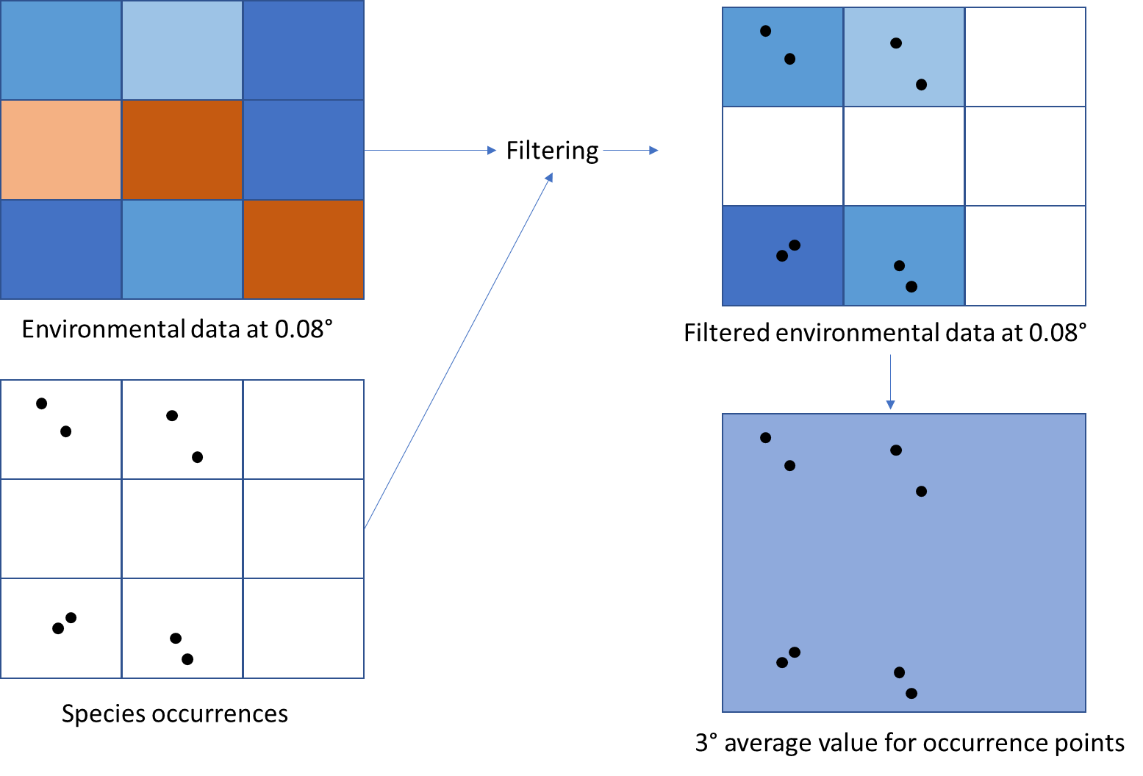

Supplementary Figure 3. Diagram illustrating how the environmental variables were acquired for each 3 degree grid cell.

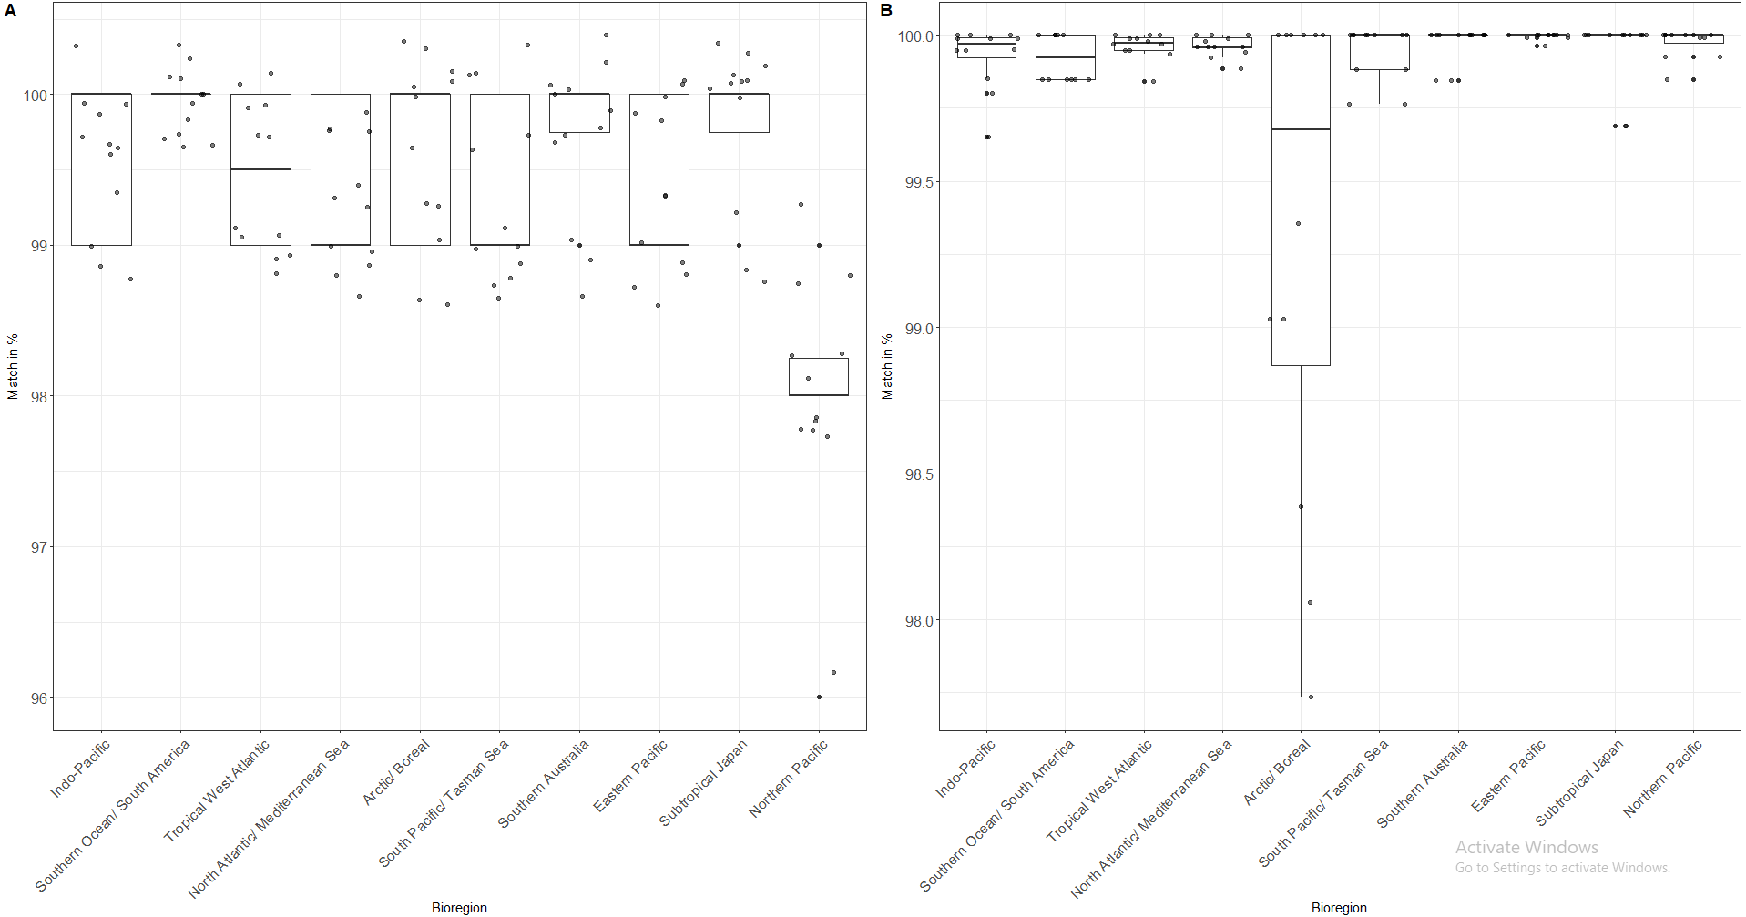

Supplementary Figure 4. The quality of the random forest model predictions showing the performance of the model per biogeographical region. A. shows the results from the multiregion model, while B. shows the results for the model assessing each biogeographical region individually. The scores are calculated by comparing the predictions with the true values for each region of the 12 test data sets, with each match generating a point and the scores calculated per data set showing the performance of the model per region.

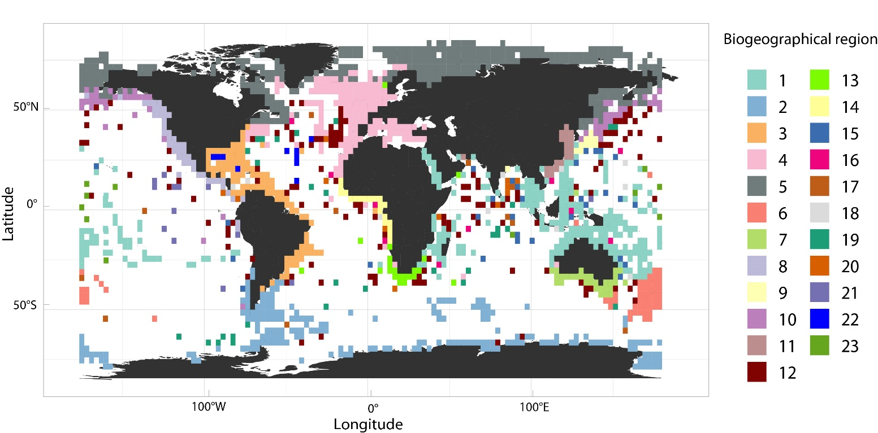

Supplementary Figure 5. Map of the 23 global benthic biogeographical regions delineated by the network analysis.

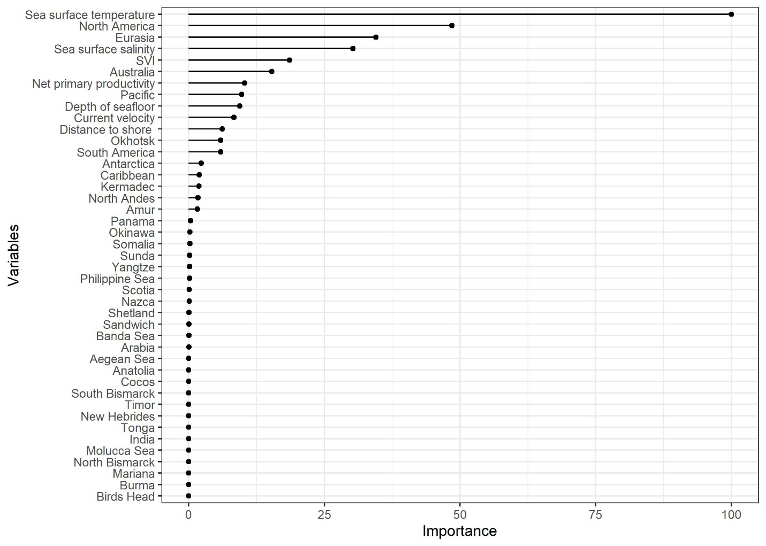

Supplementary Figure 6. The results from the varImp function illustrating the importance of each variable when modelling the predictors of all the biogeographical regions with random forest.

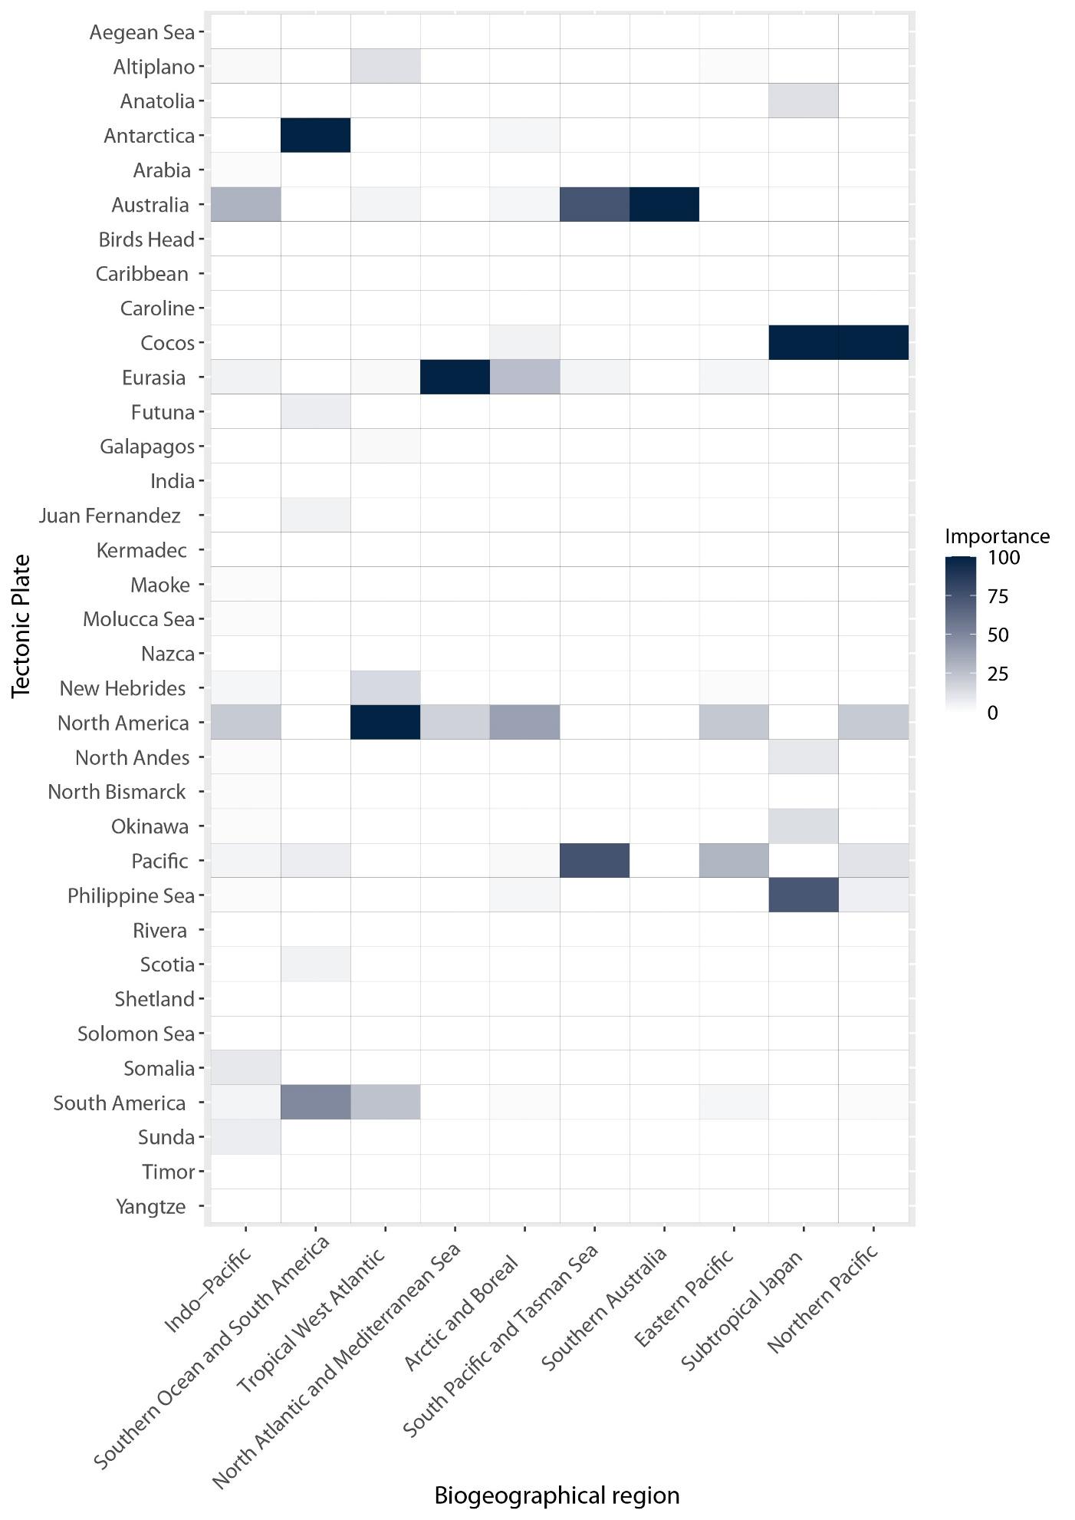

Supplementary Figure 7. The importance of tectonic plates on the major biogeographical regions based on the varImp- function from package “caret”. Tectonic plates which do not impact any of the ten main regions have been removed for illustrative purposes.

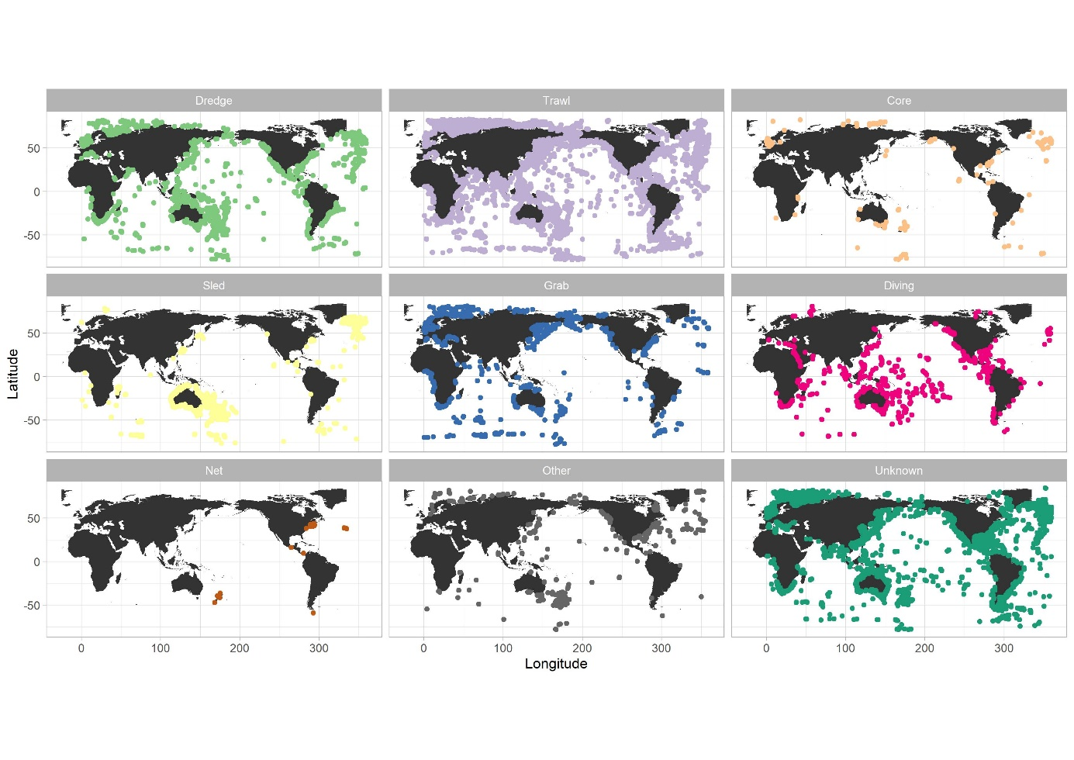Supplementary Figure 8. Map of the spatial distribution of different sampling equipment used to collect the Ophiuroidea data.

**Supplementary Table 1** The full list of variables that were considered for the analysis and that were correlation tested to each other and the biogeographical regions.

|  |  |
| --- | --- |
| **Layer code** | **Variable** |
| MS_bathy_5m | Bathymetry |
| MS_biogeo05_dist_shore_5m | Distance to shore |
| MS_biogeo08_sss_mean_5m | Sea surface salinity (annual mean) |
| MS_biogeo13_sst_mean_5m | Sea surface temperature (annual mean) |
| MS_biogeo16_sst_range_5m | Sea surface temperature (range) |
| BO2_chloltmax_bdmax | Chlorophyll concentration (longterm max at max depth) |
| BO2_chloltmax_bdmean | Chlorophyll concentration (longterm max at mean depth) |
| BO2_chloltmax_bdmin | Chlorophyll concentration (longterm max at min depth) |
| BO2_chloltmin_bdmax | Chlorophyll concentration (longterm min at max depth) |
| BO2_chloltmin_bdmean | Chlorophyll concentration (longterm max at mean depth) |
| BO2_chloltmin_bdmin | Chlorophyll concentration (longterm min at min depth) |
| BO2_curvelltmax_bdmax | Current velocity (longterm max at max depth) |
| BO2_curvelltmax_bdmean | Current velocity (longterm max at mean depth) |
| BO2_curvelltmax_bdmin | Current velocity (longterm max at min depth) |
| BO2_curvelltmin_bdmax | Current velocity (longterm min at max depth) |
| BO2_curvelltmin_bdmean | Current velocity (longterm max at mean depth) |
| BO2_curvelltmin_bdmin | Current velocity (longterm min at min depth) |
| BO2_templtmax_bdmax | Sea water temperature (longterm max at max depth) |
| BO2_templtmax_bdmean | Sea water temperature (longterm max at mean depth) |
| BO2_templtmax_bdmin | Sea water temperature (longterm max at min depth) |
| BO2_templtmin_bdmax | Sea water temperature (longterm min at max depth) |
| BO2_templtmin_bdmean | Sea water temperature (longterm max at mean depth) |
| BO2_templtmin_bdmin | Sea water temperature (longterm min at min depth) |
| BO2_carbonphytoltmax_bdmax | Carbon phytoplankton biomass (longterm max at max depth) |
| BO2_carbonphytoltmax_bdmean | Carbon phytoplankton biomass (longterm max at mean depth) |
| BO2_carbonphytoltmax_bdmin | Carbon phytoplankton biomass (longterm max at min depth) |
| BO2_carbonphytoltmin_bdmax | Carbon phytoplankton biomass (longterm min at max depth) |
| BO2_carbonphytoltmin_bdmean | Carbon phytoplankton biomass (longterm max at mean depth) |
| BO2_carbonphytoltmin_bdmin | Carbon phytoplankton biomass (longterm min at min depth) |
| npp.tif | Net primary producitivy |
| svi.tif | Seasonal variation of NPP |
| PB2002_plates | Tectonic plates |

**Supplementary Table 2** Summary of the range of values for each variable for the ten main regions that were modelled with random forest.



Supplementary text

*Note 1 Species distribution data*

The dataset analysed consists of 95 559 records attributed to 2201 species from the class of Ophiuroidea. There are 1913 species which are valid entities according to WoRMS (Ahyong et al. 2023) and 288 species that are provisional names, but considered to be valid species hypotheses according to experts. In the ophiuroid database the column survey refers to the expedition, and site is the expedition with the station. For example, Challenger 186 means Challenger station 186. The collection method refers to how the data was sampled. The depth column in an average depth between maximum and minimum depth sampled.

The specimens were collected during the last 130 years and are mostly conserved in natural history collections. These records derived from exploration programs, starting with expeditions conducted in the 19th century. The sampling scheme reflects the priority of the expeditions; exploration of various habitats and different geographical areas. Data from areas that are difficult to reach (such as abyssal plains, geographically remote areas etc.) or with less a priori interests are less represented in the data set. The histogram represents the temporal distribution of the data divided into shallow (above -200 m depth) and deep records (below -200m). Among these records, 3523 lack a collection date and 54 lack a depth record. More than 70% of the specimens were collected between 1976 and 2018 (55% of which above -200m).

Supplementary Figure 8. Temporal distribution of the records divided into shallow (above -200m) and deep records (below -200m).

Of the records below 200m depth, 15% have been collected between 1976 and 2018 by the cruises organised under the umbrella of Tropical Deep-Sea Benthos program (de Forges et al. 2021). The TDSB program also facilitated the creation of an international network of taxonomists, which study the material producing species identifications (de Forges et al. 2021). The TDSB program started by an opportunity: in 1976, the French Office of Overseas Scientific and Technical Research (ORSTOM) - now the Institut de Recherche pour le Développement (IRD), assigned its research trawler, the RV Vauban, to Noumea. On the way from Marseille, the ship made a detour via the Philippines for a 10-day oceanographic campaign organised by a team of researchers from the ORSTOM and the Muséum national d’Histoire naturelle (MNHN) in search of the "living fossil" crustacean *Neoglyphea Inopinata*. On March 22, 1976, the RV Vauban found *Neoglyphea inopinata* exactly where the RV Albatross had collected the first specimen in 1908. This spectacular rediscovery was accompanied by a harvest of samples from all zoological groups. Jacques Forest and Alain Crosnier, promoters of the "Musorstom campaign", surrounded themselves with a network of experts to describe the collected specimens and publish them. This is the beginning of the "Musorstom campaigns", which in 1999 became the Tropical Deep-Sea Benthos program.

By 2021, the Tropical Deep-Sea Benthos program has carried out 87 cruises, corresponding to about 7,500 dredge and trawl operations, in one of the last frontiers of biodiversity exploration: the bathyal domain of the large tropical islands. With the launch of the RV Alis in 1986, the program experienced an incomparable golden age in New Caledonia before spreading to the South Pacific archipelagos: Vanuatu, Fiji, Wallis & Futuna, Tonga, Marquesas, Austral Islands, under the tireless driving of Bertrand Richer de Forges. In 2000, came the turn of the great archipelagos of Melanesia: Solomon Islands, Papua New Guinea. International partnerships were forged for the exploration of Taiwan, the Philippines, Madagascar and Mozambique. In 2014, the program extended to the American tropical Atlantic. All the material collected has been deposited in the collections of the MNHN. The ophiuroid dataset includes records from 67 cruises from the TDSB program. To this day, a significant portion of the collections sit on the MNHN’s shelves in Paris waiting for identification by taxonomic experts.

Supplementary figure 9. The portion of deep-sea data (below 200m) associated with the TDSB campaigns

**Supplementary Table 3** List of the Tropical Deep-Sea Benthos cruises according to Bary (2018) and modified to include themost recent research cruises. The DOI refer to the inventory of campaigns operated by the French Oceanographic fleet (campagnes.flotteoceanographique.fr). The operations column refers to the number of bottom fishing gear that has been deployed. The few campaigns that include submarine images have been marked with a cross. The cruises that have not provided records in the present data are indicated in grey.

|  |  |  |  |  |  |
| --- | --- | --- | --- | --- | --- |
| YEAR | ACRONYM | DOI | OPERATIONS | AREAS | IMAGING |
| 1976 | MUSORSTOM_1 | 10.17600/76380010 | 59 | PHILIPPINES |  |
| 1979 | VAUBAN_1978-1979 |  | 48 | NEW CALEDONIA |  |
| 1980 | CORINDON_2 | 10.17600/80005712 | 59 | INDONESIA |  |
| 1980 | MUSORSTOM_2 | 10.17600/80010211 | 70 | PHILIPPINES |  |
| 1984 | CHALCAL_1 | 10.17600/84001711 | 98 | NEW CALEDONIA |  |
| 1985 | BIOCAL | 10.17600/85002911 | 68 | NEW CALEDONIA |  |
| 1985 | MUSORSTOM_3 | 10.17600/85005911 | 59 | PHILIPPINES |  |
| 1985 | MUSORSTOM_4 | 10.17600/85009111 | 104 | NEW CALEDONIA |  |
| 1986 | CHALCAL_2 | 10.17600/86006511 | 38 | NEW CALEDONIA |  |
| 1986 | MUSORSTOM_5 | 10.17600/86006611 | 137 | NEW CALEDONIA |  |
| 1986 | SMIB_1 | 10.17600/86009711 | 15 | NEW CALEDONIA |  |
| 1986 | SMIB_2 | 10.17600/86009611 | 31 | NEW CALEDONIA |  |
| 1987 | BIOGEOCAL | 10.17600/87001811 | 49 | NEW CALEDONIA |  |
| 1987 | SMIB_3 |  | 33 | NEW CALEDONIA |  |
| 1988 | CORAIL_2 |  | 173 | NEW CALEDONIA |  |
| 1989 | CALSUB | 10.17600/89009911 | 22 | NEW CALEDONIA | X |
| 1989 | GEMINI | 10.17600/89005211 | 13 | VANUATU |  |
| 1989 | MUSORSTOM_6 | 10.17600/89004811 | 103 | NEW CALEDONIA |  |
| 1989 | SMIB_4 | 10.17600/89004911 | 36 | NEW CALEDONIA |  |
| 1989 | SMIB_5 |  | 36 | NEW CALEDONIA |  |
| 1989 | VOLSMAR |  | 38 | NEW CALEDONIA |  |
| 1990 | AZTEQUE | 10.17600/90010211 | 11 | NEW CALEDONIA |  |
| 1990 | SMIB_6 | 10.17600/90005911 | 40 | NEW CALEDONIA |  |
| 1991 | BERYX_2 | 10.17600/91000811 | 17 | NEW CALEDONIA |  |
| 1991 | KARUBAR |  | 91 | INDONESIA |  |
| 1992 | BERYX_11 | 10.17600/92005011 | 60 | NEW CALEDONIA |  |
| 1992 | MUSORSTOM_7 | 10.17600/92005111 | 145 | WALLIS & FUTUNA |  |
| 1993 | BATHUS_1 | 10.17600/93000350 | 75 | NEW CALEDONIA |  |
| 1993 | BATHUS_2 | 10.17600/93000360 | 58 | NEW CALEDONIA |  |
| 1993 | BATHUS_3 | 10.17600/93000370 | 78 | NEW CALEDONIA |  |
| 1993 | LAGON |  | NA | NEW CALEDONIA |  |
| 1993 | SMIB_8 | 10.17600/93000640 | 63 | NEW CALEDONIA |  |
| 1993 | SMIB_9 | 10.17600/93000650 | NA | NEW CALEDONIA |  |
| 1994 | BATHUS_4 | 10.17600/94100030 | 74 | NEW CALEDONIA |  |
| 1994 | HALICAL_1 | 10.17600/94100020 | 38 | NEW CALEDONIA |  |
| 1994 | HALIPRO_1 | 10.17600/94100010 | 32 | NEW CALEDONIA |  |
| 1994 | MUSORSTOM_8 | 10.17600/94100040 | 186 | FIDJI |  |
| 1995 | SMIB_10 |  | 15 | NEW CALEDONIA |  |
| 1996 | HALIPRO_2 | 10.17600/94100010 | 106 | NEW CALEDONIA |  |
| 1996 | SMCB |  | 590 | FRENCH POLYNESIA |  |
| 1997 | MUSORSTOM_9 | 10.17600/97100020 | 165 | FRENCH POLYNESIA |  |
| 1998 | MUSORSTOM_10 | 10.17600/98100080 | 83 | FIDJI |  |
| 1999 | BORDAU_1 | 10.17600/99100020 | 117 | FIDJI |  |
| 1999 | LITHIST |  | 18 | NEW CALEDONIA |  |
| 1999 | PALEO-SURPRISE | 10.17600/99100040 | 28 | NEW CALEDONIA |  |
| 2000 | BORDAU_2 | 10.17600/100060 | 111 | TONGA |  |
| 2000 | TAIWAN_2000 |  | 55 | TAIWAN |  |
| 2001 | NORFOLK_1 | 10.17600/1100050 | 89 | NEW CALEDONIA |  |
| 2001 | SALOMON_1 | 10.17600/1100090 | 118 | ILES SALOMON |  |
| 2001 | TAIWAN_2001 |  | 80 | TAIWAN |  |
| 2002 | BENTHAUS | 10.17600/2100100 | 318 | FRENCH POLYNESIA |  |
| 2002 | TAIWAN_2002 |  | 45 | TAIWAN |  |
| 2003 | NORFOLK_2 | 10.17600/3100030 | 141 | NEW CALEDONIA |  |
| 2003 | TAIWAN_2003 |  | 24 | TAIWAN |  |
| 2004 | BOA0 | 10.17600/4100140 | 27 | VANUATU |  |
| 2004 | SALOMON_2 | 10.17600/4100090 | 141 | ILES SALOMON |  |
| 2004 | TAIWAN_2004 |  | 34 | TAIWAN |  |
| 2005 | BOA1 | 10.17600/5100060 | 71 | VANUATU |  |
| 2005 | EBISCO | 10.17600/5100080 | 172 | NEW CALEDONIA |  |
| 2005 | PANGLAO_2005 |  | 79 | PHILIPPINES |  |
| 2006 | SANTO_2006 | 10.17600/6100100 & 10.17600/6100110 | 134 | VANUATU |  |
| 2007 | AURORA_2007 |  | 224 | PHILIPPINES |  |
| 2007 | SALOMONBOA_3 | 10.17600/7100070 | 96 | ILES SALOMON |  |
| 2008 | CONCALIS | 10.17600/8100010 | 103 | NEW CALEDONIA |  |
| 2008 | LUMIWAN_2008 |  | 68 | PHILIPPINES |  |
| 2008 | TERRASSES | 10.17600/8100100 | 99 | NEW CALEDONIA |  |
| 2009 | MAINBAZA |  | 46 | MOZAMBIQUE CHANEL |  |
| 2009 | MIRIKY |  | 119 | NORTH MADAGASCAR |  |
| 2009 | TARASOC | 10.17600/9100040 | 212 | FRENCH POLYNESIA |  |
| 2010 | ATIMO_VATAE | 10.17600/10110040 | 121 | SOUTH MADAGASCAR |  |
| 2010 | BIOPAPUA | 10.17600/10100040 | 156 | PAPUA NEW GUINEA |  |
| 2011 | EXBODI | 10.17600/11100080 | 161 | NEW CALEDONIA |  |
| 2012 | PAPUA_NIUGINI | 10.17600/18000841 | 265 | PAPUA NEW GUINEA |  |
| 2013 | TAIWAN_2013 |  | 16 | TAIWAN |  |
| 2014 | DONGSHA_2014 |  | 12 | TAIWAN |  |
| 2014 | GUYANE_2014 |  | 68 | FRENCH GUYANA |  |
| 2014 | KAVIENG_2014 | 10.17600/14004400 | 95 | PAPUA NEW GUINEA |  |
| 2014 | MADEEP | 10.17600/14004000 | 105 | PAPUA NEW GUINEA | X |
| 2014 | NANHAI_2014 |  | 21 | TAIWAN |  |
| 2015 | KARUBENTHOS_2015 | 10.17600/15005400 | 139 | GUADELOUPE |  |
| 2015 | ZHONGSHA_2015 |  | 36 | TAIWAN |  |
| 2016 | KANACONO | 10.17600/16003900 | 134 | NEW CALEDONIA |  |
| 2017 | BIOMAGLO | 10.17600/17004000 | 89 | MAYOTTE AND GLORIOUS ISLANDS | X |
| 2017 | KANADEEP1 | 10.17600/17003800 | 139 | NEW CALEDONIA |  |
| 2018 | WALTER SHOAL (MD208) | 10.17600/17002700 | 56 | WALTER SHOAL |  |
| 2019 | KANADEEP2 | 10.17600/18000883 | 45 | NEW CALEDONIA | X |
| 2021 | SPANBIOS | 10.17600/18000701 | 180 | NEW CALEDONIA |  |

*Note 2 Random forest specifications*

All random forest models were trained by producing a 1000-decision trees with the specifications of the “ranger” method, with internal training control parameters of repeated cross validation of five folds and three repetitions, and using permutations to calculate the importance of each variable. The predictions on the test data set were implemented by random forest with the out-of-bag error estimates calculating a vector of predictions. Additionally we assessed the quality of the predictions by comparing the predicted values to the observed values in order to calculate the success rate in predicting the correct region (Fig. S4). We evaluated the importance of each environmental variable using the standard RF variable importance procedure. The *varImp* function tracks changes in model statistics for each predictor and accumulates the reduction in the statistic as the variables are added to the model. The total reduction is what is calculated as the variable importance.

*Note 3 Interpretation of differences between global biogeographic delineations as illustrated in Table 2*

When assessing the spatial congruency to shallow benthos biogeographical regions, also produced by networks (Kocsis et al. 2018), there is an overall good agreement. The main differences arise from their Arctic region expanding deeper into the Atlantic and the Pacific. In this study, however, we have delineated a deeper additional biogeographical region of Temperate & Central Atlantic Ocean, while in the subarctic Pacific we have three different regions. One of the most conspicuous dissimilarities is caused by the Eastern Pacific biogeographical region, which is divided into multiple regions in other studies (Table 2.). Our Indo-Pacific biogeographical region is also larger than in others studies, where several subunits are produced (Table 2.), but its northern extent matches with the bathyal provinces (Watling et al. 2013). In addition, the Subtropical Japan biogeographical region is typically integrated to a larger temperate biogeographical region, despite here being conspicuous. Similarly, there are discrepancies in the Southern Ocean and South America boundary, as others propose multiple units (Table 2.). However, our results indicate that this biogeographical region extends to South-America, but remains distinct from the South-Pacific/Tasman Sea or Southern Australia biogeographical regions as observed in regional studies (Griffiths et al., 2009; O'Hara et al., 2013) and in the shallow benthos (Kocsis et al. 2018). The study of bathyal provinces and MEOW group the Southern Australia biogeographical region into the Indian Ocean and Temperate Australasia, respectively, while other studies can identify a clear boundary. Furthermore, in the bathyal scheme, the Tropical West Atlantic biogeographical region is grouped together with the North-Atlantic and Mediterranean Sea, but our results in addition to other network based studies suggest that these are distinctly different, with the Tropical West Atlantic biogeographical region linked to the South-American plate (Costello et al. 2017, Kocsis et al. 2018). Meanwhile the North Atlantic and the Mediterranean Sea form a single biogeographical region, which is in good agreement with the biogeographical regions of amphipods (Arfianti and Costello 2020) and shallow benthic biogeographical regions based on seven different taxa (Kocsis et al. 2018).

**Supplementary Table 4** Number of cells which could not be evaluated at each resolution (i.e., cells which had less than 10 species, or had only singletons, or had less than 3 sampled sub-cells.

|  |  |  |  |
| --- | --- | --- | --- |
| Resolution | Total number of cells | Number of cells which could not be evaluated | Percentage of which could not be evaluated |
| 1° | 5579 | 4651 | 83% |
| 2° | 2846 | 2106 | 74% |
| 3° | 1855 | 1239 | 68% |
| 4° | 1326 | 832 | 63% |
| 5° | 1032 | 615 | 60% |

**Supplementary Table 5** Number of faunal links between regions

|  |  |  |
| --- | --- | --- |
| Source biogeographical region | Destination biogeographical region | Number of links |
| Tropical West Atlantic | Arctic Boreal | 2 |
| Eastern Pacific | Arctic Boreal | 4 |
| Indo-Pacific | Arctic Boreal | 5 |
| North Atlantic Mediterranean Sea | Arctic Boreal | 27 |
| Northern Pacific | Arctic Boreal | 15 |
| South Pacific Tasman Sea | Arctic Boreal | 2 |
| Southern Ocean South America | Arctic Boreal | 2 |
| Arctic Boreal | Tropical West Atlantic | 4 |
| Eastern Pacific | Tropical West Atlantic | 14 |
| Indo-Pacific | Tropical West Atlantic | 4 |
| Minor clusters | Tropical West Atlantic | 9 |
| North Atlantic Mediterranean Sea | Tropical West Atlantic | 25 |
| Northern Pacific | Tropical West Atlantic | 1 |
| South Pacific Tasman Sea | Tropical West Atlantic | 1 |
| Southern Ocean South America | Tropical West Atlantic | 8 |
| Arctic Boreal | Eastern Pacific | 3 |
| Tropical West Atlantic | Eastern Pacific | 1 |
| Indo-Pacific | Eastern Pacific | 3 |
| Minor clusters | Eastern Pacific | 6 |
| North Atlantic Mediterranean Sea | Eastern Pacific | 3 |
| Northern Pacific | Eastern Pacific | 16 |
| South Pacific Tasman Sea | Eastern Pacific | 1 |
| Southern Ocean South America | Eastern Pacific | 1 |
| Subtropical Japan | Eastern Pacific | 2 |
| Arctic Boreal | Indo-Pacific | 1 |
| Tropical West Atlantic | Indo-Pacific | 1 |
| Tropical West Atlantic | Indo-Pacific | 4 |
| Minor clusters | Indo-Pacific | 69 |
| North Atlantic Mediterranean Sea | Indo-Pacific | 7 |
| Northern Pacific | Indo-Pacific | 3 |
| South Pacific Tasman Sea | Indo-Pacific | 56 |
| Southern Australia | Indo-Pacific | 42 |
| Southern Ocean South America | Indo-Pacific | 5 |
| Subtropical Japan | Indo-Pacific | 37 |
| Arctic Boreal | North Atlantic Mediterranean Sea | 11 |
| Tropical West Atlantic | North Atlantic Mediterranean Sea | 19 |
| Indo-Pacific | North Atlantic Mediterranean Sea | 5 |
| Minor clusters | North Atlantic Mediterranean Sea | 20 |
| South Pacific Tasman Sea | North Atlantic Mediterranean Sea | 3 |
| Southern Ocean South America | North Atlantic Mediterranean Sea | 3 |
| Subtropical Japan | North Atlantic Mediterranean Sea | 1 |
| Arctic Boreal | Northern Pacific | 13 |
| Eastern Pacific | Northern Pacific | 14 |
| Indo-Pacific | Northern Pacific | 9 |
| Minor clusters | Northern Pacific | 13 |
| North Atlantic Mediterranean Sea | Northern Pacific | 3 |
| South Pacific Tasman Sea | Northern Pacific | 1 |
| Southern Ocean South America | Northern Pacific | 1 |
| Subtropical Japan | Northern Pacific | 17 |
| Indo-Pacific | South Pacific Tasman Sea | 68 |
| Minor clusters | South Pacific Tasman Sea | 9 |
| North Atlantic Mediterranean Sea | South Pacific Tasman Sea | 6 |
| Southern Australia | South Pacific Tasman Sea | 28 |
| Southern Ocean South America | South Pacific Tasman Sea | 10 |
| Subtropical Japan | South Pacific Tasman Sea | 6 |
| Indo-Pacific | Southern Australia | 69 |
| Minor clusters | Southern Australia | 17 |
| North Atlantic Mediterranean Sea | Southern Australia | 6 |
| South Pacific Tasman Sea | Southern Australia | 43 |
| Southern Ocean South America | Southern Australia | 5 |
| Subtropical Japan | Southern Australia | 3 |
| Tropical West Atlantic | Southern Ocean South America | 8 |
| Minor clusters | Southern Ocean South America | 9 |
| North Atlantic Mediterranean Sea | Southern Ocean South America | 4 |
| South Pacific Tasman Sea | Southern Ocean South America | 14 |
| Southern Australia | Southern Ocean South America | 2 |
| Subtropical Japan | Southern Ocean South America | 1 |
| Arctic Boreal | Subtropical Japan | 5 |
| Tropical West Atlantic | Subtropical Japan | 1 |
| Eastern Pacific | Subtropical Japan | 10 |
| Indo-Pacific | Subtropical Japan | 85 |
| Minor clusters | Subtropical Japan | 24 |
| North Atlantic Mediterranean Sea | Subtropical Japan | 4 |
| Northern Pacific | Subtropical Japan | 29 |
| South Pacific Tasman Sea | Subtropical Japan | 8 |
| Southern Australia | Subtropical Japan | 2 |
| Southern Ocean South America | Subtropical Japan | 1 |

References

Ahyong, S. et al. 2023. World Register of Marine Species (WoRMS).

Arfianti, T. and Costello, M. J. 2020. Global biogeography of marine amphipod crustaceans : latitude , regionalization , and beta diversity. - Mar. Ecol. Prog. Ser. 638: 83–94.

Bary, S. 2018. Les représentations de la biodiversité dans les fonds marins: une approche épistémologique et scientifique.

Costello, M. J. et al. 2017. Marine biogeographic realms and species endemicity. - Nat. Commun. 8: 1–9.

de Forges, B. R. et al. 2021. Alain Crosnier’s role in modern carcinology: exploration, international collaboration, and taxonomy. - J. Crustac. Biol. 41: 1–8.

Griffiths, H. J. et al. 2009. Towards a generalized biogeography of the Southern Ocean benthos.: 162–177.

Hara, T. D. O. et al. 2013. Biogeographical and phylogeographical relationships of the bathyal ophiuroid fauna of the Macquarie Ridge , Southern Ocean.: 321–333.

Kocsis, Á. T. et al. 2018. The stability of coastal benthic biogeography over the last 10 million years. - Glob. Ecol. Biogeogr. 27: 1106–1120.

Watling, L. et al. 2013. A proposed biogeography of the deep ocean floor. - Prog. Oceanogr. 111: 91–112.