Tectonics
Supporting Information for
Paleomagnetic rotations in the North-eastern Caribbean region reveal major intraplate deformation since the Eocene
Leny Montheil¹, Mélody Philippon², Philippe Münch¹, Pierre Camps¹, Bram Vaes³, Jean-Jacques Cornée², Thierry Poidras¹, Douwe J.J. van Hinsbergen³

¹ Geosciences Montpellier (UMR 5243, CNRS/UM/Université des Antilles), Université de
Montpellier, Montpellier, France.
² Geosciences Montpellier (UMR 5243, CNRS/UM/Université des Antilles), Université des Antilles, Pointe-à-Pitre, France.
³ Department of Earth Sciences, Utrecht University, Utrecht, the Netherlands

Contents of this file

Figure S1 : K-T analysis.

Figure S2 : Inclination diagrams against ages.

Figure S3 : Reversal tests.

Figure S4 : Conglomerat test, Martinique.

Additional Supporting Information (Files uploaded separately)

Table S1 : Relative rotation between compared collections of data.
Introduction
The Supporting Information files contains Figures showing several tests (K-T experiment, reversal test, conglomerate test) used on the paleomagnetic analysis to understand the origin of magnetization of the specimens and decipher if the Characteristic Remanent Magnetization component interpreted by the direction analysis is primary or not.
It also includes a Figure showing the Inclination values of the paleomagnetic datasets and a Table detailing the relative rotation estimated between all the comparable collection of paleomagnetic data (i.e. datasets from the same island or dataset of comparable age from different island).
Figures

Figure S1. K-T analysis. Thermomagnetic curves, second derivative diagrams and description of the diagrams for each specimen analysed.
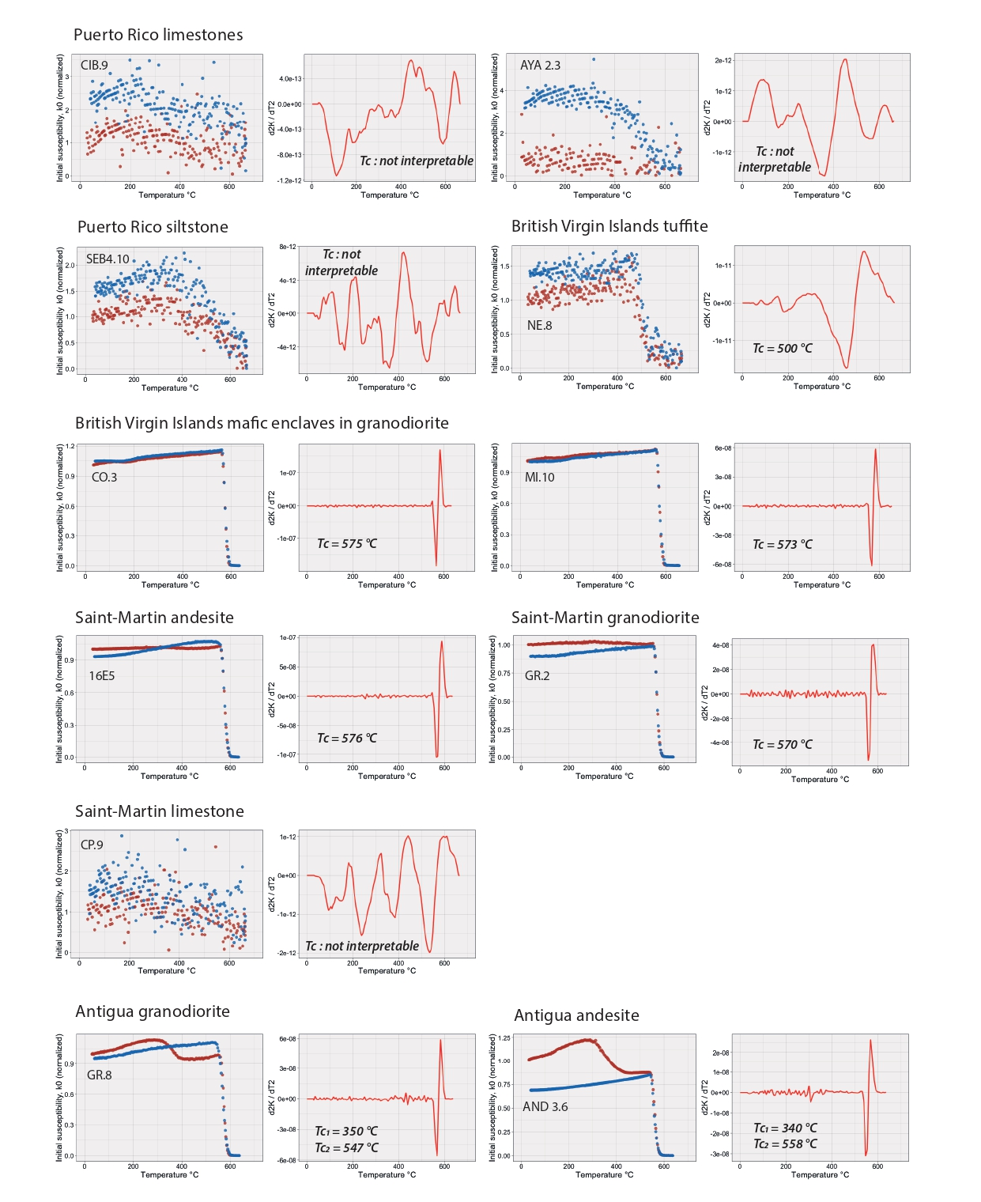

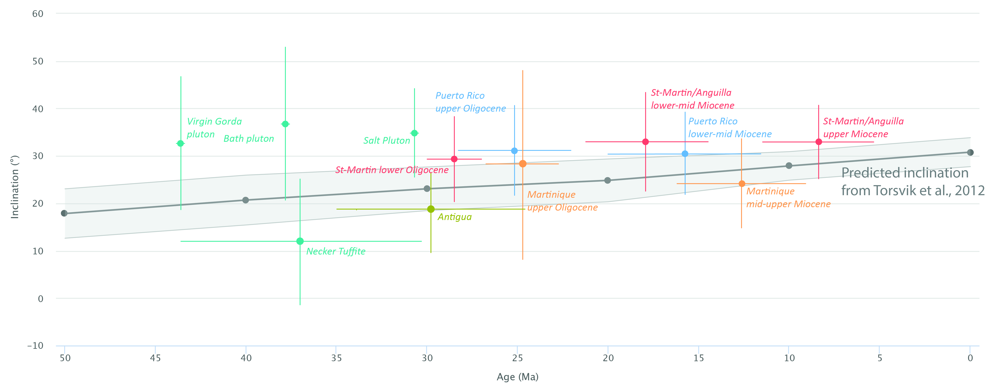
Figure S2 : Inclination diagrams against ages showing inclination consistency of the paleomagnetic collections of this study compared to the predicted values of inclination for the Caribbean plate from Torsvik et al. (2012).

Figure S3 : Bootstrapped reversal tests on the collection of ChRM directions of the British Virgin Island, Saint-Martin, Anguilla, Antigua and Martinique datasets.

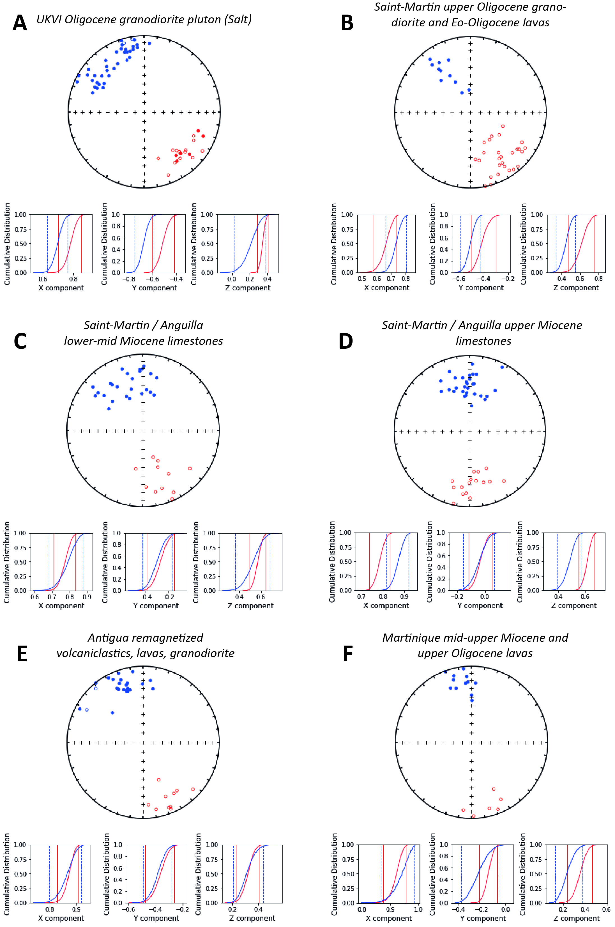
Figure S4 : Field photography and stereographic projection of the interpreted direction of the conglomerat test in Miocene lavas. Erratic directions indicate that blocks were magnetized prior to the deposition and that no remagnetization events affected the site.
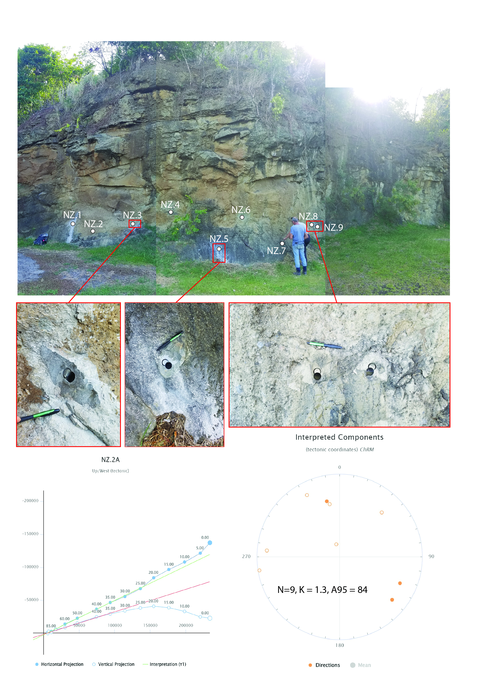

Table

Table S1 : Table of relative rotation between the collections estimated with the bootstrapped approach. Negative values represent relative counterclockwise rotation of the “rotating collection” relative to the reference collection. To adequately weight the bootstrapped approach to equal n, the reference collection must be the collection with larger n. In red : significant rotation, in black : unsignificant rotation

