Supporting Information:
Threatened fish species in the Northeast Atlantic are functionally rare

Supplementary Appendix 2 – Figures

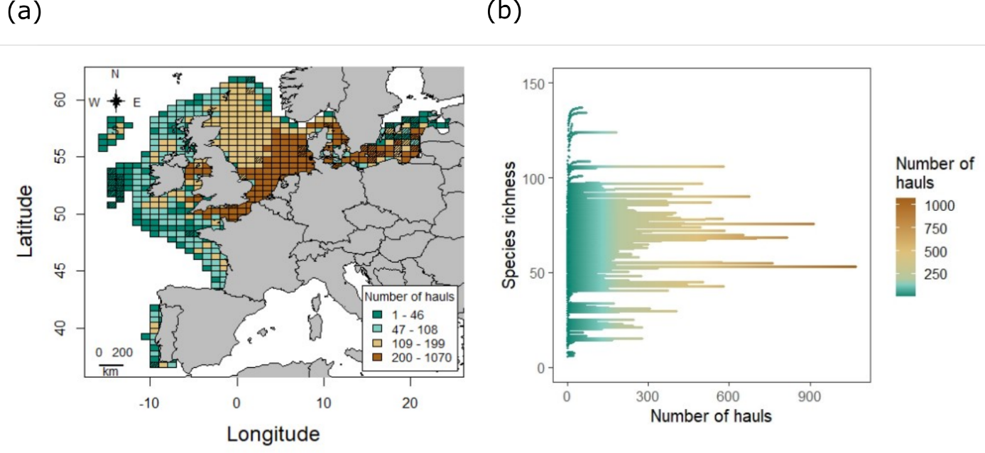
Figure S1. Sampling effort in the seas of the European continental shelf. (a) Total haul number performed from 1984 to 2020 within each ICES rectangle. Deleted rectangles due to undersampling are black striped. (b) Species Accumulation Curves for each rectangle. The Michaelis-Menten function is given by: 𝑓(𝑥) = 𝑆 × 𝑥 / 𝑎 + 𝑥 with f the number of species, S the asymptotic species richness estimated, x the number of hauls and a the estimated minimum number of hauls to capture half of the asymptote values. Only the rectangles covering 65% of the asymptotic number of species are included in the analysis.
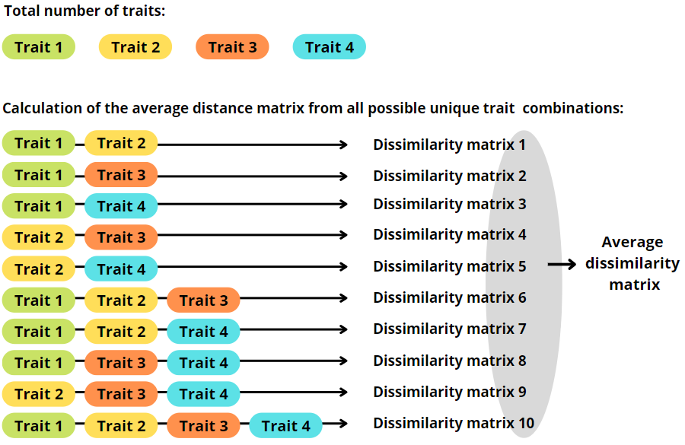
Figure S2. Flowchart of the methodology applied to calculate the average dissimilarity matrix on which the integrated distinctiveness index is based: To characterize the difference between two species, we constructed 10 unique trait combinations from an initial set of 4 traits, and computed the average dissimilarity matrix from 10 dissimilarity matrices from 4 traits considering that a minimum of 2 traits is needed to characterize the difference between two species.

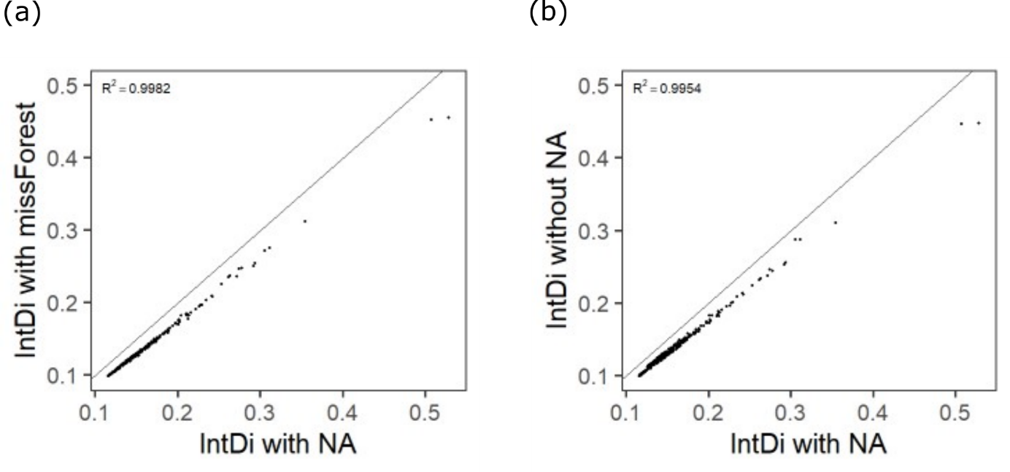
Figure S3. Robustness of the Integrated distinctiveness index (IntDi) classification to missing traits values. The bisector x = y is plotted, with (a) classification of species with complete trait data compared to the one defined independently of the presence of "NA" in the traits. A total of 339 species out of 425 were considered for the calculation, witheach dot representing a species. (b) Classification of species after imputing missing information using the ‘missForest’ package compared to the classification defined independently of the presence of NA in the traits. A total of 425 species out of 425 were considered for the calculation, with each dot representing a species.

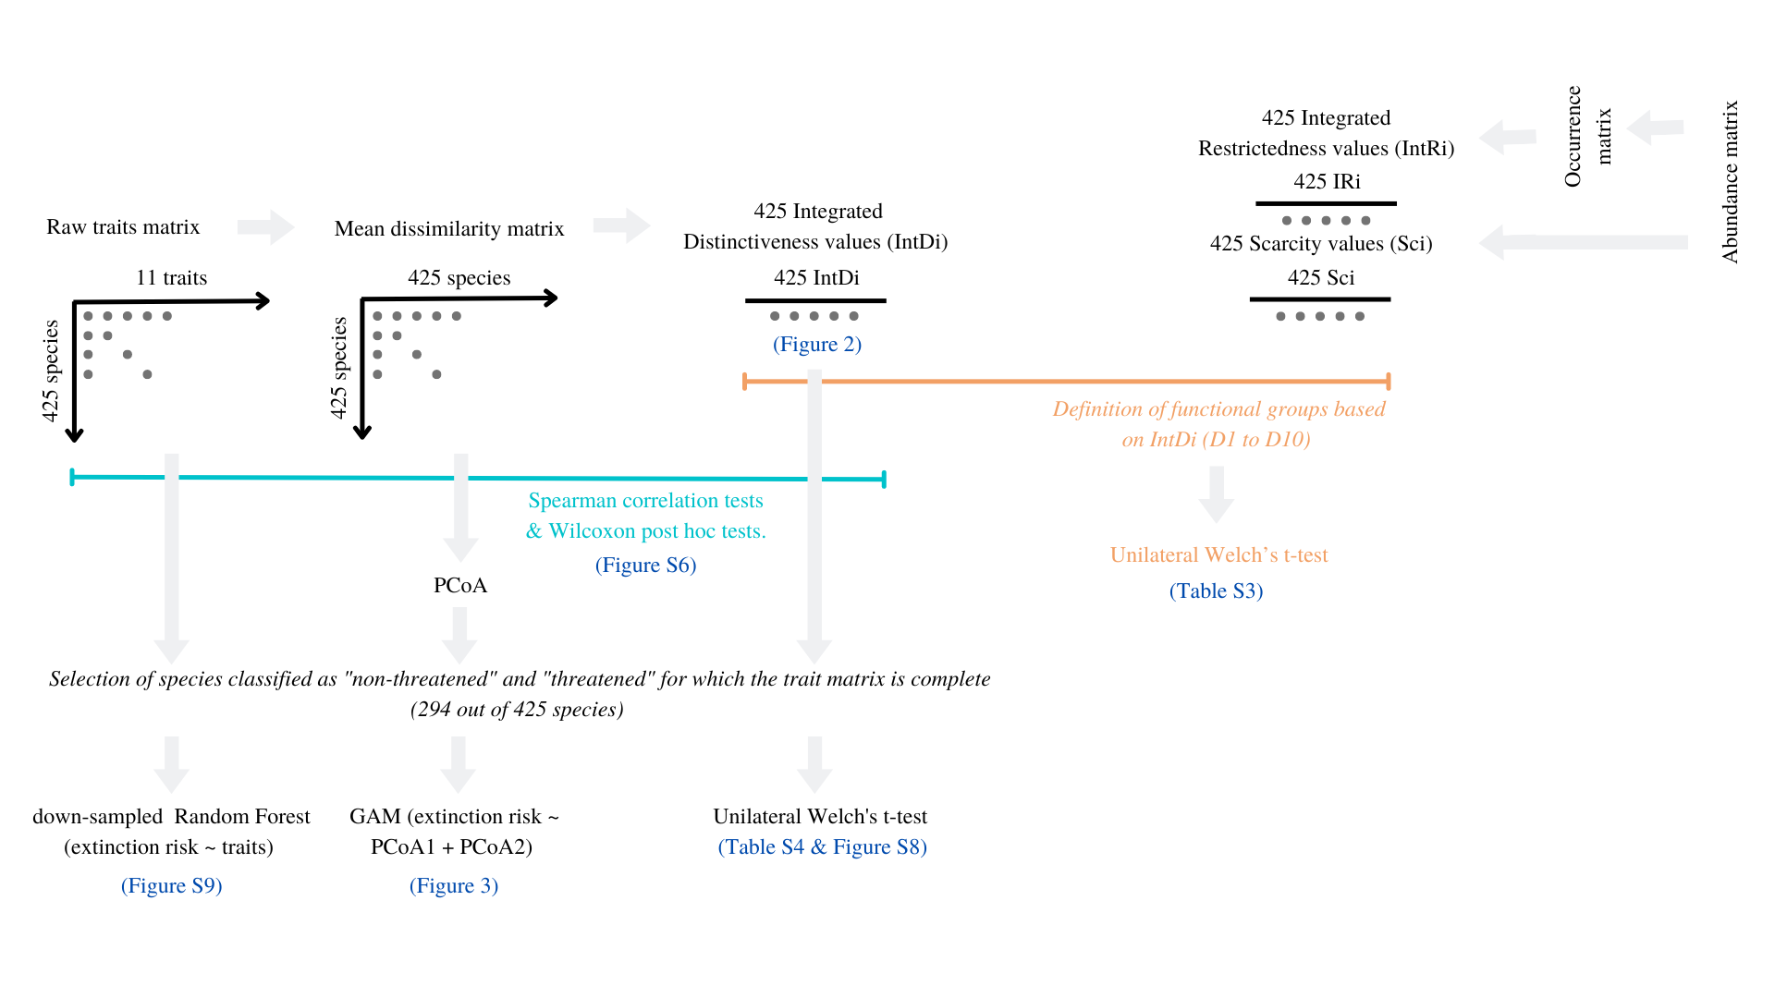
Figure S4. Flowchart of the methodology applied in our study

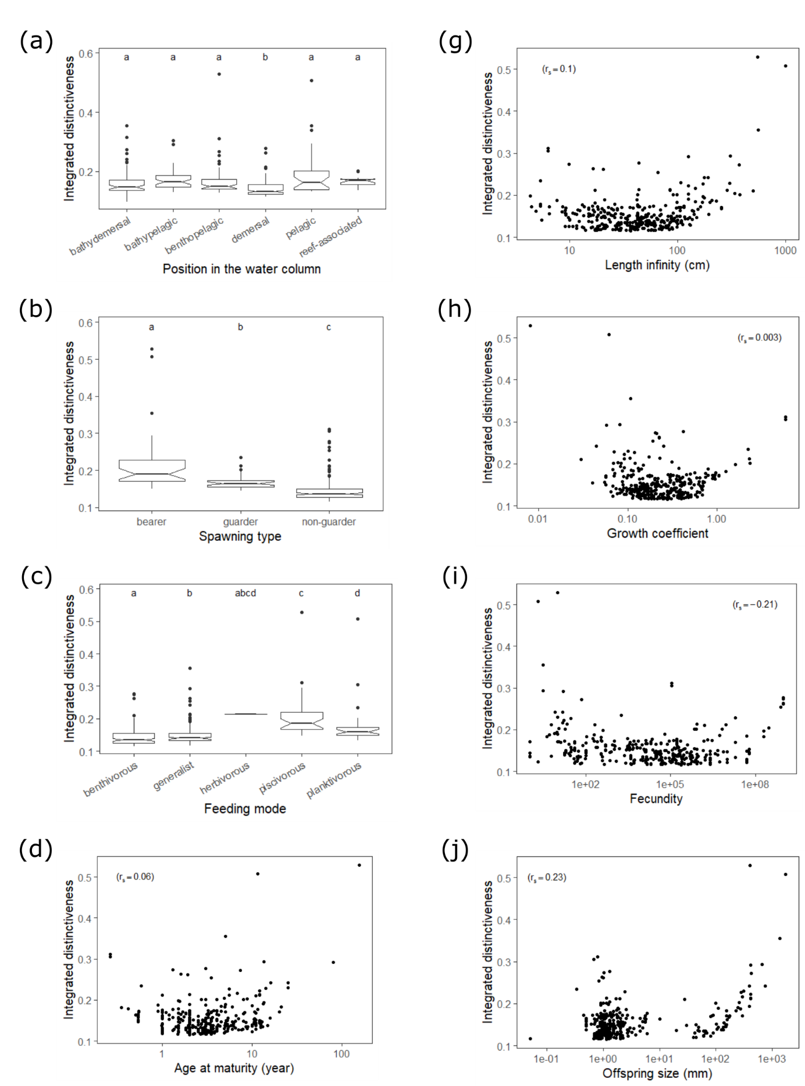
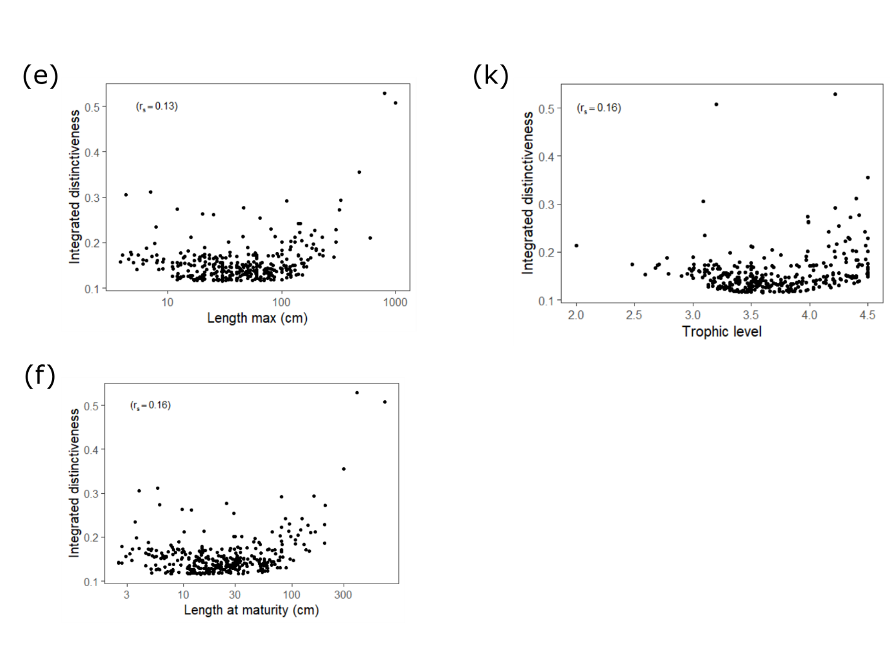
Figure S5. Statistical relationships between species functional distinctiveness and their ecological traits. (a) position in the water column, (b) spawning type, (c) feeding mode, (d) age at maturity (year; log₁₀ transformed), (e) length at maturity (cm; log₁₀ transformed), (f) infinite length (cm; log₁₀ transformed), (g) maximal length at maturity (cm; log₁₀ transformed), (h) growth coefficient (log₁₀ transformed), (i) fecundity (log₁₀ transformed), (j) offspring size (mm; log₁₀ transformed), and (k) trophic level. Letters above boxplots denote significant differences between trait attributes (Wilcoxon post-hoc test).

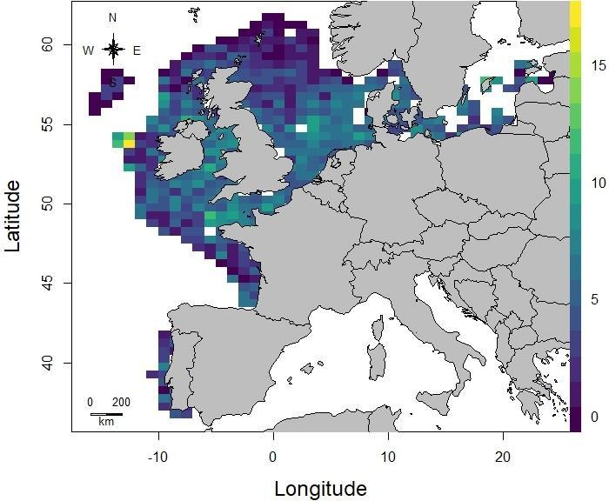
Figure S6. Map of the percentage of distinct species per rectangle across European Seas. The color gradient refers to the percentage of distinct species.

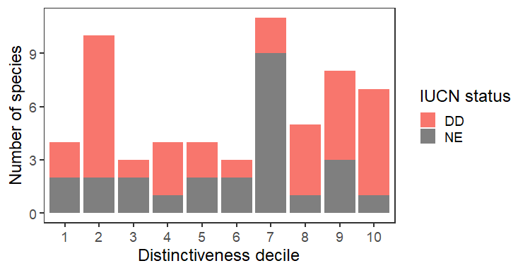
Figure S7. Distribution of IUCN Data Deficient (DD) and Not Assessed (NE) status across functional distinctiveness groups.

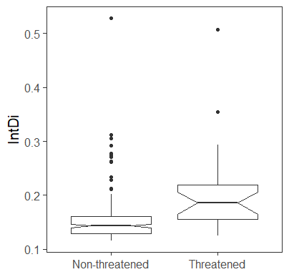

Figure S8. Boxplot showing the distribution of integrated distinctiveness values in the "not threatened" and "threatened" categories (unilateral Welch’s t-test; p = .003).

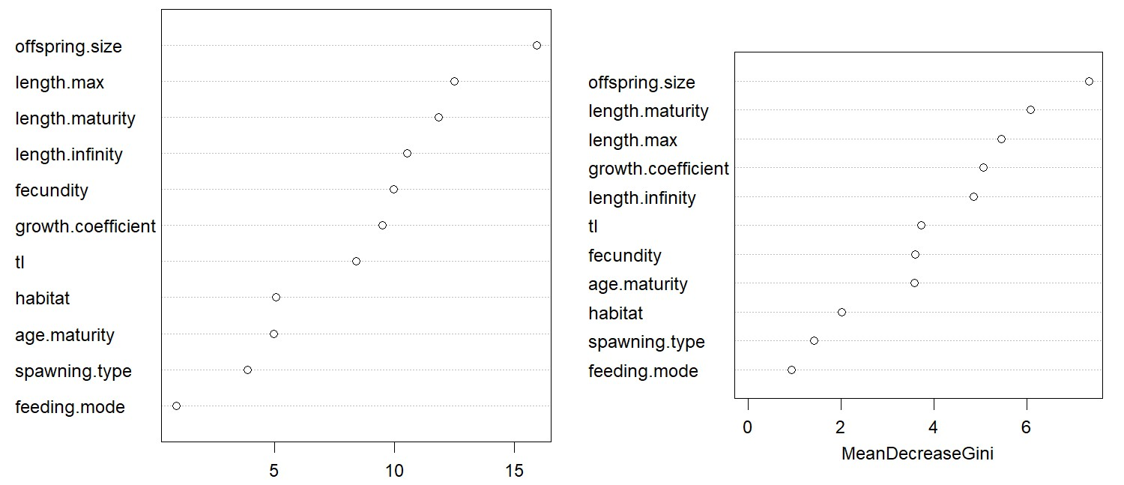
Figure S9. Dot-chart of variable importance as measured by the down-sampled random forest with species threat (1: threatened, 196 species; 0: not threatened, 17 species) as response variable and species traits values as predictors.

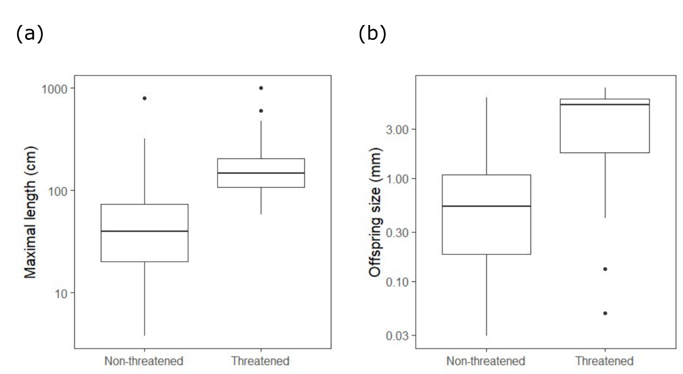
Figure S10. Boxplot showing the distribution of values of the most important traits in determining species extinction risk. (a) Threatened species have a larger maximal length (log₁₀ transformed). (b) Threatened species have a much larger offspring size (log₁₀ transformed).

