Supplemental material

Table S1. Coefficients a, b and c of equation (7) for the seasonal cycles of fCO₂, SST and SSS in 2019 plotted in Figure 5.
Region | Coefficients | fCO₂ | SST | SSS
26-33ºN | a | 395.2 | 20.0 | 36.48
 | b | -14.7 | -1.7 | 0.12
 | c | -10.2 | -1.0 | 0.05
20-26ºN | a | 421.0 | 20.5 | 36.42
 | b | -14.4 | -1.4 | 0.14
 | c | 31.2 | -1.1 | -0.09
10ºN-18ºN | a | 404.3 | 25.3 | 36.05
 | b | -21.0 | -2.6 | 0.08
 | c | -23.2 | -0.1 | -0.14

Table S2. Mean, standard deviation, minimum and maximum values of seawater fCO₂, SST and SSS measured by the Cap San Lorenzo between 28ºN and 36ºN in 2019 and the observations of Curbelo-Hernández et al. (2021) between the Strait of Gibraltar and the Canary Islands in their Table 1.
 | Mean | Standard deviation | minimum | maximum | Curbelo-Hernández
WINTER
fCO₂ | 377.3 | 6.2 | 362.4 | 399.0 | 370.31 ± 1.62
SST | 18.20 | 0.79 | 16.87 | 19.67 | 18.15 ± 0.12
SSS | 36.51 | 0.10 | 36.20 | 36.69 | 36.595 ± 0.022
SPRING
fCO₂ | 391.9 | 12.0 | 369.5 | 431.0 | 382.90 ± 2.38
SST | 19.18 | 0.85 | 16.55 | 20.93 | 18.60 ± 0.10
SSS | 36.51 | 0.07 | 36.29 | 36.74 | 36.418 ± 0.038
SUMMER
fCO₂ | 413.6 | 16.0 | 347.0 | 439.9 | 420.70 ± 2.76
SST | 21.46 | 0.59 | 18.62 | 22.53 | 22.09 ± 0.17
SSS | 36.47 | 0.12 | 36.16 | 36.70 | 36.580 ± 0.042
AUTUMN
fCO₂ | 410.6 | 16.6 | 372.0 | 440.9 | 394.50 ± 2.20
SST | 21.86 | 1.30 | 18.08 | 23.76 | 20.79 ± 0.22
SSS | 36.40 | 0.15 | 35.86 | 36.71 | 36.650 ± 0.042

Biological effect on inorganic carbon using high resolution chlorophyll concentrations

The ship crosses the PU region (20ºN-26ºN) in about 2 days. For each voyage of 2019, we calculate the averaged chlorophyll concentrations over these days to obtain the chlorophyll map at the time of the CO₂ observations. The chlorophyll concentrations are then collocated along the track of the ship. In winter and autumn, both chlorophyll and CO₂ concentrations are high (Figures S1a, S1d, S1e, S1h, S1i, S1l). In spring 2019, the biological uptake is more evident with a peak of chlorophyll in May-June (Figure S1b) associated with a decrease of TCO₂ (Figure S1f) and fCO₂ (Figure S1j). In summer 2019, the strongest CO₂ uptake occurs at the end of July (Figures S1g and S1k) and is associated with a peak of chlorophyll near 21ºN (Figure S1c).
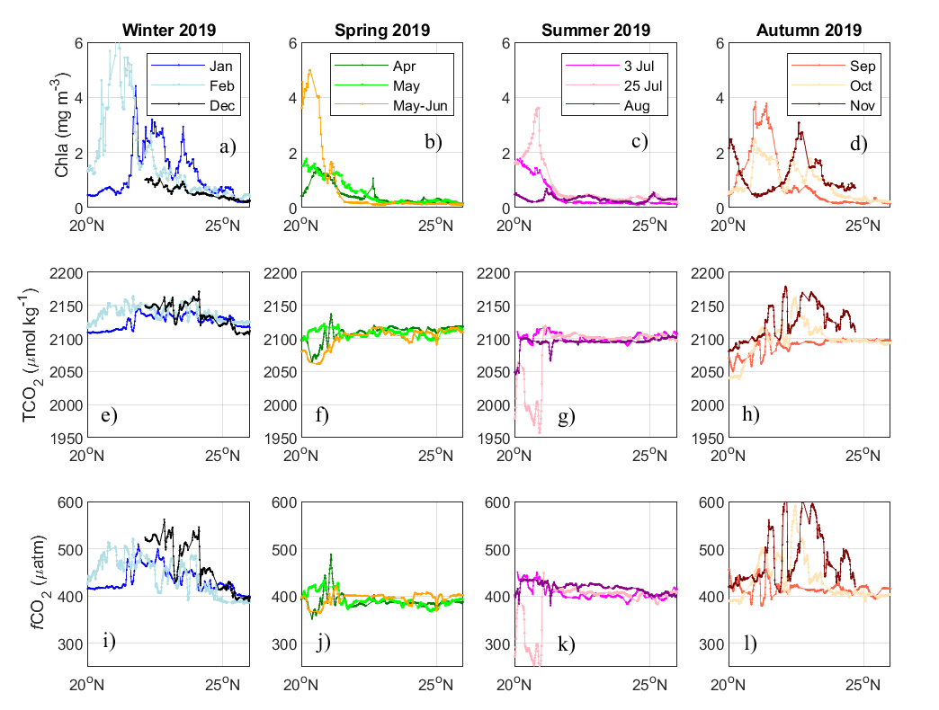
Figure S1. Latitudinal variations of chlorophyll, TCO₂ and fCO₂ along the track of the ship in the PU region for each season of 2019.

In winter and summer, the correlation between TCO₂ and chlorophyll is positive and significant at the 5% level. Figure S2 shows the results for winter 2019 in the PU region. In both seasons, the negative correlations between TCO₂ and SST (r=-0.78 in winter and r=-0.87 in autumn), and fCO₂ and SST, indicate that upwelling of cold and CO₂-rich water dominates at this time of the year.

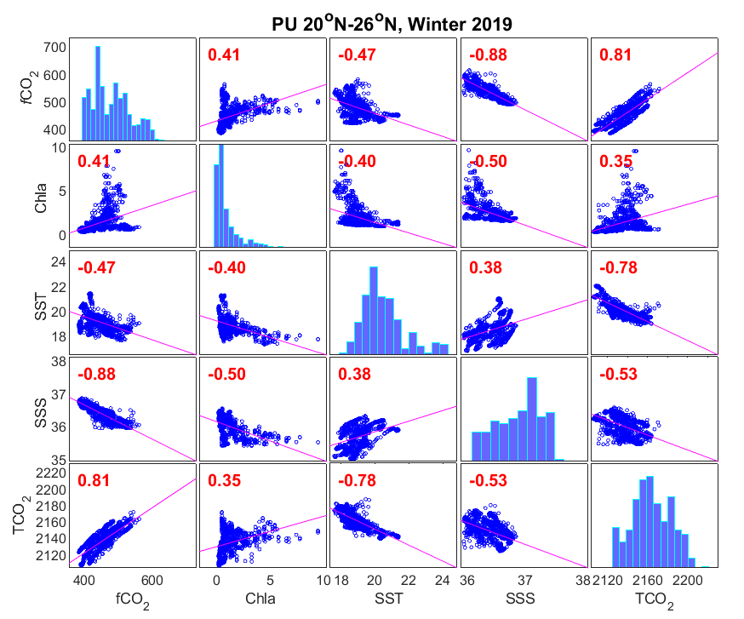
Figure S2. Matrix of plots showing the correlations between all pairs of variables. Histograms of the variables are displayed along the matrix diagonal. The dataset includes the December, January and February transects, a total of 1176 observations. The correlation coefficient are indicated in the plots. Correlation coefficients highlighted in red correspond to significant correlations.

These high resolution plots confirm the results obtained with monthly-averaged chlorophyll concentrations and ship transects binned by 0.25º of latitude (section 3.3).

Unlike winter and autumn, the correlation between TCO₂ and chlorophyll is negative in summer and spring. Figure S3 shows the results for summer 2019. The biological activity is more pronounced near 21ºN as shown by the latitudinal distribution of chlorophyll in spring and summer (Figures S1a and S1b). The increase of chlorophyll is correlated to a consumption of carbon, which leads to a negative correlation between TCO₂ and chlorophyll (Figure S3).
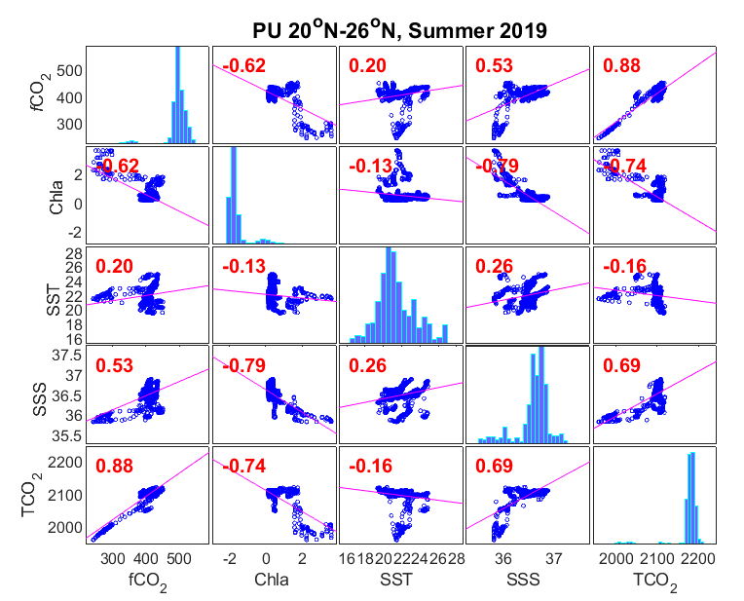
Figure S3. Same as Figure S2 for the PU region in summer 2019. The dataset includes 1513 observations of the July and August transects.

The daily maps of the chlorophyll concentrations show chlorophyll concentrations before, during and after the sampling by the ship between the 7th and 8th of February (Figure S4). The chlorophyll concentrations gradually increase from the 3rd of February, near the coast, especially in the southern part of the PU region (Figure S4). Then, the chlorophyll concentrations spread offshore. When the ship samples the region, on the 7th and 8th of February, it crosses a patch of high chlorophyll, reaching 6 mg m⁻³ (Figure S1a). An increase of TCO₂ and fCO₂ is also observed (Figures S1e, S1i).
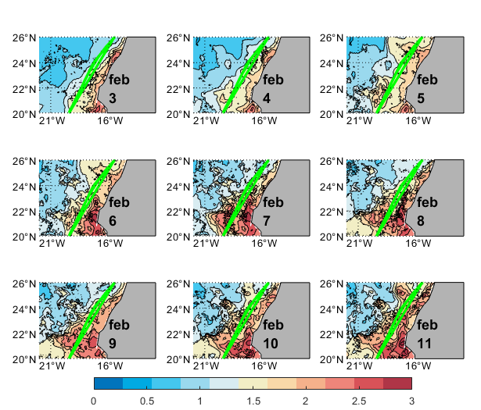
Figure S4. Daily maps of chlorophyll concentrations (mg m⁻³) from the 3rd to the 11th of February with the track of the ship superimposed on the map. The ship sampled the region on the 7th and 8th of February.

In spring and summer, the increase of chlorophyll (Figures S1b, S1c is associated with a decrease of TCO₂ (Figures S1f, S1g) and fCO₂ (Figures S1j, S1k), highlighting the biological activity. The voyages of early and end of July show very different conditions. The daily maps of chlorophyll concentrations from the 1st to the 9th of July show strong concentrations of chlorophyll close to the coast and gradually spreading offshore (Figure S5). During the 3-4 July, when the ship samples the region, it sails slightly west of the main patch of chlorophyll with concentrations lower than 2 mg m⁻³ (Figure S1c).

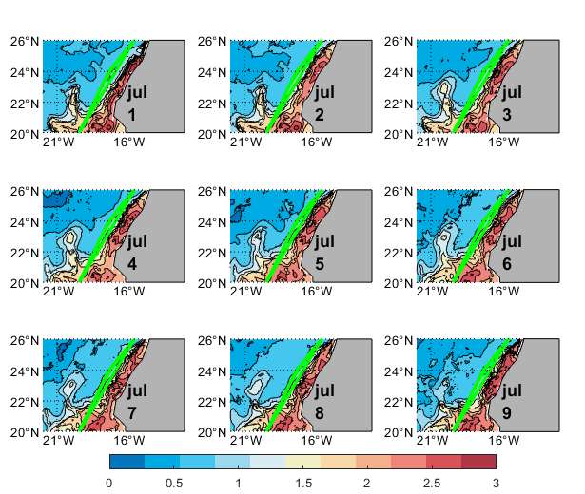
Figure S5. Daily maps of chlorophyll concentrations (mg m⁻³) from the 1st to the 9th of July with the track of the ship superimposed on the map. The ship sampled the region on the 3rd and 4th of July.

A few days later, when the ship samples the same region again (25-26 July), the high chlorophyll concentrations have spread offshore (Figure S6). A peak of chlorophyll close to 4 mg m⁻³ (Figure S1c) is associated with a strong decrease of TCO₂ and fCO₂ (Figures S1g, S1k).
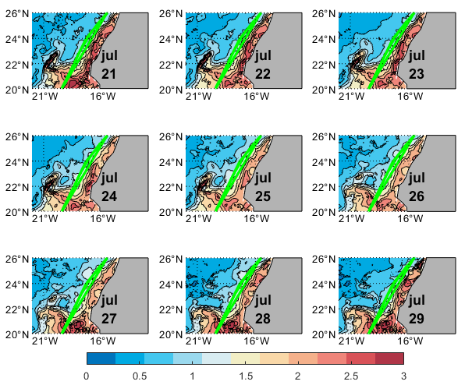
Figure S6. Daily maps of chlorophyll concentrations (mg m⁻³) from the 21st to the 29th of July with the track of the ship superimposed on the map. The ship sampled the region on the 25th and 26th of July.

