Supplementary material
On the timing of megafaunal extinction and associated floristic consequences in Australia through the lens of functional palaeoecology.

Authors: Matthew Adesanya ADELEYE^{a,b,c}; Samuel Charles ANDREW^{d}; Rachael GALLAGHER^{e}; Sander VAN DER KAARS^{f,g}; Patrick DE DECKKER^{h}; Quan HUA^{i}; Simon Graeme HABERLE^{b,c}

Corresponding author: Matthew Adeleye (ORCID: https://orcid.org/0000-0002-6034-5807, Email: matthew.adeleye@anu.edu.au)

Institutional affiliations and address:
ª Department of Geography, University of Cambridge, 20 Downing Pl. CB2 3EL, Cambridgeshire, United Kingdom.
^{b} School of Culture, History and Language, 9 Fellows Rd, HC Coombs, The Australian National University, Acton, ACT 2600, Australia.
^{c} Australian Research Council Centre of Excellence for Australian Biodiversity and Heritage, 9 Fellows Rd, HC Coombs, The Australian National University, Acton, ACT 2600, Australia.
^{d} The Commonwealth Scientific and Industrial Research Organisation (CSIRO), 101, Clunies Ross Street Black Mountain ACT 2601, Australia.
^{e} Hawkesbury Institute for the Environment, Western Sydney University, L9, Science Rd, Richmond, NSW 2753, Australia.
^{f} School of Earth, Atmosphere and Environment, Monash University, 9 Rainforest Walk, Clayton, VIC 3800, Australia.
^{g} Department of Earth Sciences, Vrije Universiteit Amsterdam, Amsterdam, The Netherlands.
^{h} Research School of Earth Sciences, The Australian National University, 142 Mills Rd, Acton, ACT 2600, Australia.
^{i} Australian Nuclear Science and Technology Organisation, New Illawarra Rd, Lucas Heights, NSW 2234, Australia.

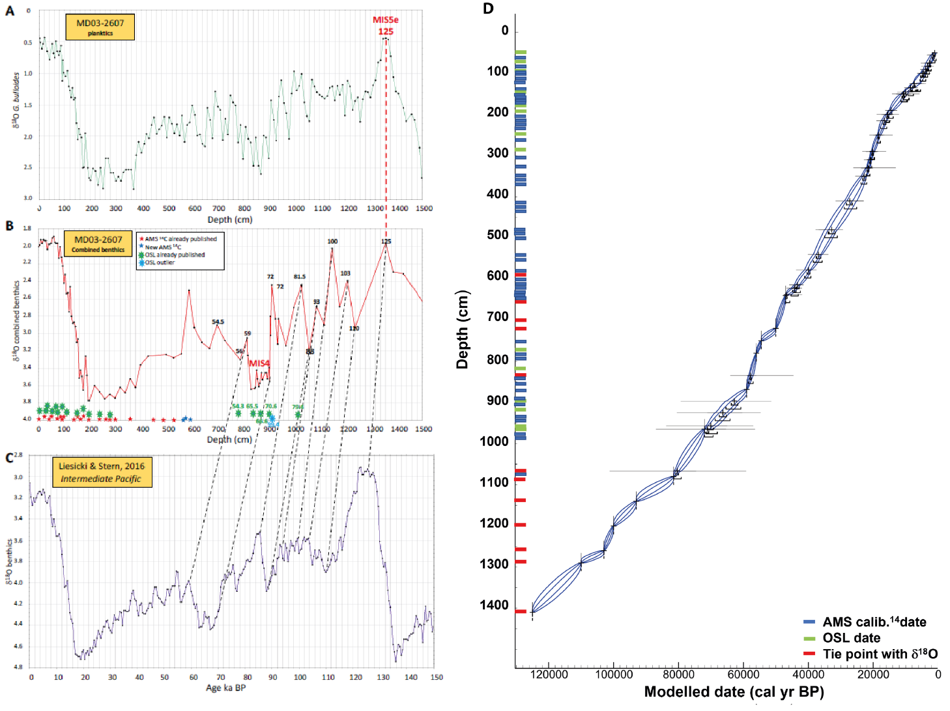
Supplementary figure 1: Correlation between δ¹⁸O curves used to identify tie points in core MD03-2607 and age-depth model (reproduced from De Deckker et al. (2021)’s supplementary material). (A) The δ¹⁸O of the planktic foraminifera Globigerina bulloides from core MD03-2607 was used to confirm the Marine Isotope Stage 5e peak at 125 ka. (B) The δ¹⁸O record of benthic foraminifera obtained from De Deckker et al. (2021) and Lopes dos Santos et al. (2012) combined. Positions of AMS ¹⁴C dates are marked in red (Lopes dos Santos et al., 2012) and blue stars (De Deckker et al., 2021), and the locations of OSL dates are marked by green stars. (C) The Intermediate Waters for the Pacific Ocean’s benthic foraminifera δ¹⁸O curve (Lisiecki and Stern, 2016). Black dashed lines indicate respective tie points and dates used in building core MD03-2607 age-depth model presented in (D) (see reference De Deckker et al. (2021)).
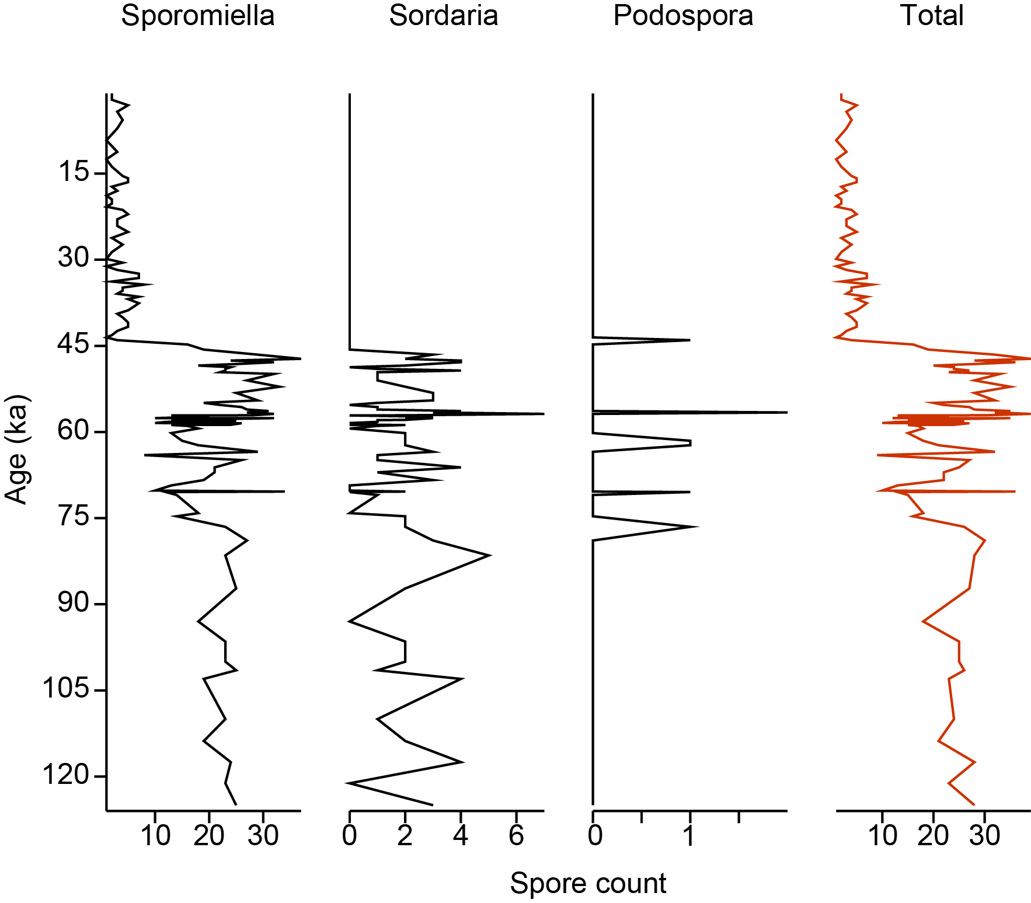
Supplementary figure 2: Individual coprophilous fungal spore raw count and total diagram from core MD03-2607.

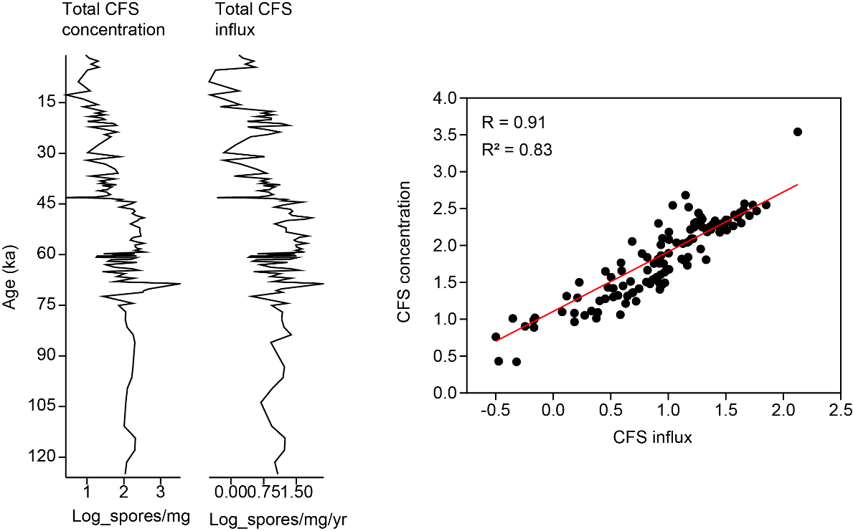
Supplementary figure 3: Strong similarity between coporophilous fungal spore (CFS) concentration and influx from core MD03-2607.
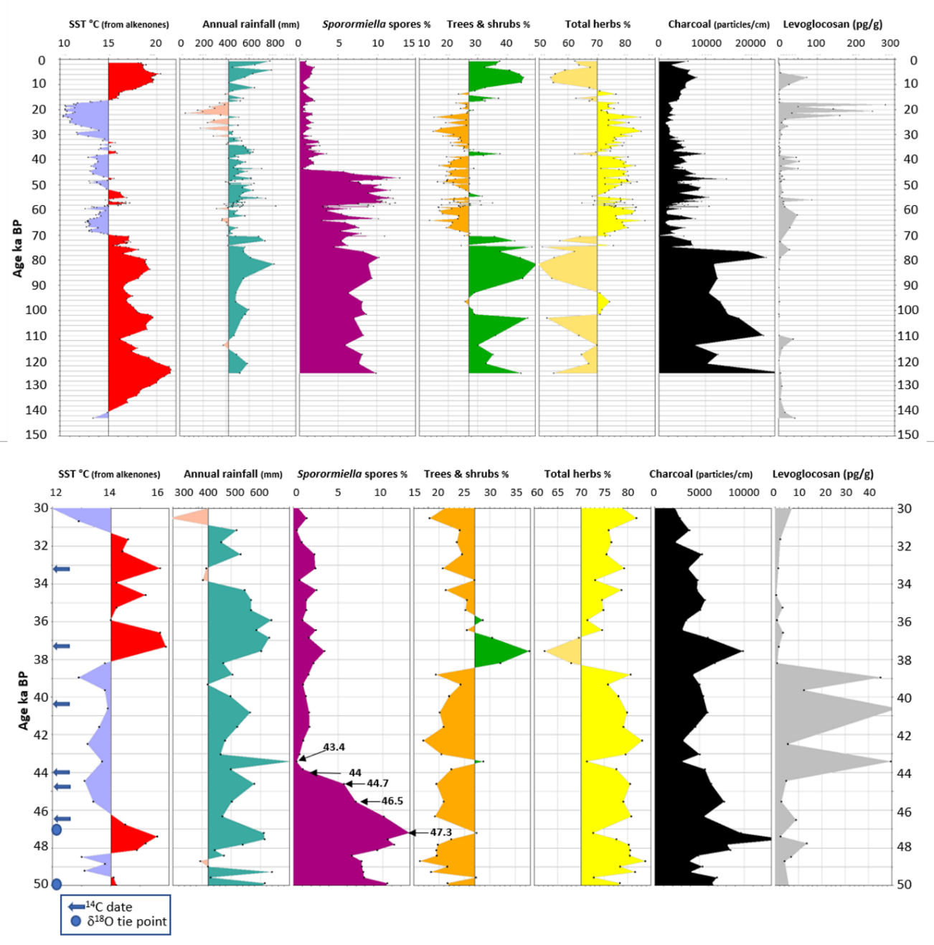
Supplementary figure 4: Palaeoclimatic reconstructions (SST= sea-surface temperature and fossil pollen-based estimated rainfall), and percentages of fungal spores and pollen of selected taxa, as well as charcoal counts (particles/cm) (De Deckker et al., 2021), plus the biomass burning indicator Levoglucosan (pg/g) adapted from Lopes dos Santos et al. (2013). The top diagram represents the record for the entire deep-sea core MD03-2607, and the lower diagram focuses on the 50-30 ka record during which the timing of the megafaunal extinction is postulated to have occurred at 43.5 ka. Note the position of AMS¹⁴C dates and tie points from δ¹⁸O of planktic foraminifera (see Fig. 3 in main text for more details). The ages listed in the Sporormiella diagram indicate shifts in spore abundance.
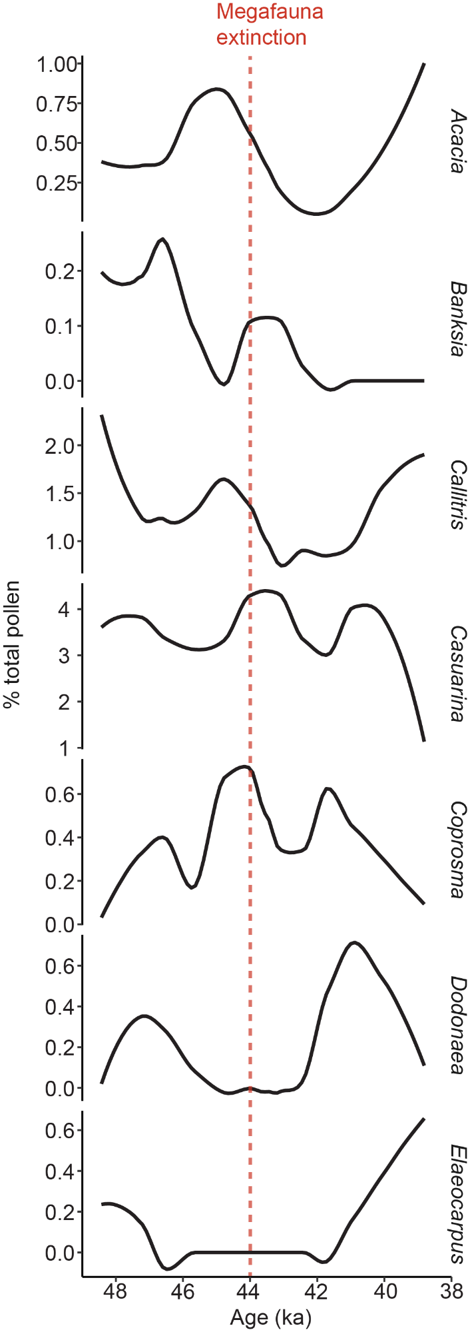
Supplementary figure 5: Percentage abundance of large-seeded pollen taxa during the megafauna extinction window from core MD03-2607. Refer to Supplementary table 1 for dispersal modes.
References
De Deckker, P., van der Kaars, S., Haberle, S., Hua, Q., Stuut, J.-B.W., 2021. The pollen record from marine core MD03-2607 from offshore Kangaroo Island spanning the last 125 ka; implications for vegetation changes across the Murray-Darling Basin. Australian Journal of Earth Sciences 68, 928–951. https://doi.org/10.1080/08120099.2021.1896578
Lisiecki, L.E., Stern, J.V., 2016. Regional and global benthic δ18O stacks for the last glacial cycle. Paleoceanography 31, 1368–1394. https://doi.org/10.1002/2016PA003002
Lopes dos Santos, R.A., De Deckker, P., Hopmans, E.C., Magee, J.W., Mets, A., Sinninghe Damsté, J.S., Schouten, S., 2013. Abrupt vegetation change after the Late Quaternary megafaunal extinction in southeastern Australia. Nature Geosci 6, 627–631. https://doi.org/10.1038/ngeo1856
Lopes dos Santos, R.A., Wilkins, D., De Deckker, P., Schouten, S., 2012. Late Quaternary productivity changes from offshore Southeastern Australia: A biomarker approach. Palaeogeography, Palaeoclimatology, Palaeoecology 363–364, 48–56. https://doi.org/10.1016/j.palaeo.2012.08.013

