Supporting Information for:
On submarine landslide volume assessment
Thore F. Sager^{1*}, Morelia Urlaub¹, Christian Berndt¹
¹GEOMAR Helmholtz Centre for Ocean Research Kiel, Kiel, Germany
*Corresponding author: tsager@geomar.de
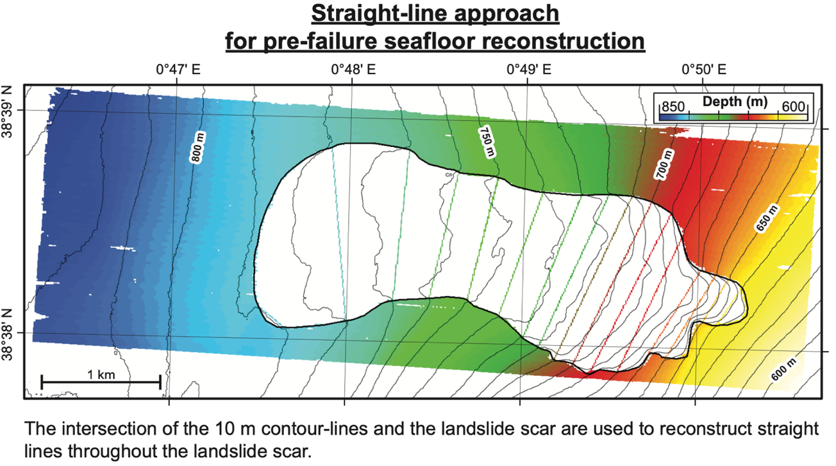
Supplementary Figure 1: ‘Straight-line ’ pre-failure seafloor reconstruction approach.

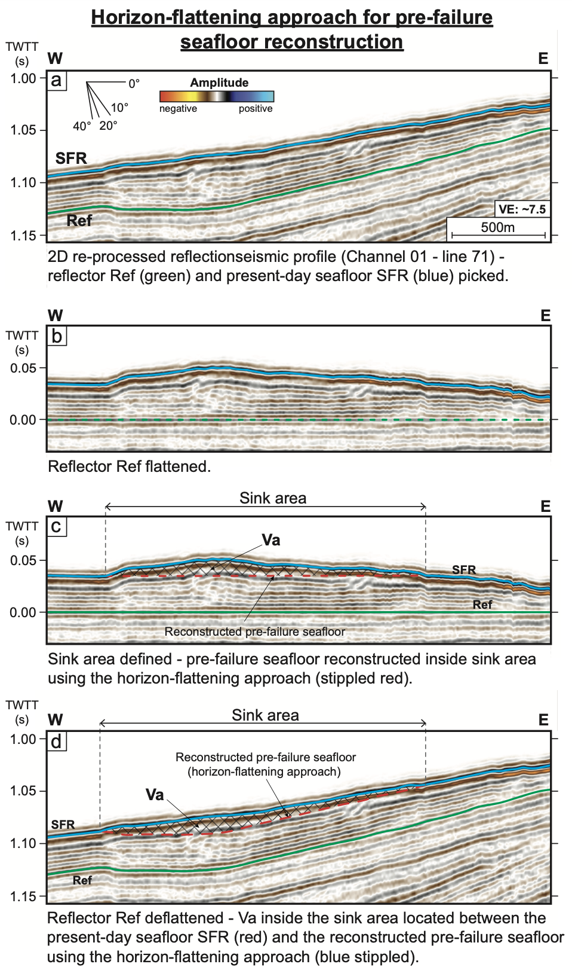
Supplementary Figure 2: ‘Horizon-flattening’ pre-failure seafloor reconstruction approach:

