**Appendix A**

**Supplementary material to “Basin-scale variability in phytoplankton size-abundance spectra across the Atlantic Ocean” by González-García et al.**

Table S1, Figures S1 to S5

**Table S1.** Details of the cruises, surveys and time series from which data of phytoplankton cell size and abundance were obtained.

|  |  |  |  |  |  |  |
| --- | --- | --- | --- | --- | --- | --- |
| Cruise/program | Ship | Year(s) | Latitude | Longitude | Number of samples | Reference |
| AMT1 | RRS James Clark Ross | 1995 | 49°N - 51°S | 57°W - 9°W | 50 | Sal et al., 2013 |
| AMT2 | RRS James Clark Ross | 1996 | 49°N - 47°S | 55°W - 8°W | 53 | Sal et al., 2013 |
| AMT3 | RRS James Clark Ross | 1996 | 47°N - 52°S | 57°W - 18°W | 76 | Sal et al., 2013 |
| AMT4 | RRS James Clark Ross | 1997 | 48°N - 51°S | 57°W - 14°W | 53 | Sal et al., 2013 |
| Trynitrop 1 | RV Hespérides | 2007 | 29°N - 33°S | 38°W - 15°W | 21 | Huete-Ortega et al., 2012 |
| Malaspina Leg 1 | RV Hespérides | 2010-2011 | 35°N - 21°S | 35°W - 9°W | 24 | Moreno-Ostos et al., 2015 |
| Malaspina Leg 2 | RV Hespérides | 2011 | 24°S - 33°S | 36°W - 15°E | 16 | Moreno-Ostos et al., 2015 |
| Abraços 2 | RV Antea | 2017 | 3°S - 9°N | 36°W - 31°W | 104 | Bertrand, 2017 |
| ACEx | RV Cruzeiro do Sul | 2012 | 26°S - 34°S | 52°W - 45°W | 14 | Gonçalves-Araujo et al., 2018 |
| PATEX | RV Ary Rongel | 2008 | 20°S - 39°S | 71°W - 51°W | 38 | Gonçalves-Araujo et al., 2012 |
| Benguela | RV Meteor | 2000 | 19°S - 25°S | 11°E - 14°E | 54 | Sal et al., 2013 |
| Angola monitoring lines | RV Dr Fridtjof Nansen | 2008-2016 | 6°S - 17°S | 10°E - 13°E | 46 | Silva et al., 2018 |
| Ría de Vigo survey | RV Mytilus | 2001-2002 | 42°N | 8°W | 75 | Marañón et al., 2004 |
| RADIALES | RV Lura | 1994, 1999, 2003 | 43°N | 8°W | 30 | Huete-Ortega et al., 2010 |
| Ría de Vigo survey | RV Kraken | 2021-2022 | 42°N | 8°W | 52 | unpublished |

**Figure S1.** Locations of sampled stations in the different cruises, programs and surveys.

**Figure S2.** Comparison of phytoplankton size spectra in which nano- and microphytoplankton cells had been examined with (A) the ataxonomic, image-analysis method and (B) the taxonomic, classical microscopy method. Lines indicate the linear reggression fit for each individual size spectrum. Samples were collected in the central Atlantic Ocean along the 10°N-30°S latitudinal range during cruises (A) Trynitrop 1 and Malaspina (*n* = 25) and (B) AMT3 (*n* = 38).



**Figure S3.** Bivariate plots showing the relationship between mean values of different variables at 10°-latitudinal bands along the open-ocean latitudinal cruises AMT1-4, Trynitrop and Malaspina. Bars indicate the standard deviation. Pearson’s correlation coefficient and level of significance are given for each relationship (*n* = 10).

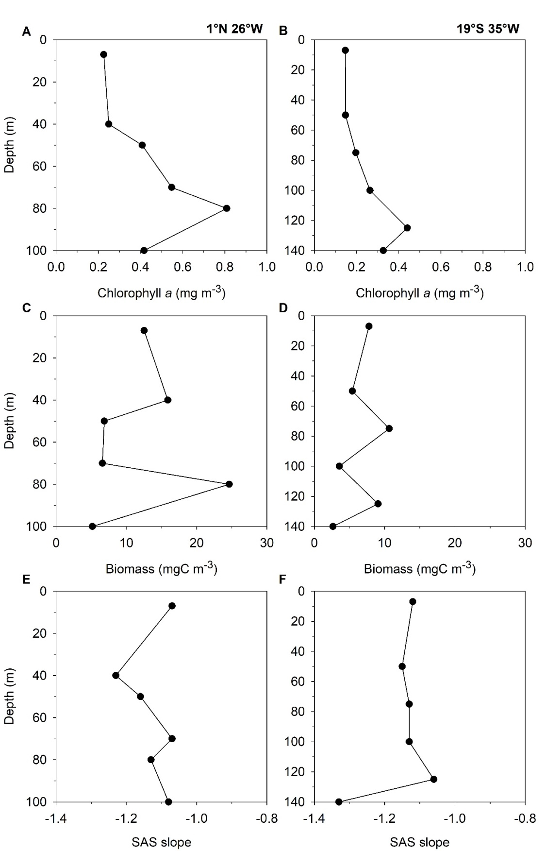

**Figure S4.** Vertical profiles of (A-B) chlorophyll *a* concentration, (C-D) phytoplankton biomass and (E-F) slope of the size-abundance spectrum at 1°N 26°W and 19°S 35°W during the AMT3 cruise.

**Figure S5**. Relationship between log10-chlorophyll *a* concentration and the slope of the size-abundance spectrum for (A) samples with chlorophyll *a* concentration < 2 mg m-3 and (B) samples with chlorophyll *a* concentration > 2 mg m-3. The linear regression models are (A) *y* = − 0.86 + 0.31 *x* (*r*2 = 0.28, *p* <0.0001, *n* = 274) and (B) *y* = − 0.73 + 0.07 *x* (*r*2 = 0.01, *p* = 0.368, *n* = 92).

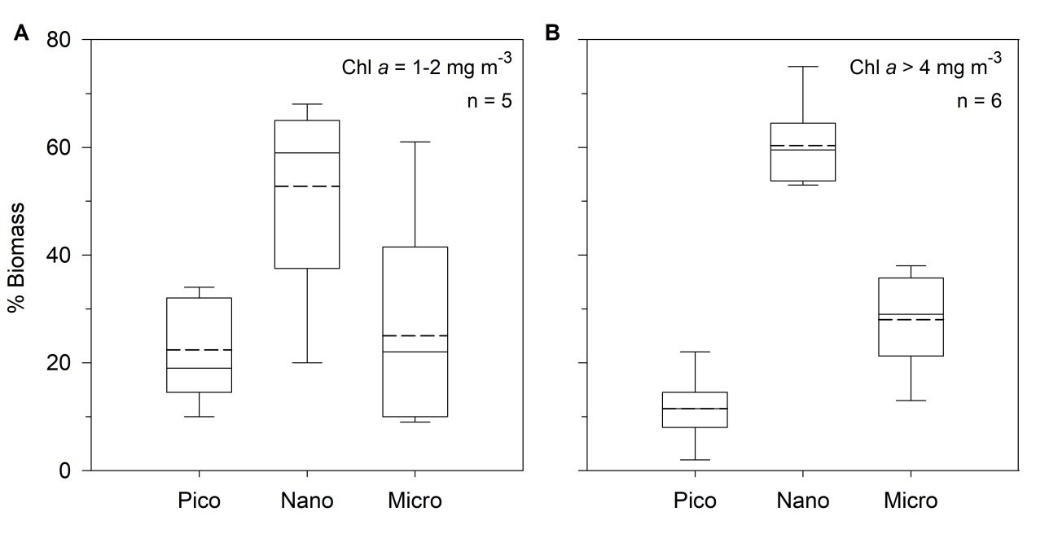

**Figure S6.** Box plots showing the variability in the percentage of biomass contributed by pico-, nano- and microphytoplankton in surface samples of Ría de Vigo (NW Iberian peninsula) with chlorophyll *a* concentration (A) between 1-2 mg m-3 and (B) above 4 mg m-3.

**Fig S7.** Relationship between sea surface temperature (SST, °C) and the slope of phytoplankton size-abundance spectra from surface samples (0-10 m) in coastal and open-ocean regions across the Atlantic Ocean. The linear regression beween SST (*x*) and SAS slope (*y*) was: *y* = −0.69 − 0.01 *x* (r2 = 0.01, *p* = 0.0923, n = 299).

**Figure S8.** Relationship between log10-transformed phytoplankton biomass and chlorophyll *a* concentration in surface samples obtained from open-ocean and coastal environments during cruises AMT3-4, Trynitrop 1, Abraços 2 and an annual survey of Ría de Vigo (NW Iberian peninsula). The line indicates the reduced major axis regression (*y* = 1.49 *x* – 2.42, *r*2 = 0.57, *p* < 0.01, *n* = 85).

### **Supplementary References**

Bertrand, A., 2017. ABRACOS 2 cruise, Antea R/V. https://doi.org/10.17600/17004100

Gonçalves-Araujo, R., de Souza, M.S., Mendes, C.R.B., Tavano, V.M., Pollery, R.C., Garcia, C.A.E., 2012. Brazil-Malvinas confluence: Effects of environmental variability on phytoplankton community structure. J. Plankton Res. 34, 399–415. https://doi.org/10.1093/plankt/fbs013

Gonçalves-Araujo, R., de Souza, M.S., Tavano, V.M., Mendes, C.R., Souza, R.B. de, Schultz, C., Pollery, R.C., 2018. Phyto- and protozooplankton assemblages and hydrographic variability during an early winter survey in the Southern Brazilian Continental Shelf. J. Mar. Syst. 184, 36–49. https://doi.org/10.1016/j.jmarsys.2018.04.005

Huete-Ortega, M., Cermeño, P., Calvo-Díaz, A., Marañón, E., 2012. Isometric size-scaling of metabolic rate and the size abundance distribution of phytoplankton. Proc. Royal Soc. B 279, 1815–1823. https://doi.org/10.1098/rspb.2011.2257

Huete-Ortega, M., Marañón, E., Varela, M., Bode, A., 2010. General patterns in the size scaling of phytoplankton abundance in coastal waters during a 10-year time series. J. Plankton Res. 32, 1–14. https://doi.org/10.1093/plankt/fbp104

Marañón, E., Cermeño, P., Fernández, E., Rodríguez, J., Zabala, L., 2004. Significance and mechanisms of photosynthetic production of dissolved organic carbon in a coastal eutrophic ecosystem. Limnol. Oceanogr. 49, 1652–1666. https://doi.org/10.4319/lo.2004.49.5.1652

Moreno-Ostos, E., Blanco, J.M., Agustí, S., Lubián, L.M., Rodríguez, V., Palomino, R.L., Llabrés, M., Rodríguez, J., 2015. Phytoplankton biovolume is independent from the slope of the size spectrum in the oligotrophic Atlantic Ocean. J. Mar. Syst. 152, 42–50. https://doi.org/10.1016/j.jmarsys.2015.07.008

Sal, S., López-Urrutia, Á., Irigoien, X., Harbour, D.S., Harris, R.P., 2013. Marine microplankton diversity database. Ecology 94, 1658. https://doi.org/10.1890/13-0236.1

Silva, S., Macuéria, M., Maurício, D., Ruby, C., Ferdandes y Coelho, P., 2018. Dinámica del fitoplancton y la variabilidade del clima en las costas de Angola. Revista Cubana de Investigaciones Pesqueras, 35, 9-12.