Supplementary Material
Oceanographic and anthropogenic variables driving marine litter distribution in Mediterranean Protected Areas: extensive field data supported by forecasting modelling
Matteo Galli^{1,a}, Matteo Baini^{1,2,a}, Cristina Panti^{1,2,}*, Dario Giani¹, Ilaria Caliani¹, Tommaso Campani¹, Massimiliano Rosso^{2,3}, Paola Tepsich^{2,3}, Vanessa Levati^{3,4}, Federica Laface^{5,6}, Teresa Romeo^{2,6}, Gianfranco Scotti⁷, Francois Galgani⁸, Maria Cristina Fossi^{1,2}
¹ Department of Physical, Earth and Environmental Sciences, University of Siena, Via Mattioli 4, 53100 Siena, Italy
²NBFC, National Biodiversity Future Center, Palermo, Italy
³ CIMA Research Foundation, 17100, Savona, Italy
⁴ Department of Biology, University of Napoli Federico II, Corso Umberto I 40, 80138, Napoli, Italy
⁵Department of Chemical, Biological, Pharmaceutical and Environmental Sciences, University of Messina, Viale Ferdinando Stagno D'Alcontres 31, 98166 Messina, Italy
⁶Department of Integrative Marine Ecology (EMI), Stazione Zoologica Anton Dohrn - National Institute of Biology, Ecology and Marine Biotechnology, Sicily Marine Centre, Villa Pace - Contrada Porticatello 29, 98167 Messina, Italy
⁷ISPRA, Italian Institute for Environmental Protection and Research, 98057 Milazzo, Italy
⁸IFREMER, Unit RMPF, Vairao, Tahiti, French Polynesia
*Corresponding author Dr. Cristina Panti e-mail: panti4@unisi.it
ªThese authors equally contributed to the manuscript.

Table S1. Current status of peer-reviewed papers published on floating macrolitter abundance (items/km²) in the Mediterranean Sea Sub Regions proposed by MSFD. Detailed sampling information (sampling site and year, vessel speed, observer height and width and distance travelled) and the minimum detectable size of the object considered are also reported. UNEP/MAP threshold value for the Mediterranean Sea is reported in red. Studies entirely or partially performed in the MPAs are reported in bold. n.a. is used when no information is available.
Mediterranean Sea sub-region | Sampling_area (MPAs) | Sampling year | Vessel speed (kt) | Observer height (m) | Observed width (m) | Distance travelled (km) | Density items/km² | Min. detected size (cm) | References
Mediterranean Sea | - | - | - | - | - | - | 5 | - | UNEP/MAP, 2020
Western Mediterranean Sea | Catalan Sea | 2018-2019 | n.a. | 2.5 | 10 | 85 | 19.7 ± 25.8 | n.a. | Garcia-garin et al., 2020
Western Mediterranean Sea | Balearic basin | 2005-2015 | 2 | 0.5 | Nets mouth:  0.8×0.6 m. | 613,112 | 116.6 ± 254.3 kg/km2 | 2.5 | Compa et al., 2019
Western Mediterranean Sea | Ligurian Sea  (Pelagos Sanctuary) | 2013-2016 | 19-25 | 17-25 | n.a. | 3724 | 1.8 ± 0.2 | 20 | Arcangeli et al., 2018
Western Mediterranean Sea | Sardinian-Balearic basin | 2013-2016 | 19-25 | 17-25 | n.a. | 5098 | 2.5 ± 0.3 | 20 | Arcangeli et al., 2018
Western Mediterranean Sea | Bonifacio Strait  (Bouches de Bonifacio) | 2013-2016 | 19-25 | 17-25 | n.a. | 2303 | 2.4 ± 0.4 | 20 | Arcangeli et al., 2018
Western Mediterranean Sea | Central Tyrrhenian Sea | 2013-2016 | 19-25 | 17-25 | n.a. | 2488 | 2.1 ± 0.4 | 20 | Arcangeli et al., 2018
Western Mediterranean Sea | Sicilian-Sardinian Channel | 2013-2016 | 19-25 | 17-25 | n.a. | 4500 | 2.8 ± 0.5 | 20 | Arcangeli et al., 2018
Western Mediterranean Sea | Balearic Sea, Bonifacio Strait and Tyrrhenian Sea | 2013-2016 | 19–25 | 17–25 | 100 | 18,113 | 2.3 ± 0.4 | 20 | Campana et al., 2018
Western Mediterranean Sea | Ligurian Sea  (Pelagos Sanctuary) | 2006–2015 | 6 | 3 | n.a. | 5171.57 | 15 ± 23 | 1 | Di-Méglio and Campana, 2017
Western Mediterranean Sea | Ligurian Sea  (Pelagos Sanctuary) | 2014 | n.a. | n.a. | 20 | 125.53 | 175.2 | 2.5 | Fossi et al., 2017
Western Mediterranean Sea | Ligurian Sea  (Pelagos Sanctuary) | 1996 | 3.2–11.5 | top deck | 50 | 176 | 15 –25  (range) | n.a. | Aliani et al., 2003
Western Mediterranean Sea | Ligurian Sea  (Pelagos Sanctuary) | 2000 | 6 | top deck | n.a. | 252 | 1.5 - 3.0  (range) | n.a. | Aliani et al., 2003
Western Mediterranean Sea | Ligurian Sea  (Pelagos Sanctuary) | 2013 | 10 | 5 | 30 | 1538 | 24.9 ± 2.5 | 2 | Suaria and Aliani, 2014
Western Mediterranean Sea | Corsica Channel  (Pelagos Sanctuary) | 2013 | 10 | 5 | n.a. | 73.1 | 24.7 | 2 | Suaria and Aliani, 2014
Western Mediterranean Sea | Strait of Sicily | 2013 | 10 | 5 | n.a. | 37.4 | 10.4 | 2 | Suaria and Aliani, 2014
Western Mediterranean Sea | Central Tyrrhenian Sea | 2013 | 10 | 5 | n.a. | 70.1 | 4.9 | 2 | Suaria and Aliani, 2014
Western Mediterranean Sea | South Tyrrhenian Sea | 2013 | 10 | 5 | n.a. | 110.8 | 24.1 | 2 | Suaria and Aliani, 2014
Western Mediterranean Sea | Sea of Sardinia | 2013 | 10 | 5 | n.a. | 103.8 | 19.3 | 2 | Suaria and Aliani, 2014
Western Mediterranean Sea | Balearic Sea | 2013 | 10 | 5 | n.a. | 141.8 | 30.7 | 2 | Suaria and Aliani, 2014
Western Mediterranean Sea | Algerian Basin | 2013 | 10 | 5 | n.a. | 187.4 | 52.9 | 2 | Suaria and Aliani, 2014
Western Mediterranean Sea | Sardinia Channel | 2013 | 10 | 5 | n.a. | 342.8 | 10.9 | 2 | Suaria and Aliani, 2014
Western Mediterranean Sea | Corsica Channel  (Pelagos Sanctuary) | 2016 | 7 | 9 | 10 | n.a. | 165 | 2.5 | Campanale et al., 2019
Western Mediterranean Sea | Sardinian Sea | 2016 | 7 | 9 | 10 | n.a. | 47 | 2.5 | Campanale et al., 2019
Western Mediterranean Sea | Central-southern Tyrrhenian Sea | 2016 | 7 | 9 | 10 | n.a. | 16 | 2.5 | Campanale et al., 2019
Western Mediterranean Sea | Strait of Messina | 2016 | 7 | 9 | 10 | n.a. | 4.8 | 2.5 | Campanale et al., 2019
Western Mediterranean Sea | n.a. | 2013 | n.a. | n.a. | n.a. | n.a. | 40.5 | n.a. | Galgani et al., 2013
Western Mediterranean Sea | n.a. | 2006-2008 | n.a. | n.a. | n.a. | n.a. | 3.1 | n.a. | UNEP/MAP, 2015
Adriatic Sea | Croatia  (Archipelago of Zadar) | 2015 | 2–3 | 2.2 | 7 | 36.6 | 175 ± 181 | 2.5 | Palatinus et al., 2019
Adriatic Sea | Italy, Slovenia, Croatia, and Montenegro | 2014-2015 | 2–3 | 1–3 | 10 | 415 | 260 ± 596 | 2.5–5 | Zeri et al., 2018
Adriatic Sea | Italy, Slovenia, Croatia, and Montenegro | 2014-2015 | 26 | 2_3 | 100 | 9.062 | 4 ± 3 | 20 | Vlachogianni et al., 2017
Adriatic Sea | Italy, Slovenia, Croatia, and Montenegro | 2014-2015 | 25 | 1_3 | 8 | 415 | 332 ± 749 | 2.5 | Vlachogianni et al., 2017
Adriatic Sea | Slovenia | 2008 | n.a. | n.a. | n.a. | n.a. | 5.7 | n.a. | UNEP/MAP, 2015
Adriatic Sea | Slovenia | 2011 | n.a. | n.a. | n.a. | n.a. | 2 | n.a. | UNEP/MAP, 2015
Adriatic Sea | Central sector | 2013 | 10 | 5 | n.a. | 28.4 | 54.6 | n.a. | Suaria and Aliani, 2014
Adriatic Sea | Southwestern sector | 2013 | 10 | 5 | n.a. | 101.8 | 52.1 | n.a. | Suaria and Aliani, 2014
Adriatic Sea | Southeaster sector | 2013 | 10 | 5 | n.a. | 47.2 | 25.8 | n.a. | Suaria and Aliani, 2014
Adriatic Sea | Central southern  sector | 2013-2016 | 19-25 | 17-25 | n.a. | 6733 | 4.7 ± 0.5 | 20 | Arcangeli et al., 2018
Adriatic Sea | Northern sector | 2016 | 7 | 9 | 10 | n.a. | 414 | 2.5 | Campanale et al., 2019
Adriatic Sea | Central sector | 2016 | 7 | 9 | 10 | n.a. | 535 | 2.5 | Campanale et al., 2019
Adriatic Sea | Southern sector | 2016 | 7 | 9 | 10 | n.a. | 1,313 | 2.5 | Campanale et al., 2019
Adriatic Sea | Central sector. | 2013 | n.a. | n.a. | 31 | 922.2 | 31.5 | 2.5 | Carlson et al., 2017
Adriatic Sea | Southern sector | 2015 | n.a. | n.a. | 23.6 | 922.2 | 114.7 | 2.5 | Carlson et al., 2017
Adriatic Sea | Northern central sector | 2015 | n.a. | n.a. | 10 | 922.2 | 74.8 | 2.5 | Carlson et al., 2017
Ionian Sea and the Central Mediterranean Sea | Ionian Sea | 2016 | 7 | 9 | 10 | n.a. | 100 | 2.5 | Campanale et al., 2019
Ionian Sea and the Central Mediterranean Sea | Ionian Sea | 2013-2016 | 19-25 | 17-25 | n.a. | 4565 | 1.9 ± 0.2 | 20 | Arcangeli et al., 2018
Ionian Sea and the Central Mediterranean Sea | Strait of Otranto | 2013 | 10 | 5 | n.a. | 100.2 | 12.9 | 2 | Suaria and Aliani, 2014
Ionian Sea and the Central Mediterranean Sea | North-western Ionian Sea | 2013 | 10 | 5 | n.a. | 61.8 | 21.6 | 2 | Suaria and Aliani, 2014
Ionian Sea and the Central Mediterranean Sea | Sicilian Sea | 2013 | 10 | 5 | n.a. | 26.2 | 6.3 | n.a. | Suaria and Aliani, 2014
Ionian Sea and the Central Mediterranean Sea | n.a. | n.a. | n.a. | n.a. | n.a. | n.a. | 2.1 | n.a. | UNEP/MAP, 2015
Ionian Sea and the Central Mediterranean Sea | Malta and Gozo mpa | 2018-2019 | n.a. | 2 | 6 | n.a. | 681 ± 1,004 | 2.5 | Curmi and Axiak, 2021
Ionian Sea and the Central Mediterranean Sea | Malta and Gozo mpa | 2018-2019 | n.a. | 2 | 6 | n.a. | 933 ± 1,594 | 2.5 | Curmi and Axiak, 2021
Ionian Sea and the Central Mediterranean Sea | Malta and Gozo mpa | 2018-2019 | n.a. | 2 | 6 | n.a. | 1,272 ± 4,403 | 2.5 | Curmi and Axiak, 2021
Ionian Sea and the Central Mediterranean Sea | Malta and Gozo mpa | 2018-2019 | n.a. | 2 | 6 | n.a. | 2,392 ± 7,477 | 2.5 | Curmi and Axiak, 2021
Aegean-Levantine Sea | Algeria | 2017-2018 | n.a. | n.a. | n.a. | n.a. | 136,514  max items | 2.5 | Tata et al., 2020
Aegean-Levantine Sea | n.a. | 2017 | n.a. | 27 | 50 | 1784 | 232 ± 325 | 2.5 - 50 | Constantino et al., 2019
Aegean-Levantine Sea | n.a. | 2008 | n.a. | n.a. | n.a. | n.a. | 2.1 | n.a. | UNEP, 2011
Black Sea | n.a. | 2017 | n.a. | 10 | 50 | n.a. | 41.5 ± 30.1 | 2.5 | Berov and Klayn, 2021
Mediterranean Sea | n.a. | 1979 | n.a. | 12 | 10 | n.a. | 19.7 ± 25.8 | 1.5 | Morris, 1980
Table S2. Current status of peer-reviewed papers published on floating microlitter abundance (items/km² and corresponding value expressed as items/m³ “in parentheses”) in the Mediterranean Sea Sub Regions proposed by MSFD. Detailed sampling information (sampling site and year, number of samples, sampling nets and mesh) is reported. UNEP/MAP mean baseline value for the Mediterranean Sea is reported in red. Studies entirely or partially performed in the MPAs are reported in bold. n.a. is used when no information is available.
Mediterranean Sea sub-region | Sampling area  (MPAs) | Sampling year | N°. Samples | Sampling nets | Net mesh (µm) | Abundance items/km²  (items/m³) | References
Mediterranean Sea | - | - | - | - | - | 340.000 | UNEP/MAP, 2017
Western Mediterranean Sea | Ligurian Sea  (Pelagos Sanctuary) | 2018-2019 | 11 | Manta trawl | 300 | 59,388 ± 107,913 | Tesán Onrubia et al., 2021
Western Mediterranean Sea | Balearic sea, Mallorca | 2017 | 63 | Manta trawl | 335 | 858,029 ± 4,082,964 | Compa et al., 2020
Western Mediterranean Sea | Ligurian Sea  (Pelagos Sanctuary) | 2019 | 20 | Manta trawl | 330 | 255,865 ± 841,221 | Caldwell et al., 2020
Western Mediterranean Sea | Balearic sea, (Menorca channel) | 2014-2015 | 48 | Manta trawl | 333 | 224,294 | Ruiz-Orejón et al., 2019
Western Mediterranean Sea | Ligurian Sea  (Pelagos Sanctuary) | 2018 | 34 | Manta trawl | 330 | 28,376 ± 28,917 | Caldwell et al., 2019
Western Mediterranean Sea | Alboran and Catalan-Balearic Sea | 2015 | 21 | Manta trawl | 330 | 108,000 ± 90,000 | de Haan et al., 2019
Western Mediterranean Sea | Gulf of Lion | 2014-2016 | 43 | Manta trawl | 780 | 112,000 | Schmidt et al., 2018
Western Mediterranean Sea | Balearic sea | 2014 | 20 | Manta trawl | 333 | 900,324 ± 1,171,738  (3.28 ± 4.05) | Ruiz-Orejón et al., 2018
Western Mediterranean Sea | Ligurian Sea  (Pelagos Sanctuary) | 2014 | 21 | High-speed manta trawl | 330 | 82,000 ± 79,000 | Fossi et al., 2017
Western Mediterranean Sea | Ligurian Sea  (Pelagos Sanctuary) | 2013 | 33 | Neuston net | 200 | 125,930 ± 132,485 | Pedrotti et al., 2016
Western Mediterranean Sea | Gulf of Lion, Balearic Islands, Sardinia and Corsica | 2012 | 41 | Manta trawl | 330 | 129,682 | Faure et al., 2015
Western Mediterranean Sea | Ligurian Sea  (Pelagos Sanctuary) | 2011-2012 | 38 | WP2 | 200 | 115,000 | Collignon et al., 2014
Western Mediterranean Sea | Gulf of Lion, Ligurian Sea  (Pelagos Sanctuary) and Tyrrhenian Sea | 2010 | 40 | Manta trawl | 333 | 116,000 | Collignon et al., 2012
Western Mediterranean Sea | Tyrrhenian Sea  (Pelagos Sanctuary) | 2013-2014 | 24 | Manta trawl | 330 | 69,161 ± 83,244  (0.26 ± 0.33) | Baini et al., 2018
Western Mediterranean Sea | Balearic island and Tyrrhenian Sea | 2011 | 26 | Manta trawl | 333 | 101,408 ± 148,114 | Ruiz-Orejón et al., 2016
Western Mediterranean Sea | Balearic sea  (Cabrera national park) | 2019 | n.a. | Manta trawl | 330 | n.a.  (3.52 ± 8.81) | Fagiano et al., 2022
Western Mediterranean Sea | Algerian coast | 2018 | n.a. | n.a. | n.a. | n.a.  (0.86 ± 0.35) | Setiti et al., 2021
Western Mediterranean Sea | Bay of Marseille  (Calanque National Park) | 2017-2018 | n.a. | Manta trawl | 150 | n.a.  (0.05) | Schmidt et al., 2021
Western Mediterranean Sea | Gulf of Lion | 2015 | 17 | WP2 plankton net | 200 | n.a.  (0.23 ± 0.20) | Lefebvre et al., 2019
Western Mediterranean Sea |  | 2013 | 74 | Neuston net | 200 | n.a.  (1.00 ± 1.84) | Suaria et al., 2016
Western Mediterranean Sea | Ligurian sea  (Asinara National Park and Pelagos Sanctuary) | 2012 | 70 | WP2 | 200 | n.a.  (0.31 ± 1.17) | Fossi et al., 2016
Western Mediterranean Sea | Ligurian sea  (Asinara National Park and Pelagos Sanctuary) | 2012-2013 | 27 | WP2 | 200 | n.a.  (0.17 ± 0.32) | Panti et al., 2015
Western Mediterranean Sea | Sardinian Sea | 2013 | 30 | Manta trawl | 500 | n.a.  (0.15 ± 0.11) | de Lucia et al., 2014
Western Mediterranean Sea | Ligurian Sea (Pelagos Sanctuary) and Sardinian Sea | 2011 | 23 | WP2 | 200 | n.a.  (0.62 ± 2.00) | Fossi et al., 2012
Western Mediterranean Sea | Têt river | 2016 | 13 | Manta trawl | 333 | n.a.  (0.18) | Constant et al., 2018
Western Mediterranean Sea | Rhône river | 2016 | 18 | Manta trawl | 333 | n.a.  (0.19) | Constant et al., 2018
Western Mediterranean Sea | Tyrrhenian Sea,  Eolie islands | 2015 |  | Manta trawl and WP2 | 333 | n.a.  (0.27 ± 0.08) | de Lucia et al., 2018
Western Mediterranean Sea | Tyrrhenian Sea,  (Ischia, Regno di Nettuno MPA) | 2015 |  | Manta trawl and WP2 | 333 | n.a.  (0.49 ± 0.14) | de Lucia et al., 2018
Western Mediterranean Sea | Tyrrhenian Sea,  (Ventotene MPA) | 2015 |  | Manta trawl and WP2 | 333 | n.a.  (0.20 ± 0.09) | de Lucia et al., 2018
Western Mediterranean Sea | Tyrrhenian Sea | 2015 |  | Manta trawl and WP2 | 333 | n.a.  (0.23 ± 0.06) | de Lucia et al., 2018
Western Mediterranean Sea | Ligurian sea  (Asinara National Park) | 2015 |  | Manta trawl and WP2 | 333 | n.a.  (0.12 ± 0.04) | de Lucia et al., 2018
Western Mediterranean Sea | Tyrrhenian Sea | 2015 |  | Manta trawl and WP2 | 333 | n.a.  (0.57 ± 0.16) | de Lucia et al., 2018
Ionian Sea and the Central Mediterranean Sea | Tunisian waters | 2017 | 8 | Manta trawl | 200 | 63,739 | Zayen et al., 2020
Ionian Sea and the Central Mediterranean Sea | Italian and Greek waters | n.a. | 43 | n.a. | n.a. | 1,300 | Morris, 1980
Ionian Sea and the Central Mediterranean Sea | Otranto Strait, North Ionian waters, and Kerkyraikos Gulf | 2014-2015 | 30 | Manta trawl | 200 | 410,000 | Digka et al., 2018
Ionian Sea and the Central Mediterranean Sea | n.a. | 2011 | n.a. | Manta trawl | 333 | 181,918 ± 242,799 | Ruiz-Orejón et al., 2016
Aegean-Levantine Sea | Iskenderun Bay | 2017 | 14 | Manta trawl | 333 | 1,067,120 | Gündoğdu et al., 2017
Aegean-Levantine Sea | Iskenderun Bay and Mersin Bay | 2016-2017 | 8 | Manta trawl | 333 | 539,189 | Gündoğdu et al., 2018
Aegean-Levantine Sea | Iskenderun Bay and Mersin Bay | 2016-2017 | 8 | Manta trawl | 333 | 7,699,716 | Gündoğdu et al., 2018
Aegean-Levantine Sea | Turkish waters | 2015 | 17 | Manta trawl | 330 | 140,418 ± 120,671 | Güven et al., 2017
Aegean-Levantine Sea | Iskenderun Bay and Mersin Bay | 2016 | 7 | Manta trawl | 333 | 376,000  (2.73) | Gündoğdu and Çevik, 2017
Aegean-Levantine Sea | n.a. | 2013-2015 | 108 | Manta trawl | 333 | n.a.  (7.68 ± 2.38) | van der Hal et al., 2017
Aegean-Levantine Sea | Lebanese waters | 2018 | n.a. | Manta trawl | 52 | n.a.  (4.3) | Kazour et al., 2019
Aegean-Levantine Sea | Turkish waters | n.a. | 17 | Manta trawl | 333 | n.a.  (0.7) | Güven et al. 2017
Aegean-Levantine Sea | Iskenderun Bay | n.a. | n.a. | Manta trawl | 333 | n.a.  (7.26) | Gündoğdu 2017
Adriatic Sea | Northern sector | 2014 | 8 | Manta trawl | 330 | 1,200,861 ± 2,683,014 | Vianello et al., 2018
Adriatic Sea | Northern sector | 2014 | 17 | Neuston net | 300 | 472,000 ± 201,000 | Gajšt et al., 2016
Adriatic Sea | n.a. | 2014-2015 | 2 | Manta trawl | 308 | 228,046 ± 30,060 | UNEP/MAP, 2015
Adriatic Sea | n.a. | 2014-2015 | 4 | Manta trawl | 308 | 287,924 ± 52,979.5 | UNEP/MAP, 2015
Adriatic Sea | n.a. | 2014 | 11 | n.a. | n.a. | 63,175 | UNEP/MAP, 2015
Adriatic Sea | Northern central sector  (Archipelago of Zadar) | 2015 | 26 | n.a. | 308 | 127,135 ± 294,847  (0.9 ± 1.9) | Palatinus et al., 2019
Adriatic Sea | Northern central sector | 2014-2015 | 65 | Manta trawl | 330 | 315,009 ± 568,578 | Zeri et al., 2018
Adriatic Sea | Northern sector | 2014-2015 | n.a. | n.a. | 308 | 259,310 ±57,096 | Kovač Viršek et al., 2017
Adriatic Sea | Northern sector | 2014-2015 | n.a. | Manta trawl | 308 | 1,304,811 ± 609,426 | Kovač Viršek et al., 2017
Adriatic Sea | Northern sector | 2011 | 11 | Manta trawl | 333 | 178,676 ± 292,753 | Ruiz-Orejón et al., 2016
Adriatic Sea | Central sector | 2018 | 7 | Manta trawl | 300 | n.a.  (0.8) | Capriotti et al., 2021
Adriatic Sea | Southern sector,  Tremiti islands | 2015 | n.a. | Manta trawl and WP2 | 333 | n.a.  (0.16 ± 0.04) | de Lucia et al., 2018
Adriatic Sea | Northern sector,  Po' river | 2015 | n.a. | Manta trawl and WP2 | 333 | n.a.  (0.64 ± 0.23) | de Lucia et al., 2018
Adriatic Sea | Northern sector,  Po' river | 2016 | n.a. | Manta trawl | 300 | n.a.  (1 – 84 range) | Atwood et al., 2019
Black Sea | Marmara Sea | 2017 | 18 | n.a. | 333 | 12,626,775 | Tuncer et al., 2018
Black Sea | South-western sector | 2017 | 10 | Manta trawl | 300 | 46,200 | Berov and Klayn, 2020
Black Sea | Southern sector | 2015-2016 | n.a. | Manta trawl | 300 | 656,000 | Oztekin and Bat, 2017
Black Sea | Marmara Sea | 2017 | 18 | Manta trawl | 333 | n.a.  (12.6) | Tuncer et al., 2018
Black Sea | Romanian waters | 2018 | 12 | Neuston net | 200 | n.a.  (7) | Pojar et al., 2021
Black Sea | n.a. | 2014-2015 | 12 | Neuston net | 200 | n.a.  (11,000) | Aytan et al., 2016
Black Sea | North-western sector | n.a. | 12 | Neuston net | 200 | n.a.  (9) | Pojar and Stock 2019
Black Sea | Southern sector | 2015-2016 | n.a. | Neuston net | 300 | n.a.  (2.67 ± 2.33) | Oztekin and Bat, 2017
Whole Mediterranean | n.a. | 2013 | 39 | Neuston net | 200 | 243,853 | Cózar et al., 2015

Figure S1. Experimental designs carried out during the Pelagos Sanctuary (A) and Tuscan Archipelago National Park (B) sampling campaigns. Macro (green) and microlitter transects (orange) were performed simultaneously starting one nautical mile from the coast and repeated every 3 and 10 nautical miles in the Pelagos Sanctuary and Tuscan Archipelago National Park, respectively.

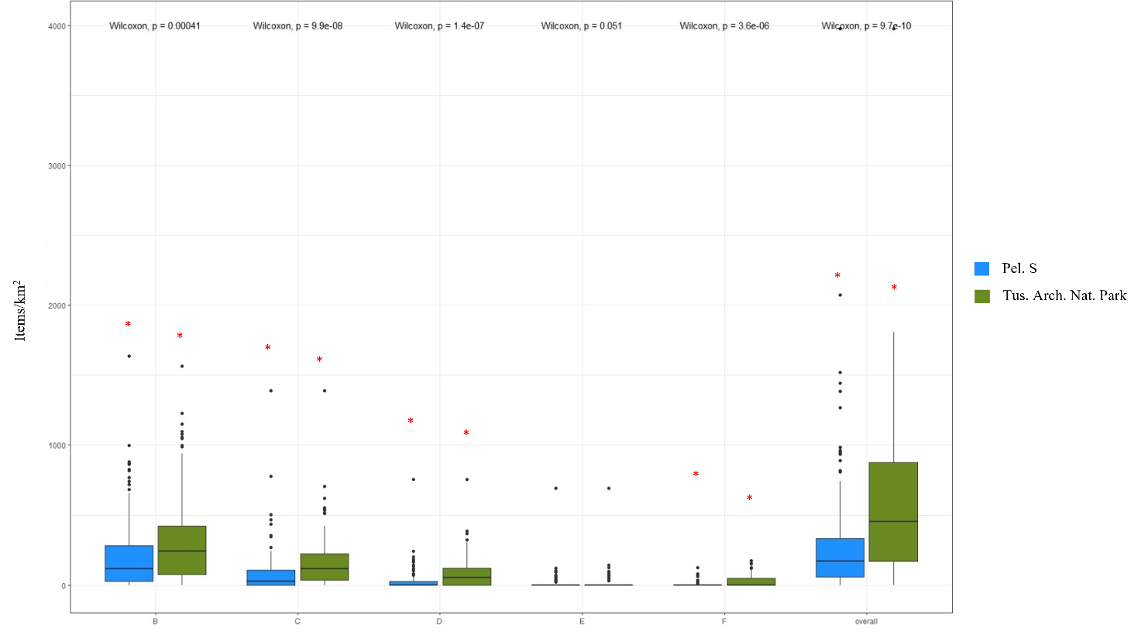
Figure S2. Floating macrolitter different distribution among the two study areas considered (Pelagos Sanctuary: blue box plots; Tuscan Archipelago National Park: green boxplots) according to both size classes (B. 2.5-5 cm, C. 5-10 cm, D.10-20 cm, E. 20-30 cm, F. 30-50 cm, G. > 50 cm) and total avg. concentration. * indicates difference statistically significative (p < 0.05).

Table S3. Mean concentration of floating litter according to different categories, for the two considered study areas. Grey cells evidenced statistically significant higher values (Wilcoxon test; p < 0.05).
G-code and corresponding category | Concentration [Items / km²] – mean (sd) |  | Wilcoxon test  P (< 0.05)
 | Pelagos Sanctuary | Tuscan Archipelago National Park
G2-Bags | 2.422 (13.771) | 5.018 (19.075) | W = 9153, p-value = 0.1517
G6-Bottles | 0.474 (4.582) | 3.809 (13.923) | W = 8928.5, p-value = 0.006334
G18-Crates and containers/baskets | 0.815 (6.476) | 4.782 (15.669) | W = 8814.5, p-value = 0.004033
G38-Cover / packaging | 0.336 (4.410) | 0.345 (3.623) | W = 9484, p-value = 0.7541
G45-Mussel nets / Oyester nets | 0.197 (2.585) | 2.5 (2.585) | W = 9135.5, p-value = 0.02362
G48-Synthetic rope | 10.572 (28.626) | 20.036 (37.932) | W = 8516.5, p-value = 0.03621
G51-Fishing net | 1.254 (9.728) | 1.264 (9.370) | W = 9506.5, p-value = 0.9583
G58-Fish boxes - expanded polystyrene | 0.191 (2.509) |  | n.a.
G63-Buoys |  | 1.091 (11.442) | n.a.
G67-Sheets, indus. packaging, plastic sheeting | 125.110 (289.537) | 347.591 (435.738) | W = 5255.5, p-value = 1.628e-10
G74-Foam packaging/insulation/polyurethane |  | 1.082 (11.346) | n.a.
G79-Plastic pieces 2.5cm ><50 cm | 100.393 (167.452) | 163.836 (193.097) | W = 7424.5, p-value = 0.001434
G80-Plastic pieces >50 cm | 0.925 (6.465) | 3.336 (23.555) | W = 9470.5, p-value = 0.8075
G82-Polystyrene pieces 2.5cm ><50 cm | 17.012 (44.943) | 19.400 (94.435) | W = 9920, p-value = 0.3895
G83-Polystyrene pieces >50 cm | 1.127 (10.662) | 0.618 (6.484) | W = 9539.5, p-value = 0.8402
G94-Table cloth | 0.283 (3.725) |  | n.a.
G124-Other plastic/polystyrene items (identifiable) | 16.156 (32.322) | 36.918 (50.646) | W = 7607, p-value = 0.0006935
G125-Balloons and balloon sticks | 1.491 (9.104) | 1.645 (9.9) | W = 9529, p-value = 0.9441
G135-Clothing (clothes, shoes) |  | 0.345 (3.623) | n.a.
G142-Rope, string and nets |  | 0.618 (6.484) | n.a.
G145-Other textiles (incl. rags) | 0.168 (2.205) |  | n.a.
G149-Paper packaging | 0.769 (7.139) |  | n.a.
G158-Other paper items | 0.150 (1.977) | 0.936 (7.117) | W = 9396, p-value = 0.3195
G160-Pallets |  | 0.355 (3.719) | n.a.
G168-Wood boards | 0.214 (2.070) | 1.555 (9.382) | W = 9362.5, p-value = 0.3209
G173-Other (specify)* | 0.133 (0.1749) |  | n.a.
G197-Other (metal) | 0.208 (2.737) | 0.682 (5.088) | W = 9397, p-value = 0.3236

Table S4. Mean concentration of floating litter according to different size classes in the Tuscan Archipelago National Park. Grey cells evidenced statistically significant higher values (Kruskal-Wallis significance test for p < 0.05).
Dimension | Items / km² mean (sd)
 | Gorgona | Capraia | Elba | Montecristo | Pianosa | Giglio | Giannutri
B 2.5-5cm | 463.25  (396.10) | 268.15  (288.69) | 193.71  (182.47) | 121.83  (124.12) | 356.07  (355.88) | 384.13  (417.84) | 579.25  (402.43)
C 5-10cm | 136.75  (160.33) | 177.77  (128.41) | 134.10  (168.48) | 95.83  (111.40) | 187.57  (176.74) | 153.75  (152.32) | 249.25  (213.60)
D 10-20cm | 79.00  (82.15) | 64.92  (104.70) | 81.67  (101.38) | 18.67  (36.69) | 122.29  (118.36) | 36.19  (48.35) | 110.83  (92.56)
E 20-50cm | 17.33  (31.94) |  | 11.67  (26.82) | 5.08  (17.61) | 30.93  (49.98) | 6.50  (18.06) | 39.00  (39.34)
F 50-100cm | 27.75  (43.16) | 14.38  (28.06) | 11.19  (23.96) | 17.33  (33.44) | 38.86  (68.51) | 30.31  (43.47) | 38.00  (47.97)

Table S5. Mean and SD weight density and concentration values for each considered Island in the Tuscan Archipelago National Park.
Island | Concentration (items/km²) | Density (mg/m²)
Gorgona | 563,962 ± 1,123,234 | 0.317 ± 0.662
Capraia | 211,650 ± 159,736 | 0.088 ± 0.052
Elba | 469,624 ± 468,907 | 0.231 ± 0.219
Pianosa | 290,966 ± 321,938 | 0.105± 0.103
Montecristo | 102,966 ± 83,089 | 0.023 ± 0.019
Giglio | 241,007 ± 292,466 | 0.101 ± 0.109
Giannutri | 211,074 ± 106,240 | 0.129 ± 0.099

Table S6. Floating macrolitter and MPs concentrations in the different habitats considered in the study areas.
Habitat | Floating macrolitter (items/km²) | MPs (items/km²)
Bathyal (> 2000 m) | 176 ± 158 | 88,508 ± 38,146
Canyon (200 m - 2000 m) | 238 ± 337 | 378,137 ± 1,107,092
Seamount (400 m - > 2000 m) | 205 ± 245 | 86,796 ± 59,482
Slope (200 m – 2000 m) | 257 ± 340 | 161,176 ± 245,238
Continental shelf (0 m -200 m) | 573 ± 572 | 310,489 ± 559,776

Table S7. Summary descriptive statistics of environmental and anthropogenic variables and their correlation with floating macrolitter concentration. The strength of Spearman’s rank correlation is reported using different shades of blue. Lighter blue corresponds to weak correlations (rho < 0.03), light blue to correlations (0.3< rho <0.5) and blue to strong correlations (rho > 0.5). The statistical significance is reported with different shades of grey. Light grey corresponds to p-values < 0.05, medium grey to p-values < 0.02, and dark grey to p-values < 0.01.
Floating macrolitter
Descr.  statistics | SST  (°C) | SSH  (m) | MLD  (m) | Curr. velocity (m/s) | Bath.  (m) | Vess.  all | Vess.  fishing | Vess.  sailing | Vess.  pleasure | Vess.  passenger | Vess.  cargo | Vess.  tanker | Dist.  port (km) | Dist.  coast (km) | Dist.  outfalls (km) | Dist.  Big  outfalls (km) | Dist.  Little  outfalls (km) | Plastic density (items/km²)
mean | 23.47 | -0.38 | 12.00 | 0.10 | -723.21 | 7.59 | 0.62 | 2.34 | 1.45 | 2.29 | 0.15 | 0.46 | 24.72 | 16.70 | 30.20 | 38.15 | 46.15 | 399.01
sd | 3.17 | 0.11 | 0.68 | 0.08 | 843.70 | 76.93 | 2.20 | 28.37 | 15.97 | 31.22 | 0.35 | 6.34 | 20.12 | 18.59 | 17.37 | 21.14 | 32.00 | 485.84
median | 24.48 | -0.41 | 11.89 | 0.07 | -216.60 | 1.13 | 0.00 | 0.26 | 0.27 | 0.04 | 0.00 | 0.00 | 19.87 | 5.98 | 28.83 | 37.31 | 37.86 | 219.37
trimmed | 23.64 | -0.38 | 11.90 | 0.09 | -588.92 | 1.73 | 0.17 | 0.36 | 0.32 | 0.12 | 0.07 | 0.02 | 21.90 | 13.52 | 28.93 | 37.14 | 41.98 | 305.39
mad | 3.57 | 0.13 | 0.07 | 0.05 | 287.52 | 1.36 | 0.00 | 0.31 | 0.30 | 0.06 | 0.00 | 0.00 | 19.36 | 6.91 | 16.12 | 22.43 | 30.00 | 248.66
min | 17.03 | -0.59 | 11.58 | 0.00 | -2617.4 | 0.00 | 0.00 | 0.00 | 0.00 | 0.00 | 0.00 | 0.00 | 1.38 | 0.26 | 2.69 | 3.94 | 2.69 | 0.00
max | 28.12 | -0.17 | 18.10 | 0.37 | -3.98 | 1267.23 | 24.70 | 468.95 | 263.90 | 515.59 | 3.14 | 104.75 | 78.84 | 70.59 | 77.76 | 82.05 | 132.49 | 3,974.39
range | 11.09 | 0.42 | 6.52 | 0.37 | 2613.47 | 1267.23 | 24.70 | 468.95 | 263.90 | 515.59 | 3.14 | 104.75 | 77.46 | 70.33 | 75.07 | 78.11 | 129.80 | 3,974.39
skew | -0.41 | 0.08 | 6.64 | 1.31 | -1.08 | 16.09 | 7.56 | 16.29 | 16.22 | 16.28 | 4.40 | 16.31 | 1.00 | 1.24 | 0.63 | 0.35 | 0.99 | 2.61
kurtois | -1.07 | -1.23 | 47.50 | 0.87 | -0.31 | 260.37 | 69.53 | 264.95 | 263.29 | 264.56 | 25.31 | 265.40 | 0.15 | 0.66 | 0.34 | -0.62 | 0.40 | 11.09
se | 0.19 | 0.01 | 0.04 | 0.00 | 51.06 | 4.66 | 0.13 | 1.72 | 0.97 | 1.89 | 0.02 | 0.38 | 1.22 | 1.13 | 1.05 | 1.28 | 1.94 | 29.04
Shapiro-Wilk normality test
p-value | 1.11 e-06 | 8.88 e-09 | <2.2e-16 | 1.39e-12 | <2.2e-16 | <2.2e-16 | < 2.2e-16 | <2.2e-16 | <2.2e-16 | < 2.2e-16 | <2.2e-16 | <2.2e-16 | 2.45e-10 | <2.2e-16 | 4.01e-05 | 5.62e-04 | 7.92e-12 | <2.2e-16
Anderson-Darling test
p-value | 7.22e-12 | 4.28e-11 | <2.2e-16 | <2.2e-16 | <2.2e-16 | <2.2e-16 | < 2.2e-16 | <2.2e-16 | < 2.2e-16 | < 2.2e-16 | < 2.2e-16 | < 2.2e-16 | < 2.2e-16 | <2.2e-16 | 7.89e-05 | 1.46e-06 | 3.35e-16 | <2.2e-16
*Spearman’s rank correlation
rho | 0.24 | 0.22 | -0.17 | -0.27 | 0.33 | 0.076 | 0.25 | 0.17 | -0.022 | -0.055 | -0.24 | -0.19 | -0.34 | -0.36 | -0.085 | -0.18 | -0.12
p-value | 0.0001 | 0.00028 | 0.0064 | 1.09e-05 | 2.22e-08 | 0.21 | 2.90e-05 | 0.004579 | 0.7224 | 0.3621 | 4.23e-05 | 0.001198 | 7.80E-09 | 8.023E-07 | 0.1605 | 0.002301 | 0.04737

Figure S3. Correlation scatterplots among floating macrolitter concentration and environmental (SST (A), SSH (B), MLD (C), Current velocity (D), and Depth (E)) and anthropogenic (distance from ports (F), distance from the coast (G), distance from rivers outfalls (H and I) and marine traffic (L - R)) factors. The crescent number of * symbol indicates the statistical significance strength (* p-values < 0.05, ** p-values < 0.02, *** p-values < 0.01).
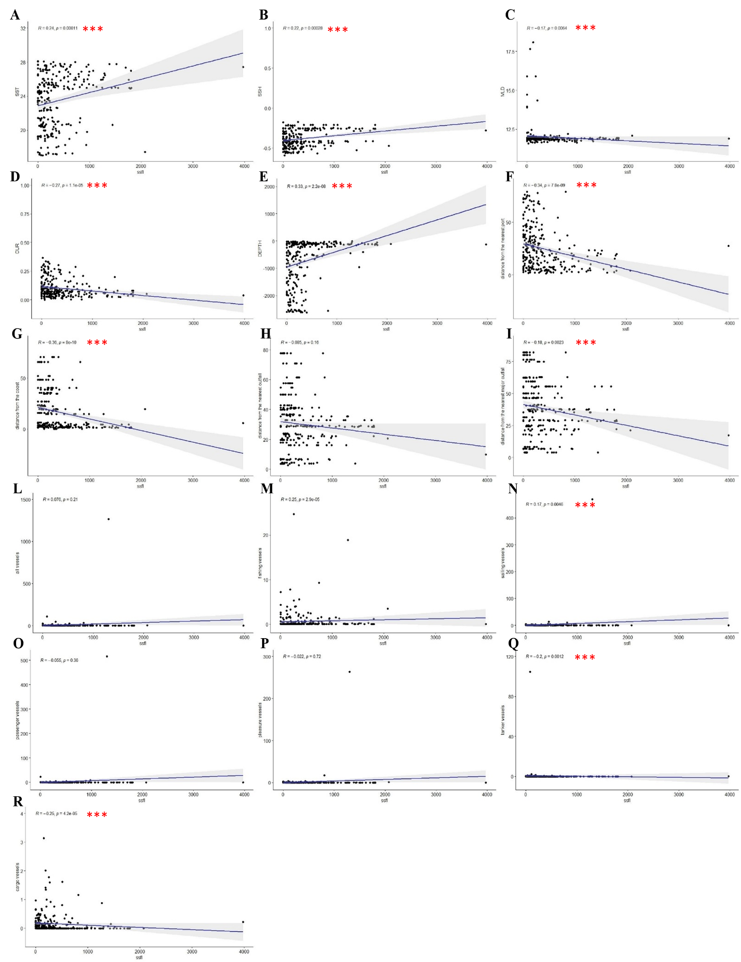

Table S8. Summary descriptive statistics of environmental and anthropogenic variables and their correlation with MPs concentration. The strength of Spearman’s rank correlation is reported using different shades of blue. Lighter blue corresponds to weak correlations (rho < 0.03), light blue to correlations (0.3 < rho < 0.5) and blue to strong correlations (rho > 0.5). The statistical significance is reported with different shades of grey. Light grey corresponds to p-values < 0.05, medium grey to p-values < 0.02, and dark grey to p-values < 0.01.
MPs
Descr.  statistics | SST  (°C) | SSH  (m) | MLD  (m) | Curr. velocity (m/s) | Bath.  (m) | Vess.  all | Vess.  fishing | Vess.  sailing | Vess.  pleasure | Vess.  passenger | Vess.  cargo | Vess.  tanker | Dist.  port (km) | Dist.  coast (km) | Dist.  outfalls (km) | Dist.  Big  outfalls (km) | Dist.  Little  outfalls (km) | Plastic density (items/km²)
mean | 23.59 | -0.38 | 12.00 | 0.10 | -681.73 | 3.90 | 0.68 | 0.77 | 0.59 | 0.45 | 0.15 | 0.81 | 23.94 | 14.73 | 32.20 | 41.21 | 45.59 | 259,490
sd | 3.21 | 0.11 | 0.67 | 0.08 | 835.86 | 10.74 | 2.41 | 1.62 | 1.52 | 1.99 | 0.38 | 8.82 | 19.94 | 19.21 | 19.61 | 21.80 | 31.84 | 586,477
median | 24.57 | -0.41 | 11.89 | 0.07 | -173.60 | 1.33 | 0.00 | 0.30 | 0.32 | 0.04 | 0.00 | 0.00 | 19.00 | 3.84 | 30.38 | 39.16 | 37.86 | 105,195
trimmed | 23.78 | -0.38 | 11.90 | 0.08 | -539.13 | 1.88 | 0.21 | 0.39 | 0.36 | 0.12 | 0.06 | 0.02 | 21.01 | 10.20 | 30.77 | 40.88 | 41.43 | 139,875
mad | 3.55 | 0.14 | 0.06 | 0.05 | 208.67 | 1.40 | 0.00 | 0.40 | 0.38 | 0.06 | 0.00 | 0.00 | 19.26 | 3.38 | 14.71 | 16.90 | 29.28 | 85,294
min | 17.05 | -0.57 | 11.62 | 0.00 | -2,607.5 | 0.00 | 0.00 | 0.00 | 0.00 | 0.00 | 0.00 | 0.00 | 1.92 | 1.19 | 2.69 | 3.44 | 2.69 | 15,757
max | 28.09 | -0.17 | 17.67 | 0.33 | -3.98 | 109.75 | 24.70 | 12.95 | 17.23 | 22.47 | 3.14 | 104.75 | 78.84 | 72.57 | 73.08 | 96.13 | 132.35 | 4,933,909
range | 11.04 | 0.39 | 6.04 | 0.33 | 2,603.6 | 109.75 | 24.70 | 12.95 | 17.23 | 22.47 | 3.14 | 104.75 | 76.92 | 71.38 | 70.39 | 92.69 | 129.66 | 4,918,152
skew | -0.43 | 0.04 | 6.49 | 1.32 | -1.16 | 7.47 | 7.60 | 4.77 | 9.37 | 9.77 | 4.68 | 11.61 | 1.04 | 1.85 | 0.55 | 0.25 | 0.99 | 5.67
kurtois | -1.09 | -1.27 | 44.98 | 0.72 | -0.13 | 66.14 | 68.61 | 27.86 | 98.60 | 104.03 | 28.19 | 133.85 | 0.24 | 2.48 | -0.33 | -0.49 | 0.47 | 36.23
se | 0.28 | 0.01 | 0.06 | 0.01 | 70.39 | 0.90 | 0.20 | 0.14 | 0.13 | 0.17 | 0.03 | 0.74 | 1.68 | 1.62 | 1.65 | 1.84 | 2.68 | 49,390
Shapiro-Wilk normality test
p-value | 1.627e-03 | 1.209e-02 | <2.2e-16 | 2.81e-08 | 3.99e-11 | <2.2e-16 | <2.2e-16 | <2.2e-16 | < 2.2e-16 | < 2.2e-16 | <2.2e-16 | < 2.2e-16 | 2.44e-09 | 7.78E-13 | 9.622E-04 | 0.00014 | 1.21e-07 | <2.2e-16
Anderson-Darling test
p-value | 2.43e-05 | 1.57e-04 | <2.2e-16 | <2.2e-16 | <2.2e-16 | <2.2e-16 | < 2.2e-16 | <2.2e-16 | < 2.2e-16 | < 2.2e-16 | <2.2e-16 | <2.2e-16 | 1.40e-09 | <2.2e-16 | 1.19e-07 | 6.40e-03 | 3.80e-08 | < 2.2e-16
*Spearman’s rank correlation

rho | 0.26 | 0.18 | -0.070 | -0.18 | 0.21 | 0.13 | 0.16 | 0.20 | 0.11 | 0.032 | -0.19 | -0.081 | -0.28 | -0.25 | 0.060 | -0.13 | -0.013
p-value | 0.0021 | 0.034 | 0.42 | 0.035 | 0.012 | 0.13 | 0.052 | 0.017 | 0.19 | 0.70 | 0.023 | 0.34 | 0.00085 | 0.0027 | 0.48 | 0.12 | 0.88

Figure S4. Correlation scatterplots among floating microlitter concentration and environmental (SST (A), SSH (B), MLD (C), Current velocity (D), and Depth (E)) and anthropogenic (distance from ports (F), distance from the coast (G), distance from rivers outfalls (H and I) and marine traffic (L - R)) factors. The crescent number of the * symbol indicates the statistical significance strength (* p-values < 0.05, ** p-values < 0.02, *** p-values < 0.01).
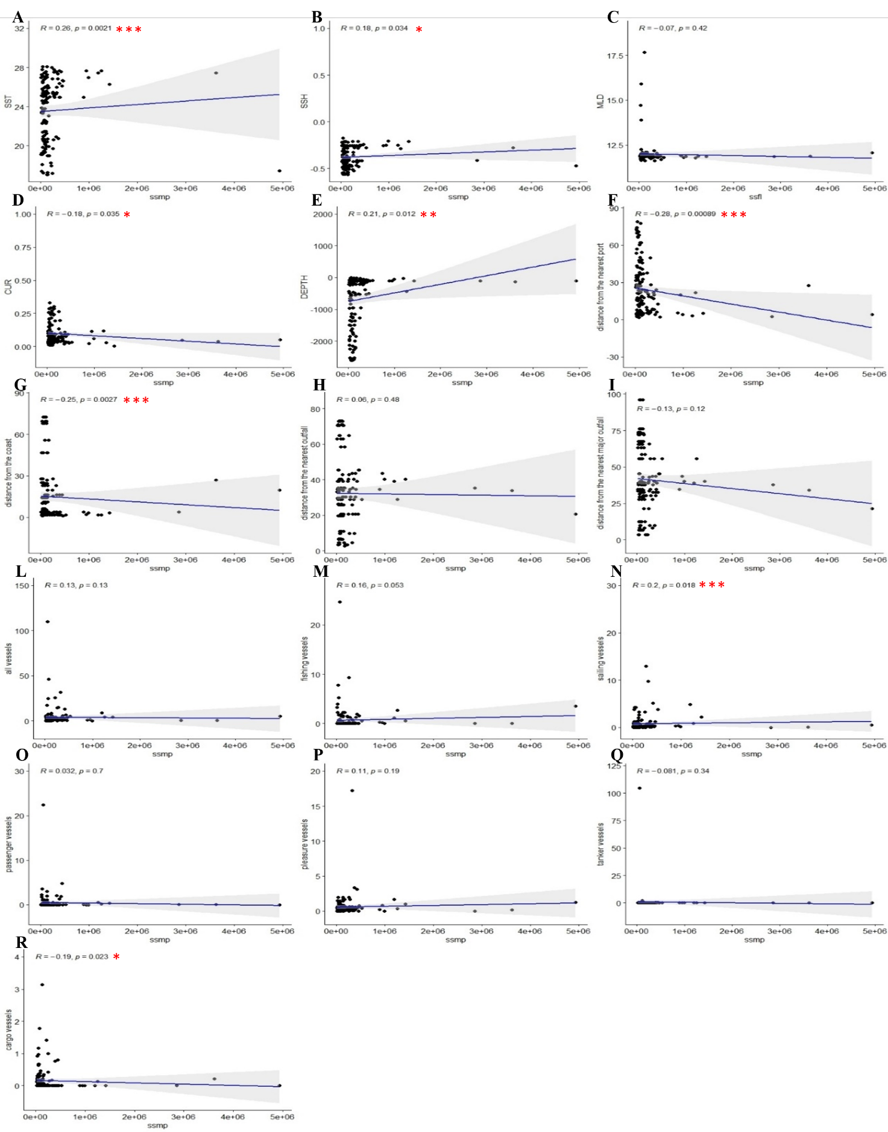

Table S9. Generalized additive models (GAMs) results for each environmental and anthropogenic factor potentially influencing the floating macrolitter distribution. The corresponding p-value of each variable and the deviance of data explained (%) were shown. Variables significantly influencing the floating macrolitter concentrations were highlighted in blue. The crescent number of the * symbol indicates the statistical significance strength (* p-values < 0.05, ** p-values < 0.02, *** p-values < 0.01).
GAM for environmental variables | p-value | Deviance explained
Floating macrolitter conc. ~ s(sst) | 6.45e-05 *** | 10.2%
Floating macrolitter conc. ~ s(ssh) | 6.14e-06 *** | 7.55%
Floating macrolitter conc. ~ s(mld) | 0.0597 | 1.34%
Floating macrolitter conc. ~ s(mld without outliers) | 0.221 | 0.578%
Floating macrolitter conc. ~ s(cur) | 6.64e-05 *** | 5.9%
Floating macrolitter conc. ~ s(bath) | 0.0597 | 1.34%
GAM for anthropic variables sources | p-value | Deviance explained
Floating macrolitter conc. ~ s(v_all conc.) | 0.071 | 1.2%
Floating macrolitter conc. ~ s(v_all conc. without outliers) | 0.682 | 0.0652%
Floating macrolitter conc. ~ s(v_fishing conc.) | 0.415 | 0.246%
Floating macrolitter conc. ~ s(v_fishing conc. without outliers) | 0.419 | 0.506%
Floating macrolitter conc. ~ s(v_sailing conc.) | 0.0567 | 1.36%
Floating macrolitter conc. ~ s(v_sailing conc. without outliers) | 0.256 | 0.482%
Floating macrolitter conc. ~ s(v_pleasure conc.) | 0.0601 | 1.3%
Floating macrolitter conc. ~ s(v_pleasure conc. without outliers) | 0.273 | 0.45%
Floating macrolitter conc. ~ s(v_passenger conc.) | 0.0642 | 1.26%
Floating macrolitter conc. ~ s(v_passenger conc. without outliers) | 0.383 | 0.292%
Floating macrolitter conc. ~ s(v_tanker conc.) | 0.241 | 1.44%
Floating macrolitter conc. ~ s(v_tanker conc. without outliers) | 0.108 | 2.06%
Floating macrolitter conc. ~ s(v_cargo conc.) | 0.128 | 2.19%
Floating macrolitter conc. ~ s(v_cargo conc. without outliers) | 0.0412 * | 3.29%
Floating macrolitter conc. ~ s(d_coast) | 1.19e-06 *** | 11.8%
Floating macrolitter conc. ~s(d_port) | 1.47e-06 *** | 8.44%
Floating macrolitter conc. ~ s(d_outfall) | 2.42e-05 *** | 13.9%
Floating macrolitter conc. ~ s(d_big_outfall) | 0.000132 *** | 9.02%
Floating macrolitter conc. ~ s(d_little_outfall) | 3.96e-05 *** | 11%

Table S10. Generalized additive models (GAMs) results for each environmental and anthropogenic factor potentially influencing the MPs distribution. The corresponding p-value of each variable and the deviance of data explained (%) were shown. Variables significantly influencing the MPs concentrations were highlighted in blue. The crescent number of * symbol indicates the statistical significance strength (* p-values < 0.05, ** p-values < 0.02, *** p-values < 0.01).
GAM for environmental variables | p-value | Deviance explained
MPs concentration ~ s(sst) | 0.0278 * | 7.97%
MPs concentration ~ s(ssh) | 0.217 | 1.14%
MPs concentration ~ s(mld) | 0.609 | 0.197%
MPs concentration ~ s(mld without outliers) | 0.439 | 0.464%
MPs concentration ~ s(cur) | 0.0647 | 2.53%
Floating litter density ~ s(bath) | 0.0242 * | 3.61%
GAM for pollution sources | p-value | Deviance explained
MPs concentration ~ s(v_all density) | 0.844 | 0.0297%
MPs concentration ~ s(v_all density without outliers) | 0.112 | 1.93%
MPs concentration ~ s(v_fishing density) | 0.298 | 2.9%
MPs concentration ~ s(v_fishing density without outliers) | 0.283 | 0.872%
MPs concentration ~ s(v_sailing density) | 0.644 | 0.155%
MPs concentration ~ s(v_sailing density without outliers) | 0.521 | 0.303%
MPs concentration ~ s(v_pleasure density) | 0.593 | 0.209%
MPs concentration ~ s(v_pleasure density without outliers) | 0.227 | 1.08%
MPs concentration ~ s(v_passenger density) | 0.645 | 0.154%
MPs concentration ~ s(v_passenger density without outliers) | 0.572 | 0.237%
MPs concentration ~ s(v_tanker density) | 0.715 | 0.0981%
MPs concentration ~ s(v_tanker density without outliers) | 0.509 | 0.322%
MPs concentration ~ s(v_cargo density) | 0.478 | 0.364%
MPs concentration ~ s(v_cargo density without outliers) | 0.469 | 0.388%
MPs concentration ~ s(d_coast) | 0.455 | 0.402%
MPs concentration ~s(d_port) | 0.0237 * | 3.64%
MPs concentration ~ s(d_outfall) | 0.236 | 3.06%
MPs concentration ~ s(d_big_outfall) | 0.250 | 2.9%
MPs concentration ~ s(d_little_outfall) | 0.402 | 0.507%

