Supplementary Material
The role of humic-type ligands in the bioavailability and stabilization of dissolved iron in the Western Tropical South Pacific Ocean
Gabriel Dulaquais¹*, Pierre Fourrier¹, Cécile Guieu², Léo Mahieu³, Ricardo Riso¹, Pascal Salaun³, Chloé Tilliette², Hannah Whitby³
¹Laboratoire des Sciences de l’Environnement Marin CNRS UMR 6539, Institut Universitaire Européen de la Mer, Université de Bretagne Occidentale. Place Nicolas Copernic - 29280 Plouzané, France.
²Sorbonne Université, CNRS, Laboratoire d'Océanographie de Villefranche, LOV, Villefranche‐sur‐Mer, France.
³Department of Earth, Ocean and Ecological Sciences, School of Environmental Sciences, University of Liverpool, UK
* Correspondence:
Corresponding Author: gabriel.dulaquais@univ-brest.fr

Supplementary Text
Marine eHS concentrations (µg.L-1) are determined by the method of standard addition using voltammetric methods. The standards used are often SRFA (Dulaquais et al., 2018 ; Laglera et al., 2019 ) or SRHA (Whitby and van den berg, 2015) because of a lack of eHS marine standard. Irrespective of the method, absolute values of eHS concentrations are dependent on the standard being used, simply because each standard has a different sensitivity. eHS concentrations should therefore always indicate the standard (e.g. µg eqSRFA L⁻¹). The eHS concentrations are then converted to iron binding ligands of humic nature (L_{FeHS}, unit: e.g. nmol eqFe L⁻¹) using the binding capacity of the external standard. This concentration represents the maximum amount of Fe that eHS may complex, based on the known binding capacity of the standard used. It is argued that in the absence of marine external standard an envelope encompassing the binding capacity of both SRHA (32 nmol Fe mgSRHA⁻¹ ; Laglera and van den berg 2009) and SRFA (14.6 nmol Fe mgSRFA⁻¹ ; Sukekava et al., 2018) should be used for the conversion, leading to L_{FeHS} concentration varying by a factor of 2 (Whitby et al., 2020)
In this study, the detection of eHS is based on the reduction of adsorbed Fe(III) present in the natural iron-humic complex to Fe(II). To quantify the signal of the sample, a standard addition is performed with successive additions of a Fe-saturated standard (e.g. SRFA). The sensitivity (i.e. slope of the standard addition) is thus directly dependent on the Fe binding capacity of the standard, making L_{FeHS} independent on the choice of standard. We demonstrate this below and therefore highlight that the use of a concentration range for L_{FeHS} is not required as long as the binding capacity of the specific standard used is known.
We analysed eHS in a surface seawater sample collected from the TONGA expedition (15 m depth, LD5-T3) using both Suwannee River Humic Acids (SRHA) and Suwannee River Fulvic Acids (SRFA) as an external standard (Figure S1). The eHS concentrations determined using SRHA result in an ambient concentration of 62.8 ± 9.4 µg eqSRHA L⁻¹. eHS concentrations determined using SRHA result in an ambient concentration of 143.3 ± 9.5 µg eqSRFA L⁻¹. We then converted to L_{FeHS} considering the iron binding capacity of SRHA and SRFA in seawater. L_{FeHS} were calculated as 2.09 ± 0.30 nmol eq Fe L⁻¹ using SRHA and as 2.09 ± 0.14 nmol eq Fe L⁻¹ using SRFA. The determination of L_{FeHS} is similar using SRHA or SRFA when uncertainties are taken into account..

Supplementary Figures
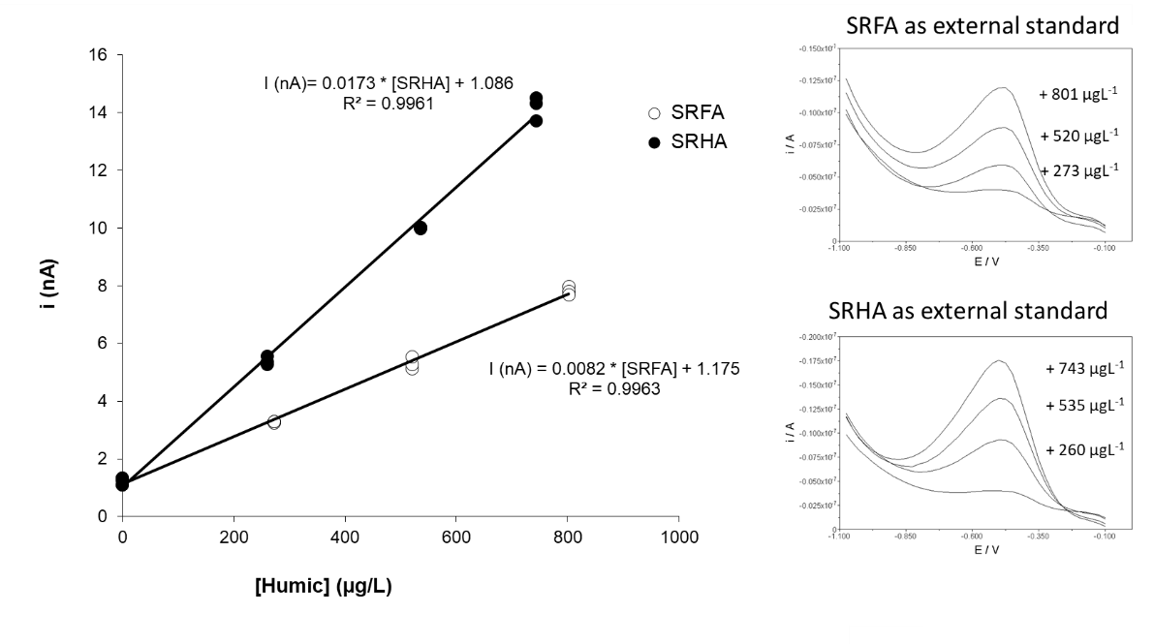
Supplementary Figure 1 : Analysis of electroactive humic substances (eHS) in a surface seawater sample from the TONGA expedition (15 m depth, LD5-T3) using either Suwannee River Humic Acids (SRHA) or Suwannee River Fulvic Acids (SRFA) as external standard. Sensitivity of the method is standard dependant and provides different eHS concentrations. After conversion into iron binding ligands of humic nature (L_{FeHS}) considering the iron binding capacity of the two external standards, L_{FeHS} determined were similar when uncertainties were considered (see Text S1).
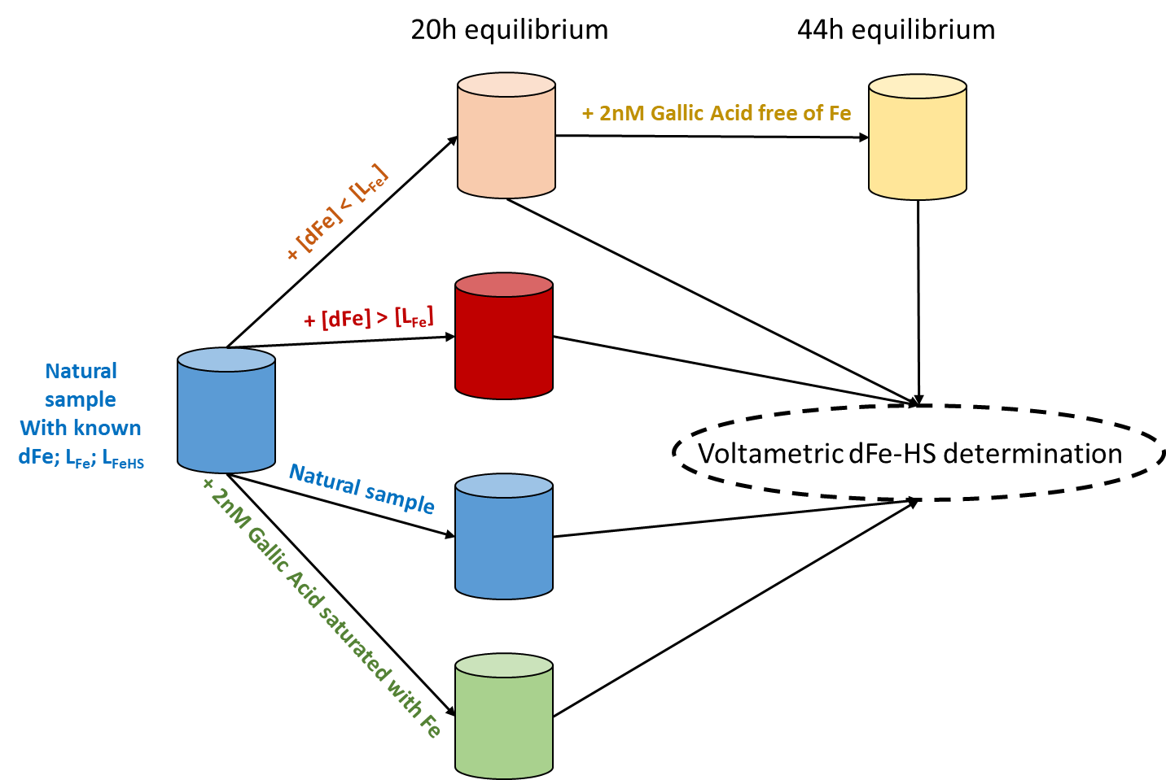
Supplementary Figure 2: Chart of the experimental settings of the iron binding ligand competition experiments between ambient iron binding ligands (L_{Fe}) including humic type ligands (L_{FeHS}) and Gallic Acid. (see section 2.5 in main text)

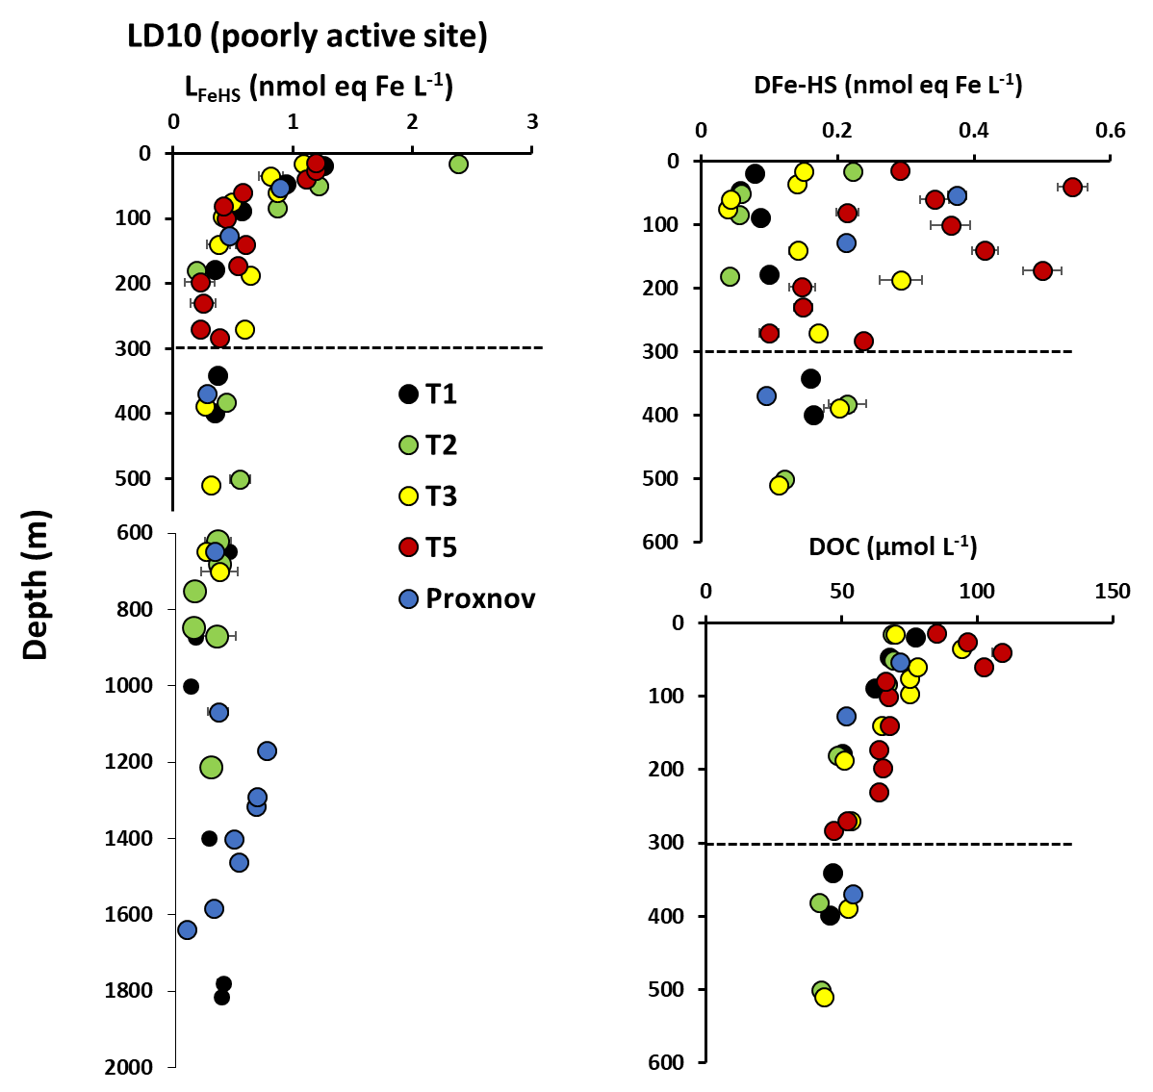
Supplementary Figure 3 : Vertical distribution of humic-type ligands concentrations (L_{FeHS}) above and in the vicinity of ST10 volcanic site. Dashed lines indicate the approximate depth of the hydrothermal plume at ST10-T5 (~190m). Associated concentrations of dissolved iron complexed by L_{FeHS} (DFe-HS) and of dissolved organic carbon (DOC) are presented for the upper 300 meters. The impact of the Metis volcano on L_{FeHS} is seen in the 1200-100 meters layer (Proxnov). T5 is the closest subcast to the volcano, T1 the most distant.

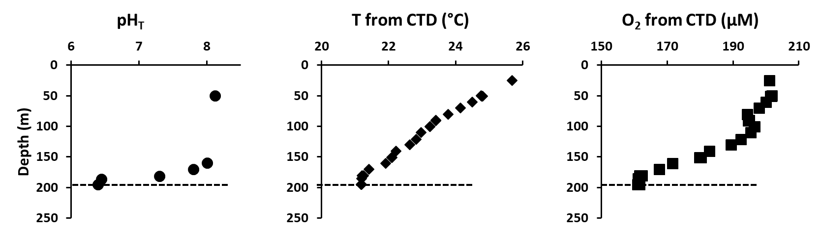

Supplementary Figure 4 : Vertical distribution of pH on total scale (pH_{T}), temperature (T in Celcius degree) and dissolved oxygen derived from CTD sensor (O₂ in µM) at LD5-T5. Dashed lines indicate the approximate depth of the hydrothermal plume (~196m).

