Supplementary Material

**Living in darkness: functional diversity of mesopelagic fishes in the western tropical Atlantic**

**\*Kátia Cristina Aparecido1,2,Thierry Frédou2, Leandro Nolé Eduardo1, Michael Maia Mincarone3,4, Rayssa Siqueira Lima2, Maria Fernanda da Silva Morais2, Bastien Mérigot1**

1MARBEC, Univ. Montpellier, CNRS, Ifremer, IRD, Sète, France.

2Universidade Federal Rural de Pernambuco (UFRPE), Departamento de Pesca e Aquicultura, Recife, PE, Brazil.

3Universidade Federal do Rio de Janeiro (UFRJ), Instituto de Biodiversidade e Sustentabilidade, Macaé, RJ, Brazil.

4 Chapman University, Schmid College of Science and Technology, Orange, CA, USA.

**\*Correspondence:**  katy.cristina@gmail.com

TABLE S1. Species list (n=200 species).

|  |  |  |
| --- | --- | --- |
| Order | Family | Species |
| ALEPOCEPHALIFORMES | Alepocephalidae | Alepocephalidae sp. |
| ALEPOCEPHALIFORMES | Alepocephalidae | *Photostylus pycnopterus* Beebe, 1933 |
| ALEPOCEPHALIFORMES | Platytroctidae | Platytroctidae sp. |
| ANGUILLIFORMES | Eurypharyngidae | *Eurypharynx pelecanoides* Vaillant, 1882 |
| ANGUILLIFORMES | Nemichthyidae | *Avocettina infans* (Günther, 1878) |
| ANGUILLIFORMES | Nemichthyidae | *Labichthys carinatus* Gill & Ryder, 1883 |
| ANGUILLIFORMES | Nemichthyidae | *Nemichthys scolopaceus* Richardson, 1848 |
| ANGUILLIFORMES | Serrivomeridae | *Serrivomer beanii* Gill & Ryder, 1883 |
| ANGUILLIFORMES | Serrivomeridae | *Serrivomer lanceolatoides* (Schmidt, 1916) |
| ANGUILLIFORMES | Serrivomeridae | *Stemonidium hypomelas* Gilbert, 1905 |
| ARGENTINIFORMES | Bathylagidae | *Dolicholagus longirostris* (Maul, 1948) |
| ARGENTINIFORMES | Bathylagidae | *Melanolagus bericoides* (Borodin, 1929) |
| ARGENTINIFORMES | Microstomatidae | *Xenophthalmichthys danae* Regan, 1925 |
| ARGENTINIFORMES | Opisthoproctidae | *Opisthoproctus soleatus* Vaillant, 1888 |
| ARGENTINIFORMES | Opisthoproctidae | *Rhynchohyalus natalensis* (Gilchrist & von Bonde, 1924) |
| ARGENTINIFORMES | Opisthoproctidae | *Winteria telescopa* Brauer, 1901 |
| ATELEOPODIFORMES | Ateleopodidae | Ateleopodidae sp. |
| AULOPIFORMES | Anotopteridae | *Anotopterus pharao* Zugmayer, 1911 |
| AULOPIFORMES | Alepisauridae | *Omosudis lowii* Günther, 1887 |
| AULOPIFORMES | Evermannellidae | *Odontostomops normalops* (Parr, 1928) |
| AULOPIFORMES | Giganturidae | *Gigantura chuni* Brauer, 1901 |
| AULOPIFORMES | Giganturidae | *Gigantura indica* Brauer, 1901 |
| AULOPIFORMES | Chlorophthalmidae | *Parasudis truculenta* (Goode & Bean, 1896) |
| AULOPIFORMES | Notosudidae | *Ahliesaurus berryi* Bertelsen, Krefft & Marshall, 1976 |
| AULOPIFORMES | Paralepididae | *Lestrolepis intermedia* (Poey, 1868) |
| AULOPIFORMES | Paralepididae | *Macroparalepis brevis* Ege, 1933 |
| AULOPIFORMES | Paralepididae | *Stemonosudis gracilis* (Ege, 1933) |
| AULOPIFORMES | Paralepididae | *Stemonosudis intermedia* (Ege, 1933) |
| AULOPIFORMES | Scopelarchidae | *Benthalbella infans* Zugmayer, 1911 |
| AULOPIFORMES | Scopelarchidae | *Rosenblattichthys hubbsi* Johnson, 1974 |
| AULOPIFORMES | Scopelarchidae | *Scopelarchoides danae* Johnson, 1974 |
| AULOPIFORMES | Scopelarchidae | *Scopelarchus analis* (Brauer, 1902) |
| AULOPIFORMES | Scopelarchidae | *Scopelarchus guentheri* Alcock, 1896 |
| BERYCIFORMES | Cetomimidae | *Cetomimus* sp. |
| BERYCIFORMES | Cetomimidae | *Cetostoma regani* Zugmayer, 1914 |
| BERYCIFORMES | Cetomimidae | *Ditropichthys storeri* Goode & Bean, 1895 |
| BERYCIFORMES | Cetomimidae | *Gyrinomimus bruuni* Rofen, 1959 |
| BERYCIFORMES | Melamphaidae | *Melamphaes eulepis* Ebeling, 1962 |
| BERYCIFORMES | Melamphaidae | *Melamphaes leprus* Ebeling, 1962 |
| BERYCIFORMES | Melamphaidae | *Melamphaes longivelis* Parr, 1933 |
| BERYCIFORMES | Melamphaidae | *Melamphaes polylepis* Ebeling, 1962 |
| BERYCIFORMES | Melamphaidae | *Melamphaes typhlops* (Lowe, 1843) |
| BERYCIFORMES | Melamphaidae | *Melamphaes* sp. |
| BERYCIFORMES | Melamphaidae | *Poromitra megalops* (Lütken, 1878) |
| BERYCIFORMES | Melamphaidae | *Poromitra* sp. |
| BERYCIFORMES | Melamphaidae | *Scopeloberyx opercularis* Zugmayer, 1911 |
| BERYCIFORMES | Melamphaidae | *Scopeloberyx opisthopterus* (Parr, 1933) |
| BERYCIFORMES | Melamphaidae | *Scopelogadus mizolepis* (Günther, 1878) |
| BERYCIFORMES | Rondeletiidae | *Rondeletia loricata* Abe & Hotta, 1963 |
| CAPROIFORMES | Caproidae | *Antigonia capros* Lowe, 1843 |
| CAPROIFORMES | Caproidae | *Antigonia combatia* Berry & Rathjen, 1959 |
| GADIFORMES | Bregmacerotidae | *Bregmaceros* cf. *atlanticus* Goode & Bean, 1886 |
| GADIFORMES | Macrouridae | *Bathygadus* sp. |
| GADIFORMES | Macrouridae | *Macrouroides inflaticeps* Smith & Radcliffe, 1912 |
| GADIFORMES | Melanonidae | *Melanonus zugmayeri* Norman, 1930 |
| KUTIFORMES | Apogonidae | *Paroncheilus affinis* (Poey, 1875) |
| LAMPRIFORMES | Lophotidae | *Eumecichthys fiski* (Günther, 1890) |
| LAMPRIFORMES | Trachipteridae | *Desmodema polystictum* (Ogilby, 1898) |
| LAMPRIFORMES | Trachipteridae | *Trachipterus* sp. |
| LAMPRIFORMES | Trachipteridae | *Zu cristatus* (Bonelli, 1819) |
| LOPHIIFORMES | Caulophrynidae | *Caulophryne* sp. |
| LOPHIIFORMES | Ceratiidae | *Ceratias uranoscopus* Murray, 1877 |
| LOPHIIFORMES | Gigantactinidae | *Gigantactis watermani* Bertelsen, Pietsch & Lavenberg, 1981 |
| LOPHIIFORMES | Gigantactinidae | *Rhynchactis* sp. |
| LOPHIIFORMES | Melanocetidae | *Melanocetus johnsonii* Günther, 1864 |
| LOPHIIFORMES | Himantolophidae | *Himantolophus sp.* |
| LOPHIIFORMES | Oneirodidae | *Chaenophryne draco* Beebe, 1932 |
| LOPHIIFORMES | Oneirodidae | *Chaenophryne ramifera* Regan & Trewavas, 1932 |
| LOPHIIFORMES | Oneirodidae | *Dolopichthys* sp. |
| LOPHIIFORMES | Oneirodidae | *Oneirodes anisacanthus* (Regan, 1925) |
| LOPHIIFORMES | Oneirodidae | *Oneirodes carlsbergi* (Regan & Trewavas, 1932) |
| LOPHIIFORMES | Thaumatichthyidae | *Thaumatichthys* sp. |
| MYCTOPHIFORMES | Myctophidae | *Benthosema suborbitale* (Gilbert, 1913) |
| MYCTOPHIFORMES | Myctophidae | *Bolinichthys distofax* Johnson, 1975 |
| MYCTOPHIFORMES | Myctophidae | *Bolinichthys photothorax* (Parr, 1928) |
| MYCTOPHIFORMES | Myctophidae | *Bolinichthys supralateralis* (Parr, 1928) |
| MYCTOPHIFORMES | Myctophidae | *Ceratoscopelus warmingii* (Lütken, 1892) |
| MYCTOPHIFORMES | Myctophidae | *Dasyscopelus asper* (Richardson 1845) |
| MYCTOPHIFORMES | Myctophidae | *Dasyscopelus obtusirostre* (Tåning, 1928) |
| MYCTOPHIFORMES | Myctophidae | *Dasyscopelus selenops* (Tåning, 1928) |
| MYCTOPHIFORMES | Myctophidae | *Diaphus bertelseni* Nafpaktitis, 1966 |
| MYCTOPHIFORMES | Myctophidae | *Diaphus brachycephalus* Tåning, 1928 |
| MYCTOPHIFORMES | Myctophidae | *Diaphus dumerilii* (Bleeker, 1856) |
| MYCTOPHIFORMES | Myctophidae | *Diaphus fragilis* Tåning, 1928 |
| MYCTOPHIFORMES | Myctophidae | *Diaphus garmani* Gilbert, 1906 |
| MYCTOPHIFORMES | Myctophidae | *Diaphus lucidus* (Goode & Bean, 1896) |
| MYCTOPHIFORMES | Myctophidae | *Diaphus mollis* (Tåning, 1928) |
| MYCTOPHIFORMES | Myctophidae | *Diaphus perspicillatus* (Ogilby, 1898) |
| MYCTOPHIFORMES | Myctophidae | *Diaphus problematicus* Parr, 1928 |
| MYCTOPHIFORMES | Myctophidae | *Diaphus splendidus* (Brauer, 1904) |
| MYCTOPHIFORMES | Myctophidae | *Diogenichthys atlanticus* (Tåning, 1928) |
| MYCTOPHIFORMES | Myctophidae | *Electrona risso* (Cocco, 1829) |
| MYCTOPHIFORMES | Myctophidae | *Hygophum hygomii* (Lütken, 1892) |
| MYCTOPHIFORMES | Myctophidae | *Hygophum macrochir* (Günther, 1864) |
| MYCTOPHIFORMES | Myctophidae | *Hygophum reinhardtii* (Lütken, 1892) |
| MYCTOPHIFORMES | Myctophidae | *Hygophum taaningi* Becker, 1965 |
| MYCTOPHIFORMES | Myctophidae | *Lampadena luminosa* (Garman, 1899) |
| MYCTOPHIFORMES | Myctophidae | *Lampanyctus alatus* Goode & Bean, 1896 |
| MYCTOPHIFORMES | Myctophidae | *Lampanyctus lineatus* Tåning, 1928 |
| MYCTOPHIFORMES | Myctophidae | *Lampanyctus festivus* Tåning, 1928 |
| MYCTOPHIFORMES | Myctophidae | *Lampanyctus nobilis*Tåning, 1928 |
| MYCTOPHIFORMES | Myctophidae | *Lampanyctus tenuiformis* (Brauer, 1906) |
| MYCTOPHIFORMES | Myctophidae | *Lepidophanes guentheri* (Goode & Bean, 1896) |
| MYCTOPHIFORMES | Myctophidae | *Myctophum nitidulum* Garman, 1899 |
| MYCTOPHIFORMES | Myctophidae | *Notoscopelus resplendens* (Richardson, 1845) |
| MYCTOPHIFORMES | Myctophidae | *Taaningichthys bathyphilus* (Tåning, 1928) |
| MYCTOPHIFORMES | Neoscopelidae | *Scopelengys tristis*Alcock, 1890 |
| NOTACANTHIFORMES | Halosauridae | *Aldrovandia* sp. |
| OPHIDIIFORMES | Bythitidae | *Bythitidae* sp. |
| PERCIFORMES | Bramidae | *Brama brama* (Bonaterre, 1788) |
| PERCIFORMES | Bramidae | *Brama caribbea* Mead, 1972 |
| PERCIFORMES | Bramidae | *Taractichthys longipinnis* (Lowe, 1843) |
| PERCIFORMES | Caristiidae | *Paracaristius nudarcus* Stevenson & Kenaley, 2011 |
| PERCIFORMES | Caristiidae | *Platyberyx andriashevi* (Kukuev, Parin & Trunov, 2012) |
| PERCIFORMES | Caristiidae | *Platyberyx paucus* Stevenson & Kenaley, 2013 |
| PERCIFORMES | Caristiidae | *Platyberyx pietschi* Stevenson & Kenaley, 2013 |
| PERCIFORMES | Howellidae | *Bathysphyraenops simplex* Parr, 1933 |
| PERCIFORMES | Howellidae | *Howella atlantica* Post & Quéro, 1991 |
| SCOMBRIFORMES | Gempylidae | *Gempylus serpens* Cuvier, 1829 |
| SCOMBRIFORMES | Gempylidae | *Lepidocybium flavobrunneum* (Smith, 1843) |
| SCOMBRIFORMES | Gempylidae | *Nesiarchus nasutus* Johnson, 1862 |
| SCOMBRIFORMES | Gempylidae | *Promethichthys prometheus* (Cuvier, 1832) |
| SCOMBRIFORMES | Nomeidae | *Cubiceps pauciradiatus* Günther, 1872 |
| SCOMBRIFORMES | Nomeidae | *Psenes cyanophrys* Valenciennes, 1833 |
| SCOMBRIFORMES | Trichiuridae | *Aphanopus intermedius* Parin, 1983 |
| SCOMBROLABRACIFORMES | Scombrolabracidae | *Scombrolabrax heterolepis* Roule, 1921 |
| SCORPAENIFORMES | Setarchidae | *Ectreposebastes imus* Garman, 1899 |
| SQUALIFORMES | Dalatiidae | *Isistius brasiliensis* (Quoy & Gaimard, 1824) |
| STOMIIFORMES | Diplophidae | *Diplophos australis* Ozawa, Oda & Ida, 1990 |
| STOMIIFORMES | Diplophidae | *Diplophos taenia* Günther, 1873 |
| STOMIIFORMES | Diplophidae | *Manducus maderensis* (Johnson, 1890) |
| STOMIIFORMES | Diplophidae | *Triplophos hemingi* (McArdle, 1901) |
| STOMIIFORMES | Gonostomatidae | *Bonapartia pedaliota* (Goode & Bean, 1896) |
| STOMIIFORMES | Gonostomatidae | *Cyclothone* spp. |
| STOMIIFORMES | Gonostomatidae | *Gonostoma atlanticum* Norman, 1930 |
| STOMIIFORMES | Gonostomatidae | *Gonostoma denudatum* Rafinesque, 1810 |
| STOMIIFORMES | Gonostomatidae | *Margrethia obtusirostra* Jespersen & Tåning, 1919 |
| STOMIIFORMES | Gonostomatidae | *Sigmops bathyphilus* Vaillant, 1884 |
| STOMIIFORMES | Gonostomatidae | *Sigmops elongatus* (Günther, 1878) |
| STOMIIFORMES | Phosichthyidae | *Ichthyococcus polli* Blache, 1964 |
| STOMIIFORMES | Phosichthyidae | *Phosichthys argenteus* Hutton, 1872 |
| STOMIIFORMES | Phosichthyidae | *Pollichthys mauli* (Poll, 1953) |
| STOMIIFORMES | Phosichthyidae | *Vinciguerria nimbaria* (Jordan & Williams, 1895) |
| STOMIIFORMES | Sternoptychidae | *Argyropelecus aculeatus* Valenciennes, 1850 |
| STOMIIFORMES | Sternoptychidae | *Argyropelecus affinis* Garman, 1899 |
| STOMIIFORMES | Sternoptychidae | *Argyropelecus gigas* Norman, 1930 |
| STOMIIFORMES | Sternoptychidae | *Argyropelecus hemigymnus* Cocco, 1829 |
| STOMIIFORMES | Sternoptychidae | *Argyropelecus sladeni* Regan, 1908 |
| STOMIIFORMES | Sternoptychidae | *Sternoptyx diaphana* Hermann, 1781 |
| STOMIIFORMES | Sternoptychidae | *Sternoptyx pseudobscura* Baird, 1971 |
| STOMIIFORMES | Sternoptychidae | *Sternoptyx pseudodiaphana* Borodulina, 1977 |
| STOMIIFORMES | Sternoptychidae | *Valenciennellus tripunctulatus* (Esmark, 1871) |
| STOMIIFORMES | Stomiidae | *Aristostomias grimaldii* Zugmayer, 1913 |
| STOMIIFORMES | Stomiidae | *Aristostomias tittmanni* Welsh, 1923 |
| STOMIIFORMES | Stomiidae | *Astronesthes atlanticus* Parin & Borodulina, 1996 |
| STOMIIFORMES | Stomiidae | *Astronesthes gemmifer* Goode & Bean, 1896 |
| STOMIIFORMES | Stomiidae | *Astronesthes gudrunae* Parin & Borodulina, 2002 |
| STOMIIFORMES | Stomiidae | *Astronesthes richardsoni* (Poey, 1852) |
| STOMIIFORMES | Stomiidae | *Astronesthes similus* Parr, 1927 |
| STOMIIFORMES | Stomiidae | *Bathophilus nigerrimus* Giglioli, 1882 |
| STOMIIFORMES | Stomiidae | *Bathophilus pawneei* Parr, 1927 |
| STOMIIFORMES | Stomiidae | *Borostomias elucens* (Brauer, 1906) |
| STOMIIFORMES | Stomiidae | *Chauliodus sloani* Bloch & Schneider, 1801 |
| STOMIIFORMES | Stomiidae | *Eustomias bibulbosus* Parr, 1927 |
| STOMIIFORMES | Stomiidae | *Eustomias braueri* Zugmayer, 1911 |
| STOMIIFORMES | Stomiidae | *Eustomias brevibarbatus* Parr, 1927 |
| STOMIIFORMES | Stomiidae | *Eustomias enbarbatus* Welsh, 1923 |
| STOMIIFORMES | Stomiidae | *Eustomias minimus* Clarke, 1999 |
| STOMIIFORMES | Stomiidae | *Eustomias schmidti* Regan & Trewavas, 1930 |
| STOMIIFORMES | Stomiidae | *Eustomias* sp. 1 |
| STOMIIFORMES | Stomiidae | *Eustomias* sp. 2 |
| STOMIIFORMES | Stomiidae | *Eustomias* sp. 3 |
| STOMIIFORMES | Stomiidae | *Eustomias* sp. 4 |
| STOMIIFORMES | Stomiidae | *Eustomias* sp. 5 |
| STOMIIFORMES | Stomiidae | *Grammatostomias dentatus* Goode & Bean, 1896 |
| STOMIIFORMES | Stomiidae | *Grammatostomias ovatus* Prokofiev, 2014 |
| STOMIIFORMES | Stomiidae | *Heterophotus ophistoma* Regan & Trewavas, 1929 |
| STOMIIFORMES | Stomiidae | *Leptostomias gladiator* (Zugmayer, 1911) |
| STOMIIFORMES | Stomiidae | *Malacosteus niger Ayres, 1848* |
| STOMIIFORMES | Stomiidae | *Melanostomias biseriatus* Regan & Trewavas, 1930 |
| STOMIIFORMES | Stomiidae | *Melanostomias bartonbeanis* Parr, 1927 |
| STOMIIFORMES | Stomiidae | *Melanostomias dio* Villarins, Fischer, Prokofiev, Mincarone, 2023 |
| STOMIIFORMES | Stomiidae | *Melanostomias tentaculatus* (Regan & Trewavas, 1930) |
| STOMIIFORMES | Stomiidae | *Pachystomias microdon* (Günther, 1878) |
| STOMIIFORMES | Stomiidae | *Photonectes achirus* Regan & Trewavas, 1930 |
| STOMIIFORMES | Stomiidae | *Photostomias atrox* (Alcock, 1890) |
| STOMIIFORMES | Stomiidae | *Photostomias goodyeari* Kenaley & Hartel, 2005 |
| STOMIIFORMES | Stomiidae | *Stomias danae* Ege, 1933 |
| STOMIIFORMES | Stomiidae | *Stomias longibarbatus* (Brauer, 1902) |
| STOMIIFORMES | Stomiidae | *Thysanactis dentex* Regan & Trewavas, 1930 |
| STYLEPHORIFORMES | Stylephoridae | *Stylephorus chordatus* Shaw, 1791 |
| TRACHICHTHYIFORMES | Anoplogastridae | *Anoplogaster cornuta* (Valenciennes, 1833) |
| TRACHICHTHYIFORMES | Diretmidae | *Diretmoides pauciradiatus* (Woods, 1973) |
| TRACHICHTHYIFORMES | Diretmidae | *Diretmus argenteus* Johnson, 1864 |
| TRACHICHTHYIFORMES | Trachichthyidae | *Aulotrachichthys argyrophanus* (Woods, 1961) |
| TRACHINIFORMES | Chiasmodontidae | *Chiasmodon braueri* Weber, 1913 |
| TRACHINIFORMES | Chiasmodontidae | *Chiasmodon niger* Johnson, 1864 |
| TRACHINIFORMES | Chiasmodontidae | *Kali kerberti* (Weber, 1913) |
| TRACHINIFORMES | Chiasmodontidae | *Pseudoscopelus cordilluminatus* Melo, 2010 |
| TRACHINIFORMES | Chiasmodontidae | *Pseudoscopelus scutatus* Krefft, 1971 |

TABLE S2.Functional diversity index value in each station (alpha diversity) of **\***epipelagic**, \***upper mesopelagic and,**\***lower mesopelagic layers.

|  |  |  |  |  |  |  |  |
| --- | --- | --- | --- | --- | --- | --- | --- |
| **Station** | **Richness** | **Fdis** | **Feve** | **Fric** | **Fdiv** | **Fori** | **Fspe** |
| 1_1**\*** | 11 | 0.31 | 0.29 | 0.15 | 0.93 | 0.05 | 0.57 |
| 1_12**\*** | 12 | 0.27 | 0.55 | 0.32 | 0.55 | 0.07 | 0.57 |
| 1_14**\*** | 21 | 0.39 | 0.60 | 0.49 | 0.78 | 0.41 | 0.49 |
| 1_15**\*** | 7 | 0.27 | 0.54 | 0.07 | 0.72 | 0.25 | 0.62 |
| 1_20**\*** | 3 | 0.30 | 0.14 | 0.02 | 0.66 | 0.11 | 0.61 |
| 1_21**\*** | 3 | 0.17 | 0.32 | 0.01 | 0.76 | 0.31 | 0.53 |
| 1_22**\*** | 25 | 0.50 | 0.74 | 0.70 | 0.70 | 0.22 | 0.55 |
| 1_25**\*** | 4 | 0.26 | 0.58 | 0.06 | 0.78 | 0.11 | 0.44 |
| 1_26**\*** | 4 | 0.15 | 0.21 | 0.06 | 0.69 | 0.39 | 0.72 |
| 1_31**\*** | 4 | 0.20 | 0.39 | 0.04 | 0.70 | 0.37 | 0.56 |
| 1_34**\*** | 9 | 0.52 | 0.69 | 0.30 | 0.84 | 0.08 | 0.51 |
| 1_4**\*** | 3 | 0.17 | 0.88 | 0.01 | 0.90 | 0.27 | 0.45 |
| 1_5**\*** | 9 | 0.26 | 0.45 | 0.21 | 0.95 | 0.02 | 0.59 |
| 1_51**\*** | 9 | 0.19 | 0.57 | 0.31 | 0.23 | 0.61 | 0.40 |
| 1_52**\*** | 3 | 0.12 | 0.12 | 0.17 | 0.98 | 0.72 | 0.39 |
| 1_9**\*** | 13 | 0.22 | 0.48 | 0.49 | 0.62 | 0.03 | 0.56 |
| 2_16**\*** | 36 | 0.37 | 0.40 | 0.82 | 0.64 | 0.28 | 0.52 |
| 2_21**\*** | 32 | 0.35 | 0.51 | 0.58 | 0.58 | 0.33 | 0.51 |
| 2_28**\*** | 23 | 0.28 | 0.34 | 0.35 | 0.57 | 0.02 | 0.50 |
| 2_35**\*** | 25 | 0.22 | 0.58 | 0.55 | 0.94 | 0.07 | 0.67 |
| 2_39**\*** | 59 | 0.32 | 0.45 | 0.84 | 0.85 | 0.32 | 0.57 |
| 2_40A**\*** | 29 | 0.50 | 0.47 | 0.53 | 0.74 | 0.18 | 0.61 |
| 2_41A**\*** | 53 | 0.44 | 0.46 | 0.87 | 0.75 | 0.18 | 0.61 |
| 2_41B**\*** | 8 | 0.43 | 0.66 | 0.19 | 0.54 | 0.33 | 0.53 |
| 2_42A**\*** | 55 | 0.43 | 0.52 | 0.90 | 0.65 | 0.45 | 0.52 |
| 2_44A**\*** | 63 | 0.49 | 0.54 | 0.93 | 0.69 | 0.43 | 0.51 |
| 2_44B**\*** | 5 | 0.49 | 0.79 | 0.27 | 0.90 | 0.29 | 0.53 |
| 2_45B**\*** | 13 | 0.26 | 0.26 | 0.14 | 0.81 | 0.02 | 0.54 |
| 2_46A**\*** | 3 | 0.27 | 0.28 | 0.05 | 0.79 | 0.35 | 0.71 |
| 2_46B**\*** | 5 | 0.45 | 0.71 | 0.10 | 0.75 | 0.13 | 0.68 |
| 2_48A**\*** | 10 | 0.53 | 0.38 | 0.58 | 0.93 | 0.22 | 0.68 |
| 2_48B**\*** | 4 | 0.14 | 0.36 | 0.09 | 0.48 | 0.29 | 0.51 |
| 2_49A**\*** | 40 | 0.47 | 0.60 | 0.69 | 0.82 | 0.30 | 0.54 |
| 2_49B**\*** | 28 | 0.26 | 0.49 | 0.49 | 0.73 | 0.02 | 0.55 |
| 2_50A**\*** | 22 | 0.51 | 0.65 | 0.53 | 0.86 | 0.43 | 0.61 |
| 2_52A**\*** | 54 | 0.47 | 0.58 | 0.90 | 0.65 | 0.29 | 0.49 |
| 2_52B**\*** | 23 | 0.31 | 0.44 | 0.59 | 0.62 | 0.14 | 0.62 |
| 2_53A**\*** | 47 | 0.45 | 0.51 | 0.87 | 0.84 | 0.35 | 0.58 |
| 2_53B**\*** | 10 | 0.30 | 0.41 | 0.21 | 0.65 | 0.06 | 0.61 |
| 2_54B**\*** | 49 | 0.40 | 0.53 | 0.84 | 0.93 | 0.24 | 0.56 |
| 2_56B**\*** | 4 | 0.09 | 0.60 | 0.05 | 0.20 | 0.22 | 0.62 |
| 2_56C**\*** | 14 | 0.28 | 0.46 | 0.40 | 0.70 | 0.03 | 0.59 |
| 2_58A**\*** | 13 | 0.30 | 0.54 | 0.21 | 0.82 | 0.25 | 0.61 |
| 2_59A**\*** | 33 | 0.35 | 0.49 | 0.85 | 0.82 | 0.37 | 0.56 |
| 2_59B**\*** | 14 | 0.18 | 0.29 | 0.20 | 0.87 | 0.20 | 0.61 |
| 2_60B**\*** | 17 | 0.47 | 0.54 | 0.47 | 0.91 | 0.42 | 0.63 |
| 2_9**\*** | 6 | 0.02 | 0.01 | 0.00 | 0.76 | 0.00 | 0.57 |

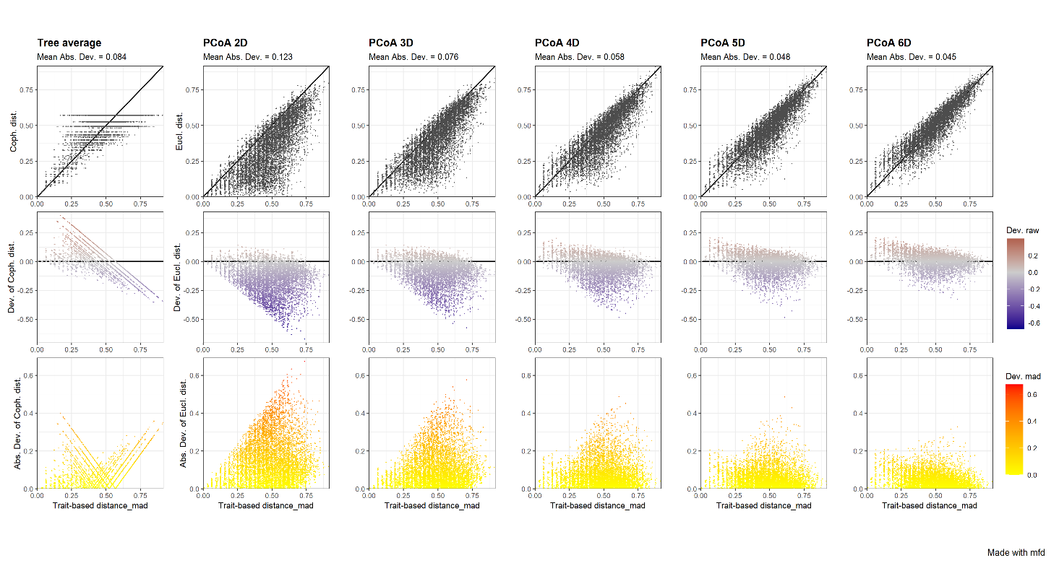

FIGURE S1.Quality of functional space computed from the initial species trait-based matrix by (i) a clustering analyses (UPGMA dendrogram “tree average”), and (ii) a Principal Coordinated Analysis (PCoA) considering 2 to 5 dimensions (D). It shows the relation among the initial species trait-based distance matrix and species distance matrix from each multivariate analysis. Deviation among those distance matrices accesses if the matrix from the multi-variate analysis is faithful to the initial trait-based matrix (deviation metric ranges between 0 and 1). The higher the value of the deviation metric, the higher the deviations among the initial trait-based and space-based distances among species, hence the lower the quality of the functional space is.

TABLE S3 Mean and standard deviation values of the complementary functional indices by oceanographic layer and period.

|  |  |  |  |  |  |  |
| --- | --- | --- | --- | --- | --- | --- |
| **Day** | | | | | | |
|  | FRic | FEve | FDiv | FDis | FOri | FSpe |
| **Epipelagic** | 0.094 ± 0.02 | 0.585 ± 0.06 | 0.759 ± 0.04 | 0.243 ± 0.03 | 0.289 ± 0.00 | 0.504 ± 0.01 |
| **Upper meso** | 0.265 ± 0.05 | 0.499 ± 0.03 | 0.619 ± 0.04 | 0.322 ± 0.03 | 0.204 ± 0.01 | 0.650 ± 0.01 |
| **Lower meso** | 0.509 ± 0.06 | 0.470 ± 0.03 | 0.777 ± 0.02 | 0.365 ± 0.03 | 0.341 ± 0.03 | 0.573 ± 0.02 |
|  |  |  |  |  |  |  |
| **Night** | | | | | | |
|  | FRic | FEve | FDiv | FDis | FOri | FSpe |
| **Epipelagic** | 0.212 ± 0.03 | 0.400 ± 0.03 | 0.732 ± 0.02 | 0.271 ± 0.02 | 0.0984 ± 0.02 | 0.552 ± 0.00 |
| **Upper meso** | 0.681 ± 0.05 | 0.527 ± 0.01 | 0.764 ± 0.00 | 0.414 ± 0.00 | 0.292 ± 0.03 | 0.549 ± 0.01 |
| **Lower meso** | 0.704 ± 0.03 | 0.544 ± 0.02 | 0.728 ± 0.04 | 0.359 ± 0.02 | 0.314 ± 0.02 | 0.548 ± 0.01 |

FIGURE S2. Draftsman plotshowing pairwise relationship among diversity indices (species richness and functional diversity indices, described in Table 1) and, environmental variables (depth, dissolved oxygen, temperature, salinity). Upper panel provides Pearson and Spearman correlation coefficients (chosen because linear relationships observed). Diagonal panel shows histograms of index values and density curves. Lower panel provides x-y plots for pairwise indices, with cloud of points fitted by a non-parametric local regression (LOcally WEighted Scatter plot Smoothing, LOWESS).

FIGURE S3. Sample-size-based accumulation curves of observed (solid line segment) and extrapolated (dotted line segments) species richness (gamma diversity) according to number of samples (here stations). Extrapolation is computed until 100 stations. Confidence intervals of 95% are drawn around curves (shaded areas).

FIGURE S4. Functional evenness index (FEve) - Minimum Spanning Tree linking species of each layer (A: epipelagic, B: upper mesopelagic, and C: lower mesopelagic). Each species has a different size (blue round) given its relative weight in the layer.

FIGURE S5. Functional divergence index (FDiv) - The gravity center of vertices of each layer are plotted as a green square. Each species has a different size given its relative weight into the layer (A: epipelagic, B: upper mesopelagic, and C: lower mesopelagic).

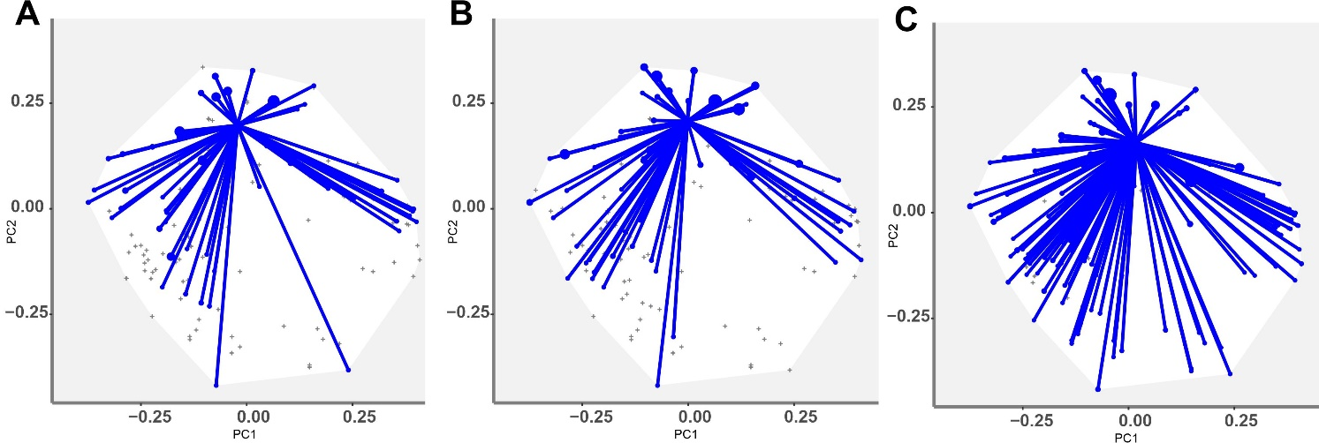

FIGURE S6. Functional dispersion index (FDis) - The traits represent distances of each species to the center of gravity of species (defined by FIde values). The center of gravity of each layer is plotted using a square and a triangle. Each species has a different size given its relative weight into the layer (A: epipelagic, B: upper mesopelagic, and C: lower mesopelagic).

FIGURE S7. Functional originality index (FOri) - The arrows represent the distances of each species to the nearest species in the global species pool, for each layer. Each specie has a different size given its relative weight into the layer (A: epipelagic, B: upper mesopelagic, and C: lower mesopelagic).

FIGURE S8 Functional specialization index (FSpe) - The traits represent distances of each species to the center of gravity of the global pool. The center of gravity is plotted with a green diamond. Each species has a different size given its relative weight into the layer (A: epipelagic, B: upper mesopelagic, and C: lower mesopelagic).

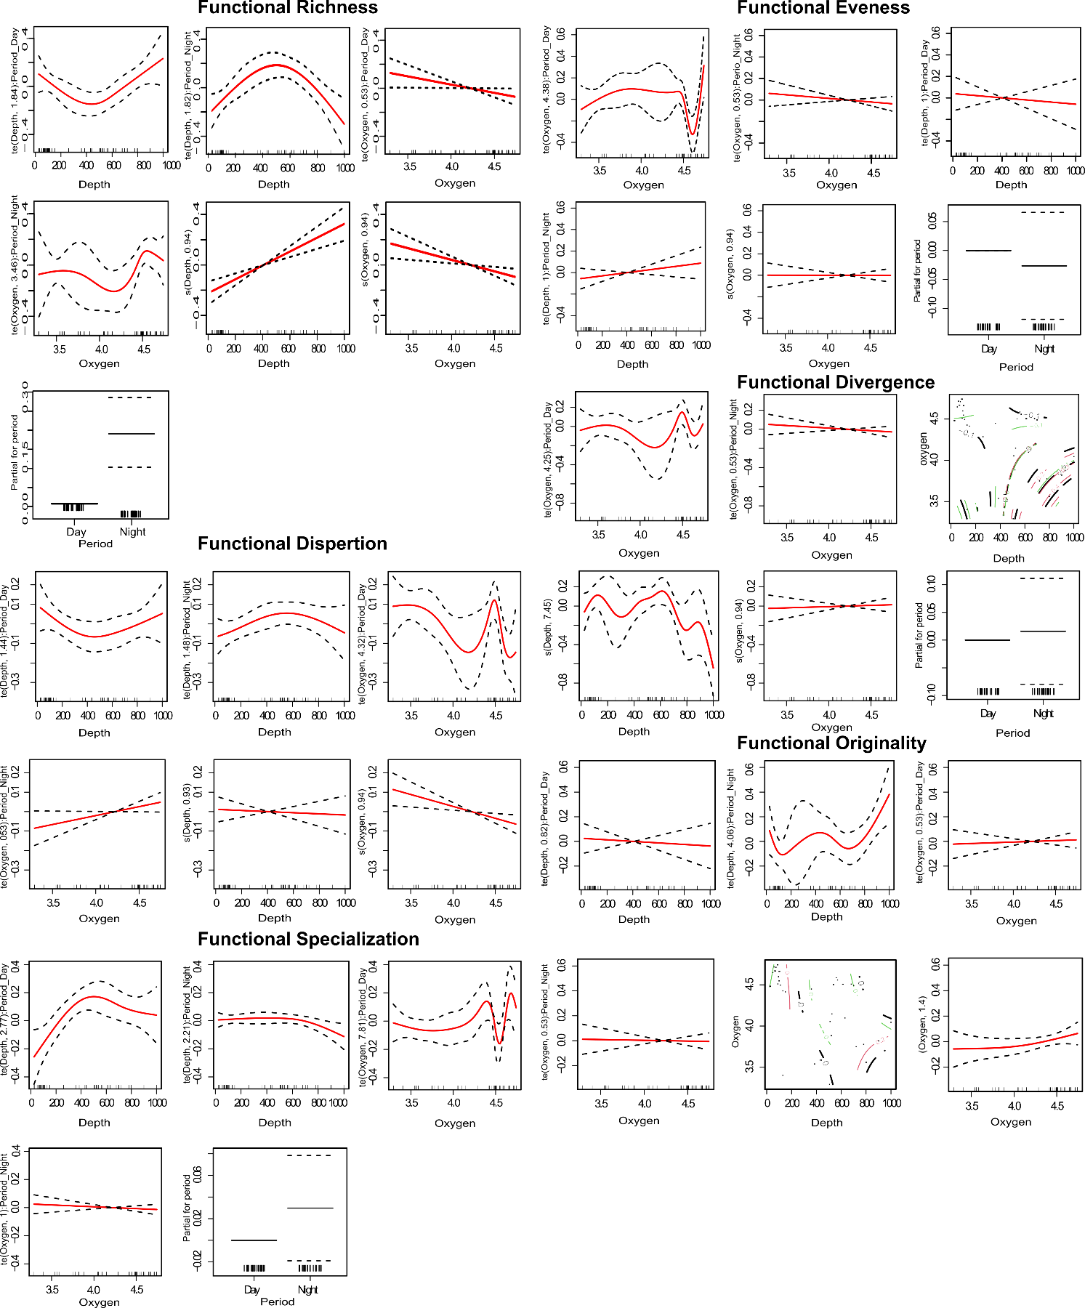

FIGURE S9. Generalised additive models (GAM), plots showing associations among functional diversity index and environmental variables (depth, oxygen), and time period (day/night) with 95% confidence intervals. FRic; FEve; FDiv; FDis; FOri; and FSpe.

FIGURE S10. Fourth-corner analysis (FCA) with 9.999 permutations investigating pairwise correlations between traits and environmental variables (depth and oxygen) for day and night periods. Cells in red indicate positive correlations and cells in grey non-significant correlations. No negative correlations were observed.