# Supplementary Material

**Environmental DNA complements scientific trawling in surveys of marine fish biodiversity.**

**Authors:** Pierre Veron1,8, Romane Rozanski1,2,3, Virginie Marques2,3, Stéphane Joost4, Marie Emilie Deschez1, Verena M. Trenkel1, Pascal Lorance1, Alice Valentini5, Andrea Polanco F.6, Loïc Pellissier2,3, David Eme1,7* and Camille Albouy1,2,3#*

# Methods S1: Calculation of the phylogenetic trees

For Actinopterygii, we used the molecular phylogenetic trees of Rabosky et al. (2018) as a backbone tree including 204 species known to occur in the Bay of Biscay. For taxa detected at the genus level, we arbitrarily selected one representative species if the genus forms a clade (i.e., a monophyletic group) in which all species diverged over the same amount of time from their common ancestor and thus have the same phylogenetic distances, as in Rozanski et al. (2022). We further re-grafted 21 species on the backbone tree that were initially absent, based on their taxonomic affinities and a list of taxonomic constraints, using the phylogenetic classification of bony fishes (Betancur *et al.,* 2017). We randomly sampled the time between two speciation events, defining the branch length for the 21 missing taxa from an exponential distribution based on a Yule model parameter of speciation estimated by maximum likelihood from the molecular tree of the 204 species (Nee *et al.,* 1994). The Yule model accounted for the incomplete and small fraction of species present in our tree in comparison to the known extent of species diversity in Actinopterygii. Here, we used a sampling fraction of 204/36149 = 0.0056, as 36,149 species were officially recognized (Fricke *et al.,* 2022). To account for the phylogenetic uncertainty introduced by re-grafting the species, we generated 100 trees including the 225 Actynopterygii species.

For the Elasmobranchii, we extracted 100 trees from the posterior distribution of the molecular phylogenies published by Stein et al. (2018) and selected the 28 species present in the area. Finally, we built a single set of 100 trees grouping both Actinopterygii and Elasmobranchii taxa, with a total of 253 species, considering an estimated divergence time between the two clades between 421 and 468 Ma (Benton *et al.,* 2015; Stein *et al.,* 2018). To account for the phylogenetic uncertainties in the downstream analyses, we computed the phylogenetic diversity indices for each of the 100 trees and reported averages (and standard deviations). To build this distribution of trees including both Actinopterygii and Elasmobranchii taxa we used the ape (Paradis and Schliep 2019) and phytools (Revell, 2012) R packages.

**Table S1:** Corrections on taxa detected by both the trawling and the eDNA metabarcoding sampling methods. To perform taxa aggregation and analyses based on fish clades, we retrieved the taxonomic classification from the online databases Barcode of Life Data System (BOLD; Ratnasingham and Herbert 2007) and World Register of Marine Species (WoRMS; Horton *et al.,* 2022).

|  |  |  |  |  |
| --- | --- | --- | --- | --- |
| **Taxa detected** | **Merged into** |  | **Taxa detected** | **Merged into** |
| *A., A. fallax* | *Alosa fallax* |  | *M., M. poutassou* | *Micromesistius poutassou* |
| *Anguilla* | *Anguilla anguilla* |  | *M., M. mola* | *Mola mola* |
| *A., A. silus, A. sphyranea* | *Argentina* |  | *M., M. molva, M. macrophtalma* | *Molva* |
| *A., A. imperialis, A. laterna* | *Arnoglossus* |  | *M., M. surmuletus* | *Mullus surmuletus* |
| *B., B. capriscus* | *Balistes capriscus* |  | *N., N. elongatus, N. kroyeri* | *Notoscopelus* |
| *B. B. belone* | *Belone* |  | *P., P. acarne, P. bogaraveo, P. erythrinus* | *Pagellus* |
| *B., B. splendens* | *Beryx splendens* |  | *P. P. lascaris* | *Pegusa* |
| *B. B. boops* | *Boops boops* |  | *P., P. fluviatilis* | *Perca* |
| *C., C. aper* | *Capros aper* |  | *P., P. blennoides* | *Phycis* |
| *C., C macrophthalma* | *Cepola* |  | *P., P. lozanoi, P. minutus,*  *P. norvegicus* | *Pomatoschistus* |
| *C., C. cuculus, C. cuculus,*  *C. obscurus* | *Chelidonichthys* |  | *R., R. brachyura, R. clavata, R. microocellata,*  *R. montagui, R. undulata* | *Raja* |
| *C., C. ramada* | *Chelon* |  | *S. S. sarda* | *Sarda sarda* |
| *C., C. caelorhincus* | *Coelorinchus* |  | *S., S. pilchardus* | *Sardina pilchardus* |
| *C., C. conger* | *Conger conger* |  | *S., S. colias* | *Scomber colias* |
| *C., C. linearis* | *Crystallogobius linearis* |  | *S., S. canicula, S. stellaris* | *Scyliorhinus* |
| *E., E. encrasicolus* | *Engraulis* |  | *S., S. koefoedi* | *Searsia koefoedi* |
| *E., E. spinax* | *Etmopterus* |  | *S. S. senegalensis, S. solea* | *Solea* |
| *E., E. gurnardus* | *Eutrigla gurnardus* |  | *S., S. cantharus* | *Spondyliosoma cantharus* |
| *G., G. argenteus* | *Gadiculus* |  | *S., S. boa* | *Stomias* |
| *G., G. melastomus* | *Galeus* |  | *T., T. thynnus* | *Thunnus* |
| *G., G. semisquamatus* | *Gymnammodytes* |  | *T., T. draco* | *Trachinus draco* |
| *H., H. dactylopterus* | *Helicolenus dactylopterus* |  | *T., T. mediterraneus,*  *T. picturatus, T. trachurus* | *Trachurus* |
| *L., L. boscii, L. whiffiagonis* | *Lepidorhombus* |  | *T., T. esmarkii, T. minutus* | *Trisopterus* |
| *L., L. circularis, L. fullonica, L. naevus* | *Leucoraja* |  | *U., U. canariensis* | *Umbrina* |
| *L., L. budegassa,*  *L. piscatorius* | *Lophius* |  | *X., X. copei* | *Xenodermichthys* |
| *M., M. muelleri* | *Maurolicus* |  | *Z., Z. faber* | *Zeus faber* |
| *M., M. merluccius* | *Merluccius* |  |  |  |

# Table S2: Species traits used to calculate functional diversity. We chose nine traits associated with several functions (habitat, feeding, reproduction and mobility) performed by fish in the ecosystem: maximum length (cm), average depth and depth range (m), trophic level, position in the water column (environment), body shape, reproduction mode (Repro; D: dioecism, A: protandry, G: protogyny, H: hermaphroditism), fertilization mode (Fert; E: external, I: internal, B: brood pouch), and parental care (Y: yes, N: no).

|  | **Max length**  **(cm)** | **Average**  **depth (m)** | **Depth**  **range (m)** | **Trophic**  **level** | **Environment** | **Body**  **shape** | **Repro** | **Fert** | **Parental**  **care** |
| --- | --- | --- | --- | --- | --- | --- | --- | --- | --- |
| *Alosa fallax* | 60 | 205 | 390 | 4 | pelagic | fusiform | D | E | N |
| *Ammodytes marinus* | 25 | 80 | 140 | 3.3 | demersal | elongated | D | E | N |
| *Anguilla anguilla* | 122 | 350 | 700 | 3.6 | demersal | eel-like | D | E | N |
| *Aphanopus carbo* | 151 | 1250 | 2100 | 4.5 | bathypelagic | eel-like | D | E | N |
| *Aphia minuta* | 7.9 | 48.5 | 97 | 3.1 | pelagic | elongated | D | E |  |
| *Argentina silus* | 70 | 790 | 1300 | 3.3 | bathypelagic | elongated | D | E | N |
| *Argentina sphyraena* | 35 | 375 | 650 | 3.5 | bathydemersal | elongated | D | E | N |
| *Argyrosomus regius* | 230 | 157.5 | 285 | 4.3 | demersal | fusiform | D | E |  |
| *Arnoglossus imperialis* | 25 | 185 | 330 | 3.8 | demersal | flat | D | E | N |
| *Arnoglossus laterna* | 25 | 105 | 190 | 3.6 | demersal | flat | D | E | N |
| *Arnoglossus rueppelii* | 15 | 491 | 812 | 4 | demersal | flat | D | E | N |
| *Arnoglossus thori* | 18 | 157.5 | 285 | 3.3 | demersal | flat | D | E | N |
| *Atherina presbyter* | 20 | 10 | 20 | 3.7 | pelagic | elongated | D | E | N |
| *Balistes capriscus* | 60 | 50 | 100 | 4.1 | reef-associated | short/deep | D | E | Y |
| *Belone belone* | 104 | 10 | 20 | 4.2 | pelagic | elongated | D | E | N |
| *Belone svetovidovi* | 41.8 | 10 | 20 | 4 | pelagic | elongated | D | E | N |
| *Beryx splendens* | 70 | 662.5 | 1275 | 4.3 | demersal | fusiform | D | E |  |
| *Boops boops* | 40 | 175 | 350 | 2.8 | demersal | fusiform | G | E | N |
| *Borostomias antarcticus* | 30 | 1465 | 2330 | 3.6 | bathydemersal | elongated | D | E |  |
| *Buglossidium luteum* | 16.4 | 227.5 | 445 | 3.3 | demersal | flat | D | E | N |
| *Callionymus lyra* | 30.5 | 217.5 | 425 | 3.3 | demersal | elongated | D | E | N |
| *Callionymus maculatus* | 16.5 | 347.5 | 605 | 3.3 | demersal | elongated | D | E | N |
| *Capros aper* | 30 | 370 | 660 | 3.1 | demersal | short/deep | D | E | N |
| *Cepola macrophthalma* | 80 | 207.5 | 385 | 3.1 | demersal | elongated | D | E | N |
| *Ceratoscopelus maderensis* | 8.1 | 765.5 | 1429 | 3.3 | bathypelagic | elongated | D | E |  |
| *Chelidonichthys cuculus* | 70 | 207.5 | 385 | 3.8 | demersal | fusiform | D | E | N |
| *Chelidonichthys lastoviza* | 40 | 80 | 140 | 3.5 | demersal | fusiform | D | E | N |
| *Chelidonichthys lucerna* | 75.1 | 169 | 298 | 4 | demersal | elongated | D | E | N |
| *Chelidonichthys obscurus* | 50.5 | 95 | 150 | 3.7 | demersal | fusiform | D | E | N |
| *Chelon auratus* | 59 | 15 | 10 | 2.8 | pelagic | fusiform | D | E | N |
| *Chelon labrosus* | 75 | 7.5 | 15 | 2.6 | demersal | elongated | D | E | N |
| *Chelon ramada* | 70 | 15 | 10 | 2.3 | pelagic | fusiform | D | E | N |
| *Chimaera monstrosa* | 150 | 720 | 1360 | 3.5 | bathydemersal | elongated | D | I | N |
| *Coelorinchus caelorhincus* | 48 | 787.5 | 1395 | 3.5 | demersal | elongated |  |  |  |
| *Coelorinchus caudani* | 36 | 1090 | 640 | 3.5 | bathydemersal | elongated |  |  |  |
| *Coelorinchus labiatus* | 50 | 1340 | 1760 | 4 | bathydemersal | elongated |  |  |  |
| *Conger conger* | 300 | 585.5 | 1171 | 4.3 | demersal | eel-like | D | E |  |
| *Crystallogobius linearis* | 4.7 | 200.5 | 399 | 3.4 | demersal | elongated | D | E | Y |
| *Cyclothone microdon* | 7.6 | 2750.5 | 5101 | 3 | bathypelagic | elongated | A |  |  |
| *Dasyatis pastinaca* | 69.5 | 102.5 | 195 | 4.1 | demersal | ray-like | D | I | Y |
| *Dasyatis tortonesei* | 80 | 150 | 100 | 4 | demersal | ray-like | D | I |  |
| *Dicentrarchus labrax* | 103 | 55 | 90 | 3.5 | demersal | fusiform | D | E | N |
| *Dicentrarchus punctatus* | 70 | 55 | 90 | 3.9 | pelagic | fusiform | D | E | N |
| *Dicologlossa cuneata* | 30 | 235 | 450 | 3.3 | demersal | short/deep | D | E | N |
| *Dipturus intermedius* | 230 | 750.5 | 1499 | 4.1 | demersal | ray-like | D | I | N |
| *Echiichthys vipera* | 15 | 75 | 150 | 4.4 | demersal | elongated | D | E | N |
| *Enchelyopus cimbrius* | 41 | 335 | 630 | 3.5 | demersal | elongated | D | E | N |
| *Engraulis encrasicolus* | 20 | 200 | 400 | 3.1 | pelagic | elongated | D | E | N |
| *Etmopterus princeps* | 94 | 1256.5 | 1913 | 4.2 | bathydemersal | elongated | D | I |  |
| *Etmopterus pusillus* | 50 | 560 | 1120 | 4.2 | bathydemersal | elongated | D | I | Y |
| *Etmopterus spinax* | 60 | 1280 | 2420 | 4.1 | bathydemersal | elongated | D | I | Y |
| *Eutrigla gurnardus* | 60 | 175 | 330 | 3.9 | demersal | elongated | D | E | N |
| *Gadiculus argenteus* | 15.3 | 550 | 900 | 3.6 | pelagic | fusiform | D | E | N |
| *Gadiculus thori* | 15 | 550 | 900 | 3.5 | pelagic | fusiform | D | E | N |
| *Gaidropsarus macrophthalmus* | 25 | 340 | 380 | 3.5 | demersal | elongated | D | E | N |
| *Galeus atlanticus* | 45 | 540 | 200 | 4 | bathydemersal | elongated | D | I |  |
| *Galeus melastomus* | 75 | 964 | 1818 | 4.2 | demersal | elongated | D | I | N |
| *Galeus murinus* | 63 | 837.5 | 725 | 4 | bathydemersal | elongated | D | I |  |
| *Gymnammodytes cicerelus* | 17 | 60 | 120 | 3.4 | demersal | eel-like | D | E | N |
| *Gymnammodytes semisquamatus* | 30 | 65 | 110 | 2.7 | demersal | elongated | D | E |  |
| *Helicolenus dactylopterus* | 50 | 575 | 1050 | 3.5 | bathydemersal | fusiform | D | I | N |
| *Hexanchus griseus* | 482 | 1250.5 | 2499 | 4.5 | bathydemersal | elongated | D | I | Y |
| *Hippocampus hippocampus* | 15 | 15 | 30 | 3.2 | demersal | other | D | B | Y |
| *Lamna nasus* | 350 | 680 | 1360 | 4.6 | pelagic | fusiform | D | I |  |
| *Lampanyctus crocodilus* | 30 | 600 | 1200 | 3.2 | bathypelagic | elongated | D | E | N |
| *Lampanyctus festivus* | 13.8 | 546 | 1012 | 3.2 | bathypelagic | elongated |  |  |  |
| *Lampanyctus intricarius* | 20 | 395 | 710 | 3.4 | bathypelagic | elongated |  |  |  |
| *Lampanyctus macdonaldi* | 16 | 762 | 1404 | 3.1 | bathypelagic | elongated |  |  |  |
| *Lampanyctus photonotus* | 8.5 | 570 | 1060 | 3.2 | bathypelagic | elongated |  |  |  |
| *Lampanyctus pusillus* | 4.3 | 445 | 810 | 3.4 | bathypelagic | elongated |  |  |  |
| *Lepidorhombus boscii* | 40 | 403.5 | 793 | 3.7 | demersal | flat | D | E | N |
| *Lepidorhombus whiffiagonis* | 60 | 400 | 600 | 4.3 | bathydemersal | flat | D | E | N |
| *Lepidotrigla dieuzeidei* | 20 | 328 | 536 | 3.7 | demersal | fusiform | D | E | N |
| *Lesueurigobius friesii* | 13 | 70 | 120 | 3.4 | demersal | fusiform | D | E |  |
| *Leucoraja circularis* | 120 | 405 | 790 | 3.5 | demersal | ray-like | D | I | N |
| *Leucoraja fullonica* | 120 | 315 | 570 | 3.5 | bathydemersal | ray-like | D | I | N |
| *Leucoraja naevus* | 81 | 456 | 888 | 4.2 | demersal | ray-like | D | I | N |
| *Lithognathus mormyrus* | 55 | 75 | 150 | 3.4 | demersal | fusiform | A | E | N |
| *Lophius budegassa* | 100 | 541.5 | 943 | 4.4 | bathydemersal | short/deep | D | E | N |
| *Lophius piscatorius* | 200 | 510 | 980 | 4.5 | bathydemersal | short/deep | D | E | N |
| *Macroramphosus scolopax* | 20 | 312.5 | 575 | 3.5 | demersal | short/deep | D | E | N |
| *Malacocephalus laevis* | 60 | 600 | 800 | 3.8 | bathydemersal | elongated |  |  |  |
| *Maurolicus amethystinopunctatus* | 5 | 765 | 670 | 3.1 | pelagic | fusiform |  |  |  |
| *Maurolicus muelleri* | 8 | 897.5 | 1253 | 3 | bathypelagic | elongated | D |  |  |
| *Melanostigma atlanticum* | 15 | 1126.5 | 1453 | 3 | bathypelagic | elongated | D | E | N |
| *Merlangius merlangus* | 91.5 | 105 | 190 | 4.4 | demersal | fusiform | D | E | N |
| *Merluccius merluccius* | 140 | 552.5 | 1045 | 4.4 | demersal | elongated | D | E | N |
| *Merluccius senegalensis* | 81 | 407.5 | 785 | 4.5 | demersal | elongated | D | E | N |
| *Microchirus variegatus* | 35 | 210 | 380 | 3.3 | demersal | flat | D | E | N |
| *Micromesistius poutassou* | 55.5 | 1575 | 2850 | 4.1 | bathypelagic | elongated | D | E | N |
| *Microstomus kitt* | 65 | 105 | 190 | 3.2 | demersal | short/deep | D | E | N |
| *Mola mola* | 333 | 255 | 450 | 3.3 | pelagic | short/deep | D | E | N |
| *Molva dypterygia* | 155 | 575 | 850 | 4.5 | demersal | elongated | D | E | N |
| *Molva macrophthalma* | 108 | 515 | 970 | 4.5 | demersal | elongated | D | E | N |
| *Molva molva* | 200 | 550 | 900 | 4.4 | demersal | elongated | D | E | N |
| *Mora moro* | 80 | 1475 | 2050 | 3.8 | bathypelagic | fusiform | D | E | N |
| *Mullus surmuletus* | 40 | 207 | 404 | 3.5 | demersal | fusiform | D | E |  |
| *Mustelus asterias* | 140 | 175 | 350 | 3.6 | demersal | elongated | D | I |  |
| *Myctophum punctatum* | 11 | 500 | 1000 | 3.4 | bathypelagic | fusiform | D | E |  |
| *Myliobatis aquila* | 183 | 150.5 | 299 | 3.6 | demersal | ray-like | D | I |  |
| *Nezumia aequalis* | 36 | 1260 | 2120 | 3.3 | demersal | elongated | D | E | N |
| *Notoscopelus bolini* | 10.2 | 650 | 1300 | 3.1 | pelagic | fusiform |  |  |  |
| *Notoscopelus caudispinosus* | 14 | 180 | 360 | 3.2 | bathypelagic | fusiform |  |  |  |
| *Notoscopelus kroeyeri* | 14.3 | 500 | 1000 | 3.2 | pelagic | fusiform |  |  |  |
| Pagellus acarne | 36 | 270 | 460 | 3.8 | demersal | fusiform | A | E | N |
| Pagellus bogaraveo | 70 | 425 | 550 | 4.2 | demersal | fusiform | A | E | N |
| Pagellus erythrinus | 60 | 160 | 280 | 3.5 | demersal | fusiform | G | E | N |
| Parablennius pilicornis | 12.7 | 12.5 | 25 | 3.2 | demersal | fusiform | D | E |  |
| Pegusa lascaris | 40 | 177.5 | 345 | 3.3 | demersal | short/deep | D | E | N |
| Phycis blennoides | 110 | 605 | 1190 | 3.7 | demersal | fusiform | D | E | N |
| Polymetme thaeocoryla | 21.6 | 806 | 1187 | 3.6 | demersal | fusiform |  |  |  |
| Pomatoschistus lozanoi | 8 | 75 | 10 | 3.1 | demersal | fusiform | D | E |  |
| Pomatoschistus marmoratus | 8 | 45 | 50 | 3.4 | demersal | fusiform | D | E |  |
| Pomatoschistus microps | 9 | 6 | 12 | 3.3 | demersal | elongated | D | E |  |
| Pomatoschistus minutus | 11 | 102 | 196 | 3.2 | demersal | elongated | D | E | Y |
| Pomatoschistus norvegicus | 8 | 171.5 | 307 | 3.3 | demersal | fusiform | D | E |  |
| Pomatoschistus pictus | 6 | 28 | 54 | 3.1 | demersal | fusiform | D | E |  |
| Prionace glauca | 400 | 500.5 | 999 | 4.4 | pelagic | fusiform | D | I |  |
| Raja asterias | 75 | 172.5 | 341 | 3.8 | demersal | ray-like | D | I | N |
| Raja brachyura | 120 | 195 | 370 | 3.8 | demersal | ray-like | D | I | N |
| Raja clavata | 105 | 512.5 | 1015 | 3.8 | demersal | ray-like | D | I | N |
| Raja microocellata | 87 | 60 | 80 | 3.9 | demersal | ray-like | D | I | N |
| Raja miraletus | 63 | 239.5 | 445 | 3.7 | demersal | other | D | I | N |
| Raja montagui | 83.5 | 269 | 522 | 3.9 | demersal | ray-like | D | I | N |
| Raja undulata | 100 | 125 | 150 | 3.5 | demersal | ray-like | D | I | N |
| Rhynchoconger flavus | 150 | 104.5 | 157 | 4.2 | demersal | eel-like | D | E |  |
| Sarda sarda | 91.4 | 140 | 120 | 4.5 | pelagic | fusiform | D | E | N |
| Sardina pilchardus | 27.5 | 55 | 90 | 3.1 | pelagic | fusiform | D | E | N |
| Sarpa salpa | 51 | 37.5 | 65 | 2 | demersal | fusiform | A | E | N |
| Scomber colias | 55 | 500 | 1000 | 3.9 | pelagic | fusiform | D | E | N |
| Scomber scombrus | 60 | 500 | 1000 | 3.6 | pelagic | fusiform | D | E | N |
| Scomberesox saurus | 50 | 15 | 30 | 3.9 | pelagic | elongated | D | E |  |
| Scophthalmus maximus | 100 | 45 | 50 | 4.4 | demersal | short/deep | D | E |  |
| Scophthalmus rhombus | 75 | 27.5 | 45 | 4.4 | demersal | short/deep | D | E | N |
| Scorpaena scrofa | 50 | 260 | 480 | 4.3 | demersal | fusiform | D | E | N |
| Scyliorhinus canicula | 100 | 395 | 770 | 3.8 | demersal | elongated | D | I | N |
| Scyliorhinus stellaris | 170 | 200.5 | 399 | 4 | reef-associated | elongated | D | I | N |
| Searsia koefoedi | 15 | 975 | 1050 | 3.4 | bathypelagic | elongated |  |  |  |
| Serranus cabrilla | 40 | 252.5 | 495 | 3.4 | demersal | fusiform | H | E |  |
| Solea senegalensis | 60 | 38.5 | 53 | 3.3 | demersal | short/deep | D | E | N |
| Solea solea | 70 | 75 | 150 | 3.2 | demersal | flat | D | E | N |
| Spondyliosoma cantharus | 60 | 152.5 | 295 | 3.3 | demersal | fusiform | G | E |  |
| Sprattus sprattus | 16 | 80 | 140 | 3 | pelagic | fusiform | D | E | N |
| Squalus acanthias | 160 | 730 | 1460 | 4.4 | demersal | elongated | D | I | Y |
| Syngnathus acus | 50 | 55 | 110 | 3.3 | demersal | eel-like | D | B | Y |
| Thunnus alalunga | 140 | 300 | 600 | 4.3 | pelagic | fusiform | D | E | N |
| Thunnus albacares | 239 | 125.5 | 249 | 4.4 | pelagic | fusiform | D | E | N |
| Thunnus obesus | 250 | 750 | 1500 | 4.5 | pelagic | fusiform | D | E | N |
| Thunnus thynnus | 458 | 492.5 | 985 | 4.5 | pelagic | fusiform | D | E | N |
| Torpedo marmorata | 100 | 186 | 368 | 4.5 | reef-associated | ray-like | D | I |  |
| Trachinus draco | 53 | 75.5 | 149 | 4.2 | demersal | elongated | D | E | N |
| Trachurus mediterraneus | 60 | 250 | 500 | 3.8 | pelagic | fusiform | D | E | N |
| Trachurus picturatus | 60 | 337.5 | 65 | 3.3 | demersal | fusiform | D | E | N |
| Trachurus trachurus | 70 | 525 | 1050 | 3.7 | pelagic | fusiform | D | E | N |
| Trachyscorpia cristulata | 50 | 615 | 970 | 4.2 | demersal | fusiform | D | E | N |
| Trigla lyra | 60 | 425 | 550 | 3.7 | bathydemersal | fusiform | D | E | N |
| Trisopterus esmarkii | 35 | 175 | 250 | 3.2 | demersal | fusiform | D | E | N |
| Trisopterus luscus | 46 | 65 | 70 | 3.7 | demersal | fusiform | D | E | N |
| Trisopterus minutus | 40 | 220.5 | 439 | 3.7 | demersal | fusiform | D | E | N |
| Umbrina cirrosa | 73 | 50 | 100 | 3.4 | demersal | fusiform | D | E | N |
| Umbrina ronchus | 100 | 110 | 180 | 3.4 | demersal | fusiform | D | E | N |
| Xenodermichthys copei | 31 | 1375 | 2550 | 3.2 | bathypelagic | elongated | D | E |  |
| Zeus faber | 90 | 202.5 | 395 | 4.5 | demersal | short/deep | D | E | N |

**Table S3:** Summary of the statistical tests comparing the average SES values of the different alpha diversity metric obtained with eDNA metabarcoding and trawling for the 15 sites in the Bay of Biscay. We reported the values of the non-parametric Wilcoxon’s test and the parametric Student’s test that were considered using paired data. Bold p.values highlight significant differences in average for the corresponding biodiversity indices.

|  |  |  |  |  |  |  |  |
| --- | --- | --- | --- | --- | --- | --- | --- |
| **Test** | **Index** | **Statistic** | **p.value** | **Av.ses.eDNA** | **Sd.ses.eDNA** | **Av.ses.Trawl** | **Sd.ses.Trawl** |
| Wilcoxon | SR | 120 | **7e-04** | 42.2 | 6.5049 | 18.4667 | 3.9255 |
| Wilcoxon | PD.ses | 113 | **0.0012** | 0.9586 | 0.8045 | -0.3311 | 1.0915 |
| Wilcoxon | VPD.ses | 67 | 0.7197 | -0.0733 | 0.8221 | -0.0844 | 1.1666 |
| Wilcoxon | MPD.ses | 83 | 0.2078 | 0.1039 | 0.8018 | -0.1958 | 0.9373 |
| Wilcoxon | FD.ses | 89 | 0.107 | -1.6985 | 0.8805 | -2.3093 | 0.9097 |
| Wilcoxon | FEve.ses | 102 | **0.0151** | 0.3816 | 0.9979 | -0.8636 | 1.655 |
| Wilcoxon | FDiv.ses | 87 | 0.1354 | 0.4207 | 0.9307 | -0.1561 | 0.9461 |
| T.test | SR | 12.8628 | **0** | 42.2 | 6.5049 | 18.4667 | 3.9255 |
| T.test | PD.ses | 4.1793 | **9e-04** | 0.9586 | 0.8045 | -0.3311 | 1.0915 |
| T.test | VPD.ses | 0.0261 | 0.9796 | -0.0733 | 0.8221 | -0.0844 | 1.1666 |
| T.test | MPD.ses | 0.8921 | 0.3874 | 0.1039 | 0.8018 | -0.1958 | 0.9373 |
| T.test | FD.ses | 1.718 | 0.1078 | -1.6985 | 0.8805 | -2.3093 | 0.9097 |
| T.test | FEve.ses | 2.8602 | **0.0126** | 0.3816 | 0.9979 | -0.8636 | 1.655 |
| T.test | FDiv.ses | 1.6548 | 0.1202 | 0.4207 | 0.9307 | -0.1561 | 0.9461 |

**Table S4:** Results of the model selection (based on the Akaike information criterion, AIC) performed to select the optimized interspecific allometric scaled abundance coefficient (*b*) maximizing the fit of the generalized linear model (GLM) between the number of eDNA reads and the allometric scaled abundance per species for each sample replicate (filter). GLM was fitted using a negative binomial distribution error with a log link function. A second series of models was run to maximize the fit of a linear model (LM) between the relative number of eDNA reads per taxa per filter and the allometric scaled abundance per species for each sample replicate (filter). Response.var: indicates the response variable, “Nb. reads” indicates that the response variable is the number of eDNA reads, “Relat nb. reads” indicates that the response variables was the relative number of reads that were modelled with a LM. best.b: the best inter-specific allometric scaling coefficient retained when optimizing the fit of the model. nb.taxa: the number of taxa used to fit the relationship. Res

|  |  |  |  |  |  |  |  |  |  |
| --- | --- | --- | --- | --- | --- | --- | --- | --- | --- |
| **Response.var** | **Station** | **Filter** | **AIC** | **R2** | **Intercept** | **Slope** | **P.value** | **nb.taxa** | **best.b** |
| Nb. reads | 1 | 1 | 198.958 | 0.043 | 8.556 | 0.012 | 0.554 | 10 | 1 |
| Nb. reads | 1 | 2 | 149.595 | 0.172 | 8.352 | -0.014 | 0.105 | 8 | 0.6 |
| Nb. reads | 2 | 1 | 345.652 | 0.132 | 10.953 | -0.014 | 0.027 | 15 | 1 |
| Nb. reads | 2 | 2 | 315.085 | 0.097 | 10.549 | -0.01 | 0.114 | 14 | 1 |
| Nb. reads | 3 | 1 | 278.336 | 0.563 | 9.171 | 0.001 | 0.002 | 13 | 0 |
| Nb. reads | 3 | 2 | 283.53 | 0.228 | 9.546 | 0.001 | 0.131 | 13 | 0 |
| Nb. reads | 4 | 1 | 273.383 | 0.366 | 11.116 | -0.147 | 0 | 12 | 0.88 |
| Nb. reads | 4 | 2 | 296.78 | 0.265 | 10.876 | -0.119 | 0.01 | 13 | 1 |
| Nb. reads | 5 | 1 | 226.299 | 0.191 | 9.487 | -0.027 | 0.013 | 11 | 0.47 |
| Nb. reads | 5 | 2 | 216.723 | 0.124 | 10.095 | -0.014 | 0.08 | 10 | 0 |
| Nb. reads | 6 | 1 | 295.604 | 0.031 | 9.699 | -0.01 | 0.328 | 14 | 1 |
| Nb. reads | 6 | 2 | 348.91 | 0.078 | 9.004 | 0.001 | 0.278 | 17 | 0 |
| Nb. reads | 7 | 1 | 339.614 | 0.009 | 11.298 | -0.021 | 0.666 | 14 | 0.96 |
| Nb. reads | 7 | 2 | 311.82 | 0.032 | 9.818 | 0.002 | 0.469 | 14 | 0 |
| Nb. reads | 8 | 1 | 158.213 | 0.061 | 9.728 | 0.038 | 0.53 | 7 | 1 |
| Nb. reads | 8 | 2 | 170.818 | 0.006 | 9.261 | 0.001 | 0.834 | 8 | 0 |
| Nb. reads | 9 | 1 | 372.126 | 0.347 | 8.743 | 0.09 | 0.001 | 18 | 1 |
| Nb. reads | 9 | 2 | 330.302 | 0.495 | 9.217 | 0.069 | 0.001 | 15 | 1 |
| Nb. reads | 10 | 1 | 334.615 | 0.002 | 9.415 | -0.007 | 0.845 | 16 | 1 |
| Nb. reads | 10 | 2 | 397.664 | 0.029 | 9.966 | -0.021 | 0.412 | 18 | 1 |
| Nb. reads | 11 | 1 | 228.914 | 0.019 | 10.719 | -0.034 | 0.596 | 10 | 1 |
| Nb. reads | 11 | 2 | 266.825 | 0.016 | 10.658 | -0.04 | 0.562 | 12 | 1 |
| Nb. reads | 12 | 1 | 178.061 | 0.07 | 10.289 | -0.091 | 0.352 | 8 | 1 |
| Nb. reads | 12 | 2 | 175.759 | 0.015 | 9.795 | -0.033 | 0.706 | 8 | 1 |
| Nb. reads | 13 | 1 | 301.95 | 0.089 | 10.463 | 0 | 0.304 | 13 | 0 |
| Nb. reads | 13 | 2 | 230.931 | 0.158 | 10.236 | 0 | 0.215 | 10 | 0 |
| Nb. reads | 14 | 1 | 207.24 | 0.249 | 9.932 | -0.051 | 0.002 | 10 | 0.71 |
| Nb. reads | 14 | 2 | 247.334 | 0.046 | 10.372 | -0.031 | 0.378 | 11 | 1 |
| Nb. reads | 15 | 1 | 167.499 | 0.317 | 8.877 | 0.105 | 0.083 | 8 | 1 |
| Nb. reads | 15 | 2 | 164.88 | 0.176 | 8.6 | 0.108 | 0.194 | 8 | 1 |
| Relat nb. reads | 1 | 1 | -45.692 | 0.081 | 0.015 | 0 | 0.426 | 10 | 111 |
| Relat nb. reads | 1 | 2 | -51.274 | 0.075 | 0.006 | 0 | 0.51 | 8 | 56 |
| Relat nb. reads | 2 | 1 | -33.748 | 0.055 | 0.059 | 0 | 0.383 | 16 | 111 |
| Relat nb. reads | 2 | 2 | -19.163 | 0.033 | 0.067 | 0 | 0.516 | 15 | 111 |
| Relat nb. reads | 3 | 1 | -59.238 | 0.903 | 0.013 | 0 | 0 | 14 | 11 |
| Relat nb. reads | 3 | 2 | -51.028 | 0.717 | 0.016 | 0 | 0 | 14 | 11 |
| Relat nb. reads | 4 | 1 | -53.874 | 0.856 | 0.026 | 0 | 0 | 13 | 11 |
| Relat nb. reads | 4 | 2 | -32.981 | 0.11 | 0.046 | 0 | 0.247 | 14 | 11 |
| Relat nb. reads | 5 | 1 | -26.746 | 0.069 | 0.049 | 0 | 0.434 | 11 | 11 |
| Relat nb. reads | 5 | 2 | -22.521 | 0.065 | 0.052 | 0 | 0.477 | 10 | 11 |
| Relat nb. reads | 6 | 1 | -43.075 | 0.547 | 0.028 | 0 | 0.002 | 15 | 11 |
| Relat nb. reads | 6 | 2 | -67.856 | 0.889 | 0.011 | 0 | 0 | 18 | 11 |
| Relat nb. reads | 7 | 1 | -25.615 | 0.005 | 0.065 | -0.001 | 0.798 | 15 | 111 |
| Relat nb. reads | 7 | 2 | -42.267 | 0.396 | 0.028 | 0 | 0.012 | 15 | 11 |
| Relat nb. reads | 8 | 1 | -33.45 | 0.954 | 0.027 | 0 | 0 | 8 | 111 |
| Relat nb. reads | 8 | 2 | -47.989 | 0.972 | 0.014 | 0 | 0 | 9 | 11 |
| Relat nb. reads | 9 | 1 | -59.026 | 0.627 | 0.012 | 0.003 | 0 | 19 | 111 |
| Relat nb. reads | 9 | 2 | -53.882 | 0.737 | 0.006 | 0.003 | 0 | 16 | 111 |
| Relat nb. reads | 10 | 1 | -57.984 | 0.204 | 0.017 | 0 | 0.069 | 17 | 24 |
| Relat nb. reads | 10 | 2 | -63.287 | 0.104 | 0.025 | 0 | 0.178 | 19 | 19 |
| Relat nb. reads | 11 | 1 | -16.489 | 0.151 | 0.043 | 0 | 0.237 | 11 | 11 |
| Relat nb. reads | 11 | 2 | -21.005 | 0.02 | 0.044 | 0 | 0.641 | 13 | 11 |
| Relat nb. reads | 12 | 1 | -16.488 | 0.03 | 0.043 | 0 | 0.656 | 9 | 111 |
| Relat nb. reads | 12 | 2 | -26.187 | 0.331 | 0.031 | 0.001 | 0.105 | 9 | 97 |
| Relat nb. reads | 13 | 1 | -35.415 | 0.278 | 0.04 | 0 | 0.053 | 14 | 11 |
| Relat nb. reads | 13 | 2 | -31.125 | 0.623 | 0.04 | 0 | 0.004 | 11 | 11 |
| Relat nb. reads | 14 | 1 | -12.576 | 0.042 | 0.069 | -0.002 | 0.546 | 11 | 111 |
| Relat nb. reads | 14 | 2 | -19.351 | 0.013 | 0.06 | -0.001 | 0.725 | 12 | 111 |
| Relat nb. reads | 15 | 1 | -22.203 | 0.015 | 0.031 | 0.002 | 0.753 | 9 | 111 |
| Relat nb. reads | 15 | 2 | -17.59 | 0.01 | 0.045 | 0 | 0.799 | 9 | 11 |

**Table S5:** Summary of the statistical tests comparing the average SES values of the different alpha diversity metric obtained with eDNA metabarcoding and trawl for the 15 sites in the Bay of Biscay, after removing 10 abundant (and ubiquitous) species showing multiple successive occurrences. We reported the values of the non-parametric Wilcoxon’s test and the parametric Student’s test that were considered using paired data. Bold p.values highlight significant differences in average for the corresponding biodiversity indices.

|  |  |  |  |  |  |  |  |
| --- | --- | --- | --- | --- | --- | --- | --- |
| **Test** | **Index** | **Statistic** | **p.value** | **Mean.ses.eDNA** | **Sd.ses.eDNA** | **Mean.ses.Trawl** | **Sd.ses.Trawl** |
| Wilcoxon | SR | 120 | **7e-04** | 30.4 | 6.3336 | 12.6667 | 3.5389 |
| Wilcoxon | PD.ses | 94 | 0.0554 | 0.5671 | 2.4176 | -1.152 | 2.228 |
| Wilcoxon | VPD.ses | 76 | 0.3894 | 0.8084 | 0.9837 | 0.5283 | 1.6217 |
| Wilcoxon | MPD.ses | 86 | 0.1514 | 0.9215 | 1.9693 | -0.0218 | 1.5719 |
| Wilcoxon | FD.ses | 78 | 0.3303 | -2.6589 | 1.708 | -4.1184 | 3.7229 |
| Wilcoxon | FEve.ses | 70 | 0.5995 | -1.678 | 3.8221 | -1.9781 | 2.1225 |
| Wilcoxon | FDiv.ses | 101 | **0.0181** | 0.2993 | 1.1759 | -1.0055 | 1.2715 |
| T.test | SR | 10.011 | **0** | 30.4 | 6.3336 | 12.6667 | 3.5389 |
| T.test | PD.ses | 2.2856 | **0.0384** | 0.5671 | 2.4176 | -1.152 | 2.228 |
| T.test | VPD.ses | 0.5144 | 0.615 | 0.8084 | 0.9837 | 0.5283 | 1.6217 |
| T.test | MPD.ses | 1.625 | 0.1265 | 0.9215 | 1.9693 | -0.0218 | 1.5719 |
| T.test | FD.ses | 1.2968 | 0.2157 | -2.6589 | 1.708 | -4.1184 | 3.7229 |
| T.test | FEve.ses | 0.3337 | 0.7435 | -1.678 | 3.8221 | -1.9781 | 2.1225 |
| T.test | FDiv.ses | 2.848 | **0.0129** | 0.2993 | 1.1759 | -1.0055 | 1.2715 |

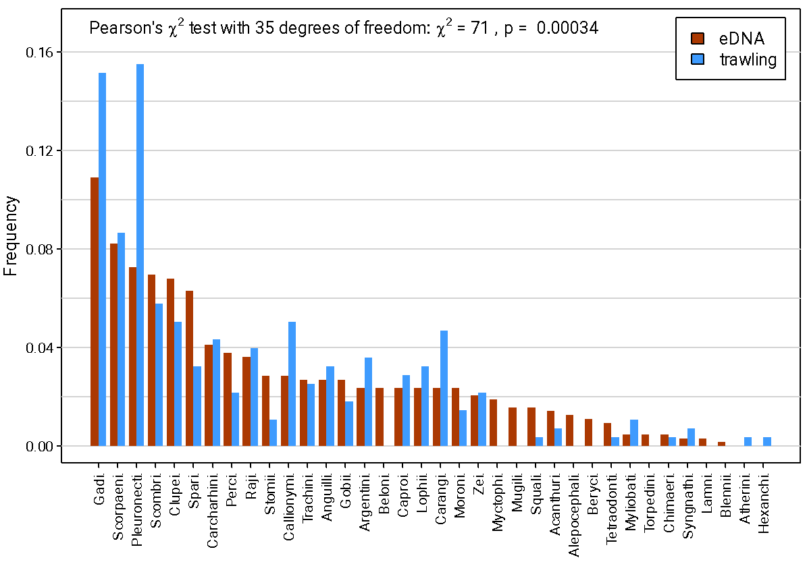

**Figure S1:** Detection frequencies of the fishes by order and by sampling method. One occurrence corresponds to one taxon of each order detected in one site.

**Figure S2:** Detection frequencies of the fishes with the eDNA metabarcoding and trawling sampling methods, for different (a) trophic levels, (b) environments (PEL: pelagic; Bathypel: bathypelagic; Dem: demersal; Bathydem: bathydemersal) and (c) body shapes (Fusi: fusiforme; Elong: elongated). Error bars indicate the standard deviation, as uncertainty in the traits could exist for taxa detected at the genus level.

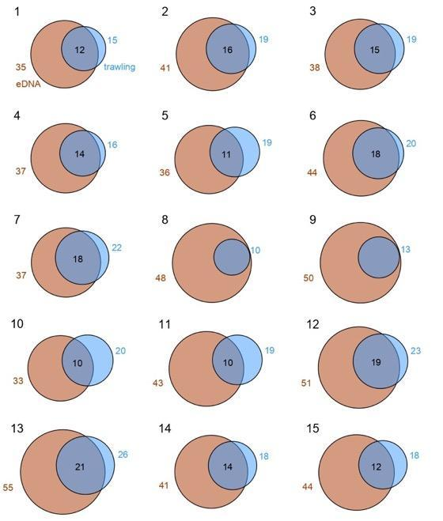

**Figure S3:** Venn diagrams of the number of detected taxa at each site, between eDNA metabarcoding (after pooling the species list of the two filter replicates per site) and trawling sampling methods. The red circles represent the number of taxa detected by eDNA, whereas the blue circles represent the number of taxa detected by trawling. The intersection between circles shows the taxa detected by both sampling methods.

**Figure S4:** (a)Taxonomic composition, (b) phylogenetic tree and (c) functional space of four selected sampling sites, presented to illustrate the identified diversity patterns. We chose to represent site 2 (offshore, high phylogenetic richness), site 5 (offshore, high functional richness detected with trawling, some rare species detected), site 8 (closer to the coast, high taxonomic diversity, with all the taxa detected by trawling nested in the list of taxa detected by eDNA metabarcoding) and site 15 (coastal, low functional diversity).

**Additional text associated with Figure S4**

The focus on site-specific phylogenetic trees and functional space made it possible to categorize the sites. Sites 2 and 15 displayed the same patterns for the three diversity components. They were characterized by relatively high species richness for both sampling methods. Considering phylogenetic diversity, the detected taxa were dispersed on the phylogenetic tree for both methods. In terms of functional diversity, the eDNA metabarcoding functional space included almost the whole functional space of trawling, which was also the case for most other sites (except sites 5 and 10; see Supp. Mat. Fig. S4). These sites were characterized by a high richness for all diversity components with eDNA metabarcoding (Table 1). Moreover, all taxa detected by trawling were also detected by eDNA metabarcoding for both sites 8 and 9 (Supp. Mat. Fig. S4). This was probably due to the low species richness (SR) in trawling, leading to a very restricted functional space (3.23) and a low phylogenetic richness (PD = 1710 Ma). Finally, site 5 was dominated by trawling in terms of functional space (the bluntnose sixgillshark *Hexanchus griseus,* only detected in this site by trawling, enlarged the space), but the relatively low SES.PD indicated a high level of phylogenetic clustering of species detected by trawling. Even with a larger functional space, we measured a slightly lower FD with trawling (5.44) than with eDNA (5.61).

 **Figure S5:** Community matrix of the detected taxa in the individual sampling sites. Taxa are indicated with their class and order. Colours indicate if taxa were not detected (white) or were detected by eDNA metabarcoding (red), trawling (blue), or both (black).

**Figure S6:** Functional space (first two axes of a principal coordinates analysis, PCoA) calculated for each sampling site and each sampling method (eDNA metabarcoding and trawling). The associated functional measures of richness (FD), regularity (FEve) and divergence (FDiv) are shown.

**Figure S7:** Principal coordinates analysis (PCoA) of the species composition detected with eDNA metabarcoding (circles) and trawl hauls (squares). The ellipses of dispersion of the points are based on a water depth criterion. The colours of the symbols correspond to their positions in the PCoA space, where points with similar colours have a similar species composition. (a) Relationship between axes 1 and 3; (b) relationship between axes 2 and 3.

**Figure S8:** Relationship between the average relative number of eDNA reads between the two filter replicates per site and the log10 number of individuals sampled by trawling, inferred from a linear model (LM, intercept 0.0114, slope 0.0101, *p* = 2.10-8, R² = 0.14) and a generalized least square model (GLS) accounting for the heterogeneity in the model residuals using an exponential variance structure (intercept 0.021, slope 0.006, *p* = 0.002, R2 Cox Snell = 0.23, exponential residuals variance parameter = 0.11). A lower Akaike information criterion (AIC) value of the GLS model (GLS AIC = -603.5, LM AIC = -571.3) indicates that accounting for the increase in variance of the residuals significantly improves the model fit compared with the LM model. Each point corresponds to a single site and fish. Error bars represent the difference between the two filter replicates at a given site. Solid lines correspond to the fit of the LM (blue) and the GLS model (orange), while dashed lines correspond to the standard error of the fitted models.

**Figure S9:** Relative abundance of eDNA reads per taxa per filter replicate compared with the log10 number of individuals per taxa sampled by trawling for the 15 sites. Blue and orange points correspond to the two eDNA filter replicates processed at each site. Each point corresponds to a fish detected by both methods. Solid lines indicate a significant fit of the linear model (LM), while dashed lines indicate a non-significant trend only of the LM. Asterisks indicate the degree of significance of the slope of the LM, with *** (*p* < 0.001), ** (0.001 < 𝑝 < 0.01), * (0.01 < 𝑝 < 0.05), and ns (𝑝 > 0.05).

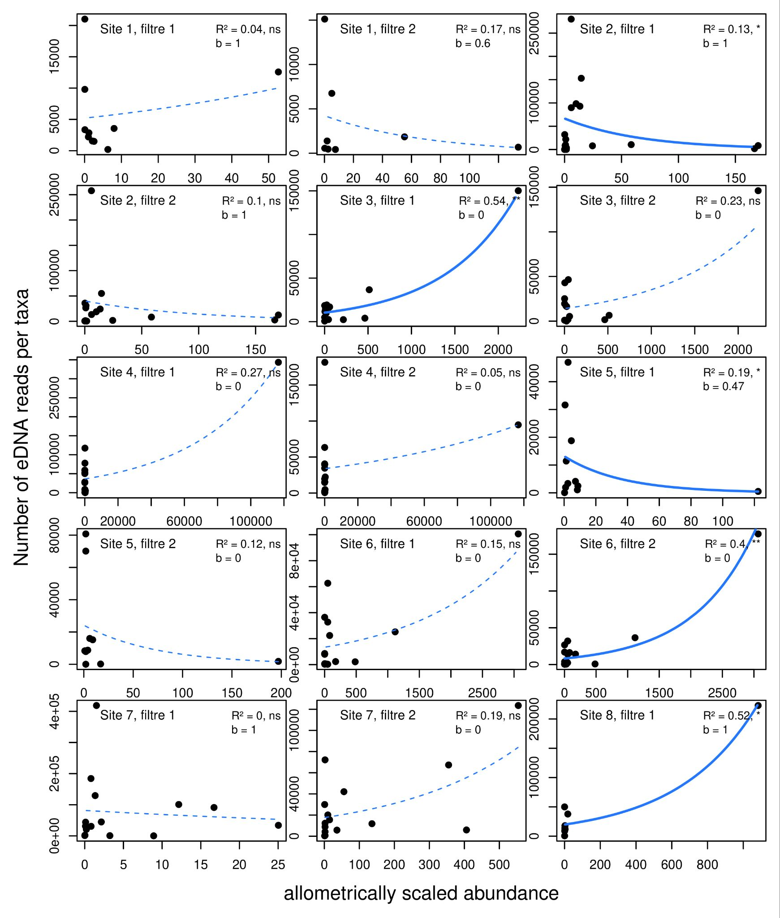

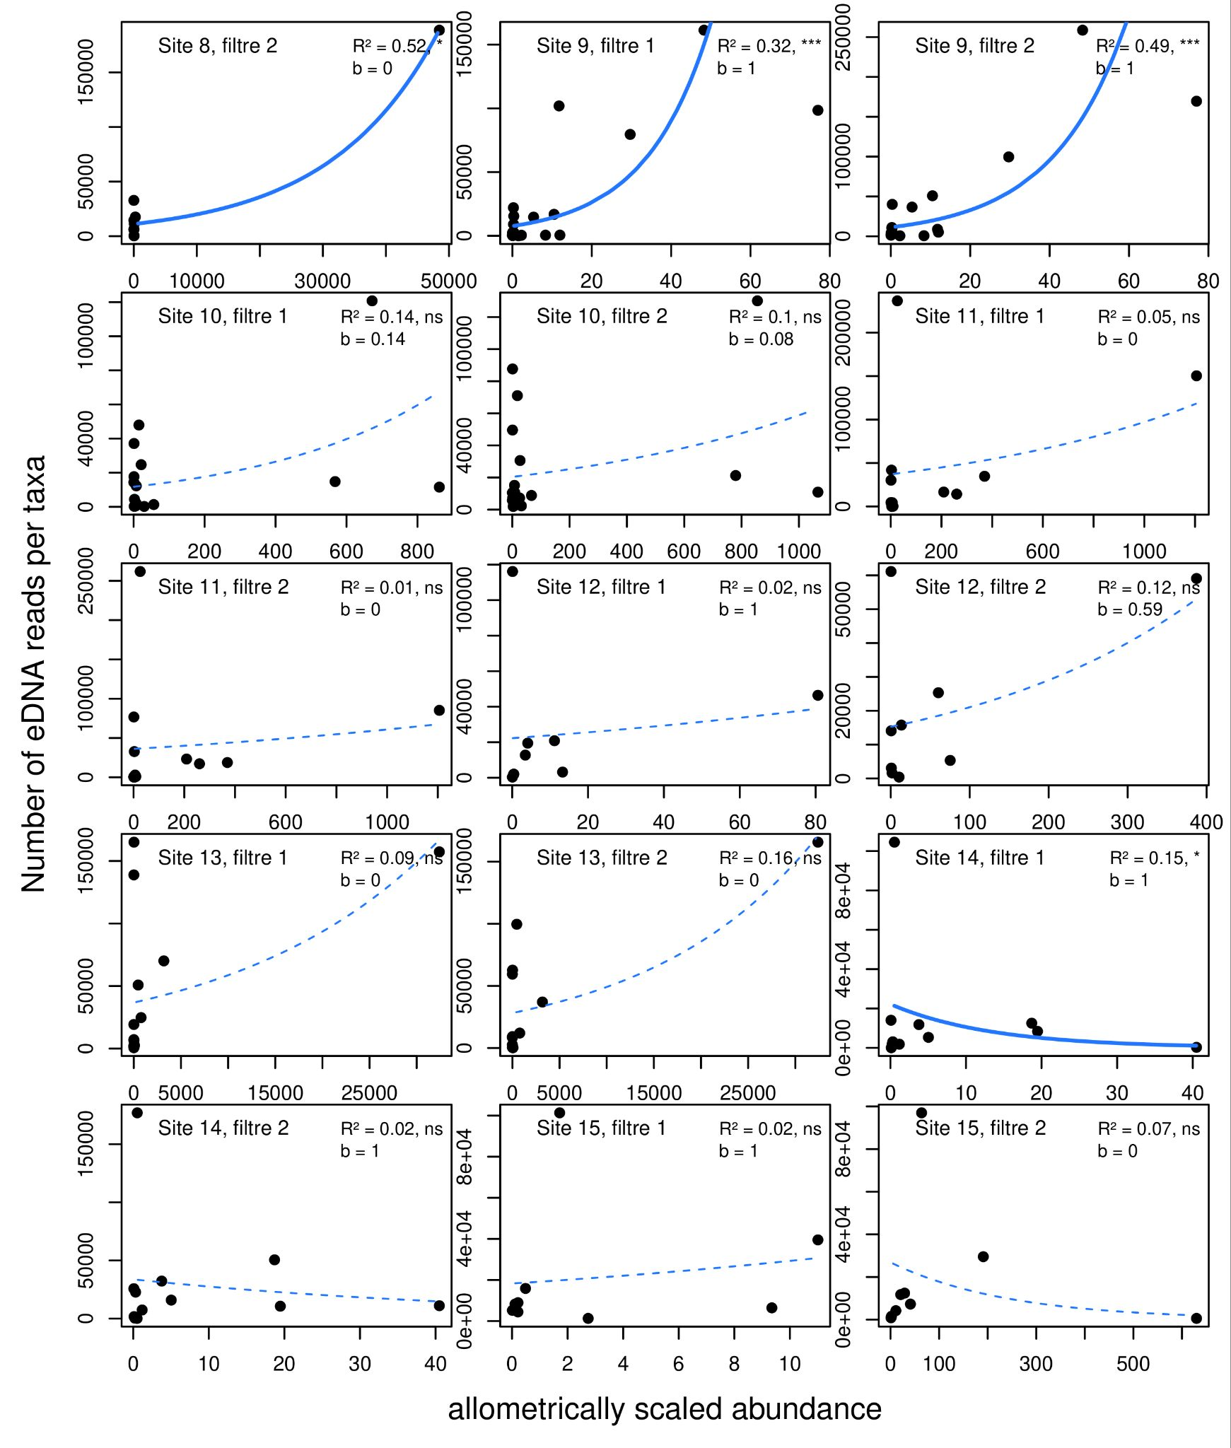

**Figure S10:** Relationships between the number of eDNA reads per species per filter replicate and the best allometric scaled abundance coefficient (*b*) estimated from the species abundance and mass from the closest trawl. The relationships come from a generalized linear model (GLM) with a negative binomial distribution error and a log link function. Continuous lines indicate a significant fit of the GLM model, while dashed lines indicate a non-significant trend only of the GLM. Asterisks indicate the degree of significance of the slope of the GLM, with *** (*p* < 0.001), ** (0.001 < 𝑝 < 0.01), * (0.01 < 𝑝 < 0.05), and ns (𝑝 > 0.05).

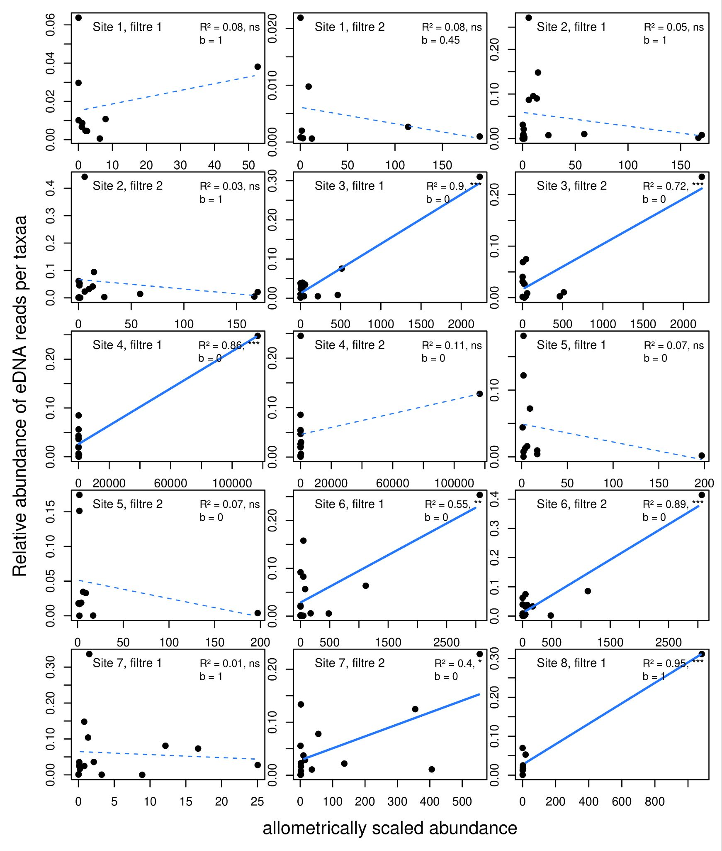

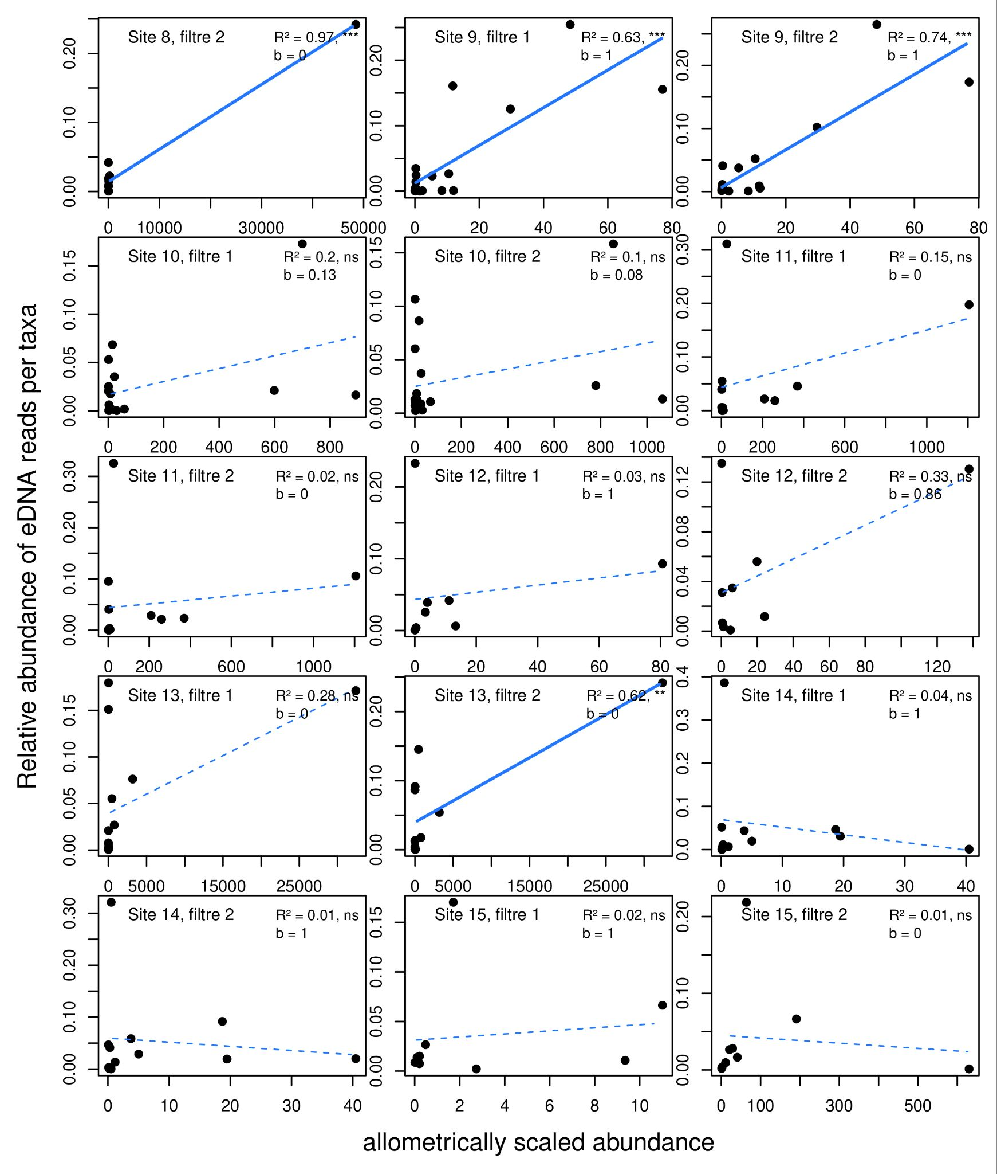

**Figure S11:** Relationships between the relative number/abundance of eDNA reads per species per filter replicate and the best allometric scaled abundance coefficient (*b*) estimated from the species abundance and mass from the closest trawl. The relationships come from a linear model (LM) with a Gaussian distribution error. Continuous lines indicate a significant fit of the LM model, while dashed lines indicate a non-significant trend only of the LM. Asterisks indicate the degree of significance of the slope of the LM, with *** (*p* < 0.001), ** (0.001 < 𝑝 < 0.01), * (0.01 < 𝑝 < 0.05), and ns (𝑝 > 0.05).

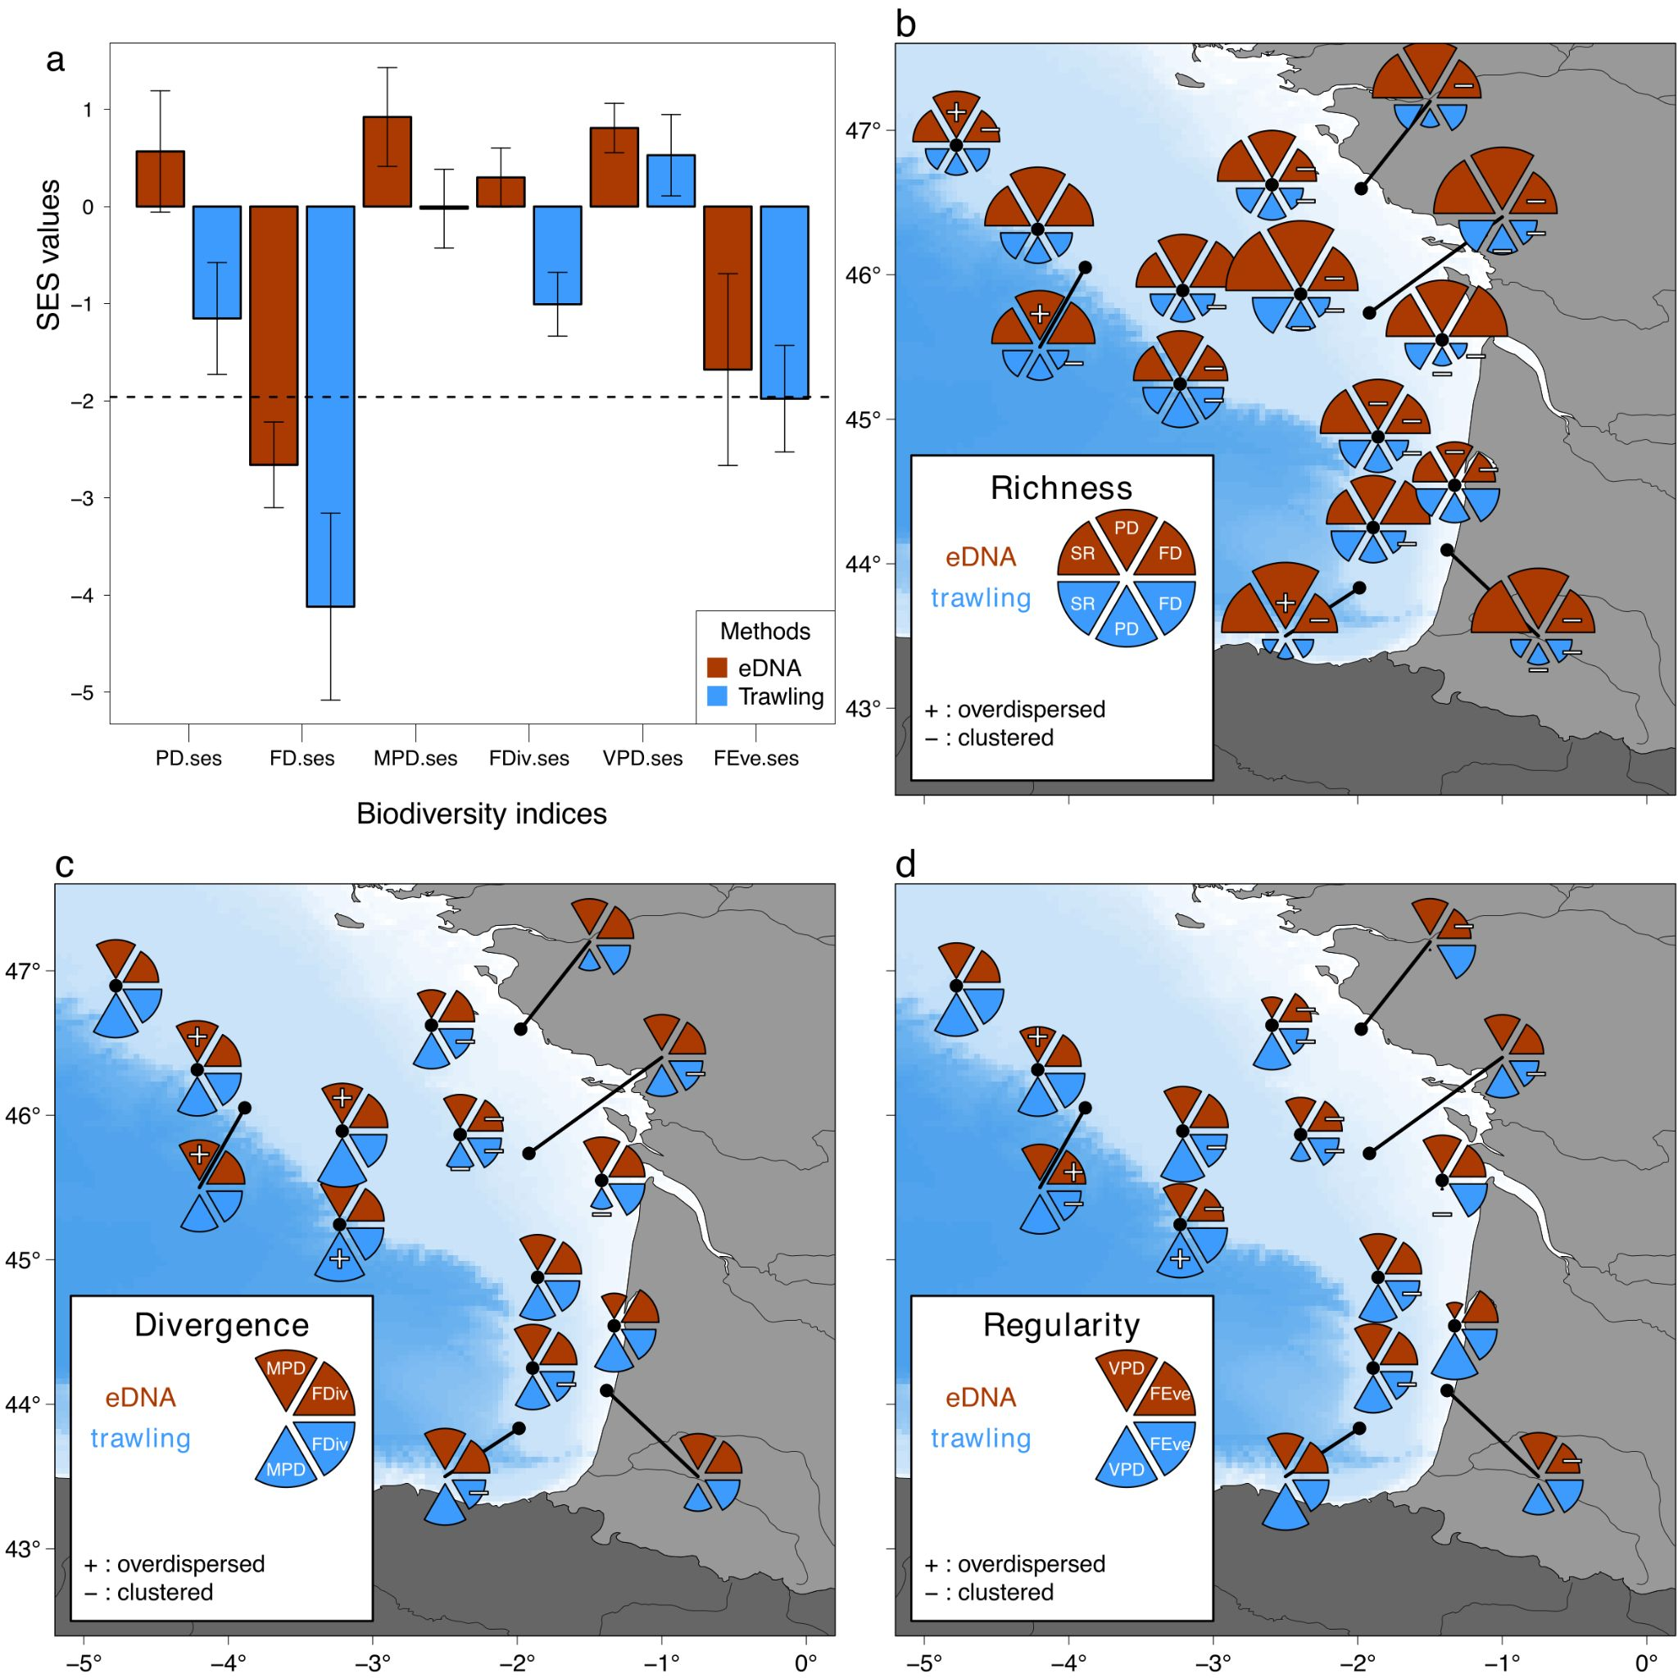

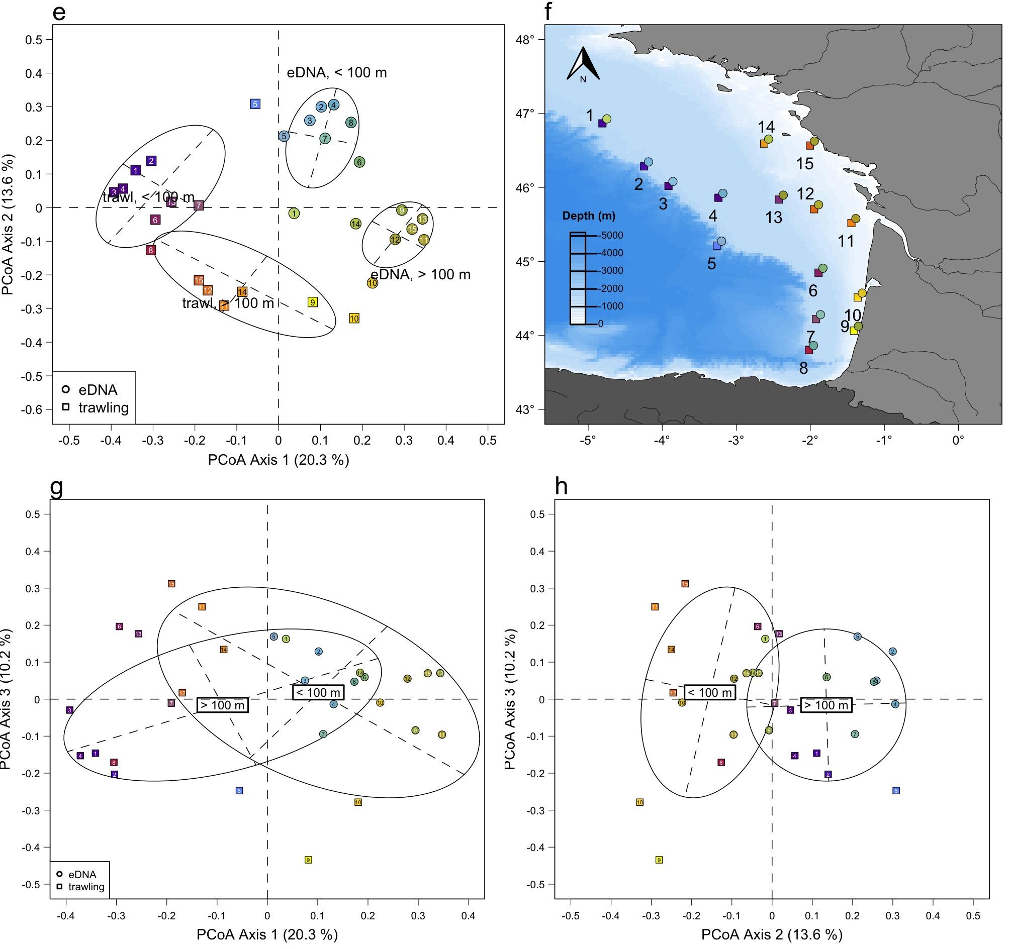

**Figure S12:** Sensitivity analysis results (removal of species which could have suffered from contamination, see list below). Comparison of average standard effect sizes (SES) for phylogenetic and functional indices including richness, divergence and regularity facets (a) associated with the two sampling methods (eDNA vs trawling). Colour bars show the average value over the 15 sites and error bars represent the standard error. The dashed horizontal line indicates a threshold of significant clustering (-1.96) for the SES of the indices. Spatial distribution of the 𝛼diversity indices of (b) richness, (c) divergence and (d) regularity separated by site and by sampling method for the three biodiversity components, recalculated for the sensitivity analysis. The radius of each circle slice is proportional to the value of the index. For functional and phylogenetic diversity, indices significantly different from the null model (based on the standardized effect size, SES) are indicated with − for overdispersion and + for clustering. Panel (e) represents the first two axes of a principal coordinates analysis of the species composition sampled by eDNA metabarcoding (circles) and by bottom trawl hauls (squares), based on the Jaccard dissimilarity distance. Ellipses display the dispersion of the sampling sites according to depth and sampling method. Panel (f) shows geographical positions of the corresponding sites, with 7 shallow sites (< 100m) and 8 deep sites (> 100m). The colour of each point corresponds to its position in the PCoA space: points with similar colours share a similar species composition. List of removed species: *Capros aper, Conger conger, Trachurus sp., Engraulis sp., Argentina sp., Dicentrarchus sp., Sardina pilchardus., Lophius sp., Pagellus bogaraveo, Micromesistius poutassou, Lepidorhombus sp*.

# References for the Supplementary Material

Benton, M., Donoghue, P., Vinther, J., Asher, R., Friedman, M. & Near, T. (2015). Constraints on the timescale of animal evolutionary history. *Palaeontologia Electronica,* 18.1.1FC; 1-106.

Betancur-R, R., Wiley, E.O., Arratia, G., Acero, A., Bailly, N., Miya, M., et al. (2017). Phylogenetic classification of bony fishes. *BMC Evolutionary Biology*, 17, 162.

Fricke, R., Eschmeyer, W.N. & der Laan, R.V. (2022). Eschmeyer’s catalog of fishes: genera, species, references. Available at: <https://researcharchive.calacademy.org/research/ichthyology/catalog/fishcatmain.asp>

Horton, T., Kroh, A., Ahyong, S., Bailly, N., Bieler, R., Boyko, C.B., et al. (2022). World Register of Marine Species (WoRMS).

Nee, S., May, R.M. & Harvey, P.H. (1994). The reconstructed evolutionary process. Philosophical Transactions of the Royal Society of London. *Series B: Biological Sciences*, 344, 305–311.

Paradis E. & Schliep K. (2019). ape 5.0: an environment for modern phylogenetics and evolutionary analyses in R. *Bioinformatics* 35, 526-528.

Rabosky, D.L., Chang, J., Title, P.O., Cowman, P.F., Sallan, L., Friedman, M., et al. (2018). An inverse latitudinal gradient in speciation rate for marine fishes. Nature, 559, 392–395.

Ratnasingham, S. & Herbert, P.D.N. (2007). bold: The Barcode of Life Data System. Molecular Ecology Notes, 7, 355–364.

Revell, L. J. (2012). phytools: An R package for phylogenetic comparative biology (and other things). *Methods in Ecology and Evolution*, 3, 217-223.

Rozanski, R., Trenkel, V.M., Lorance, P., Valentini, A., Dejean, T., Pellissier, L., et al. (2022). Disentangling the components of coastal fish biodiversity in southern Brittany by applying an environmental DNA approach. *Environmental DNA*, 4, 920–939.

Stein, R.W., Mull, C.G., Kuhn, T.S., Aschliman, N.C., Davidson, L.N.K., Joy, J.B., et al. (2018). Global priorities for conserving the evolutionary history of sharks, rays and chimaeras. *Nature Ecology & Evolution*, 2, 288–298.