Fig S1. Phylogeny tree between several strains and species of Isochrysidace built from 18S gene sequenced. Workflow ngphylogeny.fr with FastMe method and 100 bootstraps (score in blue) was used.

Fig S2. Final contact map of T. lutea reference genome obtained followed instaGRAAL workflow. Distribution of 55 contigs assembled and each yellow point represents a contact map. The 28 firsts contigs in blue represent 97% of genome size. The other 27 contigs are small (between 0.78Mb and 0.04Mb) and represent 3% of genomes in total.

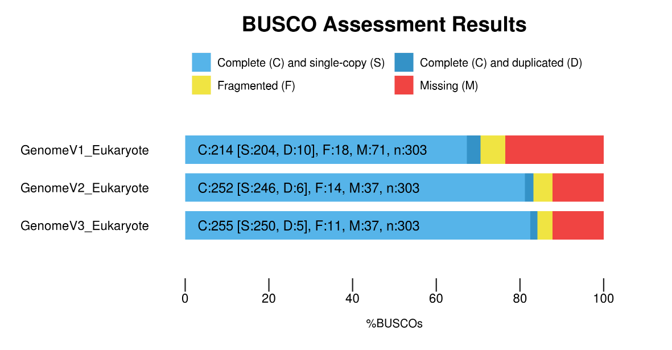
Fig S3. Busco results for several version of reference genome of Tisochrysis lutea. GenomeV1 was first draft genome (Carrier et al., 2017), GenomeV2 was reference genome with long reads (Berthelier et al., 2019), GenomeV3 is currently genome.

