Supporting Information

LA-ICP-MS analysis
Separated portions of the P. maximus shells were measured for their Ba, Mo and Li (¹³⁷Ba, ⁹⁷Mo and ⁷Li as analytes) content by means of a Laser Ablation – Inductively Coupled Plasma – Mass Spectrometry (LA-ICP-MS) system (Max Planck Institute for Chemistry in Mainz, Germany). To fit the shell samples into the ablation chamber of the laser system, an approx. 5 mm broad slab was cut from the left valves along the axis of maximum growth using a 150 µm-thin, diamond coated (galvanically bonded) disk (Art. Number.: 6911H.-104.220, Komet – Dental Gebr. Brasseler GmbH & Co. KG) connected to a manual drilling device. Measurements were accomplished between two radial ribs. The focus was placed on the portion between the first winter growth mark and the last formed growth increment (ventral margin; Fig. S1). Prior to the in-situ chemical analysis, shell slabs were immersed in 10 vol% acetic acid for ca. 1 min and ultrasonically cleaned with deionized water for about 3 min. This procedure removed sediments and epibionts that were trapped within the surface sculpture of the scallop shells. In addition, the laser performed a pre-ablation procedure (line scan) to avoid potential surface contamination by ablating at a speed of 80 µm s⁻¹ with a laser spot size of 100 µm. Measurements were conducted in line scan mode (length of 600 µm) at a constant speed of 5 µm s⁻¹ and a spot size of 80 µm on the outer surface of the shell, perpendicular to the direction of growth. Signal intensities measured from each scan were averaged because a homogeneous distribution of the studied elements within individual striae has been demonstrated (Barats et al., 2007). The daily periodicity of shell formation (Chauvaud et al., 1998; Lorrain et al., 2000) allowed to extract elemental time-series with a temporal resolution from one to two days.
The laser system (NewWave Research UP-213 Nd:YAG laser) operated at a repetition rate of 10 Hz and a laser energy density of approx. 15.8 J cm⁻², using helium (quality 5.0) as a carrier gas (0.57 L min⁻¹). With a Thermo Fisher Element 2 single collector sector-field ICP-MS system, the ion intensities were measured after each ablation, with argon (quality 5.0) as a carrier gas (0.77 L min⁻¹). To calibrate the obtained raw signals, a synthetic silicate glass (NIST SRM 612) was used as an external standard, ⁴³Ca as an internal standard and a pressed carbonate powder pellet (USGS MACS-3) was analyzed as blind sample to account for quality control. Reference materials were analyzed similar to the shell samples (i.e., in a line scan mode using similar laser system settings) and reference values derived from the GeoReM database (version 33; http://georem.mpch-mainz.gwdg.de/; last access: 16 August 2022; Jochum et al., 2011).
An in-house script (C++) was used to process raw signal intensities following the equations provided by Longerich et al. (1996) and Jochum et al. (2007, 2011) and convert them into element-to-calcium ratios such as Ba/Ca, Mo/Ca and Li/Ca (in µmol mol⁻¹). Based on the 3σ criterion, the limits of detection (LOD) were calculated from the blank signal of the calibration material (NIST SRM 612) obtained from 15 s before the laser started to ablate. Values below average LODs (Table S1) were discarded. To account for a potential time-dependent machine drift, each sequence was processed following a batchwise calibration. Thus, a batch of shell and quality control samples was calibrated using repeated measurements of reference materials (NIST SRM 612). Based on these replicate measurements of the external reference material, the relative standard deviation in percent (RSD%) was calculated to report the reproducibility for each measurement. For Ba, Mo and Li, the average RSD% was 1.2 %, 1.3 % and 1.2 %, respectively (Table S1). The blindly measured quality control material (USGS MACS-3) was used to account for accuracy with average deviations from the reference values of 6 % for Ba and Mo, and 17 % for Li. These deviations (Table S1) are potentially induced by an uneven ablation behavior of the pressed synthetic carbonate powder pellet (heterogeneity of particle sizes) which can lead to ionization differences and/or uncertainties in reported values of the non-certified quality control material (Jochum et al., 2019).

Temporal contextualization of measured shell data
The outer shell surface was photographed with a Canon EOS 600 DSLR camera mounted to a binocular microscope (Wild Heerbrugg) equipped with sectoral dark field illumination (Schott VisiLED MC 1000, reflected light). Photographs were used to measure pixel-distances between successive microgrowth lines (daily striae) and converted into µm-distance (reported in µm day⁻¹). Since the specimens were collected alive, the last growth increment at the ventral margin corresponds to the date of death allowing to assign precise calendar dates to each shell portion. However, the identification of individual striae was not always unambiguous (see Thébault et al., 2006, 2009) because of fractures that mainly occurred at the ventral margin. This led to uncertainties in the shell growth reading procedure and to inter-reader differences. To account for these discrepancies, the growth curves of multiple specimens were crossdated to form an average chronology which was used to temporally constrain the growth record. In this study, six specimens from the cage and six specimens from the sediment were used for growth pattern analysis (Table S1). Since elemental analyses were conducted on the outer shell surface, each LA-ICP-MS scan could be visually associated with a specific growth increment and thus assigned to a calendar date.

Environmental monitoring
Water samples (250 mL) from approx. 1.5 m below the sea surface were analyzed for their phytoplankton content. After biweekly water collection, the samples were transferred into silicon tubes and 8 mL of Lugol’s solution was added to fix the phytoplankton cells. The phytoplankton content from a 50 mL aliquot was then analyzed (identification and cell counting) with an inverted microscope (Axio Observer.A1-ZEISS) after the cells sedimented on a glass slide for about 24 h. The samples for analyzing particulate Ba (PBa), Mo (PMo) and Li (PLi) content were collected from the surface water (approx. 1 m below sea surface) and from the bottom water (approx. 0.20 m above the SWI). Samples were obtained by SCUBA diving twice per week between March and June and once per week from July to October. The water was filtered (using MF-MilliporeTM mixed cellulose ester filter, mesh size 0.45 µm) and the particulate trace element content was analyzed by means of ICP-MS (inductively coupled plasma mass spectrometry; Thermo Scientific Quad XSERIES 2). In addition, the filtered fraction of the water samples (using Whatman GF/F filters; mesh size 0.7 µm) were dried at 50 °C and analyzed for their particulate organic carbon (POC) content using a CHN elemental analyzer (Thermo Fisher Flash 2000). The pheophytin pigment concentrations were calculated based on the method described by Lorenzen (1966). A detailed description about the entire environmental monitoring is provided by Siebert et al. (2023).

Relationship between phytoplankton-associated trace element load, shell physiology and shell geochemistry to approximate the trace element uptake by scallops
Episodes of trace element enrichments in scallop shells (i.e., Ba/Ca_{shell}, Mo/Ca_{shell} and Li/Ca_{shell}) were demonstrably related to phytoplankton dynamics occurring in the water column (see discussion in the main text). For instance, the timing and magnitude of Ba/Ca_{shell} peaks were attributed to blooms of various phytoplankton species (mainly diatoms) that contain species-specific amounts of cellular Ba. Based on this underlying assumption, the amount of diatom-associated Ba in the seawater is controlled by the abundance of a given diatom species (cell concentration) and the Ba load contained in each cell (Fig. S2; Step 1 and 2). The daily shell growth rate measured on the shell surface (Fig. S2; Step 3) can be converted into total daily shell height (${ht}_{Shell}$; in mm; Fig. S2; Step 4) allowing to estimate the soft tissue dry weight (${wt}_{Soft tissue}$; in g) according to the allometric relationship:
 | $${wt}_{Soft tissue}=2.974×{10}^{-7}×{ht}_{Shell}^{3.817}$$ | (1)
provided by Lorrain et al. (2004). Additionally, the soft tissue dry weight (Fig. S2; Step 5) can be used to approximate the filtration rate at each day (Fig. S2; Step 6), according to the weight standardized filtration rate of 5 L h⁻¹ g⁻¹ of soft tissue dry weight (value discussed in the main text). On a theoretical basis, the amount of Ba that is ingested by a scallop at each day (Fig. S2; Step 7) can then be deduced using the amount of water that was filtered per day and the diatom-associated Ba concentration in the seawater (Fig. S2; Step 2), assuming that the total pool of diatoms in each liter is retained and digested by the bivalve. Aside from the soft tissue dry weight, the shell weight (${wt}_{Shell}$; in g) can also be determined given the allometric relationship to shell height (Lorrain et al., 2004):
 | ${wt}_{Shell}=4.09×{10}^{-4}×{ht}_{Shell}^{2.701}$. | (2)
This information about the shell weight (Fig. S2; Step 8) is required to compute the absolute amount of Ca that got precipitated at each day (Fig. S2; Step 9). Given that the shell material is composed of calcium carbonate (CaCO₃) as well as a small amount of carbonate bound organic matter (< 5 wt%), a pure Ca content of 38 wt% can be assumed which is in agreement to previous Ca measurements on bivalve shells (M. Richard, 2009 and Marali et al., 2017). Accordingly, the Ca precipitation rate (${Ca}_{prec.}$; in g day⁻¹) is calculated as:
 | ${Ca}_{prec.}=[{wt}_{Shell \left(d\right)}-{wt}_{Shell \left(d-1\right)}]×0.38$, | (3)
i.e., the Ca-proportion of the shell material deposited between two consecutive days (i.e., ${wt}_{Shell \left(d\right)}$ and ${wt}_{Shell \left(d-1\right)}).$ Considering that about 63 % of the total Ba content of scallops (soft tissues plus shell) is located in the shell (Barats, 2006), the amount of Ba incorporated into the shell material during each day (Fig. S1; Step 10) can be approximated from the totally ingested Ba (Fig. S2; Step 7). In combination with the daily precipitated amount of Ca (Fig. S2; Step 9), the Ba/Ca_{shell} weight ratios (Fig. S2; Step 11) as well as the molar ratios (Fig. S2; Step 12) can be calculated. Finally, the theoretically measured Ba/Ca_{shell} profile can be obtained taking into consideration that apart from the Ba in the particulate phase, the dissolved Ba also contributed to the Ba/Ca_{shell} background. This Ba/Ca_{shell} background signal can be approximated from the dissolved Ba/Ca ratio in the seawater (${Ba/Ca}_{Seawater}$) and a previously determined partition coefficient ($D_{Ba}$) of 0.11 (Barats et al., 2009):
 | ${Ba/Ca}_{Shell}=D_{Ba}×{Ba/Ca}_{Seawater}$. | (4)
Note that these steps are based on the presumption that the geochemical information measured on the shell surface of a specific shell portion is representative of the entire, contemporaneously formed shell material.
In this study, the above-described dependencies between growth rate, filtration rate and available Ba in the environment and their effect on Ba/Ca_{shell} data were used to reconstruct the theoretical amount of Ba that was potentially associated with Ba-containing phytoplankton in the water filtered by the scallops. Specifically, in a first step, the Ba/Ca_{shell} background level was subtracted from the Ba/Ca_{shell} profile (Fig. S2; Step 13 to 12), to remove the influence from the dissolved Ba content in the seawater. Then, the molar ratios were converted to weight ratios (Fig. S2; Step 11) and combined with the amount of precipitated Ca (Fig. S2; Step 9) to obtain an estimate about the absolute amount of Ba that was incorporated into the shell each day (Fig. S2; Step 10) and into the bivalve including soft tissues (Fig. S2; Step 7) which was considered to be equal to the total amount of Ba taken up by the scallop from the particulate seawater fraction at each day. This amount of Ba was then used together with the volume of daily filtered seawater (Fig. S2; Step 6) to gain an approximation of the particulate Ba content (i.e., phytoplankton associated) that was present in the filtered seawater (Ba_{filtered seawater} Fig. S2; Step 2). For the Mo/Ca_{shell} profiles, a similar approach was used to approximate the daily Mo incorporation and Mo_{filtered seawater} content, using different Mo/Ca_{shell} background estimations ($D_{Mo}$ = 1.5×10⁻⁴; Barats et al., 2010) and a relative Mo distribution into the shell material of 27 % (value derived from Barats, 2006). Absolute Li incorporation rates were not calculated from the Li/Ca_{hell} profiles as important information on the relative Li distribution among the soft tissues and shell material was not available.

Statistics
To statistically evaluate differences between the average shell growth patterns of cage and sediment specimens, a two-way factorial analysis of variance (i.e., two-way ANOVA test) was used. Sample site (cage vs sediment) and the timing of shell growth (comparison of monthly pooled growth rates; May to September), were considered as orthogonal and fixed factors. Shapiro-Wilk tests were performed to satisfy the underlying assumption of normally distributed data, and Bartlett tests were used to check for the homogeneity of variance. Finally, a Tukey’s post-hoc test identified which specific groups were significantly different. The average trace element-to-calcium chronologies were analyzed for statistical differences in the background levels (Ba/Ca_{shell} and Mo/Ca_{shell}) or mean profiles (Li/Ca_{shell}) between cage and sediment specimens. Therefore, episodes of pronounced Ba/Ca_{shell} and Mo/Ca_{shell} peaks, defined as any period longer than one week with values exceeding the median, were approximately delineated from the background signal. The trace element-to-calcium profiles were evaluated using the non-parametric Kruskal-Wallis test due to the lack of normality and homogeneity. All statistical analyses were performed using the programming language Python (version 3.7.4).

Growth rates of sediment and cage shells
According to growth pattern analysis, the main growing season of sediment scallops started in early March (Fig. S3). In cage shells, epibionts made the reliable identification of striae formed between early March and mid-April impossible. Between March and April, sediment shells grew from 70 to 175 µm day⁻¹ with increasing rates until mid-April. High growth rates of about 190 µm day⁻¹ at the end of April were measured for cage shells. At the beginning of May, growth rates in cage shells remained high (up to 240 µm day⁻¹) while a growth rate reduction was observed in contemporaneous specimens from the sediment (< 140 µm day⁻¹ in early May). Growth rates in sediment shells progressively increased until July, reaching a maximum of 220 µm day⁻¹, and slowly decreased until early October. Cage shells experienced a reduction in growth rate at the end of May (reaching 170 µm day⁻¹) followed by a steady increase until mid-July (up to 267 µm day⁻¹) and a moderate decline until October. Testing for statistical differences in growth rates between sediment and cage shells for the months from May to September (Fig. S3; Table S2 and S3) indicated that the position (i.e., sediment surface or 1 m above the substrate) as well as the timing of growth caused a significant difference in growth (ANOVA: F = 14.26, df = 4, p < 0.001). Furthermore, the growth rates between May and August were significantly different between cage and sediment shells (Tukey multiple comparison test, p < 0.001). Accordingly, shells grown 1 m above the SWI grew faster (except in September) compared to shells that lived on the sediment surface (Fig. S3).

Uncertainties in the trace element-related estimations
The model used to back-calculate Ba_{filtered seawater}, Mo_{filtered seawater,} total Li incorporation rates as well as the amount of cellular Ba and Mo in specific phytoplankton taxa (see Fig. S2), was based on the following presumptions that might have affected the final results. (1) The amount of daily filtered seawater was calculated using the shell height-to-soft tissue dry weight-relationship proposed by Lorrain et al. (2004) and the assumption of a relative filtration rate of about 5 L h⁻¹ g⁻¹ of soft tissue dry weight, which is in the range previously determined for bay scallops (Palmer, 1980) and juvenile king scallops at optimal temperature settings (Laing, 2004). For simplification, the relative filtration rate was assumed to be constant throughout the year despite potential influences of temperatures as well as food particle density and quality on the filtration rate of the scallops (Laing, 2004). For instance, at very low seston conditions (i.e., chlorophyll a concentration below 0.88 µg L⁻¹) the filtration rate in P. maximus was shown to reach 12 L h⁻¹ g⁻¹ (Strohmeier et al., 2009), more than twice the rate that was considered herein. Note, according to a higher filtration scenario of scallops, the estimated cellular Ba contents for the selected diatom species would notably decrease, e.g., a maximum of 221 fg Ba cell⁻¹ was calculated at a filtration rate of 5 L h⁻¹ g⁻¹ compared to 92 fg Ba cell⁻¹ at 12 L h⁻¹ g⁻¹ for the diatom species C. socialis (scenario 1; Fig. S6C). (2) Using the described relationship between the dissolved Ba/Ca and Mo/Ca ratio in the surrounding media and the Ba/Ca_{shell} and Mo/Ca_{shell} background (Gillikin et al., 2006, 2008; Barats et al., 2009, 2010), the influence of the dissolved phase was estimated considering constant Ba and Mo partition coefficients. As the dissolved Ba/Ca and Mo/Ca ratios in the seawater (Fig. S10) were assumed to be vertically homogenous within the range of 1 m (distance between sediment and cage), the estimated background signal was subtracted from the measured Ba/Ca_{shell} and Mo/Ca_{shell} profiles for both cage and sediment shells. However, the temporal variation and biological influence onto the partition coefficients remain uncertain, as the values were obtained from different years and small differences in reported partition coefficients exists between studies (e.g., Gillikin et al., 2008; Barats et al., 2010; Tabouret et al., 2012). (3) The species-specific amount of cellular Ba and Mo in phytoplankton was considered stable and potential environmental influences such as pH or Fe concentration in the seawater that can affect the Ba adsorption onto diatoms (Sternberg et al., 2005) were not included. (4) It was assumed that the distribution of the totally ingested Ba and Mo pool that ended up in the shell relative to the soft tissues remained constant during shell growth. (5) To approximate the cellular Ba contents of diatoms, the total amount of phytoplankton cells per liter of filtered seawater (measured in the water column) was expected to be retained and ingested by the scallops, without considering species-specific feeding preferences.
Although these uncertainties likely contributed to deviations from actual trace element loads that were taken up by the scallops and/or associated with individual phytoplankton cells, the calculations corroborate previously hypothesized uptake mechanisms. In the case of Ba and Mo, a sufficient amount of those trace elements was available for the scallops to induce the formation of Ba/Ca_{shell} peaks and Mo/Ca_{shell} peaks in the studied year. Moreover, the calculations demonstrated that physiological parameters of the bivalve can strongly affect the element-to-calcium ratios in its shell, which need to be considered when using trace element profiles as quantitative proxies.

Tables
Table S1. Information about 12 Pecten maximus specimens analyzed in this study. “Habitat” specifies if a specimen lived in a cage (1 m above the sediment) or directly on the sediment surface. Three cage-lived samples (Shell A-C) were analyzed for their barium, molybdenum and lithium contents using “LA-ICP-MS” and three shells from the sediment (Shell D-F). All additional shells were solely used for growth readings (“GR”) in order to generate robust averaged growth curves from shells collected from the cage (n=6) and the sediments (n=6). Average limits of detection were about 0.03 µmol mol⁻¹ for Ba/Ca_{shell}, 0.01 µmol mol⁻¹ for Mo/Ca_{shell} and 3.17 µmol mol⁻¹ for Li/Ca_{shell}. Relative standard deviation in percent (“RSD”) were calculated from measurements of the certified reference material NIST SRM 612. The pressed carbonate powder pellet USGS MACS-3 was used as a quality control material and obtained values were compared with published values (59.6 µg g⁻¹ for Ba, 1.21 µg g⁻¹ for Mo and 62.9 µg g⁻¹ Li; GeoReM database).
 |  |  |  | Ba/Ca_{shell} |  | Mo/Ca_{shell} |  |  | Li/Ca_{shell}
Sample ID | Date of collection | Habitat | Analyses | RSD  (%) | MACS3  (µg g⁻¹) | RSD  (%) | MACS3  (µg g⁻¹) |  | RSD  (%) | MACS3  (µg g⁻¹)
Shell A | 14.10.2021 | Cage | GR +  LA-ICP-MS | 0.7 | 58.0 ± 5.4 | 0.7 | 1.2 ± 0.1 |  | 1.2 | 52.3 ± 4.2
Shell B | 04.10.2021 | Cage | GR +  LA-ICP-MS | 1.7 | 55.3 ± 0.9 | 2.1 | 1.3 ± 0.1 |  | 1.8 | 53.1 ± 1.6
Shell C | 14.10.2021 | Cage | GR +  LA-ICP-MS | 1.1 | 55.1 ± 4.7 | 1.1 | 1.3 ± 0.2 |  | 0.4 | 54.9 ± 3.6
Shell 1 | 04.10.2021 | Cage | GR | – | – | – | – |  | – | –
Shell 2 | 04.10.2021 | Cage | GR | – | – | – | – |  | – | –
Shell 3 | 04.10.2021 | Cage | GR | – | – | – | – |  | – | –
Shell D | 04.10.2021 | Sed. | GR +  LA-ICP-MS | 0.9 | 55.8 ± 1.7 | 1.0 | 1.4 ± 0.2 |  | 0.9 | 52.3 ± 4.2
Shell E | 11.10.2021 | Sed. | GR +  LA-ICP-MS | 1.2 | 55.4 ± 1.6 | 1.9 | 1.2 ± 0.1 |  | 1.4 | 52.3 ± 4.2
Shell F | 04.10.2021 | Sed. | GR +  LA-ICP-MS | 1.3 | 55.6 ± 2.2 | 1.2 | 1.2 ± 0.1 |  | 1.4 | 52.3 ± 4.2
Shell 4 | 04.10.2021 | Sed. | GR | – | – | – | – |  | – | –
Shell 5 | 11.10.2021 | Sed. | GR | – | – | – | – |  | – | –
Shell 6 | 11.10.2021 | Sed. | GR | – | – | – | – |  | – | –

Table S2. Monthly Shapiro-Wilk test results to check for normality distribution of average shell growth data obtained from cage and sediment shells. Month-wise Bartlett’s test for diagnosing homoscedasticity between cage and sediment shells.
 | Shapiro-Wilk test  Cage shells |  | Shapiro-Wilk test  Sediment shells |  | Bartlett test  Cage vs Sediment
Month (2021) | Statistic | p | Statistic | p | p
May | 0.97 | 0.59 | 0.96 | 0.28 | 0.43
June | 0.94 | 0.09 | 0.97 | 0.56 | 0.11
July | 0.96 | 0.28 | 0.95 | 0.12 | 0.51
August | 0.99 | 0.95 | 0.97 | 0.58 | 0.82
September | 0.97 | 0.58 | 0.97 | 0.54 | 0.80

Table S3. Two-way ANOVA test results. “Month” accounts for the temporal influence, i.e., monthly (May to September) differences, and “Location” denotes for differences in growth rates between cage and sediment living shells.
 | Degrees of freedom (df) | Sum of squares | Mean squares | F | p
Month | 4 | 60490.13 | 15122.53 | 50.04 | 4.03×10⁻³²
Location | 1 | 51827.21 | 51827.21 | 171.50 | 3.34×10⁻³¹
Month:Location | 4 | 17232.85 | 4308.21 | 14.26 | 1.19×10⁻¹⁰
Residual | 295 | 89147.32 | 302.19 | – | –

Figures
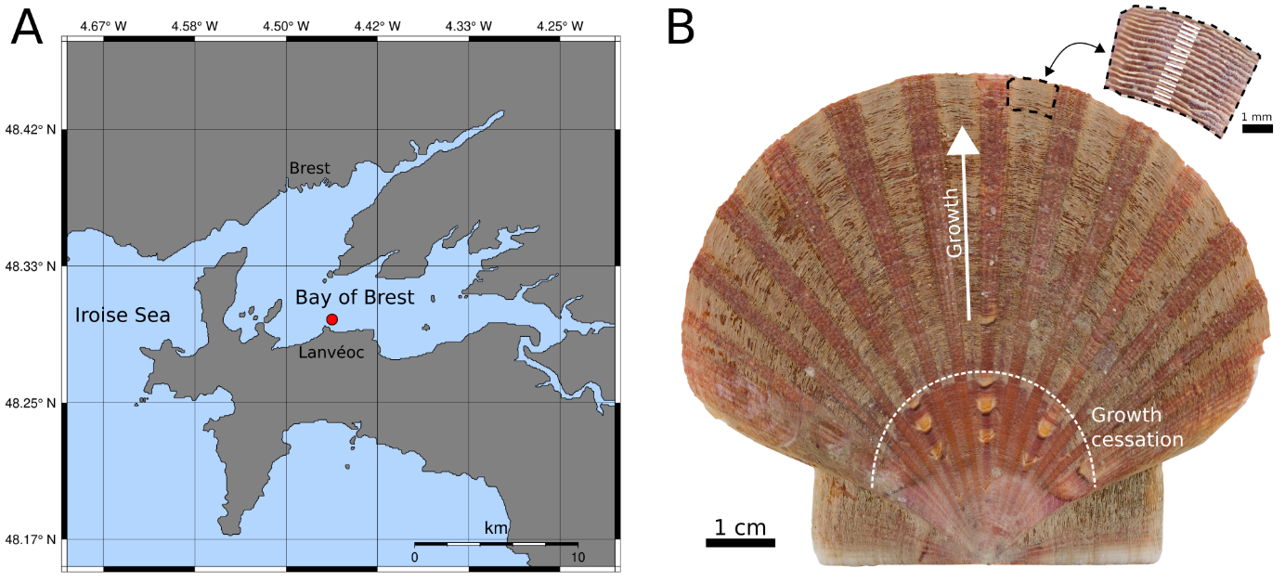
Figure S1. Map showing the Bay of Brest (northwest France) and location where the scallop specimens were hatched and collected (red circle; Pointe de Lanvéoc) (A). Left valve of a P. maximus specimen (prior to the removal of overlapping calcitic striae) and magnification of a shell portion close to the ventral margin (after removing overlapping striae) with white lines (magnified shell portion) indicating how individual LA-ICP-MS scans were positioned on the shell surface (B).
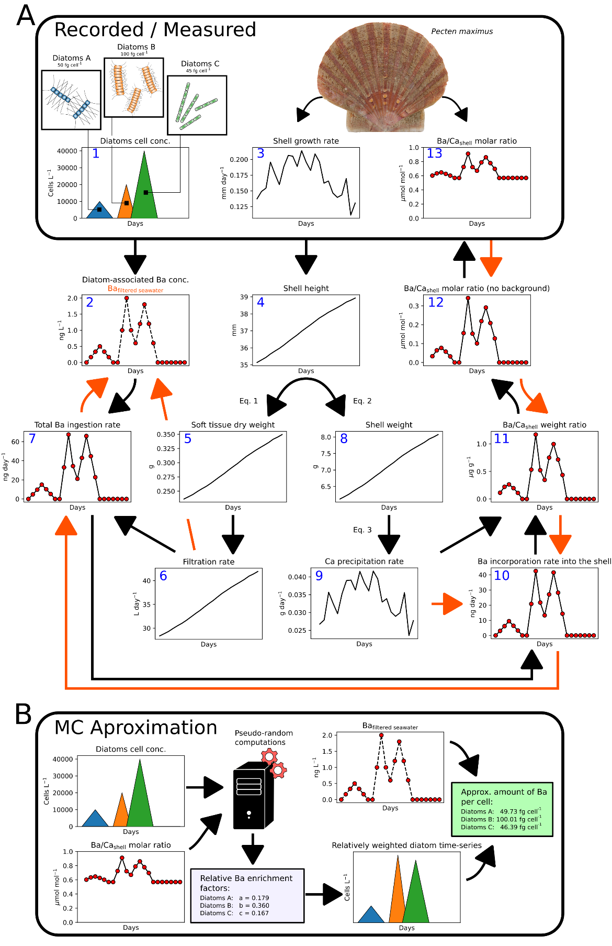

Figure S2. Simplified example of the hypothesized relationship between diatom-associated Ba (three diatom species in this example) and measured Ba/Ca_{shell} profiles, modified after and based on the calculations proposed by Thébault et al. (2009). Black arrows in A depict the connection and contribution from cellular Ba in diatoms to the obtained Ba/Ca_{shell} profiles. Orange arrows in A illustrate the steps performed to approximate the total uptake of Ba by the scallops and the amount of diatom-associated Ba in the filtered seawater from the measured Ba/Ca_{shell} profile. B illustrates how the Monte Carlo (MC) method (described in Fröhlich et al., 2022) was included to estimate the cellular Ba content of individual diatom species, i.e., approximating the Ba/Ca_{shell} profiles by iteratively testing a large number of pseudo-randomly generated weighting factors. These species-specific weighting factors served as an indication of the relative Ba enrichment associated with each diatom species. This information was used together with the previously estimated Ba_{filtered seawater} (A) to compute absolute cellular Ba concentrations of each diatom species.
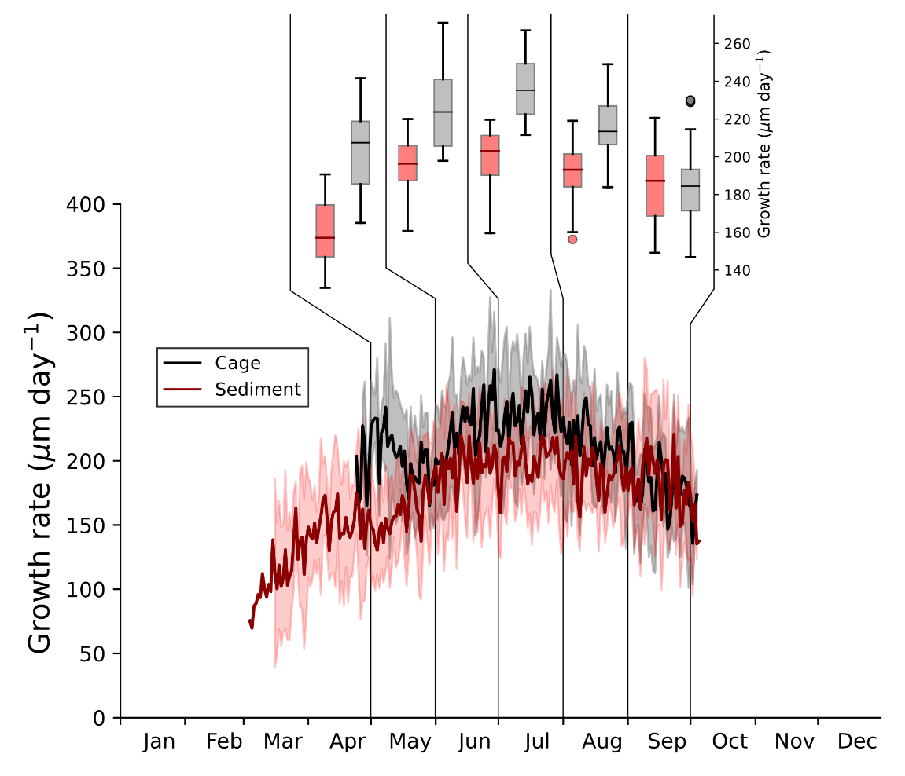
Figure S3. Growth rates measured in six specimens of P. maximus shells living in a cage (1m above the sediment) and six specimens grown on the sediment surface. Bold lines correspond to the average growth rates (±1σ) for cage and sediment shells and box plots indicate for monthly differences in measured growth rates.
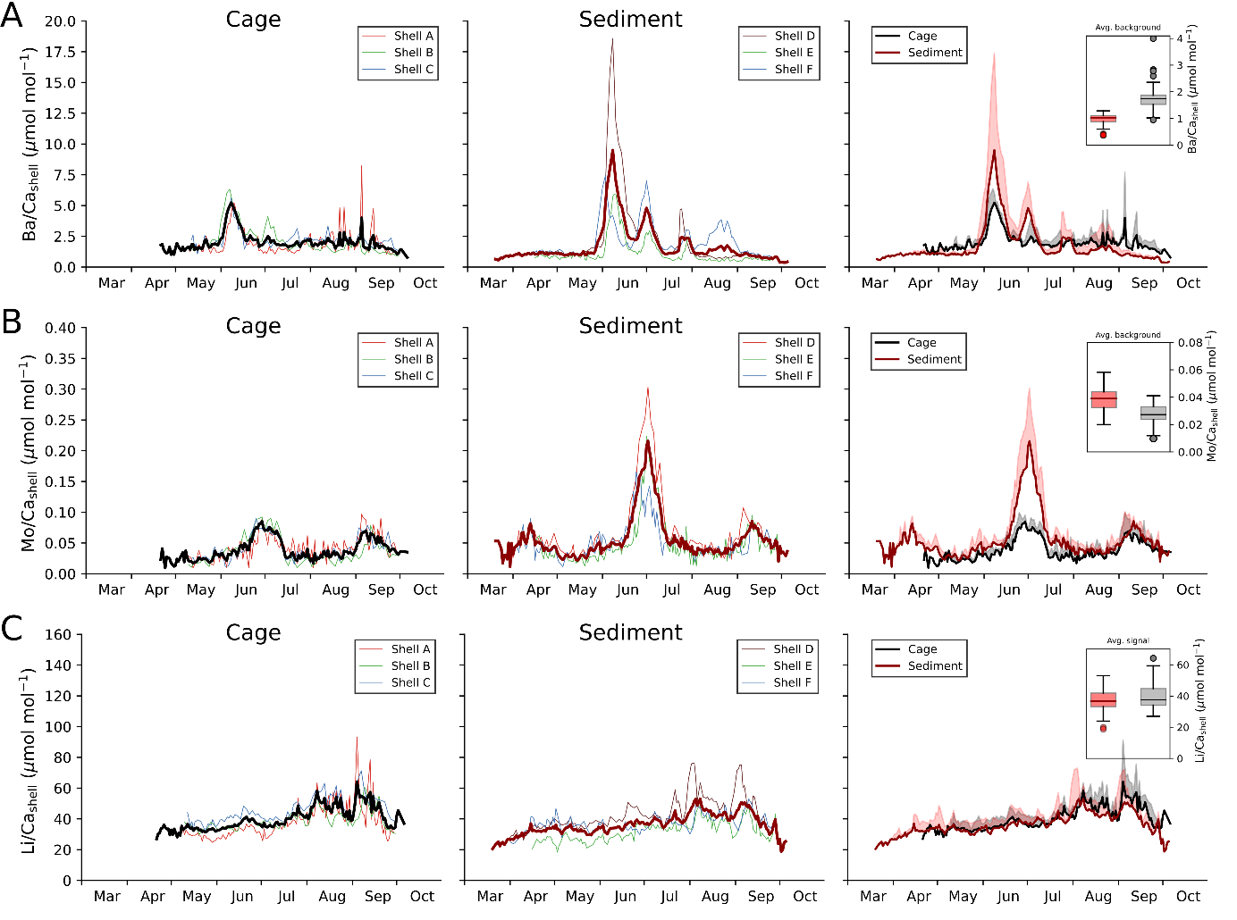
Figure S4. Ba/Ca_{shell} (A), Mo/Ca_{shell} (B) and Li/Ca_{shell} (C) measured in three P. maximus specimens grown inside a cage (Shell A-C; left panel) and on the sediment surface (Shell D-F; center panel) during 2021. Average molar element-to-calcium chronologies represented as bold lines. For better visualization, the average profiles (+1σ) from cage and sediment shells were plotted together (right panel). Box plots indicate for differences in the background signals between cage and sediment shells of average Ba/Ca_{shell} and Mo/Ca_{shell} profiles and the average signal of Li/Ca_{shell} ratios.
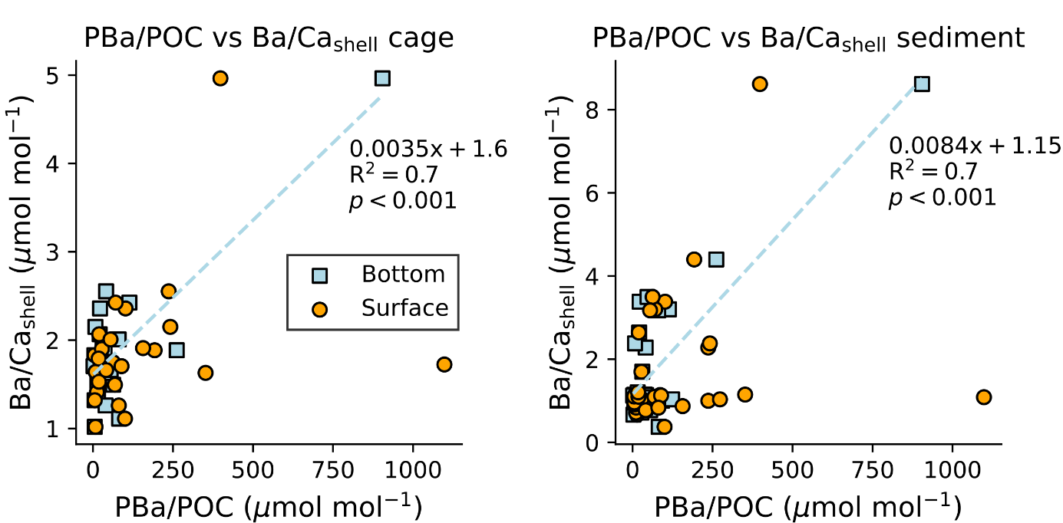
Figure S5. Cross-plots of PBa/POC ratios measured in bottom and surface waters vs average Ba/Ca_{shell} profiles from cage and sediment shells. Ba/Ca_{shell} profiles were resampled to match the resolution of the PBa/POC data. Significant (Pearson) correlations only existed between PBa/POC levels measured in bottom waters and Ba/Ca_{shell} profiles and linear regression model is indicated as blue line.
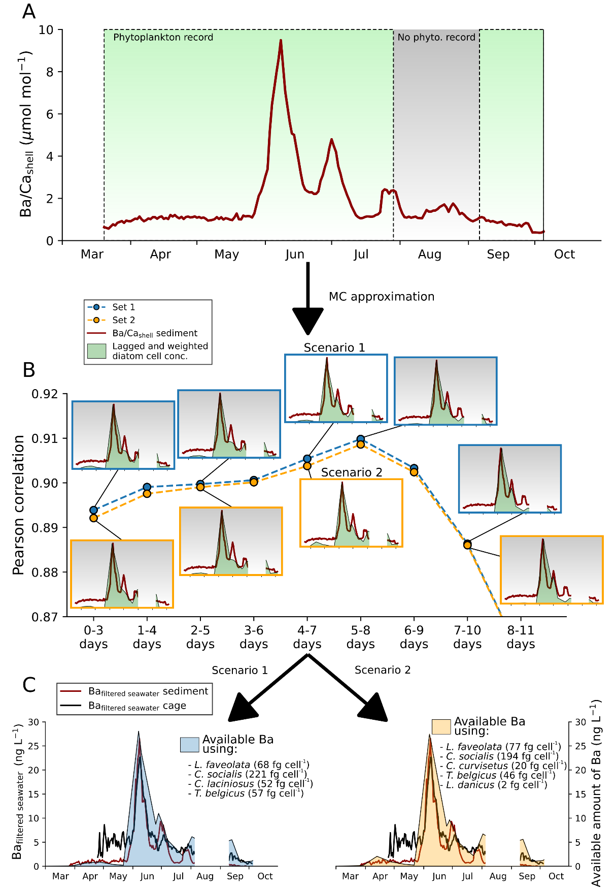
Figure S6. The average Ba/Ca_{shell} profile obtained from sediment grown shells (A) was used to approximate the potential contribution of the most abundant diatom taxa observed in the water column to the Ba/Ca_{shell} peaks. Since no phytoplankton record was available between late July to early September, the Monte Carlo (MC) approximations were performed by excluding this time period (gray area in A). Pearson correlation coefficients indicated for the best combination (small subplots illustrating the respective result of the temporally shifted and weighted diatom time-series) that were tested for different time lags (B). Considering the growth rates and filtration rates (i.e., 5 L h⁻¹ g⁻¹ soft tissue dry weight), the Ba_{filtered seawater} concentration was estimated (C). Using scenario 1 and scenario 2, the diatom-associated amount of Ba was estimated following the assumption that the ingestion of diatoms triggered the formation of the measured Ba/Ca_{shell} peaks (see calculations described in Fig. S2).

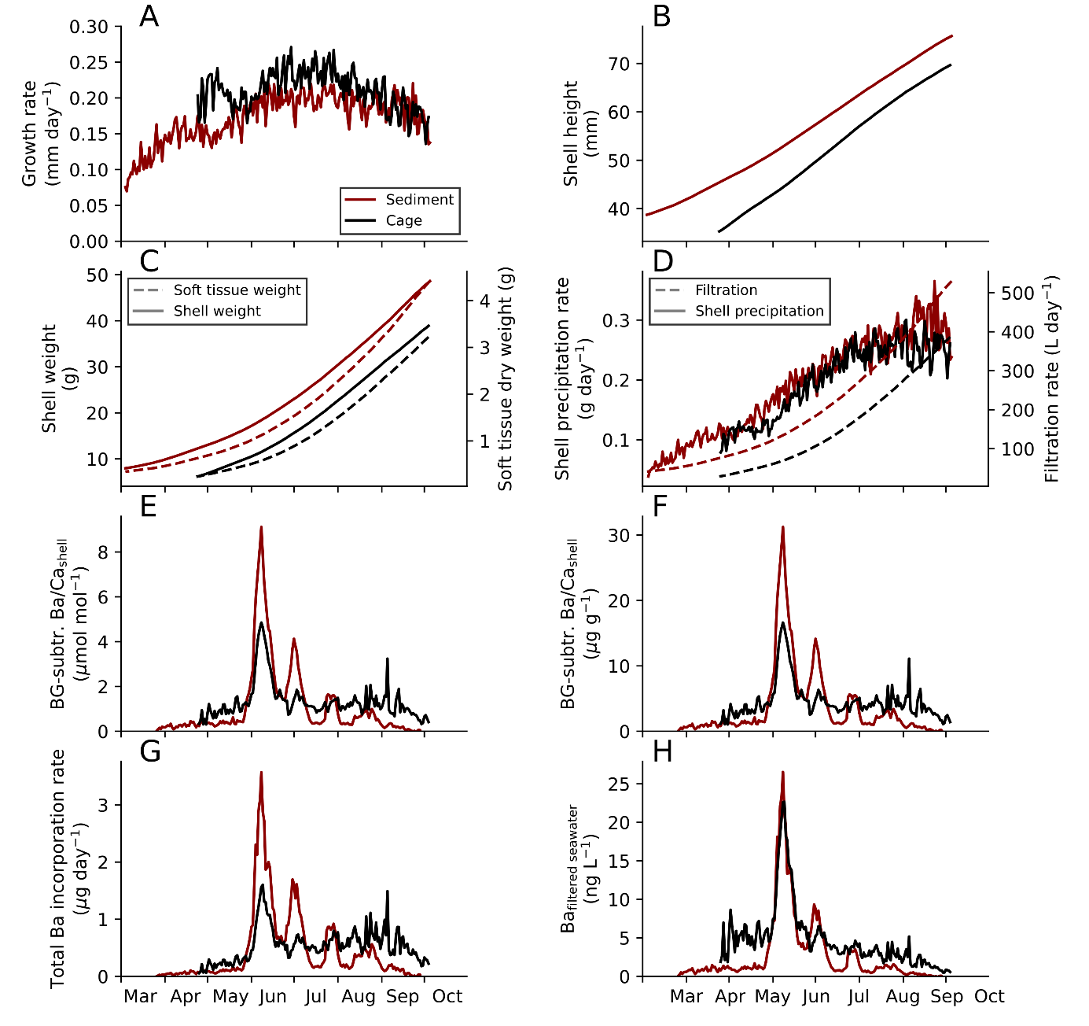
Figure S7. Average growth rates measured in sediment shells and cage shells (A; step 3 in Fig. S1) were used to calculate daily shell heights (B; step 4 in Fig. S1) and approximate the shell weight and soft tissue dry weight (C; step 8 and 5 in Fig. S1) following the allometric relationships from Lorrain et al. (2004). Estimated filtration rates (at 5 L h⁻¹ g⁻¹ soft tissue dry weight; step 6 in Fig. S1) and shell precipitation rates (D). Background subtracted averaged Ba/Ca_{shell} profiles (E; step 12 in Fig. S1) were converted into weight ratios (F; step 11 in Fig. S1) and used to approximate absolute Ba incorporation rates (G; step 7 in Fig. S1). Together with the daily filtration rate, the Ba_{filtered seawater} was estimated (H; step 2 in Fig. S1).

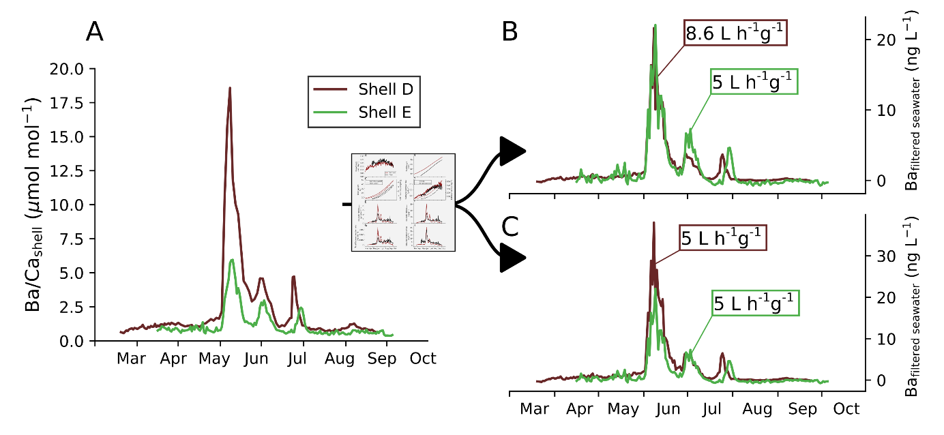
Figure S8. Differences in the Ba/Ca_{shell} profile of Shell D and Shell E that grew on the sediment (A). After considering the individual growth rates and filtration rates (following the steps performed in Fig. S1 and S3), the Ba_{filtered seawater} amount was approximated (B and C). Subplot B illustrates a likely scenario in which Shell D possessed a slightly higher weight-standardized filtration rate compared to Shell E. According to this filtration scenario, both scallops would have filtered the same amount of Ba from the seawater during the large bloom in early June (e.g., induced by a large diatom bloom). This indicates to what extent small differences in filtration rates can affect Ba_{filtered seawater} concentrations. For comparison, the Ba_{filtered seawater} amount is depicted assuming a similar weight- standardized filtration rate for both shells (C).
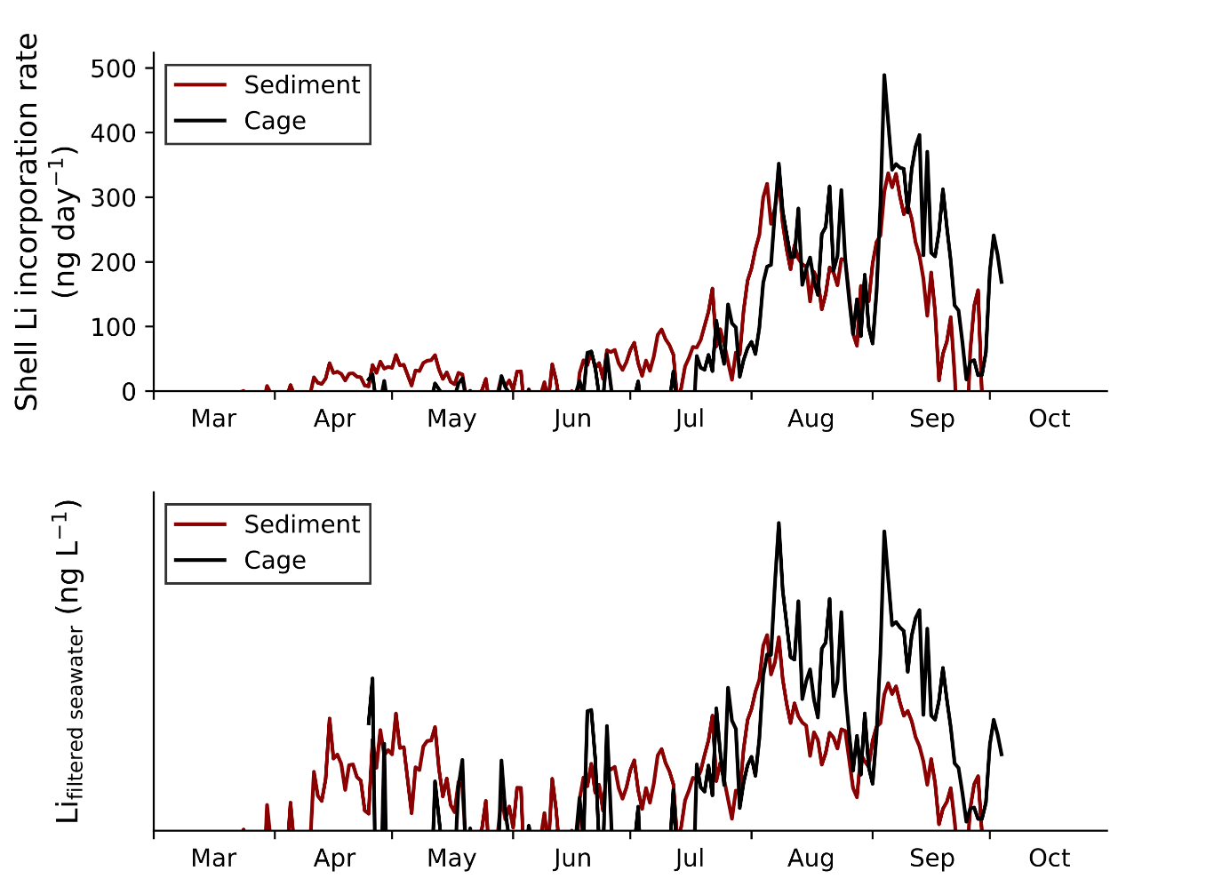
Figure S9. Estimated Li incorporation rate into the shell for cage and sediment shells (upper panel) calculated using the Li/Ca_{shell} elemental ratios together with the daily Ca precipitation rate. Note that the Li/Ca_{shell} background level was approximated, using the growth rate dependency described by Thébault and Chauvaud (2013), and subtracted from the measured Li/Ca_{shell} profiles to account for excess Li/Ca_{shell}. Relative amount of Li that was filtered by scallops from the cage and from the sediment (lower panel) considering a similar soft tissue dry weight-normalized filtration rate. Absolute values for the Li content in the filtered seawater could not be calculated as the relative Li distribution among soft tissue and shell is unknown.
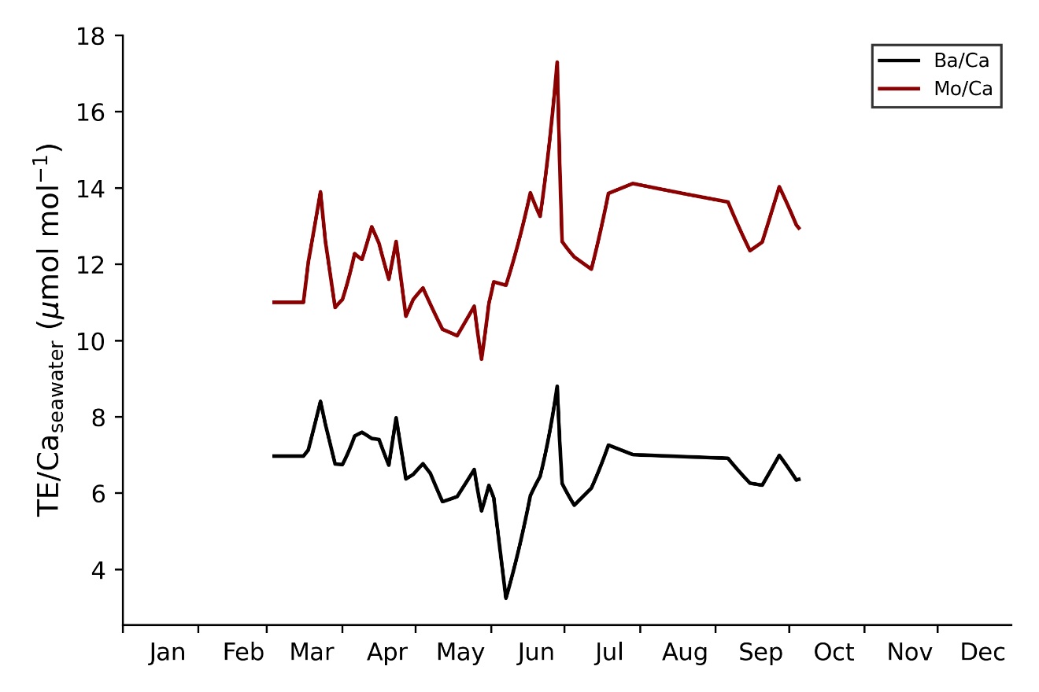
Figure S10. Dissolved Ba/Ca_{seawater} and Mo/Ca_{seawater} ratio measured in the water at the study locality.

References
Barats, A., 2006. Micro analyse quantitative des éléments traces dans la calcite de la coquille Saint Jacques (Pecten maximus) par Ablation Laser ICP-MS: une archive journalière de la biogéochimie des environnements côtiers tempérés. Diss. Université de Pau et des Pays de l’Adour.
Barats, A., Pécheyran, C., Amouroux, D., Dubascoux, S., Chauvaud, L., Donard, O.F.X., 2007. Matrix-matched quantitative analysis of trace-elements in calcium carbonate shells by laser-ablation ICP-MS: Application to the determination of daily scale profiles in scallop shell (Pecten maximus). Anal Bioanal Chem 387, 1131–1140. https://doi.org/10.1007/s00216-006-0954-8
Barats, A., Amouroux, D., Chauvaud, L., Pécheyran, C., Lorrain, A., Thébault, J., Church, T.M., Donard, O.F.X., 2009. High frequency Barium profiles in shells of the Great Scallop Pecten maximus: A methodical long-term and multi-site survey in Western Europe. Biogeosciences 6, 157–170. https://doi.org/10.5194/bg-6-157-2009
Barats, A., Amouroux, D., Pécheyran, C., Chauvaud, L., Thébault, J., X. Donard, O.F., 2010. Spring molybdenum enrichment in scallop shells: A potential tracer of diatom productivity in temperate coastal environments (Brittany, NW France). Biogeosciences 7, 233–245. https://doi.org/10.5194/bg-7-233-2010
Chauvaud, L., Thouzeau, G., Paulet, Y.M., 1998. Effects of environmental factors on the daily growth rate of Pecten maximus juveniles in the Bay of Brest (France). J Exp Mar Biol Ecol 227, 83–111. https://doi.org/10.1016/S0022-0981(97)00263-3
Fröhlich, L., Siebert, V., Huang, Q., Thébault, J., Jochum, K.P., Schöne, B.R., 2022a. Deciphering the potential of Ba/Ca, Mo/Ca and Li/Ca profiles in the bivalve shell Pecten maximus as proxies for the reconstruction of phytoplankton dynamics. Ecol Indic 141, 109121. https://doi.org/10.1016/j.ecolind.2022.109121
Gillikin, D.P., Dehairs, F., Lorrain, A., Steenmans, D., Baeyens, W., André, L., 2006. Barium uptake into the shells of the common mussel (Mytilus edulis) and the potential for estuarine paleo-chemistry reconstruction. Geochim Cosmochim Acta 70, 395–407. https://doi.org/10.1016/j.gca.2005.09.015
Gillikin, D.P., Lorrain, A., Paulet, Y.M., André, L., Dehairs, F., 2008. Synchronous barium peaks in high-resolution profiles of calcite and aragonite marine bivalve shells. Geo-Marine Letters 28, 351–358. https://doi.org/10.1007/s00367-008-0111-9
Jochum, K.P., Garbe-Schönberg, D., Veter, M., Stoll, B., Weis, U., Weber, M., Lugli, F., Jentzen, A., Schiebel, R., Wassenburg, J.A., Jacob, D.E., Haug, G.H., 2019. Nano-Powdered Calcium Carbonate Reference Materials: Significant Progress for Microanalysis? Geostand Geoanal Res 43, 595–609. https://doi.org/10.1111/ggr.12292
Jochum, K.P., Stoll, B., Herwig, K., Willbold, M., 2007. Validation of LA-ICP-MS trace element analysis of geological glasses using a new solid-state 193 nm Nd:YAG laser and matrix-matched calibration. J Anal At Spectrom 22, 112–121. https://doi.org/10.1039/b609547j
Jochum, K.P., Weis, U., Stoll, B., Kuzmin, D., Yang, Q., Raczek, I., Jacob, D.E., Stracke, A., Birbaum, K., Frick, D.A., Günther, D., Enzweiler, J., 2011. Determination of reference values for NIST SRM 610-617 glasses following ISO guidelines. Geostand Geoanal Res 35, 397–429. https://doi.org/10.1111/j.1751-908X.2011.00120.x
Laing, I., 2004. Filtration of king scallops (Pecten maximus). Aquaculture 240, 369–384. https://doi.org/10.1016/j.aquaculture.2004.02.002
Lorenzen, C.J., 1966. A method for the continuous measurement of in vivo chlorophyll concentration. Deep-Sea Research and Oceanographic Abstracts 13, 223–227. https://doi.org/10.1016/0011-7471(66)91102-8
Longerich, H.P., Jackson, S.E., Günther, D., 1996. Laser ablation inductively coupled plasma mass spectrometric transient signal data acquisition and analyte concentration calculation. J Anal At Spectrom 11, 899–904. https://doi.org/10.1039/JA9961100899
Lorrain, A., Paulet, Y.M., Chauvaud, L., Savoye, N., Nézan, E., Guérin, L., 2000. Growth anomalies in Pecten maximus from coastal waters (Bay of Brest, France): Relationship with diatom blooms. Journal of the Marine Biological Association of the United Kingdom 80, 667–673. https://doi.org/10.1017/S0025315400002496
Lorrain, A., Paulet, Y.M., Chauvaud, L., Dunbar, R.B., Mucciarone, D., Fontugne, M., 2004. δ¹³C variation in scallop shells: Increasing metabolic carbon contribution with body size? Geochim Cosmochim Acta 68, 3509–3519. https://doi.org/10.1016/j.gca.2004.01.025
Palmer, R.E., 1980. Behavioral and rhythmic aspects of filtration in the bay scallop, Argopecten irradians concentricus (Say), and the oyster, Crassostrea virginica (Gmelin). J Exp Mar Biol Ecol 45, 273–295. https://doi.org/10.1016/0022-0981(80)90062-3
Richard, M., 2009. Analyse de la composition élémentaire de Pecten maximus par HR-ICP-MS Element 2: développements méthodologiques et interprétations écologiques. Diss. Université de Bretagne occidentale-Brest.
Siebert, V., Moriceau, B., Fröhlich, L., Schöne, B.R., Amice, E., Beker, B., Bihannic, K., Bihannic, I., Delebecq, G., Devesa, J., Gallinari, M., Germain, Y., Grossteffan, É., Jochum, K.P., Le Bec, T., Le Goff, M., Liorzou, C., Leynaert, A., Marec, C., Picheral, M., Rimmelin-Maury, P., Rouget, M.-L., Waeles, M., Thébault, J., 2023. HIPPO environmental monitoring: Impact of phytoplankton dynamics on water column chemistry and the sclerochronology of the king scallop (Pecten maximus) as a biogenic archive for past primary production reconstructions. Earth System Science Data 2023, 1–32. https://doi.org/10.5194/ESSD-2023-39
Sternberg, E., Tang, D., Ho, T.Y., Jeandel, C., Morel, F.M.M., 2005. Barium uptake and adsorption in diatoms. Geochim Cosmochim Acta 69, 2745–2752. https://doi.org/10.1016/j.gca.2004.11.026
Strohmeier, T., Strand, Ø., Cranford, P., 2009. Clearance rates of the great scallop (Pecten maximus) and blue mussel (Mytilus edulis) at low natural seston concentrations. Mar Biol 156, 1781–1795. https://doi.org/10.1007/s00227-009-1212-3
Tabouret, H., Pomerleau, S., Jolivet, A., Pécheyran, C., Riso, R., Thébault, J., Chauvaud, L., Amouroux, D., 2012. Specific pathways for the incorporation of dissolved barium and molybdenum into the bivalve shell: An isotopic tracer approach in the juvenile Great Scallop (Pecten maximus). Mar Environ Res 78, 15–25. https://doi.org/10.1016/j.marenvres.2012.03.006
Thébault, J., Chauvaud, L., 2013. Li/Ca enrichments in great scallop shells (Pecten maximus) and their relationship with phytoplankton blooms. Palaeogeogr Palaeoclimatol Palaeoecol 373, 108–122. https://doi.org/10.1016/j.palaeo.2011.12.014
Thébault, J., Chauvaud, L., Clavier, J., Fichez, R., Morize, E., 2006. Evidence of a 2-day periodicity of striae formation in the tropical scallop Comptopallium radula using calcein marking. Mar Biol 149, 257–267. https://doi.org/10.1007/s00227-005-0198-8
Thébault, J., Chauvaud, L., L’Helguen, S., Clavier, J., Barats, A., Jacquet, S., Pécheyran, C., Amouroux, D., 2009. Barium and molybdenum records in bivalve shells: Geochemical proxies for phytoplankton dynamics in coastal environments? Limnol Oceanogr 54, 1002–1014. https://doi.org/10.4319/lo.2009.54.3.1002

