Supplemental Table of Contents:
Table S1: Genome assembly metrics for B ( MI47H and 5DH ) and C-strain (MI12H; gray) Hamiltonella defensa isolates. (page 2)
Table S2: Accession number for loci used in phylogenetic and other analyses. (page 3)
Table S3: Models used in phylogenetic trees. (page 4)
Table S4: Average amino acid identity and average nucleotide identity comparisons among H. defensa isolates from all five strain groups. (page 5)
Table S5: Comparison of gene inventories in B-clade H. defensa strains MI47H versus 5DH. (page 6)
Table S6: Summary of prophage and prophage islands among isolates of B- and C-clade strains of H. defensa. (page 7)
Table S7: Summary of plasmid islands among isolates of B- and C-clade H. defensa strains of H. defensa. (page 8)
Table S8: Identify and copy number of IS elements among isolates of B- and C-clade strains of H. defensa.
(page 9)

Table S9: Presence of colicin-bearing plasmids in H. defensa isolates from the five H. defensa strain clades.
(page 9)

Table S10: Data from parasitism assays (page 16)

Figure S1. Comparison of metabolic pathway among sequenced H. defensa from all five strain groups. Green indicates intact genes, gold boxes indicate pseudogenes, and gray boxes indicate absent genes. (page 10)
Figure S2. Genomes of bacteriocin-containing plasmids unique to B-strain H. defensa. (page 11)
Figure S3. Alignments showing that within-clade genomes are highly similar in content and architecture, while among-clade strains vary in these respects. (page 12)
Figure S4. A maximum likelihood phylogenetic analysis of H. defensa isolates. (page 13)
Figure S5. A maximum likelihood phylogenetic analysis of APSE modules 1, 2 & 4. (page 14)
Figure S6. Amino acid sequences of CdtB from H. defensa and other bacteria. (page 15)

Table S1: Genome assembly metrics for B ( MI47H and 5DH ) and C-strain (MI12H; gray) Hamiltonella defensa isolates
strains | 5DH |  |  |  |  |  | MI47H |  |  |  |  |  | MI12H
 | Chromo | P1 | P2 | P3 | P4 | P5 | Chromo | P1 | P2 | P3 | P4 | P5 | Chromo | CHR2 | P1 | P2
Size (bps) | 2029888 | 91765 | 57467 | 44404 | 27768 | 14565 | 2039134 | 91008 | 57469 | 47817 | 27761 | 12812 | 1078250 | 1047506 | 84572 | 42981
Total GC % | 40.4 | 42.1 | 46 | 43.5 | 45.5 | 43 | 40.4 | 42 | 46 | 43 | 45 | 43.1 | 41.2 | 40.2 | 42.6 | 46.5
 | 1968 | 106 | 64 | 45 | 32 | 17 | 1977 | 104 | 64 | 47 | 32 | 14 | 1029 | 1058 | 85 | 52
Pseudo-genes no. | 128 | 33 | 3 | 13 | 3 | 2 | 139 | 36 | 3 | 15 | 3 | 0 | 131 | 77 | 17 | 3
# of reads | 107939 |  |  |  |  |  | 115370 |  |  |  |  |  | 114000
N50 read length | 27215 |  |  |  |  |  | 39073 |  |  |  |  |  | 38583
Mapped read | 100304 |  |  |  |  |  | 105337 |  |  |  |  |  | 107668
Mean coverage | 427 |  |  |  |  |  | 708 |  |  |  |  |  | 762
Mean Read length | 10412 |  |  |  |  |  | 21127 |  |  |  |  |  | 20510
Plasmid designations P1: pHDMI47H.1/pHD5DH.1/pHDMI12.1, P2: pHDMI47H.2/pHD5DH.2/pHDMI12.2, P3: pHDMI47H.3/pHD5DH.3, P4: pHDMI47H.4/pHD5DH.4, P5: pHDMI47H.5/pHD5DH.5)

Table S2: Accession numbers used in this study.
Accession numbers for loci used in phylogenetic analyses
 | accD | ptsI | hrpA | gyrB | murE |  | rpoS | recJ
H. defensa Co26-S.avenae | KM375951.1 |  | KM375983.1 | KM375967.1 | KM375999.1 |  | KM376031.1 | KM376015.1
H. defensa Co08-S.avenae | KM375948.1 |  | KM375980.1 | KM375964.1 | KM375996.1 |  | KM376028.1 | KM376012.1
H. defensa 16-Utamphorophora | KM375956.1 |  | KM375988.1 | KM375972.1 | KM376004.1 |  | KM376036.1 | KM376020.1
H. defensa Sc02-S.fragariae | KM375954.1 |  | KM375986.1 | KM375970.1 | KM376002.1 |  | KM376034.1 | KM376018.1
H. defensa Co37-S.avenae | KM375952.1 |  | KM375984.1 | KM375968.1 | KM376000.1 |  | KM376032.1 | KM376016.1
H. defensa Co23-S.avenae | KM375950.1 |  | KM375982.1 | KM375966.1 | KM375998.1 |  | KM376030.1 | kM376014.1
H. defensa up11-S.fragariae | KM375955.1 |  | KM375987.1 | KM375971.1 | KM376003.1 |  | KM376035.1 | KM376019.1
H. defensa 402-A.fabae | KM375947.1 |  | KM375979.1 | KM375963.1 | KM375995.1 |  | KM376027.1 | KM376011.1
H. defensa-U.nigrotuberculatum | EU021767.1 | EU021874.1 | EU0218971 | EU021847.1 | EU021794.1 |  | EU021741.1 | EU021821.1
H. defensa -U.pieloui | EU021768.1 | EU021875.1 | EU021898.1 | EU021848.1 | EU021795.1 |  | EU021742.1 | EU021822.1
H. defensa-U. reynoldense | EU021772.1 | EU021879.1 | EU021902.1 | EU021852.1 | EU021799.1 |  | EU021746.1 | EU021826.1
H. defensa UA001-U.ambrosiae | EU021764.1 | EU021871.1 | EU021894.1 | EU021844.1 | EU021791.1 |  | EU021738.1 | EU021818.1
H. defensa B-U.ambrosiae | EU021763.1 | EU021870.1 | EU021893.1 | EU021843.1 | EU021790.1 |  | EU021737.1 | EU021817.1
H. defensa 5ATac-A.craccivora | EU021758.1 | EU021865.1 | EU021888.1 | EU021838.1 | EU021785.1 |  | EU021732.1 | EU021812.1
H. defensa-Geopemphigus | EU021760.1 | EU021867.1 | EU021890.1 | EU021840.1 | EU021787.1 |  | EU021734.1 | EU021813.1
H. defensa N4-Chaitophorus | EU021774.1 | EU021881.1 | EU021904.1 | EU021854.1 | EU021801.1 |  | EU021828.1 | EU021748.1
H. defensa-U.sonchi | EU021770.1 | EU021877.1 | EU021900.1 | EU021850.1 | EU021797.1 |  | EU021744.1 | EU021824.1
H. defensa-U.escalantii | EU021771.1 | EU021878.1 | EU021901.1 | EU021851.1 | EU021798.1 |  | EU021745.1 | EU021825.1
H. defensa N5-Cinara | EU021775.1 | EU021882.1 | EU021905.1 | EU021855.1 | EU021802.1 |  | EU021829.1 | EU021749.1
H. defensa-M.euphorbiae | EU021761.1 | EU021868.1 | EU021891.1 | EU021841.1 | EU021788.1 |  | EU021735.1 | EU021814.1
Various MLST from pea aphid H. defensa new to this study | OQ835201- OQ835276
Various loci from pea aphid APSE new to this study | OQ835276- OQ835308, OQ836610- OQ836625
Accession number for bacterial genome
H. defensa MI47H -A. pisum | PRJNA398079
H. defensa 5DH -A. pisum | PRJNA388069
H. defensa Mii12H -A. pisum | PRJNA398080
H. defensa 3053-Ci.curtihirsuta | PRJEB31187
H. defensa 3402-Ci.curvipes | PRJEB31188
F. symbiotica 5DX-A.pisum | PRJNA388070
Y. pestis CO92 | PRJNA235224
R. insecticola 5.15-M.persicae | PRJNA65437
R. insecticola LSR-A.pisum | PRJNA39723
H. defensa AS3-A.pisum | PRJNA345370
H. defensa A2C-A.pisum | PRJNA345370
H. defensa A1A-A.pisum | EU021781.1
H. defensa 2801-Ci.confinis | PRJEB15504
H. defensa NY26-A.pisum | PRJNA345370
H. defensa 5AT-A.pisum | PRJNA31259
H. defensa MED-B.tabaci | PRJNA80993
H. defensa MEM-B.tabaci | PRJNA312470
Accession numbers for loci associated with APSE virulence cassette region
‘Original’ APSE1 | NC_000935.1
A. craccivora APSE4 | EU794051.1
U. rudbeckiae APSE5 | EU794050.1
Various A. pisum APSE VCR sequences used in this study | OR452418-OR452422

Table S3: Models used in phylogenetic trees
Pea aphid H. defensa phylogeny
ptsI | Phosphoenolpyruvate-protein phosphotransferase | F81+F+I
recJ | Single-stranded-DNA-specific exonuclease | K2P+I
accD | Acetyl-coenzyme A carboxyl transferase beta chain | K2P+I
hrpA | ATP-dependent RNA helicase | HKY+F
H. defensa phylogeny across multiple aphid species
ptsI | Phosphoenolpyruvate-protein phosphotransferase | K2P+G4
accD | Acetyl-coenzyme A carboxyl transferase beta chain | K2P+G4
gyrB | DNA topoisomerase (ATP-hydrolyzing) subunit | TIM3e+I
hrpA | ATP-dependent RNA helicase | K2P+G4
murE | UDP-N-acetylmuramoyl-L-alanyl-D-glutamate--2, 6-diaminopimelate ligase | K2P+G4
recJ | Single-stranded-DNA-specific exonuclease | K2P+G4
rpoS | RNA polymerase sigma factor | K3P+G4
APSE phylogenies
Module 1: P51 | Phage Protein | TVMe+I+G4
Module 2: P3 | P3 ATPase | TPM3+F+G4
Module 4: P19 | Phage portal protein | TVMe+G4

Table S4: Average amino acid identity (AAI: black) and average nucleotide identity (ANI: red) comparisons among H. defensa isolates from all five strain groups. Brackets indicate the number of orthologous proteins (black) or number of nucleotide fragments (red) from which the percent averages were derived.
 | B clade |  | A clade |  | C clade | E clade | D clade |  | whitefly isolates
 | 5DH | MI47H | NY26 | 5AT | MI12H | ZA17 | AS3 | A2C | MED | MEAM
5DH | X | 99.32  (2002) | 96.77  (1472) | 96.98  (1572) | 96.62  1692 | 96.66  (1572) | 97.63  (1565) | 97.43  (1548) | 93.56  (1313) | 94.28  (1284)
MI47H | 99.95  (10796) | X | 96.73  (1486) | 96.97  (1577) | 96.55  1717 | 96.51  (1581) | 97.43  (1579) | 97.32  (1568) | 93.70  (1319) | 94.30  (1290)
NY26 | 98.60  (8367) | 98.56  (8458) | X | 99.96 | 97.55 (1492) | 97.56  (1443) | 97.53  (1442) | 97.62  (1416) | 93.41  (1220) | 93.78  (1187)
5AT | 98.60  (8388) | 98.57  (8525) | 99.98  (10264) | X | 97.57 (1582) | 97.48  (1524) | 97.69  (1522) | 97.69  (1503) | 93.80  (1276 | 94.29  (1245)
MI12 | 98.3  (8702) | 98.37  8676) | 98.78  8551) | 98.80 (8570) | X | 98.48  1700 | 97.75  1595 | 97.59  1579 | 94.01 () | 94.47  1327
ZA17 | 98.36  (8663) | 98.37  (8644) | 98.80  (8581) | 98.77  (8563) | 99.17  (9706) | X | 97.62  (1551) | 97.68  (1525) | 94.00  (1297) | 94.39  (1265)
AS3 | 98.87  (8748) | 98.88  (8787) | 98.71  (8491) | 98.65  (8609) | 98.53  (8793) | 98.57  (8680) | X | 99.94  (1731) | 94.04  (1281) | 94.68  (1233)
A2C | 98.88  (8620) | 98.87  (8662) | 98.72  (8252) | 98.70  (8312) | 98.52  (8502) | 98.51  (8578) | 99.98  (10704) | X | 94.28  (1261) | 94.79  (1218)
MED | 96.60  (6195) | 96.92  (6208) | 96.98  6003) | 97.01  (5973) | 96.92  6225 | 96.92  (6120) | 96.95  (6026) | 97.11  (5891) | X | 99.72  (1369)
MEM | 96.85  (6752) | 96.78  (6776) | 96.99  6494) | 96.98  (6408) | 96.75  6817 | 96.75  (6759) | 96.86  (6630) | 96.99  (6425) | 99.99  (7532) | X

Table S5a: Genes present in MI47H but absent in 5DH (Both B H. defensa)
Locus tag in MI47H | Description
CJJ18_03675 | IS200/IS605 family transposase
CJJ18_03690 | Hypothetical protein
CJJ18_03695 | Dehydrogenases with different specificities
CJJ18_03700 | D-lactate dehydrogenase (EC 1.1.1.28)
CJJ18_03705 | DUF378 domain-containing protein
CJJ18_03725 | Glyoxalase
CJJ18_03740 | Hypothetical protein
CJJ18_03745 | Hypothetical protein
CJJ18_03750 | Beta-lactamase (EC 3.5.2.6)
CJJ18_03755 | Hypothetical protein
CJJ18_03760 | PlcB ORFX ORFP ORFB ORFA ldh gene
CJJ18_03765 | Hypothetical protein

Table S5b: Genes in MI47H that are pseudogenized in 5DH
Locus tag in 5DH | Description
CCS40_01055 | Conjugal transfer protein TrbB
CCS40_08120 | Hypothetical protein
CCS40_08565 | Hypothetical protein
CCS40_08595 | pilus assembly protein HofM
CCS40_10400 | Hypothetical protein
CCS40_11135 | conjugal transfer protein TraH
CCS40_11505 | Hypothetical protein
Table S5c: Genes in 5DH that are pseudogenized in MI47H
Locus tag in MI47H | Description
CJJ18_02030 | RTX toxin RtxA
CJJ18_03505 | Hypothetical protein
CJJ18_04720 | Possible Yersinia enterocolitica-like Orf1
CJJ18_04830 | Octanoate-[acyl-carrier-protein]-protein-N-octanoyltransferase
CJJ18_07170 | FIG002708: Protein SirB1
CJJ18_07180 | Methionine ABC transporter ATP-binding protein (metN)
CJJ18_08000 | Homoserine lactone synthase (ypeI)
CJJ18_08105 | RTX toxin
CJJ18_08200 | Heat shock protein (ftsJ)
CJJ18_08205 | Transcription elongation factor (greA)
CJJ18_09185 | Hypothetical protein
CJJ18_10035 | Ferric siderophore transport system periplasmic binding (tonB)
CJJ18_10330 | Glutamate--cysteine ligase
CJJ18_10570 | DNA-binding response regulator
CJJ18_10640 | Hypothetical protein
CJJ18_10675 | 3-oxoacyl-ACP synthase
CJJ18_10925 | RepB family plasmid replication initiator protein
CJJ18_11285 | colicin V synthesis protein

Table S6: Summary of prophage and prophage islands among isolates of B- ( MI47H & 5DH ) and C-clade (MI12H; gray background) strains of H. defensa.
Group | Genome | start | stop | length | G+C | Total CDS | description
Phage Island Group S | MI47H | 236708 | 237277 | 570 | 45.3 | 2 | Tail protein, Hypothetical protein
 | 5DH | 236709 | 237238 | 570 | 45.3 | 2
 | MI12H(K1) | 478075 | 478320 | 246 | 42.7 | 1 | Tail Protein
Phage Island Group O | MI47H | 424287 | 425708 | 1422 | 36.2 | 3 | Tail protein, Hypothetical protein
 | 5DH | 428640 | 430061 | 1422 | 36.2 | 3
 | MI12H(K1) | 980304 | 981687 | 1384 | 35.9 | 3 | Hypothetical protein
Phage Island Group G | MI47H | 449680 | 450771 | 2252 | 45.2 | 4 | Hypothetical protein
 | 5DH | 454033 | 456318 | 2252
 | MI12H(K2) | 728211 | 741086 | 12876 | 40.7 | 20 | Hypothetical protein, YqaJ-like viral recombinase, ATP binding protein
Phage Island Group C | MI47H | 452133 | 454510 | 2414 | 47 | 5 | Holin, Lysozyme, Muraminidase
 | 5DH | 456486 | 458863 | 2414
 | MI12H(K2) | 430449 | 440886 | 10438 | 42.6 | 18 | Hypothetical protein, Lysozyme, Holin, ATP binding protein
 | MI12H(K2) | 746705 | 765832 | 19128 | 44.7 | 31 | Hypothetical protein, Lysozyme, Holin, ATP binding protein,peptidase, exonuclease, DNA adenine methylase
Phage Island group B (Myoviridae of Type 1 Cluster 3, HK97-like) | MI47H | 454676 | 472389 | 17714 | 53 | 26 | Capsid protein, Tail protein, Terminase, Baseplate protein, Transcriptional regulator, Head tail adaptor protein
 | 5DH | 459029 | 476742 | 17714
 | MI12H(K1) | 645305 | 665375 | 20071 | 54.7 | 26
 | MI12H(K2) | 405687 | 430154 | 24468 | 52.8 | 30
Phage Island group A (Myoviridae of Type 1 Cluster 8, Mu-like) | MI47H | 472571 | 480698 | 8128 | 45.2 | 9 | Integrase, Exicionase, Hypothetical protein, Antirepressor
 | 5DH | 476924 | 485051 | 8128
 | MI12H(K1) | 189329 | 192245 | 2917 | 55.8 | 3 | Restriction endonuclease, DNA (cytosine-5-)-methyltransferase CDS
 | MI12H(K1) | 665801 | 680488 | 14688 | 48.9 | 18 | Terminase, Integrase, Hypothetical protein, endolysin, Autotransporter
 | MI12H(K2) | 779408 | 817809 | 38402 |  | 51 | Hypothetical protein, Terminase, Integrase, DEAD/DEAH box helicase, Head protein, Late control protein, Phage tail protein, Base plate protein
Phage Island Group F | MI47H | 783775 | 784897 | 1123 | 48 | 3 | Terminase, HNN endonuclease, Hypothetical protein
 | 5DH | 771779 | 772901 | 1123
 | MI12H(K1) | 147837 | 149099 | 1263 | 49.4 | 4 | Hypothetical prtein, HNN endonuclease, Phage terminase
Phage Island Group D | MI47H | 1477709 | 14780353 | 2645 | 38.9 | 3 | Phage lysin, Holin, Phosphoesterase
 | 5DH | 1465771 | 1468415 | 2645
 | MI12H(K2) | 237140 | 241136 | 3968 | 41.2 | 5 | Hypothetical protein, Phosphoesterase, Lysozyme, Holin
Phage Island Group E | MI47H | 1509727 | 1516723 | 6997 | 48.5 | 10 | Phage tail protein, Baseplate assembly protein, HNN endonuclease, Hypothetical protein
 | 5DH | 1497788 | 1504784 | 6997 | 48.5 | 10
 | MI12H(K1) | 607301 | 619938 | 12638 | 45.7 | 15
Phage Island Group I | MI47H | 1517259 | 1521073 | 3815 | 34 | 6 | Hypothetical protein
 | 5DH | 1505320 | 1509134 | 3815 | 34 | 6
 | MI12H(K1) | 620489 | 624435 | 3947 | 34 | 6
Phage Island Group G | MI47H | 1521123 | 1532495 | 11373 | 42.2 | 17 | YqaJ-like viral recombinase, ATP-binding protein, DNA-binding protein, Hypothetical protein
 | 5DH | 1509184 | 1520556 | 11373
 | MI12H(K1) | 602272 | 607117 | 4846 | 43.6 | 9 | Hypothetical protein, Holin, Lysozyme, Peptidase
 | MI12H(K1) | 680525 | 686919 | 6395 | 43.3 | 4 | Hypothetical protein
Phage Island Group C | MI47H | 1539851 | 1549330 | 9480 | 45.2 | 18 | ATP-binding protein, HNN endonuclease, Holin, Lysozyme, Phage protein, Hypothetical protein
 | 5DH | 1527912 | 1537391 | 9480
Phage Island group D (Myoviridae of Type 1 Cluster 6, lambda -like) | MI47H | 1549524 | 1554439 | 4911 | 45 | 8 | Hypothetical protein, ATP-binding protein, Exonuclease
 | 5DH | 1537585 | 1542500 | 4911
 | MI12H(K1) | 627576 | 645011 | 17436 | 44 | 26 | Hypothetical protein, ATP-binding protein, Exonuclease, Integrase, Lysozyme
Phage Island Group K | MI47H | 1656528 | 1665628 | 9101 | 42.7 | 15 | Integrase, Exonuclease, Hypothetical protein, ATP-binding protein, Transcriptional regulator
 | 5DH | 1644592 | 1653692 | 9101
 | MI12H(K1) | 524893 | 527697 | 2805 | 50.4 | 6 | Hypothetical protein, ATP-binding protein, Exonuclease
Phage Island Group H | MI47H | 1677715 | 1694986 | 15861 | 44.3 | 27 | Late control protein, Hypothetical protein, XRE family transcriptional regulator
 | 5DH | 1667190 | 1683050 | 15861 | 44.3 | 26
 | MI12H(K1) | 687089 | 691434 | 4346 | 40.9 | 4 | Hypothetical protein, Integrase
 | MI12H(K2) | 821146 | 837234 | 16089 | 42.3 | 25 | Hypothetical protein, Phage repressor protein, Glycosyl hydrolase, Exicionase
Phage Island Group L | MI47H | 1739069 | 1740943 | 1876 | 39.6 | 3 | SAM-dependent methyltransferase, Hypothetical protein
 | 5DH | 1727134 | 1729007 | 1876
 | MI12H(K2) | 936510 | 946604 | 10095 | 51.2 | 17 | Hypothetical protein, Head protein, Baseplate assembly protein, Phage tail protein, addiction module antitoxin RelB
Phage Island Group H | MI47H | 1741657 | 1748069 | 6422 | 45.4 | 12 | Phage antirepressor protein, Integrase, Exonuclease, Hypothetical protein
 | 5DH | 1729721 | 1736133 | 6422
Phage Island Group H | MI47H | 1760554 | 1764910 | 4355 | 40.8 | 3 | Integrase, Hypothetical protein
 | 5DH | 1748618 | 1752974 | 4355
APSE | MI47H | 1820393 | 1856477 | 36522 | 43.9 | 45 | APSE1
 | 5DH | 1808190 | 1846893 | 38742 | 42.9 | 47 | APSE8
 | MI12H(K1) | 746982 | 766816 | 36936 | 43.9 | 43 | APSE9
Phage Island Group A | MI47H | 1856915 | 1875327 | 18413 | 49.4 | 26 | Phage tail protein, Phage baseplate assembly protein, Phage capsid protein, Terminase, Phage integrase, DNA helicase phage protein
 | 5DH | 1847609 | 1865994 | 18386
 | MI12H(K1) | 784430 | 790910 | 6481 | 40.9 | 7 | Hypothetical Protein, DEAD/DEAH helicase, Integrase
 | MI12H(K1) | 966456 | 970212 | 3757 | 50.9 | 4 | Hypothetical Protein, DEAD/DEAH helicase, Integrase, Autotransporter
Phage Island Group H | MI47H | 1977445 | 1982039 | 4595 | 45.9 | 13 | Phage repressor protein, Exicionase, Phage tail protein, Hypothetical protein
 | 5DH | 1968135 | 1972729 | 4595
 | MI12H(K2) | 951091 | 956598 | 5508 | 34.9 | 12 | Hypothetical protein
 | MI12H(K2) | 990273 | 991555 | 1238 | 40.3 | 4 | Hypothetical protein, Integrase
Phage Island group N | MI12H(K1) | 177524 | 178493 | 634 | 53.9 | 1 | Phage tail protein
Phage Island group M | MI12H(K1) | 624485 | 626979 | 2495 | 42.5 | 5 | Hypothetical protein, Integrase, YqaJ-like viral recombinase

Table S7: Summary of plasmid islands among isolates of B ( MI47H and 5DH ) and C-clade (MI12H; gray background) strains of H. defensa.
Name (homologous plasmids) | Genome | start | stop | length | G+C | Total CDS | Description
Plasmid Island Group A (pHD5D.2/pHD5AT/pHDAS3.1 /pHDA2C.1/pHDA2C.3) | MI47H | 220192 | 234951 | 14765 | 46.4 | 18 | VapB antitoxin, VapC toxin, DNA binding protein, TrbC, TrbB, TrbA, Surface Exclusion protein, TraY, TraX, TraW, pilS,pilV
 | 5DHH | 220195 | 234952 | 14763 | 46.4 | 18
 | MI12(K1) | 479781 | 523717 | 43937 | 48.7 | 54 | TrbA, TrbB, TrbC, MobA, PilS, PilV, TraY, TraX, TraR, TraH, TraT, TraO, TraM, TraN, TraJ, PilQ, PilO, PilV, PIlN
 |  | 1008030 | 1018834 | 10805 | 48.2 | 14 | PilN, PilR, PilQ, PilO, PilP, PilM, PilV, Prepillin peptidase
Plasmid Island Group J (pPSR1 from Pseudomonas syringae) | MI47H | 349505 | 366992 | 17488 | 45.3 | 23 | VirD4, virB4, VirB5, virB8, virB9, virB10,virB11,VagC, VapC toxin, pilM, staB
 | 5DH | 349507 | 366994 | 17488 | 45.3 | 23
 | MI12H(K1) | 1018914 | 1034943 | 16030 | 45.8 | 23 | Conjugal transfers Proteins, VirB11, Hypothetical protein, type II toxin and antitoxin system, MobB
Plasmid Island Group C | MI47H | 387972 | 394998 | 7027 | 38.5 | 8 | pilR, pilQ, pilT, prepilin, Hypothetical protein, addiction module toxin RelE, RepB
 | 5DH | 387975 | 395001 | 7027 | 38.5 | 8
 | MI12H(K1) | 157799 | 166156 | 8358 | 39.6 | 9 | Hypothetical protein, cupin superfamily protein, Transcriptional regulator
Plasmid Island Group D (pHD5D.1) | MI47H | 397742 | 402120 | 4379 | 43.1 | 6 | Heat shock protein, Resolvase, Plasmid stabilization protein, Prevent host death protein
 | 5DH | 397745 | 402123 | 4379 | 43.1 | 6
 | MI12H(K1) | 1065845 | 1071515 | 5671 | 42.5 | 8 | Hypothetical protein, Replication initiation protein, Plasmid stabilization protein
Plasmid Island Group M | MI47H | 403658 | 406064 | 2407 | 35.2 | 2 | Hypothetical protein, Fructose 1,6-bisphosphatase
 | 5DH | 403661 | 408585 | 5104 | 42.3 | 7
 | MI12H(K1) | 1073178 | 1078150 | 4973 | 43.2 | 4 | Hypothetical protein
Plasmid Island Group H (pHDZA17.2) | MI47H | 406469 | 407351 | 1196 | 54.3 | 2 | Hypothetical protein, type II secretion protein, heat shock protein
 | 5DH | 409031 | 412012 | 2982 | 43.3 | 5
 | MI12H(K1) | 974386 | 978874 | 4489 | 52.1 | 7 | Type II secretion protein E, PilR, lytic transglycosylase, Hypothetical protein
Plasmid Island Group B (pHDZA17.2) | MI47H | 407736 | 422788 | 15053 | 43.5 | 18 | pilR, Hypothetical protein, Prepillin, Heat shock protein, Lytic transglycosylase
 | 5DH | 412086 | 426881 | 15056 | 43.5 | 17
Plasmid Island Group K (Plasmid island 5 (Degnan et al 2009)) | MI47H | 732987 | 772909 | 39925 | 40.7 | 53 | class A beta-lactamase, glyoxalase, hydroxyacid dehydrogenase, cytochrome o ubiquinol oxidase subunit I, Hypothetical protein, HicA, type II restriction endonuclease, Transcriptional regulator, DNA mismatch repair protein MutL
 | 5DH | 737339 | 760913 | 23575 | 40.6 | 32 | Hypothetical protein, HicA, type II restriction endonuclease, Transcriptional regulator,
Plasmid Island Group K (Plasmid island 5 (Degnan et al 2009)) | MI47H | 786395 | 804697 | 18303 | 39.5 | 27 | Hypothetical protein, Replication initiation protein, traY, Transcriptional regulator, RelE/StbE
 | 5DH | 774399 | 792754 | 18356 | 39.4 | 27
 | MI12H (K1) | 105653 | 146559 | 40907 | 40.2 | 59 | Hypothetical protein, ABC transporter, Transcriptional regulator, Replication protein RepA
Plasmid Island Group D (pHDZA17.2 / pHD5D.1) | MI47H | 817602 | 823484 | 5883 | 43.3 | 9 | Heat shock protein, RepB,VapB protein
 | 5DH | 805660 | 811542 | 5883 | 43.3 | 9
Plasmid Island Group A (pHD5D.3/pHD5AT/pHDAS3.1/ pHDA2C.1/pHDA2C.3) | MI47H | 1555083 | 1580102 | 25020 | 49.2 | 34 | PilL, PilO, PilP, PilB, pulF, PilS, VapB/VapC, PilV, PilM, PilT,TraH, TraL, TraM, TraN, TraO
 | 5DH | 1543144 | 1568163 | 25020 | 49.2 | 34
Plasmid Island Group L (Plasmid island 9 (Degnan et al 2009)) | MI47H | 1875955 | 1901451 | 25497 | 38.2 | 31 | TraI, stab/staC, VapC, MobC
 | 5DH | 1866622 | 1892138 | 25517 | 38.2 | 31
 | MI12H (K1) | 11275 | 93571 | 24438 | 38.3 | 31 | Hypothetical Protein, resolvase, PIN domain containing protein

Table S8: Identify and copy number of IS elements among isolates of B- ( MI47H and 5DH ) and C-clade (MI12H; gray background) strains of H. defensa.
 | 5DH |  | MI47H |  | MI12H |  |  | Totals
 | CHR | Plasmid | CHR | Plasmid | CHR-K1 | CHR-K2 | Plasmid | MI12 | 5DH | MI47H
IS630 | 47 | 4 | 51 |  |  |  |  |  | 51 | 51
IS3 ssgr IS3 | 15 | 7 | 20 |  | 21 | 4 |  | 25 | 22 | 20
IS6 | 10 | 1 | 11 |  |  |  |  |  | 11 | 11
IS5 |  |  |  |  | 11 | 6 | 1 | 18
IS5 ssgr IS427 | 11 | 3 | 16 |  |  |  | 5 | 5 | 11 | 11
ISNCY | 9 | 9 |  | 18 | 10 | 1 | 6 | 17 | 18 | 18
Tn3 | 5 | 8 |  | 15 | 10 | 3 | 3 | 16 | 13 | 14
IS3 |  |  |  |  | 8 | 4 |  | 12
IS110 ssgr IS1111 | 3 | 1 | 4 |  | 2 | 2 |  | 4 | 4 | 4
IS21 | 3 | 1 | 4 |  | 1 | 3 |  | 4 | 4 | 4
Others
IS4 ssgr IS50 | 1 | 3 | 3 |  |  |  |  |  | 4 | 3
IS256 |  |  |  |  |  |  | 5 | 5
IS4 |  |  |  |  | 2 | 1 |  | 3
IS6 |  |  |  |  | 2 | 1 |  | 3
IS5 ssgr IS1031 |  |  |  |  |  | 2 |  | 2
IS481 | 1 |  | 1 |  |  |  |  |  | 1 | 1
IS5/IS1182 | 1 | 1 | 2 |  |  |  |  |  | 2 | 2
IS200/IS605 |  |  | 1 |  |  |  | 1 | 1 | 0 | 1
ISNCY ssgr ISPlu15 |  |  |  |  |  |  | 1 | 1
IS 701 | 2 | 1 | 3 |  |  | 1 |  | 1 | 3 | 3
IS91 | 1 |  | 1 |  | 1 |  |  | 1 | 1 | 1
IS982 | 1 | 2 | 2 | 1 | 1 |  | 2 | 3 | 3 | 3
ISKra4 ssgr ISAzba1 |  | 1 |  | 1 |  |  |  |  | 1 | 1
Retron type RNA directed DNA polymerase | 3 | 1 |  | 5 |  |  |  |  | 4 | 5
Transpoases | 1 |  |  |  |  |  |  |  | 1 | 1
New family |  |  |  |  | 3 |  |  | 3
 |  |  |  |  |  |  |  | 125 | 154 | 154

Table S9: Presence of colicin-bearing plasmids in H. defensa isolates from the five H. defensa strains (A-E)
Symbiont status | H. defensa  clades | Colicin plasmid  Yes/No | H. defensa  clade | Colicin plasmid  Yes/No
H. defensa only | A (N =45)  C (N= 17)  D (N = 24)  E (N= 3) | 0/63 | B (N= 135) | 7/0
H. defensa +  F. symbiotica |  | 0/3 |  | 123/4
H. defensa with  other symbionts |  | 0/23 |  | 1/0
total |  | 0/89 |  | 131/4

Amino Acid Biosynthesis
Clade | Genome | aroH | aroB | aroQ | aroE | aroK | aroA | aroC | pheA | aspC | thrA | asd | dapD | dapE | dapF | lysA | carA | carB | thrA | thrB |  | thrC | glyA | serA | serC | cysE | cysK | aspC | proC | iscS | asnB | putA
B | 5DH
 | MI47H
C | MI12H
E | ZA17
D | AS3
 | A2C
A | 5AT
 | NY26
 |  | Amino Acid Transportation |  |  |  |  |  |  |  |  |  |  |  |  |  |  |  |  |  |  |  |  |  |  | Vitamin/Peptide Transport
Clade | Genome | metQ | metI | metN | glnQ | glnP | glnH | artM | artQ | artI | artP | TC.LICVS | sdaC | putP | proY | lysP | mtr | tyrP | aroP |  | ABC.PA.S | ABC.PA | ABC.PA.P | gltL | panF | thiB | thiP | thiQ | sapF | sapD | sapC | sapB
B | 5DH
 | MI47H
C | MI12H
E | ZA17
D | AS3
 | A2C
A | 5AT
 | NY26

Other Transportation
Clade | Genome | lolC E | lolD | lolF | lptG | lptB | ABC-2LPSE.P | ABC-2LPSE.A | mlaC | mlaE | mlaF | ABC.FEV.P | ABC.FEV.A | ABC.FEV.S | feoC | feoB | feoA | tonB | znuA |  | znuC | znuB | sitD | sitC | sitB | sitA | pstB | pstA | pstC | pstS | mgtA | corC
B | 5DH
 | MI47H
C | MI12H
E | ZA17
D | AS3
 | A2C
A | 5AT
 | NY26

Figure S1. Comparison of metabolic pathway among sequenced H. defensa from all five strain groups. Green indicates intact genes, gold boxes indicate pseudogenes, and gray boxes indicate absent genes.

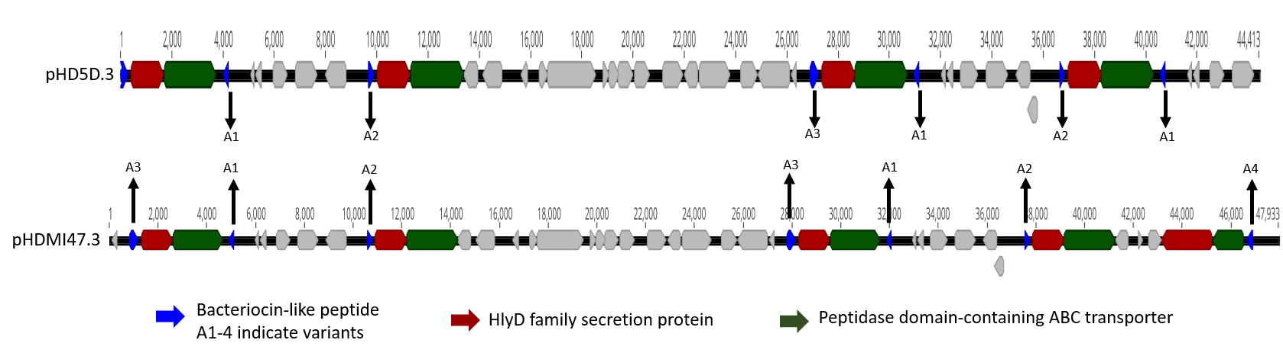
Figure S2. Genomes of bacteriocin-containing plasmids unique to B-strain H. defensa. Repeats of Type 1 secretion system components (HylD, ABC transporter) and up to four bacteriocins variants are present on each plasmid.

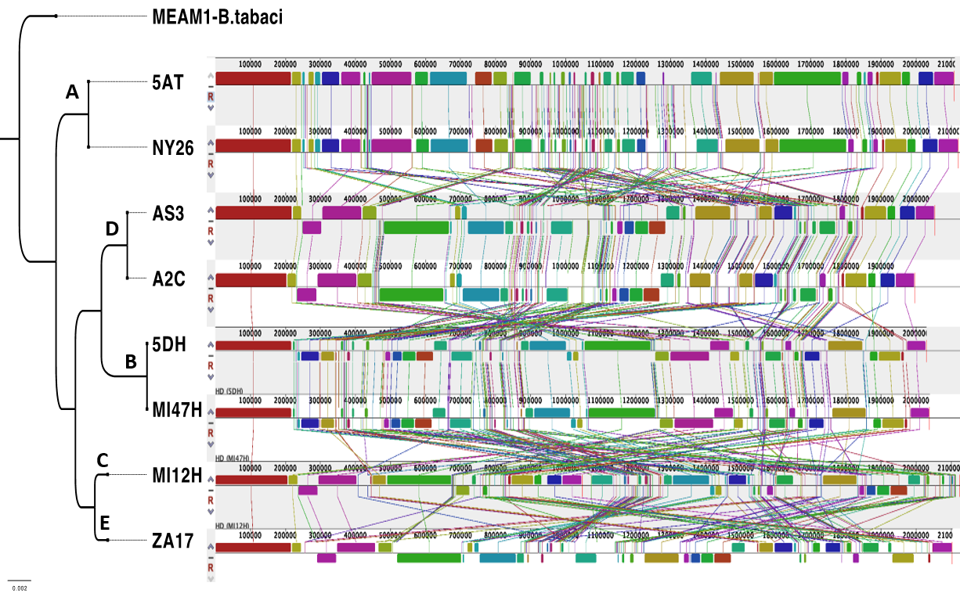
Figure S3. Mauve alignment showing that within-clade genomes highly similar in content and architecture, while among-clade strains vary in these respects.

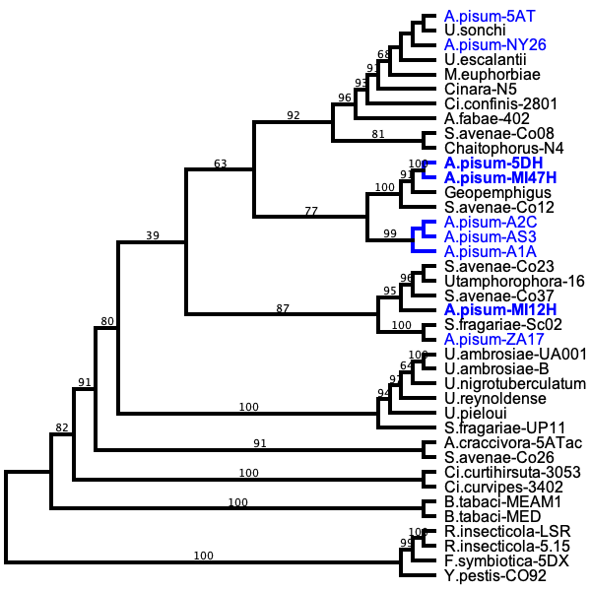
A
B
D
C
E

Figure S4. A maximum likelihood phylogenetic analysis of H. defensa isolates inferred from five partial single copy orthologous genes nucleotide sequences with partitioned model for each locus. Branch support indicated by 10,000 bootstrap replicates. Blue text indicates H. defensa isolates with sequenced genome.

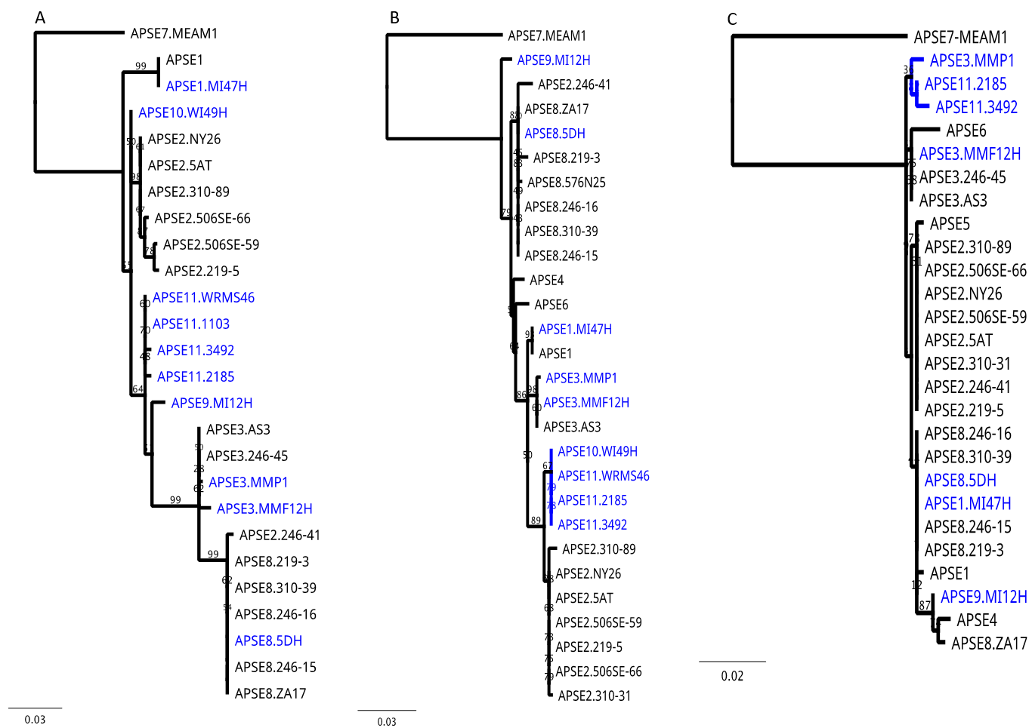

Figure S5. A maximum likelihood phylogenetic analysis of APSE (A) module 1:P51 gene (B) Module 2: P3gene (C) Module 4: P19 gene of APSE. Branch support indicated by 10,000 bootstrap replicates. Blue text indicates isolates new to this study.

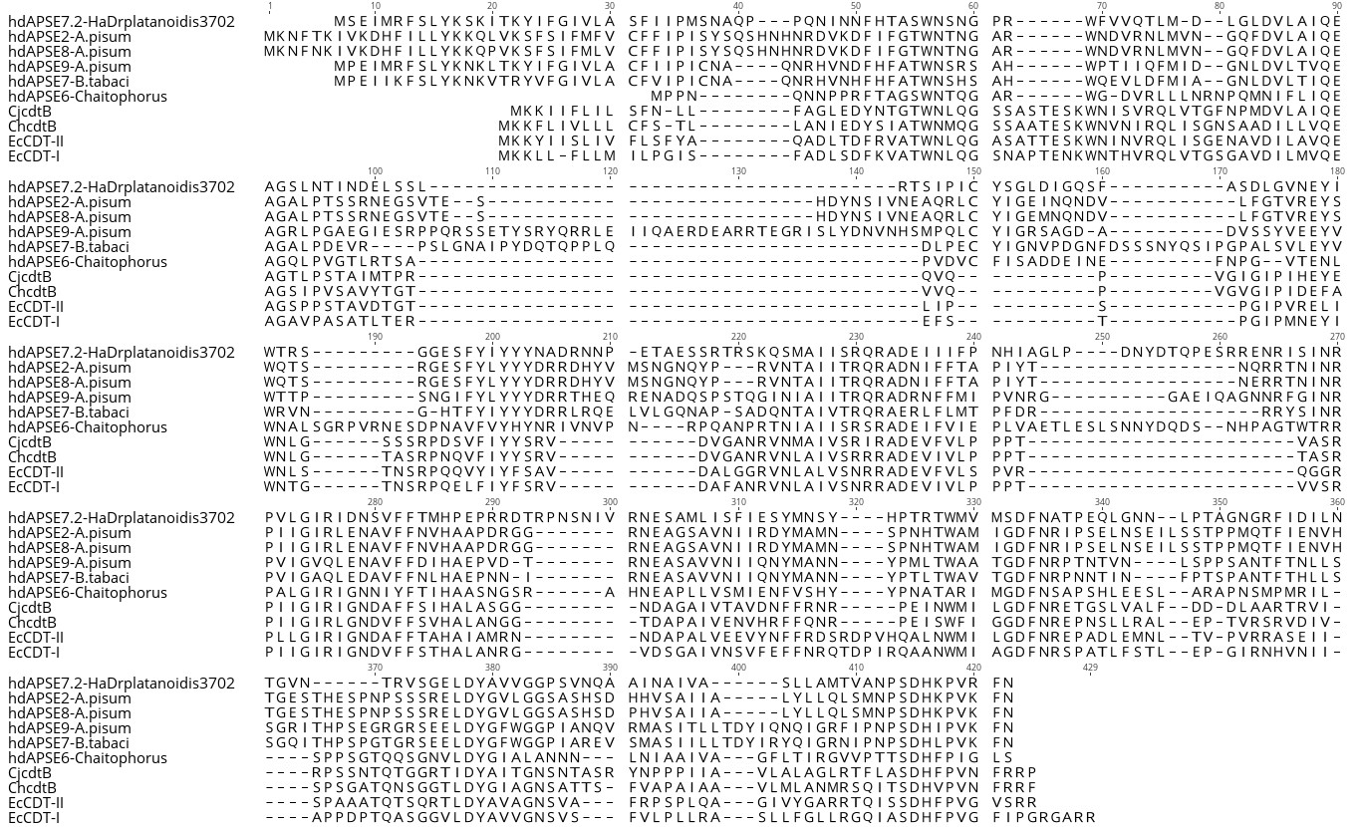

Figure S6. Amino acid sequences of CdtB from H. defensa and other bacteria aligned by using Maftt L-INS-I strategy along with scoring matrix BLOSUM62. Key active residues (boxes and arrows) are conserved in otherwise dissimilar alleles.

Table S10: Data from parasitism assays
Assay 1 | E8, B8 and B10 vs uninfected control (all same aphid genotype = 5DAB)
code | aphid line | mummy | aphids | mortality
UC | 5DAB | 9 | 3 | 8
UC | 5DAB | 11 | 2 | 7
UC | 5DAB | 16 | 3 | 1
UC | 5DAB | 14 | 3 | 7
UC | 5DAB | 18 | 2 | 0
UC | 5DAB | 12 | 1 | 7
UC | 5DAB | 18 | 0 | 1
UC | 5DAB | 10 | 2 | 8
E8 | ZA17 | 11 | 4 | 5
E8 | ZA17 | 10 | 4 | 6
E8 | ZA17 | 1 | 8 | 11
E8 | ZA17 | 4 | 7 | 9
E8 | ZA17 | 9 | 5 | 7
E8 | ZA17 | 6 | 5 | 8
E8 | ZA17 | 8 | 5 | 7
E8 | ZA17 | 9 | 9 | 2
E8 | ZA17 | 11 | 5 | 4
B8 | 5DH | 5 | 4 | 11
B8 | 5DH | 4 | 6 | 10
B8 | 5DH | 9 | 5 | 6
B8 | 5DH | 6 | 4 | 10
B8 | 5DH | 7 | 2 | 11
B8 | 5DH | 6 | 9 | 5
B8 | 5DH | 4 | 12 | 4
B8 | 5DH | 5 | 6 | 9
B8 | 5DH | 6 | 9 | 5
B8 | 5DH | 5 | 5 | 10
B10 | WI49H | 6 | 10 | 4
B10 | WI49H | 6 | 11 | 3
B10 | WI49H | 6 | 11 | 3
B10 | WI49H | 0 | 14 | 6
B10 | WI49H | 1 | 16 | 3
B10 | WI49H | 1 | 11 | 8
B10 | WI49H | 0 | 6 | 14
B10 | WI49H | 3 | 6 | 11
B10 | WI49H | 4 | 12 | 4
B10 | WI49H | 0 | 17 | 3
Assay 1B | B3 vs. uninfected control (all same aphid genotype = 5DAB)
code | aphid line | mummies | aphids alive | dual mortality
UC2 | 5DAB | 16 | 2 | 2
UC2 | 5DAB | 13 | 3 | 4
UC2 | 5DAB | 17 | 0 | 3
UC2 | 5DAB | 13 | 4 | 3
UC2 | 5DAB | 13 | 3 | 4
UC2 | 5DAB | 17 | 1 | 2
UC2 | 5DAB | 9 | 7 | 4
UC2 | 5DAB | 15 | 4 | 1
B3 | MMP1 | 14 | 7 | 0
B3 | MMP1 | 11 | 4 | 5
B3 | MMP1 | 14 | 5 | 1
B3 | MMP1 | 10 | 4 | 6
B3 | MMP1 | 6 | 11 | 3
B3 | MMP1 | 11 | 4 | 5
B3 | MMP1 | 10 | 4 | 6
B3 | MMP1 | 10 | 5 | 5
Assay 2 | B1 vs uninfected control in MI47AB aphid genotype
code | aphid line | mummies | aphids alive | dual mortality
UC | MI47HAB | 13 | 3 | 4
UC | MI47HAB | 18 | 1 | 1
UC | MI47HAB | 10 | 3 | 7
UC | MI47HAB | 15 | 3 | 2
UC | MI47HAB | 12 | 5 | 3
UC | MI47HAB | 16 | 2 | 2
UC | MI47HAB | 18 | 2 | 0
UC | MI47HAB | 17 | 3 | 0
B1 | MI47H | 0 | 10 | 10
B1 | MI47H | 0 | 18 | 2
B1 | MI47H | 0 | 12 | 8
B1 | MI47H | 0 | 18 | 2
B1 | MI47H | 0 | 20 | 0
B1 | MI47H | 0 | 10 | 10
B1 | MI47H | 0 | 14 | 6
B1 | MI47H | 0 | 20 | 0
Assay 3 | C9 vs UC control (AS3AB genotype)
code | aphid line | mummies | aphids alive | dual mortality
UC | AS3AB | 19 | 2 | 0
UC | AS3AB | 16 | 1 | 3
UC | AS3AB | 11 | 3 | 6
UC | AS3AB | 19 | 1 | 0
UC | AS3AB | 14 | 4 | 2
UC | AS3AB | 20 | 0 | 0
UC | AS3AB | 16 | 0 | 4
UC | AS3AB | 15 | 0 | 5
UC | AS3AB | 15 | 0 | 5
UC | AS3AB | 17 | 4 | 0
C9 | MI12H-AS3AB | 0 | 13 | 7
C9 | MI12H-AS3AB | 0 | 15 | 5
C9 | MI12H-AS3AB | 0 | 20 | 0
C9 | MI12H-AS3AB | 0 | 15 | 5
C9 | MI12H-AS3AB | 0 | 15 | 5
C9 | MI12H-AS3AB | 1 | 20 | 0
C9 | MI12H-AS3AB | 0 | 18 | 2
C9 | MI12H-AS3AB | 1 | 17 | 2
C9 | MI12H-AS3AB | 1 | 15 | 4
Assay 3B | C9 vs UC (2I84AB genotype)
code | aphid line | mummies | aphids alive | dual mortality
UC | 2184AB | 12 | 0 | 8
UC | 2184AB | 10 | 0 | 10
UC | 2184AB | 10 | 0 | 10
UC | 2184AB | 11 | 0 | 9
UC | 2184AB | 12 | 0 | 8
UC | 2184AB | 9 | 0 | 11
UC | 2184AB | 11 | 0 | 9
UC | 2184AB | 12 | 0 | 8
C9 | 2184H | 0 | 6 | 14
C9 | 2184H | 0 | 8 | 12
C9 | 2184H | 0 | 8 | 12
C9 | 2184H | 1 | 8 | 11
C9 | 2184H | 0 | 7 | 13
C9 | 2184H | 0 | 8 | 12
C9 | 2184H | 0 | 8 | 12
C9 | 2184H | 0 | 5 | 15

