Supplementary data 1

What is in the fish? Collaborative trial in suspect and non-target screening of organic micropollutants using LC- and GC-HRMS

Wiebke Dürig^{a,‡}, Sofia Lindblad^{a,‡}, Oksana Golovkoª, Georgios Gkotsis^{b}, Reza Aalizadeh^{b}, Maria-Christina Nika^{b}, Nikolaos Thomaidis^{b}, Nikiforos A. Alygizakis^{b, c}, Merle Plassmann^{d}, Peter Haglund^{e}, Qiuguo Fu^{f,g}, Juliane Hollender^{f,h}, Jade Chaker^{i}, Arthur David^{i}, Uwe Kunkel^{j}, André Macherius^{j}, Lidia Belova^{k}, Giulia Poma^{k}, Hugues Preud’Homme^{l}, Catherine Munschy^{m}, Yann Aminot^{m}, Carsten Jaeger^{n}, Jan Lisec^{n}, Martin Hansenº, Katrin Vorkampº, Linyan Zhuº, Francesca Cappelli^{p}, Claudio Roscioli^{p}, Sara Valsecchi^{p}, Renzo Bagnati^{q}, Belén González^{r,s}, Ailette Prieto^{r,s}, Olatz Zuloaga^{r,s}, Ruben Gil-Solsona^{t,u,v}, Pablo Gago-Ferrero^{t,v}, Sara Rodriguez-Mozaz^{t,u}, Hélène Budzinski^{w}, Marie-Helene Devier^{w}, Georg Dierkes^{x}, Lise Boulard^{x,y}, Griet Jacobs^{z}, Stefan Voorspoels^{z}, Heinz Rüdel^{zz} and Lutz Ahrensª*

ªDepartment of Aquatic Sciences and Assessment, Swedish University of Agricultural Sciences - (SLU), Box 7050, 75007 Uppsala, Sweden
^{b}Department of Chemistry, National and Kapodistrian University of Athens, 15771 Athens, Greece
^{c}Environmental Institute, Okružná 784/42, 97241 Koš, Slovakia
^{d}Department of Environmental Science, Stockholm University, 10691 Stockholm, Sweden
^{e}Department of Chemistry, Chemical Biological Centre (KBC), Umeå University, Linnaeus väg 6, 90187 Umeå, Sweden
^{f}Eawag: Swiss Federal Institute of Aquatic Science and Technology, Überlandstrasse 133, 8600 Dübendorf, Switzerland
^{g}Helmholtz Centre for Environmental Research - UFZ, Permoserstraße 15, 04318 Leipzig, Germany
^{h}Institute of Biogeochemistry and Pollutant Dynamics, ETH Zürich, Universitätstrasse 16, 8092 Zürich, Switzerland
^{i}Université de Rennes, Inserm, EHESP, Irset - UMR_S, 1085 Rennes, France
^{j}Bavarian Environment Agency, Bürgermeister-Ulrich-Straße 160, 86179 Augsburg, Germany
^{k}Toxicological Centre, University of Antwerp, Universiteitsplein 1, 2610 Wilrijk, Belgium
^{l}IPREM-UMR5254, E2S UPPA, CNRS, 2 avenue Angot, 64053 Pau cedex, France
^{m}Ifremer, CCEM Contamination Chimique des Écosystèmes Marins, 44000, Nantes, France
^{n}Bundesanstalt für Materialforschung und -prüfung (BAM), Analytical Chemistry, Richard-Willstätter-Straße 11, 12489 Berlin, Germany
ºDepartment of Environmental Science, Aarhus University, Frederiksborgvej 399, 4000 Roskilde, Denmark
^{p}Water Research Institute, National Research Council of Italy, Via del Mulino 19, 20861 Brugherio MB, Italy
^{q}Department of Environmental Health Sciences, Istituto di Ricerche Farmacologiche Mario Negri IRCCS, Via Mario Negri 2, 20156 Milan, Italy
^{r}Department of Analytical Chemistry, Faculty of Science and Technology, University of the Basque Country (UPV/EHU), Barrio Sarriena s/n, 48940 Leioa, Spain
^{s}Research Centre for Experimental Marine Biology and Biotechnology (PIE), University of the Basque Country (UPV/EHU), Plentzia, Spain
^{t}Catalan Institute for Water Research (ICRA), Carrer Emili Grahit 101, 17003 Girona, Spain
^{u}Universitat de Girona, Girona, Spain
^{v}Institute of Environmental Assessment and Water Research – Severo Ochoa Excellence Center (IDAEA), Spanish Council of Scientific Research (CSIC), Barcelona 08034, Spain.
^{w}University Bordeaux, CNRS, Bordeaux INP, EPOC, UMR 5805, 33600 Pessac, France
^{x}Federal Institute of Hydrology, Am Mainzer Tor 1, 56068 Koblenz, Germany
^{y}Metabolomics Core Facility, Centre de Ressources et Recherches Technologiques (C2RT), Institut Pasteur, 25-28 Rue du Dr Roux, 75015 Paris, France
^{z}Flemish Institute for Technological Research (VITO), Unit Separation and Conversion Technology, Boeretang 200, 2400 Mol, Belgium
^{zz}Fraunhofer Institute for Molecular Biology and Applied Ecology (Fraunhofer IME), Auf dem Aberg 1, 57392 Schmallenberg, Germany
‡These authors contributed equally to the work.
*Corresponding author: lutz.ahrens@slu.se

Table of Contents
1. Compounds used for spiking 3
2. General information on methods for analysis 8
3. Reference methods for extract preparation 13
4. In-house methods for extract preparation 14
5.1. In-house methods for extracts to be analysed by LC-HRMS 16
5.2. In-house methods for extracts to be analysed by GC-HRMS 24
6. Workflows for suspect and non-target screening 25
7. Detection of compounds from spiked samples 45
8. Detection of compounds from samples of Teltow Canal 48
9. Detection of compounds from samples of Lake Stechlin 53
References 58

1. Compounds used for spiking
Table S1. Information on the compounds used to spike freeze-dried fish tissue samples from the reference lake prior to extraction with the reference method. First is indicated whether the compound was used for spiking of samples for liquid or gas chromatography, followed by compound name, CAS number, molecular formula, SMILES annotation, monoisotopic mass, InChI annotation and predicted log K_{ow} via EPI Suite. A row highlighted with light grey indicates that the compound was known to the participants prior to analysis.
LC/GC | Compound name | CAS number | Mol. formula | SMILES | Monoisotopic mass | InChI | Predicted log K_{ow}
GC | Alachlor | 15972-60-8 | C₁₄H₂₀ClNO₂ | CCc1cccc(c1N(COC)C(=O)CCl)CC | 269.1183 | InChI=1S/C14H20ClNO2/c1-4-11-7-6-8-12(5-2)14(11)16(10-18-3)13(17)9-15/h6-8H,4-5,9-10H2,1-3H3 | 3.37
GC | Benzene, (1-ethyldecyl)- | 2400-00-2 | C₁₈H₃₀ | CCCCCCCCCC(CC)c1ccccc1 | 246.2348 | InChI=1S/C18H30/c1-3-5-6-7-8-9-11-14-17(4-2)18-15-12-10-13-16-18/h10,12-13,15-17H,3-9,11,14H2,1-2H3 | 7.87
GC | Bisphenol G | 127-54-8 | C₂₁H₂₈O₂ | CC(C)c1cc(ccc1O)C(C)(C)c2ccc(c(c2)C(C)C)O | 312.2089 | InChI=1S/C21H28O2/c1-13(2)17-11-15(7-9-19(17)22)21(5,6)16-8-10-20(23)18(12-16)14(3)4/h7-14,22-23H,1-6H3 | 6.55
GC | Chlorfenvinphos | 470-90-6 | C₁₂H₁₄Cl₃O₄P | CCOP(=O)(OCC)O/C(=C\Cl)/c1ccc(cc1Cl)Cl | 357.9695 | InChI=1S/C12H14Cl3O4P/c1-3-17-20(16,18-4-2)19-12(8-13)10-6-5-9(14)7-11(10)15/h5-8H,3-4H2,1-2H3/b12-8- | 4.15
GC | Chlorpyrifos | 2921-88-2 | C₉H₁₁Cl₃NO₃PS | CCOP(=S)(OCC)Oc1c(cc(c(n1)Cl)Cl)Cl | 348.9263 | InChI=1S/C9H11Cl3NO3PS/c1-3-14-17(18,15-4-2)16-9-7(11)5-6(10)8(12)13-9/h5H,3-4H2,1-2H3 | 5.11
GC | 1-Chlorononane | 2473-01-0 | C₉H₁₉Cl | CCCCCCCCCCl | 162.1175 | InChI=1S/C9H19Cl/c1-2-3-4-5-6-7-8-9-10/h2-9H2,1H3 | 5.02
GC | 1-Chloropyrene | 34244-14-9 | C₁₆H₉Cl | c1cc2ccc3ccc(c4c3c2c(c1)cc4)Cl | 236.0393 | InChI=1S/C16H9Cl/c17-14-9-7-12-5-4-10-2-1-3-11-6-8-13(14)16(12)15(10)11/h1-9H | 5.58
GC | Decabromodiphenyl ether | 1163-19-5 | C₁₂Br₁₀O | c1(c(c(c(c(c1Br)Br)Br)Br)Br)Oc2c(c(c(c(c2Br)Br)Br)Br)Br | 949.1783 | InChI=1S/C12Br10O/c13-1-3(15)7(19)11(8(20)4(1)16)23-12-9(21)5(17)2(14)6(18)10(12)22 | 12.11
GC | Dibenzothiophene | 132-65-0 | C₁₂H₈S | c1ccc2c(c1)c3ccccc3s2 | 184.0347 | InChI=1S/C12H8S/c1-3-7-11-9(5-1)10-6-2-4-8-12(10)13-11/h1-8H | 0.17
GC | Diphenyl phthalate | 84-62-8 | C₂₀H₁₄O₄ | c1ccc(cc1)OC(=O)c2ccccc2C(=O)Oc3ccccc3 | 318.0892 | InChI=1S/C20H14O4/c21-19(23-15-9-3-1-4-10-15)17-13-7-8-14-18(17)20(22)24-16-11-5-2-6-12-16/h1-14H | 4.1
GC | Hexabromobenzene | 87-82-1 | C₆Br₆ | c1(c(c(c(c(c1Br)Br)Br)Br)Br)Br | 545.5100 | InChI=1S/C6Br6/c7-1-2(8)4(10)6(12)5(11)3(1)9 | 7.33
GC | Musk Tibeten | 145-39-1 | C₁₃H₁₈N₂O₄ | Cc1c(c(c(c(c1C)[N+](=O)[O-])C(C)(C)C)[N+](=O)[O-])C | 266.1267 | InChI=1S/C13H18N2O4/c1-7-8(2)11(14(16)17)10(13(4,5)6)12(9(7)3)15(18)19/h1-6H3 | 5.18
GC | n-Butylbenzenesulfonamide | 3622-84-2 | C₁₀H₁₅NO₂S | CCCCNS(=O)(=O)c1ccccc1 | 213.0823 | InChI=1S/C10H15NO2S/c1-2-3-9-11-14(12,13)10-7-5-4-6-8-10/h4-8,11H,2-3,9H2,1H3 | 2.31
GC | 2,4,6-tribromoanisole | 607-99-8 | C₇H₅Br₃O | COc1c(cc(cc1Br)Br)Br | 341.7891 | InChI=1S/C7H5Br3O/c1-11-7-5(9)2-4(8)3-6(7)10/h2-3H,1H3 | 4.74
GC | Transeolide | 68140-48-7 | C₁₈H₂₆O | CC(C1=C(C)C=C(C(C)(C)C(C)C2C(C)C)C2=C1)=O | 258.1984 | InChI=1S/C18H26O/c1-10(2)17-12(4)18(6,7)16-8-11(3)14(13(5)19)9-15(16)17/h8-10,12,17H,1-7H3 | 6.31
GC | UV-327 | 3864-99-1 | C₂₀H₂₄ClNO₃ | CC(C)(C)c1cc(c(c(c1)n2nc3ccc(cc3n2)Cl)O)C(C)(C)C | 357.1608 | InChI=1S/C20H24ClN3O/c1-19(2,3)12-9-14(20(4,5)6)18(25)17(10-12)24-22-15-8-7-13(21)11-16(15)23-24/h7-11,25H,1-6H3 | 6.91
GC | Dieldrin | 60-57-1 | C₁₂H₈Cl₆O | C1C2C3C(C1C4C2O4)C5(C(=C(C3(C5(Cl)Cl)Cl)Cl)Cl)Cl | 377.8706 | InChI=1S/C12H8Cl6O/c13-8-9(14)11(16)5-3-1-2(6-7(3)19-6)4(5)10(8,15)12(11,17)18/h2-7H,1H2/t2-,3+,4+,5-,6-,7+,10+,11- | 5.45
GC | β-HCH | 58-89-9 | C₆H₆Cl₆ | C1(C(C(C(C(C1Cl)Cl)Cl)Cl)Cl)Cl | 287.8601 | InChI=1S/C6H6Cl6/c7-1-2(8)4(10)6(12)5(11)3(1)9/h1-6H | 5.26
GC | Hexachlorobenzene | 118-74-1 | C₆Cl₆ | C1(=C(C(=C(C(=C1Cl)Cl)Cl)Cl)Cl)Cl | 281.8131 | InChI=1S/C6Cl6/c7-1-2(8)4(10)6(12)5(11)3(1)9 | 5.86
LC | Natamycin | 7681-93-8 | C₃₃H₄₇NO₁₃ | [H][C@@]12C[C@H](O)C[C@]3(O)C[C@H](O)[C@@H](C(O)=O)[C@]([H])(C[C@@H](O[C@]4(C)O[C@H](C)[C@@H](O)[C@H](N)[C@@H]4O)\C=C\C=C\C=C\C=C\C[C@@H](C)OC(=O)\C=C\[C@H]1O2)O3 | 679.3204 | InChI=1S/C34H49NO13/c1-19-11-9-7-5-4-6-8-10-12-22(47-33(3)31(40)29(35)30(39)20(2)46-33)16-26-28(32(41)42)23(37)18-34(43,48-26)17-21(36)15-25-24(45-25)13-14-27(38)44-19/h4-10,12-14,19-26,28-31,36-37,39-40,43H,11,15-18,35H2,1-3H3,(H,41,42)/b5-4+,8-6+,9-7+,12-10+,14-13+/t19-,20-,21+,22+,23+,24-,25-,26+,28-,29+,30-,31+,33+,34-/m1/s1 | -2.51
LC | Metronidazole-OH | 4812-40-2 | C₆H₉N₃O₄ | OCCN1C(CO)=NC=C1[N+]([O-])=O | 187.0593 | InChI=1S/C6H9N3O4/c10-2-1-8-5(4-11)7-3-6(8)9(12)13/h3,10-11H,1-2,4H2 | -1.06
LC | Benzothiazole-2-sulfonaic acid (BTSA) potassium | 941-57-1 | C₇H₅NO₃S₂ | C1=CC=C2C(=C1)N=C(S2)S(=O)(=O)O | 214.9711 | InChI=1S/C7H5NO3S2/c9-13(10,11)7-8-5-3-1-2-4-6(5)12-7/h1-4H,(H,9,10,11) | -0.99
LC | 1,3-Dichloro-5,5-dimethylhydantoin | 118-52-5 | C₅H₆Cl₂N₂O₂ | CC1(C)N(Cl)C(=O)N(Cl)C1=O | 195.9806 | InChI=1S/C5H6Cl2N2O2/c1-5(2)3(10)8(6)4(11)9(5)7/h1-2H3 | -0.94
LC | 4-Amino-6-(trifluoromethyl)benzene-1,3-disulfonamide (2,4-disulfamyl-5-trifluoromethylaniline) | 654-62-6 | C₇H₈F₃N₃O₄S₂ | NC1=C(C=C(C(=C1)C(F)(F)F)S(N)(=O)=O)S(N)(=O)=O | 318.9908 | InChI=1S/C7H8F3N3O4S2/c8-7(9,10)3-1-4(11)6(19(13,16)17)2-5(3)18(12,14)15/h1-2H,11H2,(H2,12,14,15)(H2,13,16,17) | -0.19
LC | Sparfloxacin | 110871-86-8 | C₁₉H₂₂F₂N₄O₃ | C[C@H]1CN(C[C@@H](C)N1)C1=C(F)C2=C(C(N)=C1F)C(=O)C(=CN2C1CC1)C(O)=O | 392.1660 | InChI=1S/C19H22F2N4O3/c1-8-5-24(6-9(2)23-8)17-13(20)15(22)12-16(14(17)21)25(10-3-4-10)7-11(18(12)26)19(27)28/h7-10,23H,3-6,22H2,1-2H3,(H,27,28)/t8-,9+ | 0.12
LC | Sulisobenzone | 4065-45-6 | C₁₄H₁₂O₆S | COC1=C(C=C(C(=O)C2=CC=CC=C2)C(O)=C1)S(O)(=O)=O | 308.0355 | InChI=1S/C14H12O6S/c1-20-12-8-11(15)10(7-13(12)21(17,18)19)14(16)9-5-3-2-4-6-9/h2-8,15H,1H3,(H,17,18,19) | 0.37
LC | 2,6-Dichlorobenzamide (BAM) | 2008-58-4 | C₇H₅Cl₂NO | NC(=O)C1=C(Cl)C=CC=C1Cl | 188.9748 | InChI=1S/C7H5Cl2NO/c8-4-2-1-3-5(9)6(4)7(10)11/h1-3H,(H2,10,11) | 0.9
LC | Dazomet | 533-74-4 | C₅H₁₀N₂S₂ | CN1CSC(=S)N(C)C1 | 162.0285 | InChI=1S/C5H10N2S2/c1-6-3-7(2)5(8)9-4-6/h3-4H2,1-2H3 | 0.94
LC | Ifosfamide | 3778-73-2 | C₇H₁₅Cl₂N₂O₂P | ClCCNP1(=O)OCCCN1CCCl | 260.0248 | InChI=1S/C7H15Cl2N2O2P/c8-2-4-10-14(12)11(6-3-9)5-1-7-13-14/h1-7H2,(H,10,12) | 0.97
LC | 4-(Trifluoromethyl) benzenesulfonamide | 830-43-3 | C₇H₆F₃NO₂S | NS(=O)(=O)C1=CC=C(C=C1)C(F)(F)F | 225.0071 | InChI=1S/C7H6F3NO2S/c8-7(9,10)5-1-3-6(4-2-5)14(11,12)13/h1-4H,(H2,11,12,13) | 1.33
LC | Amidotrizoic acid | 117-96-4 | C₁₁H₉I₃N₂O₄ | CC(=O)NC1=C(I)C(C(O)=O)=C(I)C(NC(C)=O)=C1I | 613.7697 | InChI=1S/C11H9I3N2O4/c1-3(17)15-9-6(12)5(11(19)20)7(13)10(8(9)14)16-4(2)18/h1-2H3,(H,15,17)(H,16,18)(H,19,20) | 1.37
LC | Chlorzoxazone | 95-25-0 | C₇H₄ClNO₂ | ClC1=CC=C2OC(=O)NC2=C1 | 168.9931 | InChI=1S/C7H4ClNO2/c8-4-1-2-6-5(3-4)9-7(10)11-6/h1-3H,(H,9,10) | 1.59
LC | Clopyralid | 1702-17-6 | C₆H₃Cl₂NO₂ | OC(=O)C1=C(Cl)C=CC(Cl)=N1 | 190.9541 | InChI=1S/C6H3Cl2NO2/c7-3-1-2-4(8)9-5(3)6(10)11/h1-2H,(H,10,11) | 1.63
LC | Pentafluorobenzoic acid | 602-94-8 | C₇HF₅O₂ | OC(=O)C1=C(F)C(F)=C(F)C(F)=C1F | 211.9897 | InChI=1S/C7HF5O2/c8-2-1(7(13)14)3(9)5(11)6(12)4(2)10/h(H,13,14) | 1.78
LC | Perfluorobutyric acid (PFBA) | 375-22-4 | C₄HF₇O₂ | OC(=O)C(F)(F)C(F)(F)C(F)(F)F | 213.9865 | InChI=1S/C4HF7O2/c5-2(6,1(12)13)3(7,8)4(9,10)11/h(H,12,13) | 2.14
LC | Malathion | 121-75-5 | C₁₀H₁₉O₆PS₂ | CCOC(=O)CC(SP(=S)(OC)OC)C(=O)OCC | 330.0361 | InChI=1S/C10H19O6PS2/c1-5-15-9(11)7-8(10(12)16-6-2)19-17(18,13-3)14-4/h8H,5-7H2,1-4H3 | 2.29
LC | Bicalutamide | 90357-06-5 | C₁₈H₁₄F₄N₂O₄S | CC(O)(CS(=O)(=O)C1=CC=C(F)C=C1)C(=O)NC1=CC(=C(C=C1)C#N)C(F)(F)F | 430.0610 | InChI=1S/C18H14F4N2O4S/c1-17(26,10-29(27,28)14-6-3-12(19)4-7-14)16(25)24-13-5-2-11(9-23)15(8-13)18(20,21)22/h2-8,26H,10H2,1H3,(H,24,25) | 2.3
LC | Carbaryl | 63-25-2 | C₁₂H₁₁NO₂ | CNC(=O)OC1=C2C=CC=CC2=CC=C1 | 201.0790 | InChI=1S/C12H11NO2/c1-13-12(14)15-11-8-4-6-9-5-2-3-7-10(9)11/h2-8H,1H3,(H,13,14) | 2.35
LC | Pyrimethamine | 58-14-0 | C₁₂H₁₃ClN₄ | CCC1=NC(N)=NC(N)=C1C1=CC=C(Cl)C=C1 | 248.0829 | InChI=1S/C12H13ClN4/c1-2-9-10(11(14)17-12(15)16-9)7-3-5-8(13)6-4-7/h3-6H,2H2,1H3,(H4,14,15,16,17) | 2.41
LC | Daidzein | 486-66-8 | C₁₅H₁₀O₄ | OC1=CC=C(C=C1)C1=COC2=C(C=CC(O)=C2)C1=O | 254.0579 | InChI=1S/C15H10O4/c16-10-3-1-9(2-4-10)13-8-19-14-7-11(17)5-6-12(14)15(13)18/h1-8,16-17H | 2.55
LC | Mebendazole | 31431-39-7 | C₁₆H₁₃N₃O₃ | COC(=O)NC1=NC2=C(N1)C=CC(=C2)C(=O)C1=CC=CC=C1 | 295.0957 | InChI=1S/C16H13N3O3/c1-22-16(21)19-15-17-12-8-7-11(9-13(12)18-15)14(20)10-5-3-2-4-6-10/h2-9H,1H3,(H2,17,18,19,21) | 2.71
LC | Dichlofluanid | 1085-98-9 | C₉H₁₁Cl₂FN₂O₂S₂ | CN(C)S(=O)(=O)N(SC(F)(Cl)Cl)C1=CC=CC=C1 | 331.9623 | InChI=1S/C9H11Cl2FN2O2S2/c1-13(2)18(15,16)14(17-9(10,11)12)8-6-4-3-5-7-8/h3-7H,1-2H3 | 2.72
LC | Triadimefon | 43121-43-3 | C₁₄H₁₆ClN₃O₂ | CC(C)(C)C(=O)C(OC1=CC=C(Cl)C=C1)N1C=NC=N1 | 293.0931 | InChI=1S/C14H16ClN3O2/c1-14(2,3)12(19)13(18-9-16-8-17-18)20-11-6-4-10(15)5-7-11/h4-9,13H,1-3H3 | 2.94
LC | Fenpiclonil | 74738-17-3 | C₁₁H₆Cl₂N₂ | ClC1=CC=CC(C2=CNC=C2C#N)=C1Cl | 235.9908 | InChI=1S/C11H6Cl2N2/c12-10-3-1-2-8(11(10)13)9-6-15-5-7(9)4-14/h1-3,5-6,15H | 3.48
LC | Diflufenican | 83164-33-4 | C₁₉H₁₁F₅N₂O₂ | FC1=CC=C(NC(=O)C2=C(OC3=CC(=CC=C3)C(F)(F)F)N=CC=C2)C(F)=C1 | 394.0741 | InChI=1S/C19H11F5N2O2/c20-12-6-7-16(15(21)10-12)26-17(27)14-5-2-8-25-18(14)28-13-4-1-3-11(9-13)19(22,23)24/h1-10H,(H,26,27) | 3.53
LC | Ketoconazole | 65277-42-1 | C₂₆H₂₈Cl₂N₄O₄ | CC(=O)N1CCN(CC1)C1=CC=C(OC[C@H]2CO[C@@](CN3C=CN=C3)(O2)C2=CC=C(Cl)C=C2Cl)C=C1 | 530.1488 | InChI=1S/C26H28Cl2N4O4/c1-19(33)31-10-12-32(13-11-31)21-3-5-22(6-4-21)34-15-23-16-35-26(36-23,17-30-9-8-29-18-30)24-7-2-20(27)14-25(24)28/h2-9,14,18,23H,10-13,15-17H2,1H3/t23-,26-/m0/s1 | 4.45
LC | Chloroquine phosphate | 50-63-5 | C₁₈H₃₂ClN₃O₈P₂ | CCN(CCCC(NC1=C2C=CC(Cl)=CC2=NC=C1)C)CC | 319.1815 | InChI=1S/C18H26ClN3/c1-4-22(5-2)12-6-7-14(3)21-17-10-11-20-18-13-15(19)8-9-16(17)18/h8-11,13-14H,4-7,12H2,1-3H3,(H,20,21) | 4.5
LC | Glimepiride | 93479-97-1 | C₂₄H₃₄N₄O₅S | CCC1=C(C)CN(C(=O)NCCC2=CC=C(C=C2)S(=O)(=O)NC(=O)N[C@H]2CC[C@H](C)CC2)C1=O | 490.2250 | InChI=1S/C24H34N4O5S/c1-4-21-17(3)15-28(22(21)29)24(31)25-14-13-18-7-11-20(12-8-18)34(32,33)27-23(30)26-19-9-5-16(2)6-10-19/h7-8,11-12,16,19H,4-6,9-10,13-15H2,1-3H3,(H,25,31)(H2,26,27,30)/t16-,19- | 4.7
LC | Glybenclamide | 10238-21-8 | C₂₃H₂₈ClN₃O₅S | COC1=C(C=C(Cl)C=C1)C(=O)NCCC1=CC=C(C=C1)S(=O)(=O)NC(=O)NC1CCCCC1 | 493.1438 | InChI=1S/C23H28ClN3O5S/c1-32-21-12-9-17(24)15-20(21)22(28)25-14-13-16-7-10-19(11-8-16)33(30,31)27-23(29)26-18-5-3-2-4-6-18/h7-12,15,18H,2-6,13-14H2,1H3,(H,25,28)(H2,26,27,29) | 4.79
LC | N-ethyl -1,1,2,2,3,3,4,4,5,5,6,6,7,7,8,8,8-heptadecafluoro-n-(2-hydroxytheyl)octane-1-sulphona (EtFOSA) | 4151-50-2 | C₁₀H₆F₁₇NO₂S | CCNS(=O)(=O)C(C(C(C(C(C(C(C(F)(F)F)(F)F)(F)F)(F)F)(F)F)(F)F)(F)F)(F)F | 526.9848 | InChI=1S/C10H6F17NO2S/c1-2-28-31(29,30)10(26,27)8(21,22)6(17,18)4(13,14)3(11,12)5(15,16)7(19,20)9(23,24)25/h28H,2H2,1H3 | 6.76
LC | Tris(4-tert-butylphenyl) phosphate (TBPP) | 78-33-1 | C₃₀H₃₉O₄P | CC(C)(C)C1=CC=C(C=C1)OP(=O)(OC2=CC=C(C=C2)C(C)(C)C)OC3=CC=C(C=C3)C(C)(C)C | 494.2586 | InChI=1S/C30H39O4P/c1-28(2,3)22-10-16-25(17-11-22)32-35(31,33-26-18-12-23(13-19-26)29(4,5)6)34-27-20-14-24(15-21-27)30(7,8)9/h10-21H,1-9H3 | 10.43

2. General information on methods for analysis
Table S2. Summary of liquid chromatographic methods used by the participants.
Participant | Instrument and model | Column | Dimensions  (mm x mm, µm) | Mobile phase  (Aqueous phase / organic phase) | Injection volume (µL) | Flow; run time (mL min⁻¹); (min)
A | Thermo Q Exactive | Agilent Zorbax Eclipse Plus C₁₈ | 2.1 x 150, 3.5 | H₂O + 0.1% FA/ MeOH +0.1% FA | 20 | 0.3
B | AB Sciex QToF-X500R | Acquity HSS T3 | 1.0 x 150, 1.8 | H₂O + 0.01% FA/ ACN +0.01% FA | 2 | 0.1
C | Thermo Q Exactive | Waters XBridge C₁₈ | 2.1 x 100, 3.5 | H₂O + 0.05% FA/ ACN | 4 | 0.2
D | Agilent QToF | InfinityLab Poroshell 120 EC-C₁₈ | 3.0 x 100, 2.7 | H₂O + 0.1% FA/ MeOH + 0.1% FA (ESI+)  H₂O + 5mM NH₄ac / MeOH + 5mM NH₄ac (ESI-) | 2 | 0.3
E | Thermo Q Exactive HF | PepMap RSLC, C₁₈ | 0.075 x 250, 2 | 2% ACN + 0.1% FA/ 98% ACN +0.1% FA | 1 | 0.0003
F | Thermo Orbitrap Q Exactive | Acquity UPLC C₁₈ | 2.1 x 10, 1.8 | H₂O + 0.1% FA/ MeOH + 0.1% FA | 5 | 0.3
H | Bruker UHPLC-QToF-MS | Acclaim RSLC C18 + guard column Acquity UPLC BEH C₁₈ 1.7 µm, VanGuard Pre-Ccolumn | 2.1 x 100, 2.2 | H₂O:MeOH (90:10) with 5 mM NH₄FA + 0.01%FA/ MeOH with 5 mM NH₄ FA + 0.01% FA (ESI +)  H₂O:MeOH (90:10) with 10 mM NH₄ac/ MeOH with 10 mM NH₄ac (ESI-) | 5 | 200 µL min⁻¹ at 0-3 min, 400 µL min⁻¹ at 14 min, 480 µL min⁻¹ at 16 min, 200 µL min⁻¹ at 16.1-20 min
I | Thermo Dionex Ultimate 3000 UHPLC/Q Exactive Focus Orbitrap | Kinetex XB-C₁₈ | 2.1 x 150, 2.6 | H₂O + 0.1% FA/ MeOH + 0.1% FA (ESI+)  H₂O + 5mM NH₄ac / MeOH + 5 mM NH₄ac (ESI-) | 5 | 0.3
K | Thermo Q Exactive Plus | Atlantis T3 | 3.0 x 100, 3.0 | H₂O + 0.1% FA/ MeOH + 0.1% FA (ESI+)  H₂O + 5mM NH₄fa / 95% MeOH/5% H₂O (5mM NH₄fa) (ESI-) | 200 µL extract in 200 mL H₂O with online-SPE | 0.3
L | Thermo Q Exactive HF | Thermo Hypersil Gold aQ C₁₈ | 2.1 x 100, 1.9 | H₂O + 0.1% FA/ ACN +0.1% FA | 5 | 0.25
M | AB Sciex Triple ToF 6600 | Zorbax C₁₈ | 2.1 x 150, 3.5 | H₂O + 0.1% FA/ ACN +0.1% FA | 100 | 0.3
N | Agilent LC/Q-ToF 6540 | Kinetex C₁₈ | 2.1 x 100, 1.7 | H₂O + 0.1% FA/ ACN +0.1% FA (ESI+)  H2O / ACN (ESI-) | 3 | 0.3
O | AB Sciex Triple ToF 6600 | Eclipse pluse C₁₈ | 2.1 x 50, 1.8 | H₂O + 0.1% FA/ ACN | 4 | 0.5
P | Thermo Orbitrap | Waters BEH C₁₈ | 2.1 x 100, 1.7 | H₂O:MeOH (90:10) with 5 mM NH₄ac + 0.01%FA/ MeOH with 5 mM NH₄ac + 0.01% FA (ESI +)  H₂O:MeOH (90:10) with 5 mM NH₄ac/ MeOH with 5 mM NH₄ac (ESI-) | 5 | 0.35
ACN = acetonitrile, H₂O = water, MeOH = methanol, FA = formic acid, NH₄ac = ammonium acetate, NH₄fa = ammonium formate, SPE = solid-phase extraction. Column temperatures ranged from 30 to 50 °C.

Table S3. Summary of mass spectrometric parameters and data processing procedures used by the participants for LC-HRMS analysis.
Participant | Scan range | Ionization | Fragment method | Target software | Suspect list for suspect screening | Suspect and non-target procedure
A | 100-1050 | ESI ± | HCD | Trace Finder | NormanNews2, SoffIdent (both norman-network.com, EFS HRAM Compound Database (ThermoFisher)) | Compound Discoverer, MS, MS/MS
B | 50-1100 | ESI + only | n/a | Sciex OS | PubChem, Web of Science, The Blood Exposome Database, Drugbank, exposome explorer, hmdb, Norman | MarkView, In-house annotation tool¹, PubChem, MassBank, MoNA, Metlin, MS, RT, RT prediction, Isotopic ratio, MS/MS, MetFrag, CFM-ID
C | 75-950 | ESI + only | CID | Compound Discoverer 3.1 | Norman SusDat | Compound Discoverer 3.1, MS isotope pattern, MzCloud library, ChemSpider, mass list search, in silico fragmentation MS2, RT prediction
D | 100-1700 | ESI ± | CID | MassHunter Qualitative Analysis B.07.00; MassHunter PCDL Manager B.08.00 | Norman SusDat | Profinder B.08.00, Mass Profiler Professional 15.0, MassBank, MS, RT, MS/MS, prediction of MS/MS, CFM-ID
E | 75-1000 | ESI ± | HCD | Compound Discoverer | n/a | Compound Discoverer, MS, MS/MS, Library comparison (MzCloud, In house, HighRes Lib., ChemSpider with in silico comparison), mzLogic, FISH
F | 66.7-1000 | ESI + only | HCD | Xcalibur | NORMAN EXPHRMSMSAVAL (7586 compounds) | Massbank, Metlin, MoNA, MS, fragment ions in DIA
H | 50-1000 | ESI ± | CID | Target Screener R package, MS, RT, MS/MS | Norman SusDat | AutoNon-Target R package, MS, RT, MS/MS, RT prediction, Exp. RTI match, Molecular Formula evaluation, MetFrag, FragPred, CMF-ID
I | 70-1050 | ESI ± | HCD | Trace Finder 4.1 | In-house database (>29 000 compounds, sources: KEMI Market list; STOFF-ident; Uni. Athens Surfactant and Suspect list; Uni. Jaume I; Eawag; Targ_Sus_NT_WID; UFZ; PFAS Suspect list; KWR; Antibiotic list; Cosmetic products; NORMAN priority list; Swiss pesticides; Pharmaceuticals; MassBank; NormanNews; MzClouds) | Compound Discoverer 3.1, RT prediction, Massfrontiers, MetFrag, MzCloud,
K | 100-1000 | ESI ± | HCD | Xcalibur | In-house database (>1000 compounds), Norman SusDat mass list by KWR/Thermo | Compound Discoverer 3.1, MzCloud, MassBank, MS, RT, MS/MS, MetFrag, CSI-FingerID
L | 100-1000 | ESI ± | HCD | Compound Discoverer | Norman Nontarget list | Compound Discoverer, MS, MS/MS using MzCloud
M | 100-1200 | ESI ± | CID | In-house evaluation script (based on R with packages ggplot, shiny, xcms, and other), MetFrag, MzCloud, MoNA | In-house database (>800 compounds) | In-house evaluation script (based on R with packages ggplot, shiny, xcms, and other), MetFrag
N | 70-1700 | ESI ± | CID | MassHunter Qualitative B.07.00, MS, RT, MS/MS | n/a | MassHunter Qualitative B.07.00/ internal library, MassHunter PCDL Manager B.08.00 (Forensics, Metlin, Pesticides, Waters, E&L), MS, RT, MS/MS, Massbank, MetFrag
O | 50-1000 | ESI ± | CID | MSDial, MSFinder, R, MS, MS/MS | MS-DIAL "All public MS/MS", Norman SusDat | MS-Finder, MS, MS/MS
P | 60-900 | ESI ± | HCD | None | - | Compound Discoverer 3.1, MS, RT, MS/MS, RT prediction, Mass Frontier
ESI = electrospray ionisation, CID= collision-induced dissociation, HCD = higher energy CID, RT = retention time, DIA= data independent acquisition, MoNA= Massbank of North America, n/a = not available.

Table S4. Summary of gas chromatographic (GC) methods used by the participants.
Participant | Instrument and model | Column | Dimensions (mm x m, µm) | Carrier Gas | Injection volume (µL), injection mode | Temperature program
E | Thermo Q Exactive | Thermo Fisher TG-5MS | 0.25 x 60, 0.25 | He | 2, splitless | 60°C (5) – 5°C/min – 320°C (5)
G | Bruker timsToF (Scion 456-GC) | Restek Rxi-5Sil MS | 0.18 x 40, 0.18 | He | 2, splitless | 120°C (1.25) – 30°C/min – 180°C (0) – 20°C/min – 250° (0) – 9°C/min – 320°C (10.47)
H | Bruker 450 GC, QToF-MS Maxis Impact | Restek Rxi-5Sil MS | 0.25 x 30, 0.25 | He | 1, splitless | 55°C (3) - 15°C/min - 180°C (0) - 6.5°C/min - 280°C (5) - 10°C/min - 300°C (5.28)
J | Agilent 7250 GC/QToF | J&W/DB-5ms | 0.25 x 30, 0.25 | He | 1, splitless | 80°C (2) – 5°C/min – 300°C (2)
N | Agilent 7200 GC/QToF | Agilent HP-5MS | 0.25 x 30, 0.25 | He | 1, pulsed splitless (25 psi) | 50°C (2) – 10°C/min – 320°C (10)
O | Agilent 7250 GC/QToF | Agilent HP5-MS | 0.25 x 30, 0.25 | H₂ | 1, pulsed split | 60°C (2) -15°C/min – 320°C(5)

Table S5. Summary of mass spectrometry and data processing procedures used by the participants for GC-HRMS analysis.
Participant | Scan range | Ionization | Target software | Suspect list for suspect screening | Suspect and nontarget procedure
E | 60-900 | EI | TraceFinder 4.1 | Norman SusDat | NIST Library search, manual interpretation,
G | 100-1000 | APCI pos | none | In-house database (~ 150 compounds) | Haloseeker/in-house database + occasional manual search on SusDat (but LC amenable compounds produce numerous inaccurate hits on GC analysis), Library search, interpretation from in-source fragmentation patterns, occasional literature search
H | 50-1000 | APCI pos | Bruker Tasq 2.1, RT, MS, MS/MS | Norman SusDat | Mass accuracy, tR (experimental data from in-house database), MS/MS fragments (MzCloud and in-house database)
J | 50-450 | EI | n/a | n/a | NIST 2017, Library search, manual review, mass accuracy and RT check
N | 30-980 | EI | MassHunter Qualitative Analysis B.07.00 | n/a | MassHunter Unknown Analysis, -NIST11 and W9N11 Libraries search, manual interpretation, mass accuracy
O | 50-600 | EI | MS-DIAL, R | Norman SusDat | MS-DIAL, R, Library search
EI = electron ionisation, APCI= atmospheric pressure chemical ionization, RT= retention time, n/a = not available.

3. Reference methods for extract preparation
3.1. Reference method for LC-HRMS
Freeze-dried whole fish homogenate (0.5 g) was added into homogenization tubes with ceramic beads. For the spiked extracts, LC-standard mixture (100 µL) was added, and the solvent was allowed to evaporate at room temperature for 30 min. Acetonitrile with 0.1 % formic acid (3 mL) was added, and the samples were extracted (2 x 40 s, 5000 rpm) in a Precellys tissue homogenizer (Bertin Technologies, France). After centrifugation (15 min, 20 °C, 3900 rpm) and filtration through a 0.2 µm regenerated cellulose syringe filter (Thermo Scientific, Rockwood, USA) into 2 mL Eppendorf safe-lock tubes (Eppendorf AG, Hamburg, Germany), the solution was frozen (-20 °C) for at least 16 h. The sample was then left at room temperature for 10-20 min before centrifugation (3 min, 20 °C, 10 000 rpm). Aliquots (200 µL) were transferred to auto-injector vials.
3.2. Reference method for GC-HRMS
Freeze-dried whole fish homogenate (3 g) was mixed with Na₂SO₄ (12 g). For the spiked extracts, GC-standard mix (75 µL) was added. The sample was then extracted by accelerated solvent extraction (3 cycles, 100 °C). A mixture of hexane and dichloromethane (2:1) was used as the extraction solvent. Isooctane (50 µL) was added, and the sample was concentrated on a rotary evaporator (30 °C) until 10 mL remained. A solid-phase cartridge (Strata FL-PR Florisil, 170 µm, 80 Å) was conditioned with 10 % isopropanol in dichloromethane (20 mL), followed by hexane (30 mL). The sample was loaded and eluted with dichloromethane in hexane (1:1, 20 mL), followed by hexane (20 mL). Again, isooctane (50 µL) was added, and the eluate was concentrated on a rotary evaporator (30 °C) until 10 mL remained. After adding more isooctane (50 µL), the sample was concentrated using a nitrogen stream. The extract was reconstituted in hexane (1 mL), vortex stirred for 1 min, and filtered through a 0.2 µm regenerated cellulose syringe filter. Aliquots (500 µL) were then transferred to auto-injector vials.

4. In-house methods for extract preparation
Table S6. Common steps of the in-house methods used by the participants and the reference method (Ref) for preparing extracts for LC-HRMS analysis. Each participant has been allocated a unique letter. If the same laboratory analysed extracts from several in-house sample preparation protocols they were designated additional numbers following the letter (e.g. K1, K2).
Sample preparation step | Participant(s) | % of participants
Amount freeze-dried whole fish homogenate
1 g | H2 | 8
0.5 g | Ref, C, I | 23
0.2 g | F, K1, K2, H1 | 31
100 mg | B | 8
50 mg | D | 8
NA | E, O, M | 23
Extraction method
Homogenization with beads | Ref, B, E, F, M | 39
Ultrasonication, FUSLE | C, I, K1, K2, O, H1 | 46
Vortexing | D | 8
Accelerated Solvent Extraction | H2 | 8
Extraction Solvent
ACN with 0.1 % FA | Ref, C, D | 23
ACN:Citric acid buffer 1:1 | F | 8
ACN | B, I | 15
ACN:MeOH 1:2 | H2 | 8
1. ACN:H₂O 1:1, 2. ACN | K2 | 8
1. ACN:MeOH:H₂O 2:2:1, 2. ACN:MeOH:H₂O with FA, 3. ACN:MeOH:H₂O with NH₃ | K1 | 8
1. Sodium acetate buffer, 2. n-heptane, 3. ACN | M | 8
ACN:MeOH:(H₂O with 0.1 % FA) 1:1:1 | H1 | 8
Hexane:MeOH:H₂O:DCM 1:2:2:4 | E | 8
MeOH:methyl-tert-butyl ether 1:3 | O | 8
Additionals during extraction
None | Ref, B, C, E, F, I, K1, O | 62
MgSO₄:NaCl 4:1 | D, K2 | 15
0.1 % EDTA | H1 | 8
Sodium sulfate | H2 | 8
Glucuronidase | M | 8
Extraction temperature
Not controlled/specified | Ref, B, C, D, F, H2 | 46
60 °C | H1 | 8
50 °C | H2 | 8
20 °C | K1, K2 | 15
0 °C | E, I, M | 15
< 0 °C | O | 8
Filtration
Regenerated cellulose syringe filter 0.2-0.45 µm | Ref, C, H1, H2 | 31
PhreeTM plate | B | 8
Centrifugal filter 0.45 µm | D | 8
Captiva ND-Lipid filters | I | 8
None | E, F, K1, K2, O, M | 46
Freezing
-20 °C, ≥ 16 h | Ref, C, D | 23
-20 °C, ≥ 12 h | I, H1 | 15
-20 °C, 48 h | K1, K2 | 15
None | B, E, F, O, H2, M | 46
Additional clean-up
None | Ref, B, C, D, I, K1, K2, O | 62
µ-SPE | E | 8
SPE, multilayer | F, H2 | 15
SPE, silica gel | M | 8
n-hexane | H1, H2 | 15
RAM chromatography | M | 8
Evaporation
None | Ref, C | 15
Yes, unspecified, to dryness | B, D | 15
Yes, unspecified, to specific volume | M | 8
In vacuo, to dryness | E, O | 15
In vacuo, to specific volume | K1, K2 | 15
N₂ flow, to dryness | F, H1, H2 | 23
N₂ flow, to specific volume | F, I | 15
Final solvent for analysis
ACN with 0.1 % FA | Ref, C | 15
ACN with > 0.1 % FA | M | 8
ACN:H₂O 9:1 | B | 8
ACN:MeOH 1:1 | K1, K2 | 15
MeOH | D, I | 15
MeOH 5 % | E | 8
MeOH 20 % | O | 8
MeOH:H₂O 1:1 | F, H1, H2 | 23

5.1. In-house methods for extracts to be analysed by LC-HRMS

In-house method B
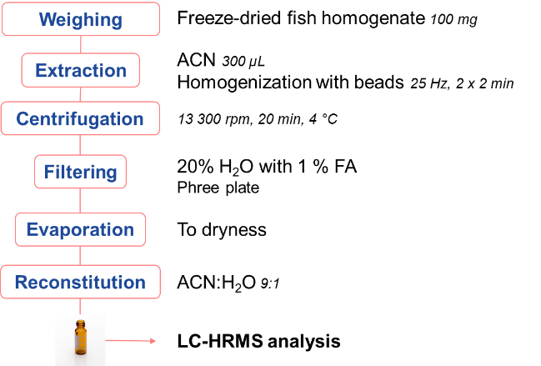
This is a modified version of a previously described sample preparation². To freeze-dried whole fish homogenate (100 mg) was added acetonitrile (300 µL). The sample was homogenized with beads (25 Hz, 2 x 2 min with 20 min break), and then centrifuged (20 min, 13 300 rpm, 4 °C). After addition of 20 % ultrapure water with 1 % formic acid, the sample was filtrated on a Phree plate. The solvent was evaporated, and the sample reconstituted in acetonitrile:ultrapure water (9:1) before analysis.

In-house method C
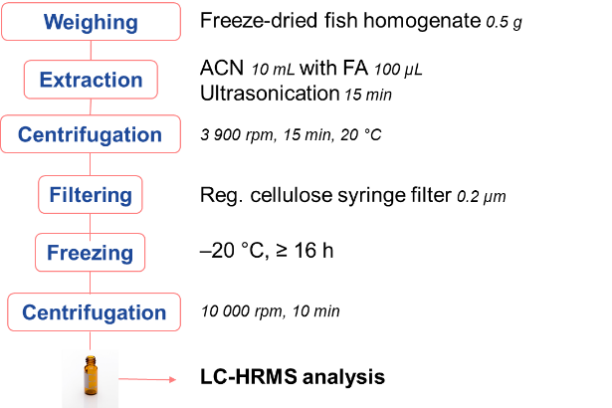
Freeze-dried whole fish homogenate (0.5 g) was added to 50 mL centrifuge tubes. For spiked samples only: LC standard mix (100 µL) was added, and the solvent was allowed to evaporate for 30 min. For all samples: acetonitrile (10 mL) and formic acid (100 µL) was added, and the tube was placed in an ultrasonic bath for 15 min. Sequentially, the sample was centrifuged (15 min, 3 900 rpm, 20 °C) and the supernatant filtered through a syringe filter (reg. cellulose, 0.2 µm) to an Eppendorf tube. The tube was stored at –20 °C for at least 16 h. Then, it was left at room temperature for 10-20 min and centrifuged (3 min, 10 000 rpm) prior to taking 200 µL of the supernatant for analysis. For blank samples, the same procedure was followed without addition of freeze-dried whole fish homogenate.

In-house method D
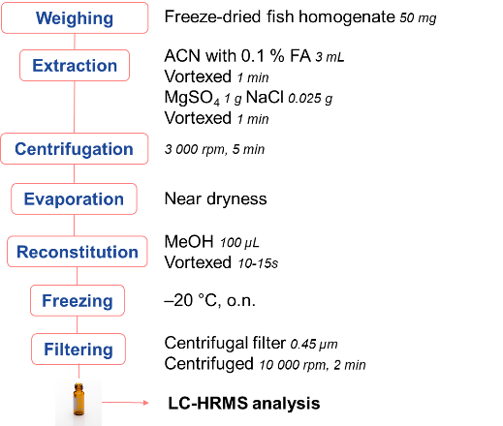
Freeze-dried whole fish homogenate (50 mg) was weighed up. For the spiked samples, provided standard mix (100 µL, 50 pg/µL) was added. Acetonitrile with 0.1 % formic acid (3 mL) was added, and the sample was vortexed for 1 min. MgSO₄ (1 g) and NaCl (0.25 g) was added, and the sample was vortexed again for 1 min, followed by centrifugation (5 min, 3 000 rpm). The supernatant was transferred, and concentrated near dryness. The sample was then reconstituted in methanol (100 µL), and vortexed for 10-15 s. After freezing the sample overnight (- 20 °C), the supernatant was transferred to a centrifugal filter (0.45 µm), and was centrifuged (2 min, 10 000 rpm). The extract was then transferred to a LC injection vial prior to analysis.

In-house method E
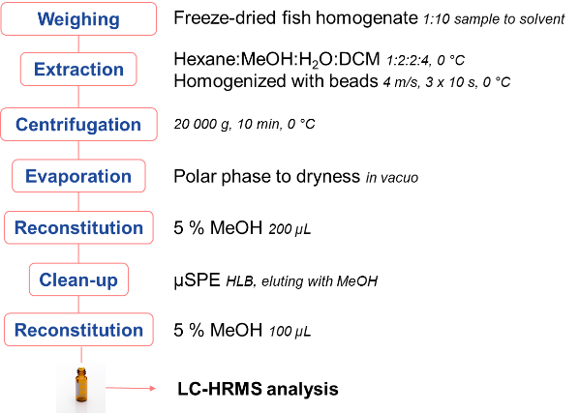
Freeze-dried whole fish homogenate was further homogenized with ice-cold hexane:methanol:water:dichloromethane (1:2:2:4) in a 1:10 sample to solvent ratio. Homogenization was performed with bead beating under liquid nitrogen cooling (3 cycles at 4 m/s and 0 °C, each cycle for 10 sec with 5 sec dwell) using 1.4 mm ceramic beads and a Bead Ruptor Elite connected to an Omni BR-Cryo cooling unit (Omni International, USA). After centrifugation (10 min, 20 000 g, 0 °C), the polar phase was collected and evaporated to dryness using a vacuum concentrator (SpeedVac SPD 1030, Thermo Scientific, Germany), and reconstituted in 200 µL of a 5% methanolic solution. Then was performed µSPE (10 mg HRP, Thermo) and elution with methanol, followed by reconstitution in 100 µL of a 5% methanolic solution.

In-house method F
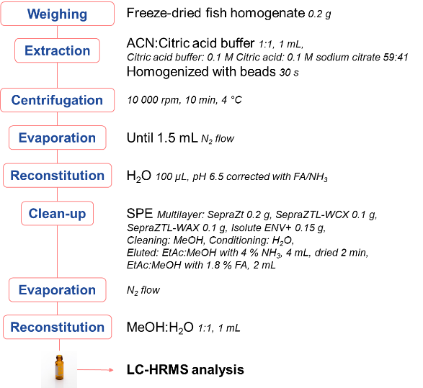
The method has been described previously³. Freeze-dried whole fish homogenate (0.2 g) was added to a 2 mL tissuelyzer tube with zirconium oxide beads (1 g). Solvent mixture (1 mL) of acetonitrile:citric acid buffer (1:1) (citric acid buffer from 0.1 M citric acid:0.1 M sodium citrate 59:41) was added. The tube was shaken (5 s) before being subjected to the tissuelyzer (30 s, power 5.5). The sample was then centrifuged (10 min, 4 °C, 10 000 rpm), and the supernatant transferred to a glass tube. More solvent mixture (1 mL) was added to the remaining pellet and the extraction process was repeated two more times. The combined supernatants were then concentrated under N₂ flow (30 min) until approximately 1.5 mL remained. HPLC-grade H₂O (100 mL) was added, and the pH was corrected to 6.5 using ammonia and/or formic acid. The solution was then passed through a homemade, multi-layer SPE cartridge containing Sepra ZT (0.2 g), Sepra ZTL-WCX (0.1 g), Sepra ZTL-WAX (0.1 g) and Isolute ENV+ (0.15 g) as described previously⁴. The cartridge had been cleaned with methanol and conditioned with HPLC-grade H₂O at pH 6.5. The sample was eluted with ethyl acetate:methanol with 2 % ammonia (4 mL), dried with air for 2 min, and then eluted again with ethyl acetate:methanol with 1.8 % formic acid (2 mL). The elute was dried by N₂ flow, and the sample was reconstituted in methanol:H₂O (1:1, 1 mL) prior to the analysis.

In-house method H1
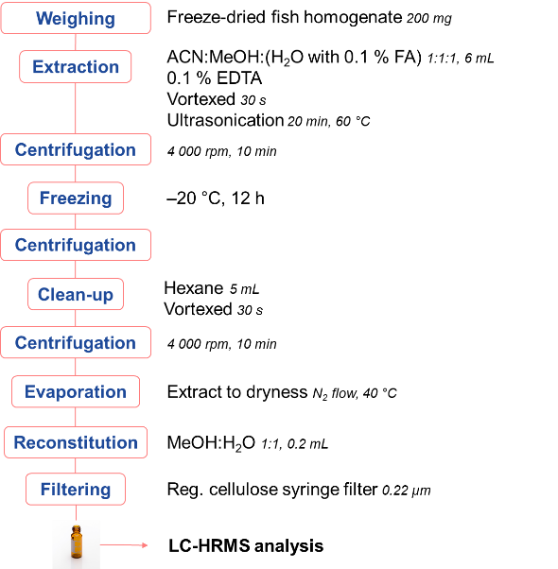
The method has been described previously⁵. Freeze-dried whole fish homogenate (200 mg) was weighed and placed into a 15 mL polypropylene centrifuge tube. The extraction of the analytes was realized by adding 2 mL of Milli-Q water containing 0.1% formic acid (v/v) and 0.1% EDTA (w/v), 2 mL of methanol and 2 mL of acetonitrile. After the addition of each solvent, the tube was vortex-mixed for 30 s. The sample set was placed in an ultrasonic bath at 60°C for 20 min, the samples were then centrifuged at 4000 rpm for 10 min, and the supernatant was decanted into a new polypropylene centrifuge tube. The tubes were then placed in the freezer, at -20 °C, for 12 h to precipitate the lipids and remaining proteins. After centrifuging and discarding the precipitate, a defatting step with hexane completed the sample clean-up. 5 mL hexane was added, and the tube was vortex-mixed for 30 s, centrifuged at 4000 rpm for 10 min, and finally the hexane layer was discarded. The extracts were collected in glass test tubes, evaporated to dryness under a gentle stream of N₂ at 40 °C, and reconstituted in 0.2 mL methanol/Milli-Q water, 50:50 (v/v). Finally, the extracts were filtered through a 0.22 μm RC syringe filter and were transferred to a glass vial for LC-HRMS analysis.

In-house method H2
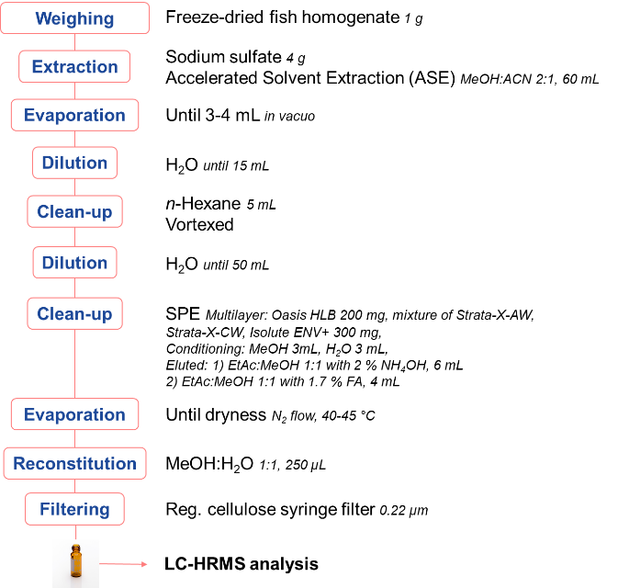
The method has been described previously⁶. Freeze-dried whole fish homogenate (1 g) was weighted and mixed with sodium sulfate (4 g) and then placed in extraction cells. The analytes were extracted by Accelerated Solvent Extractor (Dionex™ ASE™ 350, Thermo Fisher Scientific) with methanol and acetonitrile (2/1, v/v) as extraction solvents, using the following conditions: temperature: 50°C, pressure: 1500 psi, heating time: 300 s, static time: 420 s, 3 static cycles, purge time: 180 s and extraction solvents volume: 60 mL). After ASE, the extracts were pre-concentrated using a rotary evaporator (at 40°C) until reaching a final volume of 3-4 mL. Milli-Q water was added to adjust the final volume to 15 mL and 5 mL of n-hexane was added as defatting step. After vortex stirring, the hexane layer was discarded, and water was added until reaching a final volume of 50 mL. The samples were then cleaned-up by solid phase extraction (SPE). Layered ‘mixed bed’ in-house cartridges consisted of Oasis HLB (200 mg) and a mixture of Strata-X-AW (weak anion exchanger), Strata-X-CW (weak cation exchanger) and Isolute ENV+ (300 mg of total mixture) were used. Conditioning of the cartridges was performed with 3 mL methanol and 3 mL Milli-Q water. After conditioning, the samples were loaded in the SPE cartridges. The cartridges were dried and the elution of analytes from the adsorbent material was performed by a basic solution (6 mL of ethylacetate/methanol (50/50 v/v) containing 2% ammonia hydroxide (v/v)), followed by an acidic solution (4 mL of ethylacetate/methanol (50/50, v/v) containing 1.7% formic acid (v/v)). The extracts were evaporated using nitrogen stream at 40-45°C till dryness and 250 μL of methanol (LC-MS grade)/ Milli-Q water (50/50 v/v) were used for the final reconstitution of the extract. The final extract was filtered through a 0.22 μm RC syringe filter and were transferred to a glass vial for LC-HRMS analysis.

In-house method I
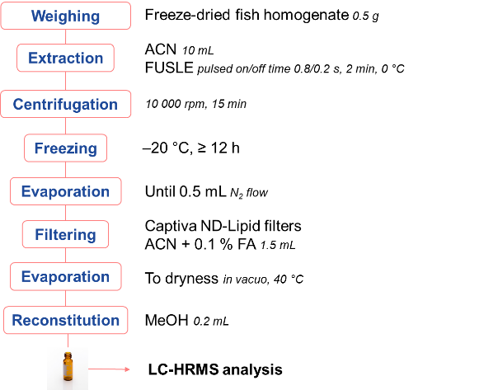
The method has been described previously⁷. To freeze-dried whole fish homogenate (0.5 g), acetonitrile (10 mL) was added, and focused ultrasound solid-liquid extraction (FUSLE) was carried out (0 °C, 2 min, pulsed on/off time of 0.8/0.2 s). The sample was centrifuged (15 min, 10 000 rpm) and the supernatant was frozen (- 20 °C) for at least 12 h, after which the new supernatant was transferred to a glass tube and concentrated using N₂ stream until 0.5 mL remained. Clean-up was performed using Captiva ND-Lipid filters. Acetonitrile containing 0.1 % formic acid (1.5 mL) was added to the cartridge, the sample was loaded and the mixture was five-fold mixed. The sample was eluted and the filter dried, after which the elute was dried in vacuo at 40 °C. The sample was then reconstituted in methanol (0.2 mL) prior to analysis.

In-house method K1
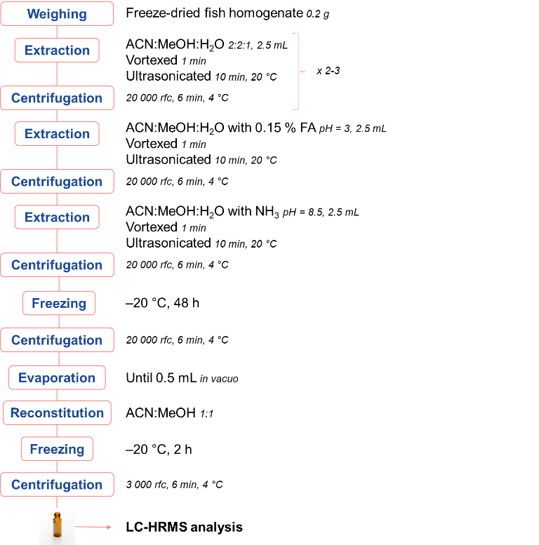
Freeze-dried whole fish homogenate (0.2 g) was spiked with standard mix and stored in the freezer overnight. Acetonitrile:methanol:H₂O (2.5 mL, 2:2:1) was added and the sample was vortexed (1 min) and sonicated (10 min, 20 °C, sonication capacity 9). After centrifugation (6 min, 4 °C, 20 000 rcf) the supernatant was transferred to an Eppendorf tube. More acetonitrile:methanol:H₂O (2.5 mL, 2:2:1) was added to the remaining pellet, and the steps were repeated until 2-3 supernatants had been transferred to the new Eppendorf tube. Acetonitrile:methanol:H₂O with 0.15 % formic acid (pH = 3) (2.5 mL) was added to the pellet, and again the extraction and centrifugation was repeated. The supernatant was transferred to a new Eppendorf tube. Then acetonitrile:methanol:H₂O with ammonia (pH = 8.5) (2.5 mL) was added to the pellet, the extraction and centrifugation was added, and the basic supernatant was transferred to the previous Eppendorf tube with the acidic supernatant. The extracts were frozen (-20 °C) for 48 h, and then centrifuged (6 min, 4 °C, 20 000 rcf). The supernatants were transferred to new Eppendorf tubes, and a Speed Vac was used to evaporate the samples until 0.5 mL. Acetonitrile:methanol (1:1) was added and the samples were frozen (-20 °C) for 2 h. After centrifugation (6 min, 4 °C, 3 000 rcf) the supernatant was transferred to 1.5 mL LC glass vials prior to analysis.

In-house method K2
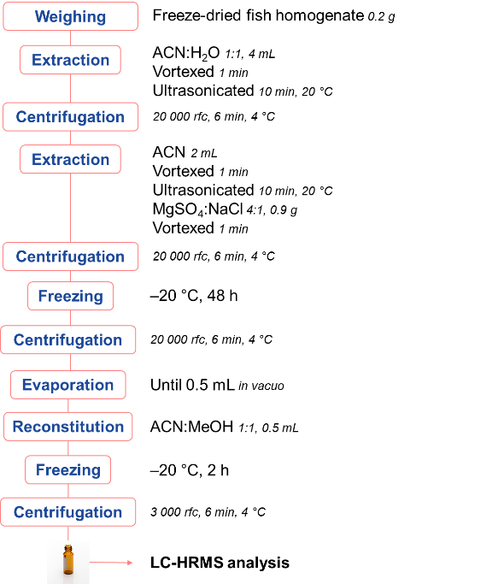
Freeze-dried whole fish homogenate (0.2 g) was spiked with standard mix and stored in the freezer overnight. Acetonitrile:H₂O (4 mL, 1:1) was added and the sample was vortexed (1 min) and sonicated (10 min, 20 °C, sonication capacity 9). Quenchers salt (0.9 g, MgSO₄:NaCl 4:1) was added, and the sample was vortexed (1 min). After centrifugation (6 min, 4 °C, 20 000 rcf) the supernatant was transferred to an Eppendorf tube. Acetonitrile (2 mL) was added to the remaining pellet, and the extraction and centrifugation was repeated as above. The supernatants were combined, and frozen (-20 °C) for 48 h. After centrifugation (6 min, 4 °C, 20 000 rcf), the supernatant was transferred to a new Eppendorf tube and evaporated on a Speed Vac until 0.5 mL remained. Acetonitrile:methanol (0.5 mL, 1:1) was added, and the sample was frozen (-20 °C) for 2 h. After centrifugation (6 min, 4 °C, 3 000 rcf) the supernatant was transferred to a 1.5 mL LC glass vial prior to analysis.

In-house method M
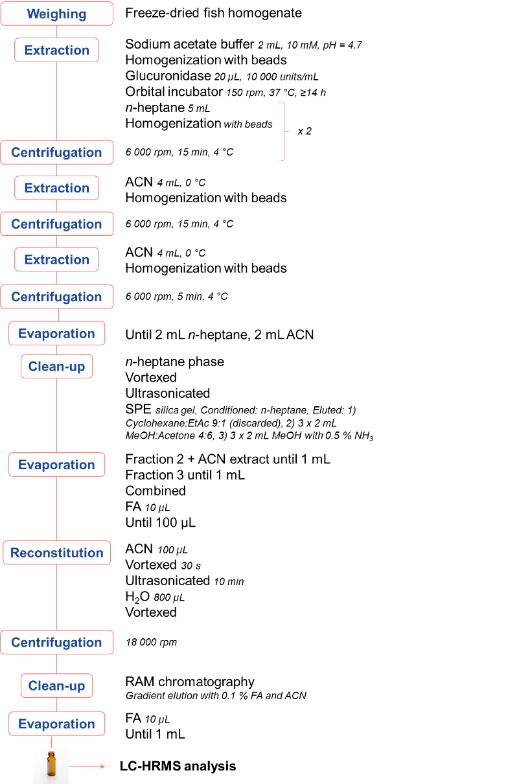
The method has been described previously⁸. Freeze-dried whole fish homogenate was mixed with garnet matrix A (500 mg, MP Biomedicals, Illkirch-Graffenstaden, France) and lysing matrix D (150 mg, MP Biomedicals). Sodium acetate buffer (2 mL, 10 mM, pH 4.7) and internal standard solution (100 µL, 0.01 mg/L) was added. The cells were disrupted by a FastPrep-24TM 5G (MP Biomedicals) with a CoolTeenPrepTM adapter (40 s, 4.0 m/s). β-Glucuronidase (20 µL, 10 000 units/mL) was added, and the samples were left in an orbital incubator SI500 (Stuart, Staffordshire, United Kingdom) for at least 14 h (150 rpm, 37 °C). n-Heptane (5 mL) was added, and the cells were disrupted by a FastPrep-24TM 5G (40 s, 4.0 m/s) before centrifugation (5 min, 6 000 rpm) with a Hettich Mikro 200R (Tuttlingen, Germany). The organic phase was removed, before more n-heptane was added and the extraction was repeated. After removing the n-heptane phase, the sample was further extracted through cell disruption with acetonitrile (4 mL, 0 °C) followed by centrifugation (15 min, 6 000 rpm, 4 °C). The supernatant was removed and the pellet was again extracted with acetonitrile through cell disruption as described and centrifugation (5 min, 6 000 rpm, 4 °C). The two n-heptane phases were combined, as were the two acetonitrile phases. The two resulting extracts were concentrated to 2 mL each. The n-heptane phase was vortexed and exposed to ultrasonication (10 min), before running silica gel SPE. The silica gel cartridge (6 mL, 1 000 mg, Chromabond, Machery-Nagel, Düren, Germany) was dried (85 °C, 3 h) and conditioned (3 x 2 mL n-heptane) before loading the n-heptane extract and eluting in three steps. 1) 3 x 2 mL cyclohexane:ethyl acetate (9:1, v/v) that was discarded, 2) 3 x 2 mL methanol:acetone (4:6, v/v) eluted directly into the previous acetonitrile extract, and 3) 3 x 2 mL methanol with 0.5 %_{v} NH₃. Fractions 2 and 3 were concentrated to 1 mL and then combined. Formic acid (10 µL) was added. Further concentration until 100 µL was performed, and acetonitrile (100 µL) was added. The sample was vortexed (30 s) and exposed to ultrasonication (10 min). Milli-Q water (800 µL) was added, before vortexing and centrifugation (18 000 rpm). The supernatant was transferred, and subjected to RAM chromatography (Agilent 1260 system, G1364C fraction collector) with lichrospher RP-8 ADS (injection volume 500 µL, solvent A: 0.1 %_{v} formic acid, solvent B: acetonitrile, flow rate 1 mL/min, gradient: 0-3 min 2 % B, 3-3.5 min 2-60 % B, 3.5-8.5 min 60 % B, 8.5-9 min 60-98 % B, 9-14 min 98 % B, 14-14.5 min 98-2 % B, 14.5-20 min 2 % B). Collection of the elute was performed between 3-13 min. Formic acid (10 µL) was added, and concentration to 1 mL was conducted prior to analysis.

In-house method O
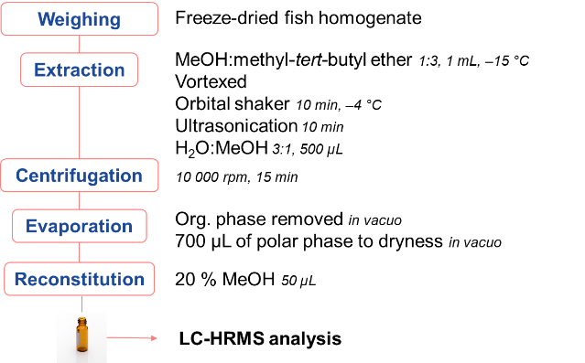
Pre-cooled extraction mixture (1 mL, - 15 °C, methanol:methyl-tert-butyl ether 1:3) was added to freeze-dried whole fish homogenate, and the sample was vortexed until fully re-suspended. The sample was incubated on an orbital shaker (10 min, - 4 °C), followed by an ultra-sonication bath (10 min). A mixture of water:methanol (500 µL, 3:1) was added, and the sample was mixed. After centrifugation, a portion of the upper organic phase was set aside for lipid analysis (not performed in this study), and the remaining organic phase was removed in vacuo. Of the remaining polar phase, a portion (700 µL) was transferred and dried in vacuo, before being reconstituted in 20 % methanol (50 µL) prior to analysis.

5.2. In-house methods for extracts to be analysed by GC-HRMS

In-house method G
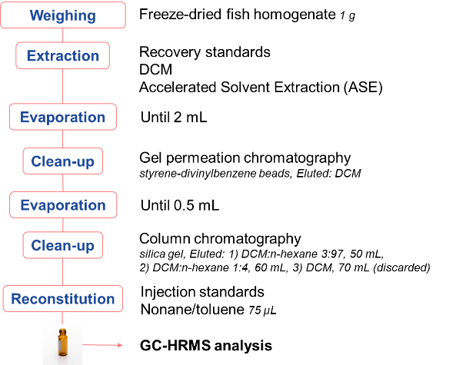
Freeze-dried samples (1 g) were extracted with dichloromethane after addition of recovery standards (¹³C or D-labelled: 17 ¹³C-labelled organochlorine pesticides, 18 ¹³C-labelled PCBs, 11 ¹³C-labelled PBDEs, 1 ¹³C-labelled MeO-PBDE, 1 ¹³C-labelled OH-PBDE, 1 ¹³C-labelled dichlorocarbazole, 5 ¹³C-labelled bromophenols, ¹³C-labelled triclosan and ¹³C-labelled methyltriclosan) by accelerated solvent extraction (ASE, Dionex). The extract was concentrated to 2 mL and purified by gel permeation chromatography in a glass column (460 × 26 mm) filled with styrene-divinylbenzene beads (65 g of Bio-Beads S-X3) and eluted with a 5 mL/min flow of dichloromethane (175 mL first discarded, followed by the collection of a 175 mL fraction). After changing the solvent to hexane and concentrating to 0.5 mL, the extracts were fractionated on a 5 g silica column (5% H₂O) into 3 successive fractions of increasing polarity: [F1] 50 mL dichloromethane:n-hexane 3:97 (v/v), [F2] 60 mL dichloromethane:n-hexane 20:80 (v/v), and [F3] 70 mL dichloromethane, using an adapted version of an established method⁹. As previous work indicated that the vast majority of GC amenable halogenated compounds eluted in F1 and F2, F3 was not processed further. The extracts were finally spiked with injection standards (3 ¹³C-labelled PCBs, 4 ¹³C-labelled PBDE, 2 D-labelled DDT derivatives, 1 ¹³C-labelled MeO-PBDE, 1 ¹³C-labelled OH-PBDE and 1 ¹³C-labelled tetrachlorocarbazole) and reconstituted in nonane/toluene (75 µL).

6. Workflows for suspect and non-target screening
Common steps for the LC-HRMS workflows were:
- Peak picking
- Filtration criteria (examples:
  - mass error < 10 ppm or 5 ppm or 3 ppm
  - fold-change > 10
  - minimum peak intensity > 1000
  - Minimum peak area > 50 000 (HESI+) and > 1000000 (HESI-)
  - Minimum peak height > 300
  - RSD of triplicates < 20% or 30%
  - Predicted RT
  - Molecular formula containing Cl, Br, S
  - Suspect masslist match
- MS² available for comparison in e.g., MzCloud

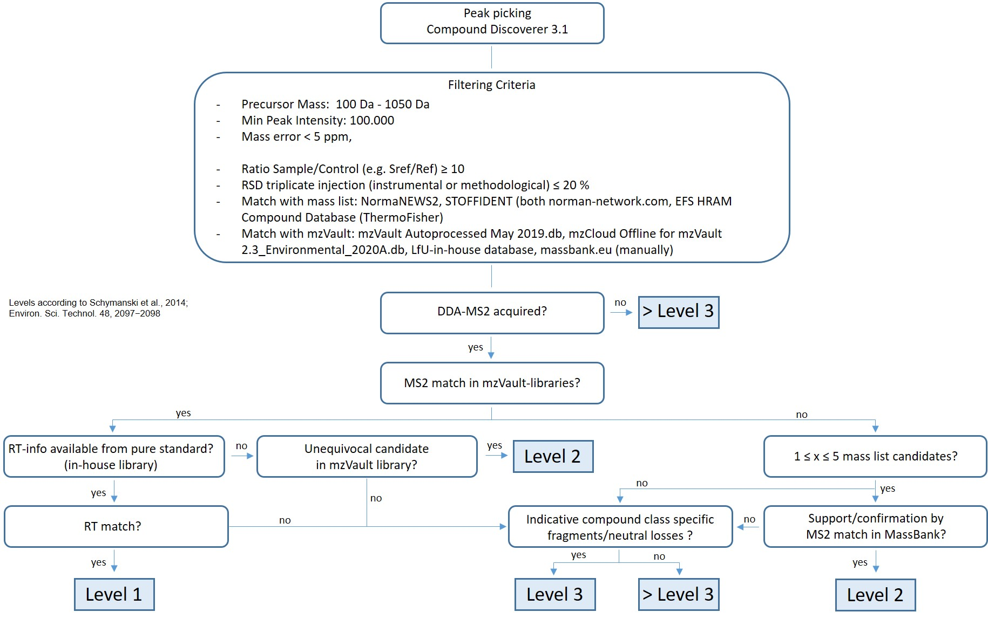
Figure S1. Suspect and non-target screening workflow for LC-HRMS analysis of the participating laboratory A.
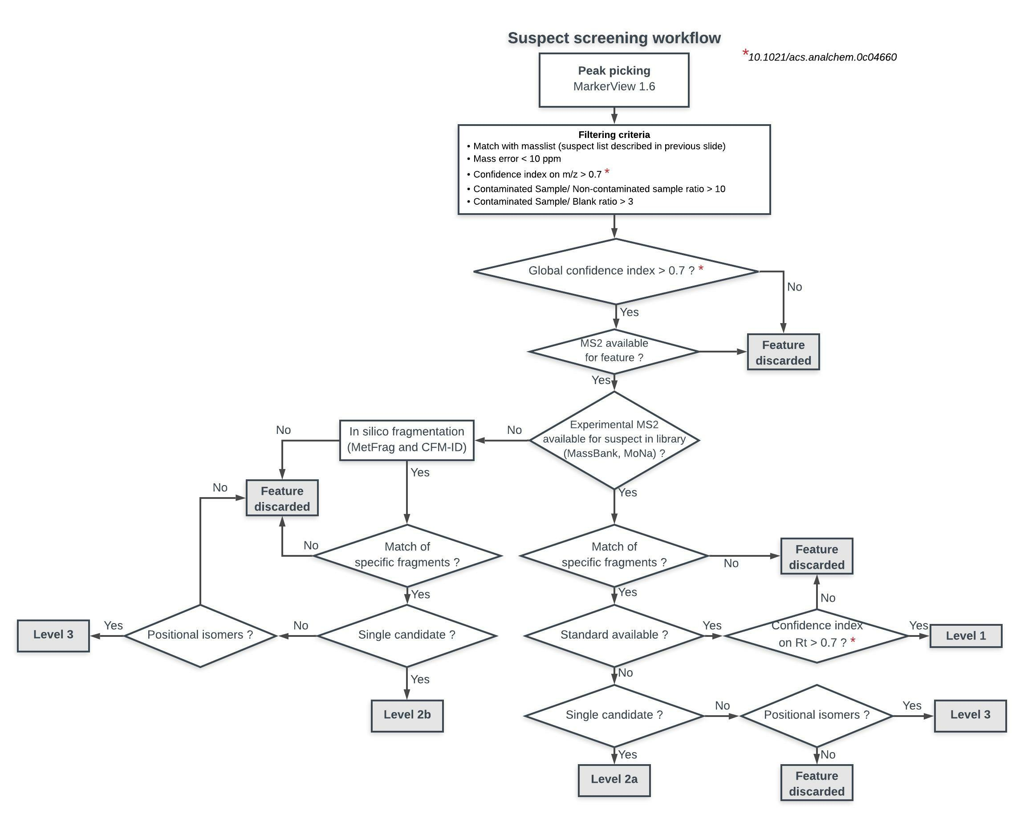
Figure S2. Suspect screening workflow for LC-HRMS analysis of the participating laboratory B according to Chaker et al (2021)¹.
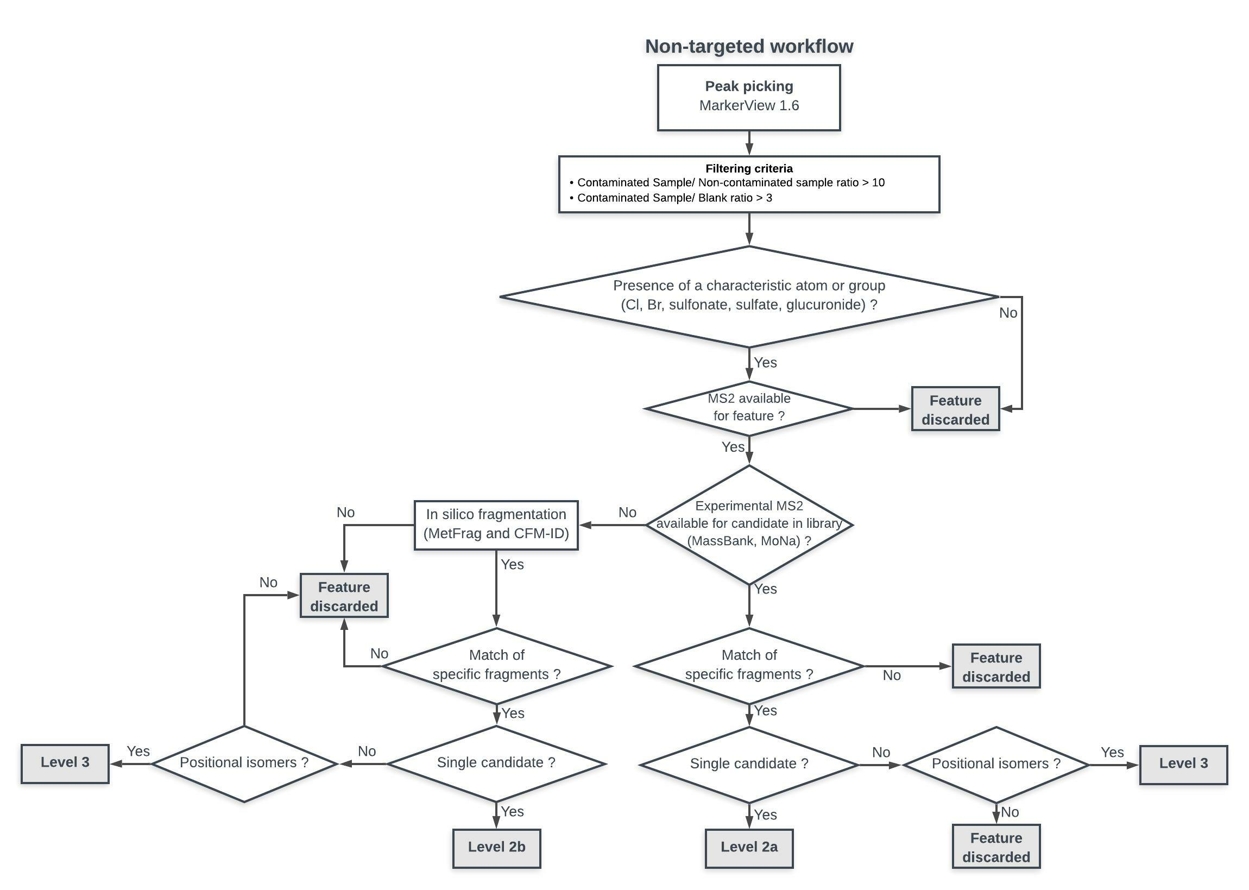
Figure S3. Non-target screening workflow for LC-HRMS analysis of the participating laboratory B.
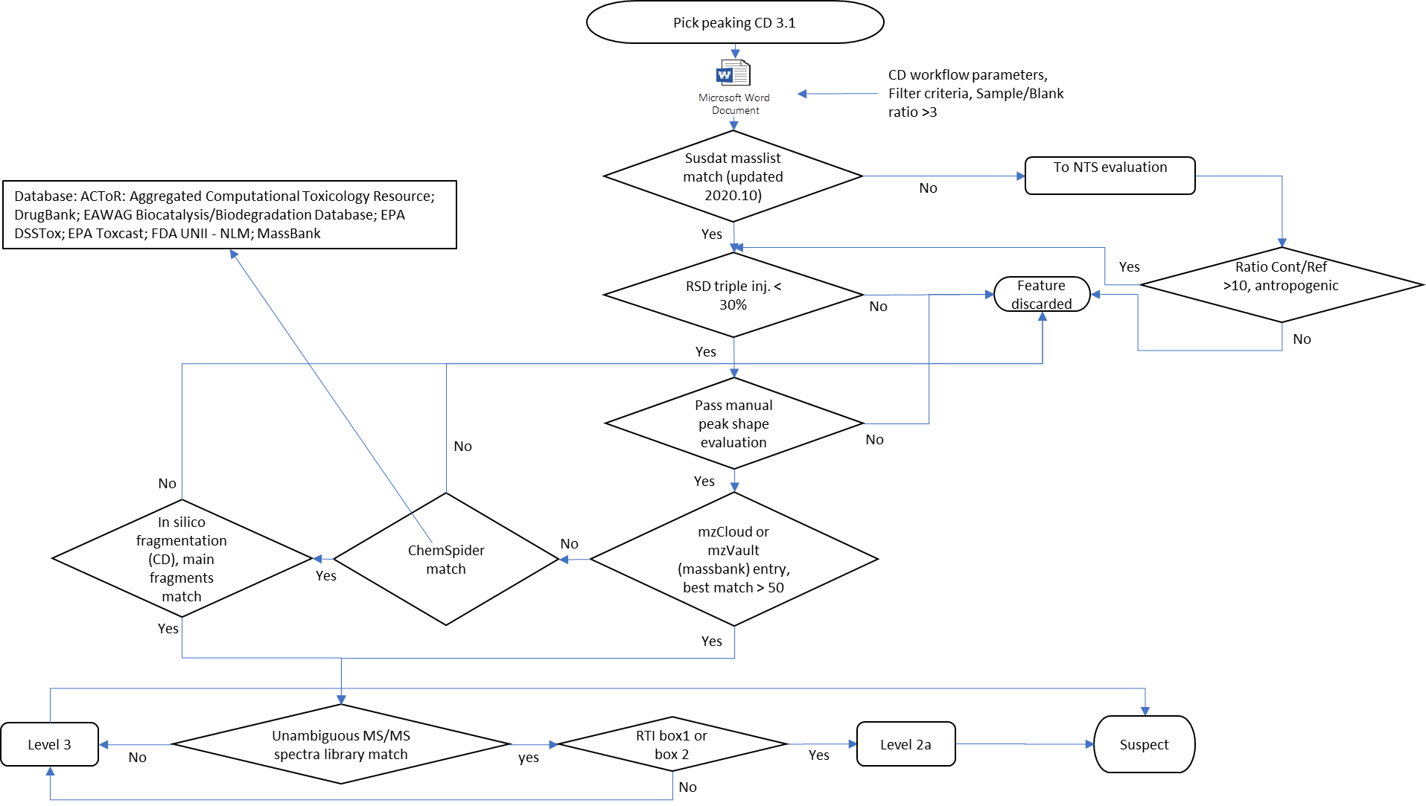
Figure S4. Suspect and non-target screening workflow for LC-HRMS analysis of the participating laboratory C.
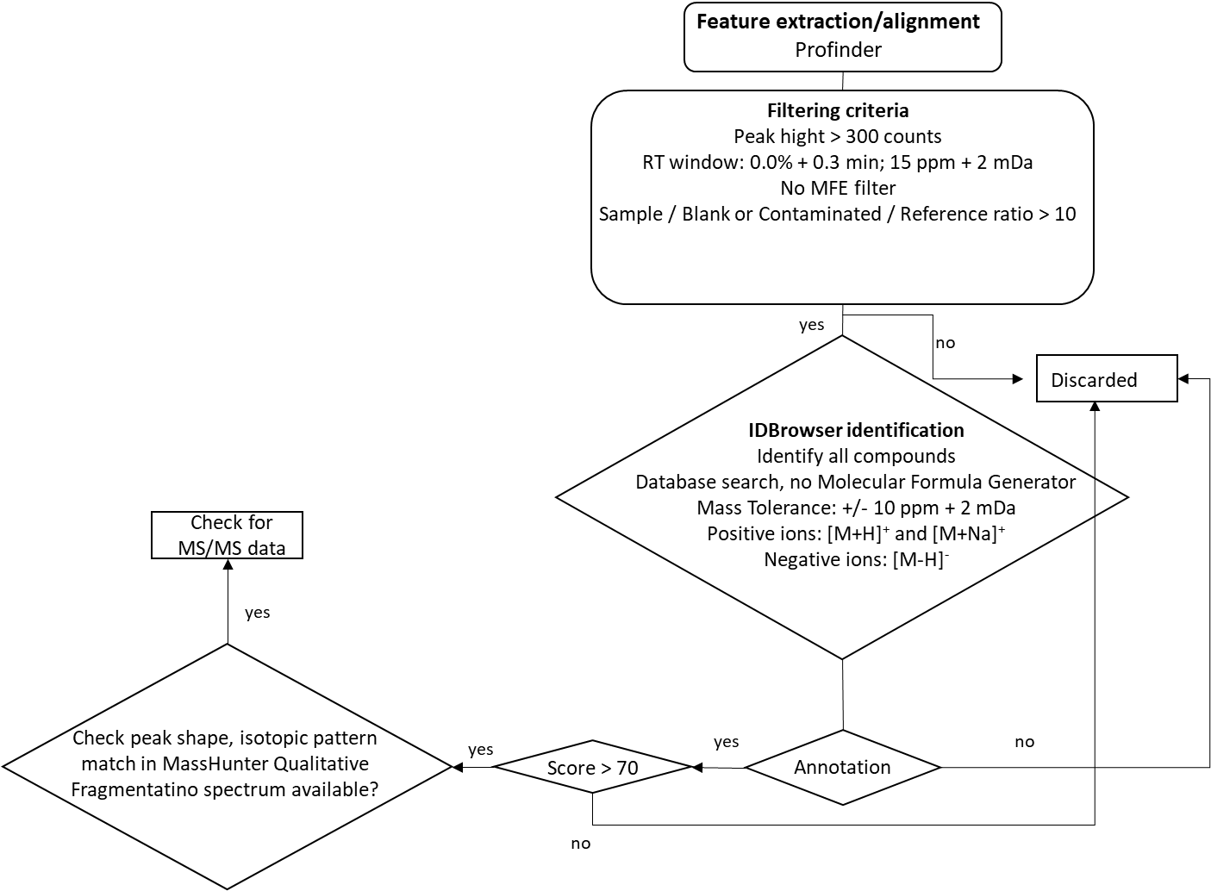
Figure S5. Suspect and non-target screening workflow for LC-HRMS analysis of the participating laboratory D.
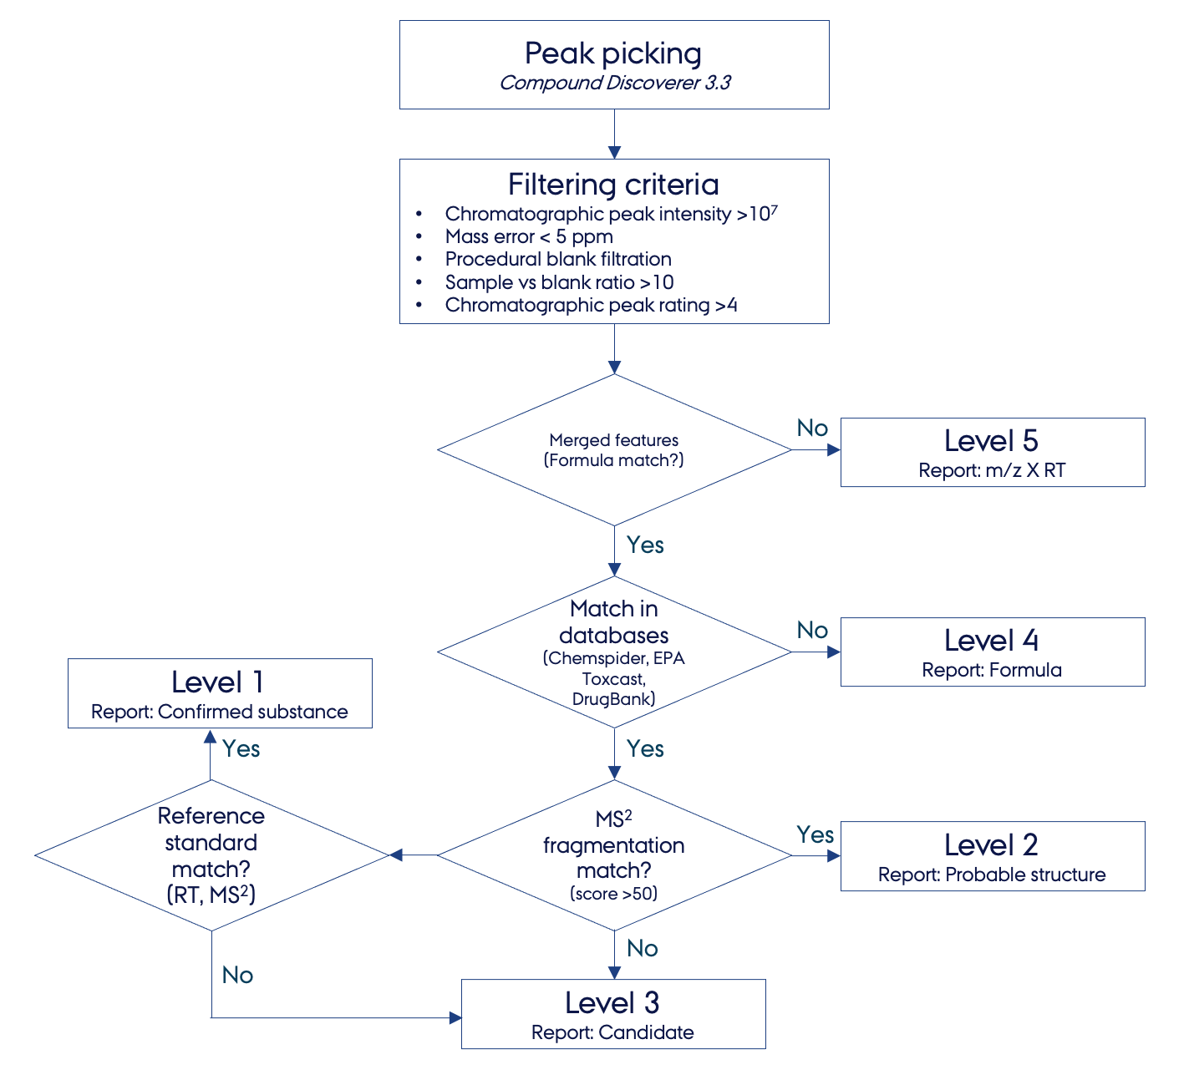
Figure S6. Suspect and non-target screening workflow for LC-HRMS analysis of the participating laboratory E.
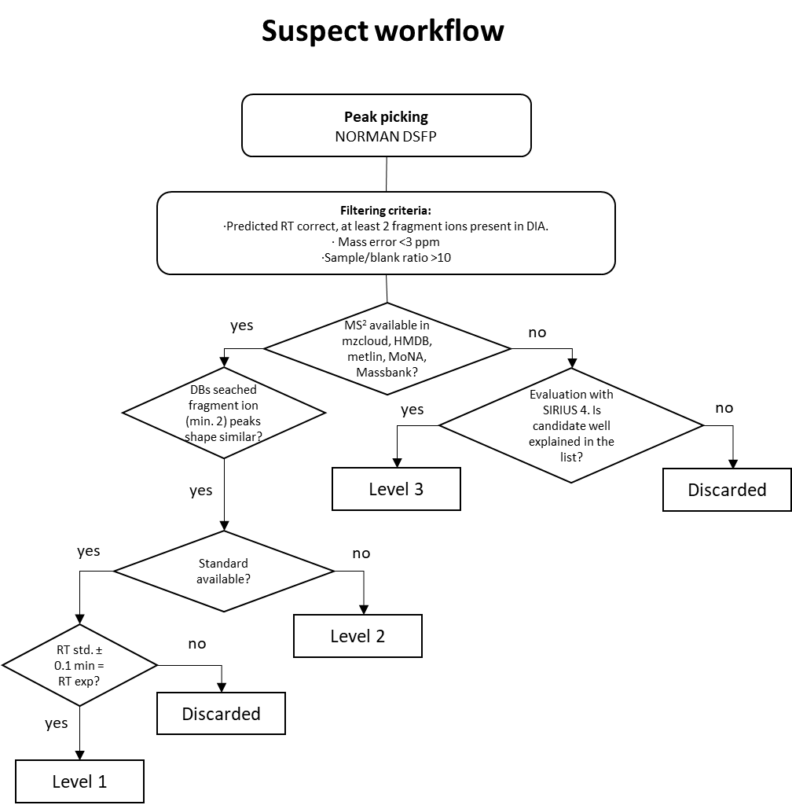
Figure S7. Suspect screening workflow for LC-HRMS analysis of the participating laboratory F.
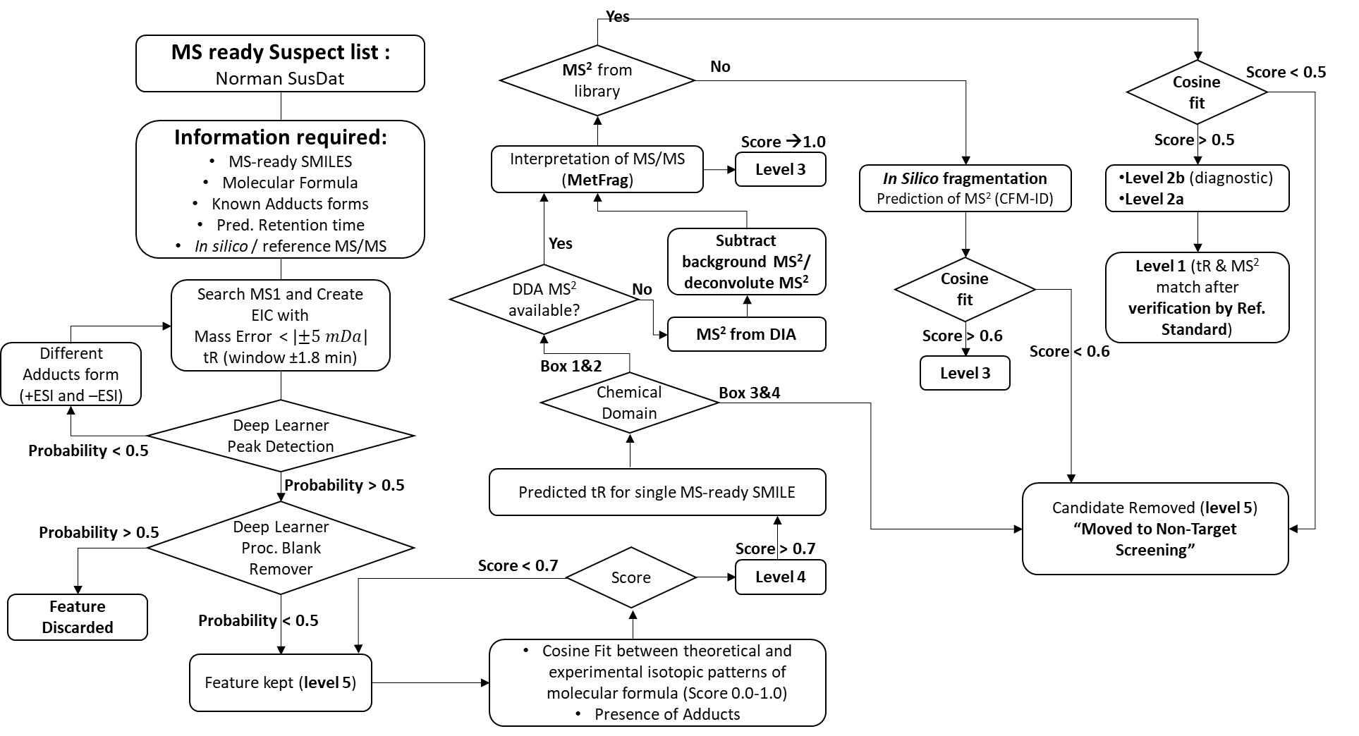

Figure S8. Suspect screening workflow for LC-HRMS analysis of the participating laboratory H.

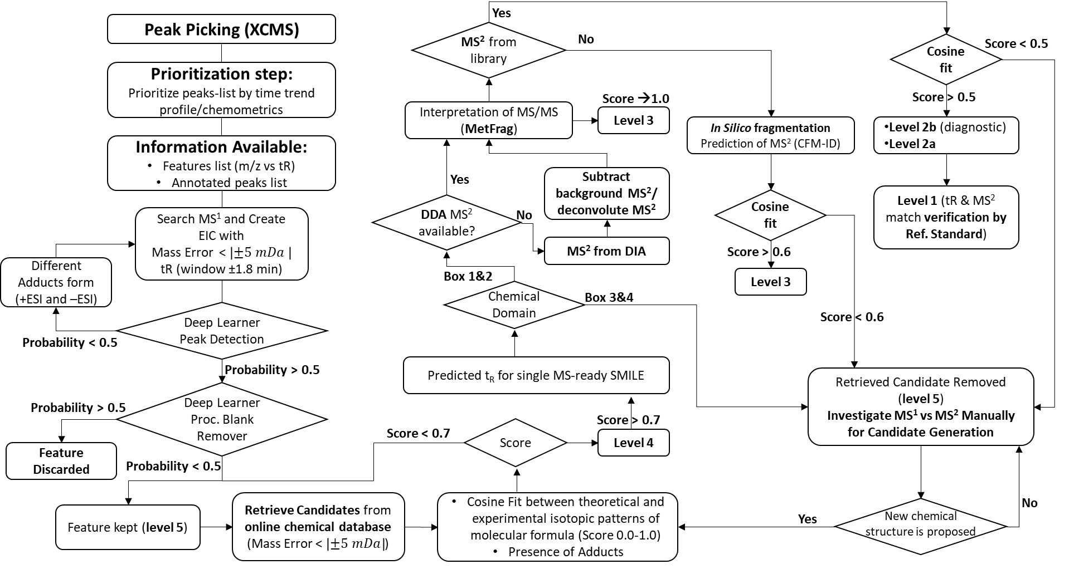

Figure S9. Non-target screening workflow¹⁰ for LC-HRMS analysis of the participating laboratory H.

Figure S10. Suspect screening workflow for LC-HRMS analysis of the participating laboratory I.
Figure S11. Non-target screening workflow for LC-HRMS analysis of the participating laboratory I.

Figure S12. Suspect screening workflow for LC-HRMS analysis of the participating laboratory K.
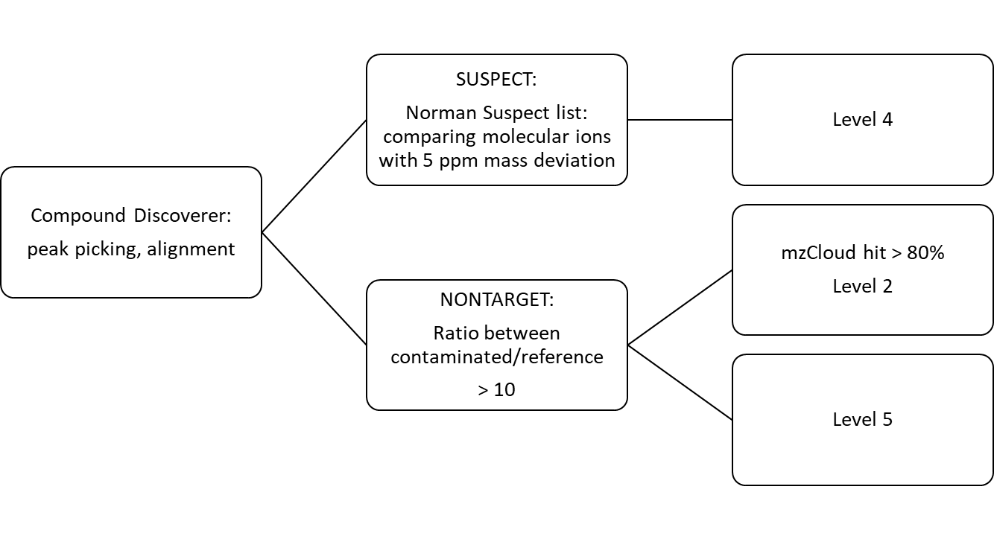
Figure S13. Suspect and non-target screening workflow for LC-HRMS analysis of the participating laboratory L.

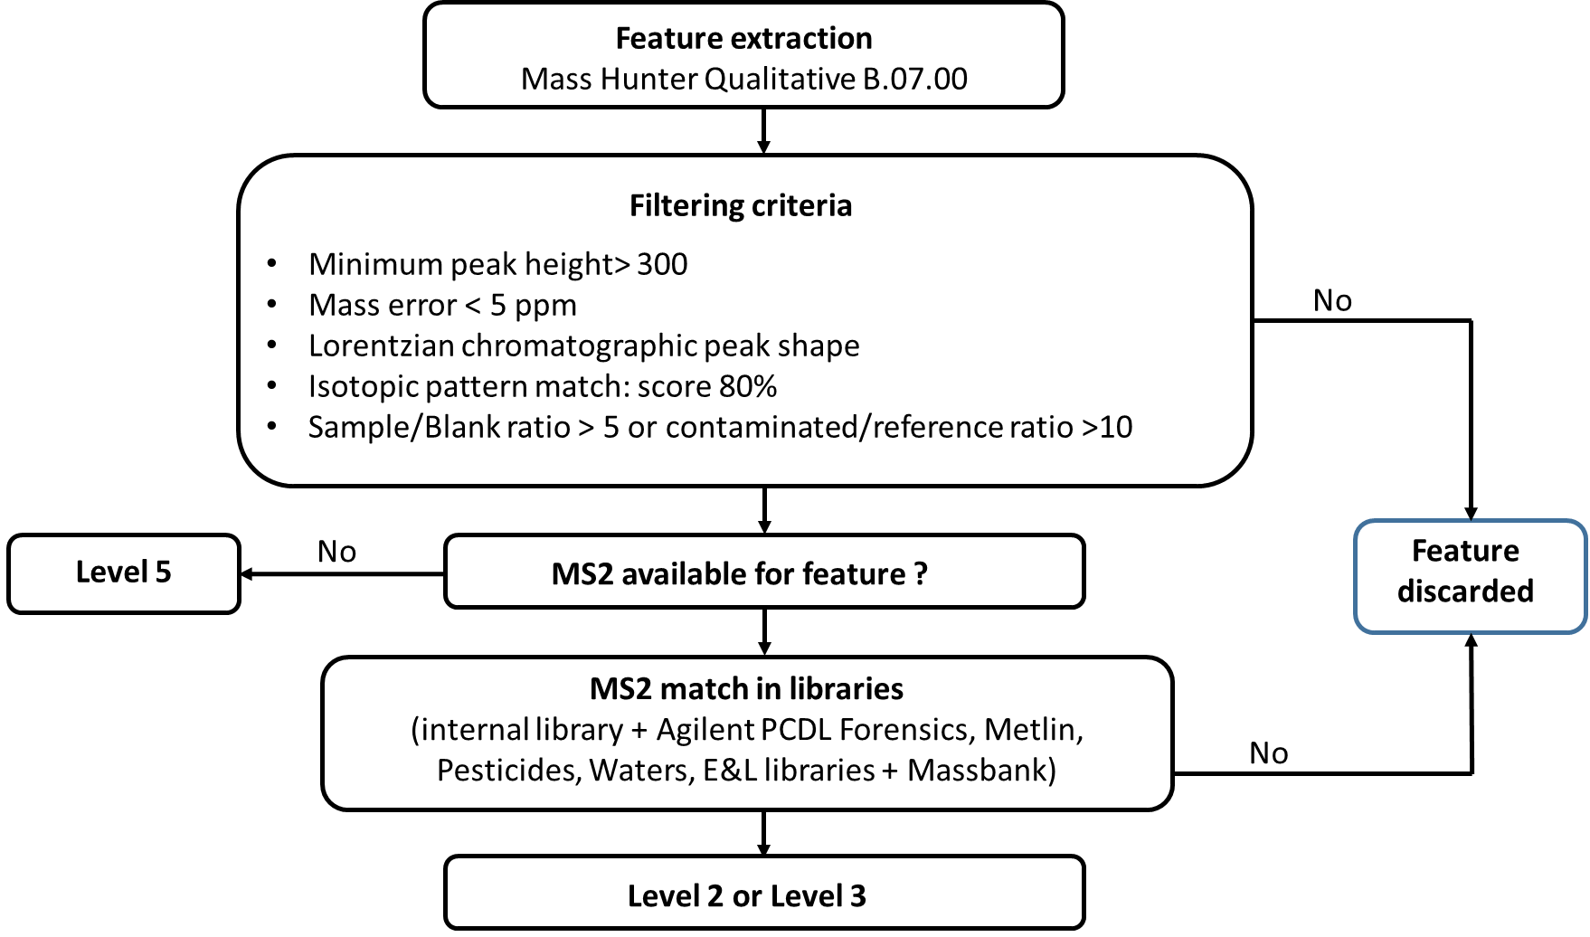
Figure S14. Suspect and non-target screening workflow for LC-HRMS analysis of the participating laboratory N.

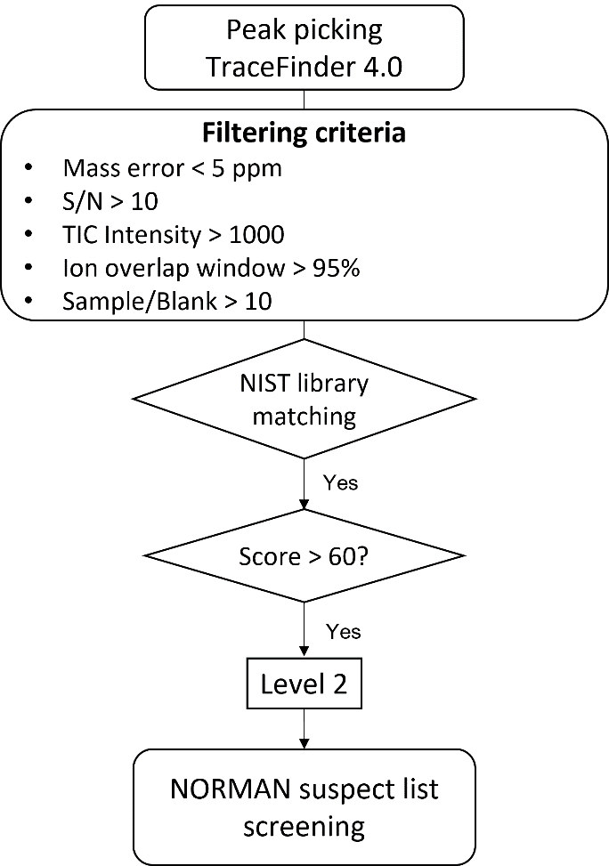
Figure S15. Suspect screening workflow for GC-HRMS analysis of the participating laboratory E.
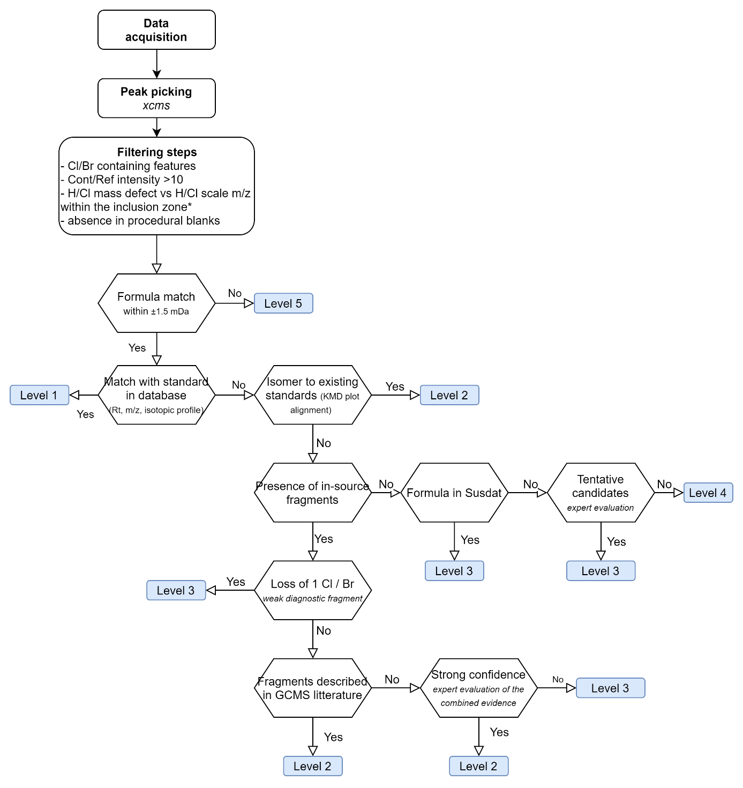
Figure S16. Suspect and non-target screening workflow for GC-HRMS analysis of the participating laboratory G.
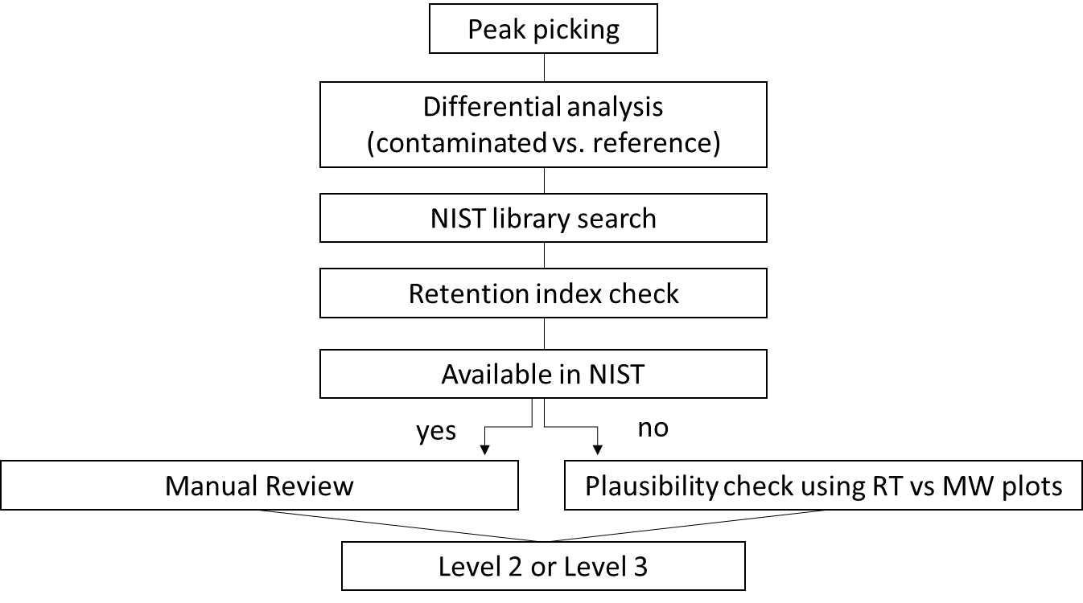
Figure S17. Non-target screening workflow for GC-HRMS analysis of the participating laboratory J.

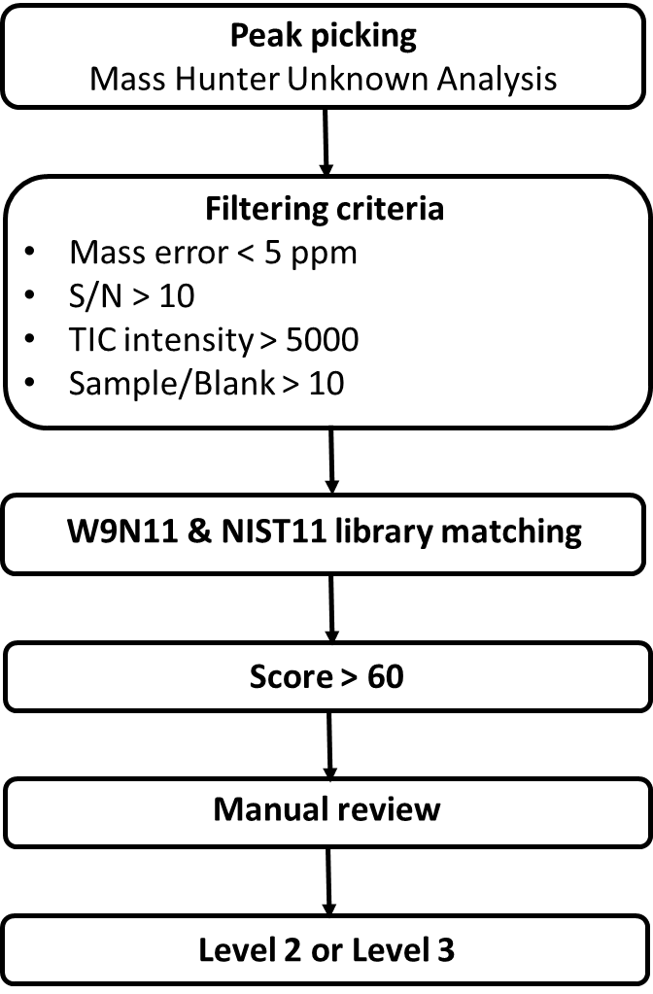

Figure S18. Non-target screening workflow for GC-HRMS analysis of the participating laboratory N.
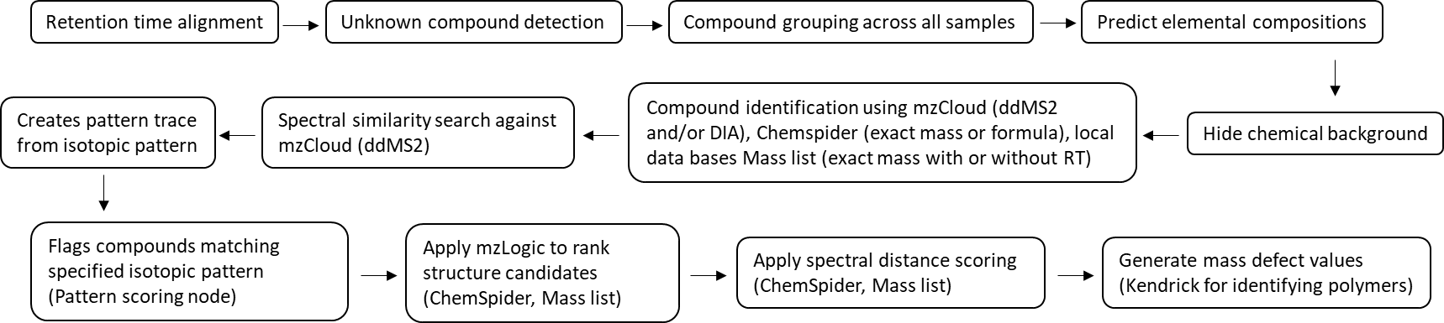

Figure S19. Non-target screening workflow for LC-HRMS analysis of the participating laboratory P.

7. Detection of compounds from spiked samples

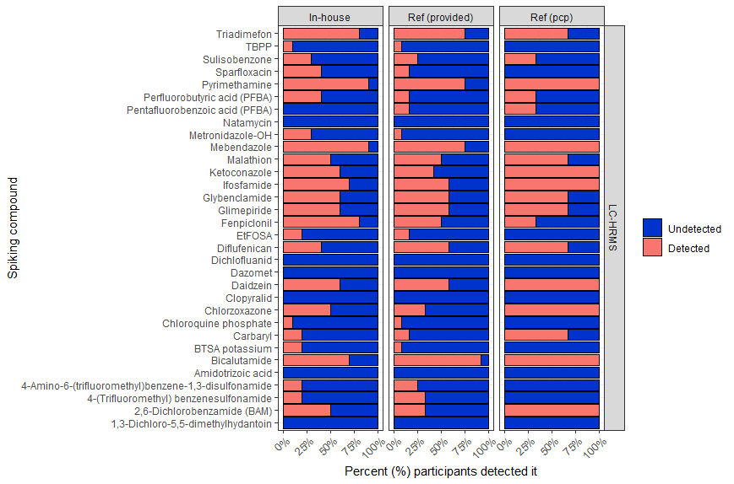
Figure S20. The percentage of participants (n = 10, 12 and 3 for In-house, Ref(provided) and Ref(pcp), respectively) detecting the compounds added during the spiking of fish samples for LC-HRMS analysis, divided on the different sample preparation methods.

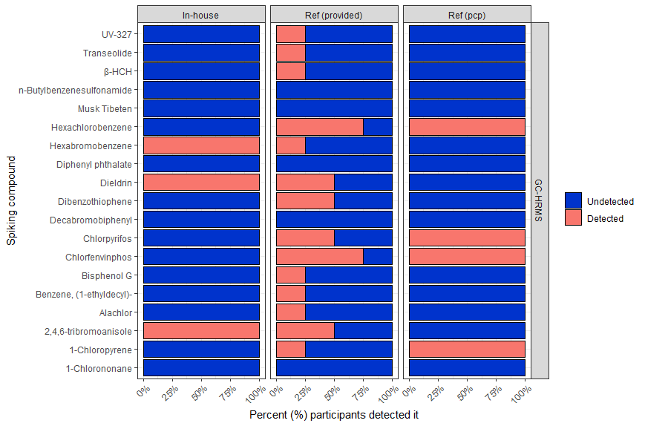
Figure S21. The percentage of participants (n = 1, 4 and 1 for In-house, Ref(provided) and Ref(pcp), respectively) detecting the compounds added during the spiking of fish samples for GC-HRMS analysis, divided on the different sample preparation methods.

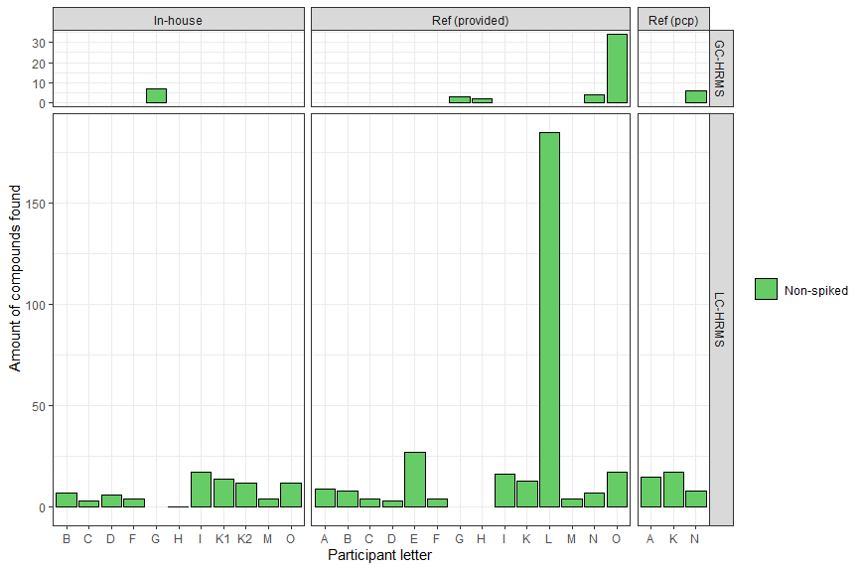
Figure S22. The number of compounds that were not added during spiking, detected from the spiked samples by the different participants.

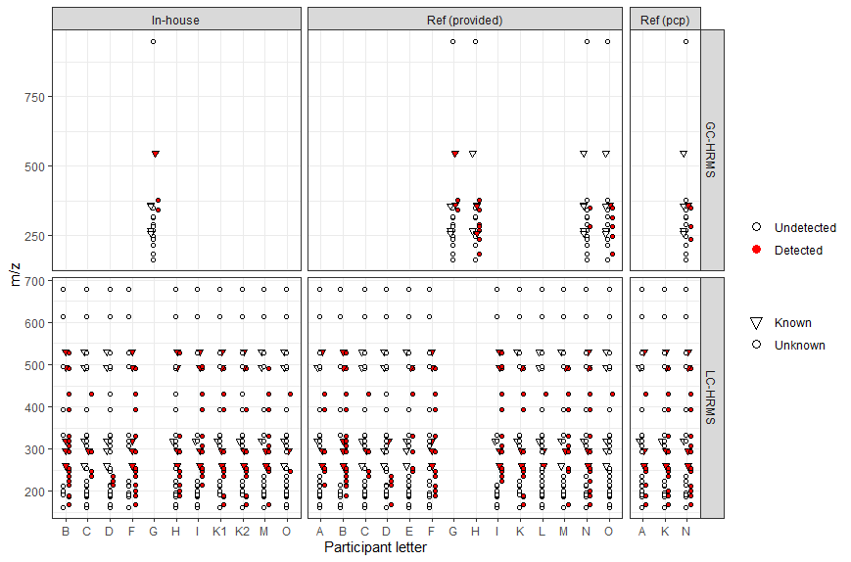
Figure S23. The m/z of the spiking compounds, with indication whether it was detected by the participant (red fill) or not (white fill). The compounds known to the participants are depicted by a triangle, and the unknown compounds by circles.
Table S7. Overall medians and means with standard deviations of the percentages indicating how many spiked compounds were correctly identified by the participants of each group (divided on sample preparation method, method for analysis and whether the compound was known or unknown).
Method of analysis | Method of sample preparation | Type of compound | Mean and standard deviation (%) | Median (%) | # Participants
LC-HRMS | In-house | Known | 60 ± 37 | 80 | 10
 |  | Unknown | 32 ± 17 | 33
 | Ref (provided) | Known | 51 ± 34 | 50 | 12
 |  | Unknown | 28 ± 17 | 28
 | Ref (pcp) | Known | 73 ± 12 | 80 | 3
 |  | Unknown | 36 ± 12 | 41
GC-HRMS | In-house | Known | 20 | 20 | 1
 |  | Unknown | 14 | 14
 | Ref (provided) | Known | 30 ± 26 | 30 | 4
 |  | Unknown | 29 ± 17 | 25
 | Ref (pcp) | Known | 20 | 20 | 1
 |  | Unknown | 21 | 21

8. Detection of compounds from samples of Teltow Canal
Table S8. A list of the compounds, with predicted log K_{OW} from EPI Suite 4.0 and m/z, from bream in the Teltow Canal that was identified through LC-HRMS and suspect screening by at least two of the participating laboratories with the same sample preparation method. Ref (provided) corresponds to the obtained extract, Ref (pcp) to the extract prepared by the participants themselves following the reference method, and in-house to the extract prepared by the participants through their own protocols.

Compound | Log K_{OW} | m/z | Sample preparation method(s) | No. of times found
N-(6-Aminohexyl)-4-hydroxybutyramide | -0.19 | 202.17 | Ref (provided) | 2
 |  |  | Ref (pcp) | 2
1-Naphthol | 2.69 | 144.06 | Ref (provided) | 2
 |  |  | Ref (pcp) | 2
2-(Decylsulfanyl)ethan-1-ol | 4.37 | 218.17 | In-house | 3
 |  |  | Ref (provided) | 2
 |  |  | Ref (pcp) | 3
Acridine | 3.32 | 179.07 | In-house | 2
 |  |  | Ref (provided) | 2
 |  |  | Ref (pcp) | 2
4-(1,1,3,3-Tetramethylbutyl)phenol | 5.28 | 206.17 | Ref (provided) | 2
 |  |  | Ref (pcp) | 2
Alachlor-OXA | 1.55 | 265.13 | In-house | 2
Galaxolidone | 5.26 | 272.18 | In-house | 3
 |  |  | Ref (provided) | 3
 |  |  | Ref (pcp) | 3
Estradiol | 3.94 | 273.18 | Ref (provided) | 2
Fenuron | 1.38 | 164.09 | In-house | 2
 |  |  | Ref (provided) | 3
Eicosapentaenoic acid  (Icosapent) | 7.85 | 303.22 | In-house | 2
 |  |  | Ref (provided) | 2
Amorolfine | 6.00 | 317.27 | In-house | 3
 |  |  | Ref (provided) | 2
Megestrol | 3.41 | 342.22 | Ref (provided) | 2
 |  |  | Ref (pcp) | 2
1,2,3-Benzotriazole | 1.17 | 119.13 | In-house | 3
 |  |  | Ref (provided) | 2
2-(Methylthio)benzothiazol | 3.22 | 181.00 | Ref (provided) | 2
 |  |  | Ref (pcp) | 2
Ibuprofen | 3.79 | 206.13 | In-house | 4
 |  |  | Ref (provided) | 2
 |  |  | Ref (pcp) | 2
Perfluorooctanesulfonic acid  (PFOS) | 4.49 | 500.13 | In-house | 2
 |  |  | Ref (provided) | 4
 |  |  | Ref (pcp) | 2

Table S9. The ranges of log K_{OW}’s and m/z detected by the different methods for identification, analysis and sample preparation of fish samples from Teltow Canal. The number of identified compounds refer to unique chemicals within the specified group, not counting reports of m/z with a molecular formula as sole identifier.
Method of identification | Method of analysis | Method of sample preparation | Min log K_{OW} | Max log K_{OW} | Min m/z | Max m/z | # Identified compounds
Suspect | LC-HRMS | Ref (provided) | -5.16 | 16.13 | 82.04 | 760.58 | 1109
Suspect | LC-HRMS | In-house | -9.85 | 16.11 | 68.03 | 748.51 | 750
Suspect | LC-HRMS | Ref (pcp) | -9.85 | 16.13 | 98.12 | 760.59 | 1260
Suspect | GC-HRMS | Ref (provided) | -1.27 | 14.12 | 83.05 | 485.71 | 47
Suspect | GC-HRMS | In-house | 5.22 | 8.91 | 235.01 | 643.53 | 32
Suspect | GC-HRMS | Ref (pcp) | - | - | - | - | 0
Non-target | LC-HRMS | Ref (provided) | -0.73 | 8.87 | 126.04 | 497.66 | 29
Non-target | LC-HRMS | In-house | -7.52 | 8.76 | 161.12 | 714.33 | 37
Non-target | LC-HRMS | Ref (pcp) | -0.73 | 10.24 | 135.01 | 499.94 | 22
Non-target | GC-HRMS | Ref (provided) | -0.59 | 14.12 | 96.17 | 452.94 | 79
Non-target | GC-HRMS | In-house | 2.57 | 10.03 | 208.95 | 509.73 | 26
Non-target | GC-HRMS | Ref (pcp) | 0.06 | 14.12 | 68.08 | 448.75 | 22

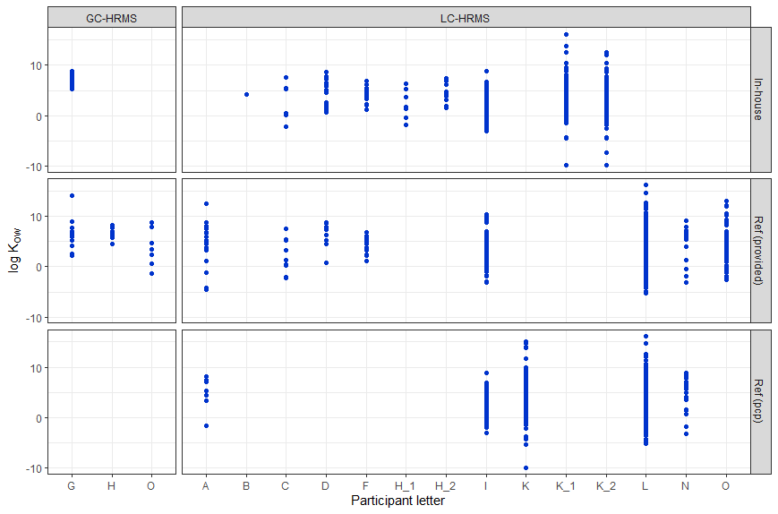
Figure S24. The predicted log K_{OW} values for the compounds detected by the different participants through suspect screening of the fish samples from Teltow Canal. The data is divided into sample preparation method (In-house, Ref (provided) and Ref (pcp)) and method of analysis (LC-HRMS and GC-HRMS). Reported compounds that were ambiguously identified (not containing a name/SMILES/other identifier, or containing several for the same m/z) were excluded from this figure since no single log K_{OW} could be calculated.
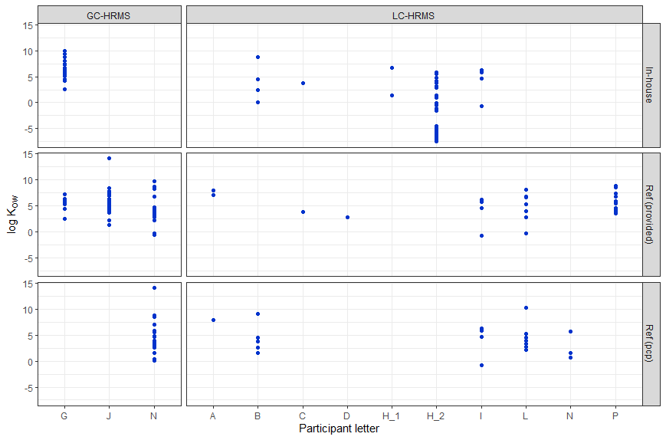
Figure S25. The predicted log K_{OW} values for the compounds detected by the different participants through non-target screening of the fish samples from Teltow Canal. The data is divided into sample preparation method (In-house, Ref (provided) and Ref (pcp)) and method of analysis (LC-HRMS and GC-HRMS). Reported compounds that were ambiguously identified (not containing a name/SMILES/other identifier, or containing several for the same m/z) were excluded from this figure since no single log K_{OW} could be calculated.

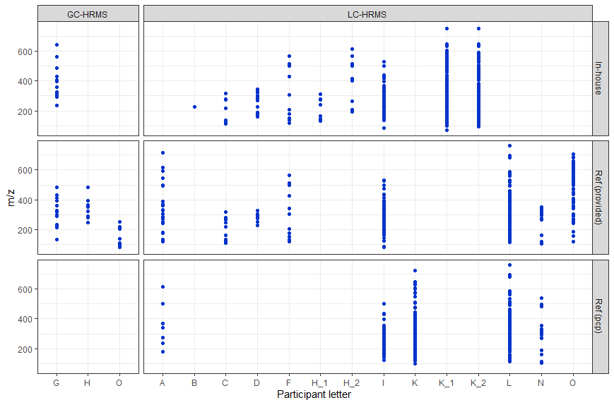
Figure S26. The m/z of compounds detected by suspect screening in the fish samples from Teltow Canal. Reported compounds that were ambiguously identified (not containing a name/SMILES/other identifier, or containing several for the same m/z) were excluded from this figure.
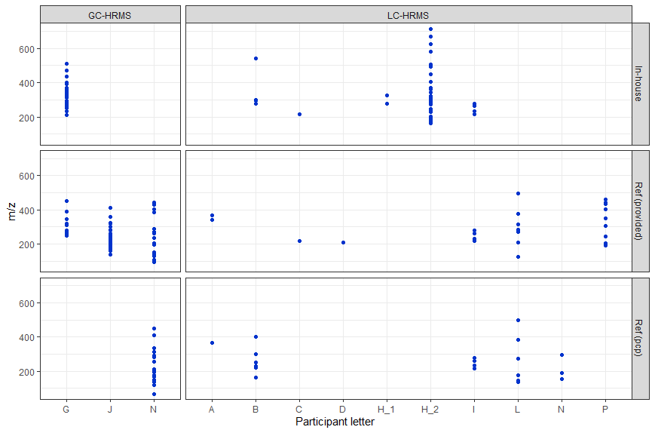
Figure S27. The m/z of compounds detected by non-target screening in the fish samples from Teltow Canal. Reported compounds that were ambiguously identified (not containing a name/SMILES/other identifier, or containing several for the same m/z) were excluded from this figure.

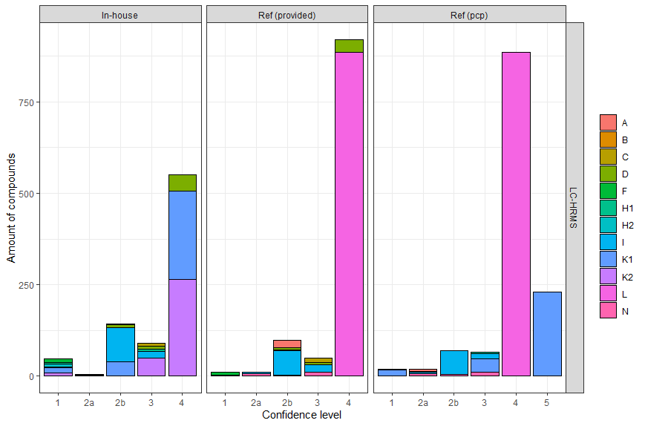
Figure S28. The confidence levels of compounds reported by different participants from Teltow Canal using suspect screening and LC-HRMS. The numbers are however approximate since not all participants reported confidence levels of their features.
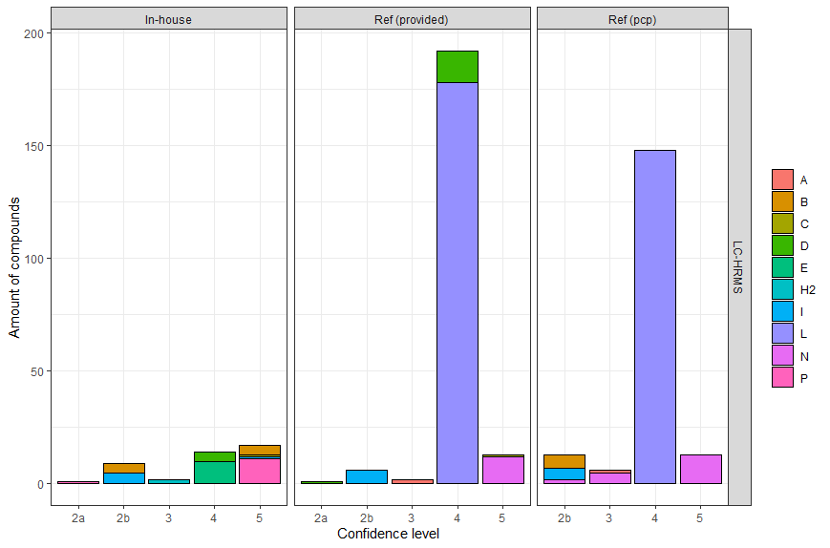
Figure S29. The confidence levels of compounds reported by different participants from Teltow Canal using non-target screening and LC-HRMS. The numbers are however approximate since not all participants reported confidence levels of their features. It is also worth mentioning that not all workflows included the reporting of confidence level 4 and 5.

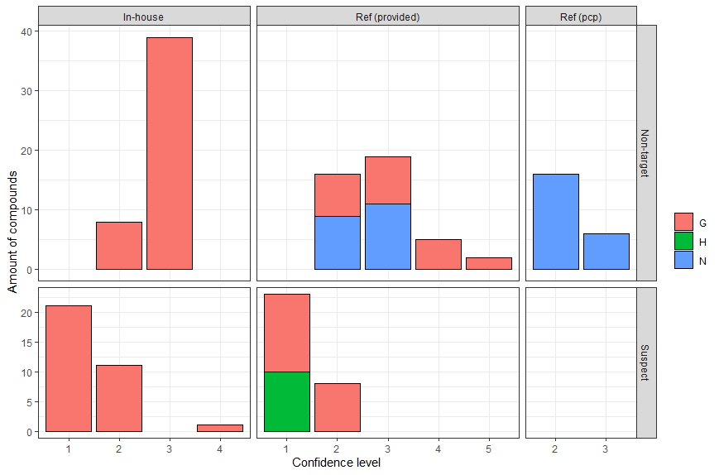
Figure S30. The confidence levels of compounds reported by different participants from Teltow Canal using GC-HRMS and suspect or non-target screening. The numbers are however approximate since not all participants reported confidence levels of their features.

9. Detection of compounds from samples of Lake Stechlin
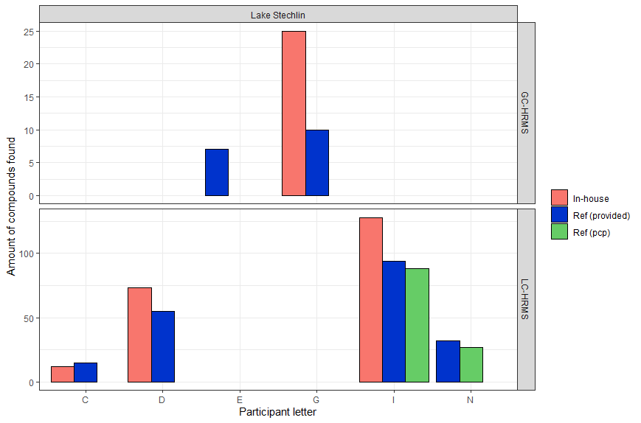
Figure S31. The amount of compounds found through suspect screening in fish from Lake Stechlin by the different participants. The data is divided into sample preparation method (sample prepared through participant’s in-house = red, provided sample prepared through reference method = blue, sample prepared through reference method by the participant = green), and method of analysis.
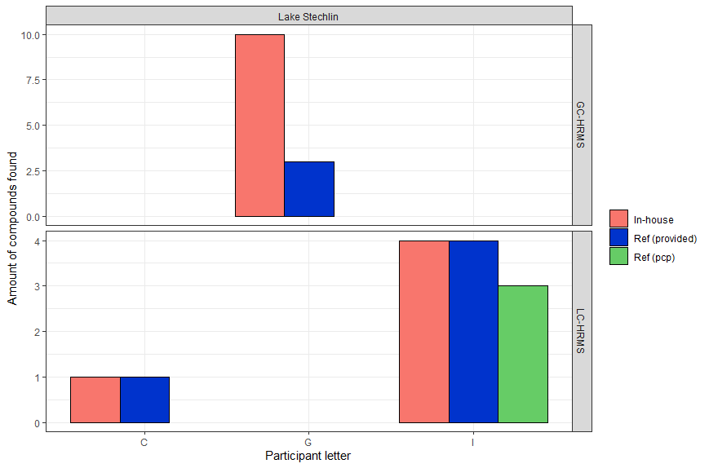
Figure S32. The amount of compounds found through non-target screening in fish from Lake Stechlin by the different participants. The data is divided into sample preparation method (sample prepared through participant’s in-house = red, provided sample prepared through reference method = blue, sample prepared through reference method by the participant = green, and method of analysis.
Table S10. The ranges of log K_{OW}’s and m/z detected by the different methods for identification, analysis and sample preparation of fish samples from Lake Stechlin. The number of identified compounds refer to unique chemicals within the specified group, not counting reports of m/z with a molecular formula as sole identifier.
Method of identification | Method of analysis | Method of sample preparation | Min log K_{OW} | Max log K_{OW} | Min m/z | Max m/z | # Identified compounds
Suspect | LC-HRMS | Ref (provided) | -3.16 | 11.81 | 82.04 | 734.56 | 145
Suspect | LC-HRMS | In-house | -3.07 | 10.4 | 82.04 | 714.51 | 153
Suspect | LC-HRMS | Ref (pcp) | -3.16 | 8.84 | 104.11 | 714.51 | 115
Suspect | GC-HRMS | Ref (provided) | 2.31 | 14.12 | 194.23 | 485.71 | 17
Suspect | GC-HRMS | In-house | 5.87 | 8.91 | 235.01 | 643.53 | 25
Suspect | GC-HRMS | Ref (pcp) | - | - | - | - | 0
Non-target | LC-HRMS | Ref (provided) | -0.73 | 6.27 | 216.15 | 279.26 | 5
Non-target | LC-HRMS | In-house | 3.78 | 6.27 | 216.15 | 279.26 | 4
Non-target | LC-HRMS | Ref (pcp) | 4.64 | 6.27 | 216.15 | 279.26 | 3
Non-target | GC-HRMS | Ref (provided) | 3.78 | 7.30 | 216.15 | 311.04 | 3
Non-target | GC-HRMS | In-house | 3.78 | 7.30 | 216.15 | 345.00 | 5
Non-target | GC-HRMS | Ref (pcp) | - | - | - | - | 0

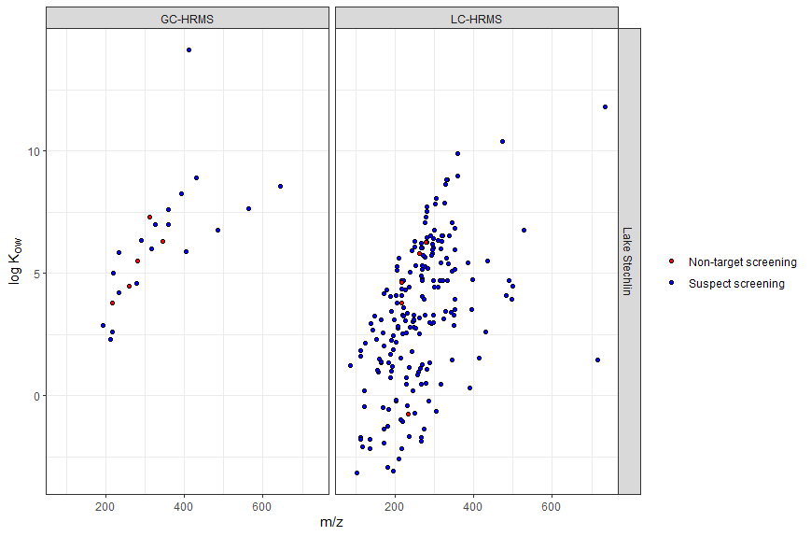
Figure S33. Plots of log K_{OW}’s versus m/z for the compounds found by suspect screening (blue) or non-target screening (red) in fish from Lake Stechlin. The data is divided into method of analysis, but all three sample preparation methods (In-house, Ref (provided) and Ref (pcp)) are included. Reported compounds that were ambiguously identified (not containing a name/SMILES/other identifier, or containing several for the same m/z) were excluded from this figure since no single log K_{OW} could be calculated.
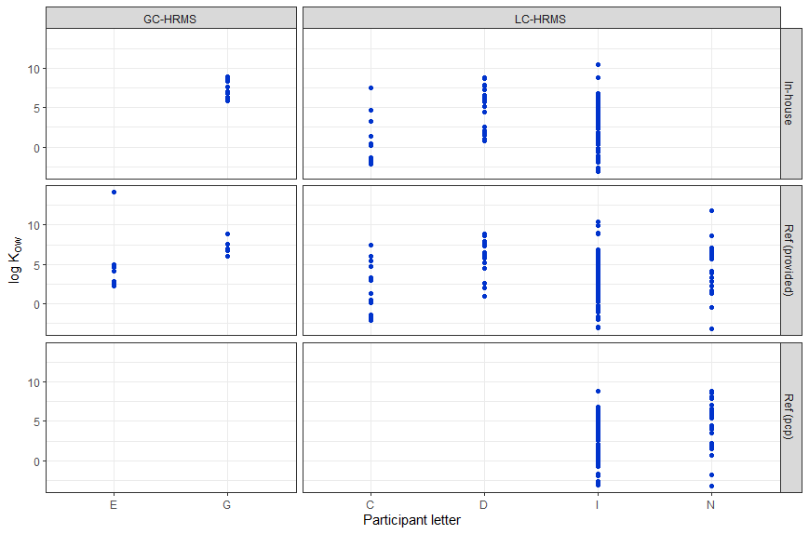
Figure S34. The predicted log K_{OW} values for the compounds detected by suspect screening in the fish samples from Lake Stechlin. Reported compounds that were ambiguously identified (not containing a name/SMILES/other identifier, or containing several for the same m/z) were excluded from this figure since no single log K_{OW} could be calculated.

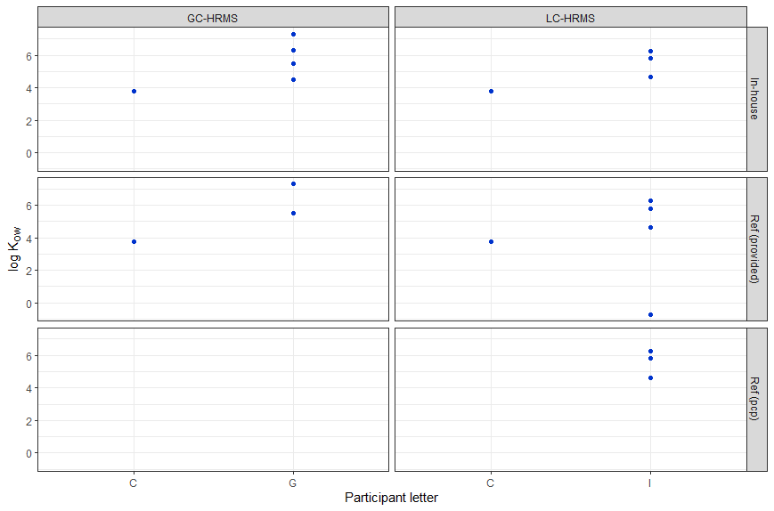
Figure S35. The predicted log K_{OW} values for the compounds detected by non-target screening in the fish samples from Lake Stechlin. Reported compounds that were ambiguously identified (not containing a name/SMILES/other identifier, or containing several for the same m/z) were excluded from this figure since no single log K_{OW} could be calculated.
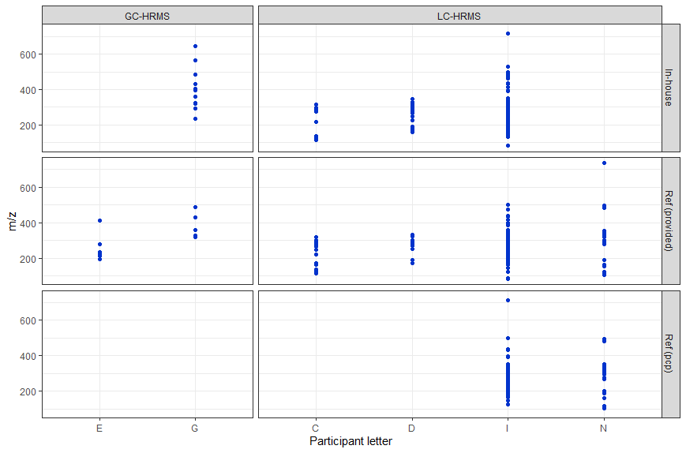
Figure S36. The m/z of compounds detected by suspect screening in the fish samples from Lake Stechlin. Reported compounds that were ambiguously identified (not containing a name/SMILES/other identifier, or containing several for the same m/z) were excluded from this figure.

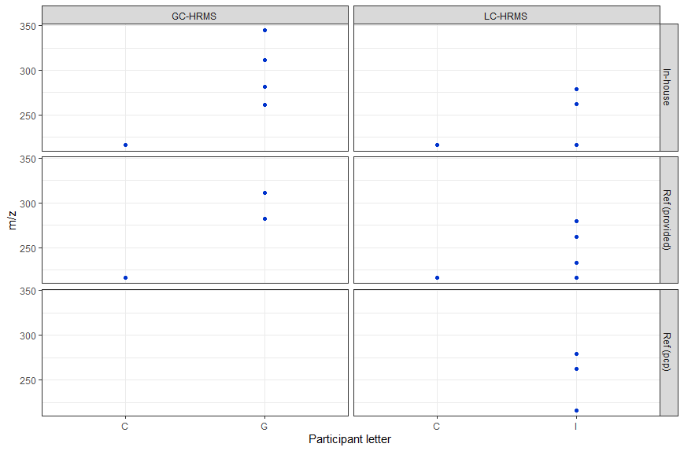
Figure S37. The m/z of compounds detected by non-target screening in the fish samples from Lake Stechlin. Reported compounds that were ambiguously identified (not containing a name/SMILES/other identifier, or containing several for the same m/z) were excluded from this figure.

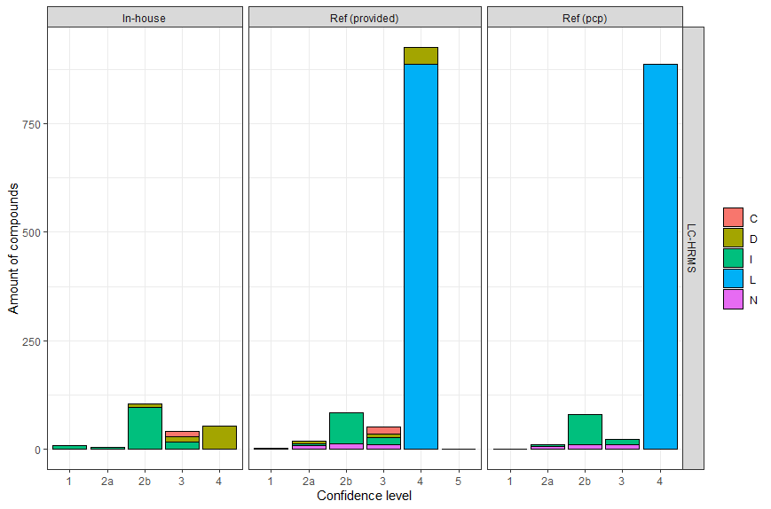
Figure S38. The confidence levels of compounds reported by different participants from Lake Stechlin using suspect screening and LC-HRMS. The numbers are however approximate since not all participants reported confidence levels of their features.

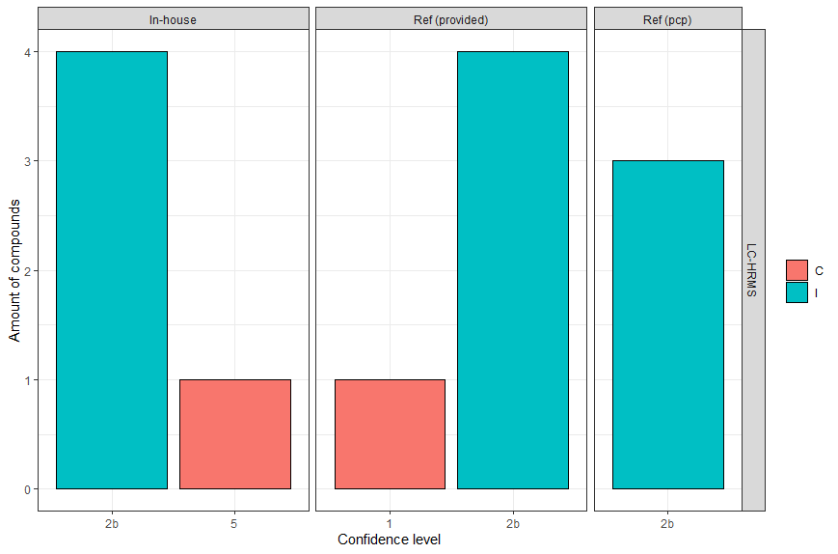
Figure S39. The confidence levels of compounds reported by different participants from Lake Stechlin using non-target screening and LC-HRMS. The numbers are however approximate since not all participants reported confidence levels of their features.

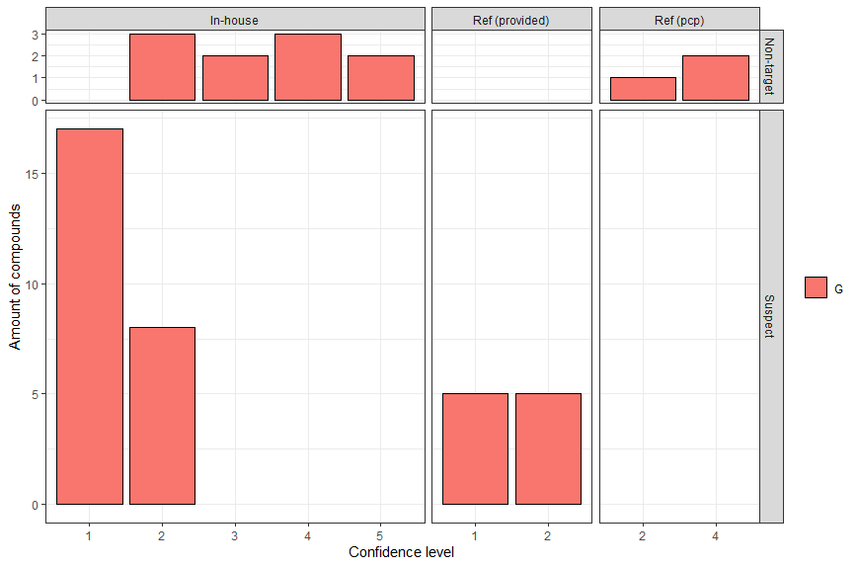
Figure S40. The confidence levels of compounds reported by the participant, identified from Lake Stechlin using GC-HRMS and suspect or non-target screening. The numbers are however approximate since not all participants reported confidence levels of their features.

References

1. Chaker J., Gilles E., Léger T., Jégou B. and David A. From Metabolomics to HRMS-Based Exposomics: Adapting Peak Picking and Developing Scoring for MS1 Suspect Screening. Anal. Chem. 2021, 93, 1792-1800.

