Title
Highly structured populations of deep-sea copepods associated with hydrothermal vents across the Southwest Pacific, despite contrasting life history traits.
Authors
Coral Diaz-Recio Lorenzo^{1,2,5*}, Tasnim Patel³, Eve-Julie Arsenault-Pernet⁴, Camille Poitrimol^{4,5}, Didier Jollivet⁵, Pedro Martinez Arbizu⁶, Sabine Gollner¹
Affiliations
¹NIOZ Royal Netherlands Institute for Sea Research, Landsdiep 4, 1797 SZ, ‘t Horntje (Texel), The Netherlands.
²Utrecht University, Budapestlaan 4, 3584 CD, Utrecht, The Netherlands.
³ Royal Belgian Institute of Natural Sciences, Vautierstraat 29, B-1000, Brussels.
⁴ Biologie et Ecologie des Ecosystèmes marins Profonds (UMR BEEP UBO-CNRS-IFREMER), IFREMER Centre de Bretagne, F 29280, Plouzané, France
⁵Adaptation et Diversité en Milieu Marin (AD2M), Station Biologique de Roscoff, Sorbonne Université, CNRS, Roscoff, 29680, France
⁶ Senckenberg am Meer, German Center for Marine Biodiversity Research, Südstrand 44, 26382 Wilhelmshaven, Germany.

*Corresponding author
Email: coral.diazrecio@nioz.nl
Address: Landsdiep 4, 1797 SZ, ‘t Horntje (Texel), The Netherlands. Department of Ocean Systems (OCS).

Keywords: Hydrothermal vent, meiofauna, copepods, diversity, demography, traits

Abstract

Hydrothermal vents are extreme environments, where abundant communities of copepods with contrasting life history traits co-exist along hydrothermal gradients. Here, we discuss how these traits may contribute to the observed differences in molecular diversity and population genetic structure. Samples were collected from vent locations across the globe including active ridges and back-arc basins and compared to existing deep-sea hydrothermal vent and shallow water data, covering a total of 22 vents and 3 non-vent sites. A total of 806 sequences of mtDNA from the Cox1 gene were used to reconstruct the phylogeny, haplotypic relationship and demography within vent endemic copepods (Dirivultidae, Stygiopontius spp.) and non-vent-endemic copepods (Ameiridae, Miraciidae and Laophontidae). A species complex within Stygiopontius lauensis was studied across five pacific back-arc basins at eight hydrothermal vent fields, with cryptic species being restricted to the basins they were sampled from. Copepod populations from the Lau, North Fiji and Woodlark basins are undergoing demographic expansion, possibly linked to an increase in hydrothermal activity in the last 10 kya. Highly structured populations of Amphiascus aff. varians 2 were also observed from the Lau to the Woodlark basins with populations also undergoing expansion. Less abundant harpacticoids exhibit little to no population structure and stable populations. This study suggests that similarities in genetic structure and demography may arise in vent-associated copepods despite having different life history traits. As structured meta-populations may be at risk of local extinction should major anthropogenic impacts, such as deep-sea mining, occur, we highlight the importance of incorporating a trait-based approach to investigate patterns of genetic connectivity and demography, particularly regarding area-based management tools and environmental management plans.
S2) Bayesian Posterior Probability tree parameters

Fig 1: Model selection workflow schematic for BPP using BEAST. Model implies independent variation in evolutionary forces between the data partitions and the branches within the partitions but concatenates these results into a final tree. Image from BEAST tutorial (https://beast.community/constructing_models).

Fig 2: Above, the Maximum Likelihood tree found in the main text based on 559 bp of codon position partitioning of the mitochondrial Cox1 for dirivultid copepods. Tree built with IQ-TREE (node values are ML bootstraps). Below, the Bayesian Posterior Probability (BPP) tree with strict clock (node values are BPP). Tip nodes are proportional to the number of sequences in each clade. Numbers in brackets denote the number of individuals used to build the trees.
Table 1: Model parameters as given in the output from Tracer v1.7.2 for the Bayesian tree run for the harpacticoid alignment. For each parameter the mean and the Effective Sample Size (ESS) is given. All parameters are said to have converged when the ESS is above 200.
Model parameter | Mean | ESS
posterior | -5241.367 | 617
likelihood | -5554.595 | 2230
prior | 2.258 | 1561
speciescoalescent | 310.97 | 513
birthRate.t:Species | 6.153 | 3161
YuleModel.t:Species | 8.249 | 1369
popMean | 2.80E-03 | 418
TreeHeight.Species | 0.382 | 1284
TreeHeight.t:harps_final_withbathy_1 | 0.42 | 1580
treeLikelihood.harps_final_withbathy_1 | -1283.26 | 1425
treeLikelihood.harps_final_withbathy_2 | -462.648 | 4573
treeLikelihood.harps_final_withbathy_3 | -3808.687 | 2962
treePrior.t:harps_final_withbathy_1 | 176.492 | 1145
clockRate.c:harps_final_withbathy_2 | 9.40E-02 | 3302
clockRate.c:harps_final_withbathy_3 | 10.088 | 2178
rateAC.s:harps_final_withbathy_1 | 0.175 | 5482
rateAG.s:harps_final_withbathy_1 | 0.486 | 1717
rateAT.s:harps_final_withbathy_1 | 0.273 | 2848
rateCG.s:harps_final_withbathy_1 | 0.11 | 5231
rateCT.s:harps_final_withbathy_1 | 4.795 | 1463
rateGT.s:harps_final_withbathy_1 | 0.162 | 3421
substmodel.s:harps_final_withbathy_1 | 1.23E+05 | 7783
rateAC.s:harps_final_withbathy_2 | 0.536 | 7711
rateAG.s:harps_final_withbathy_2 | 1.596 | 6584
rateAT.s:harps_final_withbathy_2 | 0.428 | 7604
rateCG.s:harps_final_withbathy_2 | 1.924 | 6489
rateCT.s:harps_final_withbathy_2 | 1.075 | 7668
rateGT.s:harps_final_withbathy_2 | 0.439 | 8092
substmodel.s:harps_final_withbathy_2 | 1.22E+05 | 8299
rateAC.s:harps_final_withbathy_3 | 0.239 | 6138
rateAG.s:harps_final_withbathy_3 | 2.002 | 1482
rateAT.s:harps_final_withbathy_3 | 0.244 | 3429
rateCG.s:harps_final_withbathy_3 | 0.475 | 3942
rateCT.s:harps_final_withbathy_3 | 2.805 | 1330
rateGT.s:harps_final_withbathy_3 | 0.234 | 4249
substmodel.s:harps_final_withbathy_3 | 1.22E+05 | 7771
BMT_ModelIndicator.s:harps_final_withbathy_1 | 15.12 | 7936
BMT_ModelIndicator.s:harps_final_withbathy_2 | 16.253 | 8206
BMT_ModelIndicator.s:harps_final_withbathy_3 | 12.545 | 6598
BMT_gammaShape.s:harps_final_withbathy_1 | 0.804 | 957
BMT_gammaShape.s:harps_final_withbathy_2 | 0.248 | 1916
BMT_gammaShape.s:harps_final_withbathy_3 | 1.151 | 2492
BMT_ProportionInvariable.s:harps_final_withbathy_1 | 0.277 | 588
BMT_ProportionInvariable.s:harps_final_withbathy_2 | 0.253 | 2270
BMT_ProportionInvariable.s:harps_final_withbathy_3 | 2.30E-02 | 1325
hasGammaRates.s:harps_final_withbathy_1 | 1 | -
hasGammaRates.s:harps_final_withbathy_2 | 0.975 | 2456
hasGammaRates.s:harps_final_withbathy_3 | 1 | -
hasInvariableSites.s:harps_final_withbathy_1 | 0.777 | 758
hasInvariableSites.s:harps_final_withbathy_2 | 0.683 | 5089
hasInvariableSites.s:harps_final_withbathy_3 | 0.238 | 3904
ActivePropInvariable.s:harps_final_withbathy_1 | 0.262 | 571
ActivePropInvariable.s:harps_final_withbathy_2 | 0.201 | 2228
ActivePropInvariable.s:harps_final_withbathy_3 | 5.44E-03 | 4290
ActiveGammaShape.s:harps_final_withbathy_1 | 0.804 | 957
ActiveGammaShape.s:harps_final_withbathy_2 | 0.212 | 3133
ActiveGammaShape.s:harps_final_withbathy_3 | 1.151 | 2492
hasEqualFreqs.s:harps_final_withbathy_1 | 4.22E-03 | 402
hasEqualFreqs.s:harps_final_withbathy_2 | 0.00E+00 | -
hasEqualFreqs.s:harps_final_withbathy_3 | 0.00E+00 | -
BMT_frequencies.s:harps_final_withbathy_1.1 | 0.277 | 2119
BMT_frequencies.s:harps_final_withbathy_1.2 | 0.167 | 1991
BMT_frequencies.s:harps_final_withbathy_1.3 | 0.27 | 2336
BMT_frequencies.s:harps_final_withbathy_1.4 | 0.286 | 2103
BMT_frequencies.s:harps_final_withbathy_2.1 | 0.132 | 3509
BMT_frequencies.s:harps_final_withbathy_2.2 | 0.232 | 3644
BMT_frequencies.s:harps_final_withbathy_2.3 | 0.193 | 3511
BMT_frequencies.s:harps_final_withbathy_2.4 | 0.443 | 3052
BMT_frequencies.s:harps_final_withbathy_3.1 | 0.318 | 1362
BMT_frequencies.s:harps_final_withbathy_3.2 | 0.109 | 1706
BMT_frequencies.s:harps_final_withbathy_3.3 | 0.184 | 1573
BMT_frequencies.s:harps_final_withbathy_3.4 | 0.389 | 1284

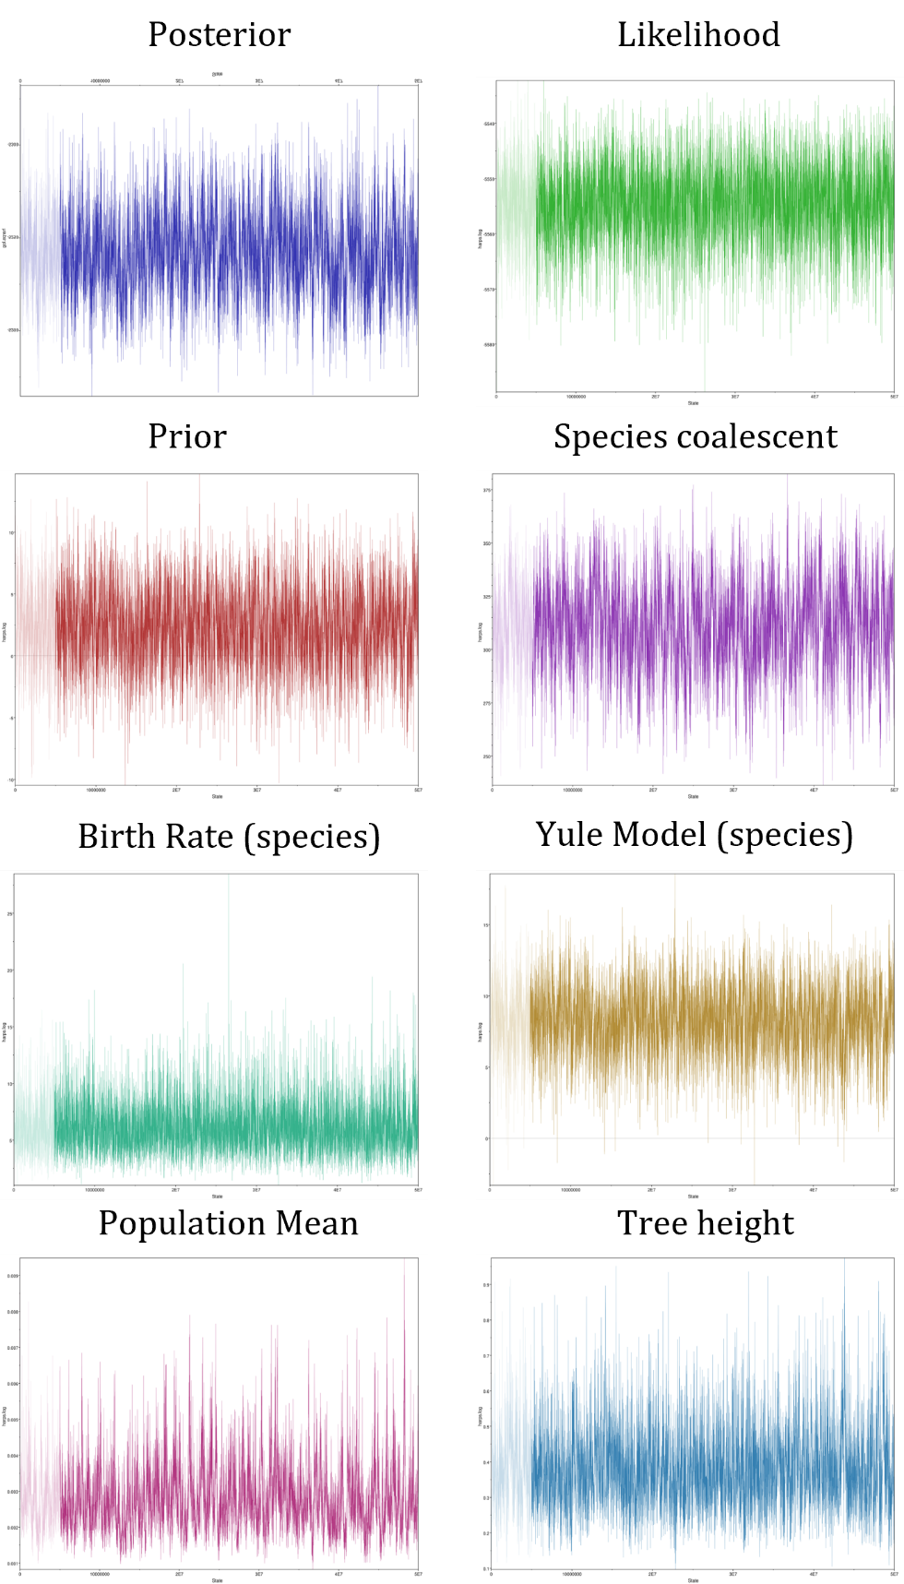

Fig 3: Trace files as show in the output of Tracer v1.7.5 for the harpacticoid alignment, for each of the top main model parameters of posterior probability, likelihood, prior, species coalescent, the birth rate for the species tree, the coalescent model for the species tree (Yule), the population mean and the tree height. All parameters show convergence and correspond to values shown in table 2.

Table 2: Model parameters as given in the output from Tracer v1.7.2. for the Bayesian tree run for the dirivultid alignment. For each parameter the mean and the Effective Sample Size (ESS) is given. All parameters are said to have converged when the ESS is above 200.

Model parameter | Mean | ESS
posterior | -4520.48 | 891
likelihood | -5492.22 | 970
prior | 17.225 | 5855
speciescoalescent | 954.513 | 902
birthRate.t:Species | 10.936 | 7926
YuleModel.t:Species | 22.967 | 2307
popMean | 1.04E-03 | 609
TreeHeight.Species | 0.32 | 1868
TreeHeight.t:truncated_1 | 0.331 | 2086
treeLikelihood.truncated_1 | -1325.32 | 1523
treeLikelihood.truncated_2 | -562.083 | 3273
treeLikelihood.truncated_3 | -3604.81 | 1298
treePrior.t:truncated_1 | 695.917 | 814
clockRate.c:truncated_2 | 0.203 | 12475
clockRate.c:truncated_3 | 11.075 | 1491
rateAC.s:truncated_1 | 0.273 | 7329
rateAG.s:truncated_1 | 0.764 | 1426
rateAT.s:truncated_1 | 0.338 | 905
rateCG.s:truncated_1 | 0.262 | 5817
rateCT.s:truncated_1 | 4.064 | 1141
rateGT.s:truncated_1 | 0.3 | 1559
substmodel.s:truncated_1 | 1.22E+05 | 9080
rateAC.s:truncated_2 | 0.401 | 31269
rateAG.s:truncated_2 | 1.708 | 31449
rateAT.s:truncated_2 | 0.378 | 29053
rateCG.s:truncated_2 | 1.575 | 27470
rateCT.s:truncated_2 | 1.578 | 29570
rateGT.s:truncated_2 | 0.36 | 31114
substmodel.s:truncated_2 | 1.22E+05 | 36001
rateAC.s:truncated_3 | 0.192 | 7182
rateAG.s:truncated_3 | 1.827 | 6986
rateAT.s:truncated_3 | 0.165 | 1456
rateCG.s:truncated_3 | 0.184 | 6089
rateCT.s:truncated_3 | 3.477 | 3015
rateGT.s:truncated_3 | 0.156 | 2466
substmodel.s:truncated_3 | 1.22E+05 | 32611
BMT_ModelIndicator.s:truncated_1 | 12.801 | 11999
BMT_ModelIndicator.s:truncated_2 | 14.867 | 36001
BMT_ModelIndicator.s:truncated_3 | 11.126 | 32747
BMT_gammaShape.s:truncated_1 | 0.672 | 7162
BMT_gammaShape.s:truncated_2 | 0.328 | 6639
BMT_gammaShape.s:truncated_3 | 1.846 | 3057
BMT_ProportionInvariable.s:truncated_1 | 0.182 | 6594
BMT_ProportionInvariable.s:truncated_2 | 0.251 | 6914
BMT_ProportionInvariable.s:truncated_3 | 1.26E-02 | 3148
hasGammaRates.s:truncated_1 | 1 | 18002
hasGammaRates.s:truncated_2 | 0.986 | 10233
hasGammaRates.s:truncated_3 | 1 | -
hasInvariableSites.s:truncated_1 | 0.714 | 10152
hasInvariableSites.s:truncated_2 | 0.695 | 15276
hasInvariableSites.s:truncated_3 | 8.18E-02 | 27891
ActivePropInvariable.s:truncated_1 | 0.158 | 6396
ActivePropInvariable.s:truncated_2 | 0.21 | 6912
ActivePropInvariable.s:truncated_3 | 1.02E-03 | 29285
ActiveGammaShape.s:truncated_1 | 0.672 | 7181
ActiveGammaShape.s:truncated_2 | 0.308 | 8642
ActiveGammaShape.s:truncated_3 | 1.846 | 3057
hasEqualFreqs.s:truncated_1 | 6.99E-02 | 351
hasEqualFreqs.s:truncated_2 | 0.00E+00 | -
hasEqualFreqs.s:truncated_3 | 0.00E+00 | -
BMT_frequencies.s:truncated_1.1 | 0.309 | 3491
BMT_frequencies.s:truncated_1.2 | 0.168 | 1702
BMT_frequencies.s:truncated_1.3 | 0.251 | 7627
BMT_frequencies.s:truncated_1.4 | 0.272 | 8272
BMT_frequencies.s:truncated_2.1 | 0.128 | 14635
BMT_frequencies.s:truncated_2.2 | 0.258 | 13658
BMT_frequencies.s:truncated_2.3 | 0.176 | 13075
BMT_frequencies.s:truncated_2.4 | 0.438 | 12491
BMT_frequencies.s:truncated_3.1 | 0.323 | 5986
BMT_frequencies.s:truncated_3.2 | 0.118 | 6408
BMT_frequencies.s:truncated_3.3 | 0.153 | 6488
BMT_frequencies.s:truncated_3.4 | 0.406 | 5753

Fig 4: Trace files as show in the output of Tracer v1.7.5 for the dirivultid alignment, for each of the top main model parameters of posterior probability, likelihood, prior, species coalescent, the birth rate for the species tree, the coalescent model for the species tree (Yule), the population mean and the tree height. All parameters show convergence and correspond to values shown in table 2.

