_____________________________________________________________________________

THE ZIRCON STORY OF THE NIGER RIVER: TIME‐STRUCTURE MAPS OF THE WEST AFRICAN CRATON AND DISCONTINUOUS PROPAGATION OF PROVENANCE SIGNALS ACROSS A DISCONNECTED SEDIMENT-ROUTING SYSTEM
Guido Pastore, Eduardo Garzanti, Pieter Vermeesch,
Germain Bayon, Alberto Resentini, Nadine Braquet, Brume Overare.
_______________________________________________________________________________

APPENDIX S1 – Sampling, compositional, and textural information

Table S1. Sample information. Location of the studied sediment samples from the Niger catchment.
Table S2. Key petrographic, heavy-mineral, and geochemical parameters for Niger River sediments. GSZ, median grain size in microns, determined by ranking of thin sections from coarsest to finest followed by visual comparison with in-house standards sieved at 0.25 ϕ. Q, quartz; KF, K-feldspar; P, plagioclase; L, lithic fragments; HM, heavy minerals; tHMC, transparent heavy-mineral concentration; n.d. = not determined. Sand classification after Garzanti (2019). Trace elements analyzed at the Pôle Spectrométrie Océan (Plouzané, France) using a Thermo Scientific Element XR sector field ICP-MS, using the Tm addition method (Barrat et al. 1996). Gd, Ho, and Yb concentrations are normalized to CI carbonaceous chondrites according to values in Barrat et al. (2012). Neodymium and hafnium isotopes were measured using a Thermo Scientific Neptune multi-collector ICP-MS, after Nd and Hf purification by conventional ion chromatography. Epsilon Nd values were calculated using the present-day chondritic (CHUR) values ¹⁴³Nd/¹⁴⁴Nd = 0.512630 and ¹⁴⁷Sm/¹⁴⁴Nd = 0.196 (Bouvier et al., 2008). Neodymium depleted mantle model ages (T_{Nd,DM}) were calculated following De Paolo (1981) and using measured Sm and Nd concentrations (¹⁴⁷Sm/¹⁴⁴Nd = Sm/Nd × 0.6049) and present-day depleted mantle values of ¹⁴³Nd/¹⁴⁴Nd = 0.513073 and ¹⁴⁷Sm/¹⁴⁴Nd = 0.21083 (Garçon 2021). Epsilon Hf values were calculated using the present-day chondritic (CHUR) values ¹⁷⁶Hf/¹⁷⁷Hf = 0.282785 and ¹⁷⁶Lu/¹⁷⁷Hf = 0.03360 (Bouvier et al., 2008). Hafnium depleted mantle model ages (T_{Hf,DM}) were calculated using measured Lu and Hf concentrations (¹⁷⁶Lu/¹⁷⁷Hf = Lu/Hf × 0.142) and present-day depleted mantle values of ¹⁷⁶Hf/¹⁷⁷Hf = 0.283294 and ¹⁷⁶Lu/¹⁷⁷Hf = 0.03933 (Blichert-Toft and Puchtel, 2010).
Table S3. Size distribution of zircon grains. For each zircon grain identified by semi-automatic Raman spectroscopy in the studied samples, the equivalent diameter d_{e} was determined by image analysis as the geometric mean of long and short axes. Mean size (in ϕ units and in microns), sorting (σϕ), and skewness (Sk) of the d_{e} distribution were calculated following Folk and Ward (1957).
CITED REFERENCES
Barrat, J.A., Keller, F., Amossé, J., Taylor, R.N., Nesbitt, R.W., and Hirata, T. (1996). Determination of rare earth elements in sixteen silicate reference samples by ICP‐MS after Tm addition and ion exchange separation: Geostandards Newsletter, 20(1), 133-139.
Barrat, J.A., Zanda, B., Moynier, F., Bollinger, C., Liorzou, C., and Bayon, G. (2012). Geochemistry of CI chondrites: Major and trace elements, and Cu and Zn isotopes: Geochimica et Cosmochimica Acta, 83, 79-92.
Blichert-Toft, J., and Puchtel, I.S. (2010). Depleted mantle sources through time: evidence from Lu–Hf and Sm–Nd isotope systematics of Archean komatiites: Earth and Planetary Science Letters, 297(3-4), 598-606.
Bouvier, A., Vervoort, J.D., and Patchett, P.J. (2008). The Lu–Hf and Sm–Nd isotopic composition of CHUR: constraints from unequilibrated chondrites and implications for the bulk composition of terrestrial planets: Earth and Planetary Science Letters, 273, 48-57.
De Paolo, D.J. (1981). Neodymium isotopes in the Colorado Front Range and crust–mantle evolution in the Proterozoic: Nature, 291(5812), 193-196.
Folk, R.L., and Ward, W.C. (1957). Brazos River bar; a study in the significance of grain size parameters: Journal of Sedimentary Petrology, 27(1), 3-26.
Garçon, M. (2021). Episodic growth of felsic continents in the past 3.7 Ga: Science Advances, 7(39), p.eabj1807.
Garzanti, E. (2019). Petrographic classification of sand and sandstone: Earth-Science Reviews, 192, 545-563.
APPENDIX S2 – Geochronological data

The complete geochronological dataset includes 6677 detrital-zircon U-Pb ages (4299 of which considered concordant) from 35 samples of eolian and fluvial sands collected throughout the Niger River catchment from Guinea to the ocean (summary of ages provided in Table S4).
From the heavy-mineral separate of 32 fluvial sands obtained by wet sieving (15-500 µm fraction) and of 3 bulk samples of eolian-dune sand, detrital zircons were concentrated with standard magnetic techniques, directly mounted in epoxy resin without any operator selection by hand picking and identified by automated phase mapping (Vermeesch et al. 2017) with a Renishaw inViaTM Raman microscope. U-Pb zircon ages were determined at the London Geochronology Centre (University College London) using an Agilent 7900 LA-ICP-MS (laser ablation-inductively coupled plasma-mass spectrometry) system, employing a NewWave NWR193 Excimer Laser operated at 10 Hz with a 25 μm spot size and ~2.2 J/cm² fluence. No cathodo-luminescence imaging was done, and the laser spot was always placed blindly in the middle of zircon grains to treat all samples equally and avoid bias in intersample comparison (“blind-dating approach” as discussed in Garzanti et al. 2018). The mass spectrometer data were converted to isotopic ratios using GLITTER 4.4.2 software (Griffin et al. 2008), employing Plešovice zircon (Sláma et al. 2008) as a primary age standard and GJ-1 (Jackson et al. 2004) and 91500 (Wiedenbeck et al., 2004) as secondary age standards. A NIST SRM612 glass was used as a compositional standard for U and Th concentrations. GLITTER files were post-processed using IsoplotR (Vermeesch 2018). Concordia ages were calculated as the maximum likelihood intersection between the concordia line and the error ellipse of ²⁰⁷Pb/²³⁵U and ²⁰⁶Pb/²³⁸U (Ludwig 1998). The discordance cutoff was set at -5/+15 (Vermeesch 2021).

Results of the analysis of geochronological standards
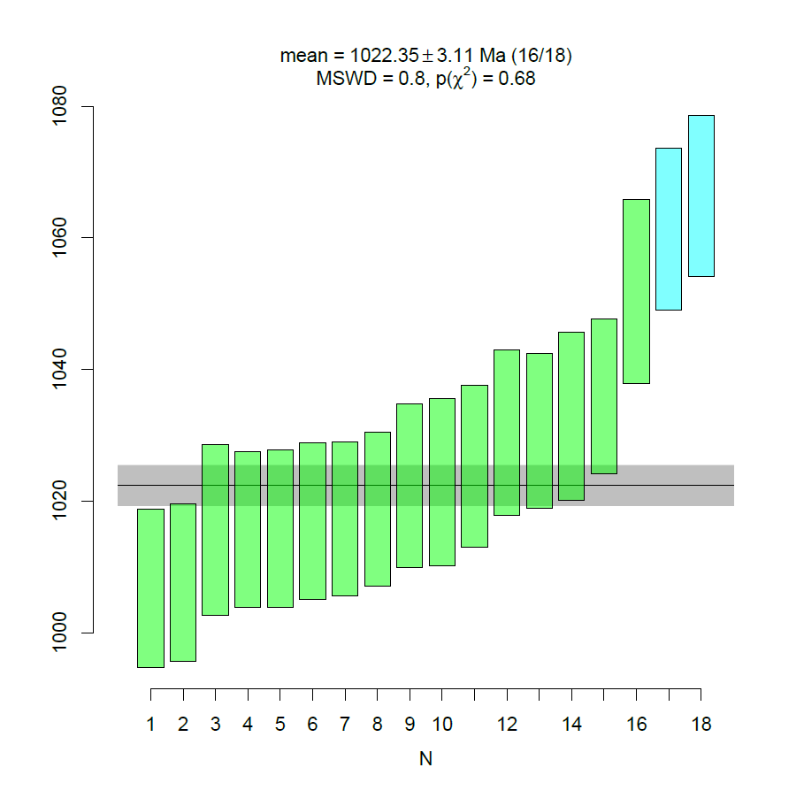
Secondary standards GJ1 (Jackson et al., 2004) and 91500 (Wiedenbeck et al., 2004) were routinely employed during isotopic analyses to assess data accuracy. Out of 66 analyses of GJ1, 65 were accepted yielding a weighted mean age of 592.3 ± 0.9 (MSWD 2.4). Out of 18 analyses of 91500, 16 were accepted yielding a weighted average age of 1022.4 ± 3.1 (MSWD 0.8).

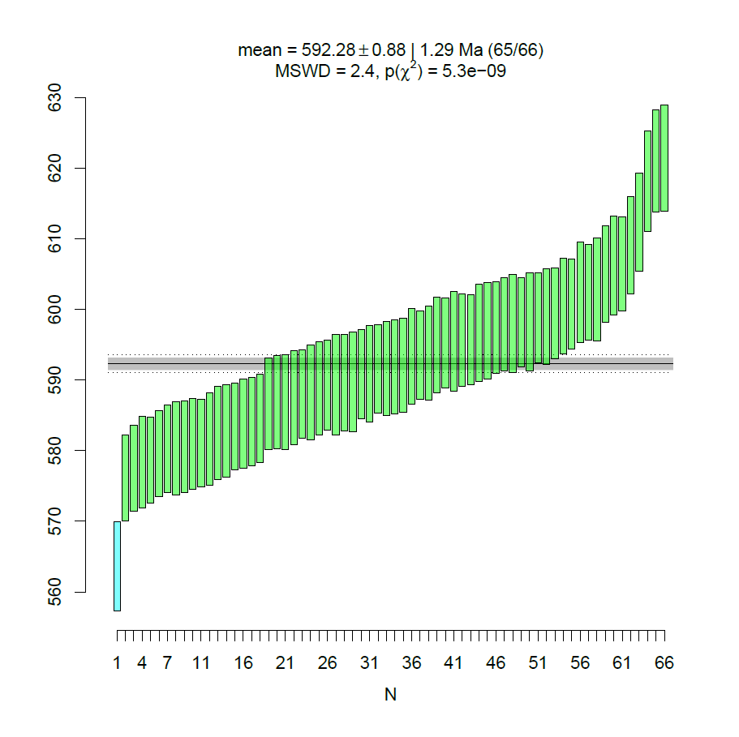

CITED REFERENCES
Garzanti, E., Vermeesch, P., Rittner, M. and Simmons, M. (2018). The zircon story of the Nile: Time‐structure maps of source rocks and discontinuous propagation of detrital signals: Basin Research, 30(6), 1098-1117.
Griffin, W.L., Powell, W.J., Pearson, N.J., and O’Reilly, S.Y. (2008). GLITTER: Data reduction software for laser ablation ICP-MS, in Sylvester, P., ed., Laser ablation-ICP-MS in the Earth Sciences: Current practices and outstanding issues: Mineralogical Association of Canada, Short Course Series 40, 204-207.
Jackson, S.E., Pearson, N.J., Griffin, W.L., and Belousova, E.A. (2004). The application of laser ablation-inductively coupled plasma-mass spectrometry to in situ U–Pb zircon geochronology: Chemical Geology, 211, 47-69.
Ludwig, K.R. (1998). On the treatment of concordant uranium-lead ages: Geochimica et Cosmochimica Acta, 62(4), 665-676.
Sláma, J., Košler, J., Condon, D.J., Crowley, J.L., Gerdes, A., Hanchar, J.M., Horstwood, M.S., Morris, G.A., Nasdala, L., Norberg, N., and Schaltegger, U. (2008). Plešovice zircon — a new natural reference material for U–Pb and Hf isotopic microanalysis: Chemical Geology, 249, 1-35.
Vermeesch, P., (2018). IsoplotR: A free and open toolbox for geochronology: Geoscience Frontiers, 9(5), 1479-1493.
Vermeesch, P. (2021). On the treatment of discordant detrital zircon U–Pb data: Geochronology, 3(1), 247-257.
Vermeesch, P., Rittner, M., Petrou, E., Omma, J., Mattinson, C, and Garzanti, E. (2017). High throughput petrochronology and sedimentary provenance analysis by automated phase mapping and LAICPMS: Geochemistry, Geophysics, Geosystems, 18, doi:10.1002/2017GC007109.
Wiedenbeck, M., Hanchar, J.M., Peck, W.H., Sylvester, P., Valley, J., Whitehouse, M., Kronz, A., Morishita, Y., Nasdala, L., Fiebig, J., Franchi, I., Girard, J.P., Greenwood, R.C., Hinton, R., Kita, N, Mason, P.R.D., Norman, M., Ogasawara, M., Piccoli, P.M., Rhede, D., Satoh, H., Schulz-Dobrick, B., Skår, O., Spicuzza, M.J., Terada, K., Tindle, A., Togashi, S., Vennemann, T., Xie, Q., and Zheng, Y.F. (2004). Further characterisation of the 91500 zircon crystal. Geostandards and Geoanalytical Research, 28, 9-39.

APPENDIX S3 – Compiled bedrock ages

The dataset contains 496 U-Pb, Rb-Sr, Sm-Nd, and K-Ar ages of igneous and metamorphic rocks exposed in diverse domains of the West African Craton, compiled from 107 literature sources. Geological domains, ages and methods are provided in Table S5; full references provided in Table S6.

