SUPPORTING INFORMATION

Spatial and temporal patterns of organophosphate Esters Flame Retardants and plasticizers in airborne particles over the Mediterranean Sea.

Kalliopi Violaki^{1,2}, Javier Castro Jimenez³, Athanasios Nenes^{1,4}, Richard Sempere², and Christos Panagiotopoulos²

¹Laboratory of Atmospheric Processes and their Impacts, School of Architecture, Civil & Environmental Engineering, École Polytechnique Fédérale de Lausanne, Lausanne, 1015, Switzerland
²Aix-Marseille Univ., Université de Toulon, CNRS, IRD, MIO, Marseille, France
³IFREMER, Chemical Contamination of Marine Ecosystems (CCEM), Rue de l’Ile d’Yeu, BP 21105, 44311 Nantes Cedex 3, France
⁴Center for the Study of Air Quality and Climate Change, Institute of Chemical Engineering Sciences, Foundation for Research and Technology Hellas, GR-26504, Patras, Greece

Number of pages: 16
Number of figures: 6
Number of tables: 13

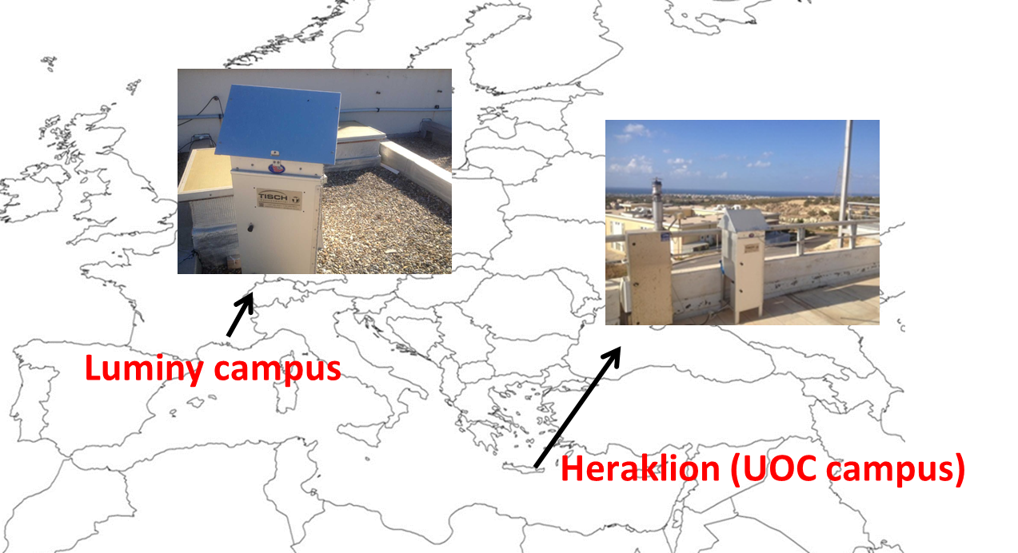
Fig. S1. The sampling site in Crete (35°18'29.82"N, 25° 4'49.41"E) in East Mediterranean and in Luminy Campus (43°14'7.16"N, 5°26'26.58"E) in North West Mediterranean.

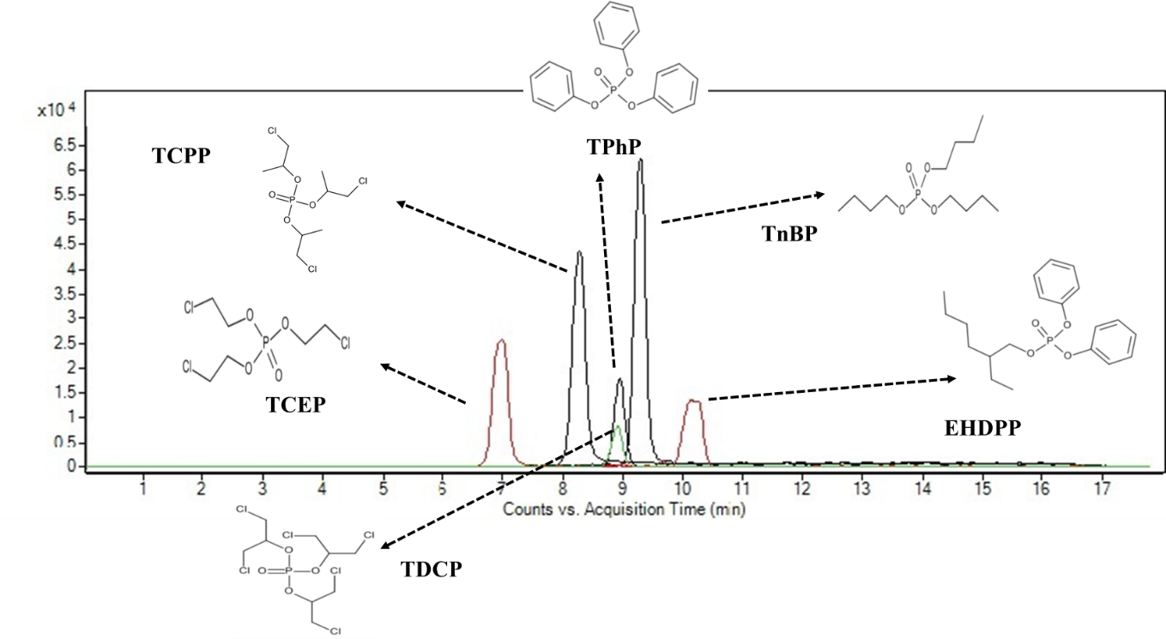
Fig. S2: Chromatographic separation with Eclipse Plus (Agilent) column with 50mm×2.1mm I.D., 1.8 μm particle size. All OPEs were ionized in positive mode and were detected as [M+H]⁺. TCEP:284.9599 m/z, TCPP:327.0090 m/z, TDCP:428.8839 m/z, TPhP: 327.0793 m/z, TnBP: 267.1715 m/z, EHDPP: 363.1711 m/z.
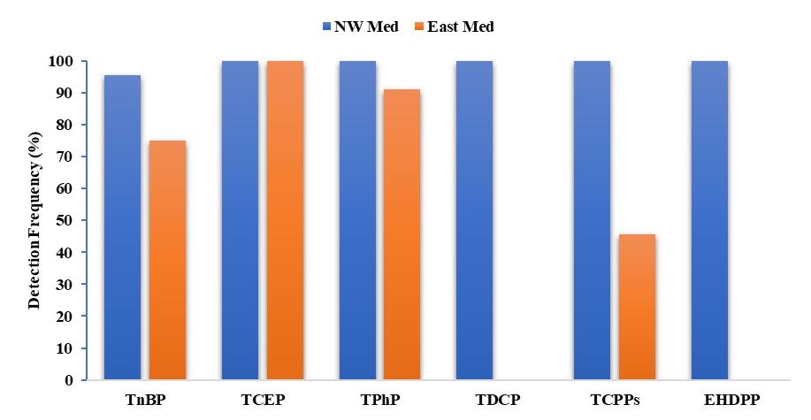
Fig. S3: OPEs detection frequency (%) measured in East and NW Mediterranean during the sampling period.

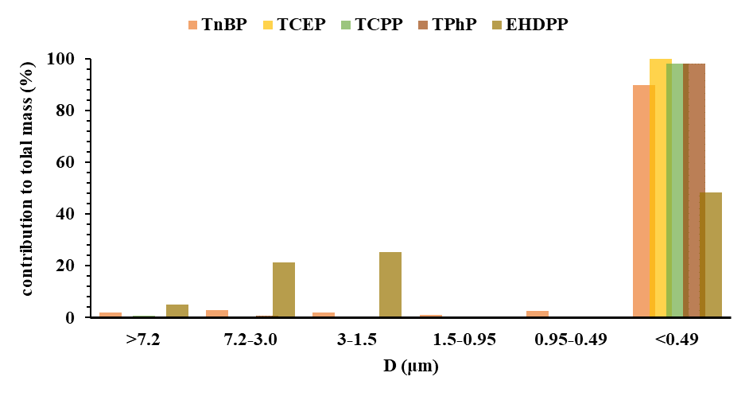
Fig. S4: Average percentage size distribution of OPEs mass from samples (n=2) collected from East Mediterranean. TDCP was not detected in the specific samples.

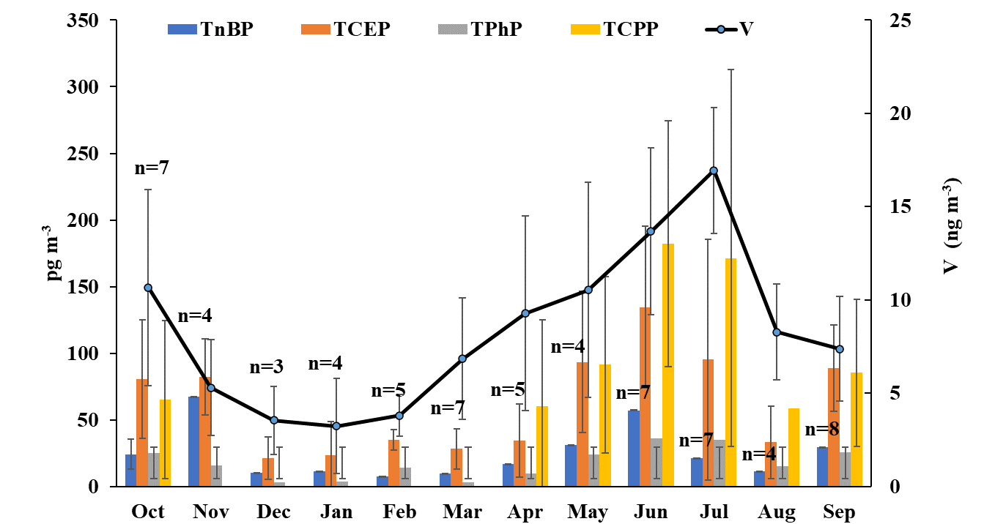
Fig. S5: Monthly variation of OPEs detected in atmospheric particles in the eastern Mediterranean. Error bars represent the standard deviation.

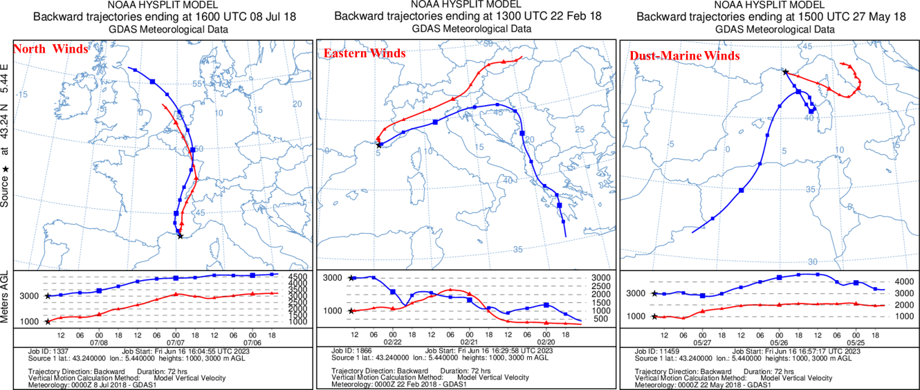

Fig. S6: The aerosols samples collected from NW Mediterranean have been classified in four main classes corresponding to the main wind sectors influencing the area during the sampling period. The three-days back trajectories of the air masses were obtained by using the Hysplit model for heights at 1000 m and 3000 m (Stein et al., 2015).

Table S1: Instrumental limits of detection (LODs) calculated based on S/N=3 ratio.

OPEs | pg m⁻³
TCPP | 1.6
TCEP | 2.1
TDCP | 1.5
TnBP | 0.7
TPhP | 0.1
EHDPP | 2.3

Table S2: OPEs method recoveries
OPEs | Recovery (%)
TCPP | 111.5±11.0
TCEP | 91.1±7.4
TDCP | 106.9±9.3
TnBP | 80.2±6.8
TPhP | 72.6±14.7
EHDPP | 82.4±1.1

Table S3: Pearson correlation coefficient (r) between the main anions, metals and P species analyzed in TSPs, collected over the NW Mediterranean area (n=10) during summer season. Only correlations with p <0.05, marked in red, are discussed.
Variables | TnBP | TCEP | TPhP | TDCP | TCPP | EHDPP
TnBP | 1
TCEP | 0.12 | 1
TPhP | 0.27 | 0.71 | 1
TDCP | 0.06 | 0.19 | 0.61 | 1
TCPP | 0.27 | 0.53 | 0.87 | 0.33 | 1
EHDPP | 0.28 | 0.84 | 0.88 | 0.24 | 0.83 | 1
Cd | -0.20 | -0.31 | 0.13 | 0.51 | 0.03 | -0.24
Sn | 0.07 | -0.25 | 0.24 | 0.84 | 0.04 | -0.20
Cs | -0.03 | -0.06 | 0.34 | 0.23 | 0.37 | 0.17
Pb | 0.06 | -0.08 | 0.49 | 0.52 | 0.43 | 0.17
Al | 0.15 | 0.42 | 0.79 | 0.49 | 0.71 | 0.60
V | -0.26 | 0.45 | 0.63 | 0.76 | 0.37 | 0.36
Cr | 0.51 | 0.11 | 0.53 | 0.71 | 0.38 | 0.25
Mn | 0.20 | 0.20 | 0.66 | 0.53 | 0.62 | 0.39
Fe | 0.07 | 0.32 | 0.64 | 0.51 | 0.61 | 0.38
Co | 0.05 | 0.46 | 0.72 | 0.57 | 0.56 | 0.49
Ni | -0.10 | 0.46 | 0.69 | 0.81 | 0.45 | 0.39
Cu | 0.37 | -0.02 | 0.58 | 0.52 | 0.62 | 0.30
Zn | 0.27 | 0.10 | 0.73 | 0.65 | 0.71 | 0.43
As | 0.14 | 0.09 | 0.57 | 0.68 | 0.38 | 0.34
Se | 0.91 | 0.13 | 0.29 | 0.28 | 0.17 | 0.21
Chloride | -0.54 | -0.43 | -0.57 | -0.23 | -0.39 | -0.50
Nitrate | -0.08 | -0.15 | 0.41 | 0.81 | 0.30 | -0.02
nss-sulfate | -0.17 | 0.18 | 0.49 | 0.81 | 0.24 | 0.14
Oxalate | -0.02 | 0.36 | 0.79 | 0.81 | 0.59 | 0.52
Na⁺ | -0.54 | -0.44 | -0.20 | 0.43 | -0.19 | -0.43
NH₄⁺ | 0.10 | 0.37 | 0.79 | 0.72 | 0.68 | 0.49
nss-K⁺ | 0.14 | 0.12 | 0.73 | 0.53 | 0.83 | 0.50
Mg²⁺ | -0.42 | -0.12 | 0.26 | 0.70 | 0.16 | -0.04
nss-Ca²⁺ | 0.25 | -0.13 | 0.30 | 0.74 | 0.03 | -0.12

Table S4: Pearson correlation coefficient (r) between the main anions, metals and P species analyzed in TSPs, collected over the NW Mediterranean area (n=8) during winter season. Only correlations with p < 0.05, marked in red, were discussed.
Variables | TnBP | TCEP | TPhP | TDCP | TCPP | EHDPP
TnBP | 1
TCEP | 0.46 | 1
TPhP | 0.70 | 0.70 | 1
TDCP | 0.77 | 0.84 | 0.93 | 1
TCPP | 0.82 | 0.70 | 0.88 | 0.89 | 1
EHDPP | 0.75 | 0.81 | 0.91 | 0.93 | 0.98 | 1
Cd | -0.22 | -0.44 | -0.22 | -0.38 | -0.38 | -0.43
Sn | -0.21 | -0.66 | -0.53 | -0.53 | -0.49 | -0.59
Cs | 0.59 | -0.16 | 0.14 | 0.22 | 0.06 | -0.02
Pb | 0.12 | -0.53 | -0.27 | -0.21 | -0.30 | -0.39
Al | 0.07 | -0.15 | -0.18 | 0.02 | -0.16 | -0.19
V | 0.72 | 0.42 | 0.83 | 0.80 | 0.82 | 0.78
Cr | 0.33 | -0.24 | -0.14 | 0.03 | -0.02 | -0.12
Mn | 0.32 | -0.22 | 0.06 | 0.16 | 0.06 | -0.02
Fe | 0.65 | -0.10 | 0.25 | 0.35 | 0.32 | 0.21
Co | 0.25 | -0.17 | 0.05 | 0.14 | 0.16 | 0.07
Ni | 0.63 | 0.34 | 0.66 | 0.69 | 0.72 | 0.66
Cu | -0.02 | -0.46 | -0.43 | -0.31 | -0.24 | -0.33
Zn | 0.07 | -0.57 | -0.25 | -0.23 | -0.26 | -0.35
As | -0.15 | -0.77 | -0.55 | -0.53 | -0.47 | -0.59
Se | 0.39 | -0.14 | -0.02 | 0.07 | 0.18 | 0.06
Chloride | 0.74 | 0.19 | 0.52 | 0.58 | 0.44 | 0.38
Nitrate | -0.29 | -0.48 | -0.60 | -0.50 | -0.50 | -0.56
nss-sulfate | -0.27 | -0.44 | -0.40 | -0.36 | -0.45 | -0.47
Oxalate | -0.35 | -0.09 | -0.22 | -0.12 | -0.37 | -0.31
Na⁺ | 0.74 | 0.38 | 0.63 | 0.72 | 0.54 | 0.52
NH₄⁺ | -0.27 | -0.57 | -0.66 | -0.58 | -0.52 | -0.59
nss-K⁺ | -0.30 | -0.37 | -0.55 | -0.42 | -0.46 | -0.48
Mg²⁺ | 0.72 | 0.38 | 0.62 | 0.71 | 0.52 | 0.50
nss-Ca²⁺ | -0.04 | -0.46 | -0.39 | -0.27 | -0.32 | -0.39

Table S5: Pearson correlation coefficient (r) between the main anions, metals and P species analyzed in TSPs, collected over the NW Mediterranean area (n=5) during spring season. Only correlations with p < 0.05, marked in red, were discussed.
Variables | TnBP | TCEP | TPhP | TDCP | TCPP | EHDPP
TnBP | 1
TCEP | 0.99 | 1
TPhP | 0.99 | 0.97 | 1
TDCP | 0.99 | 0.97 | 1.00 | 1
TCPP | 0.98 | 0.99 | 0.97 | 0.97 | 1
EHDPP | 1.00 | 0.98 | 1.00 | 1.00 | 0.97 | 1
Cd | 0.96 | 0.99 | 0.95 | 0.95 | 0.96 | 0.96
Sn | 1.00 | 0.98 | 1.00 | 1.00 | 0.98 | 1.00
Cs | 0.97 | 0.93 | 0.97 | 0.96 | 0.91 | 0.97
Pb | 1.00 | 0.98 | 0.99 | 0.99 | 0.97 | 0.99
Al | 0.93 | 0.89 | 0.93 | 0.91 | 0.84 | 0.92
V | 0.69 | 0.65 | 0.65 | 0.62 | 0.61 | 0.65
Cr | 0.97 | 0.93 | 0.97 | 0.96 | 0.91 | 0.97
Mn | 0.97 | 0.93 | 0.96 | 0.95 | 0.90 | 0.96
Fe | 0.95 | 0.91 | 0.95 | 0.93 | 0.88 | 0.94
Co | 0.97 | 0.95 | 0.96 | 0.95 | 0.92 | 0.96
Ni | 0.93 | 0.90 | 0.90 | 0.88 | 0.88 | 0.90
Cu | 0.98 | 0.95 | 0.98 | 0.97 | 0.94 | 0.98
Zn | 0.99 | 0.96 | 0.98 | 0.98 | 0.95 | 0.98
As | 0.99 | 0.95 | 0.99 | 0.99 | 0.94 | 0.99
Se | 0.27 | 0.17 | 0.38 | 0.39 | 0.22 | 0.35
Chloride | 0.97 | 0.94 | 0.99 | 0.98 | 0.93 | 0.99
Nitrate | 0.97 | 0.93 | 0.98 | 0.97 | 0.92 | 0.97
nss-sulfate | 0.75 | 0.76 | 0.67 | 0.66 | 0.72 | 0.68
Oxalate | 0.97 | 0.98 | 0.95 | 0.96 | 1.00 | 0.96
Na⁺ | 0.98 | 0.95 | 0.99 | 0.99 | 0.93 | 0.99
NH₄⁺ | 0.13 | 0.21 | 0.01 | 0.02 | 0.21 | 0.04
nss-K⁺ | 0.99 | 0.97 | 1.00 | 1.00 | 0.96 | 1.00
Mg²⁺ | 0.98 | 0.95 | 0.99 | 0.98 | 0.93 | 0.99
nss-Ca²⁺ | 0.98 | 0.96 | 0.98 | 0.98 | 0.93 | 0.98

OPEs (pg m⁻³) | TnBP | TCEP | TPhP | TDCP | TCPPs | EHDPP
North & Central France (n=10) | 54.1±51.5 | 58.1±56.8 | 19.2±16.8 | 129.8±51.4 | 617.2±376.5 | 1046.7±1389.5
Central & East Europe(n=3) | 50.9±43.0 | 62.0±70.2 | 10.3±5.3 | 157.2±116.0 | 463.3±180.1 | 674.7±437.8
South-Dust-Marine (n=7) | 38.4±60.6 | 143.3±120.4 | 23.2±31.7 | 181.9±113.2 | 749.0±541.1 | 1340.8±2291.7
Table S6: Average atmospheric concentration of OPEs measuring in NW Mediterranean corresponded to air mass sections.

Table S7: Pearson correlation coefficient (r) between the main anions, metals and P species analyzed in TSPs, collected over the eastern Mediterranean area (n=22) during summer season. Only correlations with p < 0.05, marked in red, were discussed.
Variables | TnBP | TCEP | TPhP | TCPP
TnBP | 1
TCEP | 0.76 | 1
TPhP | 0.56 | 0.92 | 1
TCPP | 0.53 | 0.67 | 0.68 | 1
Chloride | -0.49 | -0.50 | -0.38 | -0.18
Nitrate | -0.31 | -0.19 | -0.09 | -0.01
nss-Sulfate | 0.43 | 0.36 | 0.27 | 0.24
Oxalate | -0.08 | 0.03 | 0.12 | 0.14
Phosphate | 0.05 | 0.14 | 0.18 | -0.09
Na⁺ | -0.60 | -0.58 | -0.40 | -0.28
NH₄⁺ | 0.56 | 0.50 | 0.33 | 0.24
nss-K⁺ | -0.32 | -0.14 | -0.02 | -0.09
Mg²⁺ | -0.49 | -0.51 | -0.39 | -0.19
nss-Ca²⁺ | 0.02 | 0.15 | 0.29 | 0.25
Rb | -0.18 | 0.17 | 0.41 | 0.29
Sr | -0.41 | -0.17 | 0.05 | 0.13
Fe | -0.09 | 0.21 | 0.44 | 0.35
Al | -0.02 | 0.31 | 0.55 | 0.39
Pb | 0.07 | 0.08 | 0.15 | 0.35
V | 0.28 | 0.57 | 0.63 | 0.57
Cr | -0.19 | -0.22 | -0.12 | 0.17
Mn | -0.20 | 0.11 | 0.34 | 0.25
Co | -0.17 | 0.13 | 0.37 | 0.43
Ni | 0.04 | 0.23 | 0.36 | 0.52
Cu | -0.02 | 0.45 | 0.60 | 0.27
Zn | 0.00 | 0.25 | 0.31 | 0.32
Cd | 0.05 | 0.07 | 0.05 | 0.18
Cs | 0.11 | 0.14 | 0.23 | 0.28
As | -0.53 | -0.36 | -0.16 | 0.04

Table S8: Pearson correlation coefficient (r) between the main anions, metals and P species analyzed in TSPs, collected over the eastern Mediterranean area (n=18) during autumn season. Only correlations with p < 0.05, marked in red, were discussed.
Variables | TnBP | TCEP | TPhP | TCPP
TnBP | 1
TCEP | 0.18 | 1
TPhP | 0.37 | 0.85 | 1
TCPP | 0.43 | 0.55 | 0.44 | 1
Chloride | -0.05 | 0.12 | 0.09 | 0.27
Nitrate | 0.33 | 0.51 | 0.53 | 0.15
nss-Sulfate | 0.38 | -0.24 | -0.06 | -0.14
Oxalate | 0.33 | 0.07 | 0.15 | 0.15
Phosphate | 0.37 | 0.66 | 0.69 | 0.39
Na⁺ | 0.05 | -0.23 | -0.13 | 0.08
NH₄⁺ | 0.39 | -0.15 | -0.06 | -0.11
nss-K⁺ | -0.28 | 0.10 | -0.18 | -0.02
Mg²⁺ | 0.02 | -0.04 | -0.02 | 0.20
nss-Ca²⁺ | -0.05 | 0.69 | 0.49 | 0.42
Rb | 0.11 | 0.70 | 0.55 | 0.49
Sr | 0.10 | 0.66 | 0.54 | 0.52
Fe | 0.17 | 0.70 | 0.60 | 0.54
Al | 0.12 | 0.71 | 0.59 | 0.51
Pb | 0.06 | 0.27 | 0.00 | 0.06
V | 0.30 | 0.05 | 0.19 | 0.20
Cr | -0.22 | 0.31 | 0.13 | 0.34
Mn | 0.18 | 0.72 | 0.64 | 0.51
Co | 0.28 | 0.50 | 0.52 | 0.52
Ni | 0.35 | 0.01 | 0.20 | 0.15
Cu | -0.13 | 0.20 | 0.21 | 0.14
Zn | 0.28 | 0.45 | 0.27 | 0.38
Cd | -0.13 | 0.04 | 0.02 | -0.20
Cs | 0.26 | 0.48 | 0.42 | 0.52
As | 0.55 | 0.19 | 0.13 | 0.20

Table S9: Pearson correlation coefficient (r) between the main anions, metals and P species analyzed in TSPs, collected over the eastern Mediterranean area (n=12) during winter season. Only correlations with p < 0.05, marked in red, were discussed.
Variables | TnBP | TCEP | TPhP
TnBP | 1
TCEP | -0.05 | 1
TPhP | -0.13 | 0.36 | 1
Chloride | 0.22 | -0.32 | 0.00
Nitrate | 0.04 | -0.19 | 0.43
nss-Sulfate | -0.33 | -0.01 | -0.20
Oxalate | 0.03 | 0.02 | 0.11
Phosphate | 0.26 | 0.05 | 0.33
Na⁺ | 0.03 | -0.21 | 0.24
NH₄⁺ | -0.65 | -0.03 | -0.15
nss-K⁺ | 0.16 | 0.33 | -0.01
Mg²⁺ | -0.05 | -0.18 | 0.24
nss-Ca²⁺ | 0.34 | 0.41 | 0.56
Rb | 0.26 | 0.40 | 0.77
Sr | 0.27 | 0.20 | 0.55
Fe | 0.14 | 0.36 | 0.76
Al | 0.23 | 0.38 | 0.68
Pb | -0.39 | -0.03 | 0.75
V | -0.41 | -0.24 | 0.17
Cr | 0.28 | -0.76 | -0.22
Mn | -0.30 | 0.21 | 0.95
Co | -0.32 | 0.19 | 0.95
Ni | -0.34 | -0.45 | -0.10
Cu | -0.11 | 0.00 | 0.53
Zn | -0.03 | -0.25 | 0.53
Cd | -0.31 | 0.18 | 0.91
Cs | 0.26 | 0.30 | 0.80
As | -0.42 | -0.32 | 0.30

Table S10: Pearson correlation coefficient (r) between the main anions, metals and P species analyzed in TSPs, collected over the eastern Mediterranean area (n=16) during spring season. Only correlations with p < 0.05, marked in red, were discussed.
Variables | TnBP | TCEP | TPhP | TCPP
TnBP | 1
TCEP | 0.66 | 1
TPhP | 0.75 | 0.92 | 1
TCPP | 0.10 | 0.63 | 0.56 | 1
Chloride | 0.12 | 0.12 | 0.23 | 0.17
Nitrate | 0.17 | 0.50 | 0.53 | 0.43
nss-Sulfate | 0.08 | 0.23 | 0.27 | 0.36
Oxalate | 0.04 | 0.32 | 0.36 | 0.40
Phosphate | 0.72 | 0.67 | 0.75 | 0.08
Na⁺ | -0.10 | -0.06 | 0.02 | 0.15
NH₄⁺ | -0.08 | -0.10 | -0.16 | -0.03
nss-K⁺ | -0.36 | -0.08 | -0.29 | 0.04
Mg²⁺ | 0.03 | 0.11 | 0.21 | 0.24
nss-Ca²⁺ | 0.72 | 0.84 | 0.89 | 0.44
Rb | 0.58 | 0.87 | 0.88 | 0.59
Sr | 0.54 | 0.84 | 0.85 | 0.65
Fe | 0.61 | 0.89 | 0.90 | 0.60
Al | 0.59 | 0.85 | 0.88 | 0.56
Pb | 0.33 | 0.35 | 0.28 | 0.36
V | 0.39 | 0.50 | 0.41 | 0.36
Cr | -0.23 | 0.39 | 0.20 | 0.32
Mn | 0.61 | 0.89 | 0.90 | 0.60
Co | 0.57 | 0.82 | 0.78 | 0.54
Ni | 0.31 | 0.44 | 0.32 | 0.30
Cu | 0.55 | 0.75 | 0.73 | 0.32
Zn | 0.64 | 0.75 | 0.79 | 0.35
Cd | -0.10 | -0.08 | -0.05 | -0.21
Cs | 0.56 | 0.82 | 0.88 | 0.61
As | -0.10 | 0.27 | 0.27 | 0.71

Table S11: Relative percentage abundance of each compound to the total OPEs in NW and East Mediterranean. Zero values are not included.
OPEs | East Med. (N=67) | North West Med. (N=23)
 | relative abundance (%)
TCPP (mix isomers) | 50.4 | 36.5
TCEP | 29.3 | 5.4
TDCP | n.d | 7.9
TnBP | 11.2 | 3.2
TPhP | 9.0 | 1.2
EHDPP | n.d | 45.9

Table S12: Average atmospheric concentration of OPEs measuring in East Mediterranean corresponded to air mass sections.
OPEs (pg m⁻³) | TnBP | TCEP | TPhP | TCPP
Saharan Dust (n=17) | 29.5±17.6 | 85.2±48.6 | 22.5±15.8 | 116.5±76.4
Black Sea (n=22) | 21.9±21.4 | 44.7±51.8 | 15.7±15.2 | 111.7±87.4
Central Europe (n=22) | 22.2±24.4 | 66.6±56.3 | 17.8±21.8 | 117.1±115.3

1.1 Complementary sampling for the estimation of OPEs deposition velocities
Two more samples were collected from East Med. during April 2022 using a size-segregated hi-volume sampler (Tisch 230-High Volume Cascade Impactor). The impactor separated the atmospheric particles in six different stages; from larger than 7.2 µm to less than 0.49 µm, specifically the stages were as follow: a) d > 7.2 μm, b) 7.2 μm < d < 3.0 μm c) 3μm < d < 1.5 μm, d) 1.5μm < d < 0.95 μm, e) 0.95 μm < d <0.49 μm, f) d < 0.49 μm. That sampling was performed in order to estimate the size distribution of OPEs in the area, which was impossible during the main sampling campaign because the size-segregated impactor was not available that period.

Table S13: OPEs deposition velocities.
OPEs | V_{d} (cm s⁻¹)
TCPP | 0.13
TCEP | 0.10
TDCP | 0.10*
TnBP | 0.23
TPhP | 0.12
EHDPP | 1.08
*For the calculation of the Vd of TDCP was used the same size distribution with TCEP, which is in agreement with Lao et al., (2022).

  - Complementary chemical analysis
Analysis of trace metals: Trace metals were also analyzed in the same samples on a QFF sub-sample (~8 cm²), which was digested with 5 ml of HNO₃ by using a microwave digestor. Al, Ca, Mn, Fe and trace metals (V, Cr, Ni, Cu, Zn, Cd and Pb), including Total Phosphorus (TP) were analyzed by High Resolution, Inductively Coupled Plasma Mass Spectrometer (HR-ICP-MS; ELEMENT XR, Thermo). A microwave digestion system (Anton Paar Multiwave 3000) with teflon vessels and concentrated distilled nitric acid (puriss. p.a., Fluka Prod. No. 84380) was used. The heating program applied involved two steps of 30 min heating at 180°C and 999W of microwave power and a third step of heating at 100°C and 800W of microwave power for 20 min. After cooling to room temperature, the digested solution was transferred to acid-cleaned polyethylene tubes and stored in the freezer prior to HR-ICP-MS analysis. The instrument was calibrated externally using standard solutions, while indium was used as an internal standard.
Quality control of the digestion procedure and HR-ICP-MS measurements was checked by the determination of elements concentration on Certified Reference Materials (MESS-4, SLRS-5, SLEW3 and CASS-5). Recoveries obtained for certified reference materials were ranging from 90 to 104% for all studied elements except Al (60%) which was corrected accordingly. The LODs, defined as three times the standard deviation of the blank value, was below 3 ppt.
The detection limit of trace metals (V, Cr, Ni, Cu, Zn, Cd and Pb) ranged from 5 to 18 ppt and for P was 3 ppt, while for Mn, Fe the detection limit was 7 ppt and 5 ppt respectively and for Al and Ca was 0.8 ppb.
Analysis of main ions: Main ions in part of QFF (~1.5 cm²), which was extracted with 4 ml of ultrapure water (Milli-Q system, 18 MΩ.cm) by sonication for 45 min. The main anions (Cl⁻, NO₃⁻, SO₄²⁻, HPO₄²⁻, C₂O₄²⁻) in the aerosol extractions were analyzed by ion chromatography (IC) after separation on a Dionex AS4A-SC column. All the anions were determined with isocratic elution at 1.5 mL min⁻¹ with Na₂CO₃/NaHCO₃ eluent, and an ASRS-300 4 mm suppressor in auto suppression mode was used. For the cations (Na⁺, NH₄⁺, K⁺, Mg²⁺, and Ca²⁺), a CS12-SC column with a CSRS-300 4 mm suppressor was used. More details are described in Violaki et al., (2021). The detection limit ranged from 1 to 5 ppb for the main anions and cations and was 3 ppb for phosphate ions. The blanks were always below the detection limits.

