Supplementary material 4:
Catalogue of substrate categories. (1) = primary substrate (>50-100%), and (2) = secondary substrate (<50%).
Soft (1) | 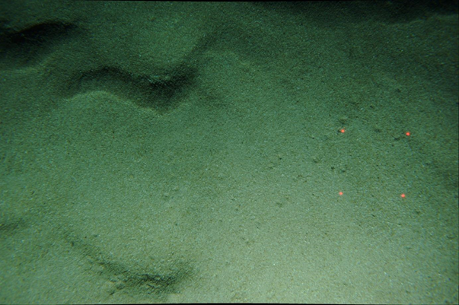
Gravels (1) | 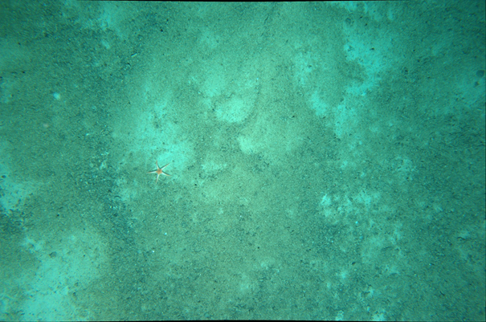
Biogenic (1) | 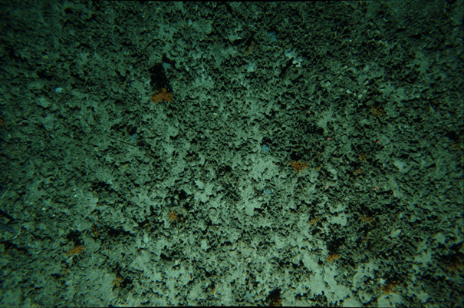  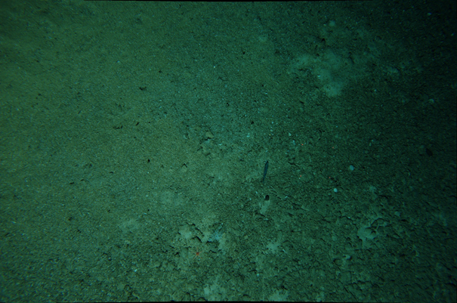
Soft (1) / Carbonate rock (2) | 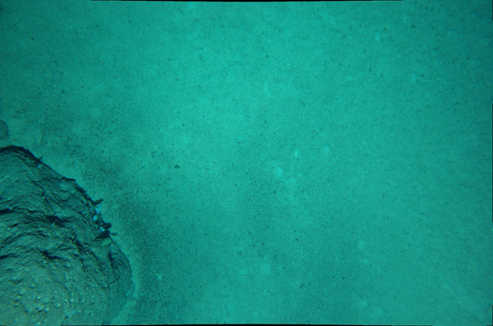
Soft (1) / Volcanic rock (2) | 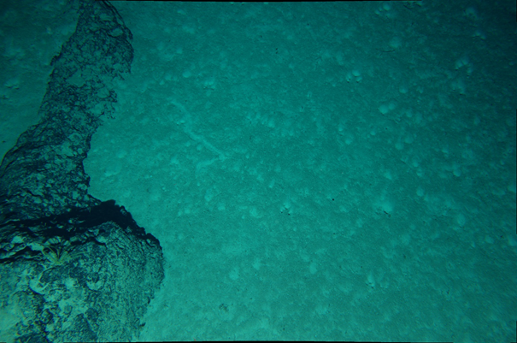
Mixed volcanic-sediment | 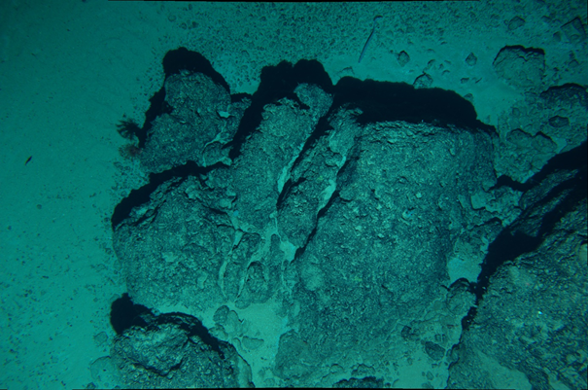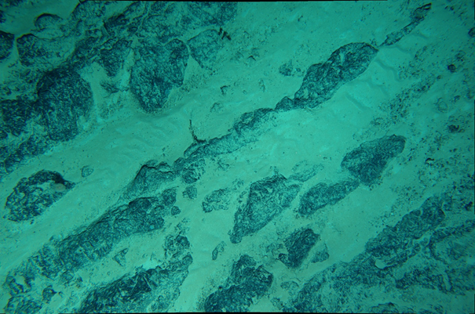
Mixed carbonate-sediment | 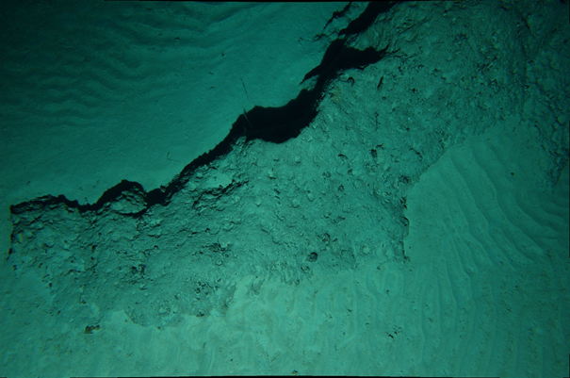
Volcanic rock (1)/ soft (2) | 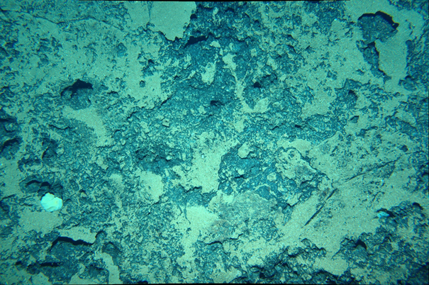
Carbonate rock (1)/ soft (2) | 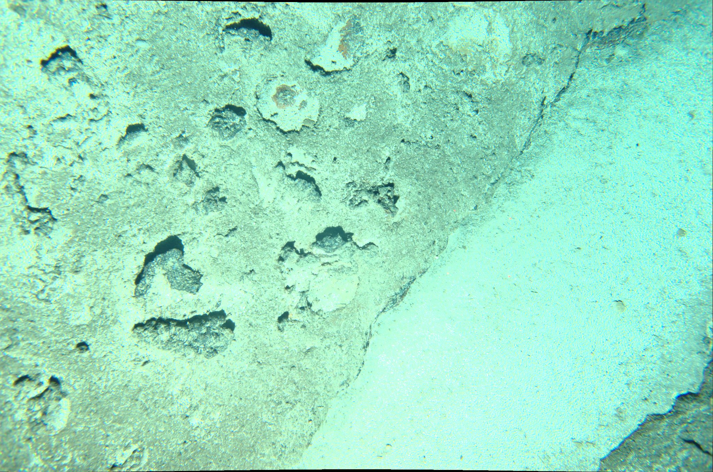
Volcanic rock (1) | 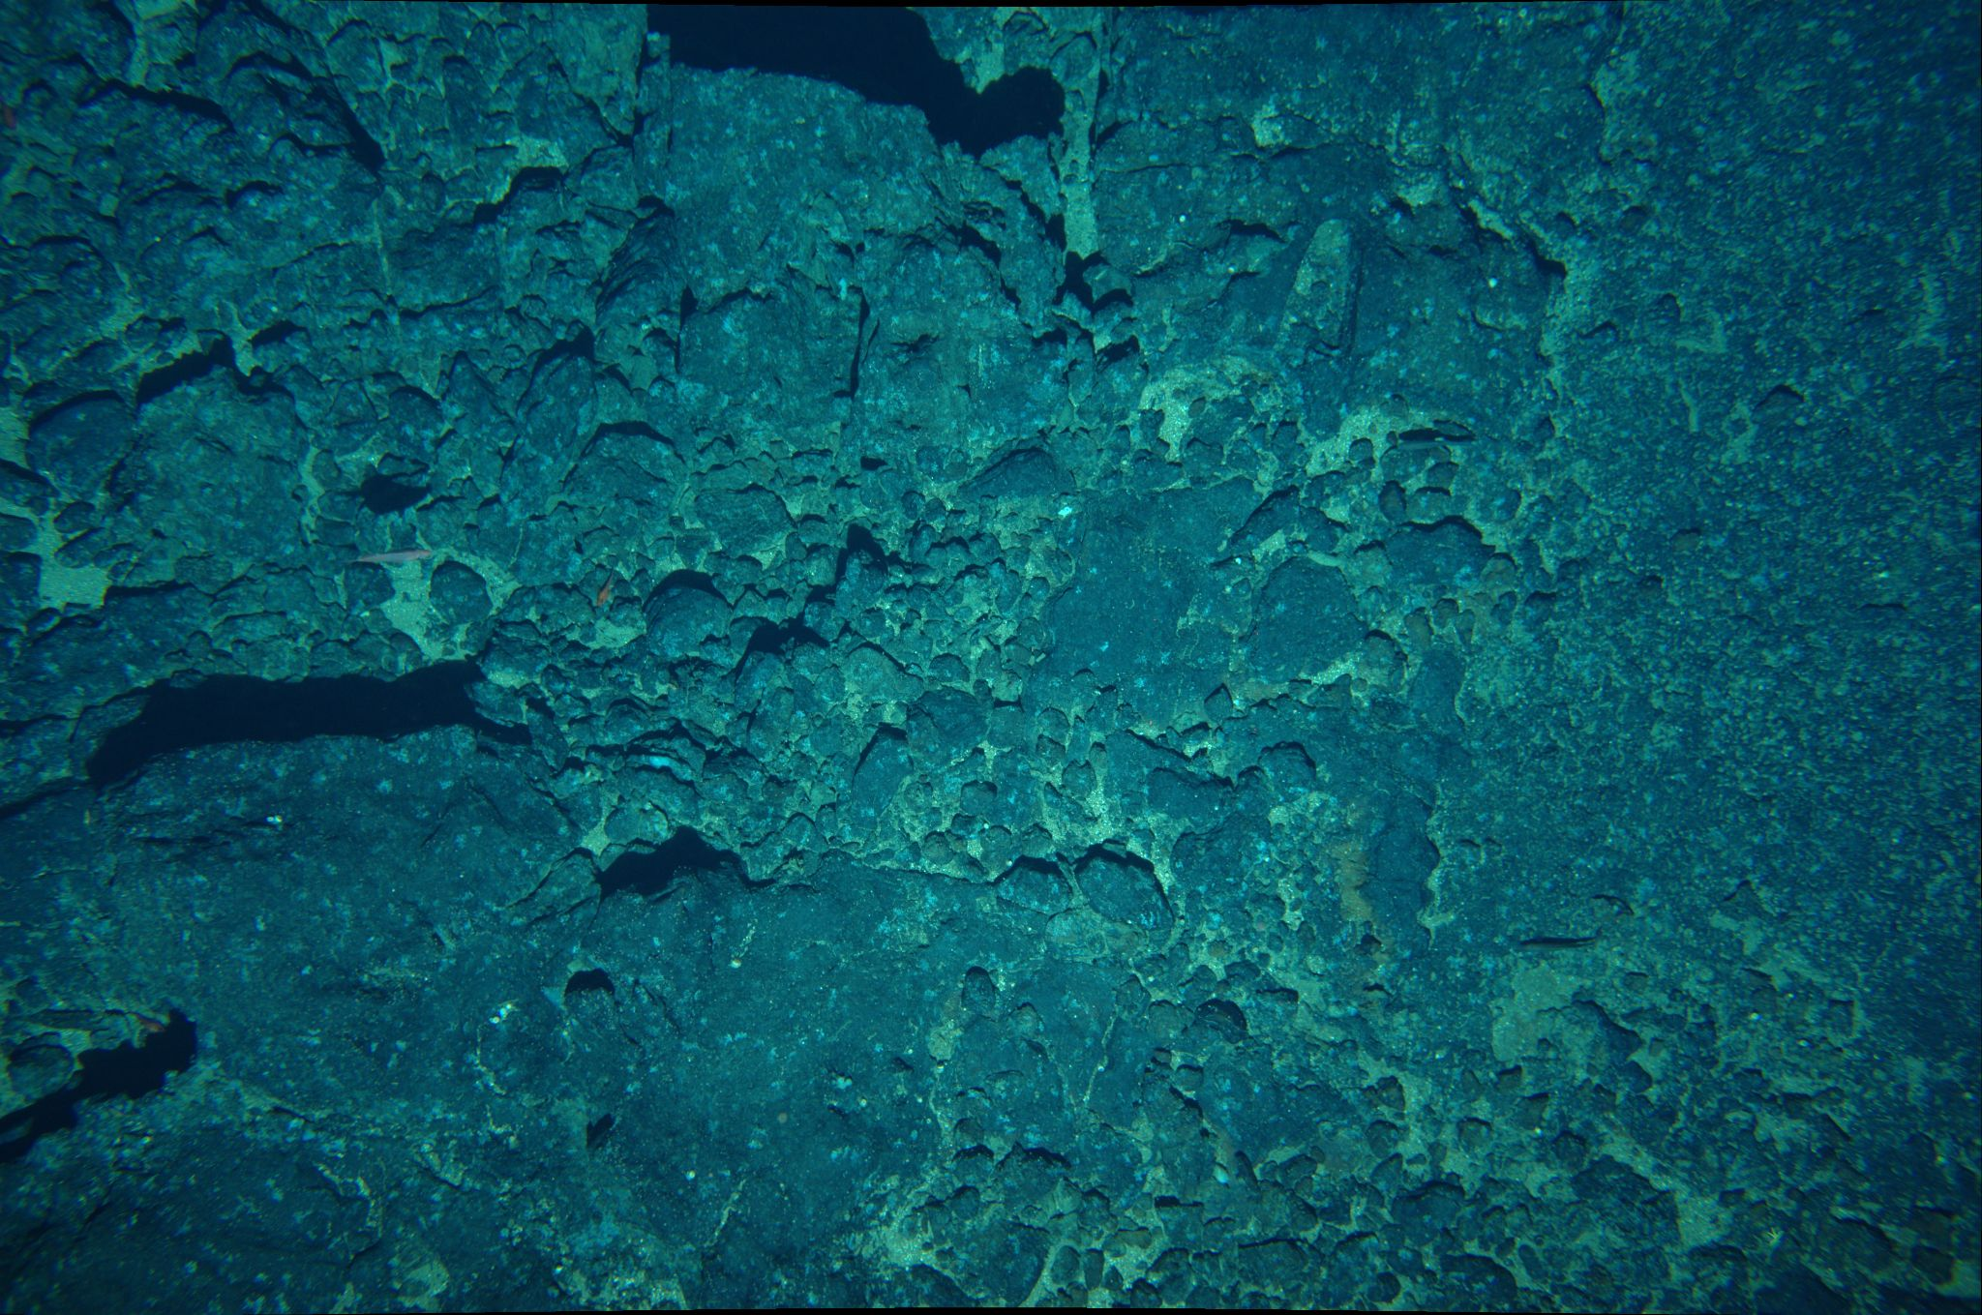
Carbonate rock (1) | 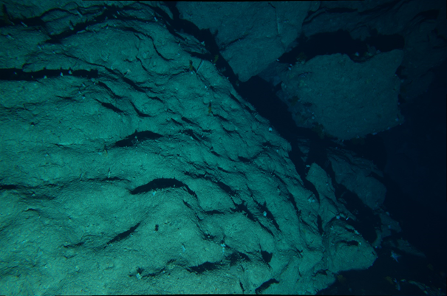  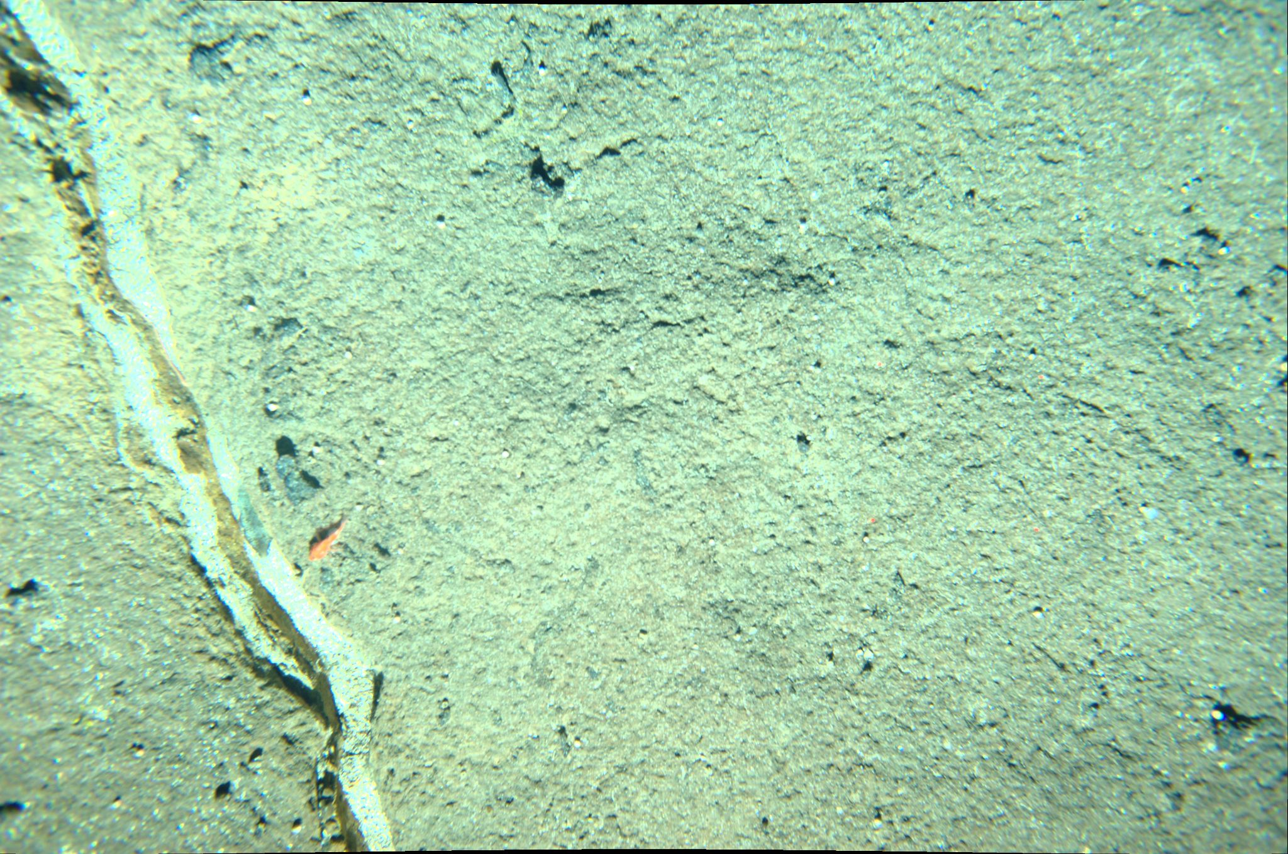
Mixed rock (volcanic, carbonate) | 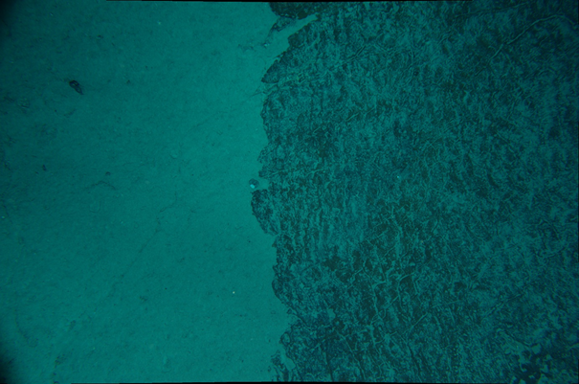  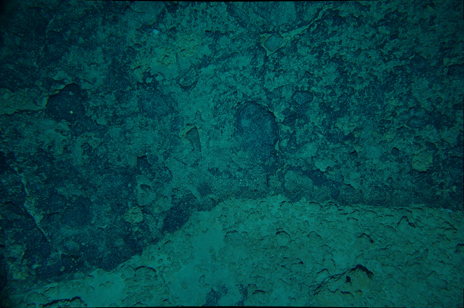
Mixed (volcanic, carbonate, soft) | 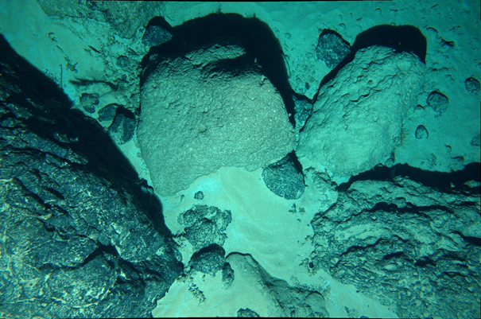
Gravels (1) /carbonate (2) | 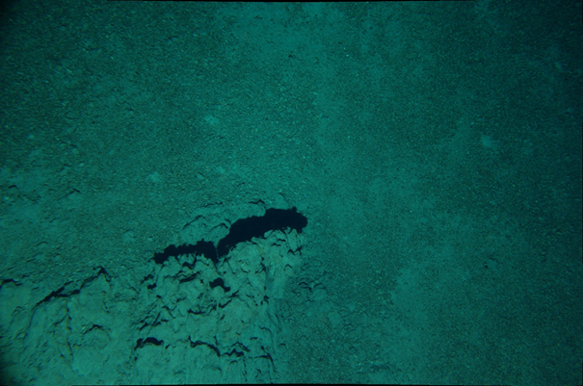
Mixed biogenic/gravels

a few images with also <<50% of carbonate or volcanic rocks.
Carbonate rock (1) /biogenic (2) | 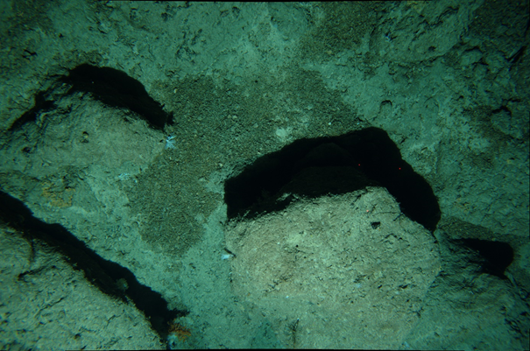

Calculation of substrate index per polygon:
- Substrate frequency per polygon:
From a presence/absence matrix of 9 substrate facies (columns) X images (rows), we summed for each substrate facies the number of images where the substrate facies is present / total number of images within the polygon.
Polygon | Image | Soft 100% | Volcanic rock  100% | Carbonate rock  100% | Gravels  100% | Biogenic  100% | Mixed rock | Mixed soft/carbonate | Mixed soft/volcanic | Mixed (volcanic, carbonate, soft)
P1 | Image 1 | 1 | 0 | 0 | 0 | 0 | 0 | 0 | 0 | 0
 | Image 2 | 1 | 0 | 0 | 0 | 0 | 0 | 0 | 0 | 0
 | Image 3 | 0 | 1 | 0 | 0 | 0 | 0 | 0 | 0 | 0
E.g.,

Substrate frequency for P1: Soft = 2/3 = ~0.66; Volcanic rock = 1/3 = ~0.33

- Substrate diversity per polygon:
Apply of the Shannon diversity calculation from the substrate frequency per polygon. Use of the diversity() function, index = “shannon” (vegan package) with R. Based on the work applied in Clark et Bowden, 2015.
Clark, M.R., Bowden, D.A., 2015. Seamount biodiversity: high variability both within and between seamounts in the Ross Sea region of Antarctica. Hydrobiologia 761, 161–180. https://doi.org/10.1007/s10750-015-2327-9

- Hardness score per polygon:

- We applied a hardness score (in brackets) to each of the substrate facies in the following way, according to the semi-quantitative substrate coverage approximation from the 17 substrate facies:

-soft sediment (100%) (1)
-gravels (100%) (2)
- biogenic (100%) (2) (fine discontinuous substrate, similar in size to gravel)
- soft (>50%) + rock carbonate (3)
-soft (>50%) + rock volcanic (3)
-mixed volcanic/soft (50-50) (4)
-mixed carbonate/soft (50-50) (4)
-rock volcanic (>50%) + soft (5)
-rock carbonate (>50%) + soft (5)
-mixed (carbonate, volcanic, soft) (5.5)
-gravels/carbonate (5.5)
-carbonate/biogenic (5.5)
-biogenic/gravels/carbonate (5.5)
-biogenic/gravels/volcanic (5.5)
- rock volcanic (100%) (6)
- rock carbonate (100%) (6)
-mixed rock (volcanic/carbonate) (50-50) (6)

- We calculated the frequency of each substrate facies/polygon see point 1) Substrate frequency per polygon.
- Next, we multiplied the hardness score * substrate frequency for each facies = facies hardness score. Then, the sum of the hardness scores of each facies present in the polygon = polygon hardness index (globally, represents the level of hardness in the polygon according to its composition and ~substrate coverage/per image).

