Supplementary material 12: Relative frequencies of megabenthic taxa with fine identification rank for the nine transects: (A) asteroids aggregated to the ranks of family and order (Brisingida), (B) echinoids aggregated to the ranks of genus and family (Laganidae), (C) decapods aggregated to the rank of family, (D) fish aggregated to the rank of order.

A | B
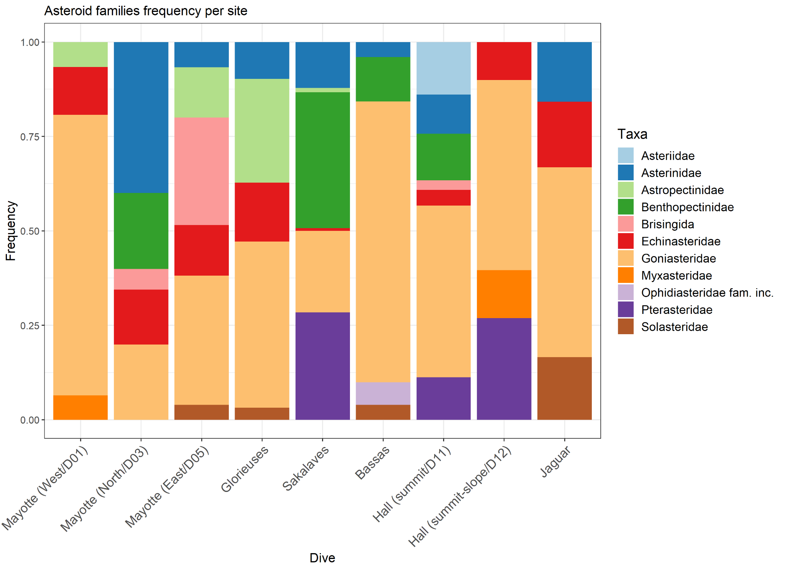 | 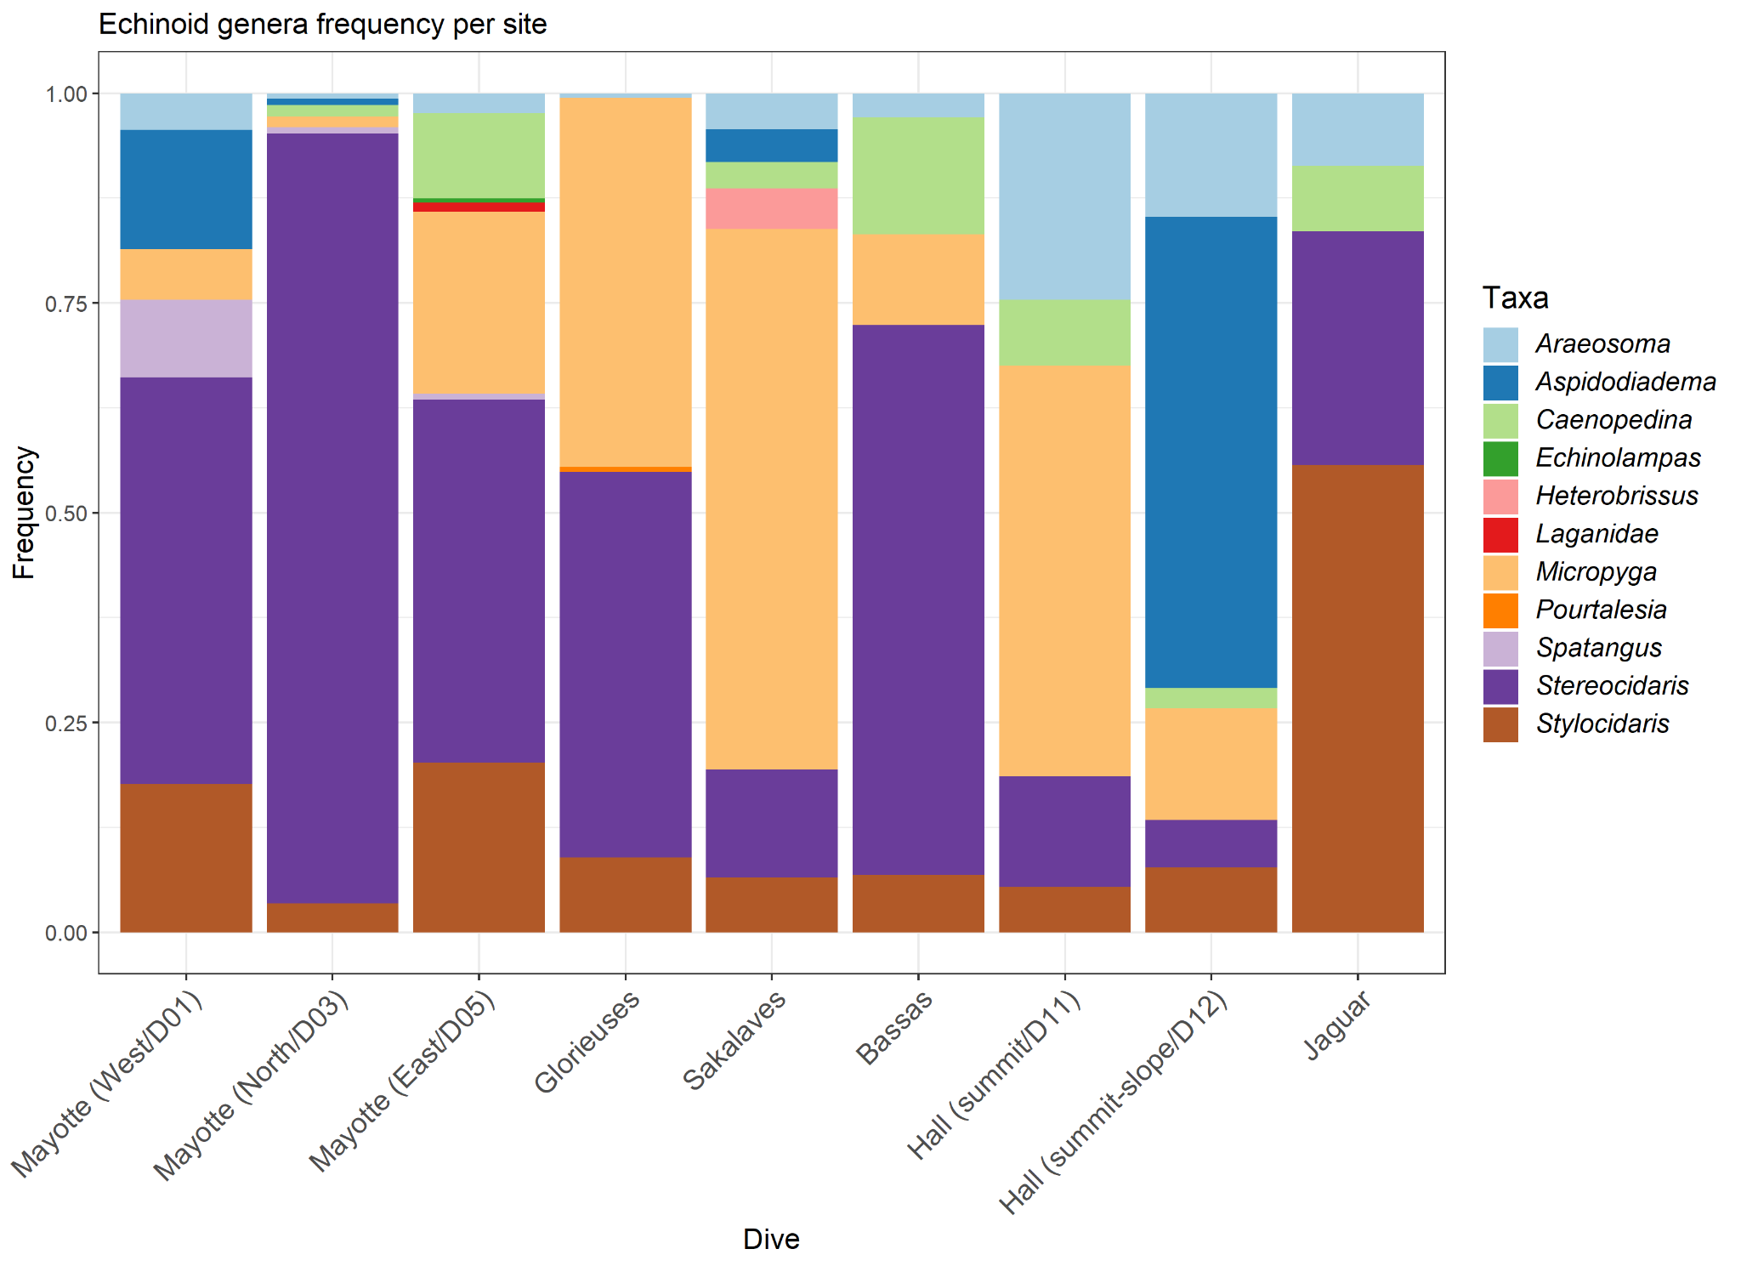
C | D
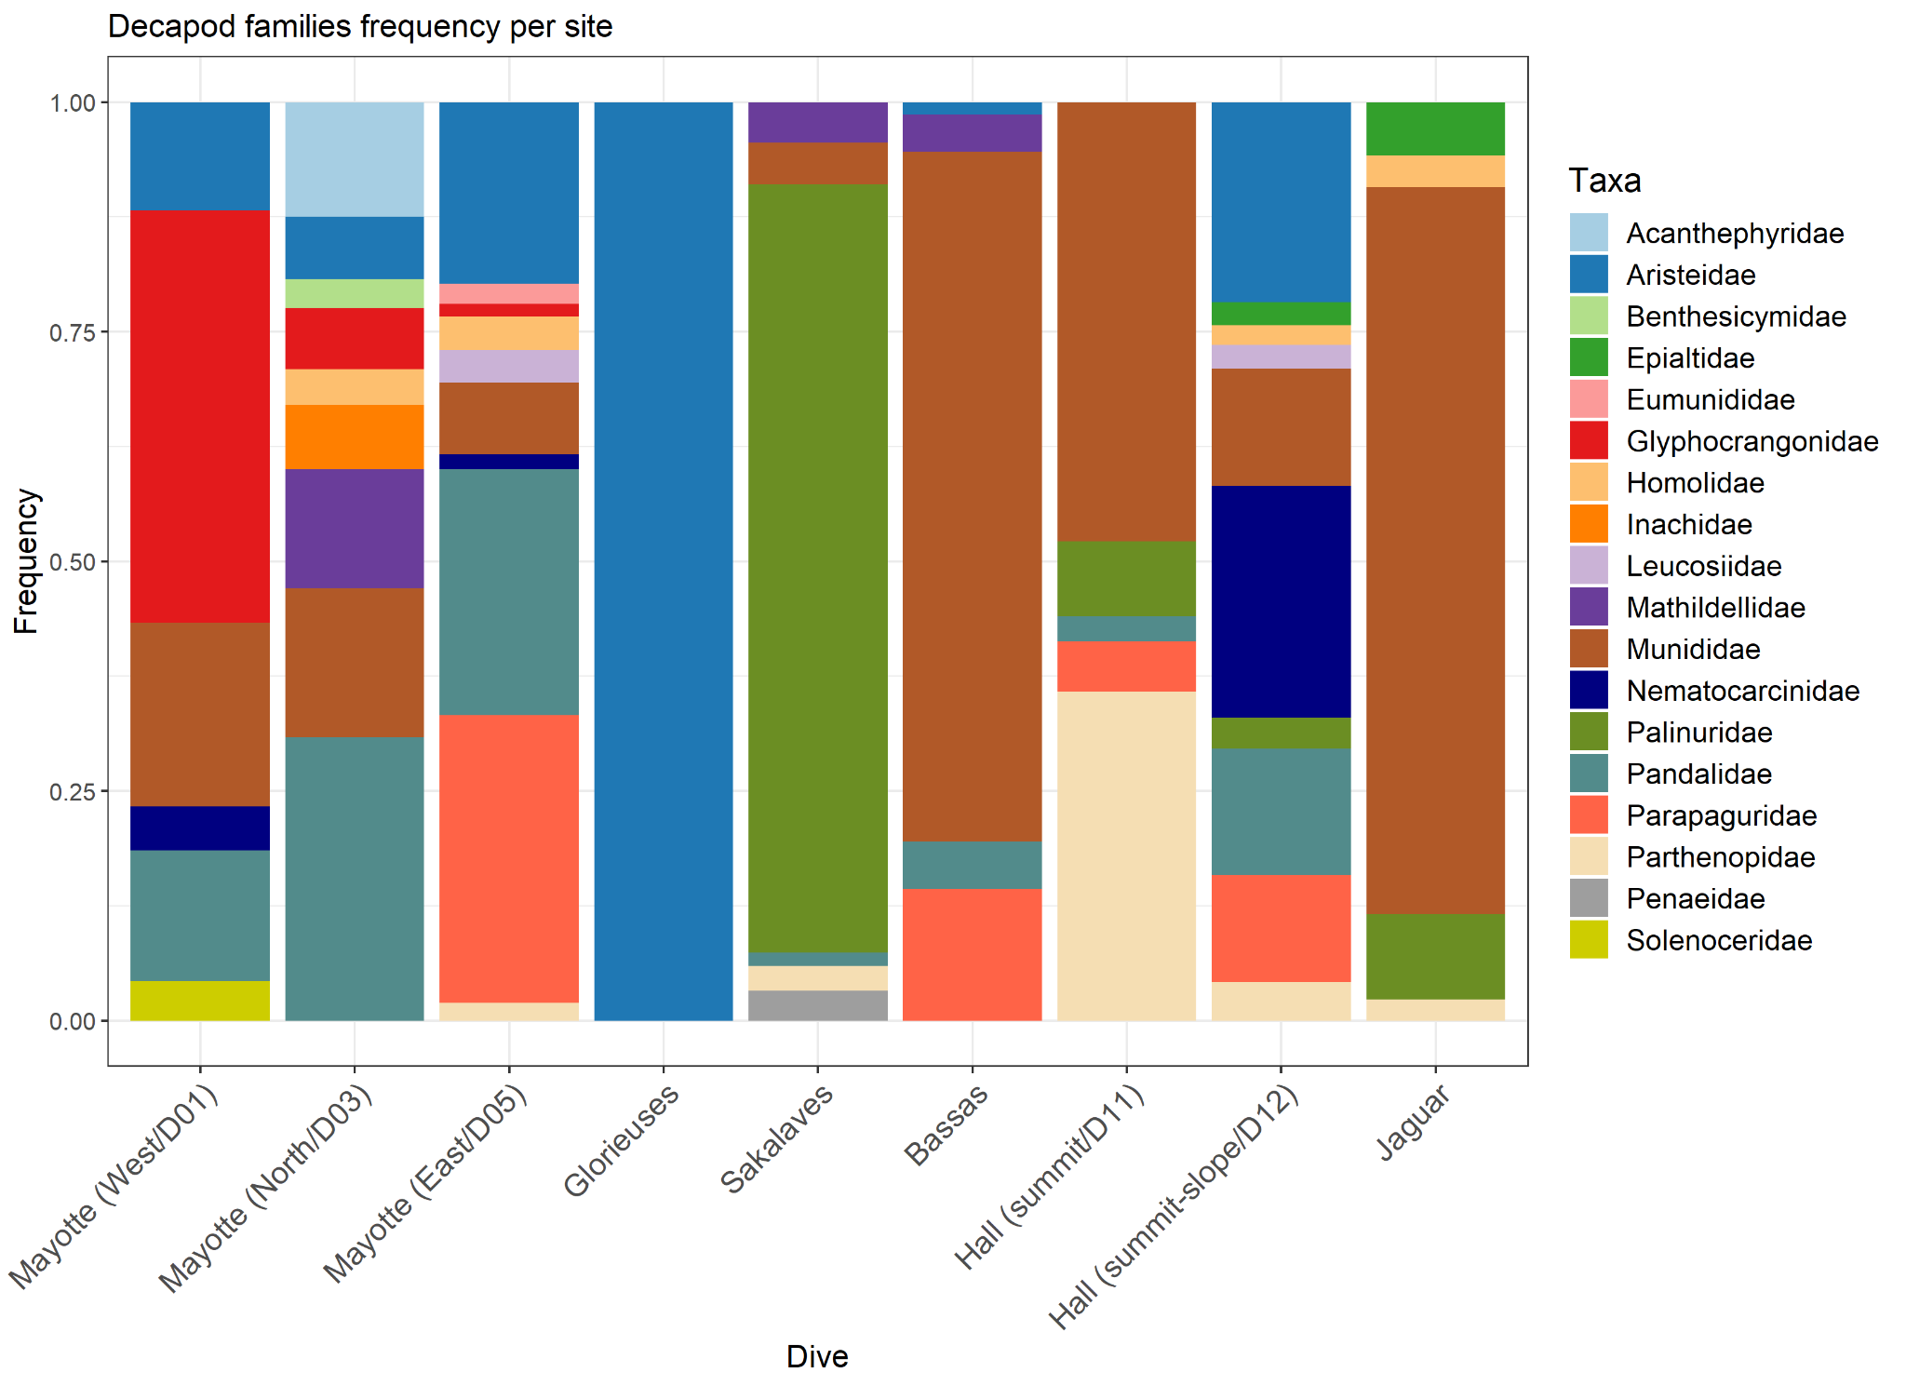 | 