Supplementary report 1. Assessment of the hydrodynamic model

To assess the realism of our regional configuration of the NEMO hydrodynamic model, hereafter named TAPIOCA36, we compared its outputs with ADCP data acquired during two cruises (ABRAÇOS 1 spring 2015 and ABRAÇOS 2 fall 2017; Bertrand 2015, 2017) and with outputs of the Global Ocean Physics Reanalysis model (GLORYS12v1; Lellouche et al. 2018). To assess the performance of the model in reproducing the near-surface dynamics (0-100 m) in the near-shore region and around the Fernando de Noronha archipelago we chose specific sections (yellow and red lines in Fig. S1).
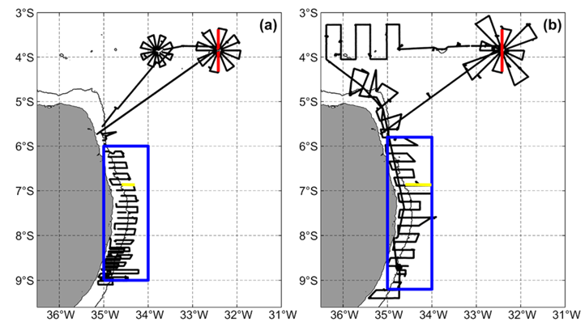Figure S1. ADCP ship tracks (black solid lines) obtained during the surveys ABRAÇOS 1 in spring 2015 (a) and ABRAÇOS 2 in fall 2017 (b). Blue rectangles and yellow and red lines indicate subsets of the data that were extracted in order to validate the TAPIOCA36 hydrodynamic configuration in both horizontal and vertical dimensions. The thin black contour indicates the shelf break (70 m isobath).

South of 5°S, the near-surface dynamics along the coast is mainly dominated by the North Brazil Undercurrent (NBUC) whose core is centred below 100 m depth (Dossa et al. 2021). In this region, the coastline orientation influences the dynamics, which changes direction around 7.5°S (Dossa et al., 2021). Around the Fernando de Noronha Archipelago, the dynamics above 100 m is controlled by Central South Equatorial Current (cSEC), which flows westward (e.g., Silva et al. 2021).

The surface current field (averaged over the 0-100 m depth range) derived from TAPIOCA36 during both spring 2015 and fall 2017 (Fig. S2b,d) corresponds well to the velocity measured during the two ABRAÇOS cruises conducted at the same time period (Fig. S2a,c). In particular, the North Brazil Current (NBC) west of 35°W between 5°S and 2°S is well reproduced with velocities up to 1 m.s⁻¹.
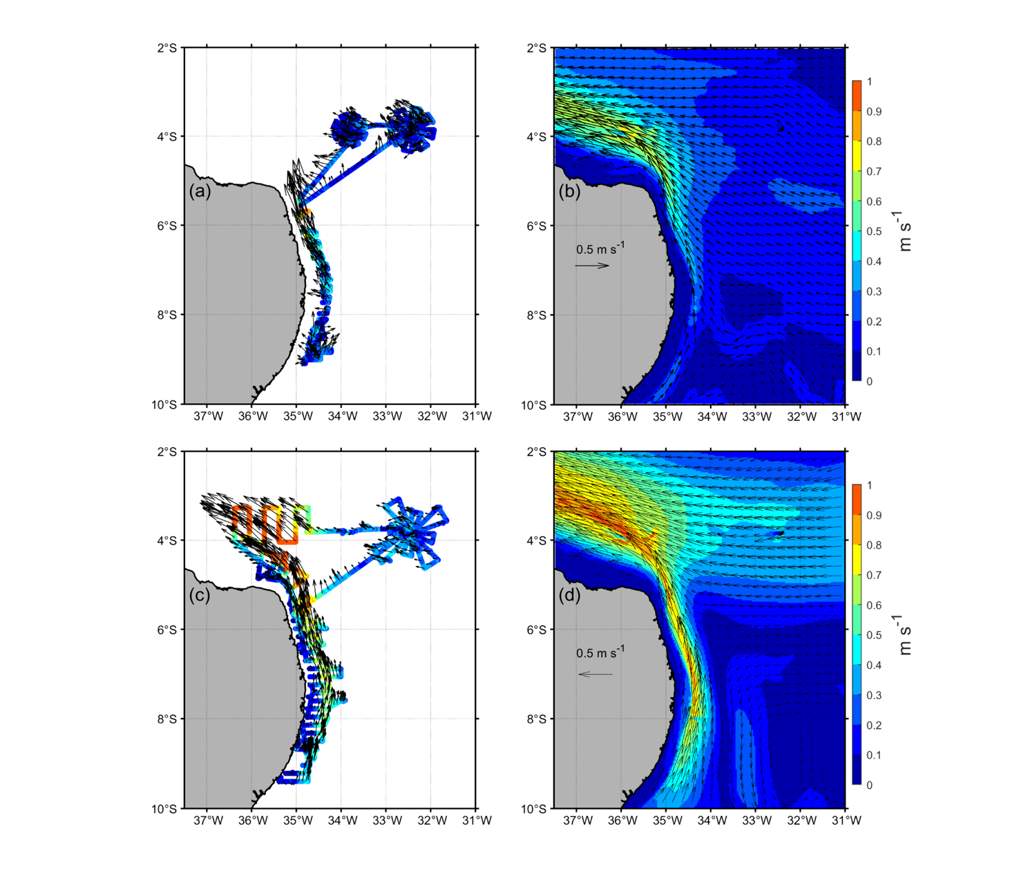
Figure S2. Surface currents speed (colour scale) and directions (arrows) averaged over spring 2015 (a,b) and fall 2017 (c, d) from ADCP data (a, c) and TAPIOCA36 simulations (b, d).

In spring 2015, south of 8°S the zonal flow assessed from ADCP data is dominantly eastward (Dossa et al., 2021) with a maximum speed of ~ 0.15 m.s⁻¹ (Fig. S3). North of 8°S, the zonal flow is westward with a speed up to 0.20 m.s⁻¹ (Fig. S3a). The TAPIOCA36 simulation is in good agreement with these results with very similar current structures and intensities (Fig. S3d). The meridional component and the global velocity characteristic of the NBUC current are also in good agreement between the measured currents (Fig. S3b, c) and TAPIOCA36 (Fig. S3e, f). In particular, the observed signature of the uplift of the upper (near-surface) boundary of the NBUC core (0.6 m.s⁻¹) extending up to ~80 - 100 m north ~ 8°S is well reproduced in TAPIOCA36 (Fig. S3b,e). The GLORYS12V1 reanalysis is also in broad agreement with the observations, but the core of the NBUC extends too far north (up to 7°S) and is too shallow (70 m compare to ~ 100m in observations and TAPIOCA36).
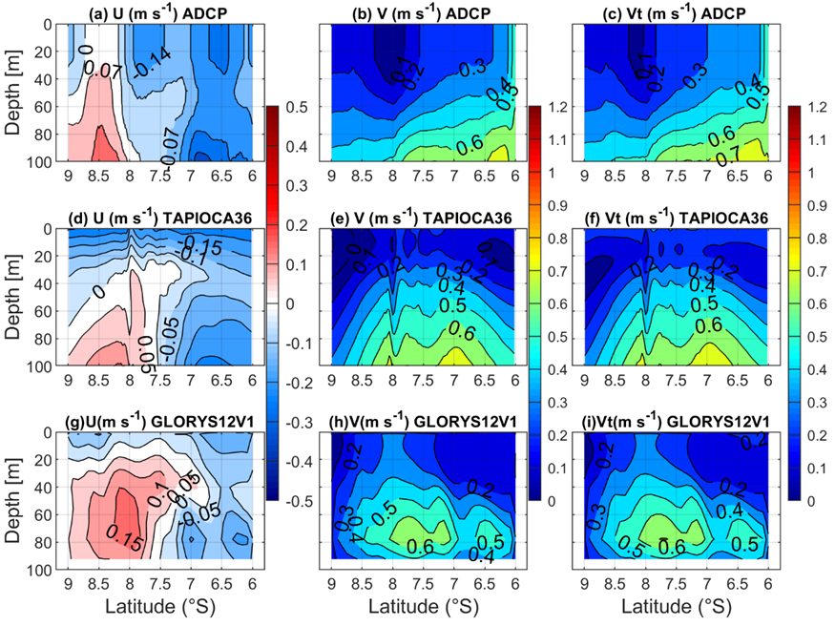
Figure S3. Comparison of the currents between ADCP data (a-c), TAPIOCA36 (d-f), and GLORYS12V1 (g-i) in spring 2015 in the region of the NBUC (blue polygon in Fig. 1a). U, V, and Vt correspond to the zonal component, meridional component and overall velocity, respectively. Observations and simulations are co-localized in time and space.

In fall 2017, TAPIOCA36 and GLORYS12V1 are again in good agreement with the zonal eastward (south of 7.5°S) and westward (north of 7.5°S) patterns observed in the ADCP with similar current structure and intensities (Fig. S4a,d,g), although the speed tends to be slighyly underestimated in the simulations. In fall, the NBUC core rises to the surface waters (Dossa et al. 2021), as evidenced in the ADCP data (Fig. S4b). TAPIOCA36 and GLORYS12V1 reproduce the NBUC core position and speed fairly well, except that the simulated currents are weaker by approximately 0.1 m/s in the core. At the surface the velocities simulated by TAPIOCA36 and GLORYS12V1 are underestimated by 0.3 up to 0.4 m/s compared to the observations (Fig. S4e,h). However, TAPIOCA36 improves this surface modelled bias by approximately 0.1 m/s.

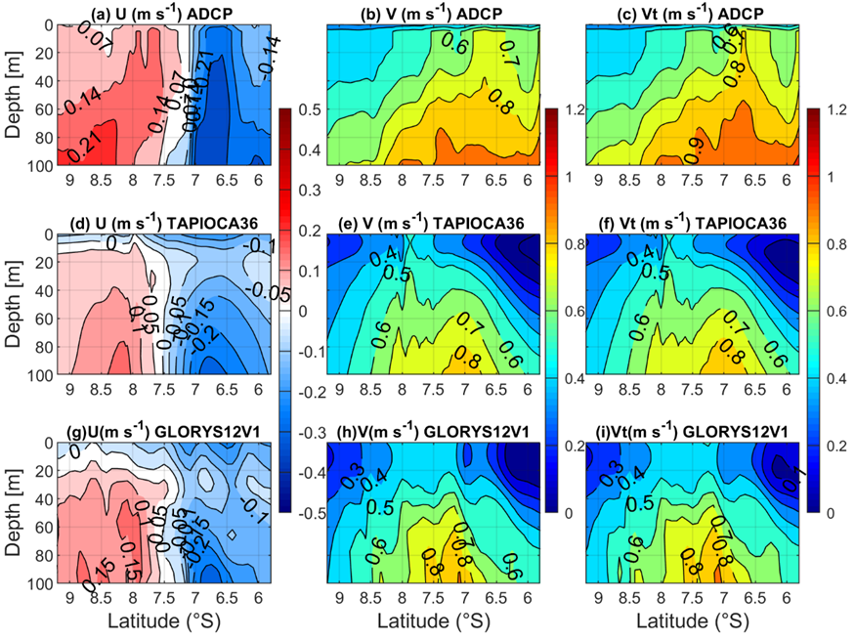
Figure S4. Comparison of the currents between ADCP data (a-c), TAPIOCA36 (d-f), and GLORYS12V1 (g-i) in fall 2017 in the region of the NBUC (blue polygon in Fig. 1a). U, V, and Vt correspond to the zonal component, meridional component and overall velocity, respectively. Observations and simulations are co-localized in time and space.

To further assess the model performance in reproducing the alongshore and cross-shore components of the NBUC, we zoomed on a specific cross-shore section (6.8°S; yellow line in Fig. S1). In spring 2015 (Fig. S5), TAPIOCA36 reproduces quite well the cross-shore current oriented eastward, but the modelled currents are more intense than the observations below 60 m depth (Fig. S5a,d), whereas GLORYS12V1 reproduces an unrealistic westward current (Fig. S5g). The alongshore northward (>0, Fig. S4 b,e,h) flow and total velocity (Fig. S4 c,f,i)characterizes the NBUC in the data and simulations, however, TAPIOCA 36 and GLORYS12V1 are slightly weaker compared to the observations above 40 m.
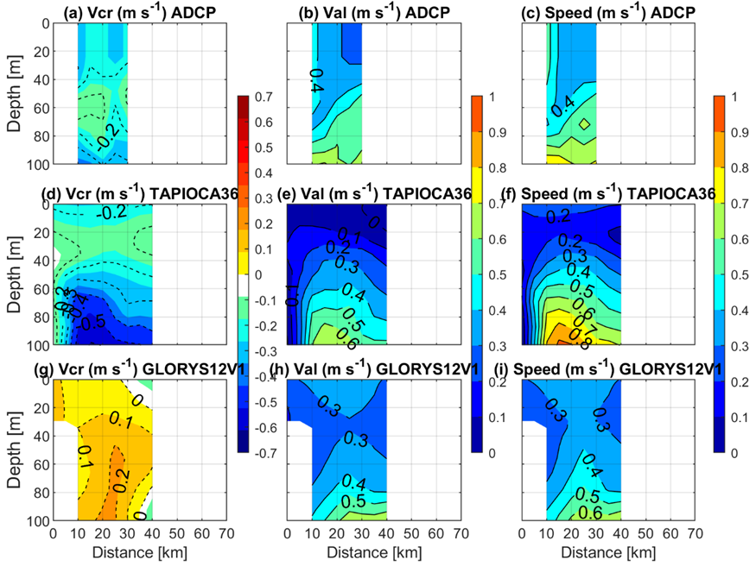
Figure S5. Comparison of the currents between ADCP data (a-c), TAPIOCA36 (d-f), and GLORYS12V1 (g-i) mean cross-shore component (Vcr), alongshore component (Val), and overall velocity (Speed) at 6.8ºS (yellow line in Figure S1a) in spring 2015. Observations and simulations are co-localized in time and space.

In fall 2017, TAPIOCA36 reproduces the cross-shore flow structure in very good agreement with observation, unlike GLORYS12V1 that failed again to reproduce the eastward current structure (Fig. S6a,d,g). However, the alongshore currents and their magnitude are too strong in both TAPIOCA36 and GLORYS12V1 compared with the observations (figure S6 b,e,h).

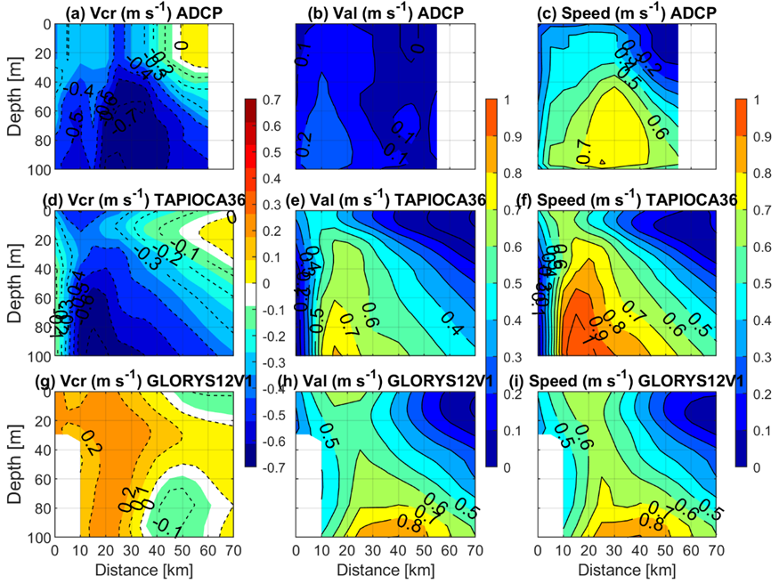
Figure S6. Comparison of the currents between ADCP data (a-c), TAPIOCA36 (d-f), and GLORYS12V1 (g-i) mean cross-shore component (Vcr), alongshore component (Val), and overall velocity (Speed) at 6.8ºS (yellow line in Figure S1a) in fall 2017. Observations and simulations are co-localized in time and space.

Along a section crossing the archipelago of Fernando de Noronha (red line in Fig. S1), in spring 2015 TAPIOCA36 reproduces the observed central South Equatorial Current (cSEC) well, performing slightly better than GLORYS12V1. However, both are weaker than the observations, in particular north of the archipelago (Fig. S7a,c,d,f,g,i). In this region, the meridional flow is weak and predominantly northward in both observations and simulations (Fig. S7b,e,h).

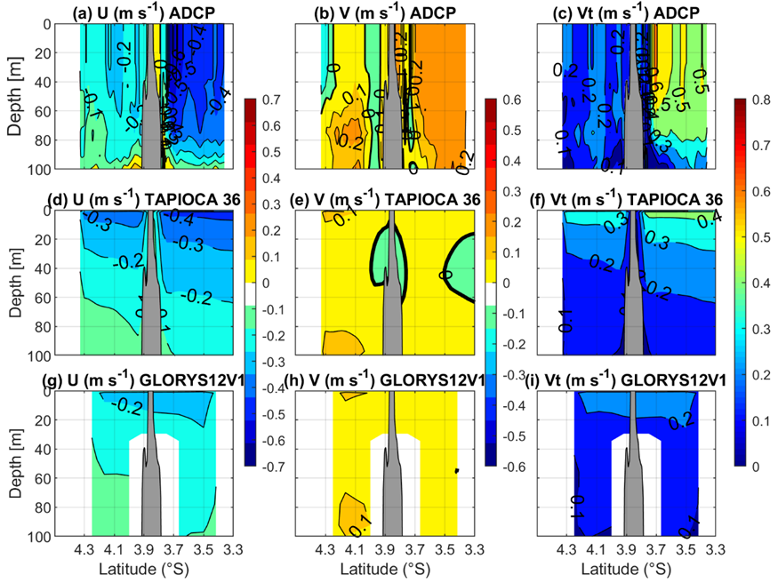
Figure S7. Comparison of the currents between ADCP data (a-c), TAPIOCA36 (d-f), and GLORYS12V1 (g-i) in spring 2015 across the archipelago Fernando de Noronha (red line in Fig1a). U, V, and Vt correspond to the current velocity's zonal, meridional, and magnitude components, respectively. Observations and simulations are co-localized in time and space.

In fall 2017, both TAPIOCA36 and GLORYS12V1 produce a slightly weaker cSEC current zonal component by 0.2 m/s compared to the data (Fig S7a,d,h). Also, the shear with the South Equatorial Undercurrent (SEUC; U>0, Fig. S7a) observed between 80 and 100 m, occurs ins deeper levels in the simulations (Fig. S7d,g). The meridional components are also slightly weaker in TAPIOCA36 and GLORYS12V1 than in the data.
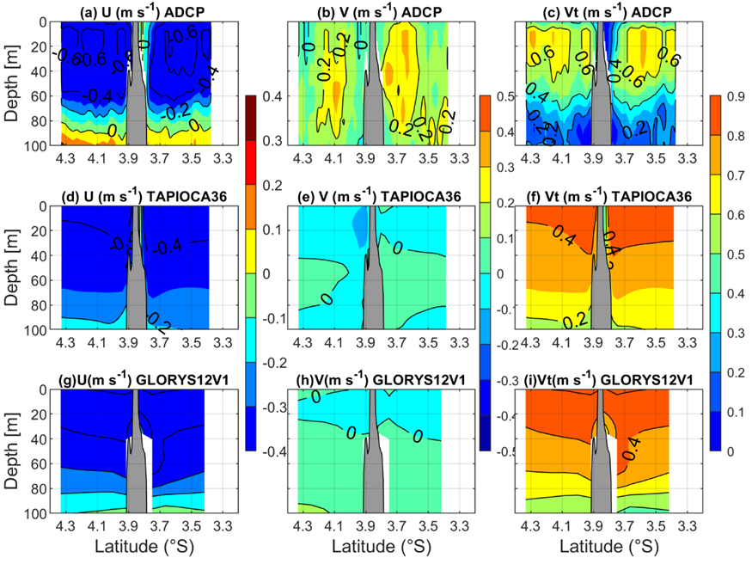

Figure S8. Comparison of the currents between ADCP data (a-c), TAPIOCA36 (d-f), and GLORYS12V1 (g-i) in fall 2017 across the archipelago Fernando de Noronha (red line in Fig1a). U, V, and Vt correspond to the current velocity's zonal, meridional, and magnitude components, respectively. Observations and simulations are co-localized in time and space.

The climatological (2009-2017) seasonal variability of the Brazilian alongshore currents from 9°S to 6°S (blue rectangle in Fig. S1; 0-100 m depth average) are stronger (>0.4 m/s) south of 7°S than in the northern part, for both TAPIOCA36 and GLORYS12V1 (Fig. S9), in agreement with previous observations (Dossa et al., 2021). However, this intensification is stronger (by ~ 0.1 m/s) and persists for a longer period in TAPIOCA36 (February-September) than in GLORYS12V1 (April-August). The current above 100 m depth corresponds to the upward movement of the core of the NBUC towards the surface. Both models capture the seasonal variability of this upward movement, resulting in higher current speeds in the autumn when compared to spring, in accordance with previous observations (Dossa et al., 2021). Nevertheless, TAPIOCA36 exhibits a more pronounced intensification of the upward movement, what is in better agreement with in-situ ADCP data (Figure S4).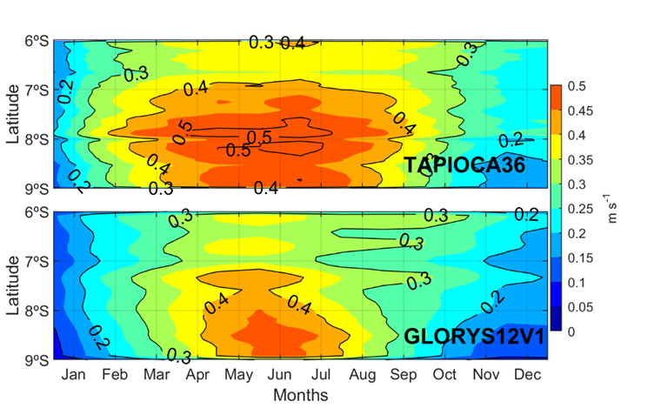
Figure S9. Climatological (2009-2017) seasonal cycle of mean Brazilian alongshore velocity (averaged between the shelf break and 40 km offshore blue rectangle in Fig. S1 and between 0-100m depth) from TAPIOCA36 (top) and GLORYS12V1 (bottom).

Across the Fernando de Noronha archipelago, where the cSEC flows westwards, both TAPIOCA36 and GLORYS simulations faithfully reproduce the seasonal behaviour of the current (Figure S10) described by Silva et al. (2021) with an increased zonal current in fall compared with spring.
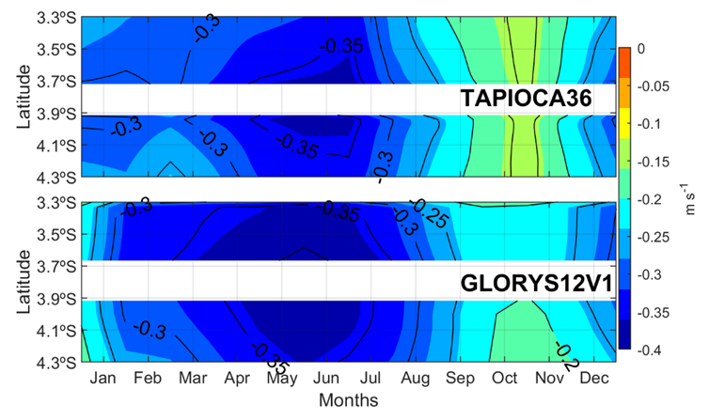
Figure S10. Climatological (2009-2017) seasonal cycle of zonal velocity component across Fernando de Noronha Archipelago (averaged over 0-100 m depth; red section in Fig. S1 ) from TAPIOCA36 (top) and GLORYS12V1 (bottom). The blank part in each panel corresponds to the archipelago location.

In conclusion, TAPIOCA36 succeeds in reproducing in fairly good agreement the circulation measured during the ABRACOS surveys performed during two distinct seasons and years. TAPIOCA36 improves some of the modelled characteristics provided by GLORYS12V1, such as the cross-shore currents structure at 6.8°S, and the meridional current close to Fernando de Noronha. However, it is essential to recognise the presence of certain finer scale biases. In our Lagrangian study, we recognise that when working with a model, results may not reflect 100 % of reality and considered the general patterns is scales larger than such biases. Moreover, we provide a huge comparison of the results of the model with in situ biological patterns (Box 1) showing that the general patterns we discuss are in accordance with reality. Thus, the overall performance of TAPIOCA36 and its ability to reproduce key circulation characteristics offer a solid basis for our Lagrangian study.
References
Bertrand, A. 2015. ABRACOS cruise,Antea R/V. in press.
Bertrand, A. 2017. ABRACOS 2 cruise,Antea R/V. in press.
Dossa, A. N. et al. 2021. Near-surface western boundary circulation off Northeast Brazil. - Prog. Oceanogr. 190: 102475.
Lellouche, J.-M. et al. 2018. The Copernicus Marine Environment Monitoring Service global ocean 1/12 physical reanalysis GLORYS12V1: description and quality assessment. - EGU Gen. Assem. Conf. Abstr. 20: 19806.
Silva, A. C. et al. 2021. Surface Circulation and Vertical Structure of Upper Ocean Variability Around Fernando de Noronha Archipelago and Rocas Atoll During Spring 2015 and Fall 2017. - Front. Mar. Sci. 8: 598101.

Bertrand, A. 2017. ABRACOS 2 cruise,Antea R/V.
Dossa, A. N. et al. 2021. Near-surface western boundary circulation off Northeast Brazil. - Prog. Oceanogr. 190: 102475.
Lellouche, J.-M. et al. 2018. The Copernicus Marine Environment Monitoring Service global ocean 1/12 physical reanalysis GLORYS12V1: description and quality assessment. - EGU Gen. Assem. Conf. Abstr. 20: 19806.
Silva, A. C. et al. 2021. Surface Circulation and Vertical Structure of Upper Ocean Variability Around Fernando de Noronha Archipelago and Rocas Atoll During Spring 2015 and Fall 2017. - Front. Mar. Sci. 8: 598101.

