Geophysics Geochemistry Geosystems
Supporting Information for
A 6.2 Ma-long record of major explosive eruptions from the NW Pacific volcanic arcs based on the offshore tephra sequences on the northern tip of the Emperor Seamount Chain
Vera Ponomareva¹, Maxim Portnyagin²*, Natalia Bubenshchikova³, Egor Zelenin⁴, Alexander Derkachev⁵; Brian Jicha⁶, Sergei Gorbarenko⁵, Eliza Cook⁷, Dieter Garbe- Schönberg^{8,9}, Kaj Hoernle^{2,8}
¹ Institute of Volcanology and Seismology, Piip Boulevard, Petropavlovsk-Kamchatsky, 9 683006, Russia, ² GEOMAR Helmholtz Center for Ocean Research Kiel, Wischhofstrasse 1-3, 24148 Kiel, Germany, ³ Shirshov Institute of Oceanology, 36, Nakhimovsky Prospect, Moscow, 117997, Russia, ⁴ Geological Institute, Pyzhevsky lane 7, Moscow, 119017, Russia, ⁵ V.I. Il’ichev Pacific Oceanological Institute, 43 Baltiyskaya St,Vladivostok 690041, 15 Russia, ⁶ Department of Geoscience, University of Wisconsin-Madison, 1215 W. Dayton Street, Madison, WI 53706, USA, ⁷ Physics of Ice, Climate and Earth (PICE), Niels Bohr Institute, University of Copenhagen, Tagensvej 16, 2900. Denmark, ⁸Kiel University, Ludewig-Meyn-Strasse 10, 24118 Kiel, Germany, ⁹ Department of Physics and Earth Sciences, Jacobs University Bremen, 28759 Bremen, Germany

Contents of this file

Text S1
Figures S1 and S2

Additional Supporting Information (Files uploaded separately)

Captions for Tables S1 to S7
Caption for Model S1

Introduction
This appendix contains data on studied tephra layers, information on the geochemical composition of tephra glass shards and details of dating methods and their primary output.

Text S1. Collection and processing of input data for the Bayesian age model of the Detroit seamount summary tephra sequence.

A Bayesian age modeling allowed us to obtain the age estimates and propagate their accuracies into the combined chronology further referred to as the Detroit age model. The model covers the time span from the oldest sampled tephra layers at ca. 6.2 Ma to the present time. Sediments older than 6.2 Ma were recovered by core 884A, they contain no tephra layers in the interval between 6.2 and 28 Ma (Cao et al., 1995) and were not incorporated in the age model.
The sources for the Bayesian modeling were individual age-depth models for the studied sites:
• For Site 882, those are X-ray fluorescence correlations to the Antarctic ice age model EDC3 for the last 800 ky (Jaccard et al., 2010) and tuning of sediment porosity variations to the orbital frequencies for the last 4 My (Tiedemann and Haug, 1995), the latter was initially adjusted to the orbital solution of Berger and Loutre (1991)
• For MD01-2416, we took 18O correlations to the stack of Bassinot et al. (1994) for the last 1.3 My (Gebhardt et al., 2008); we did not consider age-depth models for Site 882 and core MD01-2416 of Galbraith et al. (2008), which utilize the same reference chronology and 18O correlations as Jaccard et al. (2010), to avoid circular reasoning.
• Site 884 is a remarkable source of continuous magnetic reversal stratigraphy going well below the studied time interval, therefore we correlated magnetic events recorded in natural remanent magnetization (NRM) inclination collected onboard (Janus web database http://www-odp.tamu.edu/database/) to the geomagnetic polarity time scales of Channell et al. (2020) and Ogg (2012) for the Quaternary and pre-Quaternary times, respectively. The same approach was applied to the bottom 100 m of Site 882A core that have no other age information.
Most of the studies mentioned above do not provide any accuracy assessment, so we have investigated reference chronologies of the used age-depth models. First, we have readjusted the reference points of Tiedemann and Haug (1995) to the isotopic stack LR04 of Lisiecki and Raymo (2005), which reportedly converged within 4 ky in the late Quaternary to 30 kyrs in Miocene. For the EDC3 the age accuracy comprises 3 ky (Dreyfus et al., 2007, Jouzel et al., 2007). Accuracies of ages for the Pliocene geomagnetic events have been never reported, but dispersion among recently published ages for early Quaternary events (Ogg, 2012, Channell et al., 2020) have an order of tens kyrs. Therefore, we accept 50 ka as a conservative estimate of geomagnetic events accuracy for age modeling. The top of the Detroit age model is a KRM eruption found in the Greenland NGRIP ice core and dated back to 9044 - 9046 (9045±68) ages b2k (Cook et al., in preparation).
Then, the new datum levels (section 3.3.1) were incorporated in the model with accuracies set according to the reference chronologies (Lourens at al., 2004; Lisiecki and Raymo, 2005; Ogg, 2012; Channell et al., 2020).
To ensure correct modeling of sedimentation process we have subtracted tephra thickness from the MD01-2416 and ODP 884B depth metrics and used the ODP 882 composite depth of Tiedemann and Haug (1995) with tephras already subtracted. As ODP 882 reveals a significant change in sedimentation rate at the Pliocene-Pleistocene boundary, we processed it as separate P_Sequence blocks of OxCal code, 0–2.8 Ma and 2.8–5.6 Ma. After the initial runs of Bayesian modeling, we found a strong decorrelation of bottom MD01-2416 dates (Gebhardt et al., 2008) with the rest of the model, so we adjusted NRM/ARM of MD01-2416 (Gebhardt et al., 2008) to the PISO-1500 paleointensity stack (Channell et al., 2009), and Uvigerina spp. 18О of MD01-2416 (Gebhardt et al., 2008) to the LR04 isotopic stack (Lisiecki and Raymo, 2005) and assigned accuracies from LR04 to the resulting model. As we cannot reveal all the other sources of uncertainties, we considered a 5% outlier probability for any date in it by setting an Outlier() option (Bronk Ramsey, 2009b).
The final Detroit age model published here is an output of OxCal, including mean age µ, its standard error σ, and ages bounding 95.4% probability range for each tephra layer (Table S7).

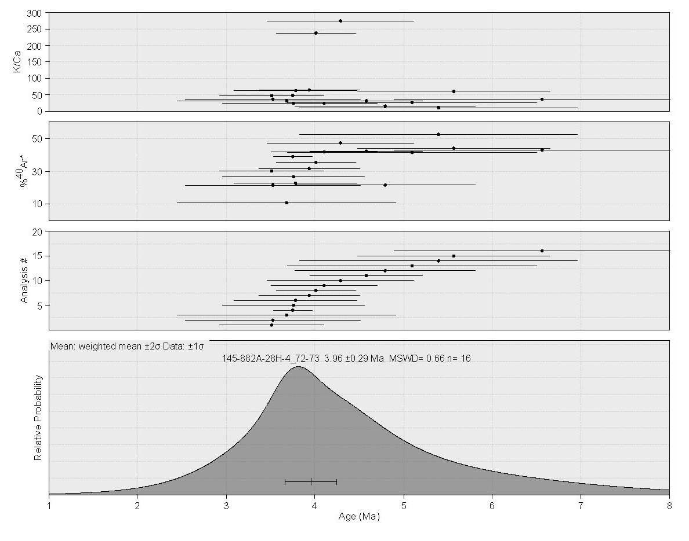Figure S1a. ⁴⁰Ar/³⁹Ar ideogram of sample 145-882A-28H-4_72-73.

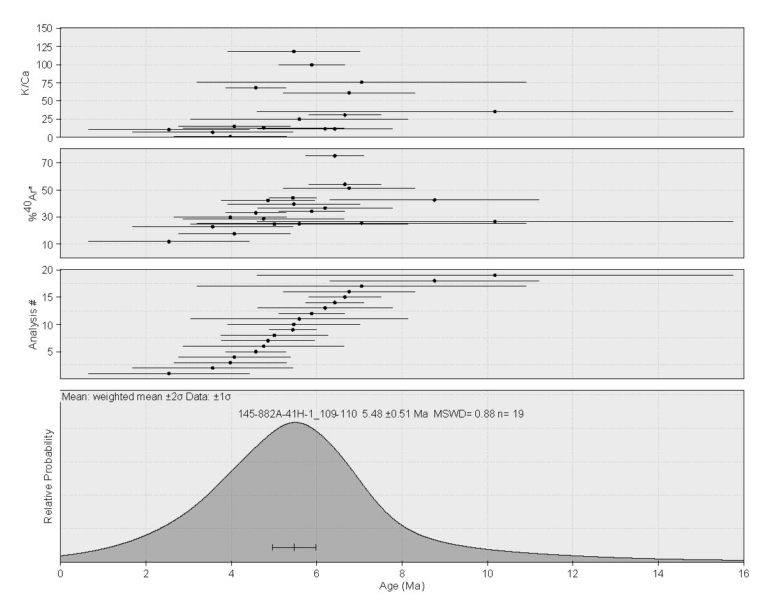Figure S1b. ⁴⁰Ar/³⁹Ar ideogram of sample 145-882A-41H-1_109-110.

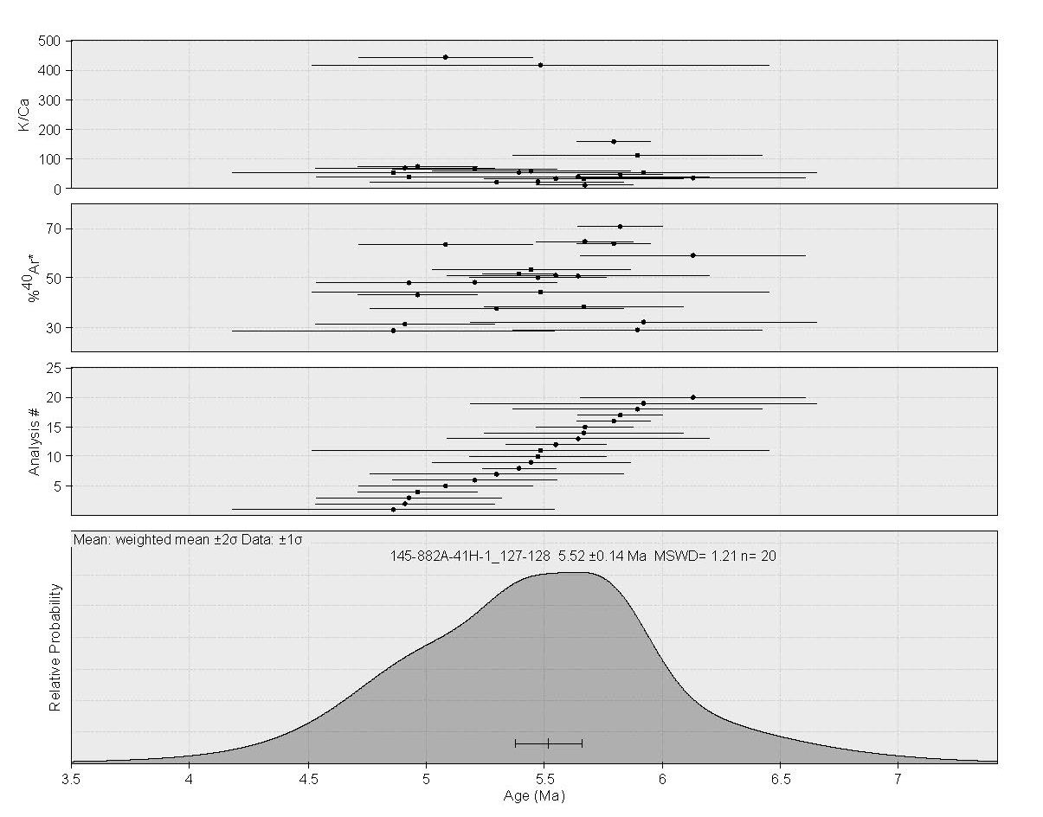Figure S1 C: ⁴⁰Ar/³⁹Ar ideogram of sample 145-882A-41H-1_127-128.

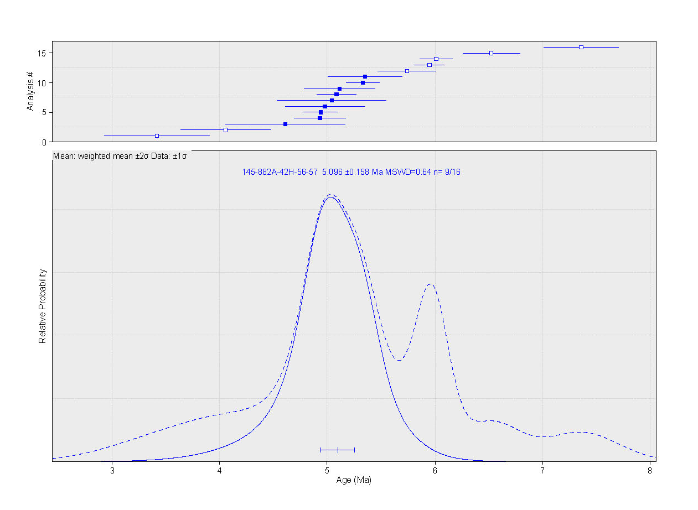Figure S1d. ⁴⁰Ar/³⁹Ar ideogram of sample 145-882A-42H_56-57.

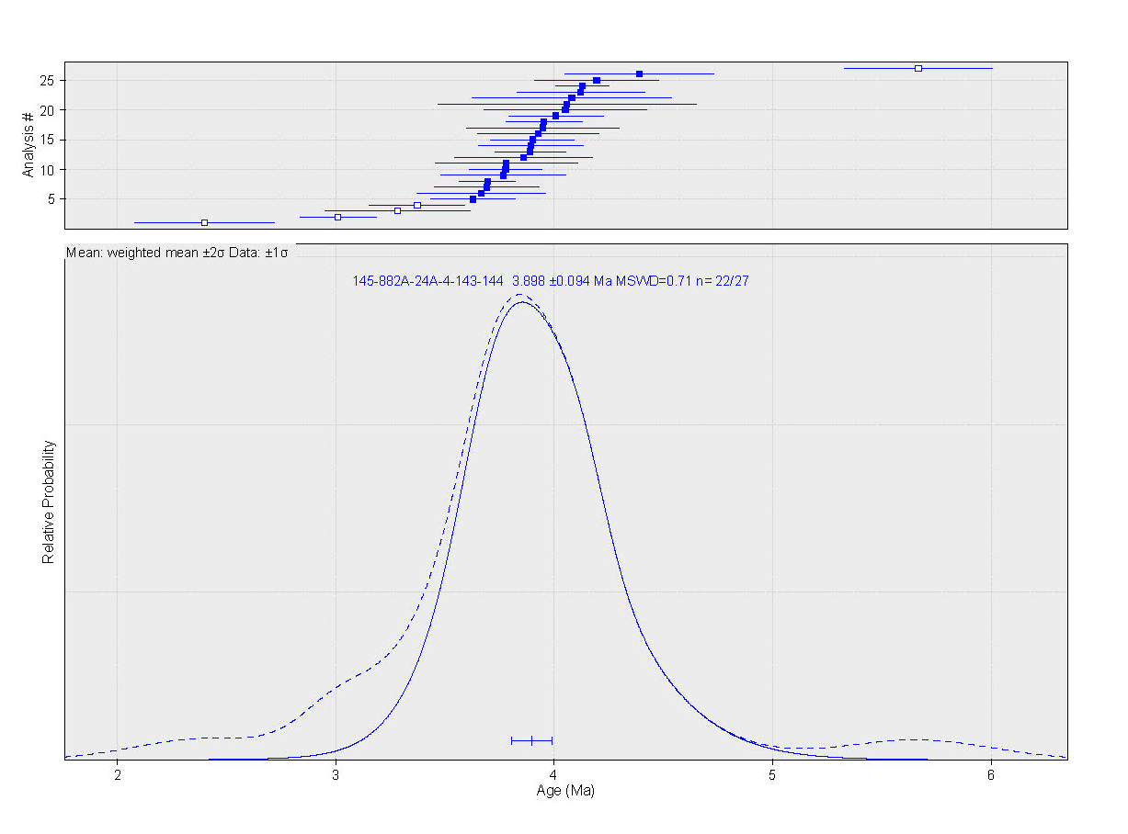Figure S1e. ⁴⁰Ar/³⁹Ar ideogram of sample 145-882A-24A-4_143-144.

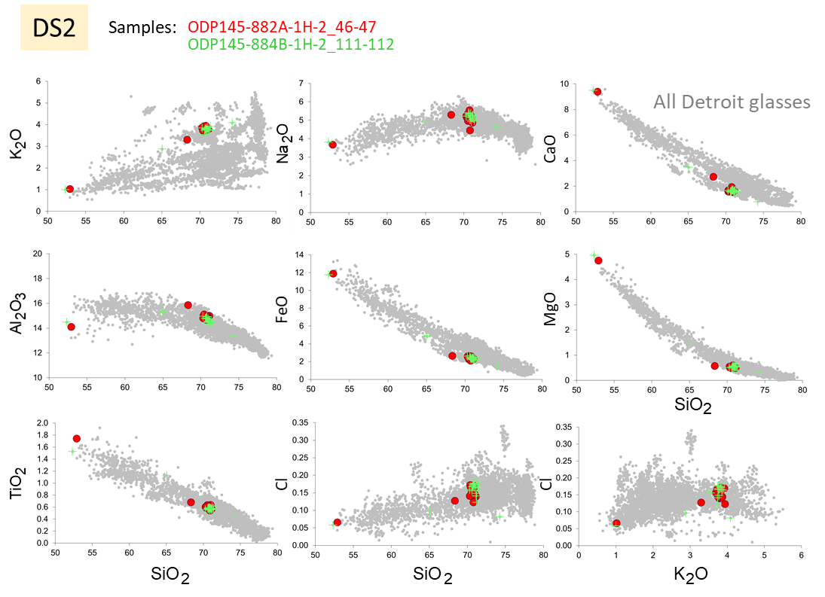
Figure S2a. Correlation of tephra layers between Detroit cores. Tephra DS2.

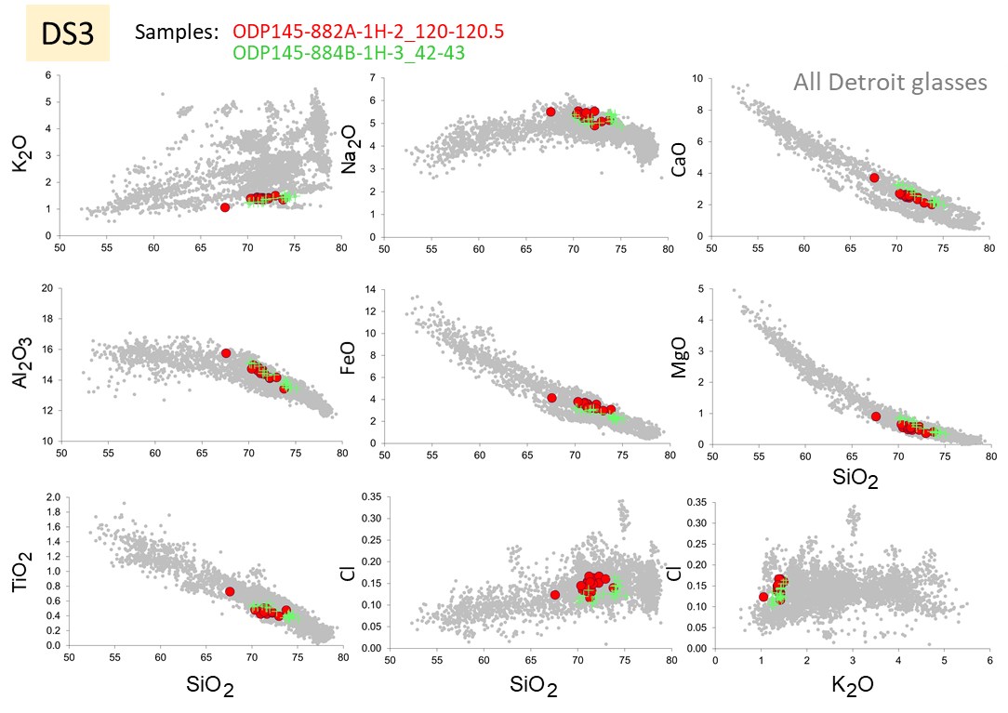
Figure S2b. Correlation of tephra layers between Detroit cores. Tephra DS3.

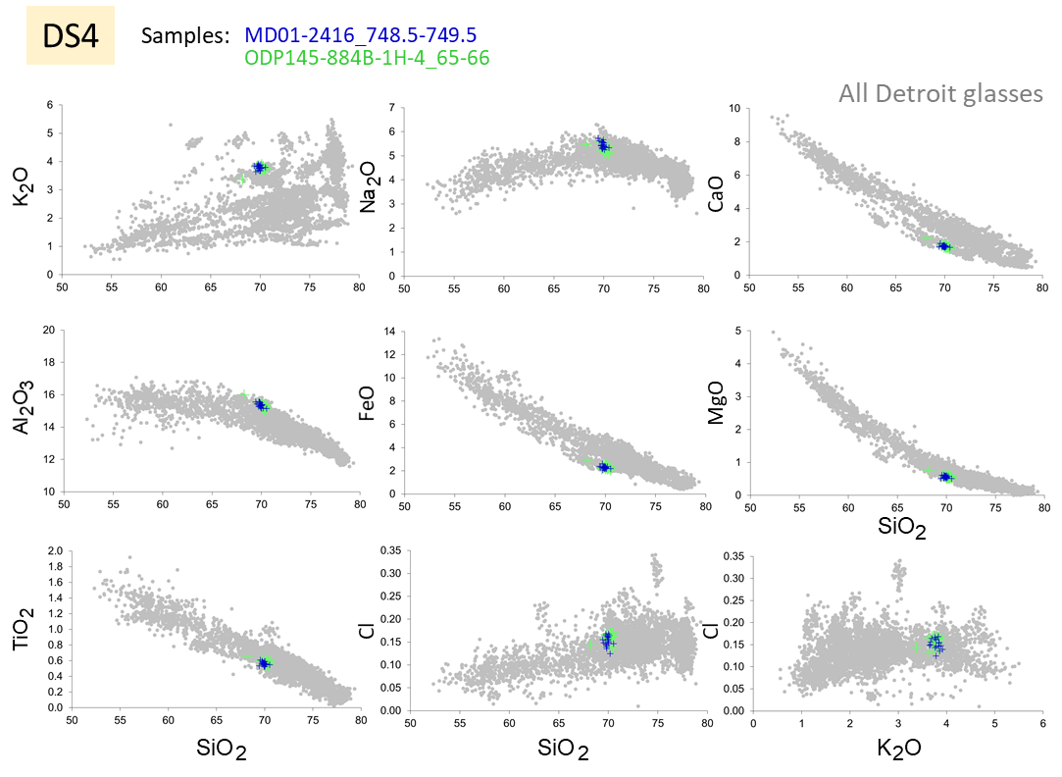
Figure S2c. Correlation of tephra layers between Detroit cores. Tephra DS4.

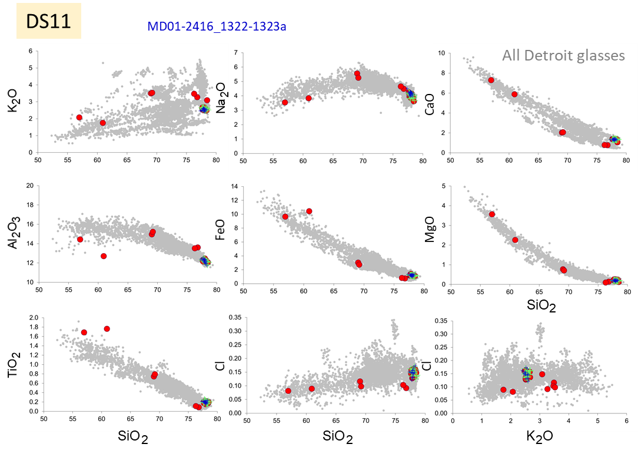
Figure S2d. Correlation of tephra layers between Detroit cores. Tephra DS11.
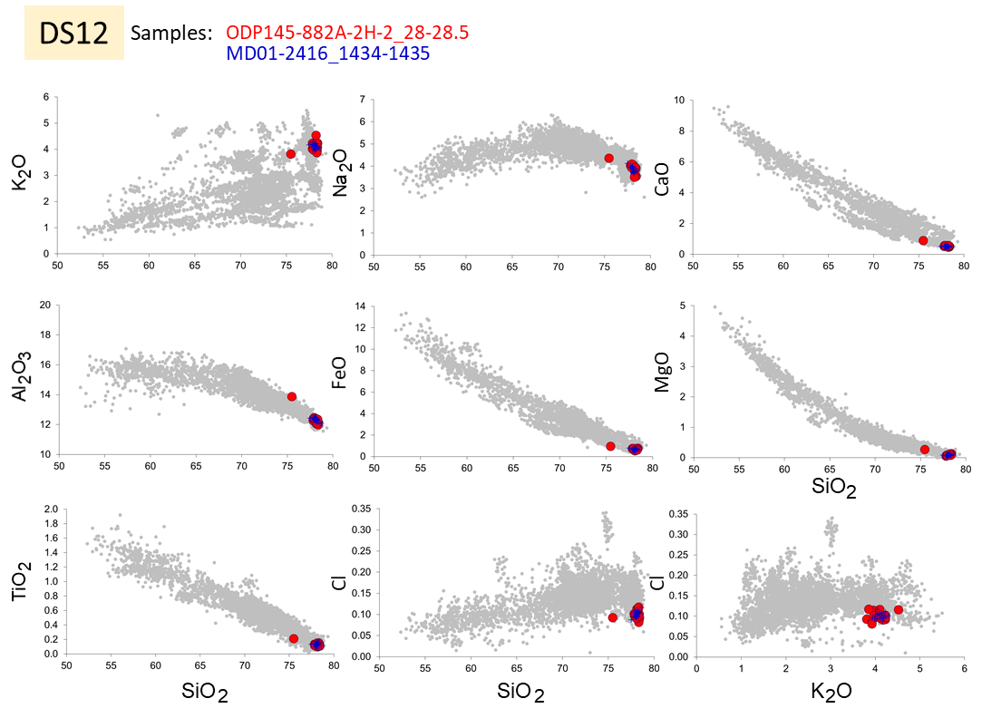
Figure S2e. Correlation of tephra layers between Detroit cores. Tephra DS12.

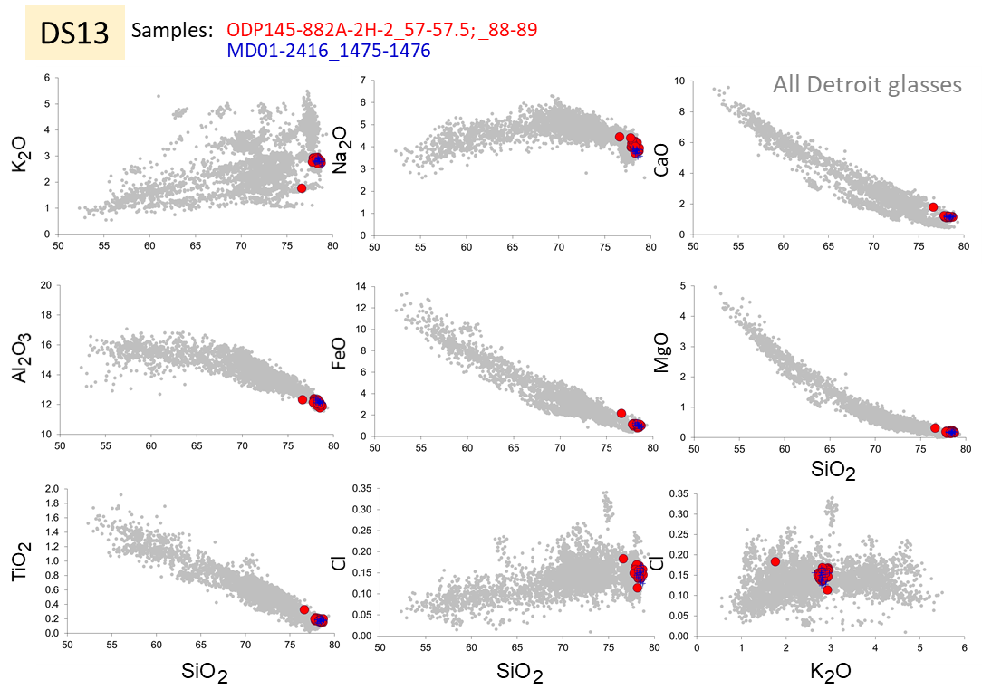
Figure S2f. Correlation of tephra layers between Detroit cores. Tephra DS13.
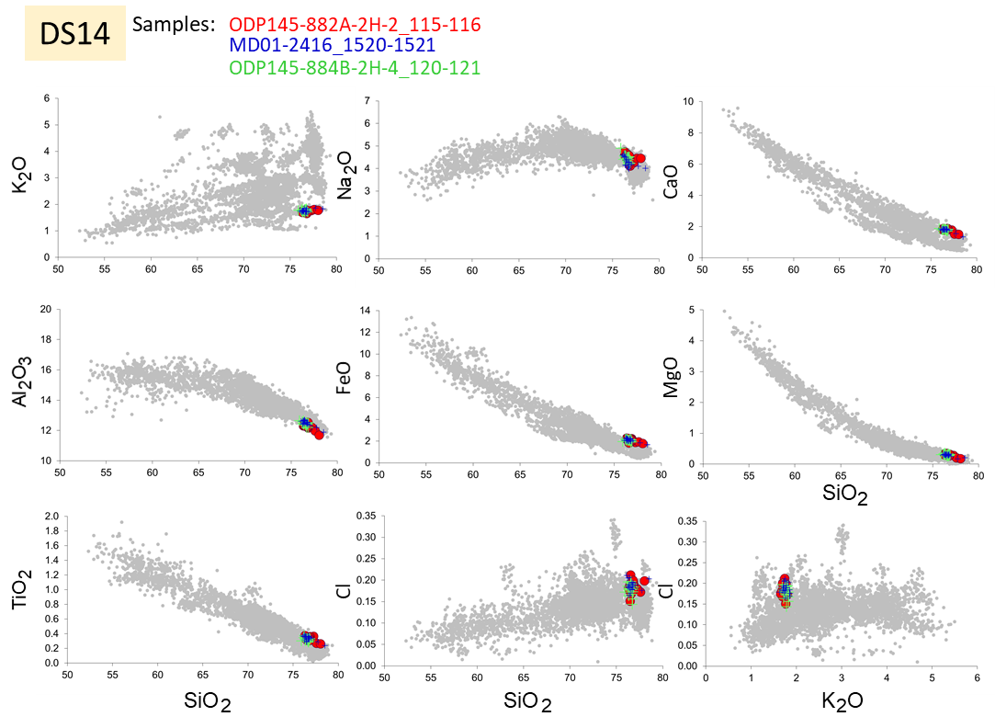
Figure S2g. Correlation of tephra layers between Detroit cores. Tephra DS14.

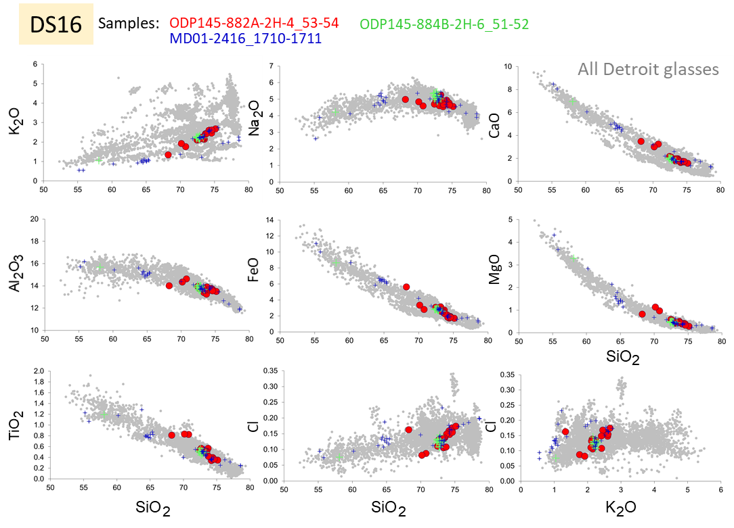

Figure S2h. Correlation of tephra layers between Detroit cores. Tephra DS16.
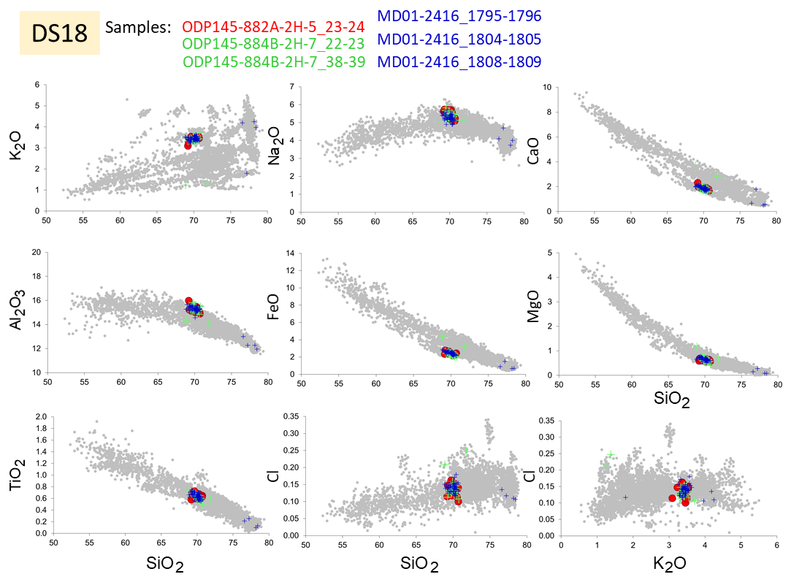
Figure S2i. Correlation of tephra layers between Detroit cores. Tephra DS18.

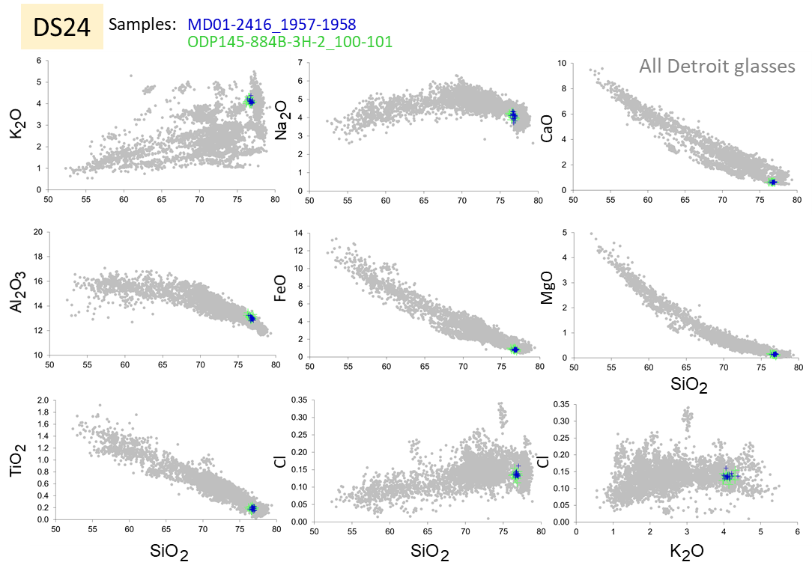
Figure S2j. Correlation of tephra layers between Detroit cores. Tephra DS24.
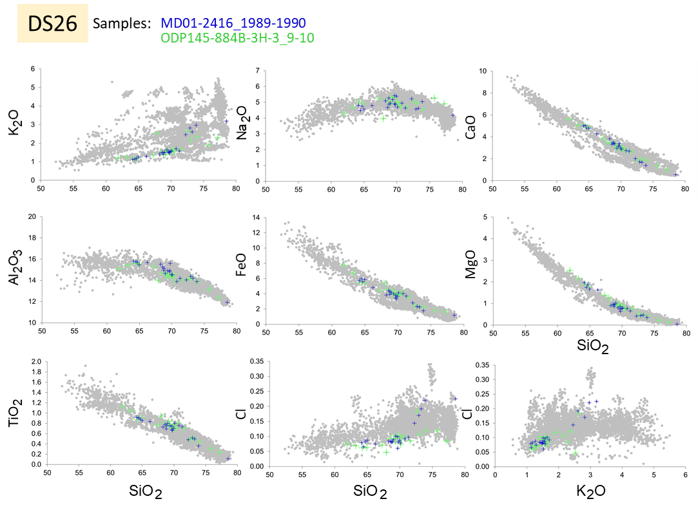
Figure S2k. Correlation of tephra layers between Detroit cores. Tephra DS26.

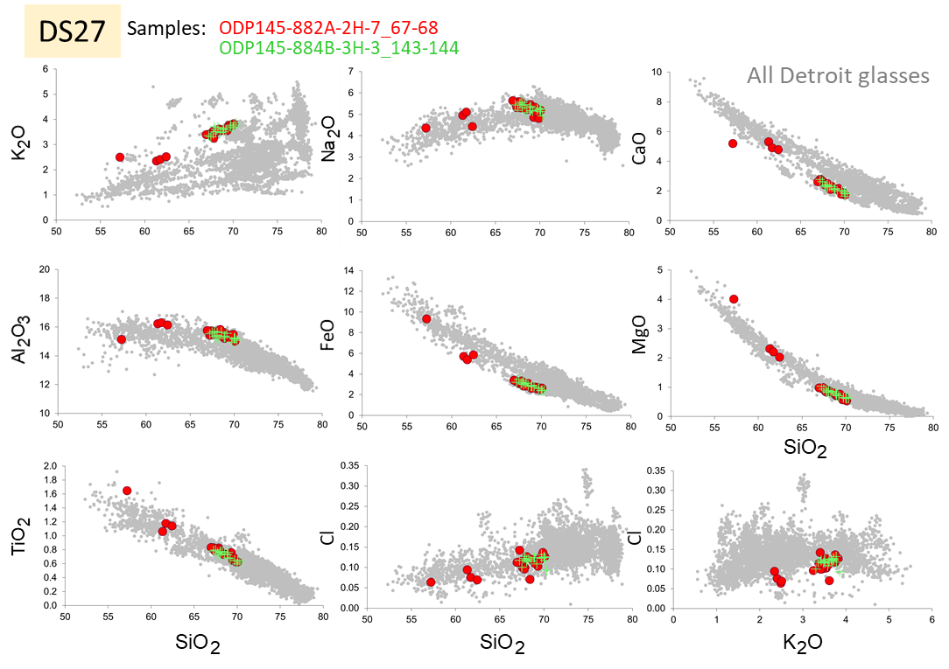
Figure S2l. Correlation of tephra layers between Detroit cores. Tephra DS27.
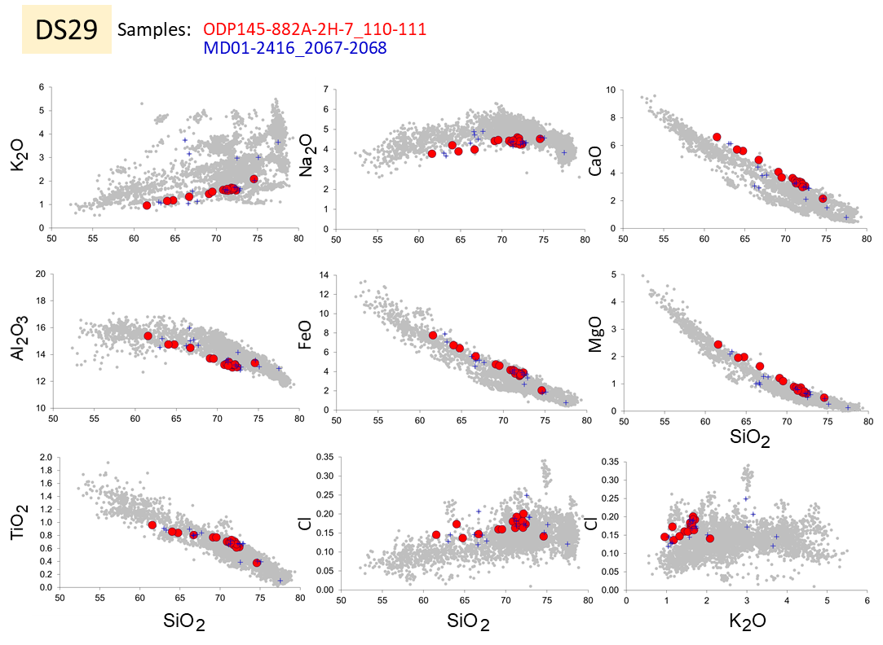
Figure S2m. Correlation of tephra layers between Detroit cores. Tephra DS29.

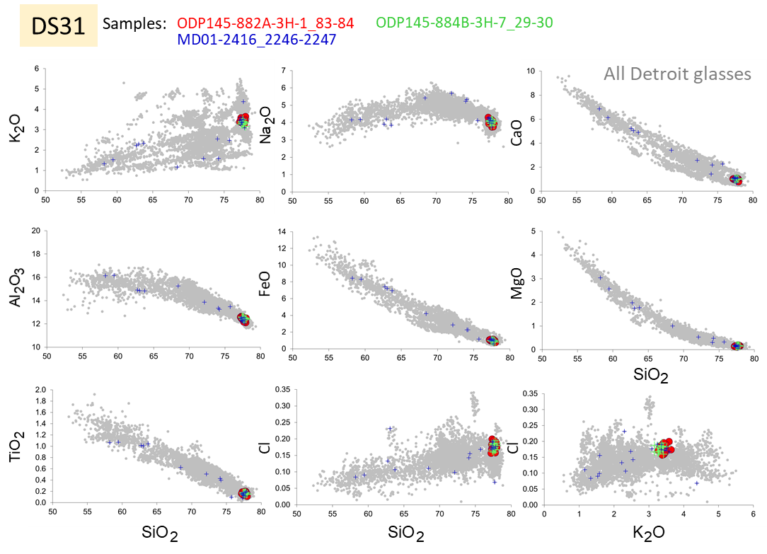
Figure S2n. Correlation of tephra layers between Detroit cores. Tephra DS31.
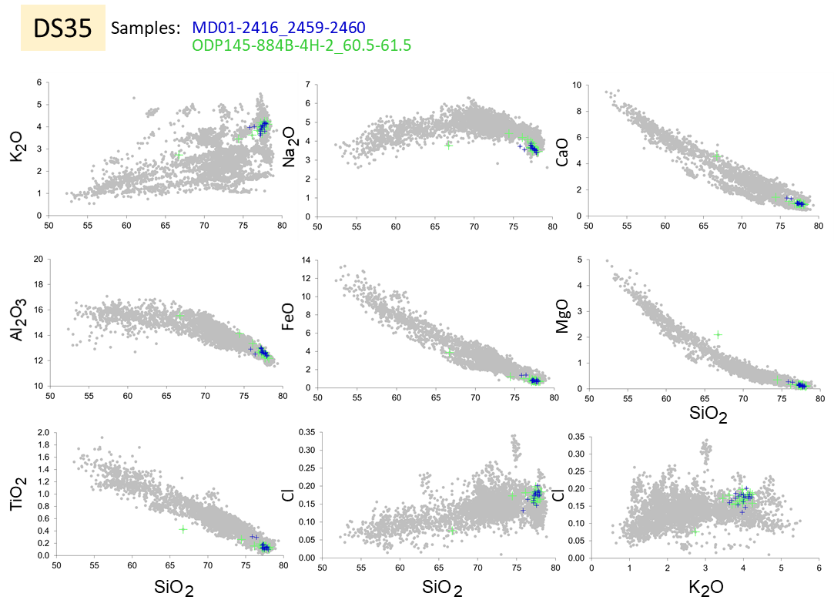

Figure S2o. Correlation of tephra layers between Detroit cores. Tephra DS35.

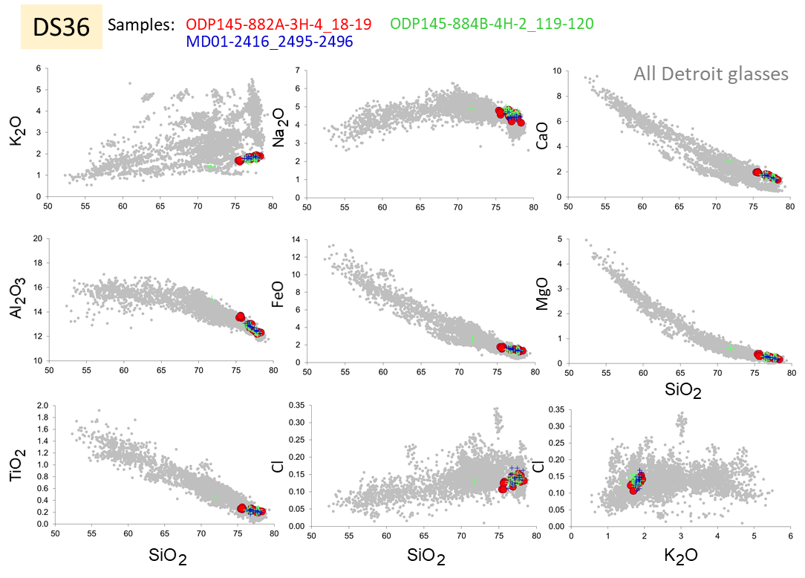
Figure S2p. Correlation of tephra layers between Detroit cores. Tephra DS36.
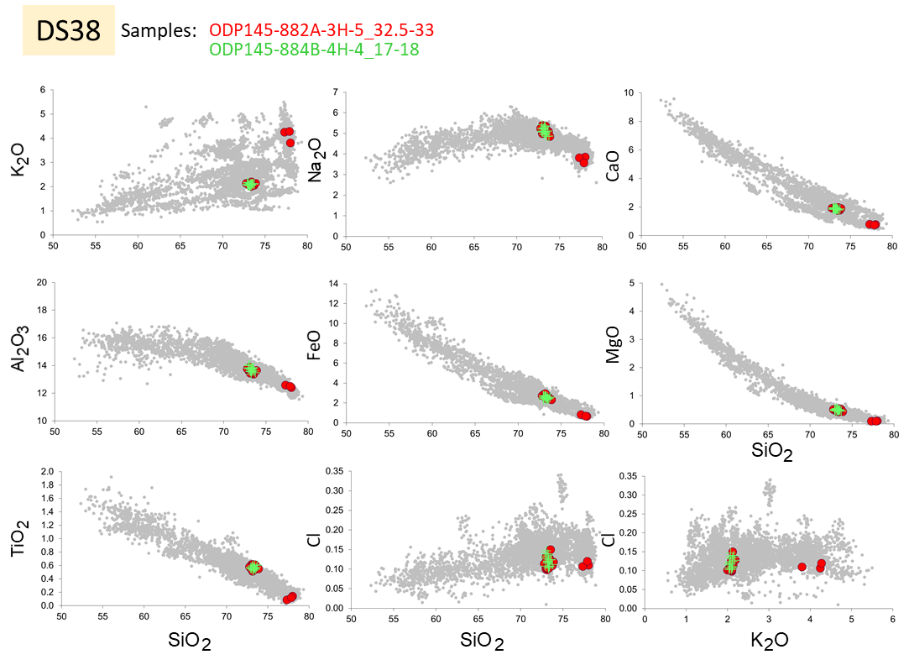
Figure S2q. Correlation of tephra layers between Detroit cores. Tephra DS38.

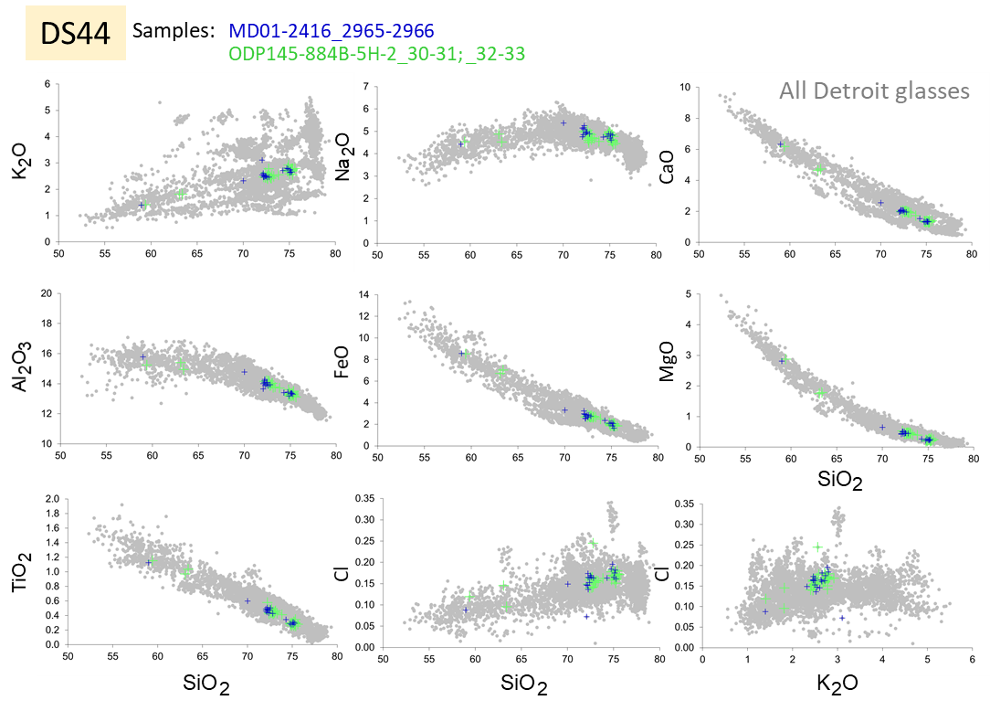

Figure S2r. Correlation of tephra layers between Detroit cores. Tephra DS44.
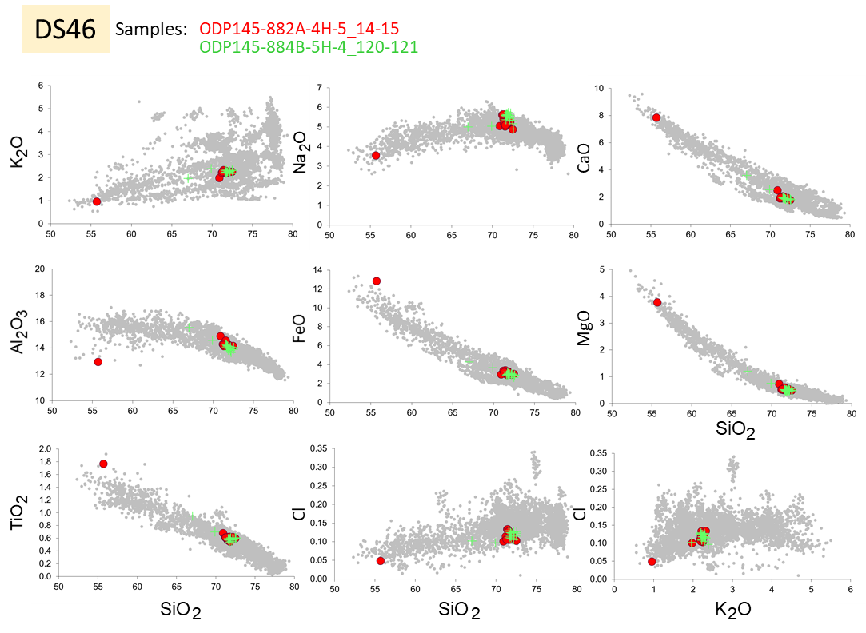
Figure S2s. Correlation of tephra layers between Detroit cores. Tephra DS46.

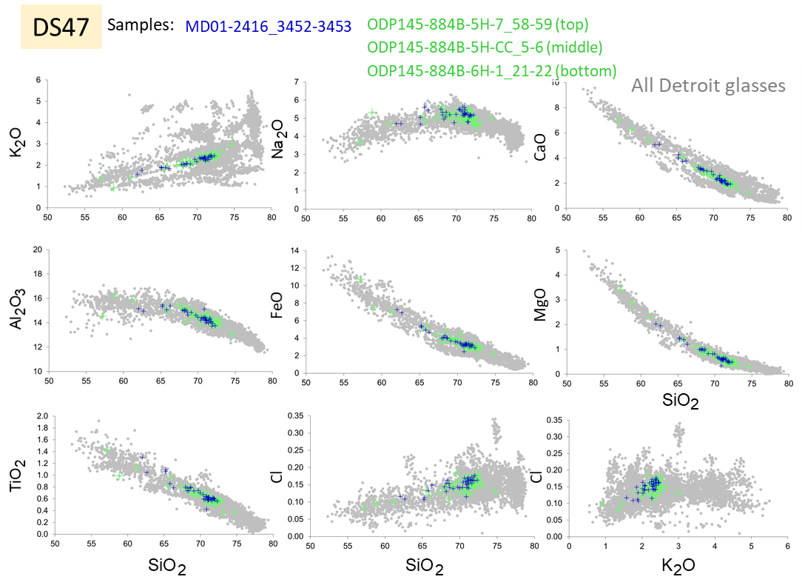
Figure S2t. Correlation of tephra layers between Detroit cores. Tephra DS47.
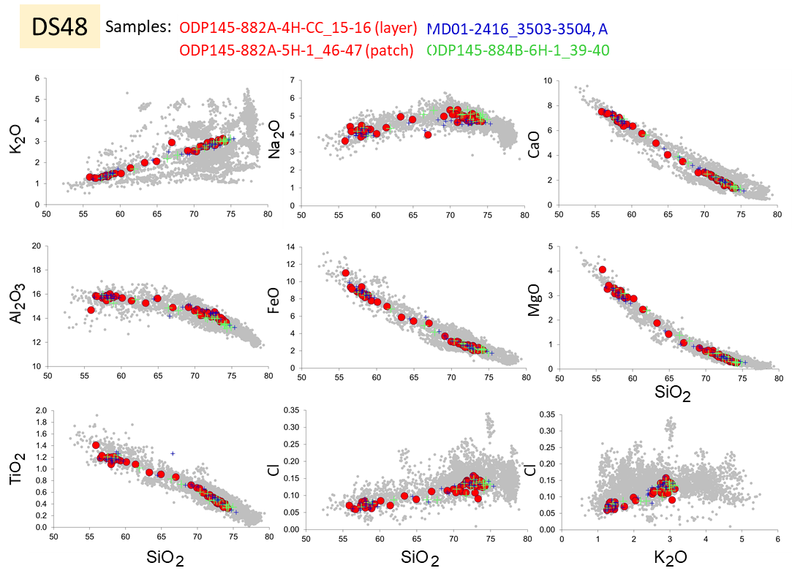
Figure S2u. Correlation of tephra layers between Detroit cores. Tephra DS48.

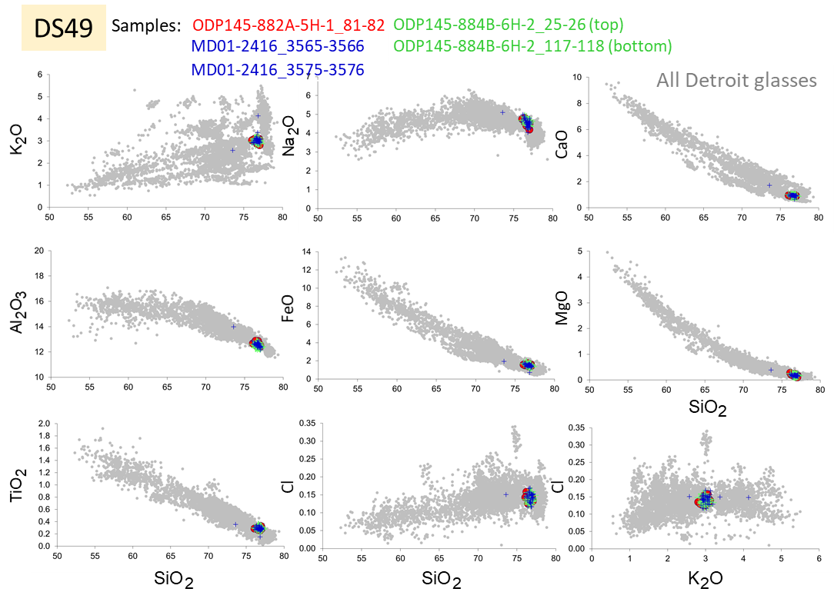
Figure S2v. Correlation of tephra layers between Detroit cores. Tephra DS49.
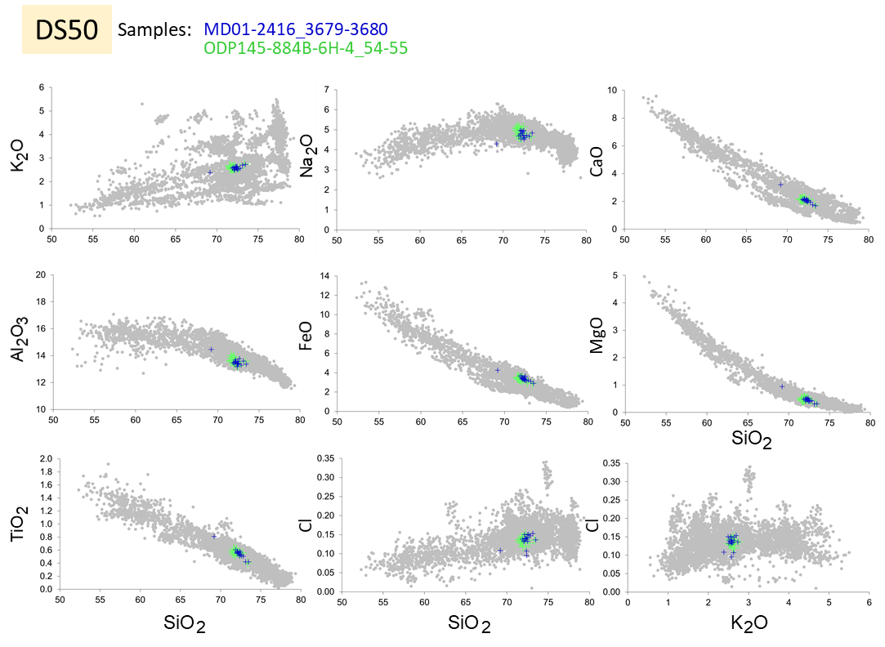

Figure S2w. Correlation of tephra layers between Detroit cores. Tephra DS50.

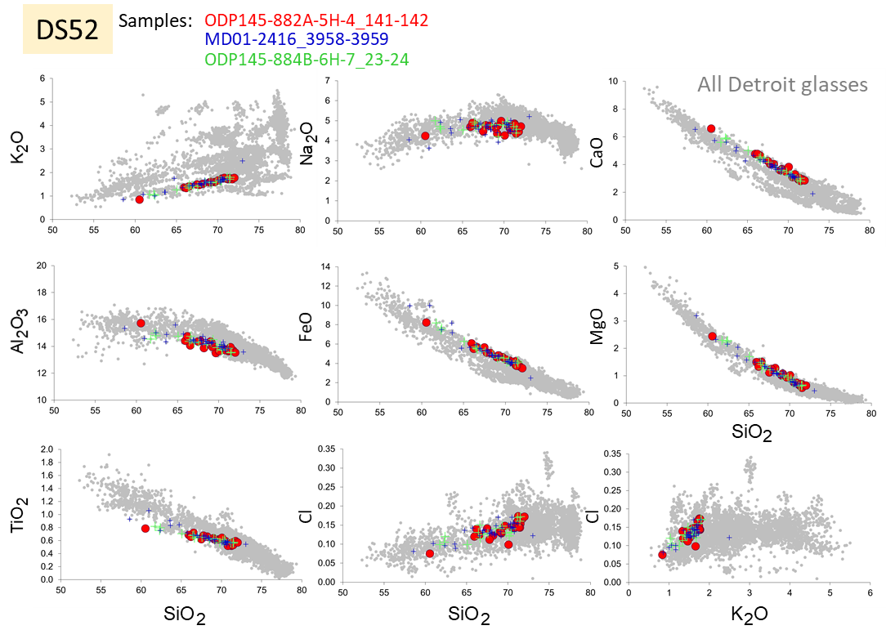
Figure S2x. Correlation of tephra layers between Detroit cores. Tephra DS52.
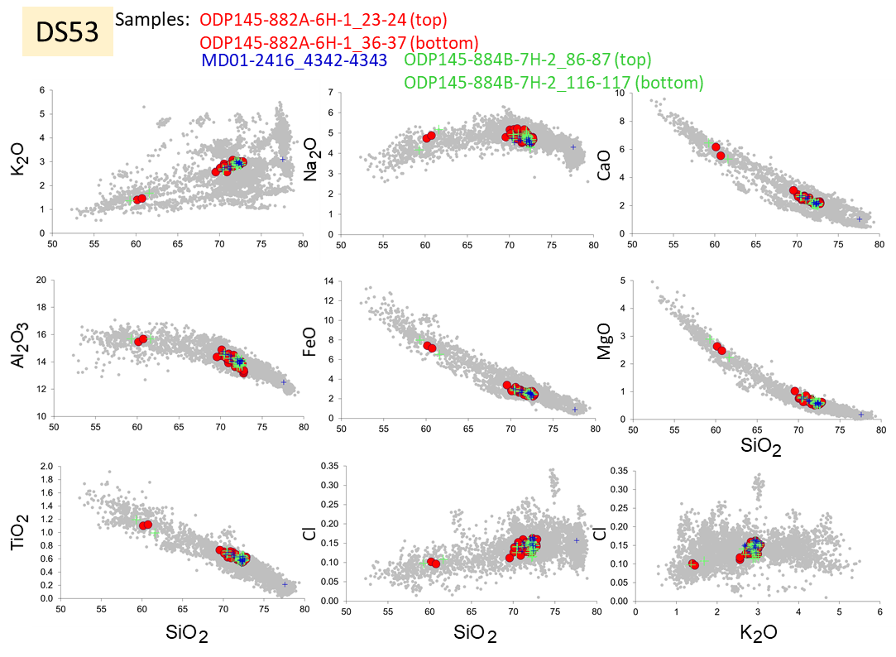

Figure S2y. Correlation of tephra layers between Detroit cores. Tephra DS53.

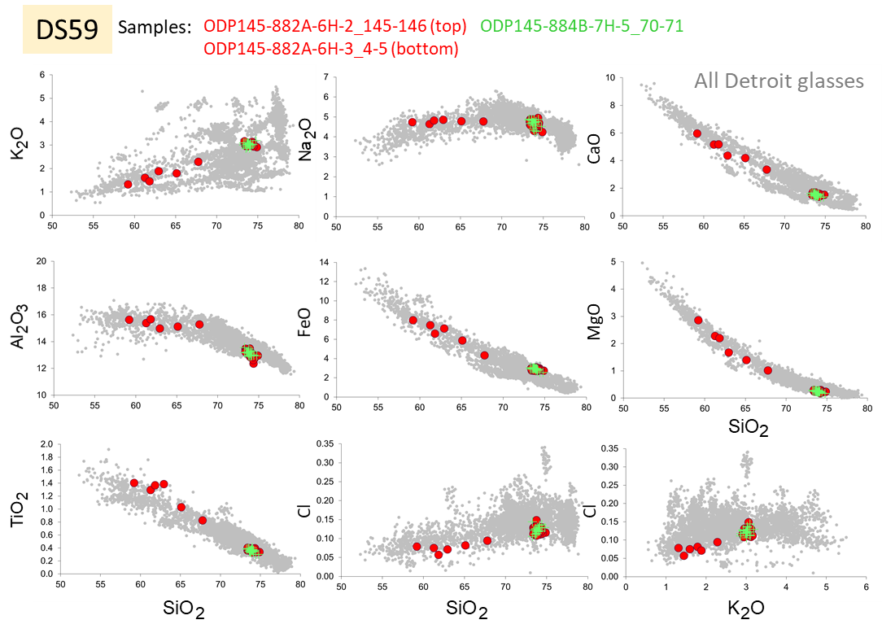
Figure S2z. Correlation of tephra layers between Detroit cores. Tephra DS59.
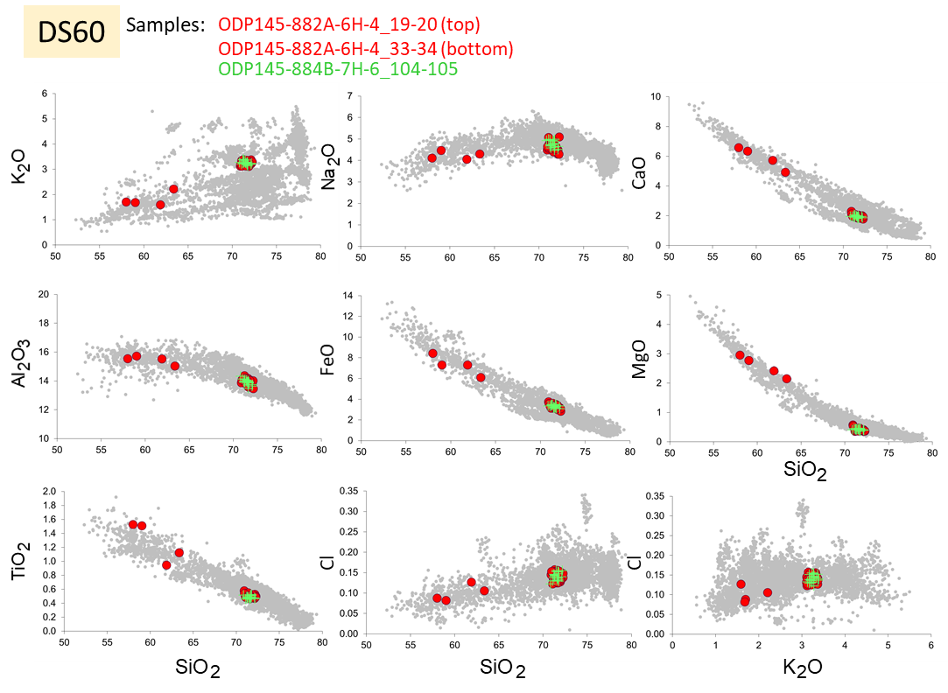
Figure S2aa. Correlation of tephra layers between Detroit cores. Tephra DS60.

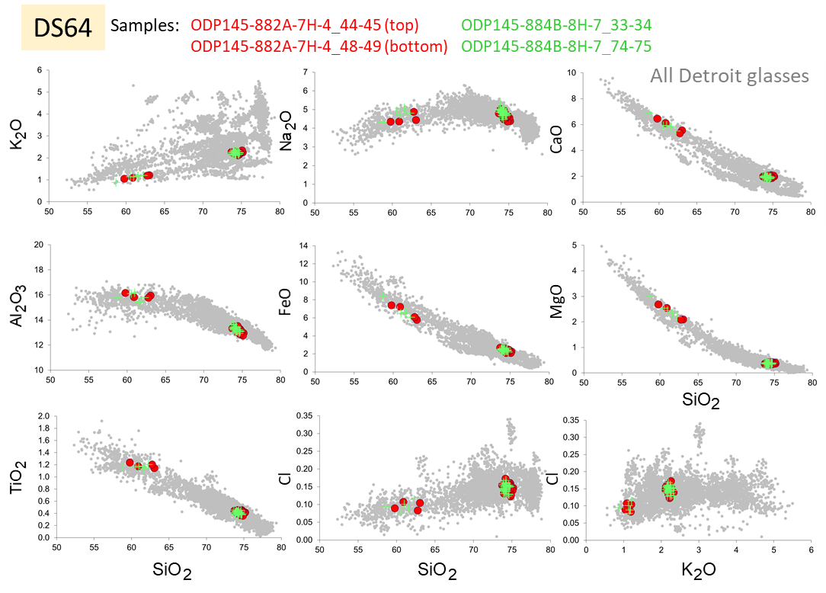
Figure S2ab. Correlation of tephra layers between Detroit cores. Tephra DS64.
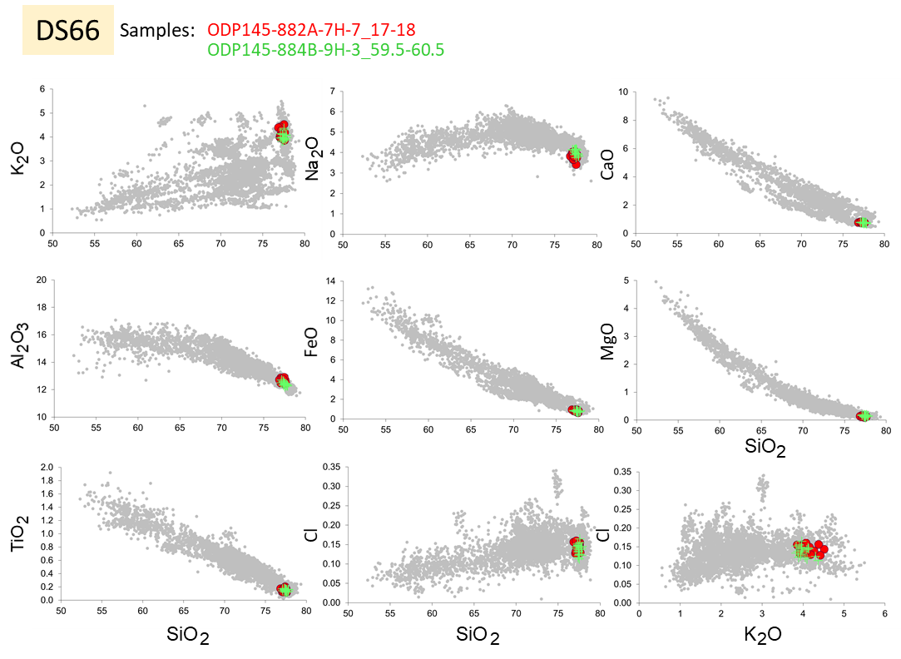
Figure S2ac. Correlation of tephra layers between Detroit cores. Tephra DS66.

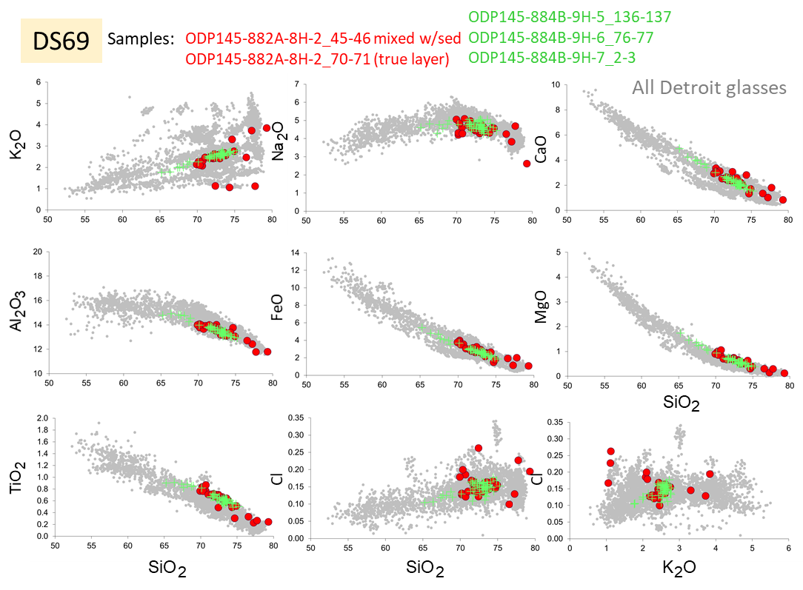
Figure S2ad. Correlation of tephra layers between Detroit cores. Tephra DS69.
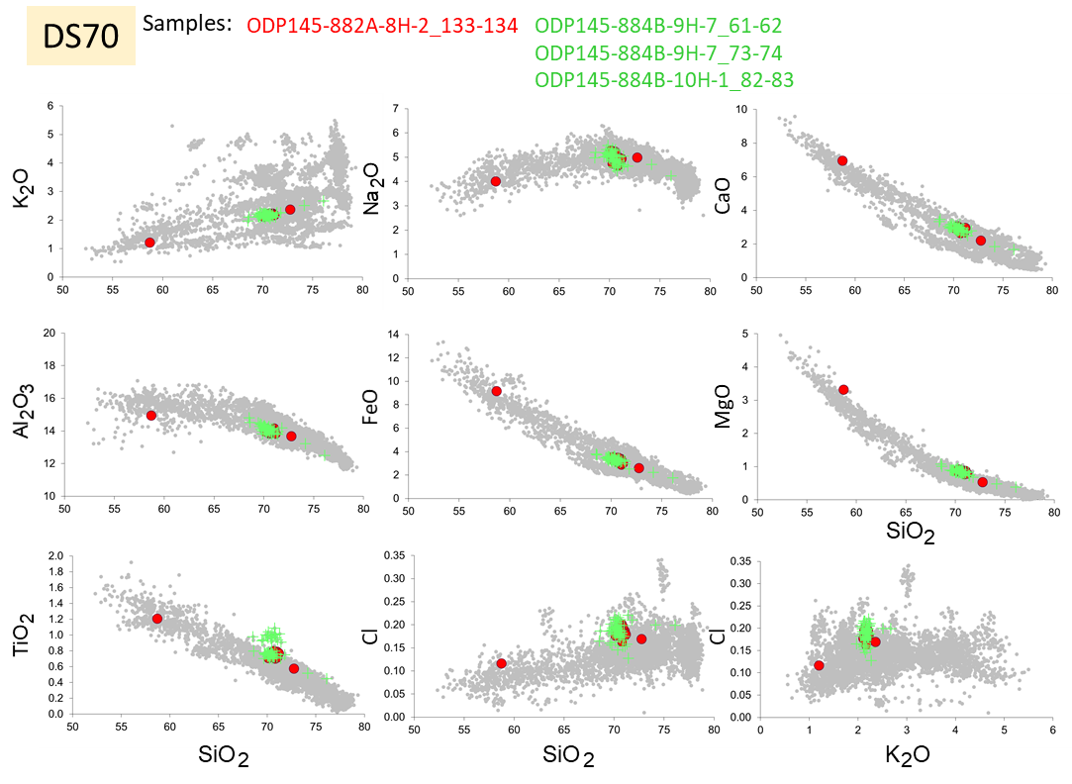
Figure S2ae. Correlation of tephra layers between Detroit cores. Tephra DS70.

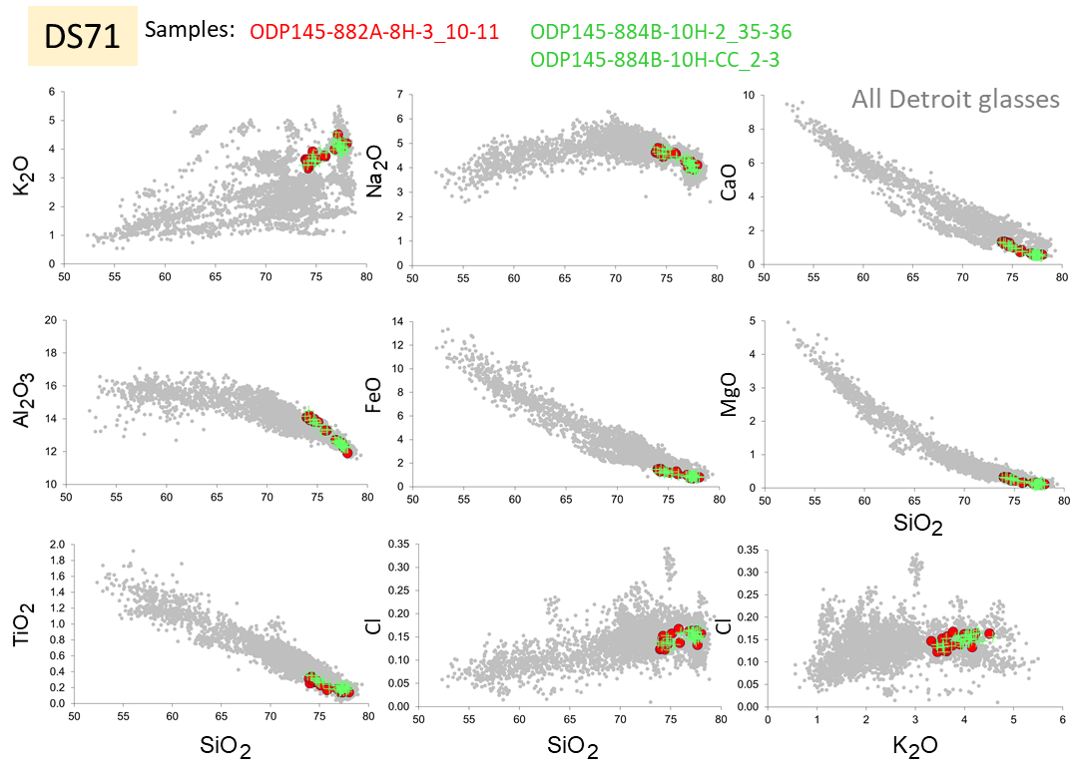
Figure S2ef. Correlation of tephra layers between Detroit cores. Tephra DS71.
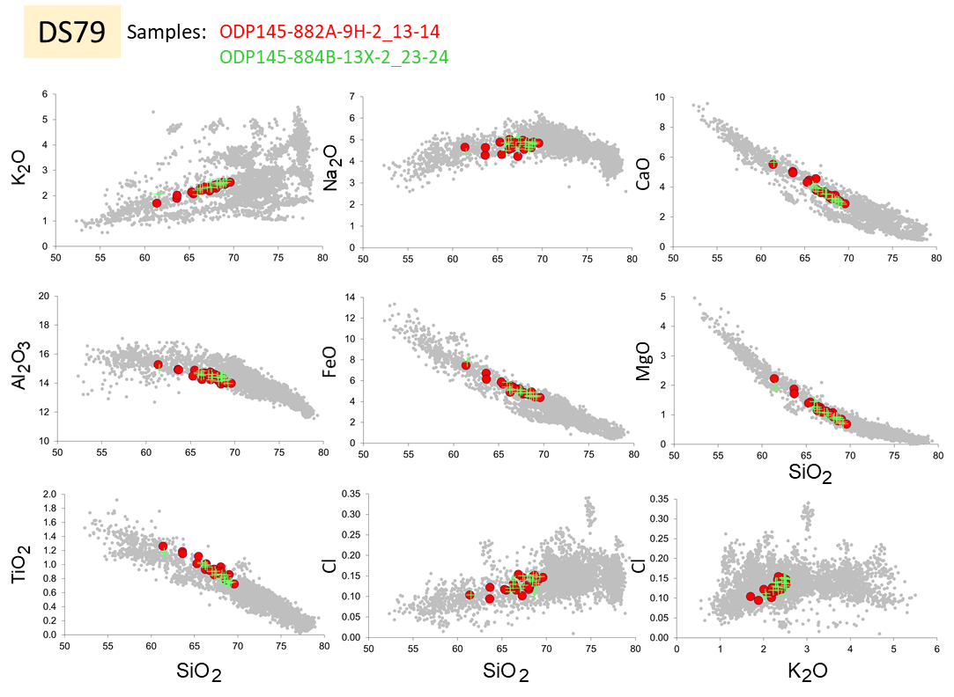
Figure S2ag. Correlation of tephra layers between Detroit cores. Tephra DS79.

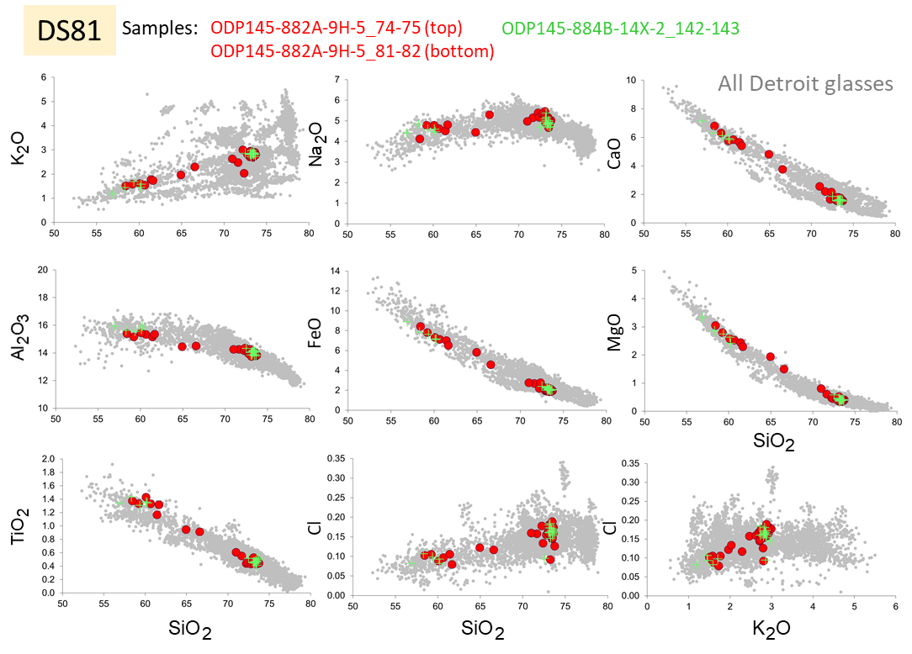
Figure S2ah. Correlation of tephra layers between Detroit cores. Tephra DS81.
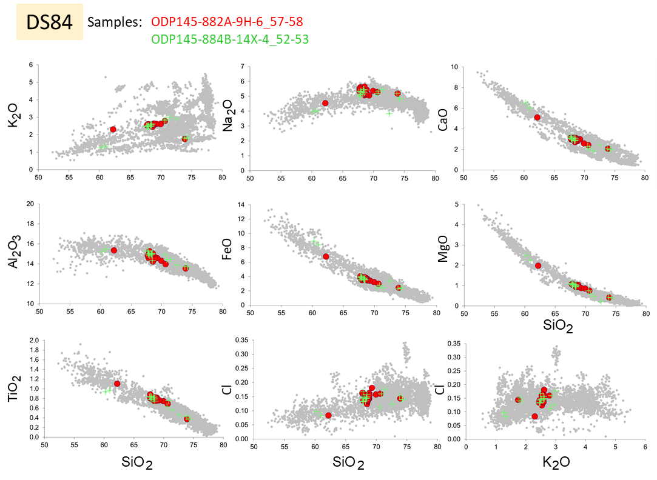
Figure S2al. Correlation of tephra layers between Detroit cores. Tephra DS84.

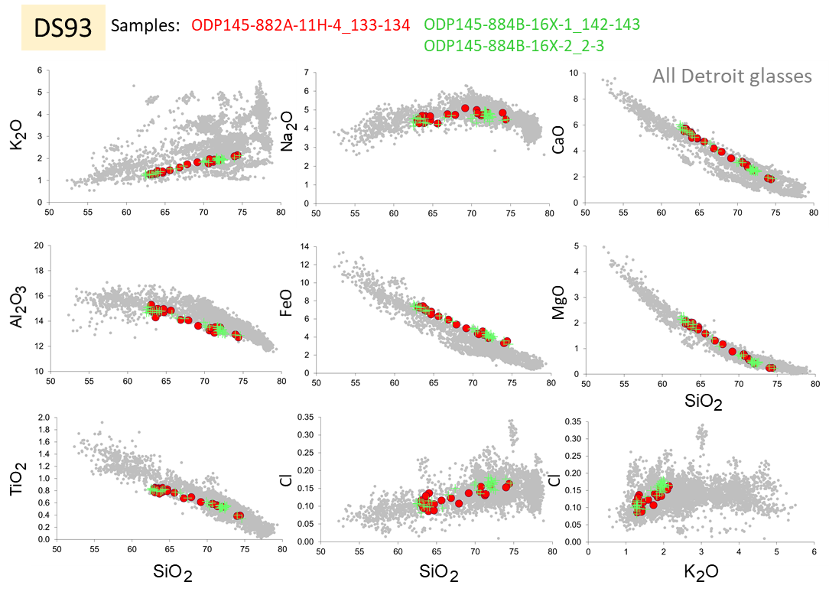
Figure S2aj. Correlation of tephra layers between Detroit cores. Tephra DS93.
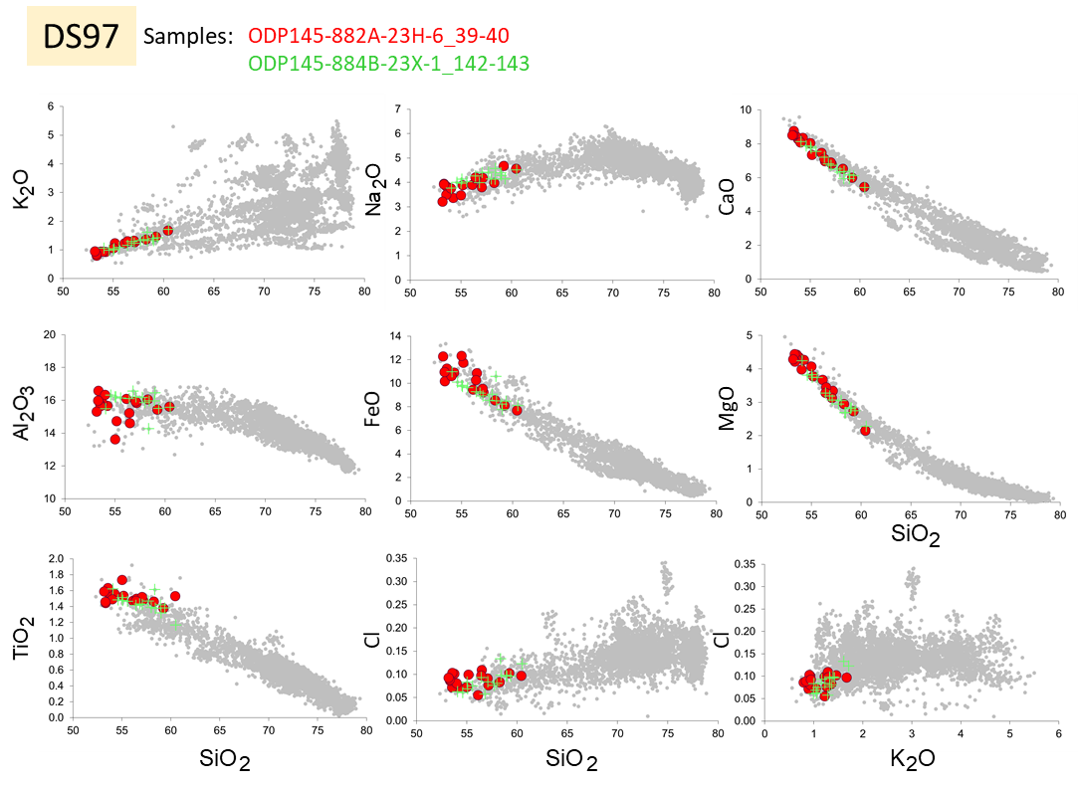
Figure S2ak. Correlation of tephra layers between Detroit cores. Tephra DS97.

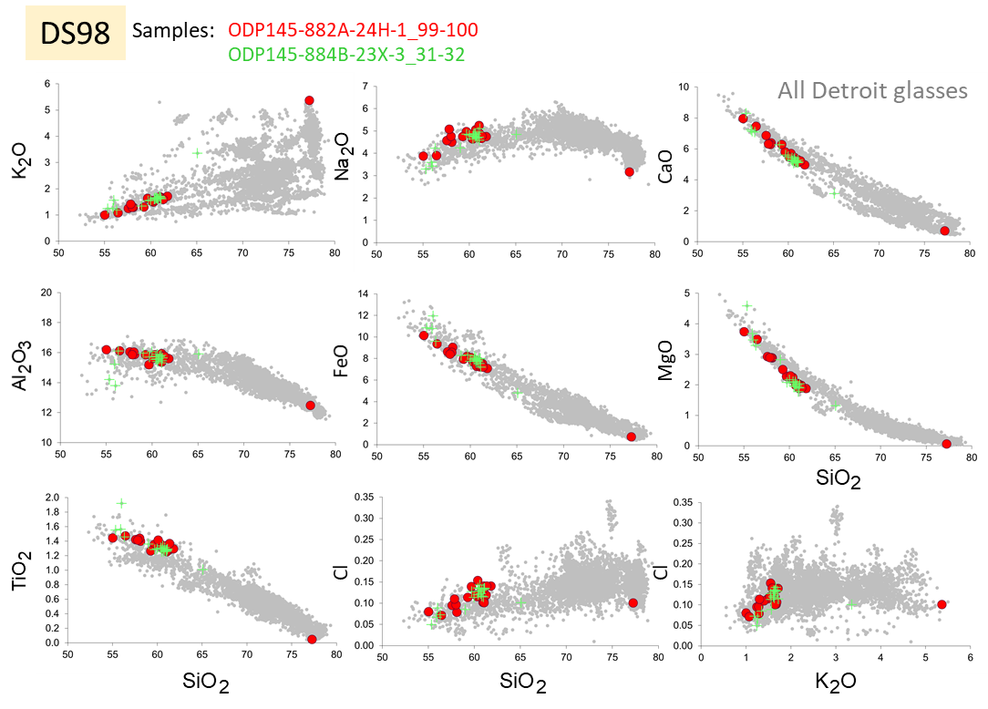
Figure S2al. Correlation of tephra layers between Detroit cores. Tephra DS98.
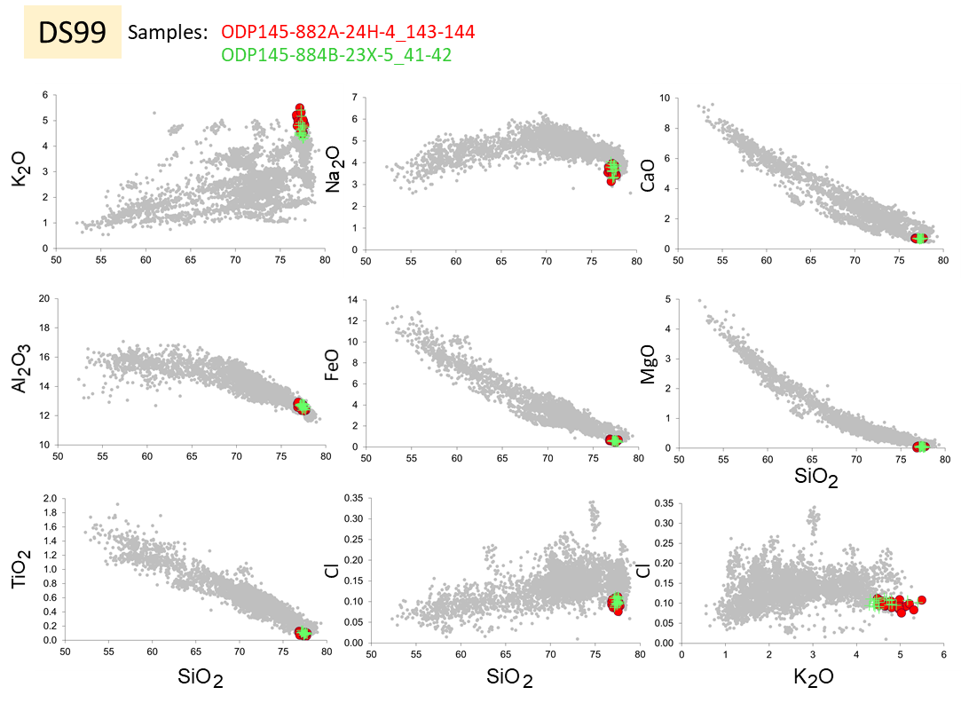
Figure S2am. Correlation of tephra layers between Detroit cores. Tephra DS99.

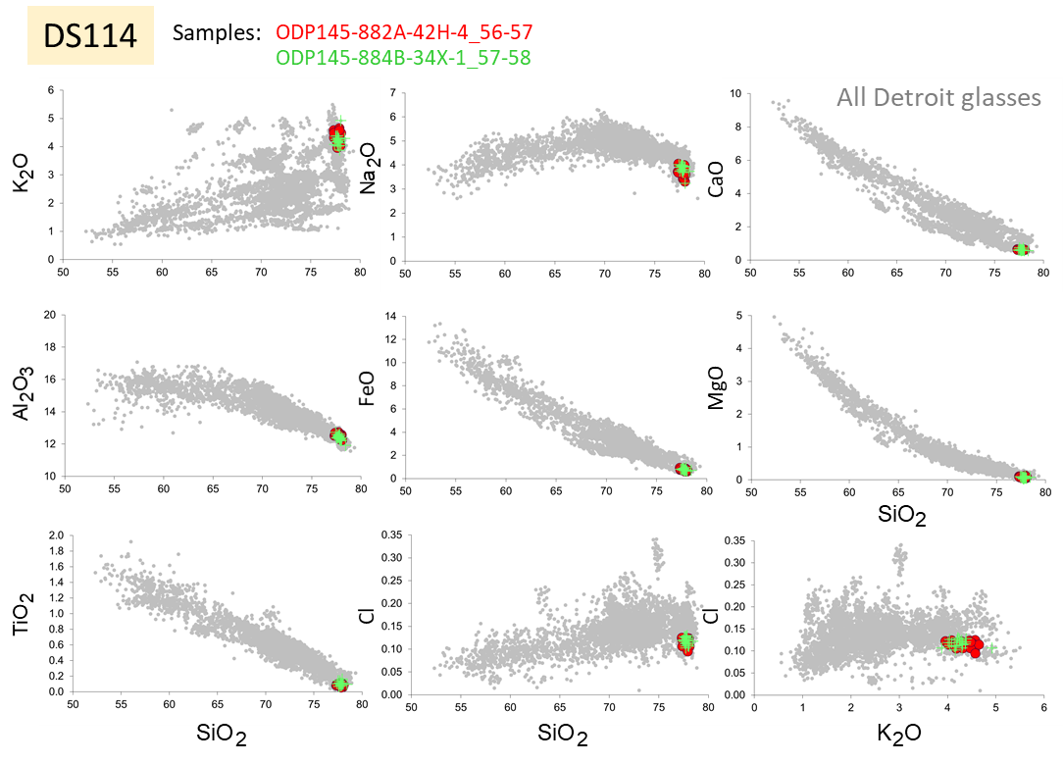
Figure S2an. Correlation of tephra layers between Detroit cores. Tephra DS114.

Table S1. Summary tephra sequence based on three Detroit Seamount cores 882A, MD01-2416, and 884B, and analyzed tephra samples. File uploaded separately.

Table S2. Major element composition of glasses from the Detroit sequence tephras obtained using electron microprobe (oxides contents are given in wt%). File uploaded separately.

Table S3. Major and trace element composition of glasses from the Detroit sequence tephras obtained using single-shard LA-ICP-MS technique (major element contents are given in wt%, trace element contents in ppm). File uploaded separately.

Table S4. Depth/ corrected depth - age control points, sedimentation rate (SR) estimates, and datums in core MD01-2416 and Sites 882A and 884B. File uploaded separately.

Table S5. Downcore position and age of the Detroit Seamount (DS) tephras 1 to DS119 in core MD01-2416 and Sites 882A and 884B. Ages in this table were calculated based on sedimentation rates. File uploaded separately.

Table S6. Complete 40Ar/39Ar data. File uploaded separately.

Table S7. Output of the Bayesian age model for Detroit Seamount tephra sequence. File uploaded separately.

Model S1. CQL code of the Detroit_pure_4.1.2 age model

