Supplementary material
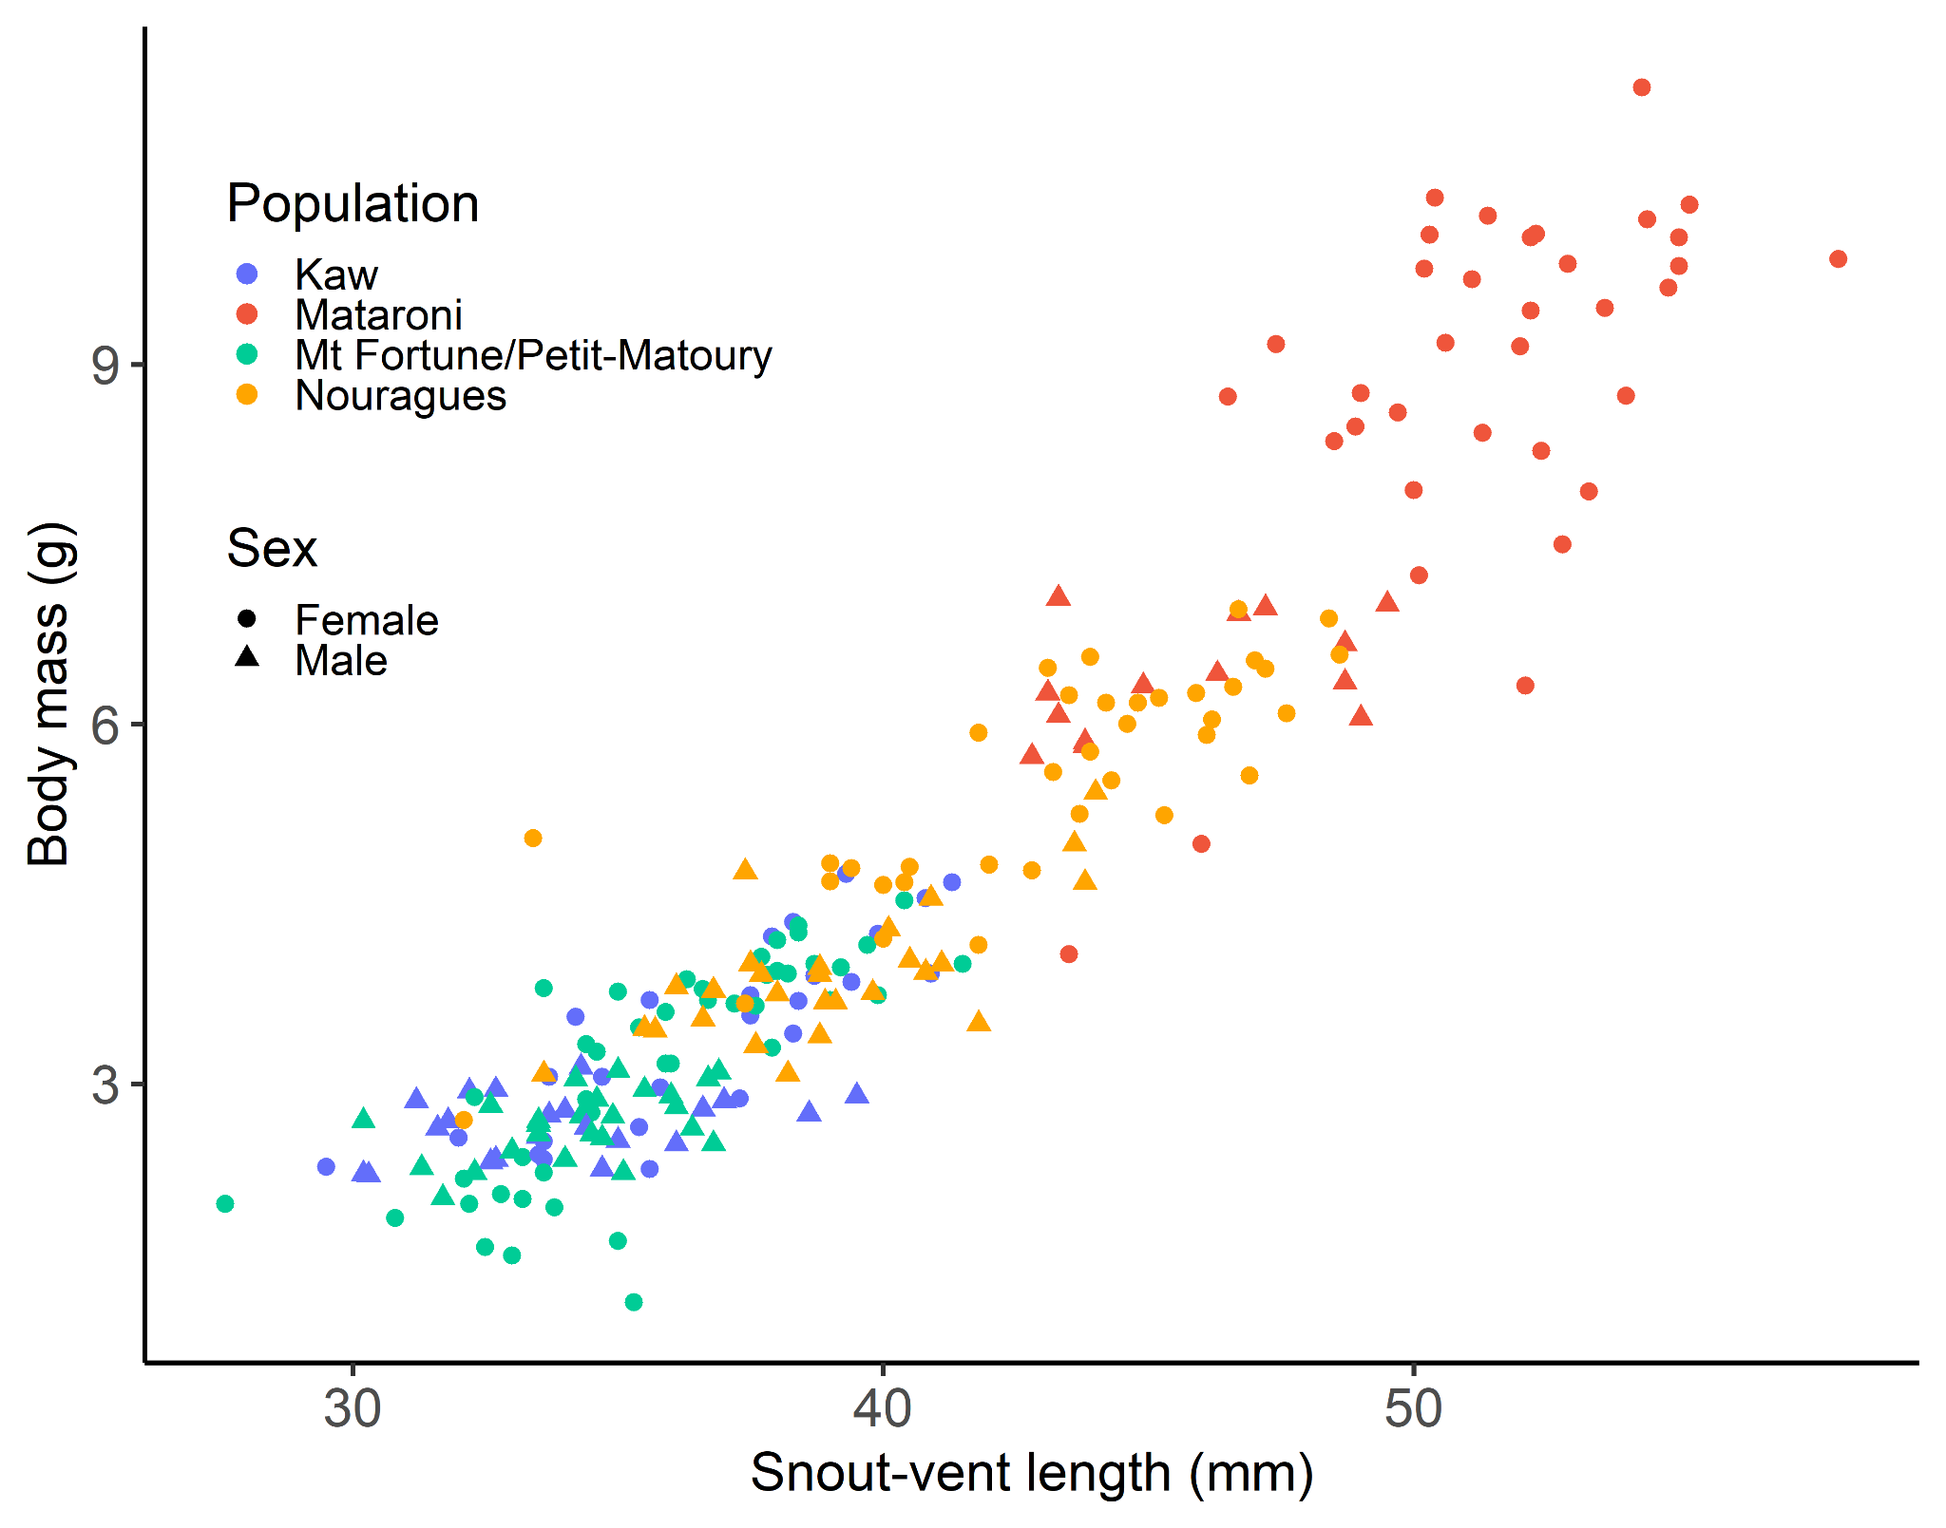
Fig. S1: The plotted relationship between snout-vent length and body mass for all observed dyeing poison frogs (Dendrobates tinctorius), shown separately for females (circles) and males (triangles) and for the different populations.

Table S1: Differences (estimate ± standard error (SE)) between estimated marginal means, based on post-hoc pairwise comparisons of linear models of SVL (left) and body mass (right) and the interaction of population with sex. Statistically significant differences (p < 0.05) are shown in bold.
 | SVL |  | Body mass
Population sex differences | Estimate ± SE | P-value | Estimate ± SE | P-value
Kaw Female - Kaw Male | 0.27 ± 0.09 | 0.04 | 0.81 ± 0.26 | 0.04
Mataroni Female - Mataroni Male | 0.57 ± 0.09 | >0.001 | 2.53 ± 0.28 | <0.001
Mt Fortune/Petit-Matoury Female - Mt Fortune/Petit-Matoury Male | 0.15 ± 0.07 | 0.46 | 0.51 ± 0.22 | 0.31
Nouragues Female - Nouragues Male | 0.42 ± 0.07 | >0.001 | 1.61 ± 0.23 | <0.001

Table S2: Overview of the model selection for the analysis of (1) number of clutches per pair, (2) days between clutch deposition, (3) clutch size, (4) number of tadpoles hatched per clutch, (5) time to hatching, (6) tadpole size at hatching, (7) time to metamorphosis, and (8) survival (from egg deposition to metamorphosis). All models within delta AIC <2, including the full and intercept only model, are shown. Models are ranked according to AIC. The marginal R² is the variation explained by the fixed effects and the conditional R² the variation explained by fixed and random effects combined. Maternal ID was included as random intercept in all analyses (except for the number of clutches per pair).
Analysis/Predictor variables | df | logLik | AICc | delta AIC | AIC weight | marginal R² | conditional R²
1. Number of clutches per pair (n = 45 pairs)
Population + female SVL | 6 | -200 | 415 | 0.00 | 1.00 | 0.65
Intercept only | 1 | -240 | 482 | 67.58 | 0.00
2. Days between clutch deposition (n = 242 clutches)
Population + clutch order | 7 | -3944 | 7903 | 0.00 | 0.82 | 0.38 | 0.96
Clutch order | 3 | -3950 | 7906 | 3.42 | 0.15 | 0.21 | 0.97
Population + female SVL + clutch order + Population × female SVL | 12 | -3942 | 7909 | 6.68 | 0.03 | 0.43 | 0.95
Intercept only | 2 | -4148 | 8301 | 398.11 | 0.00 |  | 0.94
3. Clutch size (n = 290 clutches)
Population + clutch order | 7 | -545 | 1104 | 0.00 | 0.49 | 0.13 | 0.17
Population + clutch order + female SVL | 8 | -544 | 1104 | 0.31 | 0.42 | 0.14 | 0.17
Population + clutch order + female SVL + Population × female SVL | 12 | -541 | 1107 | 3.62 | 0.08 | 0.17 | 0.18
Intercept only | 2 | -555 | 1114 | 10.62 | 0.00 |  | 0.21
4. Number of tadpoles per clutch (n = 299 clutches)
Clutch order | 3 | -584 | 1174 | 0.00 | 0.48 | 0.01 | 0.13
Intercept only | 2 | -585 | 1174 | 0.57 | 0.36 |  | 0.11
Population + clutch order + female SVL + Population × female SVL | 12 | -575 | 1176 | 2.09 | 0.17 | 0.09 | 0.09
5. Time to hatching (n = 217 clutches)
Population + average tadpole size | 7 | -600 | 1214 | 0.00 | 0.54 | 0.22 | 0.22
Population + average tadpole size + female SVL | 8 | -599 | 1216 | 1.80 | 0.22 | 0.22 | 0.22
Population + average tadpole size + clutch size | 8 | -599 | 1216 | 1.80 | 0.22 | 0.22 | 0.22
Population + female SVL + clutch size + clutch order + average tadpole size + Population × female SVL | 14 | -595 | 1221 | 7.15 | 0.02 | 0.25 | 0.25
Intercept only | 2 | -626 | 1256 | 42.30 | 0.00 |  | 0.08
6. Tadpole size (n = 738 tadpoles)
Population | 7 | -1240 | 2494 | 0.00 | 0.61 | 0.08 | 0.35
Intercept only | 3 | -1244 | 2495 | 0.91 | 0.39 |  | 0.33
Population + female SVL + clutch size + clutch order + Population × female SVL | 14 | -1248 | 2525 | 31.24 | 0.00 | 0.09 | 0.42
7. Time to metamorphosis (n = 485 froglets)
Clutch size + clutch order | 4 | -2018 | 4044 | 0.00 | 0.72 | 0.06 | 0.64
Clutch size + clutch order + female SVL | 5 | -2018 | 4046 | 1.94 | 0.27 | 0.07 | 0.64
Population + female SVL + clutch size + clutch order + Population × female SVL | 13 | -2014 | 4055 | 10.59 | 0.00 | 0.15 | 0.60
Intercept only | 2 | -2038 | 4080 | 36.06 | 0.00 |  | 0.59
8. Survival (n = 174 clutches)
Clutch size + clutch order | 4 | -391 | 791 | 0.00 | 0.48 | 0.04 | 0.22
Clutch size | 3 | -393 | 792 | 0.77 | 0.32 | 0.02 | 0.18
Intercept only | 2 | -395 | 794 | 2.32 | 0.15 |  | 0.19
Population + female SVL + clutch size + clutch order + Population × female SVL | 13 | -384 | 796 | 4.48 | 0.05 | 0.14 | 0.19

Table S3: Estimates, standard error (SE), lower (LCI) and upper (UCI) 95% confidence intervals, and p-values of explanatory variables for the analyses of (1) number of clutches per pair, (2) days between clutch deposition, (3) clutch size, (4) number of tadpoles hatched per clutch, (5) time to hatching, (6) tadpole size at hatching, (7) time to metamorphosis, and (8) survival (from egg deposition to metamorphosis) of dyeing poison frogs (Dendrobates tinctorius) from five different populations. We used the population ‘Bruyere’ as reference level. Informative parameters are presented in bold (95% confidence intervals do not overlap with zero).
Parameter | Estimate | SE | LCI | UCI | P-value
1. Number of clutches per pair (n = 45 pairs)
Intercept | -0.88 | 0.85 | -2.57 | 0.77 | 0.30
Population Kaw | 0.62 | 0.28 | 0.11 | 1.21 | 0.03
Population Mataroni | -1.41 | 0.41 | -2.20 | -0.59 | <0.001
Population Ouanary | -0.53 | 0.31 | -1.10 | 0.11 | 0.08
Population Petit-Matoury | -0.34 | 0.41 | -1.17 | 0.46 | 0.41
Female SVL | 0.08 | 0.02 | 0.03 | 0.12 | 0.00
2. Days between clutch deposition (n = 242 clutches)
Intercept | 2.00 | 0.53 | 0.92 | 3.08 | <0.001
Population Kaw | -0.01 | 0.59 | -1.21 | 1.20 | 0.99
Population Mataroni | 1.07 | 0.62 | -0.21 | 2.34 | 0.09
Population Ouanary | 1.43 | 0.62 | 0.15 | 2.70 | 0.02
Population Petit-Matoury | 0.28 | 0.69 | -1.12 | 1.68 | 0.68
Clutch order | 0.05 | 0.00 | 0.05 | 0.06 | <0.001
3. Clutch size (n = 290 clutches)
Intercept | 1.25 | 0.16 | 0.92 | 1.57 | <0.001
Population Kaw | 0.18 | 0.17 | -0.16 | 0.54 | 0.29
Population Mataroni | 0.52 | 0.18 | 0.16 | 0.88 | 0.004
Population Ouanary | 0.02 | 0.19 | -0.35 | 0.39 | 0.94
Population Petit-Matoury | -0.33 | 0.25 | -0.84 | 0.16 | 0.19
Clutch order | -0.05 | 0.04 | -0.13 | 0.02 | 0.13
4. Number of tadpoles per clutch (n = 299 clutches)
Intercept | 1.07 | 0.07 | 0.92 | 1.20 | <0.001
Clutch order | -0.01 | 0.004 | -0.02 | 0.001 | 0.11
5. Time to hatching (n = 217 clutches)
Intercept | 2.75 | 0.07 | 2.62 | 2.89 | <0.001
Population Kaw | -0.07 | 0.07 | -0.21 | 0.07 | 0.30
Population Mataroni | -0.10 | 0.08 | -0.26 | 0.06 | 0.24
Population Ouanary | -0.23 | 0.08 | -0.39 | -0.07 | 0.01
Population Petit-Matoury | -0.56 | 0.12 | -0.80 | -0.32 | <0.001
Total length | 0.11 | 0.02 | 0.07 | 0.14 | <0.001
6. Tadpole size (n = 738 tadpoles)
Intercept | 15.66 | 0.61 | 14.47 | 16.86 | <0.001
Population Kaw | -1.02 | 0.68 | -2.35 | 0.31 | 0.15
Population Mataroni | -0.77 | 0.71 | -2.16 | 0.63 | 0.30
Population Ouanary | 0.07 | 0.70 | -1.30 | 1.45 | 0.92
Population Petit-Matoury | -0.19 | 0.82 | -1.79 | 1.41 | 0.82
7. Time to metamorphosis (n = 485 froglets)
Intercept | 4.32 | 0.03 | 4.25 | 4.39 | <0.001
Clutch size | 0.02 | 0.004 | 0.01 | 0.03 | <0.001
Clutch order | 0.004 | 0.001 | 0.002 | 0.01 | <0.001
8. Survival (n = 174 clutches)
Intercept | -0.92 | 0.11 | -1.16 | -0.72 | <0.001
Clutch order | -0.13 | 0.08 | -0.28 | 0.02 | 0.10
Clutch size | -0.12 | 0.06 | -0.24 | -0.005 | 0.04

Table S4: Differences (estimate ± standard error (SE)) between estimated marginal means, based on post-hoc pairwise comparisons of linear models of the (1) number of clutches per pair and (2) number of days between clutch laying (response variable in separate analyses) of dyeing poison frogs and including population as fixed effect. Statistically significant differences (p < 0.05) are in bold.
Population comparison | 1. Number of clutches |  | 2. Days between clutch laying
 | Estimate ± SE | P-value | Estimate ± SE | P-value
Bruyere - Kaw | -0.56 ± 0.28 | 0.27 | 0.01 ± 0.59 | 1.00
Bruyere - Mataroni | 1.4 ± 0.41 | 0.01 | -1.07 ± 0.63 | 0.43
Bruyere - Ouanary | 0.53 ± 0.31 | 0.41 | -1.43 ± 0.62 | 0.15
Bruyere - Petit-Matoury | 0.34 ± 0.41 | 0.92 | -0.28 ± 0.69 | 0.99
Kaw - Mataroni | 1.96 ± 0.34 | <0.01 | -1.07 ± 0.42 | 0.08
Kaw - Ouanary | 1.08 ± 0.17 | <0.01 | -1.43 ± 0.42 | 0.01
Kaw - Petit-Matoury | 0.9 ± 0.32 | 0.04 | -0.29 ± 0.51 | 0.98
Mataroni - Ouanary | -0.87 ± 0.34 | 0.08 | -0.36 ± 0.47 | 0.94
Mataroni - Petit-Matoury | -1.06 ± 0.49 | 0.20 | 0.78 ± 0.55 | 0.61
Ouanary - Petit-Matoury | -0.19 ± 0.35 | 0.98 | 1.14 ± 0.55 | 0.22

Table S5: Differences (estimate ± standard error (SE)) between estimated marginal means, based on post-hoc pairwise comparisons of linear models of (1) clutch size, (2) time to hatching of tadpoles, and (3) tadpole size of dyeing poison frogs and including population as fixed effect. Statistically significant differences (p < 0.05) are in bold.
 | 1. Clutch size |  | 2. Time to hatching (days) |  | 3. Tadpole size (mm)
Population | Estimate ± SE | P-value | Estimate ± SE | P-value | Estimate ± SE | P-value
Bruyere - Kaw | -0.18 ± 0.17 | 0.83 | 0.07 ± 0.07 | 0.84 | 1.02 ± 0.68 | 0.58
Bruyere - Mataroni | -0.52 ± 0.18 | 0.03 | 0.1 ± 0.08 | 0.76 | 0.77 ± 0.71 | 0.82
Bruyere - Ouanary | -0.02 ± 0.19 | 1.00 | 0.23 ± 0.08 | 0.04 | -0.07 ± 0.7 | 1.00
Bruyere - Petit-Matoury | 0.33 ± 0.25 | 0.68 | 0.56 ± 0.12 | <0.01 | 0.19 ± 0.82 | 1.00
Kaw - Mataroni | -0.34 ± 0.1 | 0.01 | 0.02 ± 0.05 | 0.99 | -0.25 ± 0.48 | 0.98
Kaw - Ouanary | 0.17 ± 0.11 | 0.58 | 0.15 ± 0.05 | 0.04 | -1.09 ± 0.46 | 0.17
Kaw - Petit-Matoury | 0.52 ± 0.21 | 0.09 | 0.49 ± 0.11 | <0.01 | -0.83 ± 0.62 | 0.68
Mataroni - Ouanary | 0.51 ± 0.12 | <0.01 | 0.13 ± 0.07 | 0.32 | -0.84 ± 0.51 | 0.48
Mataroni - Petit-Matoury | 0.85 ± 0.21 | <0.01 | 0.46 ± 0.11 | 0.00 | -0.58 ± 0.66 | 0.90
Ouanary - Petit-Matoury | 0.35 ± 0.22 | 0.50 | 0.33 ± 0.11 | 0.03 | 0.26 ± 0.65 | 0.99

