Supplementary Information: preliminary analysis of the effect of past parliament composition on the current SDG indexes
The current levels of national performance on the SDG may also be due to previous representation of women and younger legislators. In light of this possibility, the article also tested the relationship between past parliament composition (in terms of the average age and percentage of female parliamentarians) on the current 2021 SDG indexes.
To examine that relationship, the article extracted the first data available for each country in the Parline database after 2009. In the Parline database, 25% of the parliaments were elected before April 2012; 50% were elected before February 2014; and 25% were elected after November 2015.
Using the same model selection method, the article found the main results from this assessment to be largely consistent with the results in the main manuscript. The explanatory variables had roughly the same relationship with the modified 2021 SDG index and the environmental SDG index (Suppl. Table 3, when compared to the models based on the latest parliament composition, Table 1). The only slight differences were the two socioeconomic SDG indexes did not show significant relationships with the average age of parliamentarians and interaction variables (Supp. Table 3).
When comparing the different model predictions (Supp. Figure 2 vs Figure 3), the changes appear to be relatively minor, suggesting that either the lag effect could be marginal or that the changes in parliament age and gender composition were less important between 2009 and 2021.
These results are preliminary since as of this writing (manuscript written in 2023), data on the SDGs and parliament composition predating 2016 are too limited to perform a full-fledged time-series analysis.
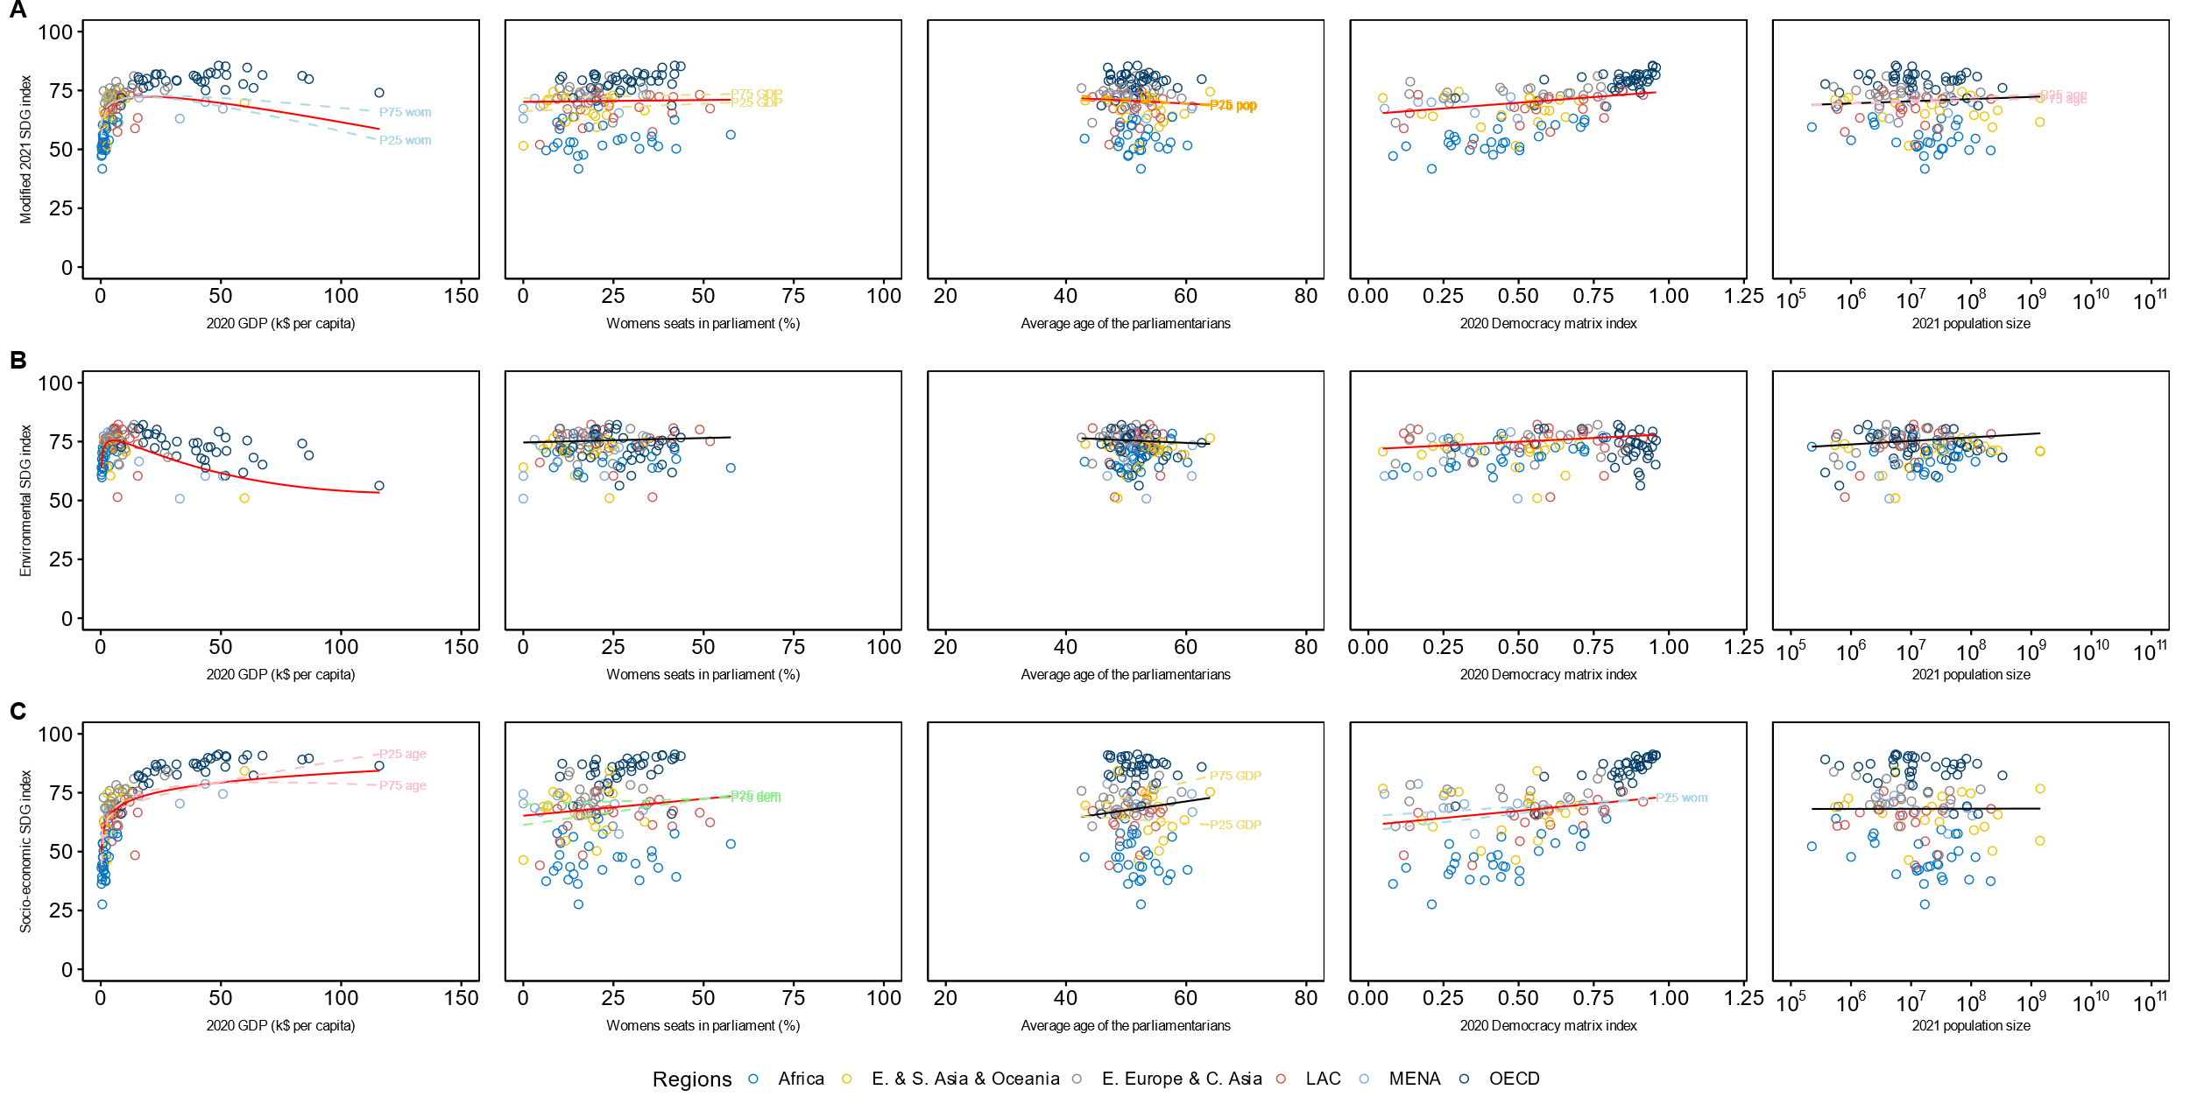
Supplementary Figure 2 - Outcome of the three models with the modified 2021 SDG index (A), the environmental SDG index (B) and the socio-economic SDG index (C) as response variables. For each model, the article presents the effects of the 2020 GDP (in k$ per capita), the percentage of women in the parliament, the average age of the parliament, the 2020 democracy matrix index, and the 2021 population size. Red lines indicate that the explanatory variable had a significant effect; black lines suggest the opposite. The lines were drawn using the model coefficients (Supplementary table 3) and setting other explanatory variables to their medians. Dashed lines represent significant interactions and show the trends for the 25th (P25) and 75th percentiles (P75) of the interaction variable. The data points are color-coded by socio-economic regions. Note that the articles used the oldest data available for the age and gender parliament composition in the Parline database after 2009 while Figure 3 uses the most recent parliament compositions.
Supplementary table 3 – Analysis of variance and coefficients of the 3 models using the old parliament composition as age and gender explanatory variables.
 |  | Analysis of variance |  |  |  |  | Model coefficients
Response variable | Explanatory variable | numDF | denDF | F-value | p-value |  | Value | Std.Error | DF | t-value | p-value
modified SDG index | Intercept | 1 | 120 | 1286.9 | 0.00 |  | 25.2 | 23.7 | 120 | 1.1 | 0.29
 | Age | 1 | 120 | 4.5 | 0.04 |  | 0.5 | 0.4 | 120 | 1.1 | 0.29
 | Women's seats | 1 | 120 | 12.0 | 0.00 |  | -0.3 | 0.2 | 120 | -1.1 | 0.28
 | log(GDP) | 1 | 120 | 56.3 | 0.00 |  | 0.1 | 3.0 | 120 | 0.0 | 0.96
 | GDP | 1 | 120 | 23.2 | 0.00 |  | 0.0 | 0.2 | 120 | 0.0 | 0.97
 | Democracy matrix | 1 | 120 | 23.0 | 0.00 |  | 9.7 | 2.0 | 120 | 5.0 | 0.00
 | log(Population) | 1 | 120 | 0.4 | 0.53 |  | 3.3 | 1.4 | 120 | 2.4 | 0.02
 | Age * Women's seats | 1 | 120 | 3.1 | 0.08 |  | 0.0 | 0.0 | 120 | 1.8 | 0.07
 | Age * log(GDP) | 1 | 120 | 1.1 | 0.29 |  | 0.1 | 0.1 | 120 | 2.1 | 0.04
 | Age * GDP | 1 | 120 | 1.8 | 0.19 |  | 0.0 | 0.0 | 120 | -2.4 | 0.02
 | Age * log(Population) | 1 | 120 | 4.4 | 0.04 |  | -0.1 | 0.0 | 120 | -2.2 | 0.03
 | Women's seats * log(GDP) | 1 | 120 | 0.0 | 0.91 |  | -0.1 | 0.0 | 120 | -2.3 | 0.02
 | Women's seats * GDP | 1 | 120 | 6.9 | 0.01 |  | 0.0 | 0.0 | 120 | 2.6 | 0.01
environmental SDG index | Intercept | 1 | 124 | 5042.4 | 0.00 |  | 64.8 | 6.2 | 124 | 10.4 | 0.00
 | Age | 1 | 124 | 0.0 | 0.97 |  | -0.1 | 0.1 | 124 | -1.9 | 0.07
 | Women's seats | 1 | 124 | 0.1 | 0.81 |  | 0.0 | 0.0 | 124 | 0.4 | 0.72
 | log(GDP) | 1 | 124 | 7.5 | 0.01 |  | 5.7 | 1.2 | 124 | 4.6 | 0.00
 | GDP | 1 | 124 | 50.2 | 0.00 |  | -2.0 | 0.5 | 124 | -4.5 | 0.00
 | Democracy matrix | 1 | 124 | 6.0 | 0.02 |  | 6.4 | 2.5 | 124 | 2.6 | 0.01
 | log(Population) | 1 | 124 | 3.6 | 0.06 |  | 0.7 | 0.3 | 124 | 2.3 | 0.02
 | Women's seats * GDP | 1 | 124 | 3.1 | 0.08 |  | 0.0 | 0.0 | 124 | 1.5 | 0.13
 | log(GDP) * GDP | 1 | 124 | 13.5 | 0.00 |  | 0.3 | 0.1 | 124 | 3.7 | 0.00
socio-economic SDG index | Intercept | 1 | 117 | 612.3 | 0.00 |  | 60.5 | 19.3 | 117 | 3.1 | 0.00
 | Age | 1 | 117 | 0.1 | 0.71 |  | -0.1 | 0.3 | 117 | -0.4 | 0.71
 | Women's seats | 1 | 117 | 11.4 | 0.00 |  | 0.4 | 0.1 | 117 | 3.7 | 0.00
 | log(GDP) | 1 | 117 | 149.7 | 0.00 |  | -44.1 | 10.2 | 117 | -4.3 | 0.00
 | GDP | 1 | 117 | 0.8 | 0.37 |  | 2.6 | 0.6 | 117 | 4.0 | 0.00
 | Democracy matrix | 1 | 117 | 18.2 | 0.00 |  | 88.1 | 29.2 | 117 | 3.0 | 0.00
 | log(Population) | 1 | 117 | 0.2 | 0.69 |  | -0.7 | 0.5 | 117 | -1.3 | 0.21
 | Age * log(GDP) | 1 | 117 | 3.3 | 0.07 |  | 0.8 | 0.2 | 117 | 4.6 | 0.00
 | Age * GDP | 1 | 117 | 13.7 | 0.00 |  | -0.1 | 0.0 | 117 | -4.1 | 0.00
 | Age * Democracy matrix | 1 | 117 | 3.0 | 0.09 |  | -1.3 | 0.5 | 117 | -2.5 | 0.01
 | Women's seats * Democracy matrix | 1 | 117 | 5.4 | 0.02 |  | -0.4 | 0.2 | 117 | -2.2 | 0.03
 | log(GDP) * log(Population) | 1 | 117 | 2.7 | 0.11 |  | 0.4 | 0.2 | 117 | 1.6 | 0.11

