Appendix to: Distance decay 2.0 – a global synthesis of taxonomic and functional decay in ecological communities
Appendix S3

Results using abundance-based total similarities

Strength of the distance decay
The distance decay of similarity had an overall exponential shape, but a few datasets showed a linear decay (Fig. S1). Based on mantel r, the distance decay of taxonomic similarity was stronger than the distance decay of functional similarity along both spatial distances (t = 10.568, df = 140, p < 0.001; Fig. S1a) and environmental distances (t = 8.062, df = 140, p < 0.001; Fig S1b). Considering abundance-based similarities, 25 datasets had stronger distance decay of functional similarities than taxonomic similarities along spatial distances, and 29 datasets along environmental distances.
Rate of the distance decay
The mean slope of the spatial distance decay was –0.006 (sd ± 0.038) for taxonomic similarities, and –0.004 (sd ± 0.020) for functional similarities. For environmental distances, the mean slope of the distance decay was –0.349 (sd ± 0.644) for taxonomic similarities and –0.397 (sd ± 0.304) for functional similarities. Regarding the biotic groups, aquatic plants had the steepest slopes along spatial distance both for taxonomic and functional similarities (Fig. S2a). Along environmental distance, corals had the steepest slopes of taxonomic similarity while foraminifera had the steepest slope of functional similarity (Fig. S2b).
Across datasets, BRT explained 38.89% of the deviance of the slopes of the spatial distance decay for taxonomic similarities, and 38.61% for functional similarities using abundance data. For the distance decay along environmental gradients, BRT explained 12.25% of the deviance of the slopes of the decay of taxonomic similarities and 8.98% for functional similarities. Spatial extent contributed most to the variation in slopes considering spatial distance or environmental distance while γ-diversity (taxonomic and functional) and latitude alternate as the second most important variable (Fig. S3 – S4).
Latitudinal patterns
The slopes of spatial distance decay of both taxonomic and functional similarities were steepest in datasets centred at ca. 35º-45º and flattened sharply for datasets at higher latitudes (Fig S3a). The slopes of environmental distance decay were flattest in datasets centred at ca. 50º, above which they got steeper (Fig. S3b).
Spatial extent
The distance decay of taxonomic and functional similarities was flatter in the datasets that covered larger spatial extent (Fig. S3a). For environmental distances, distance decay was steeper in the datasets that covered larger spatial extents for taxonomic similarities, but extent had little effect on the slopes of functional similarities (Fig S3b).
Realms
Marine ecosystems had flatter slopes compared with freshwater or terrestrial ecosystems considering spatial and environmental distances, but only for taxonomic similarities. The importance of realm in BRTs was overall low, however (Fig S3).
Organismal variables and dataset features
The slopes of distance decay were flattest for actively dispersed organisms for both spatial and environmental distance (Fig S4). Large-bodied organisms had steeper decay of taxonomic similarity along spatial distance, whereas small-bodied organisms had steeper decay of functional similarity (Fig S4). Taxonomic γ-diversity had a U-shaped relationship with slopes for distance decay along spatial and environmental distance (Fig. S4). Datasets with higher functional γ-diversity showed flatter slopes along spatial distance (Fig S4a), but steeper slopes along environmental distance (Fig S4b). Slopes of taxonomic decay were steeper in the datasets where the number of sampling sites was higher (Fig. S4a) while the opposite was found for functional similarity. The number of environmental variables increased the steepness of the relationships (Fig S4b).
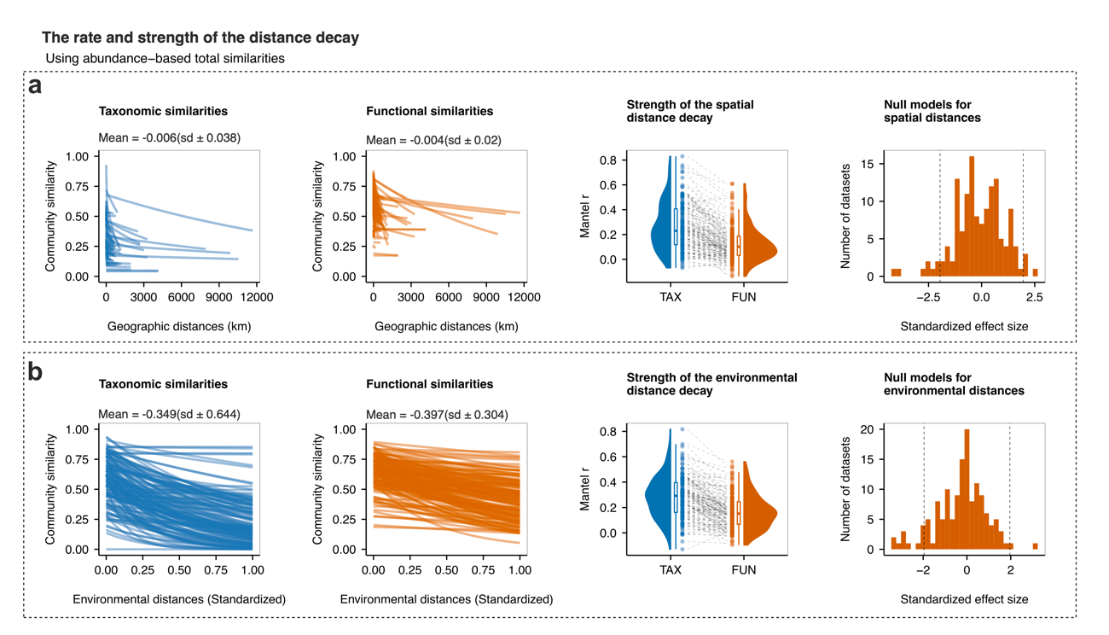
Figure S3.3. The distance decay along (a) spatial distance, and (b) environmental distance. The blue lines show the distance decay of taxonomic similarity while the orange lines show the distance decay of functional similarity. The first and second columns show the rate (slope) of the taxonomic and functional distance respectively, the third column shows the strength (mantel r) of the distance decay of taxonomic and functional similarities, and the fourth column shows the standardized effect sizes of the slopes of each dataset.
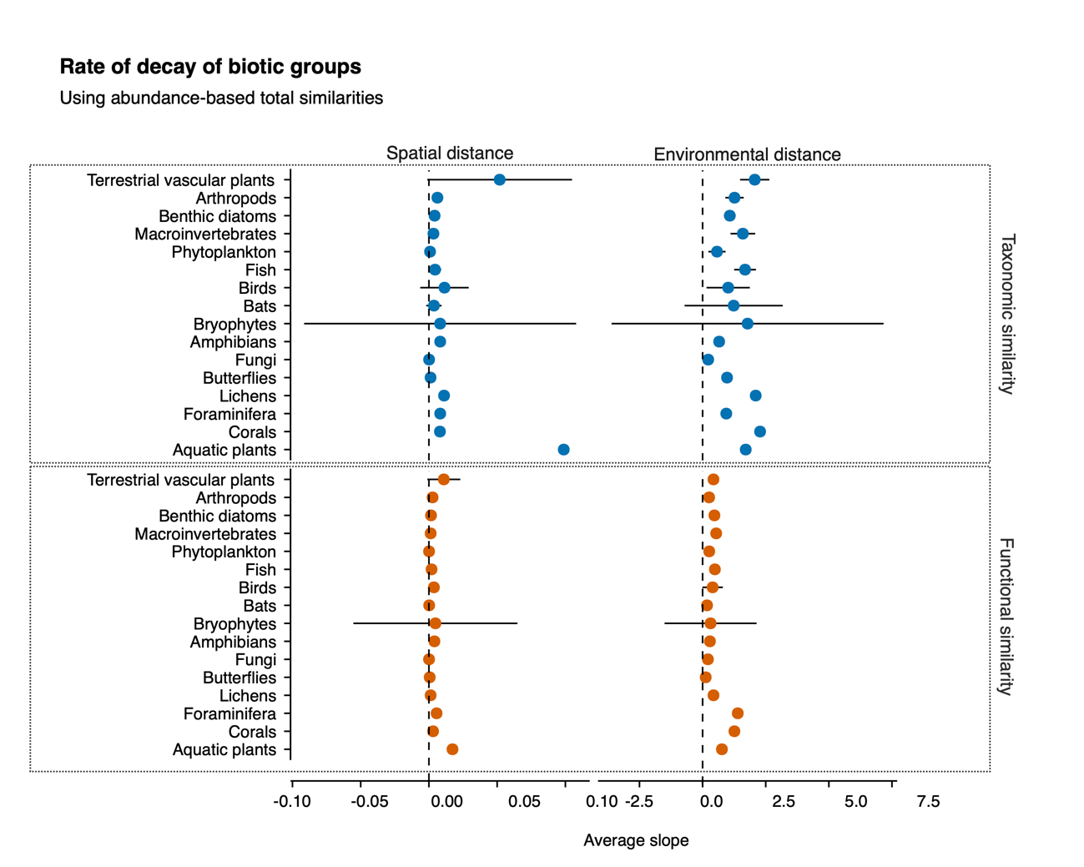
Figure S3.4. The average rate of decay of biotic groups using abundance data along spatial and environmental distances. The vertical dotted lines highlight the zero rate (absence of decay) and the horizontal lines indicate the 95% confidence interval of the mean. The blue circles show the rate of decay of taxonomic similarity while the orange circles show the rate of decay of functional similarity.
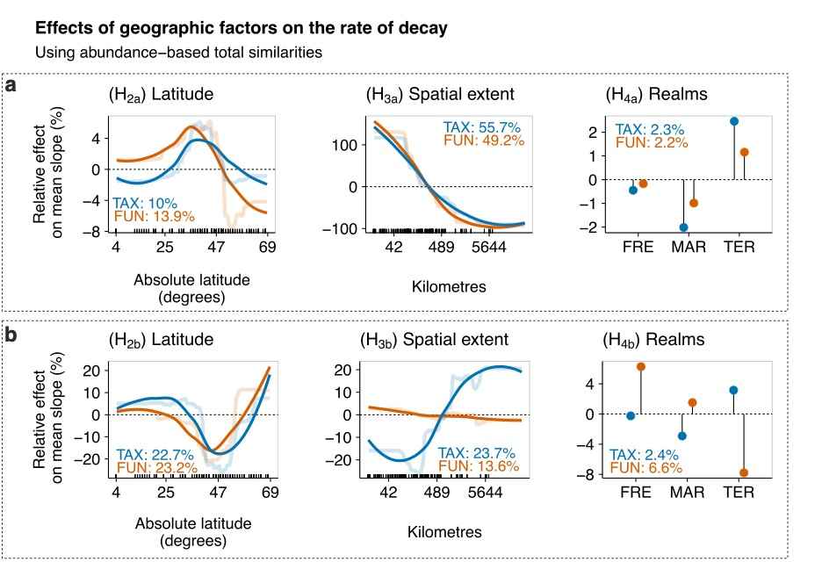
Figure S3.5. Relative effects (%) of the predictors on the mean slopes of spatial (a) and environmental (b) distance decay of the total component of taxonomic (TAX - blue) and functional (FUN - orange) similarities using abundance data across datasets. Partial dependence plots show the effects of a predictor variable on the response variable after accounting for the average effects of all other variables in the model. Positive values indicate an increase in the rate of decay (steeper slopes) compared to the mean rate whereas negative values indicate a decrease in the rate of decay (flatter slopes) compared to the mean rate. Semi-transparent lines represent the actual predicted effects; solid lines represent LOESS fits to predicted values from BRT. We show here only the variables related to the specific hypotheses, i.e., latitude, spatial extent, and realms (FRE = Freshwaters, MAR = Marine, TER = Terrestrial).
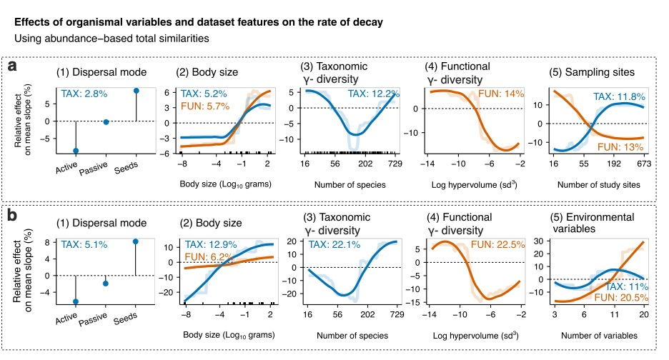
Figure S3.6. Relative effects (%) of the predictors on the rate of decay along spatial (a) and environmental (b) distance considering the total component of taxonomic (blue lines) and functional (orange lines) similarities using abundance data across datasets. Partial dependence plots show the effects of a predictor variable on the response variable after accounting for the average effects of all other variables in the model. Positive values indicate an increase in the rate of decay (steeper slopes) compared to the mean rate whereas negative values indicate a decrease in the rate of decay (flatter slopes) compared to the mean rate. Semi-transparent lines represent the actual predicted effects; solid lines represent LOESS fits to predicted values from BRT. We show here the organismal variables and the variables related to the dataset features.

