**Supporting information**

**Title :** **Alginate microgels** **encapsulation strategy of silver nanoparticles active against *Candida albicans***

Mélanie Marquis1,2*, Dafne Musino1, Valentin Gemin1, Laetitia Kolypczuk3, Delphine Passerini3, Isabelle Capron1*

1 INRAE, UR1268 Biopolymers Interactions and Assemblies, 44300 Nantes, France

2 Oniris, INRAE, UMR0703 Physiopathologie Animale et BioThérapie du muscle et du système nerveux, 44307 Nantes, France

3 Ifremer, MASAE Microbiologie Aliment Santé Environnement, 44000 Nantes, France

*Corresponding author: Mélanie Marquis, Oniris-INRAE, PAnTher. Email: [melanie.marquis@inrae.fr](mailto:melanie.marquis@inrae.fr)

**AgNP characterization**



**Figure S1.** AgNP size distributions of CNC/AgNP, ChiNC/AgNP and TChiNC/AgNP hybrids determined by image analysis.

**Microfluidic device**

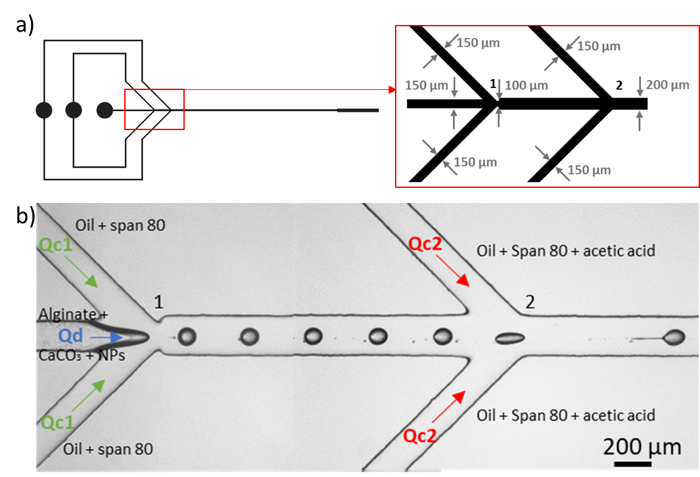

**Figure S2** : Scheme of the microfluidics flow-focusing device (FFD) used for the generation of alginate microparticles containing NPs. Scheme of the mask with dimensions : width of 150 µm for the dispersed phase (alginate) and for the continous phases (oil), of 100 µm for the restriction and of 200 µm for the central channel. The central channel had a length of 20 mm and the short exit channel had a width of 400 µm and a length of 5 mm. After photolithography and soft lithography steps, channels are rectangular in shape with a uniform depth of 130 µm.

**Antimicrobial activity**

**Table S1 :** Indicator strain characteristics used in this study. PA: Pathogens for aquaculture organisms; PH: Human pathogens or closely-related species: FS: species involved in food

