**Supplementary material**

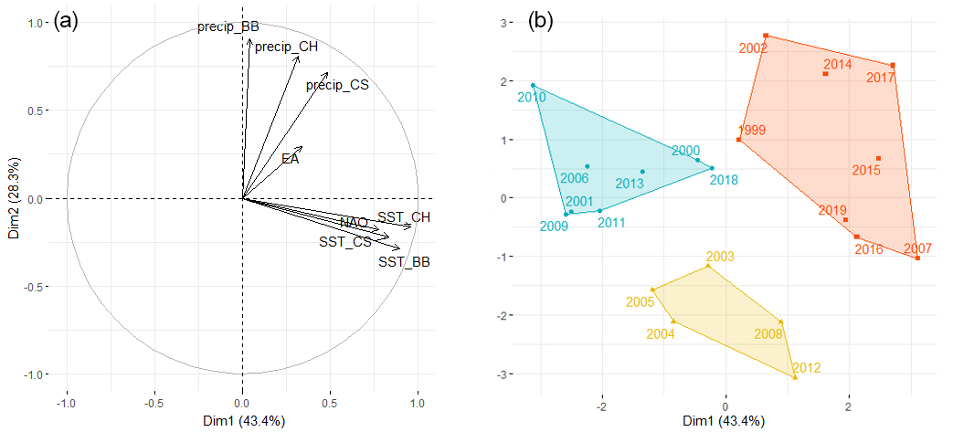

**Fig. A.1** PCA plots. a) Variable correlation plots, with “precip” being the precipitations in the Bay of Biscay (BB), English Channel (CH) and Celtic Sea (CS); “SST” the sea surface temperature and NAO and EA the atmospheric pressure index. b) Individuals (years) are regrouped by the HCPC in three clusters. The so-called “cold” years are in blue, “warm” in red and “dry” in yellow.