# Supporting information for: Tracing the fate of seabird-derived-nitrogen in a coral reef

1. **using nitrate and coral skeleton nitrogen isotopes**
2. **authors**: Choisnard N1, 2*+, Duprey NN1*+, Wald T1, Thibault M3,4, Houlbrèque F3, Foreman
3. AD1, Cuet P5, Guillaume MMM6,7, Vonhof H1, Sigman DM8, Haug GH1, Maguer JF9,
4. L’Helguen S9, Martínez-García A1++, Lorrain A9++

# Affiliations

1. 1Max Planck Institute for Chemistry (Otto Hahn Institute) Hahn-Meitner-Weg 1, 55128
2. Mainz, Germany.
3. 2Department of Biological Oceanography, Leibniz Institute for Baltic Sea Research
4. Warnemünde, Seestr. 15, 18119 Rostock, Germany.
5. 3UMR ENTROPIE (IRD—Université de La Réunion—CNRS—Université de la Nouvelle
6. Calédonie—Ifremer), Laboratoire d'Excellence Labex-CORAIL, Institut de Recherche pour
7. le Développement, BP A5, 98848 Nouméa Cedex, New Caledonia.
8. 4Centre d′Ecologie et des Sciences de la Conservation (CESCO), Museum national d′Histoire
9. naturelle, Station de Biologie Marine, 1 Place de La Croix, 29900
10. Concarneau, France.
11. 5UMR ENTROPIE (Université de La Réunion—IRD—CNRS—Université de la Nouvelle
12. Calédonie—Ifremer), Laboratoire d'Excellence Labex-CORAIL, Université de La Réunion,
13. CS 92003, 97744 St Denis Cedex 09, La Réunion, France.
14. 6UMR BorEA Muséum National d’Histoire Naturelle–SU–CNRS–IRD–UCN–UA,
15. Departement Aviv, 43 rue Cuvier, 75005 Paris, France.
16. 7LabEx CORAIL, 66860 Perpignan, France.
17. 8Department of Geosciences, Princeton University, Princeton, NJ, USA.
18. 9Univ Brest, CNRS, IRD, Ifremer, LEMAR, F-29280, Plouzané, France.

25

# Corresponding authors

1. N Choisnard contact information:
2. Email: [noemie.choisnard@io-warnemuende.de](mailto:noemie.choisnard@io-warnemuende.de)

29 phone: (+49)174 1944921

30

1. Nicolas N. Duprey contact information :
2. Email: [N.Duprey@mpic.de](mailto:N.Duprey@mpic.de)

33 phone: (+49)152 08911195

34

35 + These authors have contributed equally to this work and share first authorship

36 ++ These authors share senior/last authorship

37

38

1. Keywords: Seabird-derived-N, Coral Reef, Groundwater, N and O isotopes, Guano,
2. Nitrification, Coral Sea, Eparses Islands

41

42 **Table S1:** Table presenting the seabird populations at our three study sites.

|  |  |  |  |
| --- | --- | --- | --- |
|  | **Surprise** | **Tromelin** | **Grande**  **Glorieuse** |
| **Breeding seabird species** | Red-footed boobies (*Sula sula*), Masked boobies (*Sula dactylatra*), Brown boobies *(Sula leucogaster),*  Noddies (*Anous minitus, Anous stolidus*), Frigate birds (*Fregata* sp.),  Terns (*Sterna bergii*, *Sterna sumatrana*, *Sternula nereis*, *Gygis alba*, *Onychoprion fuscatus*),  Tropicbirds (*Phaeton lepturus*, *Phaeton rubicauda*),  Wedge-tailed shearwater (*Ardenna*  *pacifica*) (Spaggiari et al. 2007). | Red-footed boobies (*Sula sula*), Masked boobies (*Sula dactylatra),*  White tern *(Gygis alba)*, Brown boobies *(Sula leucogaster)* (Le Corre et al. 2015) | - |
| **Breeding pairs** | 14,000 (Thibault et al. 2022) | 2,000 (Le Corre et al. 2015) | - |
| **Area (km²)** | 0.3 | 1 | 7 |
| **Birds density**  **(pairs m-2)** | 47 | 2 | 0 |

43

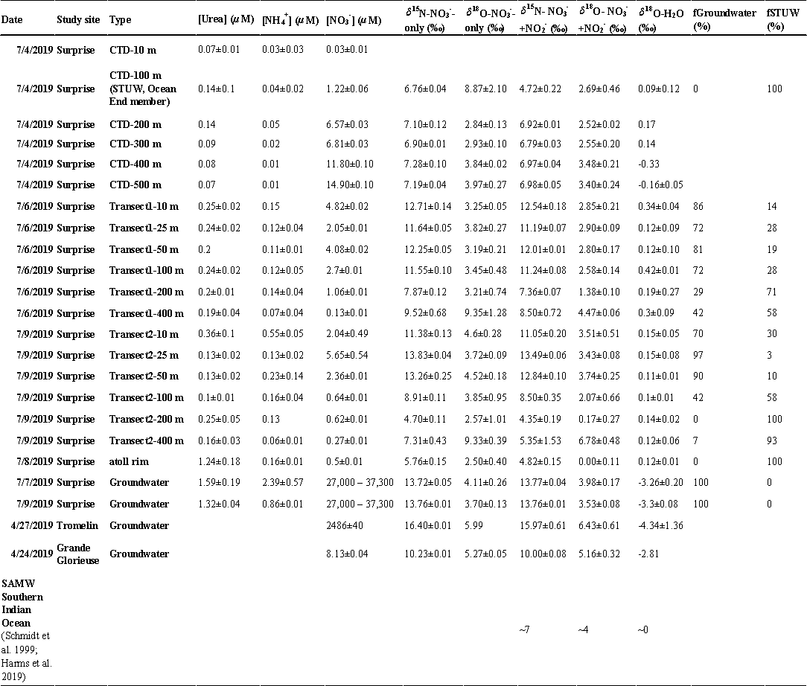

1. **Table S2:** Table compiling the water properties data used in this study. Urea, ammonium
2. [NH4+] and nitrate [NO3-] concentrations, *δ*15N, *δ*18O-NO3- and (NO3-+NO2-) and *δ*18O-H2O
3. from the different end-member considered in our mixing model and along transect. The
4. contribution of each defined end member to the *δ*15N-(NO3-+NO2-) observed at each site
5. along the transect is given per site and date and averaged between sampling dates in Fig. 6.

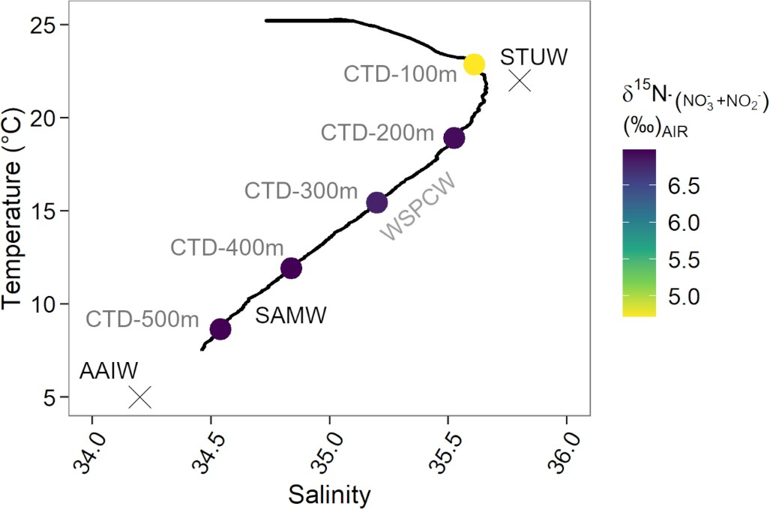49

1. **Fig. S1:** Temperature salinity plot offshore Surprise Island, Coral Sea. Several water masses
2. were identified in accordance with the literature (Emery 2003; Talley et al. 2011): below 500
3. m depth, the AntArctic Intermediate Water (AAIW) mixes with warmer, more saline waters
4. to form the SAMW (Sub-Antarctic Mode water). This latter water mass mixes with the
5. STUW (Sub-Tropical Upper Water), formed by subduction of thick winter mixed layer, to
6. create the WSPCW: Western South Pacific Central Water. The ocean-water end member used
7. in our mixing model corresponds to the STUW (see Fig.s 4 and 6).

# Text S1: Water masses identified offshore of Surprise Island

1. The main oceanic NO3--pool, by concentration, is the Subantarctic Mode Water (SAMW,
2. salinity of 34.6±0.2; 8.4±2.1 °C, Supporting Information Table. S3), identified at 500 m
3. depth, with a *δ*15N-NO3--only of 7.19±0.04 ‰ and a concentration of 14.90±0.10 *µ*M
4. (Supporting Information Table. S3). Low salinity, high nutrient SAMW originates from the
5. equatorward migration of Circumpolar Deep Water (CDW) subducted at the Subantarctic
6. Front (SAF) in the Southern Ocean (Rafter et al. 2013; Rafter and Sigman 2016). Diapycnal
7. mixing of SAMW with the warmer and fresher waters of the subducting North Caledonian Jet
8. (identified as the Subtropical Upper Water, STUW; 35.5-36.0 of salinity, 18.0-25.0 °C;
9. Supporting Information Table. S3), forms Western South Pacific Central Water (WSPCW;
10. Table 3) (Emery 2003; Gourdeau et al. 2008; Couvelard et al. 2008; Talley et al. 2011;
11. Kessler and Cravatte 2013; Cravatte et al. 2015). These water masses can be identified in a
12. temperature and salinity plot, which means that we can characterize their respective N
13. isotopic fingerprints in the Coral Sea for the first time.
14. **Table S3:** Table presenting the water masses identified in the Coral Sea and their
15. corresponding properties (See Supporting Information Fig. S1, Text S1).

|  |  |  |  |  |  |  |  |
| --- | --- | --- | --- | --- | --- | --- | --- |
| **Water mass** | **Layer/depth** | **Temperature (°C)** | **Salinity** | **[NO -] (*µ*M)**  **3** | ***δ*15N-NO - (‰)**  **3** | ***δ*18O-NO - (‰)**  **3** | ***δ*18O-H2O (‰)** |
| **STUW** | Upper  100-200 m | 18.0–25.0 | 35.50–36.00 | 1.22±0.01 | 6.76±0.04 | 8.87±2.1 | 0.1±0.1 |
| **WSPCW** | Upper  0–500 m | 6.0–22.0 | 34.50–35.80 | 6.56–11.80 | 6.90–7.35 | 2.75–3.85 | 0.1–0.2 |
| **SAMW** | Upper  0-600 m | 8.4±2.1 | 34.60± 0.20 | 11.80 - 14.90 | 7.23±0.08 | 3.90± 0.17 | -0.2±0.1 |
| **AAIW** | Intermediate 500-1200 m | 5.2±0.5 | 34.42±0.02 | 22.30±4.50 | 6.0±0.3 | - | - |

73

74

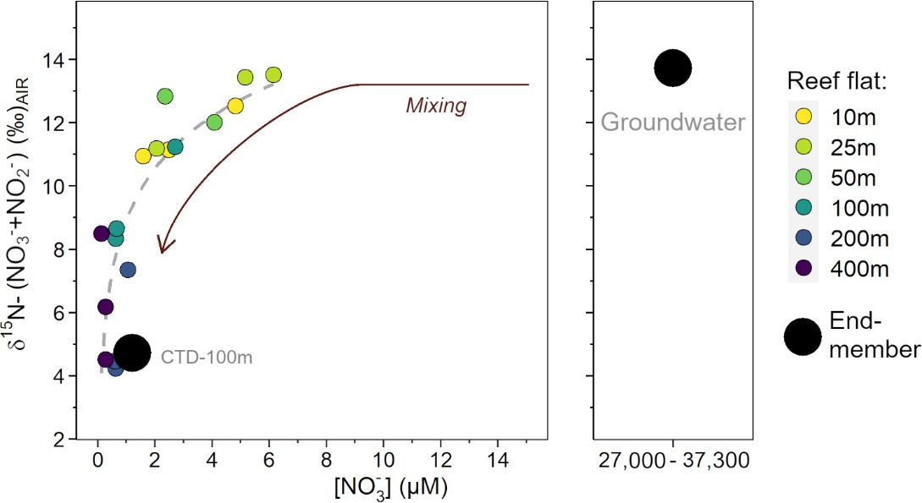75

1. **Fig. S2:** Plotting the seawater data in a *δ*15N-(NO3-+NO2-) vs NO3- concentrations space
2. highlights the various isotopic end-members (large black markers) present in the system and
3. the processes controlling the *δ*15N of (NO3-+NO2-) across the reef flat (solid circles, color is
4. based on the distance from shore). The large concentration difference between groundwater
5. and water on the reef hides the mixing between the groundwater and water from CTD-100 m
6. Subtropical Upper Water, STUW), the ocean end-member in our mixing model. The grey
7. dashed line models the curve resulting from the mixing of two sources of (NO3-+NO2-) with
8. different concentrations (log fit).

# Text S2: N transformations in the water column offshore of Surprise Island

1. The *δ*15N-(NO3-+NO2-) decrease observed below the mixed layer depth may indicate
2. that a portion of the (NO3-+NO2-) pool derives from the remineralization of newly fixed N, a
3. process most likely occurring on a regional basis (Liu et al. 1996; Karl et al. 2002; Knapp et
4. al. 2005). However, this *δ*15N decline is weaker after NO2- removal leaving the upper *δ*15N to
5. be only 0.4 ‰ lower relative to deep waters (Fig. 3), pointing to an additional overlapping
6. process occurring at 100 m. The elevation of *δ*18O-NO3- (to 8.87±2.10 ‰; Fig. 3) at 100 m
7. suggests a role for NO3- assimilation, but this process would also elevate the *δ*15N of NO3- and
8. (NO3-+NO2-) (Granger et al. 2004; Fawcett et al. 2015).
9. We suggest the following interpretation. The (NO3-+NO2-) in STUW has a low *δ*15N
10. (4.72±0.22 ‰) because of the remineralization of diazotrophic N. Upon exposure of this
11. water to the base of the euphotic zone, NO3- assimilation by phytoplankton raises the *δ*15N and
12. *δ*18O of the NO3- and (NO3-+NO2-) pools. The assimilated N is eventually exported and
13. regenerated back to NO2- and ultimately NO3-. However, at the time of sampling, the NO2--to-
14. NO3- oxidation was likely incomplete, resulting in the presence of low *δ*15N-NO2- in our
15. samples. This would explain why the low *δ*15N signature of diazotrophic N is not found in the
16. NO3- pool (Fig. 3). In this interpretation, the *δ*15N of the long term (NO3-+NO2-) supply to the
17. euphotic zone is approximately that of the *δ*15N of (NO3-+NO2-) at 100 m depth from the CTD
18. sampling, 4.72±0.22 ‰ (Fig. 3). Other offshore data also point to a *δ*15N-(NO3-+NO2-) decline
19. upward through the shallow thermocline (Yoshikawa et al. 2015), consistent with our
20. interpretation of the oceanic (NO3-+NO2-) supply to Surprise Atoll.

# Text S3: Seabird density and groundwater N properties

1. The link between seabird density and the properties of the groundwater for a given
2. tropical island may yield insight into the role of seabird population in shaping the size of the
3. NO3- reservoir of the water table. There is not much existing information regarding the NO3-
4. concentration or the dual isotopic composition of NO3- for the groundwater of tropical islands;
5. our measurements represent the first observations of these parameters across three islands of
6. varying seabird density: Grande Glorieuse and Tromelin (Eparses Islands, Western Indian
7. Ocean; Fig. 1) and Surprise (Western Pacific Ocean). The groundwater at Grande Glorieuse,
8. where the seabird population was eradicated by the introduction of rats (Russell and Le Corre
9. 2009), provides a comparison for the two other locations. Glorieuse groundwater (NO3- =

115 8.13±0.01 *µ*M; *δ*15N-NO3- = 10.23±0.01 ‰; *δ*18O-NO3- = 5.27±0.05 ‰) had NO3-

1. concentrations around 300 and more than 4,000 times lower than Tromelin and Surprise,
2. respectively (Fig. 5). The trend is consistent with the higher bird density found at Surprise (20
3. times that of Tromelin), suggesting that seabird density contributes to NO3- concentration in
4. the groundwater of tropical islands. The *δ*15N-NO3- of groundwater turned out to be a less
5. robust indicator of the seabird population, with values found at the seabird nesting islands
6. (Tromelin and Surprise) higher by 3 and 6 ‰ respectively, relative to bird-less island (Grande
7. Glorieuse) (Fig. 6). The decoupling between isotopic fractionation and NO3- concentration
8. supports the hypothesis of an isotopic enrichment driven by an abiotic process (i.e., NH3
9. volatilization), while the build-up of NO3- in the groundwater appears to be mainly controlled
10. by the supply of N (i.e., bird density).
11. In addition to bird density, differences in breeding seabird species nesting on the island might
12. play a role in governing the N inputs to the island. While Surprise and Tromelin Islands host
13. similar seabird species, noddies and wedge-tailed shearwaters were only found on Surprise
14. Island (Supporting Information Table S1). These species are thought to be responsible for
15. higher N inputs relative to other species (Staunton Smith and Johnson 1995; Graham et al.
16. 2018). However, observations regarding seabird density and species distribution do not seem
17. to govern groundwater concentration of NO3- everywhere. For instance, Heron Island supports
18. a healthy population of noddies and wedge-tailed shearwaters and has a seabird density 5
19. times higher than that of Surprise Island, but has a groundwater NO3- concentration that is 15
20. times lower (Staunton Smith and Johnson 1995; McMahon and Santos 2017). These
21. observations indicate that the relationship between seabird population and groundwater
22. properties may be affected by local variables beyond the seabird species, such as water
23. retention time, island topography, climatology and land-use changes.

# Text S4: Potential routes for explaining elevated *δ*15N of guano

1. The elevated *δ*15N values of guano have been hypothesized to not only arise from the
2. trophic level or the diet of seabirds, but also from the strong isotopic effects associated with
3. abiotic NH3 volatilization, varying from 24.5 ‰ to 60 ‰, (Högberg 1997; Robinson 2001;
4. Bedard-Haughn et al. 2003). These strong isotopic effects are due to the propensity of NH3 to
5. volatilize at elevated temperatures, high wind speeds and frequent but small volumes of rain
6. (Demmers et al. 1998; Riddick et al. 2014, 2017). The average annual air temperature (25 °C),
7. humidity (75 %) and the prevailing Easterly winds in the Coral Sea suggest that the conditions
8. for NH3 volatilization are met at Surprise Island. Abiotic fractionation of NH3 due to
9. volatilization thus helps explaining the observed N isotopic enrichment of the guano with age
10. (from 7 ‰ to 18 ‰), as well as the broad range in guano-*δ*15N values observed between
11. studies of similar islands (9.9 ‰ at Heron Island, 13.9 ‰ on Palmyra Atoll, up to 18 ‰ on
12. Reynard Islet; Schmidt et al. 2004; Young et al. 2010; Lorrain et al. 2017).
13. The moderate *δ*15N elevation in the groundwater NO3- observed at Surprise Island,
14. relative to the strong isotopic effect of NH3 volatilization also appears to apply to other
15. seabird nesting islands with similar environmental contexts. For instance, we found elevated
16. NO3- concentrations (2500 *µ*M) and moderate *δ*15N-NO3--only values (16.40±0.01 ‰, Fig. 5;
17. Supporting Information Table S2) at Tromelin Island. The consistency of this pattern suggests
18. that NH3 volatilization is incomplete on both islands, which would enable the transfer of
19. remaining NH4+ from the soil layer quickly into the water table of the island where NH3
20. volatilization is suppressed. Depending on the topography of the island and the vegetation
21. cover, the magnitude of NH3 volatilization may vary, which would partly explain the range in
22. groundwater *δ*15N-NO3- values and NO3- concentrations observed across the different islands

164 (Fig. 5).

165

# References

1. Bedard-Haughn, A., J. W. van Groenigen, and C. van Kessel. 2003. Tracing 15N through
2. landscapes: potential uses and precautions. Journal of Hydrology **272**: 175–190.

169 doi:10.1016/S0022-1694(02)00263-9

1. Couvelard, X., P. Marchesiello, L. Gourdeau, and J. Lefèvre. 2008. Barotropic Zonal Jets
2. Induced by Islands in the Southwest Pacific. Journal of Physical Oceanography **38**: 2185–

172 2204. doi:10.1175/2008JPO3903.1

1. Cravatte, S., E. Kestenare, G. Eldin, A. Ganachaud, J. Lefèvre, F. Marin, C. Menkes, and J.
2. Aucan. 2015. Regional circulation around New Caledonia from two decades of observations.

175 Journal of Marine Systems **148**: 249–271. doi:10.1016/j.jmarsys.2015.03.004

1. Demmers, T. G. M., L. R. Burgess, J. L. Short, V. R. Phillips, J. A. Clark, and C. M. Wathes.
2. 1998. First experiences with methods to measure ammonia emissions from naturally
3. ventilated cattle buildings in the U.K. Atmospheric Environment **32**: 285–293.

179 doi:10.1016/S1352-2310(97)00197-0

1. Emery, W. J. 2003. Ocean circulation | Water types and water masses, p. 1556–1567. *In*
2. Encyclopedia of Atmospheric Sciences. Elsevier.
3. Fawcett, S. E., B. B. Ward, M. W. Lomas, and D. M. Sigman. 2015. Vertical decoupling of
4. nitrate assimilation and nitrification in the Sargasso Sea. Deep Sea Research Part I:
5. Oceanographic Research Papers **103**: 64–72. doi:10.1016/j.dsr.2015.05.004
6. Gourdeau, L., W. S. Kessler, R. E. Davis, J. Sherman, C. Maes, and E. Kestenare. 2008.
7. Zonal jets entering the Coral Sea. Journal of Physical Oceanography **38**: 715–725.

187 doi:10.1175/2007JPO3780.1

1. Graham, N. A. J., S. K. Wilson, P. Carr, A. S. Hoey, S. Jennings, and M. A. MacNeil. 2018.
2. Seabirds enhance coral reef productivity and functioning in the absence of invasive rats.

190 Nature **559**: 250–253. doi:10.1038/s41586-018-0202-3

1. Granger, J., D. M. Sigman, J. A. Needoba, and P. J. Harrison. 2004. Coupled nitrogen and
2. oxygen isotope fractionation of nitrate during assimilation by cultures of marine

193 phytoplankton. Limnol. Oceanogr. **49**: 1763–1773. doi:10.4319/lo.2004.49.5.1763

194 Högberg, P. 1997. Tansley Review No. 95 15N natural abundance in soil–plant systems. The

195 New Phytologist **137**: 179–203. doi:10.1046/j.1469-8137.1997.00808.x

1. Karl, D., A. Michaels, B. Bergman, and others. 2002. Dinitrogen fixation in the world’s
2. oceans, p. 47–98. *In* E.W. Boyer and R.W. Howarth [eds.], The nitrogen cycle at regional to
3. global scales. Springer Netherlands.
4. Kessler, W. S., and S. Cravatte. 2013. Mean circulation of the Coral Sea. J. Geophys. Res.

200 Oceans **118**: 6385–6410. doi:10.1002/2013JC009117

1. Knapp, A. N., D. M. Sigman, and F. Lipschultz. 2005. N isotopic composition of dissolved
2. organic nitrogen and nitrate at the Bermuda Atlantic Time-series Study site. Global

203 Biogeochem. Cycles **19**. doi:10.1029/2004GB002320

1. Le Corre, M., D. K. Danckwerts, D. Ringler, M. Bastien, S. Orlowski, C. Morey Rubio, D.
2. Pinaud, and T. Micol. 2015. Seabird recovery and vegetation dynamics after Norway rat
3. eradication at Tromelin Island, western Indian Ocean. Biological Conservation **185**: 85–94.

207 doi:10.1016/j.biocon.2014.12.015

1. Liu, K.-K., M.-J. Su, C.-R. Hsueh, and G.-C. Gong. 1996. The nitrogen isotopic composition
2. of nitrate in the Kuroshio Water northeast of Taiwan: evidence for nitrogen fixation as a
3. source of isotopically light nitrate. Marine Chemistry **54**: 273–292. doi:10.1016/0304-

211 4203(96)00034-5

1. Lorrain, A., F. Houlbrèque, F. Benzoni, and others. 2017. Seabirds supply nitrogen to reef-
2. building corals on remote Pacific islets. Sci Rep **7**: 3721. doi:10.1038/s41598-017-03781-y
3. McMahon, A., and I. R. Santos. 2017. Nitrogen enrichment and speciation in a coral reef
4. lagoon driven by groundwater inputs of bird guano. J. Geophys. Res. Oceans **122**: 7218–

216 7236. doi:10.1002/2017JC012929

1. Rafter, P. A., P. J. DiFiore, and D. M. Sigman. 2013. Coupled nitrate nitrogen and oxygen
2. isotopes and organic matter remineralization in the Southern and Pacific Oceans: Nitrate
3. Isotopes and Remineralization. J. Geophys. Res. Oceans **118**: 4781–4794.

220 doi:10.1002/jgrc.20316

1. Rafter, P. A., and D. M. Sigman. 2016. Spatial distribution and temporal variation of nitrate
2. nitrogen and oxygen isotopes in the upper equatorial Pacific Ocean. Limnol. Oceanogr. **61**:

223 14–31. doi:10.1002/lno.10152

1. Riddick, S. N., T. D. Blackall, U. Dragosits, and others. 2014. Measurement of ammonia
2. emissions from tropical seabird colonies. Atmospheric Environment **89**: 35–42.

226 doi:10.1016/j.atmosenv.2014.02.012

1. Riddick, S. N., T. D. Blackall, U. Dragosits, and others. 2017. High temporal resolution
2. modelling of environmentally-dependent seabird ammonia emissions: Description and testing
3. of the GUANO model. Atmospheric Environment **161**: 48–60.

230 doi:10.1016/j.atmosenv.2017.04.020

231 Robinson, D. 2001. *δ*15N as an integrator of the nitrogen cycle. Trends in Ecology &

232 Evolution **16**: 153–162. doi:10.1016/S0169-5347(00)02098-X

1. Russell, J. C., and M. L. Le Corre. 2009. Introduced mammal impact on seabirds in the iles
2. eparses, Western Indian Ocean. Marine Ornithology **37**: 121–129.
3. Schmidt, S., W. C. Dennison, G. J. Moss, and G. R. Stewart. 2004. Nitrogen ecophysiology of
4. Heron Island, a subtropical coral cay of the Great Barrier Reef, Australia. Functional Plant

237 Biol. **31**: 517–528. doi:10.1071/fp04024

1. Spaggiari, J., N. Barré, J. Baudat-Franceschi, and P. Borsa. 2007. New Caledonian seabirds.
2. Payri CE, Richer de Forges B., Compendium of marine species from New Caledonia.
3. Documents Scientifiques et Techniques **7**: 415–428.
4. Staunton Smith, J., and C. Johnson. 1995. Nutrient inputs from seabirds and humans on a
5. populated coral cay. Mar. Ecol. Prog. Ser. **124**: 189–200. doi:10.3354/meps124189
6. Talley, L. D., G. L. Pickard, and W. J. Emery, eds. 2011. Descriptive physical oceanography:
7. an introduction, 6th ed. Academic Press.
8. Thibault, M., F. Houlbreque, N. N. Duprey, and others. 2022. Seabird-derived nutrients
9. supply modulates the trophic strategies of mixotrophic corals. Front. Mar. Sci. **8**: 790408.

247 doi:10.3389/fmars.2021.790408

1. Yoshikawa, C., A. Makabe, T. Shiozaki, S. Toyoda, O. Yoshida, K. Furuya, and N. Yoshida.
2. 2015. Nitrogen isotope ratios of nitrate and N* anomalies in the subtropical South Pacific.

250 Geochem. Geophys. Geosyst. **16**: 1439–1448. doi:10.1002/2014GC005678

1. Young, H. S., D. J. McCauley, R. B. Dunbar, and R. Dirzo. 2010. Plants cause ecosystem
2. nutrient depletion via the interruption of bird-derived spatial subsidies. Proc. Natl. Acad. Sci.

253 U.S.A. **107**: 2072–2077. doi:10.1073/pnas.0914169107