Supplementary methods

Data description
We cleaned both LOG and NOP datasets by removing all fishing sets outside of the EEZ or showing inconsistencies (e.g., all sets with at least 100 marketable fish discarded, as well as any set with more fish caught than hooks set, too few hooks, indicating 500 sharks bycaught in one night). If the number of hooks was lacking, we used the average number of hooks stated for the reported amount of buoys.
For annual analyses, we only kept completely observed years, excluding 2018 in both datasets and 2002 from the observer dataset.
Table S1. Annual numbers of sets reported by captains and observers.
Years | 2000 | 2001 | 2002 | 2003 | 2004 | 2005 | 2006 | 2007 | 2008 | 2009
LOG | 4 667 | 4 272 | 4 325 | 6 259 | 7 151 | 5 772 | 5 975 | 5 429 | 5 753 | 5 559
NOP | - | - | 66 | 138 | 178 | 131 | 221 | 94 | 186 | 422

Years | 2010 | 2011 | 2012 | 2013 | 2014 | 2015 | 2016 | 2017 | 2018
LOG | 5 444 | 5 776 | 6 303 | 7 483 | 7 808 | 8 980 | 9 120 | 8 895 | 5 402
NOP | 430 | 317 | 394 | 415 | 393 | 304 | 273 | 394 | 15

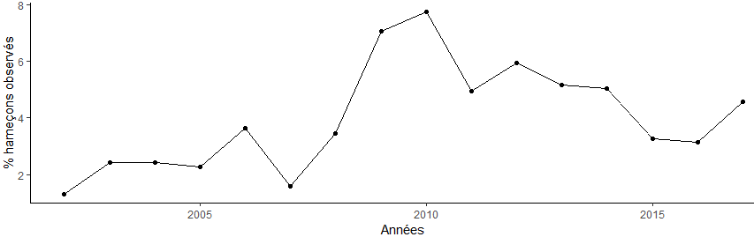
Figure S1. Proportion of hooks reported by observers.

Comparing data reported by observers and captains, and onboard observations
  - Reporting catch and bycatch
Table S2. Catch categories and associated species.
Category | SPECIES
Tuna | Thunnus alalunga, Thunnus obesus, Thunnus orientalis, Thunnus maccoyii  Thunnini, Thunnus albacares
marketable | Istiophoridae, Euthynnus lineatus, Makaira indica, Bramidae, Makaira nigricans, Scomberomorus commerson, Coryphaena hippurus, Gymnosarda unicolor, Lampris guttatus, Epinephelus malabaricus, Tetrapturus audax,  Brama brama, Paralepididae, Istiophorus platypterus, Katsuwonus pelamis,  Allothunnus fallai, Tetrapturus angustirostris, Xiphias gladius, Nototodarus sloanii, Acanthocybium solandri, Seriola lalandi
Non-marketable (rejected) | Theragra chalcogramma, Aluterus scriptus, Alepisaurus ferox, Seriola dumerili, Seriola spp, Assurger anzac, Sphyraena jello, Sphyraena spp, Platax spp, Trichiuridae, Etelis carbunculus, Sphyraena barracuda, Rexea solandri, Gempylidae, Gempylus serpens, Gnathanodon speciosus, Lepidocybium flavobrunneum, Lagocephalus lagocephalus, Lobotes surinamensis, Acanthopagrus berda, Mola mola, Nesiarchus nasutus, Ruvettus pretiosus,  Ommastrephidae, Sardina pilchardus, Promethichthys prometheus, Regalecidae, Elagatis bipinnulata, Ammodytes spp, Cololabis saira, Scomberesocidae, Lepidopus caudatus, Thyrsites atun, Lutjanidae, Spratelloides delicatulus, Sprattus sprattus, Thyrsitoides marleyi, Trachipteridae, Polyprion oxygeneios
sharks | Carcharhinus albimarginatus, Alopias vulpinus, Carcharhinus amblyrhynchos, Carcharhinus melanopterus, Carcharhinus altimus, Carcharhinus brachyurus, Prionace glauca, Carcharhinus galapagensis, Carcharhinus limbatus, Carcharhinus plumbeus, Carcharhinus obscurus, Carcharhinus falciformis, Isistius brasiliensis, Isurus paucus, Isurus spp, Metanephrops andamanicus, Carcharhinus longimanus, Odontaspis noronhai, Pseudocarcharias kamoharai, Alopias pelagicus, Rhincodon typus, Dalatias licha, Selachimorpha (Pleurotremata), Isurus oxyrinchus, Sphyrna mokarran, Sphyrna lewini, Sphyrna zygaena, Zameus squamulosus, Alopias spp, Carcharodon carcharias
Odontocetes | Delphinidae, Stenella spp, Lagenorhynchus obliquidens, Pseudorca crassidens, Phocoenoides dalli, Globicephala macrorhynchus, Phocaena dioptrica

Because boarding revealed that some species were incorrectly identified or reported, we compared the data from the NOP and LOG datasets (see table S2 for the species considered as marketable fish).
To compare the marketable fish reported, we calculated the CPUE for both datasets, for a given set i (excluding rejected fish):
$$\begin{aligned}{CPUE}_{i}=\frac{marketable {fish}_{i}}{{hooks}_{i}} \#\left(A.1\right)\end{aligned}$$
Only a few bycaught odontocetes were reported, so we manually compared catches reported in the two datasets. We calculated the relative difference for each set, for CPUE, used as a control, and sharks bycaught:
$$\begin{aligned}{Relative difference}_{ij}=\frac{x_{ijNOP}-x_{ijLOG}}{x_{ijNOP}+x_{ijLOG}} \#\left(A.2\right)\end{aligned}$$
Where 𝑥𝑖𝑗 the number reported for item j (i.e., CPUE or shark catch) in each set i. A positive relative difference indicated higher reporting by observers than by captains.
Significant differences were also found for other species: the bycatch of species of conservation interest reported by the observers were absent from the captains logbooks (75 birds, 15 turtles and 9 odontocetes). Reports of sharks (figure S3) and stingrays differ in both directions (though differences can arise from catch reported as “unspecified” by captains). Differences were observed during boarding: non-marketable species (whether discarded or kept by the crew) or birds were not recorded in the fishing logbook.

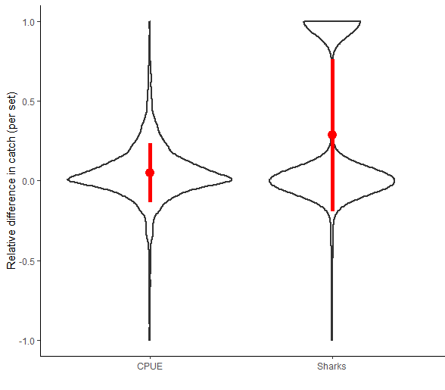
Figure S2. Relative differences for sets reported both in LOG and NOP datasets, for the CPUE and sharks. The red dot represents the mean with its standard deviation. A positive difference indicated more reporting by observers, while a negative difference corresponded to a higher value reported by captains.
  - Onboard observations
During boarding with two captains and three different crews, we reported all animal caught, with a verification of shark species (by an expert using photos taken on board).
Table S3. Comparison for the three onboard campaigns with J. Biquet on board. A negative difference indicated more sharks reported by captains. No odontocete were bycaught. ‘Other sharks’ include sharks that freed themselves before being clearly identified, including two thresher sharks and three unidentified sharks (likely silky sharks).
Boardings |  | Oceanic whitetip | blue shark | silky shark | Other sharks
1 | AUTHOR | 8 | 28 | 0 | 0
 | CAPTAIN 1 | 8 | 28 | 0 | 0
 | DIFFERENCE | 0 | 0 | 0 | 0
2 | AUTHOR | 1 | 2 | 0 | 4
 | CAPTAIN 1 | 1 | 2 | 0 | 3
 | DIFFERENCE | 0 | 0 | 0 | 1
3 | AUTHOR | 9 | 7 | 4 | 1
 | CAPTAIN 2 | 9 | 12 | 16 | 0
 | DIFFERENCE | 0 | -5 | -12 | 1

Quantifying depredation
  - Additional depredation indices, reported by observers (NOP)
Table S4. Number of fish depredated by set, damaged by A. odontocetes, and B. sharks.
 | A. Odontocetes
Number of fish depredated per set |  | 0 | 1 | 2-4 | 5-7 | 8-10 | 11-13 | 14-16 | 17 – 19 | 20 - 23 | >8
Number of sets |  | 4084 | 175 | 82 | 16 | 8 | 7 | 3 | 4 | 3 | 25
% among sets with depredation |  | - | 58.73% | 27.52% | 5.37% | 2.69% | 2.35% | 1% | 1.34% | 1% | 8.39%
 | B. Sharks
Number of fish depredated per set |  | 0 | 1 | 2-4 | 5-7 | 8-10 | 11-13 | 14-16 | 17 – 19 | 20 - 23 | >8
Number of sets |  | 3335 | 737 | 274 | 29 | 4 | 2 | 2 | 0 | 1 | 9
% among sets with depredation |  | - | 70.26% | 26.12% | 2.77% | 0.38% | 0.19% | 0.19% | 0% | 0.1% | 0.86%

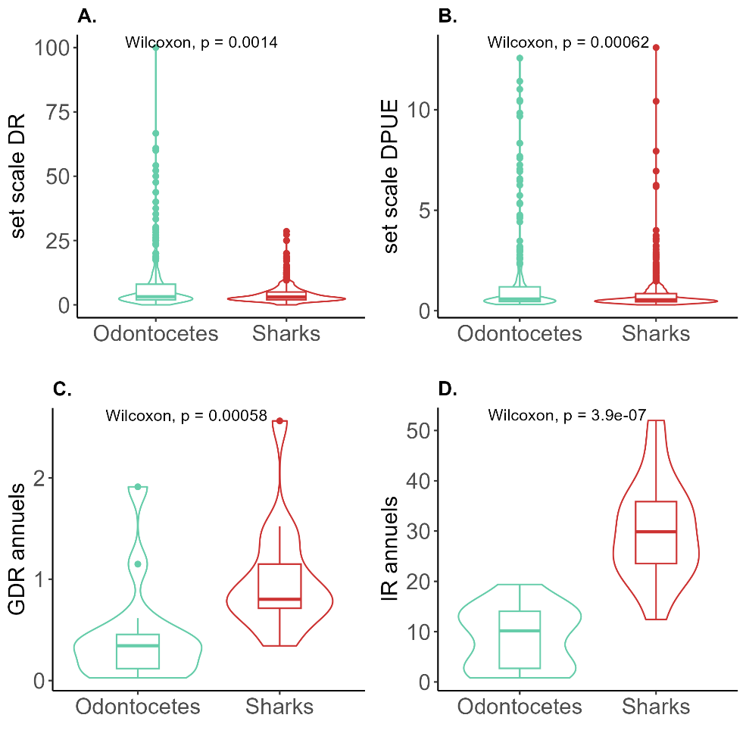
Figure S3. Pair comparison (Wilcoxon tests) of set-scale DR and DPUE, annual GDR and annual IR between shark and odontocete depredation.
  - Depredation reported by captains
We compared the reported depredated fish by observers to the “pilot whales or dolphins” box ticked by captains (for the period 2016-2018). The crew was not asked to identify odontocetes seen around the vessel. Captains could record the number of damaged fish, although because there was no allocated space in the logbook then formatted in the database, it would not be available in the database.
Since 2016, captains ticked the box 2,403 times, the annual interaction remained around 2% (1.3% in 2016, 2.5% in 2018; 461 sets in total out of 22,956 sets since 2016). It is difficult to assess whether there is an increase in depredation (as the odontocetes interaction rate reported by the observers also slightly increased, figure 1), or if it is due to the standardization of the use of this checkbox by captains. These sets were located all over the EEZ, and not only in the Marquesas archipelago were observers (Figure 2) reported higher rates of depredation.
In that period, observers reported 665 sets, where they have described 39 sets with odontocete-depredated fish; only one corresponded to a odontocete report in the fishing logbooks (box «Pilot whale/Dolphin” checked). In addition, captains reported their presence for nine sets, for which observers reported no depredated fish, so either no depredation occurred or no evidence is visible, suggesting that captains used the box as an indicator of odontocete presence. The meaning of this box therefore remained unclear.
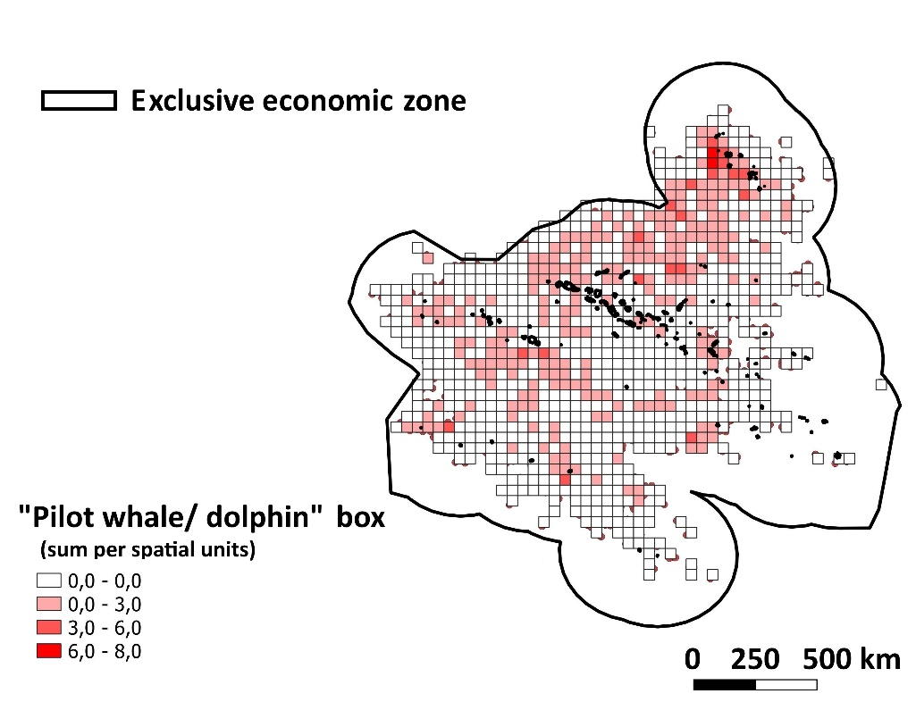
Figure S4. Spatial distribution of sets with the “pilot whales or dolphins” box ticked by captains.
  - Correlation between DPUE and CPUE
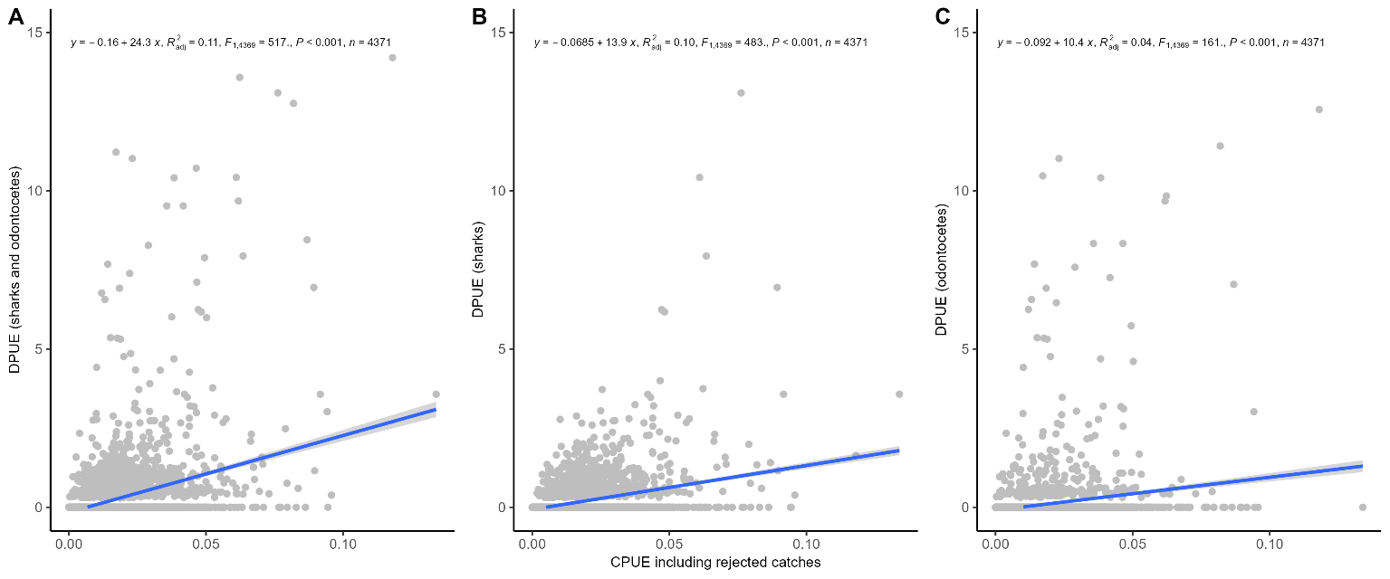
Figure S5. Correlations between DPUE and CPUE (included all rejected fish, not only due to depredation) indices, for DPUEs including depredated fish A. by both sharks and odontocetes, B. by sharks and C. by odontocetes.

Odontocete and shark bycatch
  - Species, discard rates and release conditions
Figure S6. Number of sharks retained and released over time, according to fishers (LOG) and observers (NOPs). The changes in legislation are indicated with red arrows (prohibition of retention of any sharks but makos, 2012 prohibition of mako retention) There is a strong change in shark retention after 2005/2006 (when the majority of sharks got protected). A small amount is still retained according to the captains. Only most commonly species are shown (other species are indicated as “other species”).
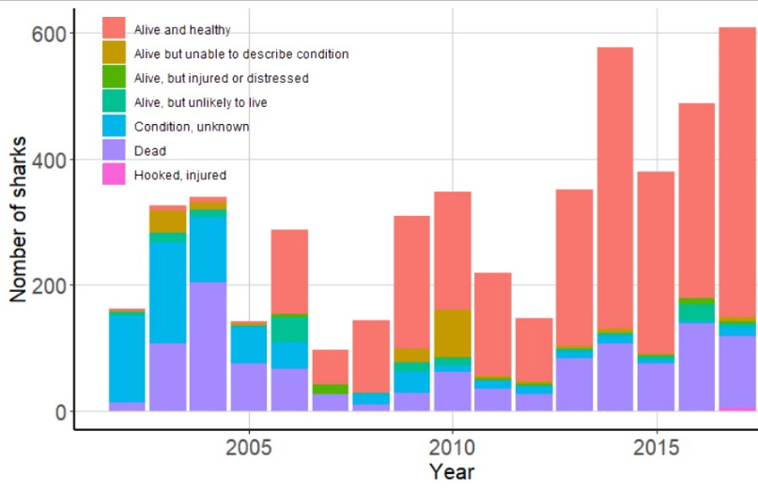
Figure S7. Conditions of discarded sharks over time as reported by observers.

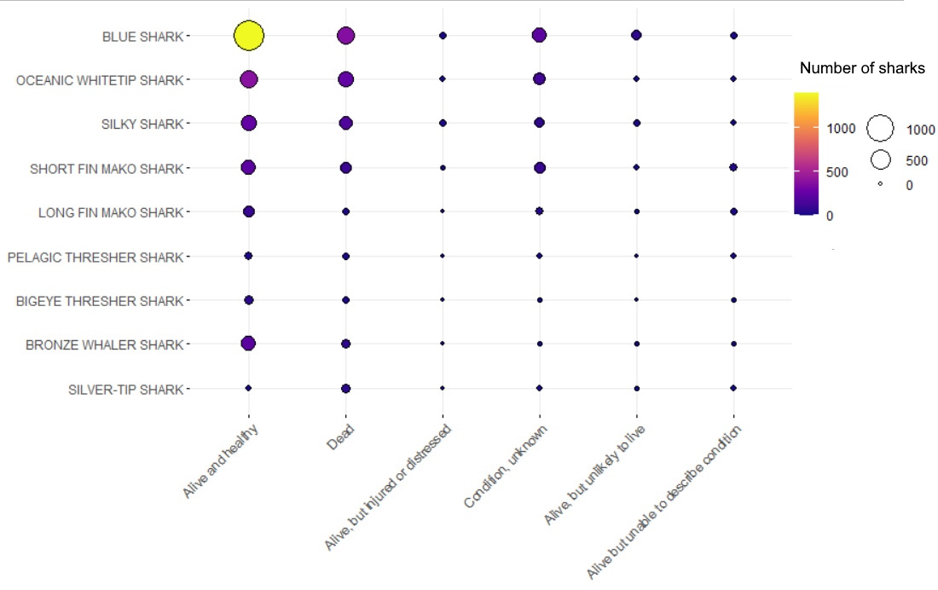
Figure S8. Condition of released sharks by species (only species with more than 50 captures are shown for clarity). Most sharks (57%) are released alive (23% dead, and 13% unknown, out of the total bycatch of these species). Blue sharks represent the vast majority of the bycatch. Copper (bronze whaler), bigeye thresher and blue sharks were more frequently recovered alive than other species (73%, 67% and 67% of them were discarded alive, respectively). Silver-tip sharks are mostly discarded dead (58%, though they were rarely caught), with silky (32%), oceanic whitetip (31%) and pelagic thresher (25%) sharks.

Table S5. Shark bycatch data reported in NOP (in grey cells; 4,947 sharks) and LOG (in white cells; 122,610 sharks). Only commonly caught species are shown (at least 50 individuals for NOP and 300 for LOG). For each species, the number of bycaught individuals, the percentage out of total shark bycatch, and the percentage of individual retained is given. For NOP data, we give the percentage of alive individuals when caught (out of the sharks with known condition) and when discarded (if not retained). Minimum and maximum annual bycatch considers completely monitored years (NOP: excluding 2002 and 2018; LOG: excluding 2018). Some species (ª) appeared not to have been monitored before 2012-2014 (Figure 2) by captains, so their minimum and maximum value are based on the 2014-2017 period. Non-identified species and unidentified mako sharks (^{b}) were reported as such until 2014, so their extreme annual values are given for the 2000-2014 time interval.
 | % total shark bycatch (number) | % retained | % alive when caught¹ | % alive when discarded † | Annual min & max
BLUE SHARK  Prionace glauca | 42.25% (2,090) | 0.86% | 84.82% | 76.45% | 44 - 271
 | 12.2% (29,908) | 0% | - | - | 2,382 - 8,514 ª
OCEANIC WHITETIP SHARK  Carcharhinus longimanus | 16.23% (803) | 1.12% | 66.27% | 61.19% | 14 - 122
 | 8.87% (21,747) | 0% |  |  | 991 - 7,566 ª
SILKY SHARK  Carcharhinus falciformis | 11.16% (552) | 1.63% | 61.64% | 59.29% | 2 - 166
 | 2.22% (5,442) | 0% | - | - | 49 - 1,937 ª
SHORT FIN MAKO SHARK  Isurus oxyrinchus | 9.88% (489) | 17.18% | 63.23% | 69.05% | 30,437
 | 1.30% (3,198) | 0% | - | - | 338 - 1,011 ª
COPPER SHARK  Carcharhinus brachyurus | 5.84% (289) | 0.35% | 70.43% | 75.26% | 6 - 91
 | - | - | - | - | -
LONG FIN MAKO SHARK  Isurus paucus | 3.76% (186) | 15.59% | 73.84% | 79.59% | 1 - 54
 | - | - | - | - | -
SILVER-TIP SHARK  Carcharhinus albimarginatus | 1.98% (98) | 8.16% | 39.80% | 26.19% | 1 - 50
 | - | - | - | - | -
BIGEYE THRESHER SHARK  Alopias superciliosus | 1.92% (95) | 4.21% | 86.44% | 77.53% | 1 - 29
 | - | - | - | - | -
PELAGIC THRESHER SHARK  Alopias pelagicus | 1.52% (75) | 1.33% | 75.0% | 69.70% | 2 - 13
 | - | - | - | - | -
THRESHER SHARK  Alopias vulpinus | - | - | - | - | -
 | 0.57% (1,405) | 0% | - | - | 87 - 456 ª
UNIDENTIFIED MAKO SHARK  Isurus spp | - | - | - | -
 | 1.90% (4,650) | 99.74% | - | - | 21 - 746 ^{b}
BLACKTIP REEF SHARK  Carcharhinus melanopterus | 1.11% (55) | 0% | 40% | 26.42% | 2 - 49
 | - | - | - | - | -
OTHER SPECIES | 4.35% (215) | 6.05% | 72.06% | 61.93% | 2 - 83
 | 0.07% (160) | 2.35% | - | - | 0 - 12 ª
NON-IDENTIFIED SPECIES | - | - | - | - | -
 | 22.76% (55,814) | 50.90% | - | - | 1,813 - 5,844 ^{b}
† considering as “alive” sharks indicated as “alive and healthy”, “alive but no condition described”, “injured or distressed”, while “dead” animals are either indicated as “dead” or “unlikely to live”.

  - Spatial distribution

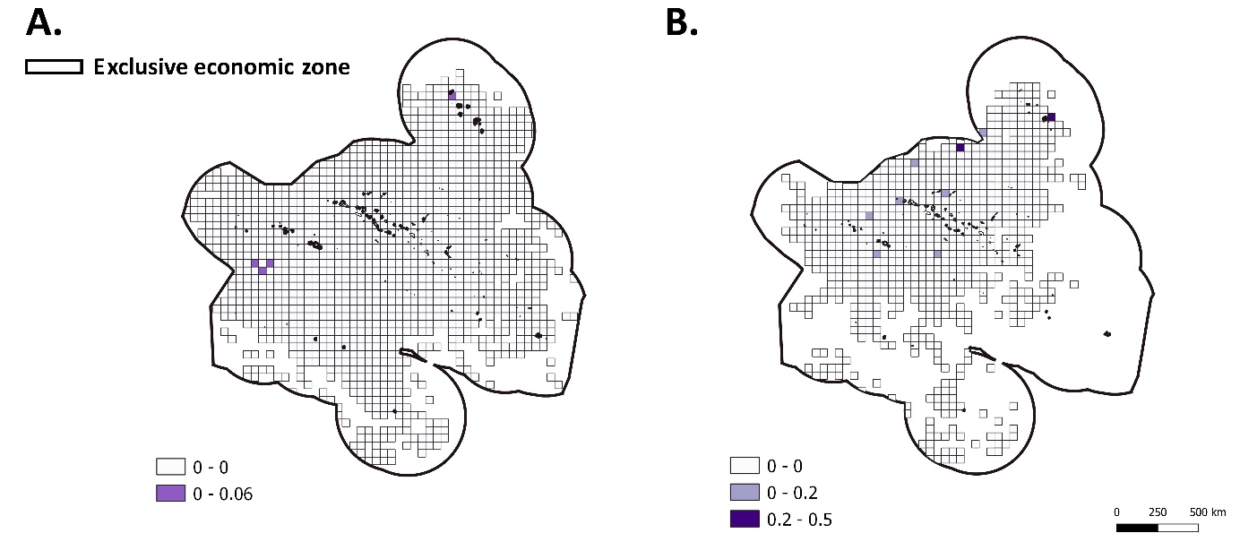
Figure S9. Spatial distribution of odontocete BPUE based on A. LOG and B. NOP databases.

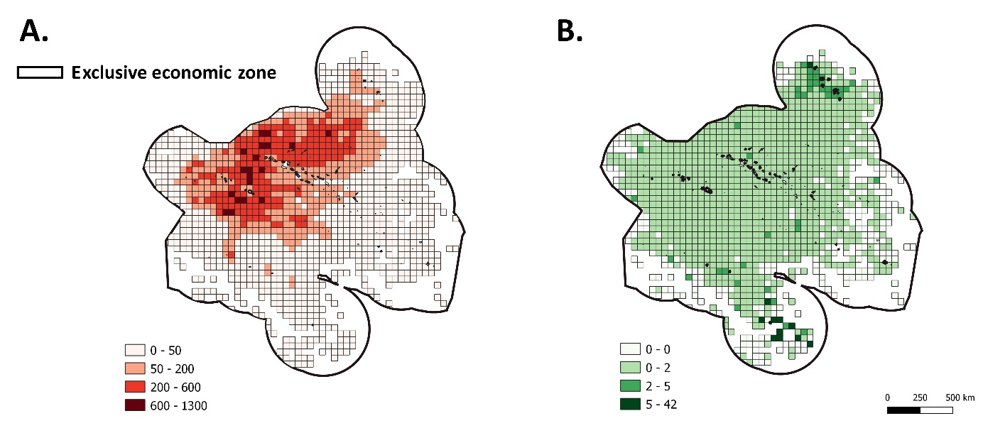
Figure S10. A. Number of sets per spatial units and B. spatial distribution of shark BPUE as reported in the LOG database.

  - Correlation between BPUE and CPUE
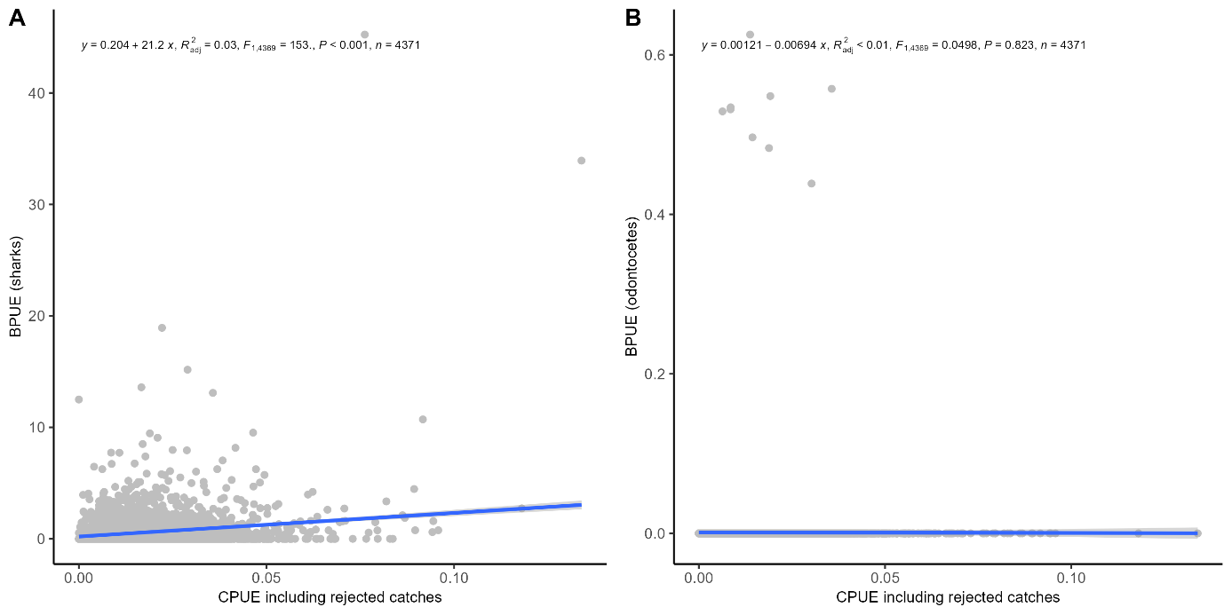
Figure S11. Correlations A. between BPUE_{sharks} and CPUE (included all rejected fish, not only due to depredation) and B. between BPUE_{odontocetes} and CPUE (only 9 BPUE_{odontocetes} are non null).

Questionnaire additional results
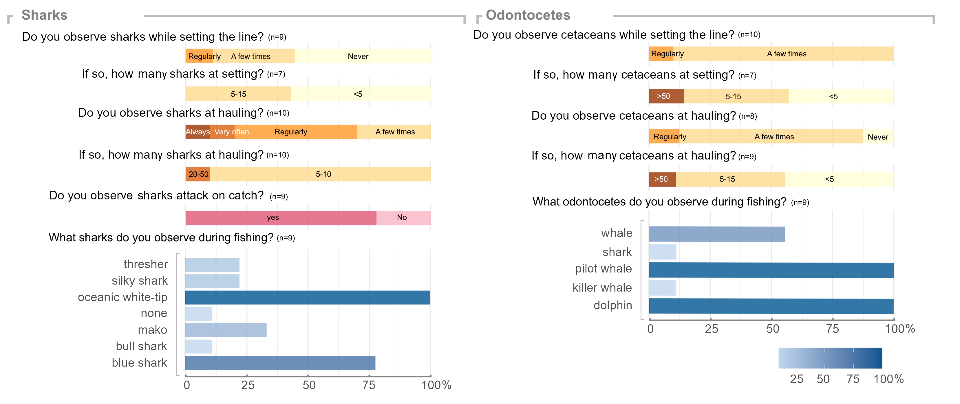
Figure S12. Additional questionnaire responses from captains given in percentage of respondents (from 0 to 1). The number of respondents is given for each question.

- Translation of the questionnaire
