Table 1S. List of sequences used in the phylogenetic study (concatenated SSU, ITS and LSU).

Species | Strain | Locality | SSU | ITS | LSU
Heterocapsa arctica | NCMA445 | North Atlantic, Baffin Bay (76°15'N, 82°33'W) | KF925338 | JQ972677 | AY571372
 | NCMA445 | North Atlantic, Baffin Bay (76°15'N, 82°33'W) | — | AB084095 | —
Heterocapsa arctica subsp. frigida | 755_1 | Baltic Sea, off Finland: Uusimaa, Raseborg, Hanko, Santala Bay (59°54'N, 23°06'E) | — | HQ875057 | —
 | 755_6 | Baltic Sea, off Finland: Uusimaa, Raseborg, Hanko, Santala Bay (59°54'N, 23°06'E) | — | HQ875058 | —
Heterocapsa bohaiensis | Isolate 1-14 | Bohai Sea, off China: Liaodong Bay, the coastal water of Panjin (40°51′N, 121°46′E) | — | MF471313 | —
 | Isolate 3-2 |  | — | — | MF471315
 | isolate 2-13 | Bohai Sea, off China: Liaodong Bay, the coastal water of Panjin (40°51′N, 121°46′E) | — | MF471314 | —
 | isolate 3-3 | Bohai Sea, off China: Liaodong Bay, the coastal water of Panjin (40°51′N, 121°46′E) | — | — | MF471316
 | isolate 4-2 | Bohai Sea, off China: Liaodong Bay, the coastal water of Panjin (40°51′N, 121°46′E) | — | — | MF471318
Heterocapsa cf. bohaiensis | 19PV100 | New Caledonia (22°39'26.2"S, 167°26'33.4"E) | OR224571 | OR224570 | OR224569
Heterocapsa busanensis | LOMME05 | South sea of Korea, Yongho Bay, (35°08′02′′ N, 129°06′53′′ E), Busan | — | MW003709 | MW003725
Heterocapsa circularisquama | HA92-1 | n.inf. | — | — | AB049709
 | aihc559-kt |  | — | LC490697 | LC490697
 | OA1 | Sea of Japan, off Japan, Obama Bay: Fukui | — | AB084089 | —
 | OK1 | Sea of Japan, off Japan, Obama Bay: Fukui | — | AB084090 | —
 | OK3 | Sea of Japan, off Japan, Obama Bay: Fukui | — | AB084091 | —
 | n.inf. | n.inf. | — | AB049711 | —
Heterocapsa claromecoensis | Arg-B5 | Monte Hermoso, Province of Buenos Aires, Argentina. | — | MN509452 | MN509451
 | IS-005 | Claromecó, Province of Buenos Aires, Argentina (38º51’29”S, 60º01’28”W) | — | MK684239 | MK684238
Heterocapsa horiguchii | FK6-D47 | western North Pacific, Seto Inland Sea, off Japan: Honshū, Chūgoku, Hiroshima, Fukuyama | — | AB084097 | —
 | NIES614 | Japan, Niigata, Kashiwazaki (37°26'N, 138°35'E) | — | AB084099 | —
Heterocapsa huensis | n.inf. | western North Pacific, South China Sea, Lang Co Lagoon, off Vietnam: Hue (16°13'N, 108°05'E) | — | AB445394 | —
Heterocapsa illdefina | NCMA446 | eastern North Pacific, off USA-CA: Santa Barbara Channel (34°15'N, 119°43'W) | — | JQ972687 | —
 | NCMA446 | eastern North Pacific, off USA-CA: Santa Barbara Channel (34°15'N, 119°43'W) | — | AB084092 | —
Heterocapsa lanceolata | TK6-D57 | western North Pacific, off Japan: Tokyo, Ariake | — | AB084096 | —
 | HL060720 | n.inf. | — | AB428419 | —
Heterocapsa minima | CCMI1070 | Ireland: Gearhies, Bantry bay, County Cork | — | KF031311 | KF031312
 | Vil39 | western Mediterranean Sea, off France: Alpes-Maritimes, Nice, Villefranche-sur-Mer (43°41'N, 7°18'E) | JX661030 | JX661019 | —
 | LOMME03 | South sea of Korea, Yongho Bay, (35°08′02′′ N, 129°06′53′′ E), Busan | — | MW626888 | —
Heterocapsa niei | NCMA447 | western North Atlantic, Caribbean Sea, off USA-PR (18°00'N, 66°30'W) | AF274265 | — | —
 | UTEX1564 | USA-CA: Salton Sea | EF492499 | — | —
Heterocapsa orientalis | CTCC 20 | South Africa: False Bay | — | — | AY464690
Heterocapsa ovata | NIES472 | Japan, Niigata, Kashiwazaki (37°26'N, 138°35'E) | — | AB084098 | —
Heterocapsa psammophila | TM43 |  | LC054933 | — | —
Heterocapsa philippinensis | FIU11 | western North Atlantic, off USA-FL | — | — | EU165273
 | KJ34-3-05 | western North Pacific, South China Sea | — | KT389965 | —
 | GBNW14 |  | LC621346 | — | —
Heterocapsa pseudotriquetra | GeoB 222 | eastern North Atlantic, off Canary Islands (24°25'N, 17°11'W) | — | AY499509 | MF423367
 | NIES473 | eastern Indian Ocean, East China Sea, off Japan: Tsushima | — | AB084100 | —
 | UTEX2722 | USA-CA: Salton Sea | KU900227 | FJ823556 | —
Heterocapsa pygmaea | 103238 | western North Atlantic, off USA-NC (35°45'N, 76°18'W) | — | JQ972681 | —
 | NCMA1734 | western North Atlantic, off USA-FL: knight Key (24°42'N, 81°08'W) | — | — | EU165312
 | NCMA2770 | western North Atlantic, Gulf of Mexico, off USA-FL: Marquesas Keys (24°35'N, 82°06'W) | — | JQ972674 | EU165271
 | QUCCCM85 | Persian Gulf, off Qatar: Doha (25°18'N, 51°31'E) | — | KX853191 | KX853175
 | QUCCCM87 | Persian Gulf, off Qatar: Doha (25°18'N, 51°31'E) | — | KX853193 | KX853177
 | QUCCCM88 | Persian Gulf, off Qatar: Doha (25°18'N, 51°31'E) | — | KX853194 | KX853178
 | UTEX1653 |  | EF492494 | AB084093 | —
 | 19PV99 | New Caledonia (21°55'36.9"S, 166°05'00.9"E) | OR194073 | OR194143 | OR194153
 | NCMA1322 |  | — | — | FJ939577
Heterocapsa cf. pygmaea | NCMA448 HtrITSC2_3 | western North Atlantic, off USA-MA: Falmouth, Perch Pond (41°32'N, 70°37'W) | — | AF352363 | —
 | NCMA448 HtrITSC3 | western North Atlantic, off USA-MA: Falmouth, Perch Pond (41°32'N, 70°37'W) | — | AF352364 | —
 | NCMA1490 | Mediterranean Sea, Ligurian Sea, off Italy: La Spezia (44°00'N, 9°30'E) | — | AB084094 | —
 | RCC1516 | Mediterranean Sea, Tyrrhenian Sea, off Italy: Campania, Naples (41°00'N, 14°15'E) | — | — | KT860562
 | UTEX2421 |  | — | FJ823558 | EU165306
 | AC24-1 | western Mediterranean Sea, off France: Alpes-Maritimes, Nice, Villefranche-sur-Mer, station B (43°41'N, | JX661034 | — | —
 | HE04 | western Mediterranean Sea, Mar Menor: off Spain | FJ549370 | — | —
Heterocapsa rotundata | CCCM680 | n.inf | AF274267 | — | —
 | NCMA1542 | western North Atlantic, off USA-MD: Chesapeake Bay (38°36'N, 76°06'W) | DQ388464 | — | —
 | SCCAP K-0479 | n.inf | — | — | AF260400
 | SCCAP K-0483 | Denmark: Southern Kattegat, Bouy St (56°02'N, 12°02'E) | — | KF240777 | KF240778
Heterocapsa sp. | CS36 | n.inf | — | FJ823557 | —
 | CS89 | Tasman Sea, off Australia: Sydney, Port Hacking | — | — | AY916548
 | FIU10 | western North Atlantic, off USA-FL | — | — | EU165272
 | FIU12R | western North Atlantic, off USA-FL | — | — | EU165274
 | FIU31 | western North Atlantic, off USA-FL | — | — | EU165275
 | HCBC88 | Arabian Sea, Gulf of Oman, off Iran | — | — | JN119844
 | USA29-9 | n.inf. | — | AF201747 | —
 | HZS-2011 | Arabian Sea, Gulf of Oman, off Iran: Chābahār | — | JN020164 | —
 | MBIC10795 | n.inf. | AB183639 | — | —
 | NIES3881 | n.inf. | LC189145 | — | —
 | NCMA424 | eastern South Pacific, Tasman Sea, off Australia: New South Wales, Cronulla, CSIRO (34°05'S, 51°10'E) | EF492492 | JQ991005 | EF205005
 | n.inf | Arabian Sea, Gulf of Oman, off Iran: Chābahā | — | JN020158 | —
 | n.inf | n.inf | AF033865 | — | AF033867
Heterocapsa sp. | HG17 | western North Pacific, Ago Bay, off Japan: Mie, Tagetami (34°18N, 136°51'E) | LC054932 | — | —
 | H060926-1 | n.inf. | — | AB428420 | —
 | H060926-2 | n.inf. | — | AB428421 | —
Heterocapsa steini | UTKG7 | Baltic Sea, off Germany: Schleswig-Holstein, Kiel (54°19'N, 10°09'E) | MF423350 | MF423355 | MF423356
 | UTKG5 | Baltic Sea, off Germany: Schleswig-Holstein, Kiel (54°19'N, 10°09'E) | MF423349 | — | —
 | UTKG4 | Baltic Sea, off Germany: Schleswig-Holstein, Kiel (54°19'N, 10°09'E) | MF423348 | — | —
 | UTKG3 | Baltic Sea, off Germany: Schleswig-Holstein, Kiel (54°19'N, 10°09'E) | MF423347 | — | —
 | UTKG1 | Baltic Sea, off Germany: Schleswig-Holstein, Kiel (54°19'N, 10°09'E) | MF423346 | — | —
 | NIES7 | western North Pacific, off Japan: Osaka Bay | — | AB084101 | —
 | NCMA448 | western North Atlantic, off USA-MA: Falmouth, Perch Pond (41°32'N, 70°37'W) | GU594638 | AF527816 | EU165307
 | St1-2 | South Korea: Lake Shihwa (Station 1) | — | HQ902267 | —
 | St3-1 | South Korea: Lake Shihwa (Station 3) | — | HQ902268 | —
 | GSW206-2 | eastern Indian Ocean, off South Korea: Gosung | AY421787 | — | EF613355
Azadinium spinosum | SHETF6 | North Atlantic, Shetland Islands (60°13’N, 01°00’W) | JX559885 | — | —
Azadinium dalianense | N-38-03 | North Atlantic, Norway (62°20’N, 05°22’E) | LS974153 | — | —
Azadinium trinitatum | N-39-04 | North Atlantic, Norway (62°28’N, 05°46’E) | LS974170 | — | —
Azadinium polongum | SHETB2 |  | JX559886 | — | —
Prorocentrum mexicanum | Brazil1 | the Marine Station of the University of São Paulo in Ubatuba, São Paulo State, Brazil (23°30'S, 45°7'W) | KY426837 | — | —
Prorocentrum micans | A10 |  | MK405477 | — | —
Prorocentrum rhathymum | PXHV-1 | n.inf. | JQ638938 | — | —
— : no sequence available

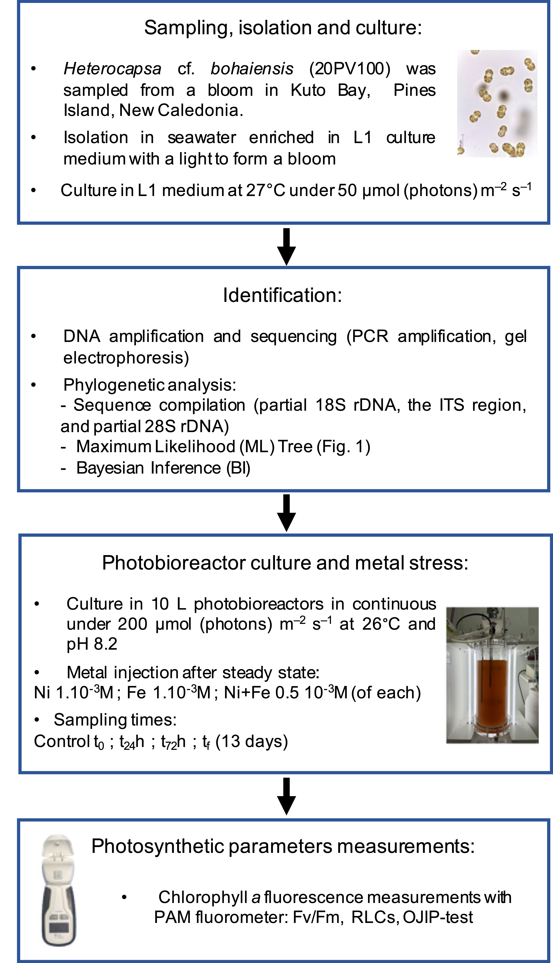
Fig. 1S. Flow chart resuming the materials and methods used in this paper.

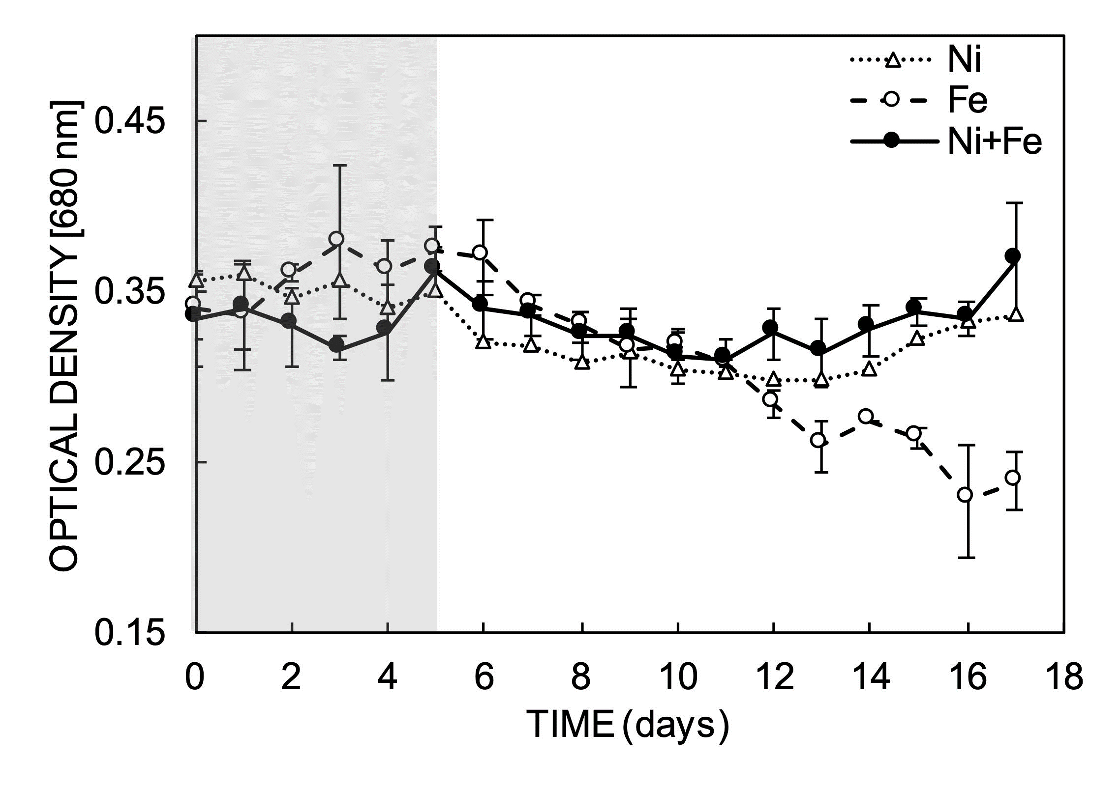
Fig. 2S. Culture stability, absorbance at 680 nm of H. cf. bohaiensis cultured in continuous before (grey part) and after (white part) injection of Ni²⁺, Fe²⁺ and Ni²⁺+Fe²⁺.

