Supplementary Material

Natural Copper-Binding Ligands in the Arctic Ocean. The Influence of the Transpolar Drift (GEOTRACES GN04)
Veronica Arnone¹, J. Magdalena Santana-Casiano¹, Melchor González-Dávila¹, Hélène Planquette², Geraldine Sarthou², Loes J. A. Gerringa³, Aridane G. González¹*
* Correspondence: Aridane G. González: aridane.gonzalez@ulpgc.es

Supplementary Figures and Tables

Supplementary Figure 1. Sea-ice stage development based on synoptic observations made onboard, according to the definitions of the Word Meteorological Organization WMO (König-Langlo, 2015). Description of levels of sea-ice stage. 3) Predominantly new and/or young ice with some first-year ice. 4) Predominantly thin first-year ice with some new and/or young ice. 5) All thin first-year ice (30-70 cm thick). 6) Predominantly medium first-year ice (70-120 cm thick) and thick first-year ice (more than 120 cm thick) with some thinner (younger) first-year ice. 7) All medium and first-year ice. 8) Predominantly medium and thick first-year ice with some old ice (usually more than 2 meters thick).
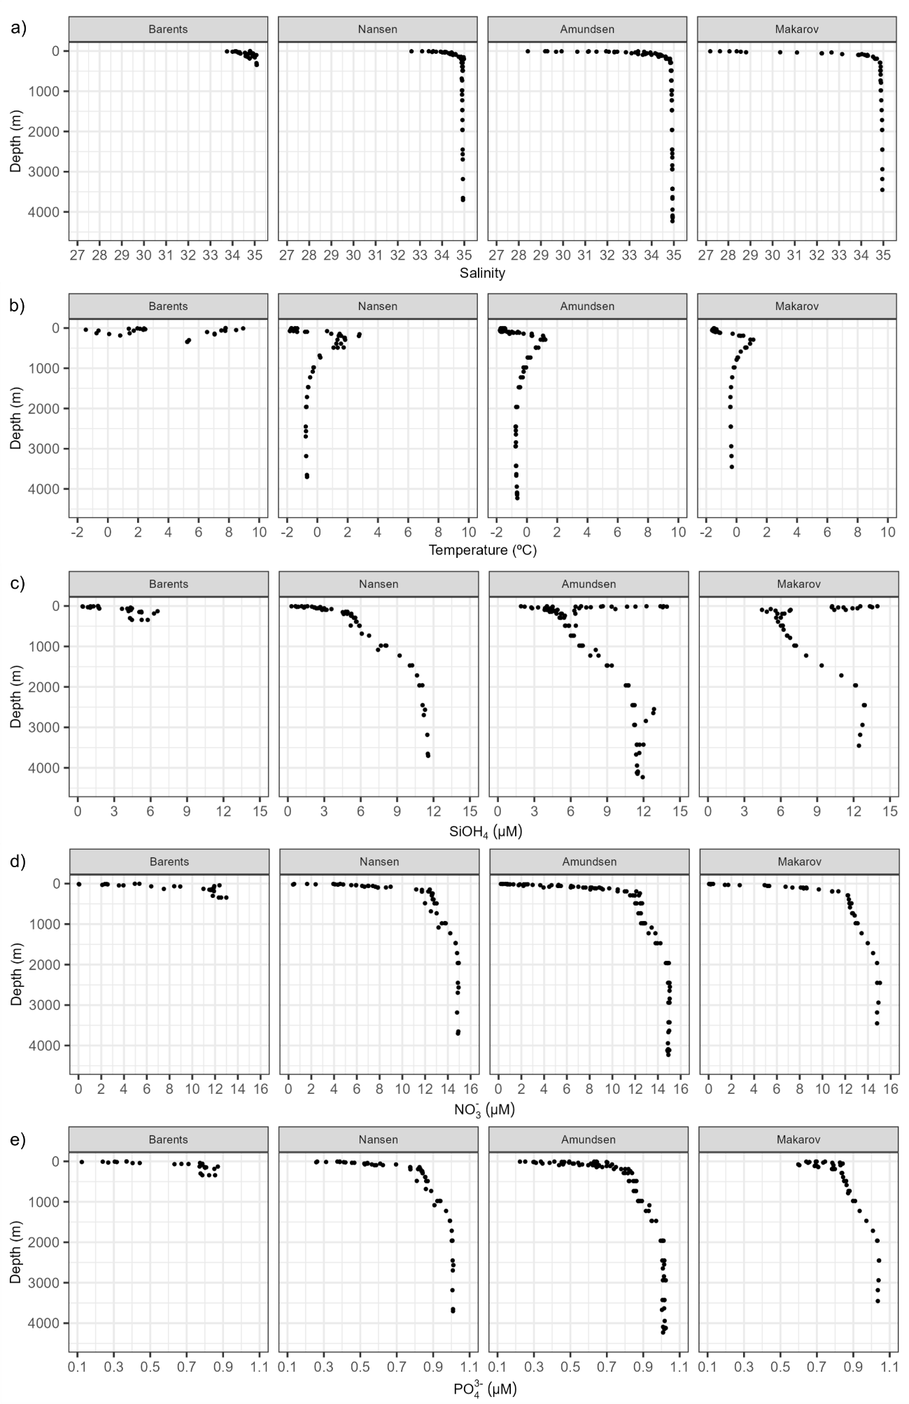
Supplementary Figure 2. Depth profiles of (a) salinity, (b) temperature (in ºC), (c) silicate (SiOH⁴, in μM), (d) nitrate (NO₃⁻, in μM), (e) phosphate (PO₄³⁻, in μM) depicted per basins. Nutrient data was reported by van Ooijen et al. (2016). Barents Sea (St. 4, 147, 169 and 173), Nansen Basin (St. 32, 50 54, 58, 64), Amundsen Basin (St. 69, 70, 81, 87, 91, 117, 119, 121, 125) and Makarov Basin (St. 96, 99, 130, 134).

Supplementary Figure 3. Distribution of (a) dissolved Cu (in nM, data reported by Gerringa et al. (2021b) and (b) fluorescence (in arbitrary units, data reported by Rabe et al. (2016) in the Arctic Ocean, including all stations and basins. Note that the purple colour in figure b represents zones with missing data.

Supplementary Figure 4. Depth profile of Cu-binding ligand conditional stability constant (logK^{cond} _{Cu2+L}) represented by station and grouped by seas and basins. Barents Sea profiles represented with a different vertical scale.

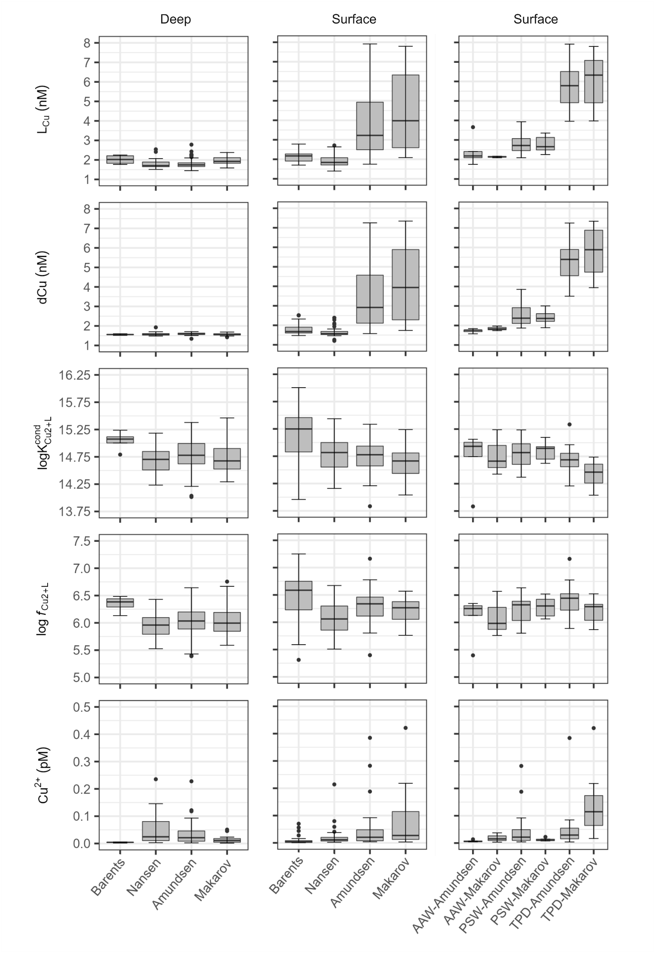
Supplementary Figure 5. Boxplot of Cu-binding ligands (L_{Cu}) and dissolved Cu (dCu) concentrations in nM (a-b), conditional stability constant (log K^{cond}_{Cu2+L}, c), side reaction coefficient (log f_{Cu2+L}, d), and the concentration of free cupric ion in pM (Cu²⁺, e). Dots indicate outliers. The left column depict data from deep waters (>200m depth) per basin, the central column represents surface samples (≤200m depth) per basin, while the right column shows data from surface waters (≤200m depth) of Amundsen and Makarov Basins per basin and water masses (AAW: Arctic Atlantic Water, PSW: Polar Surface Water). The label TPD indicate surface waters inside the flow path, while PSW indicates surface waters outside the TPD. Dissolved Cu data were reported by Gerringa et al. (2021).

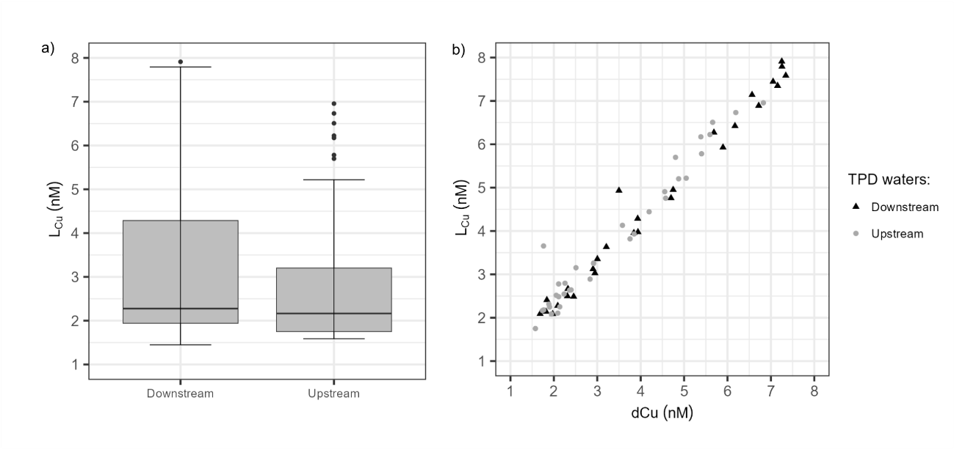
Supplementary Figure 6. Representation of surface waters located inside the Transpolar Drift (TPD) classified into downstream (St. 81 – 99) and upstream (St. 119 – 134) sections. a) Boxplot of Cu-binding ligand (L_{Cu}) in nM. b) Relationship between dissolved Cu (dCu) and L_{Cu} concentrations in nM.

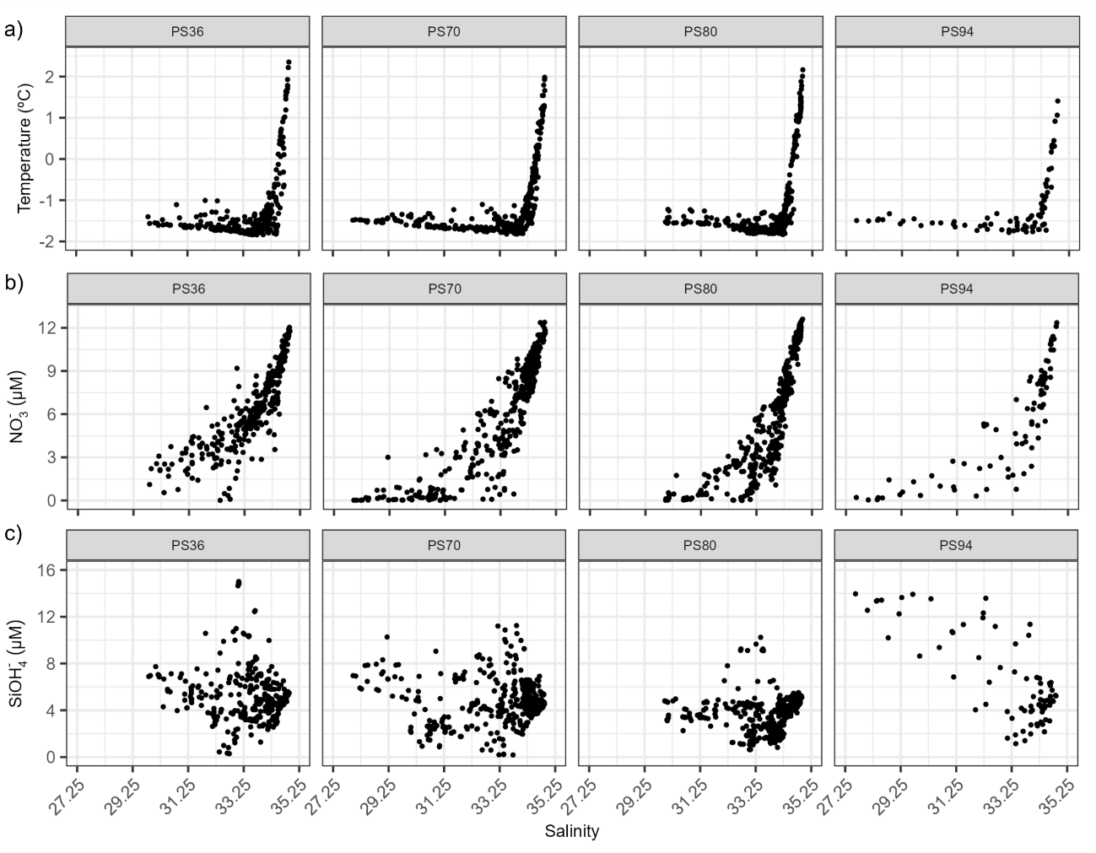
Supplementary Figure 7. Comparison of the properties recorded in the different cruises used as an example in the application of the linear model for the estimation of the concentration of copper-binding ligands. Four cruises were included: the PS36 took place in 1995 (Kattner, 2011), the PS70 in 2007 (Wisotzki & Bakker, 2008), the PS80 in 2012 (Bakker, 2014) and the PS94 (the study at hand). The properties represented against salinity were: a) temperature (ºC), b) nitrate concentration (NO₃⁻, μM), and c) silicate concentration (SiOH₄, μM)
Supplementary Table 1. Summary of range (minimum and maximum), mean and standard deviation (SD) and median of Cu speciation parameters for surface samples (≤ 200 m) of different basins and water masses. Barents Sea (BS, St. 4, 147, 169 and 173), Nansen Basin (NB, St. 32, 50 54, 58, 64), Amundsen Basin (AB, St. 69, 70, 81, 87, 91, 117, 119, 121, 125) and Makarov Basin (MB, St. 91, 96, 99, 130, 134). The surface water masses were: Polar Surface Water (PSW), Atlantic Water (AW) and Arctic Atlantic Water (AAW). Dissolved Cu data were reported by Gerringa et al. (2021). The number of samples for each water mass inside the respective basin (n) was included in the second column.
Surface | Water mass |  | dCu (nM) | L_{Cu} (nM) | logK^{cond}_{Cu2+L} | log f_{Cu2+L} | eL_{Cu} (nM) | L_{Cu}/dCu | %CuL | Cu' (pM) | Cu²⁺ (pM)
BS | PSW (n=3) | Min | 1.57 | 1.82 | 13.96 | 5.31 | 0.25 | 1.16 | 99.88 | 0.12 | 0.004
 |  | Max | 1.95 | 2.25 | 15.22 | 6.48 | 0.33 | 1.18 | 99.99 | 2.24 | 0.07
 |  | Mean±SD | 1.77±0.19 | 2.06±0.22 | 14.75±0.69 | 6.06±0.65 | 0.30±0.04 | 1.17±0.02 | 99.96±0.06 | 0.84±1.22 | 0.03±0.04
 |  | Median | 1.78 | 2.11 | 15.08 | 6.41 | 0.31 | 1.16 | 99.99 | 0.14 | 0.004
BS | AW  (n=18) | Min | 1.48 | 1.7 | 14.24 | 5.59 | 0.04 | 1.02 | 99.89 | 0.03 | 0.001
 |  | Max | 2.52 | 2.78 | 16.01 | 7.25 | 0.82 | 1.45 | 100 | 1.8 | 0.056
 |  | Mean±SD | 1.78±0.29 | 2.10±0.31 | 15.26±0.43 | 6.58±0.42 | 0.32±0.22 | 1.19±0.13 | 99.98±0.03 | 0.31±0.49 | 0.01±0.01
 |  | Median | 1.67 | 2.11 | 15.32 | 6.67 | 0.29 | 1.17 | 99.99 | 0.14 | 0.004
BS | AAW (n=4) | Min | 1.61 | 2.22 | 14.68 | 6.11 | 0.19 | 1.08 | 99.97 | 0.03 | 0.001
 |  | Max | 2.51 | 2.7 | 15.53 | 6.88 | 0.75 | 1.46 | 100 | 0.87 | 0.027
 |  | Mean±SD | 1.93±0.41 | 2.46±0.21 | 15.06±0.39 | 6.45±0.35 | 0.53±0.24 | 1.30±0.16 | 99.99±0.02 | 0.27±0.40 | 0.01± 0.01
 |  | Median | 1.79 | 2.46 | 15.01 | 6.40 | 0.60 | 1.33 | 99.99 | 0.09 | 0.003
NB | PSW (n=21) | Min | 1.2 | 1.4 | 14.27 | 5.65 | 0.02 | 1.01 | 99.57 | 0.07 | 0.002
 |  | Max | 2.39 | 2.71 | 15.44 | 6.67 | 0.54 | 1.34 | 100 | 6.85 | 0.214
 |  | Mean±SD | 1.70±0.33 | 1.94± 0.38 | 14.84±0.35 | 6.12± 0.31 | 0.24± 0.15 | 1.15± 0.09 | 99.95± 0.09 | 0.78± 1.45 | 0.02± 0.04
 |  | Median | 1.58 | 1.82 | 14.88 | 6.15 | 0.22 | 1.14 | 99.98 | 0.39 | 0.012
NB | AW (n=2) | Min | 1.46 | 1.71 | 14.41 | 5.76 | 0.25 | 1.17 | 99.98 | 0.15 | 0.005
 |  | Max | 1.52 | 2.23 | 15.1 | 6.33 | 0.71 | 1.47 | 99.99 | 0.26 | 0.008
 |  | Mean±SD | 1.49±0.04 | 1.97± 0.37 | 14.76±0.48 | 6.05± 0.40 | 0.48± 0.33 | 1.32± 0.21 | 99.99± 0.00 | 0.21± 0.08 | 0.01± 0.00
 |  | Median | 1.49 | 1.97 | 14.76 | 6.05 | 0.48 | 1.32 | 99.99 | 0.21 | 0.006
NB | AAW (n=5) | Min | 1.53 | 1.58 | 14.16 | 5.51 | 0.05 | 1.03 | 99.88 | 0.3 | 0.009
 |  | Max | 2.05 | 2.23 | 14.95 | 6.19 | 0.35 | 1.23 | 99.98 | 2.55 | 0.08
 |  | Mean±SD | 1.67± 0.22 | 1.88± 0.24 | 14.66± 0.31 | 5.93± 0.26 | 0.21± 0.11 | 1.13± 0.07 | 99.95± 0.05 | 0.97± 0.97 | 0.03± 0.03
 |  | Median | 1.56 | 1.92 | 14.71 | 6 | 0.19 | 1.12 | 99.98 | 0.37 | 0.012

Surface | Water mass |  | dCu (nM) | L_{Cu} (nM) | logK^{cond}_{Cu2+L} | log f_{Cu2+L} | eL_{Cu} (nM) | L_{Cu}/dCu | %CuL | Cu' (pM) | Cu²⁺ (pM)
AM | PSW (n=41) | Min | 1.87 | 2.09 | 14.21 | 5.8 | 0.02 | 1.01 | 99.57 | 0.13 | 0.004
 |  | Max | 7.25 | 7.91 | 15.34 | 7.16 | 1.43 | 1.41 | 100 | 12.31 | 0.385
 |  | Mean±SD | 3.67±1.59 | 4.02±1.69 | 14.75±0.27 | 6.32±0.27 | 0.35±0.29 | 1.10±0.09 | 99.95±0.07 | 1.57±2.39 | 0.05±0.07
 |  | Median | 3.09 | 3.26 | 14.78 | 6.36 | 0.34 | 1.09 | 99.98 | 0.82 | 0.026
AM | AAW (5) | Min | 1.58 | 1.75 | 13.83 | 5.4 | 0.17 | 1.11 | 99.98 | 0.13 | 0.004
 |  | Max | 1.84 | 3.65 | 15.06 | 6.35 | 1.89 | 2.07 | 99.99 | 0.44 | 0.014
 |  | Mean±SD | 1.73±0.10 | 2.42±0.73 | 14.72±0.51 | 6.09±0.39 | 0.69±0.69 | 1.39±0.39 | 99.99±0.01 | 0.23±0.12 | 0.01±0.00
 |  | Median | 1.76 | 2.18 | 14.93 | 6.25 | 0.41 | 1.24 | 99.99 | 0.19 | 0.006
MB | PSW (n=20) | Min | 1.89 | 2.25 | 14.04 | 5.87 | 0.04 | 1.01 | 99.66 | 0.25 | 0.008
 |  | Max | 7.34 | 7.79 | 15.1 | 6.52 | 0.64 | 1.26 | 99.99 | 13.47 | 0.421
 |  | Mean±SD | 4.44±1.95 | 4.74±1.96 | 14.60±0.29 | 6.24±0.20 | 0.29±0.17 | 1.08±0.07 | 99.94±0.08 | 2.72±3.33 | 0.08±0.10
 |  | Median | 4.45 | 4.6 | 14.66 | 6.29 | 0.25 | 1.06 | 99.97 | 0.97 | 0.03
MB | AAW (n=3) | Min | 1.74 | 2.09 | 14.43 | 5.76 | 0.11 | 1.06 | 99.94 | 0.11 | 0.003
 |  | Max | 1.97 | 2.16 | 15.24 | 6.57 | 0.43 | 1.25 | 99.99 | 1.19 | 0.037
 |  | Mean±SD | 1.84±0.12 | 2.13±0.04 | 14.78±0.42 | 6.10±0.42 | 0.29±0.16 | 1.16±0.10 | 99.97±0.03 | 0.59±0.55 | 0.02±0.02
 |  | Median | 1.82 | 2.14 | 14.66 | 5.98 | 0.32 | 1.18 | 99.97 | 0.49 | 0.015

Supplementary Table 2. Three different linear regression model were developed to determine the relationship between Cu-binding ligand concentration (L_{Cu} in nM), physical water properties (temperature in ºC, or salinity) and nutrient concentrations (μM). Different nutrients were considered: nitrate (NO₃⁻), silicate (SiOH₄) and phosphate (PO₄³⁻). These equations were developed considering surface waters (≤ 200 m depth) from station 58 to 134. The parameters included were chosen according to the Bayesian Information Criterion (Sakamoto et al., 1986).
EQ | Formula
1 | L_{Cu} = 10.87321 – 0.244 · Salinity – 0.1519 · NO₃⁻ + 0.25263 · SiOH₄
2 | L_{Cu} = 3.93719 + 0.44556 · Temperature – 0.31863 · NO₃⁻ + 0.30287 · SiOH₄
3 | L_{Cu} = 16.45641 + 0.404 · Salinity + 0.29444 · SiOH₄ – 2.38481 · PO₄³⁻
4 | L_{Cu} = 3.78431 + 0.430 · Temperature – 0.34127 · NO₃⁻ + 0.27951 · SiOH₄ + 0.68346 · PO₄³⁻
5 | L_{Cu} =12.63534 – 0.2932 · Salinity – 0.09855 · NO₃⁻ + 0.27274 · SiOH₄ – 0.95829 · PO₄³⁻
6 | L_{Cu} =16.61124 – 0.40326 · Salinity + 0.06208 · Temperature + 0.30187 · SiOH₄ –2.64021 · PO₄³⁻
7 | L_{Cu} =2.88253 – 0.24144 · NO₃⁻ + 0.31985 · SiOH₄
8 | L_{Cu} = 2.66181 – 0.28919 · NO₃⁻ + 0.27465 · SiOH₄ + 1.29088 · PO₄³⁻
9 | L_{Cu} = 18.39616 – 0.49585 · Salinity – 0.21479 · Temperature + 0.20122 · SiOH4
10 | L_{Cu} = 20.38904 – 0.54619 · Salinity + 0.18718· SiOH₄

Supplementary Table 3. Values of the linear regression models reported in Table S2a, which include the relation between the model parameters and coefficients. This table include the value of each parameter and statistical information corresponding to the equation (EQ) reported in Table S2a. The coefficients p-values (<0.05) indicate that in each equation all parameters included are significant. The model column includes the residual standard error (RSE) in terms of degrees of freedom (df), the adjusted R² and p-value of the model.
EQ | Coefficients |  |  |  | Coefficients p-values |  |  |  |  | Model
 | A | B | C | D | Intercept | A | B | C | D | RSE | Adjusted R² | p-value
1 | Salinity | NO₃⁻ | SiOH₄ |  | 1.27E-04 | 3.71E-03 | 4.96E-05 | 1.22E-12 |  | 0.4734 on 60 df | 0.936 | <2.2e-16
2 | Temperature | NO₃⁻ | SiOH₄ |  | <2e-16 | 4.84E-04 | <2e-16 | <2e-16 |  | 0.4587 on 60 df | 0.9399 | <2.2e-16
3 | Salinity | SiOH₄ | PO₄³⁻ |  | 4.77E-13 | 4.31E-10 | 1.01E-11 | 8.31E-05 |  | 0.4773 on 60 df | 0.9349 | < 2.2e-16
4 | Temperature | NO₃⁻ | SiOH₄ | PO₄³⁻ | 4.48E-13 | 9.12E-04 | 4.95E-11 | 5.95E-10 | 0.4887 | 0.4607 on 59 df | 0.9394 | <2.2e-16
5 | Salinity | NO₃⁻ | SiOH₄ | PO₄³⁻ | 7.40E-04 | 6.57E-03 | 0.2180 | 2.77E-09 | 0.4557 | 0.4751 on 59 df | 0.9355 | < 2.2e-16
6 | Salinity | Temperature | SiOH₄ | PO₄³⁻ | 8.01E-13 | 5.98E-10 | 0.6078 | 7.31E-11 | 8.82E-04 | 0.4802 on 59 df | 0.9341 | < 2.2e-16
7 | NO₃⁻ | SiOH₄ |  |  | <2e-16 | <2e-16 | <2e-16 |  |  | 0.5039 on 61 df | 0.9274 | < 2.2e-16
8 | NO₃⁻ | SiOH₄ | PO₄³⁻ |  | 8.54E-14 | 9.25E-09 | 9.16E-09 | 0.2240 |  | 0.5019 on 60 df | 0.928 | < 2.2e-16
9 | Salinity | Temperature | SiOH₄ |  | 9.06E-14 | 1.31E-13 | 3.38E-02 | 5.56E-10 |  | 0.5234 on 60 df | 0.9217 | < 2.2e-16
10 | Salinity | SiOH₄ |  |  | <2e-16 | <2e-16 | 3.98E-09 |  |  | 0.5392 on 61 df | 0.917 | < 2.2e-16

