Supplementary Figures

Van Audenhaege, L., Sarrazin, J., Legendre, P., Perrois, G., Cannat, M., Matabos, M. Monitoring ecological dynamics on complex hydrothermal structures: a novel photogrammetry approach reveals fine scale variability of vent assemblages.
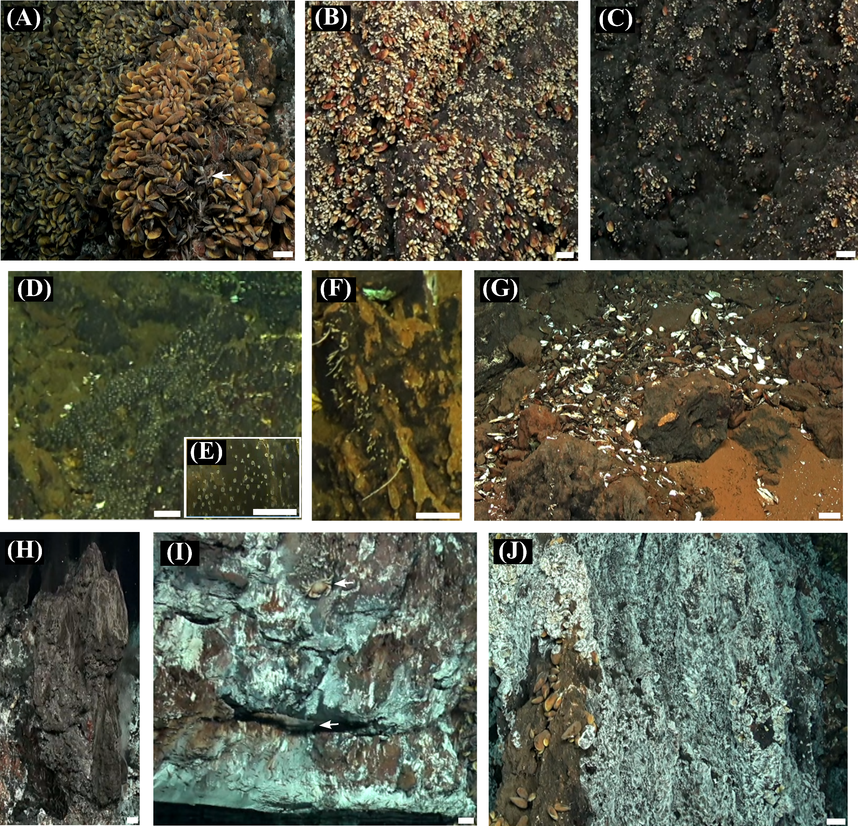Supplementary Figure S1: Assemblages and substrata investigated in this study. White bars in the bottom right corner scale is 5 cm. (A) Dense aggregation of large Bathymodiolus azoricus vent mussels. Note the white arrow showing presence of shrimps Mirocaris fortunata aggregating near a diffuse outflow. (B) Clumps of medium vent mussels B. azoricus. (C) Sparse and small vent mussels B. azoricus over the bare substratum. (D) Dense aggregation of unidentified zoanthids. (E) Zoanthids shown with a higher zoom level. (F) Erected white morphospecies, possibly composed of microcarnivorous sponges and/or arboramminid foraminifera. Empty shells of B. azoricus accumulating at the base of the Eiffel Tower edifice, on the bare substratum. (H) Black substratum, here displaying focused vent emissions. (I) White material resulting from the precipitation of anhydrite and barytine from hydrothermal activity. The upper arrow indicates the presence of a vent crab Segonzacia mesatlantica. The lower arrow indicates a flange pool where accumulating vent fluid reflects the ROV light. (J) White filamentous microbial mats, here covering the bare substratum. Microbial mats can also cover B. azoricus assemblages.
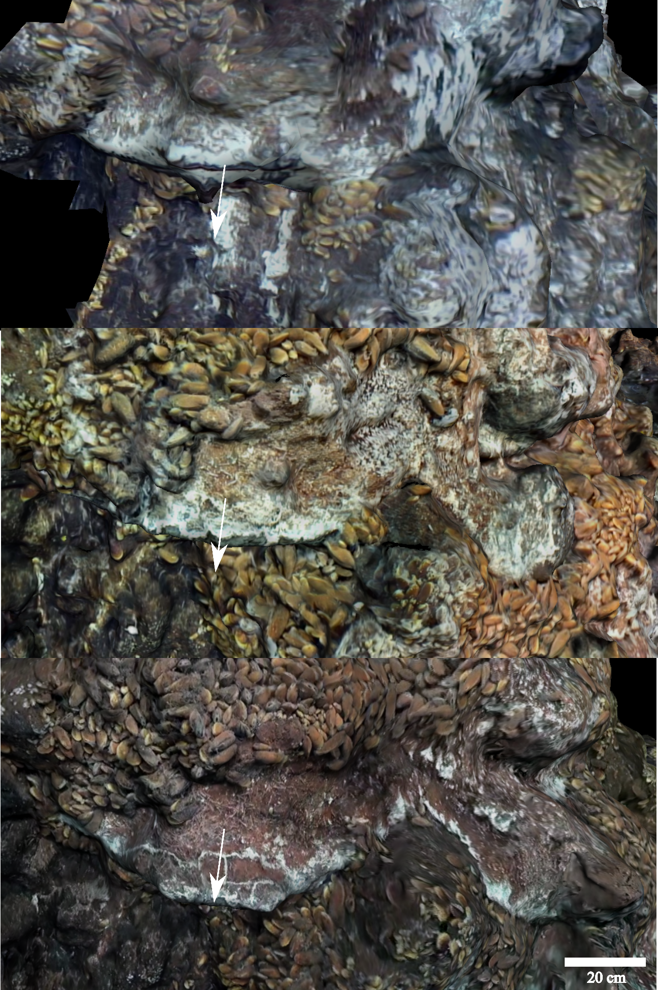
Supplementary Figure S2: Forward growth of a flange measured by the 20-cm white arrows drawn over the 3D models from 2015, 2018 and 2020 (top to bottom). Note the mineralisation of the flange over time, shifting from black to white to brown and reddish.
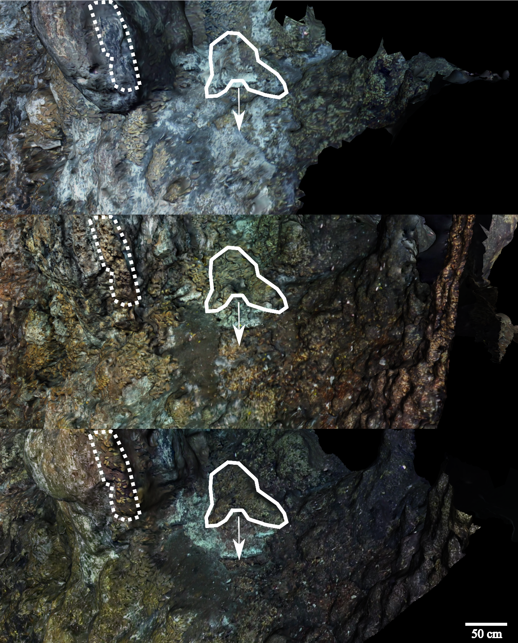
Supplementary Figure S3: Downward accretion of a flange blanketing the bare substratum. The displacement is measured by the 53-cm white arrows drawn over the 3D models from 2015 to2020 (top to bottom). This event is the most extensive flange accretion event observed over Eiffel Tower (excluding black smoker chimney buildup and bulbous outcrops; e.g. Suppl. Fig. S5). Note that this substratum underwent mineralisation over time (i.e., change from white to brown colour) and mussels possibly migrated to follow that directional accretion. On the left, the dotted-contour polygon illustrates mineralisation that occurred between 2015 and 2018 (white to brownish) and the colonisation of a few mussel individuals of medium size.

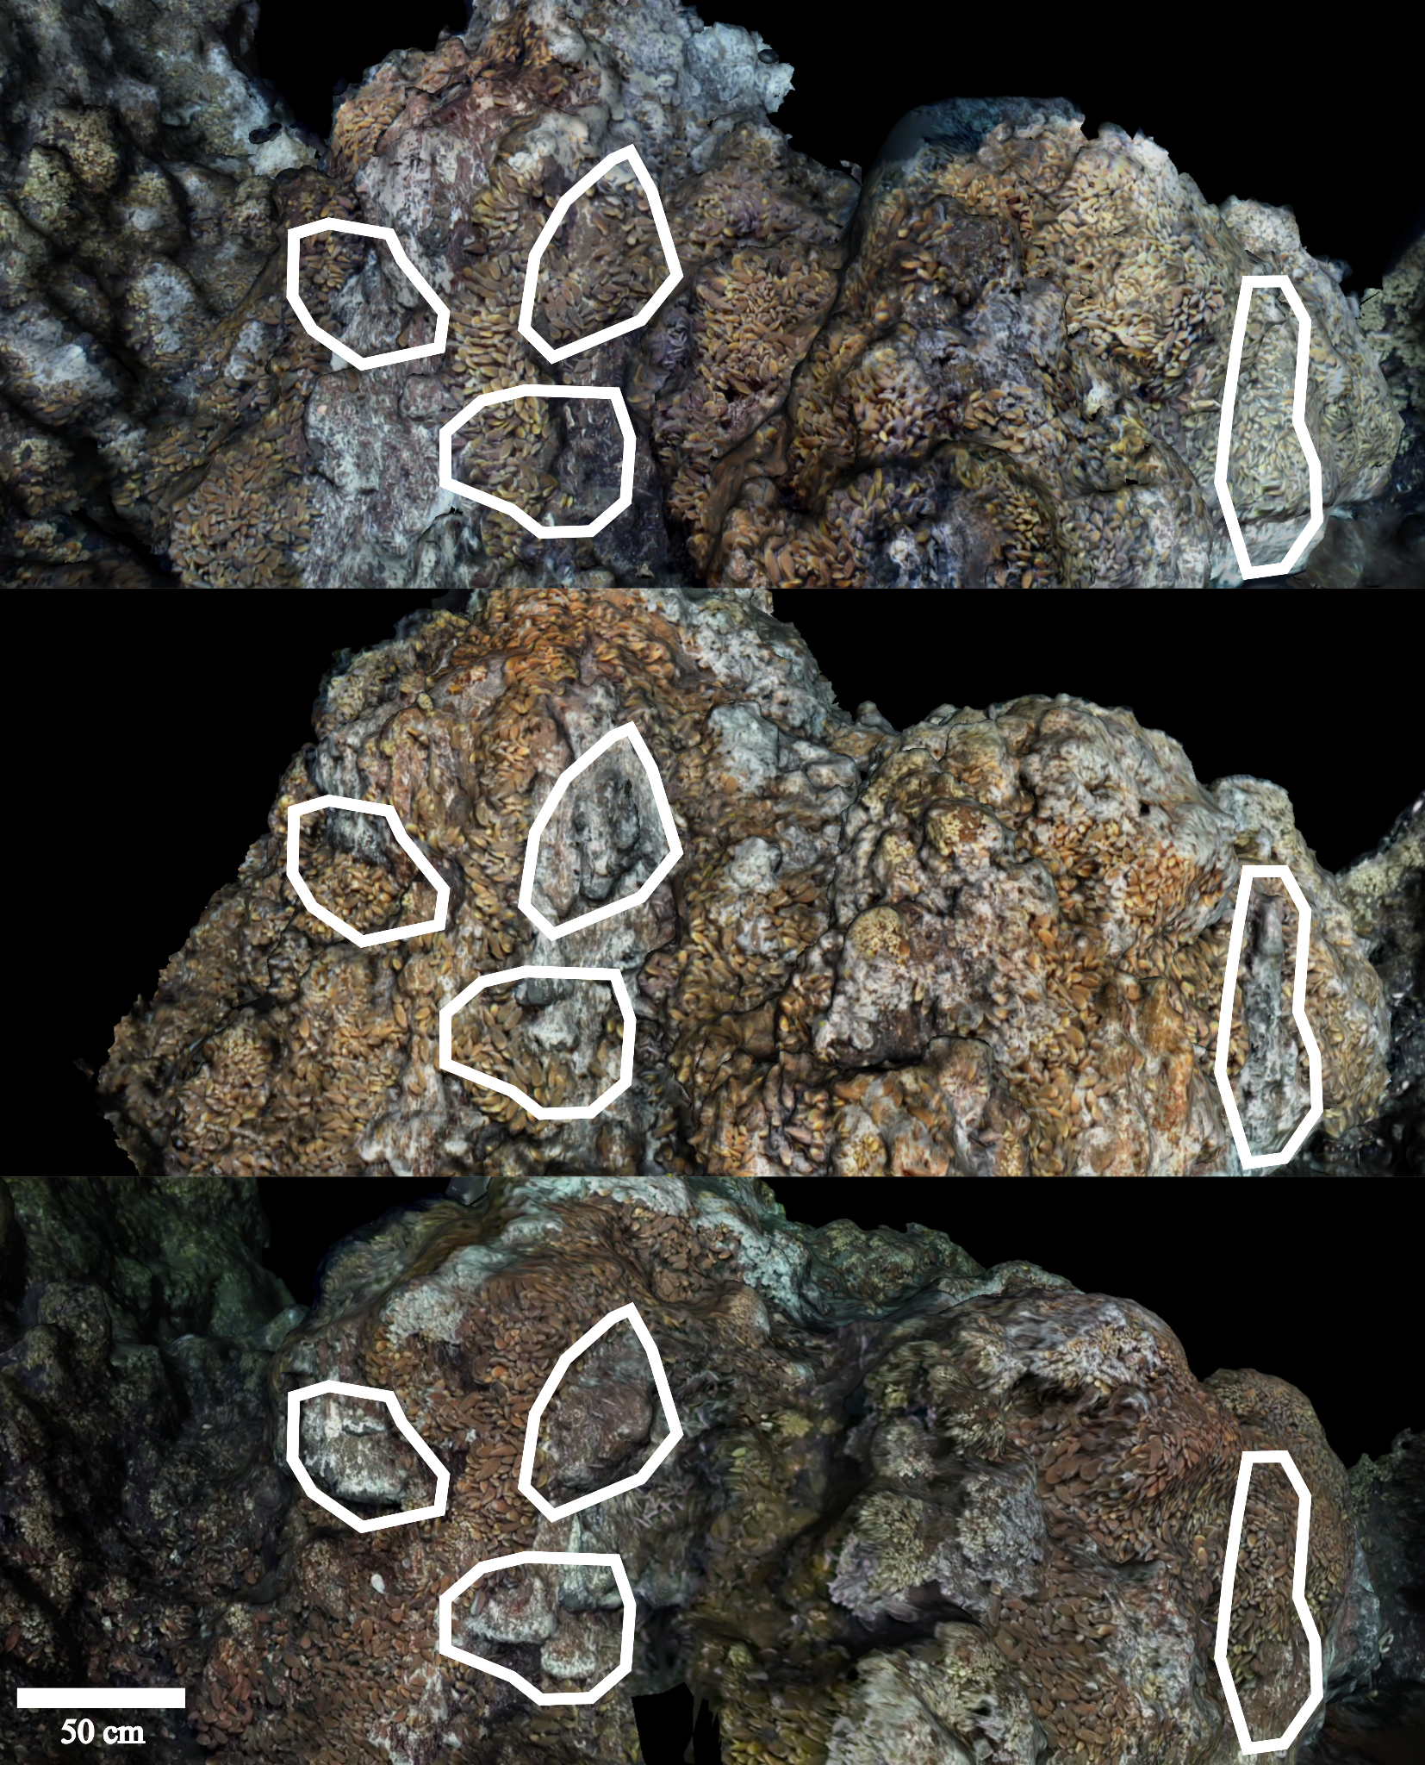
Supplementary Figure S4: Examples of the different dynamics that outcrops can exhibit, as delimited by line-contour polygons over the 3D models from 2015, 2018 and 2020 (top to bottom). Outcrops can activate (i.e., switch from bare substratum to white material due to the release of vent fluid). After activation, mussels usually disappear from the activated area. Activation usually signals that the outcrop will build up, due to the precipitation of minerals. Outcrops can then deactivate, allowing mussels to colonise the substratum that underwent mineralisation.
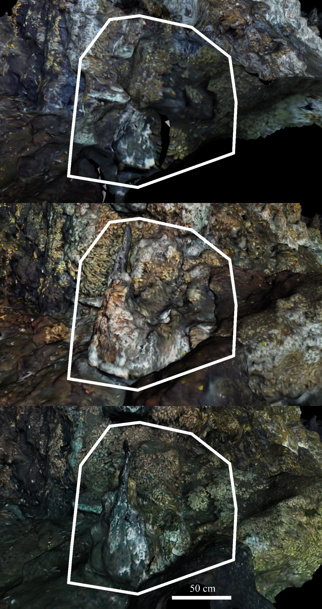
Supplementary Figure S5: A large bulbous outcrop that grew considerably from 2015 to 2018 (approximately + 0.25 m³). It displays a black smoker on top releasing vent fluid from the main conduit, while more dilute fluid is forced to exit from underneath the outcrop.
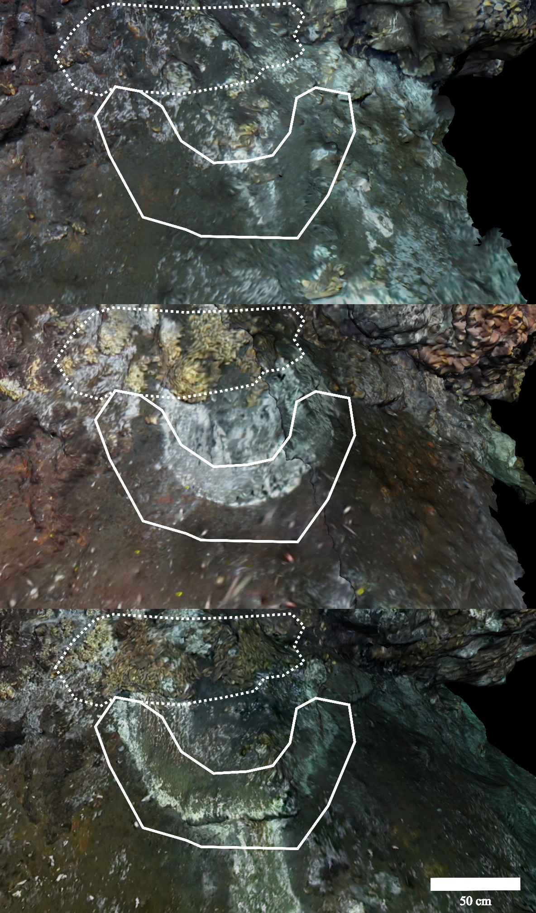
Supplementary Figure S6: Emergence and directional buildup of a circular feature in soft black sediment from 2015 to 2020 (white line-contour polygon). Note the resulting colonisation of a mix of medium and large mussels on top as shown in the dotted-contour polygon.
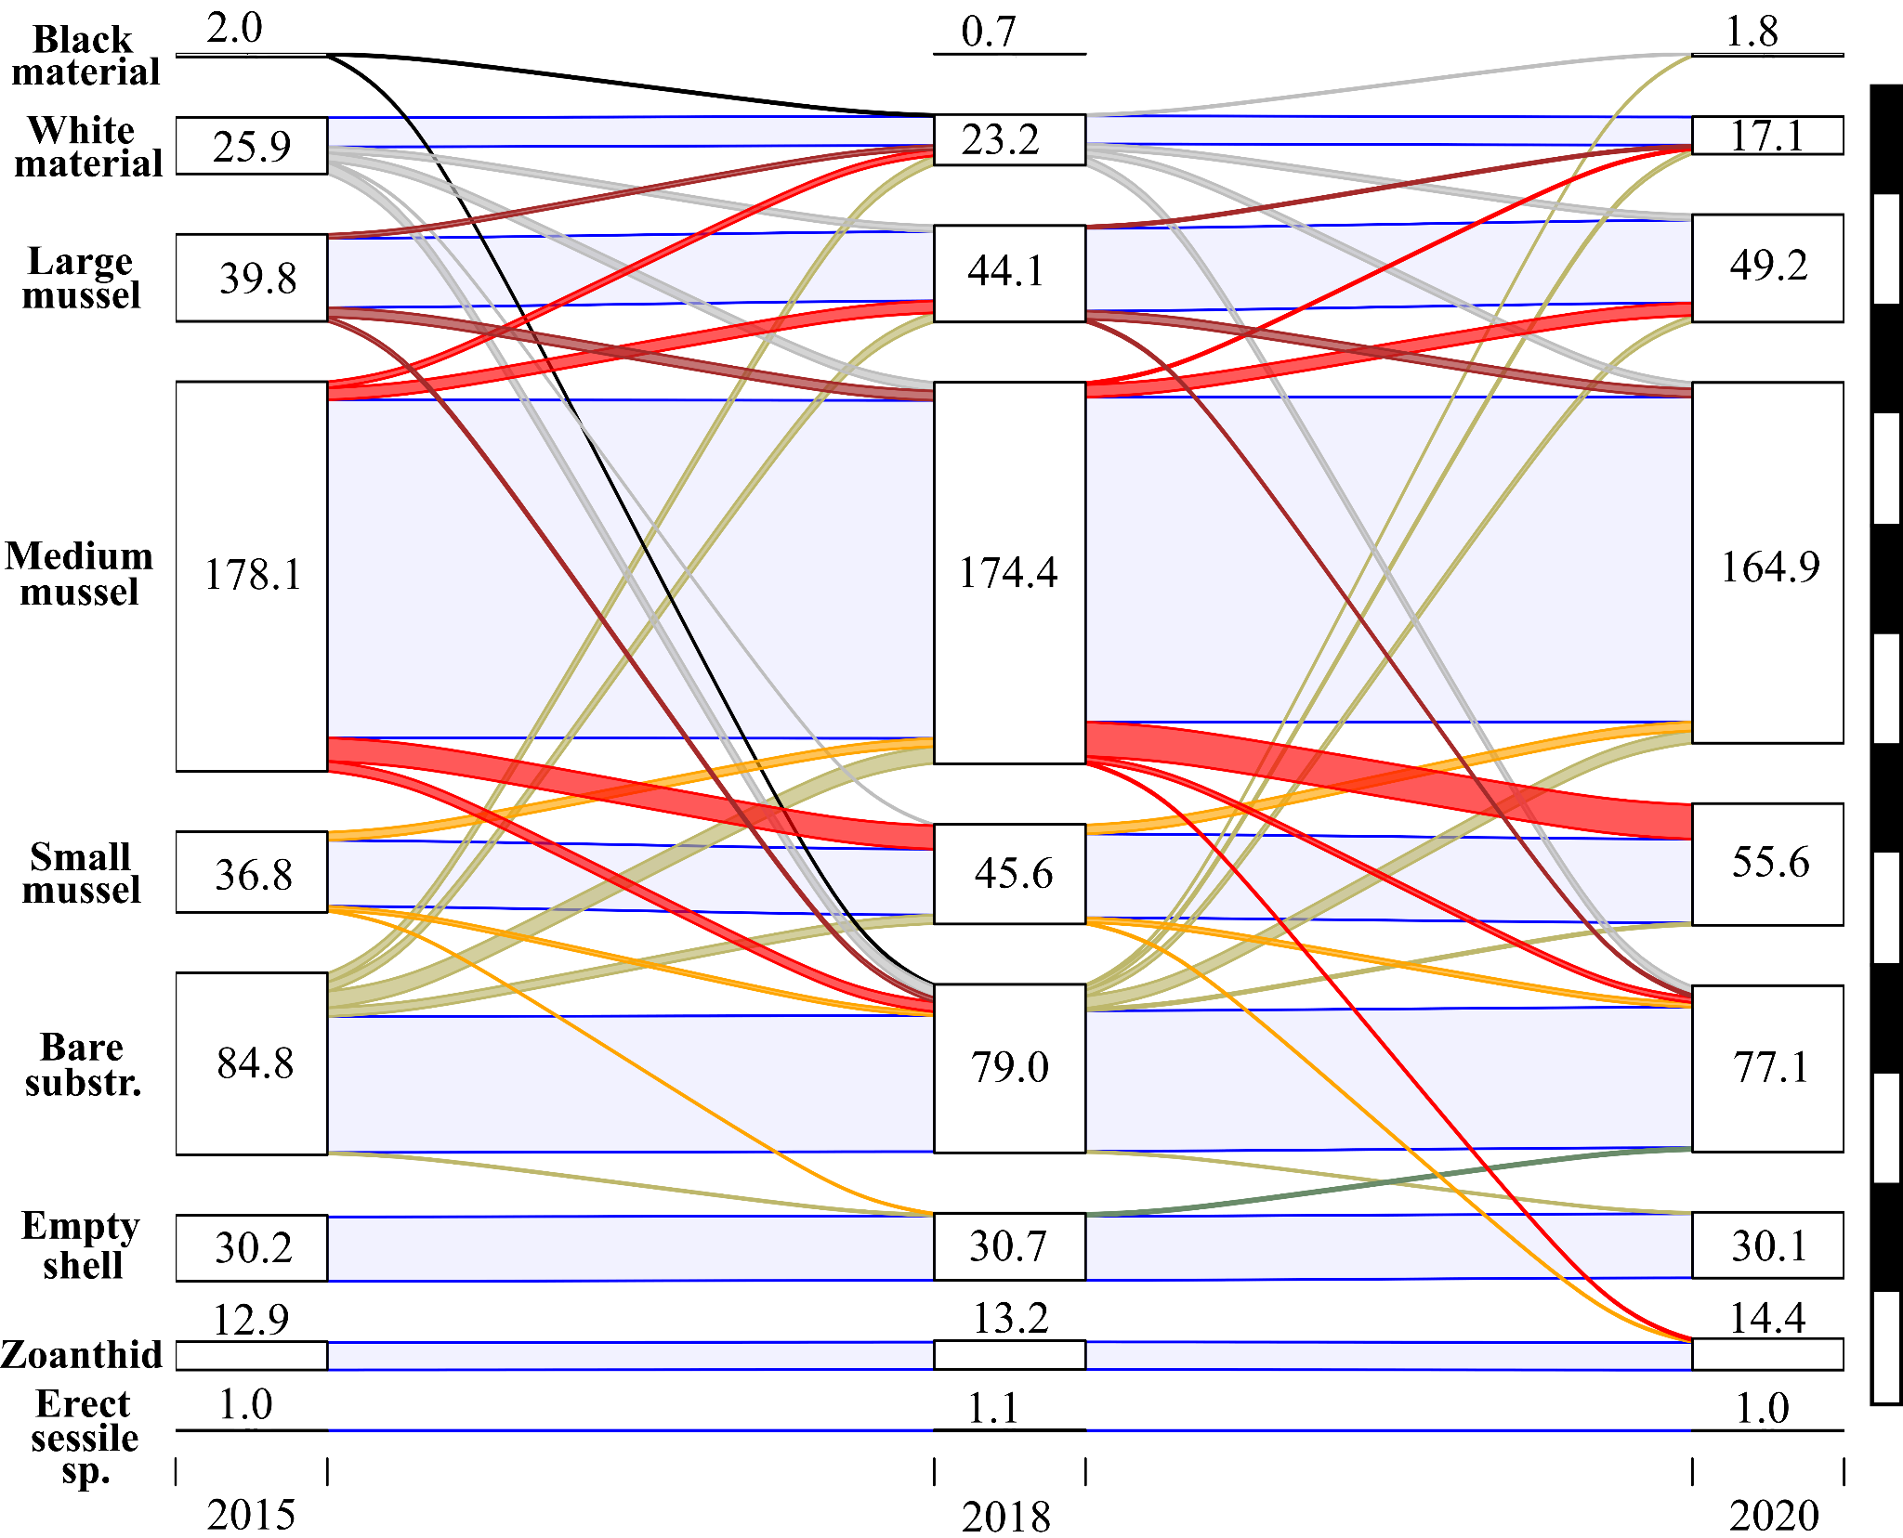

Supplementary Figure S7: Sankey diagram describing patterns of assemblage succession for all polygons annotated on 3D reconstructions of Eiffel Tower in 2015, 2018 and 2020 (i.e. stages). White boxes (i.e., nodes) correspond to assemblage cover at given stages. Coloured segments (i.e., flows) describe the successions occurring in nodes from stage _{(t)} to stage _{(t+1)}. When no change is observed, the flow is shaded in light blue. Each black/wide segment of the vertical bar on the right, scales the height of nodes and flows at a surface of 50 m². Only flows ≥ 0.5 m² are displayed.
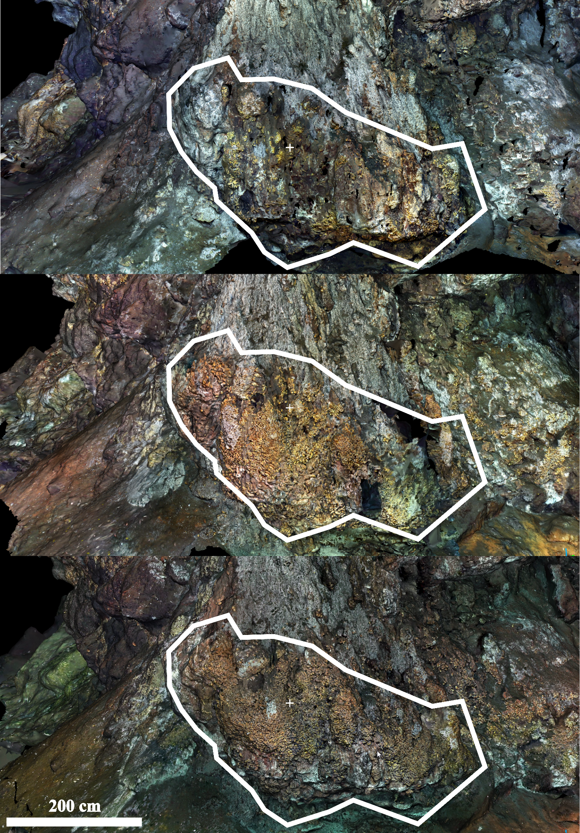
Supplementary Figure S8: Colonisation by large Bathymodiolus azoricus mussels delimited by white line-contour polygons drawn over screenshot of the 3D models from 2015, 2018, to 2020 (top to bottom).

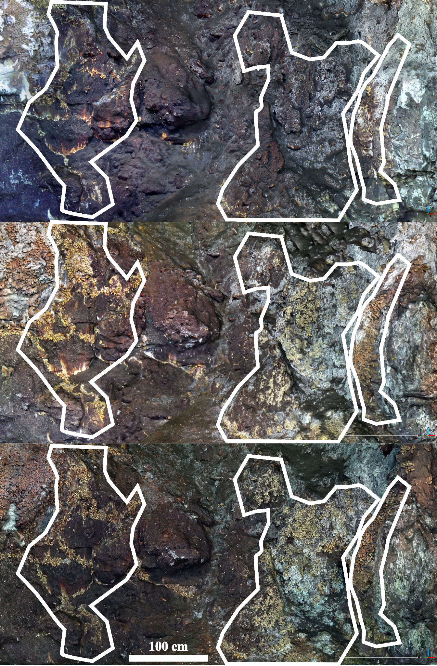
Supplementary Figure S9: Colonisation of medium Bathymodiolus azoricus mussels delimited by white line-contour polygons drawn over screenshot of the 3D models predominantly from 2015 to 2018, and less importantly in 2020 (top to bottom). Note the increasing cover of microbial mats over time on the right.

