Supporting Information

for

Accelerated fragmentation of two thermoplastics (polylactic acid and polypropylene) into microplastics after UV radiation and seawater immersion

Zhiyue Niu^{1,2*}, Marco Curto³, Maelenn Le Gall⁴, Elke Demeyer⁵, Jana Asselman², Colin R. Janssen², Hom Nath Dhakal³, Peter Davies⁴, Ana Isabel Catarino^{1**} and Gert Everaert^{1**}
- Flanders Marine Institute (VLIZ), InnovOcean site, Wandelaarkaai 7, 8400 Oostende, Belgium
- Blue Growth Research Lab, Ghent University, Bluebridge Building, Ostend Science Park 1, 8400, Ostend, Belgium
- Advanced polymers and Composites (APC) Research Group, School of mechanical and Design Engineering, University of Portsmouth, Portsmouth PO1 3DJ, UK
- Marine Structures Laboratory, IFREMER, Centre de Bretagne, 29280, France
- Functional Thermoplastic Textiles, Centexbel, Industriepark Zwijnaarde 70, 9052 Gent, Belgium

*Corresponding author: zhiyue.niu@vliz.be
**Authors had an equal contribution and share senior authorship

Comprises
- Table S1. Summary of microplastic formation results.
- Figure S 1. Fluorescence microscopy images of identified PP and PLA microplastic.
- Figure S 2. Cumulative frequency distributions for released microplastic properties per polymer.
- Figure S 3. µFTIR spectra of pristine and UV weathered microplastics

Table S1. Summary of microplastic formation results. Measured number of released microplastic (50 – 5,000 µm) are expressed as mean ± standard deviation, including particles were quantified by image analysis and manual counting.
Polymer | Treatment | Average abundance of released microplastic (50 – 5,000 µm)
 |  | Total | Image counting | Manual counting¹
SR-PLA | Pristine (D0) | 2 ± 3 | 2 ± 3 | 0
 | 57-day dark | 8 ± 3 | 8 ± 3 | 0
 | 57-day UV | 15 ± 8 | 14 ± 7 | 1 ± 1
 | 76-day dark | 7 ± 3 | 6 ± 3 | 1 ± 1
 | 76-day UV | 22 ± 9 | 21 ± 9 | 2 ± 2
PP | Pristine (D0) | 1 ± 1 | 1 ± 1 | 0
 | 57-day dark | 3 ± 4 | 3 ± 4 | 0
 | 57-day UV | 278 ± 270 | 273 ± 270 | 5 ± 3
 | 76-day dark | 5 ± 3 | 5 ± 3 | 0
 | 76-day UV | 224 ± 111 | 219 ± 113 | 5 ± 4
¹: includes particles (section 2.3.2) and long fibers (section 2.3.1) which cannot be measured with our ImageJ macro.

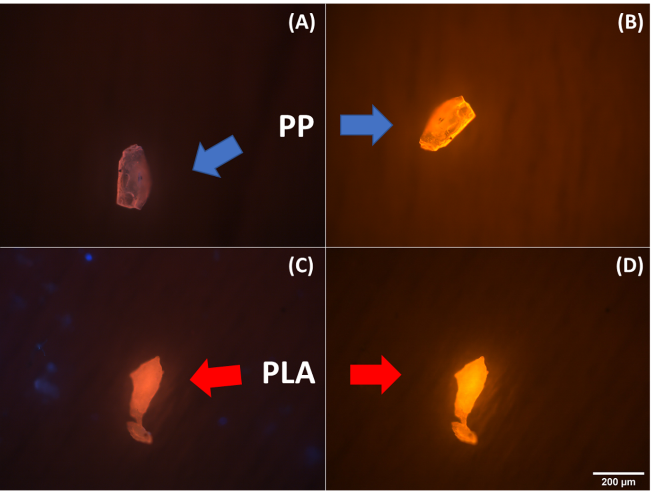
Figure S 1. Fluorescence microscopy images of identified PP and PLA microplastic. A) and C) Image captured under UV filter. B) and D) Image captured under blue filter. Some airborne contamination is visible, and distinguished by having a “blue” color under UV filter (e.g. left side of photograph C), but no longer visible under the Blue filter of the fluorescent microscope.

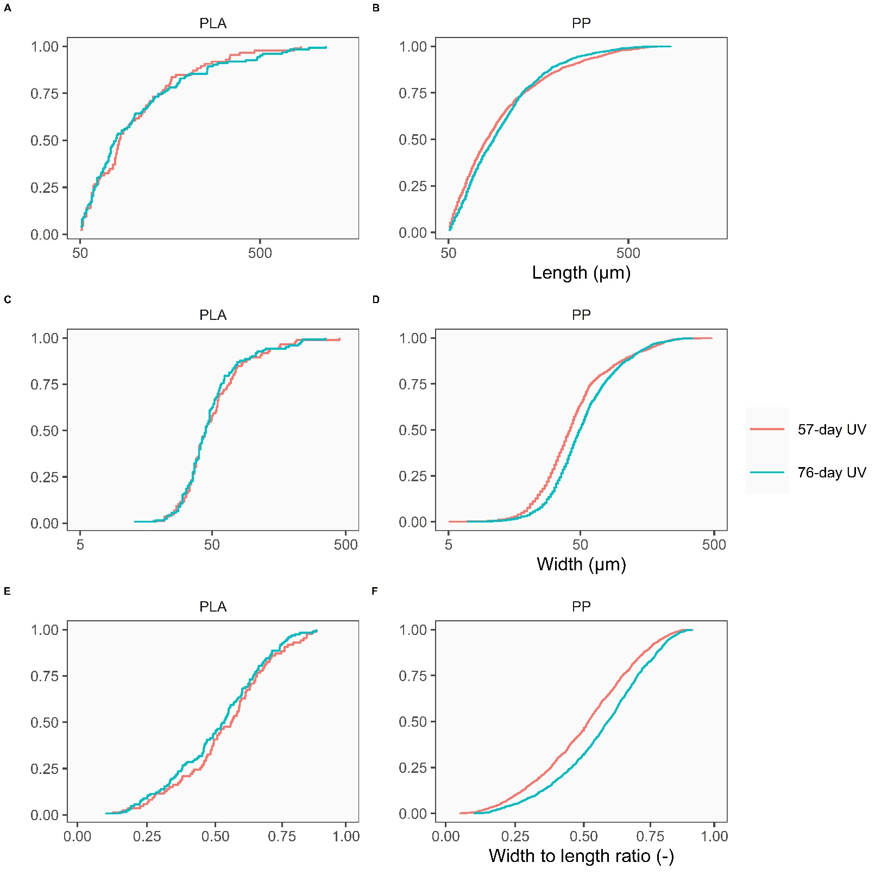
Figure S 2. Cumulative frequency distributions for released microplastic properties per polymer, with A and B) length, C and D) width, E and F) width to length ratio. All distributions are plotted on a log x-axis scale, except for panel E and F), which uses a linear x-axis scale. The different colors indicate 57- (red) and 76-day (blue) UV exposure.

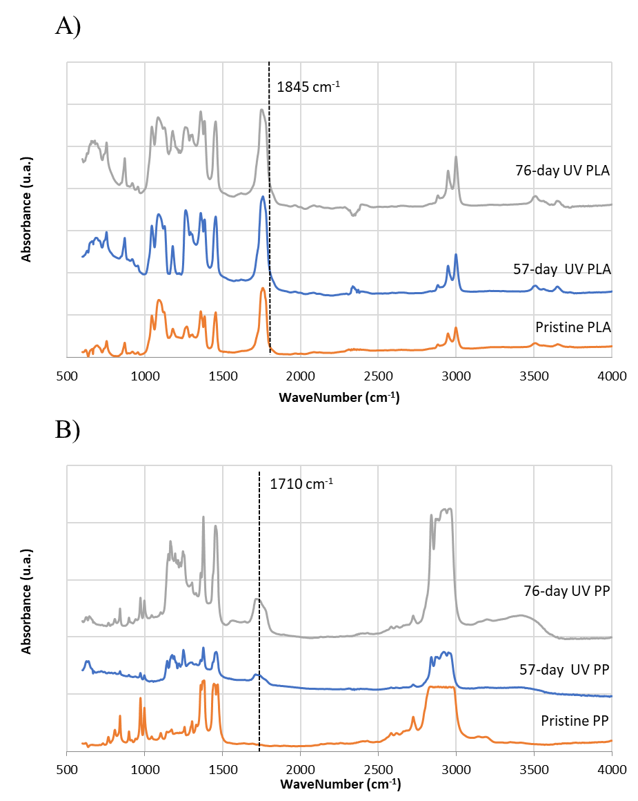
Figure S 3. µFTIR spectra of pristine and UV weathered microplastics from A) PLA and B) PP, with absorbance (u.a.) versus Wavenumber (cm⁻¹). The color of spectra represents “pristine” (orange), “57-day UV weathered” (blue), and “76-day UV weathered” (grey) samples.

